TABLE OF CONTENTS

Filed Pursuant to Rule 424(b)(4)

Registration No. 333-223602

PROSPECTUS

12,000,000 Shares
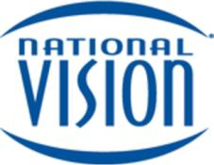

National Vision Holdings, Inc.

Common Stock

The selling stockholders named in this prospectus are offering 12,000,000 shares of common stock of National Vision Holdings, Inc. We will not receive any proceeds from the sale of our common stock by the selling stockholders.

Our common stock is listed on the NASDAQ Global Select Market, or NASDAQ, under the symbol “EYE.” On March 14, 2018, the closing sales price of our common stock as reported on the NASDAQ was $33.57 per share.

To the extent that the underwriters sell more than 12,000,000 shares of our common stock, the underwriters have the option to purchase up to an additional 1,800,000 shares from the selling stockholders at the public offering price, less the underwriting discounts and commissions, within 30 days of the date of this prospectus. We will not receive any proceeds from the sale of our common stock by the selling stockholders pursuant to any exercise of the underwriters’ option to purchase additional shares.

Investing in our common stock involves risk. See “Risk Factors” beginning on page 17 of this prospectus and the risk factors in the documents incorporated by reference in this prospectus to read about factors you should consider before buying shares of our common stock.

Neither the Securities and Exchange Commission, or the SEC, nor any state securities commission has approved or disapproved of these securities or passed upon the adequacy or accuracy of this prospectus. Any representation to the contrary is a criminal offense.

 |  |  |  |  | Per Share |  |  |  | Total
 | Public offering price |  |  | $ | 33.00 | $ |  |  | 396,000,000
Underwriting discounts and commissions |  |  |  | $ | 1.32 |  | $ |  | 15,840,000
 | Proceeds, before expenses, to the selling stockholders⁽¹⁾ |  |  | $ | 31.68 | $ |  |  | 380,160,000

- See “Underwriting (Conflicts of Interest)” for additional information regarding underwriting compensation.

The underwriters expect to deliver the shares against payment in New York, New York on or about March 19, 2018.

Joint Book-Running Managers

BofA Merrill Lynch Citigroup Goldman Sachs & Co. LLC Jefferies KKR

Morgan Stanley UBS Investment Bank Wells Fargo Securities

Co-Managers

Guggenheim Securities Mizuho Securities Macquarie Capital

Prospectus dated March 14, 2018.

TABLE OF CONTENTS
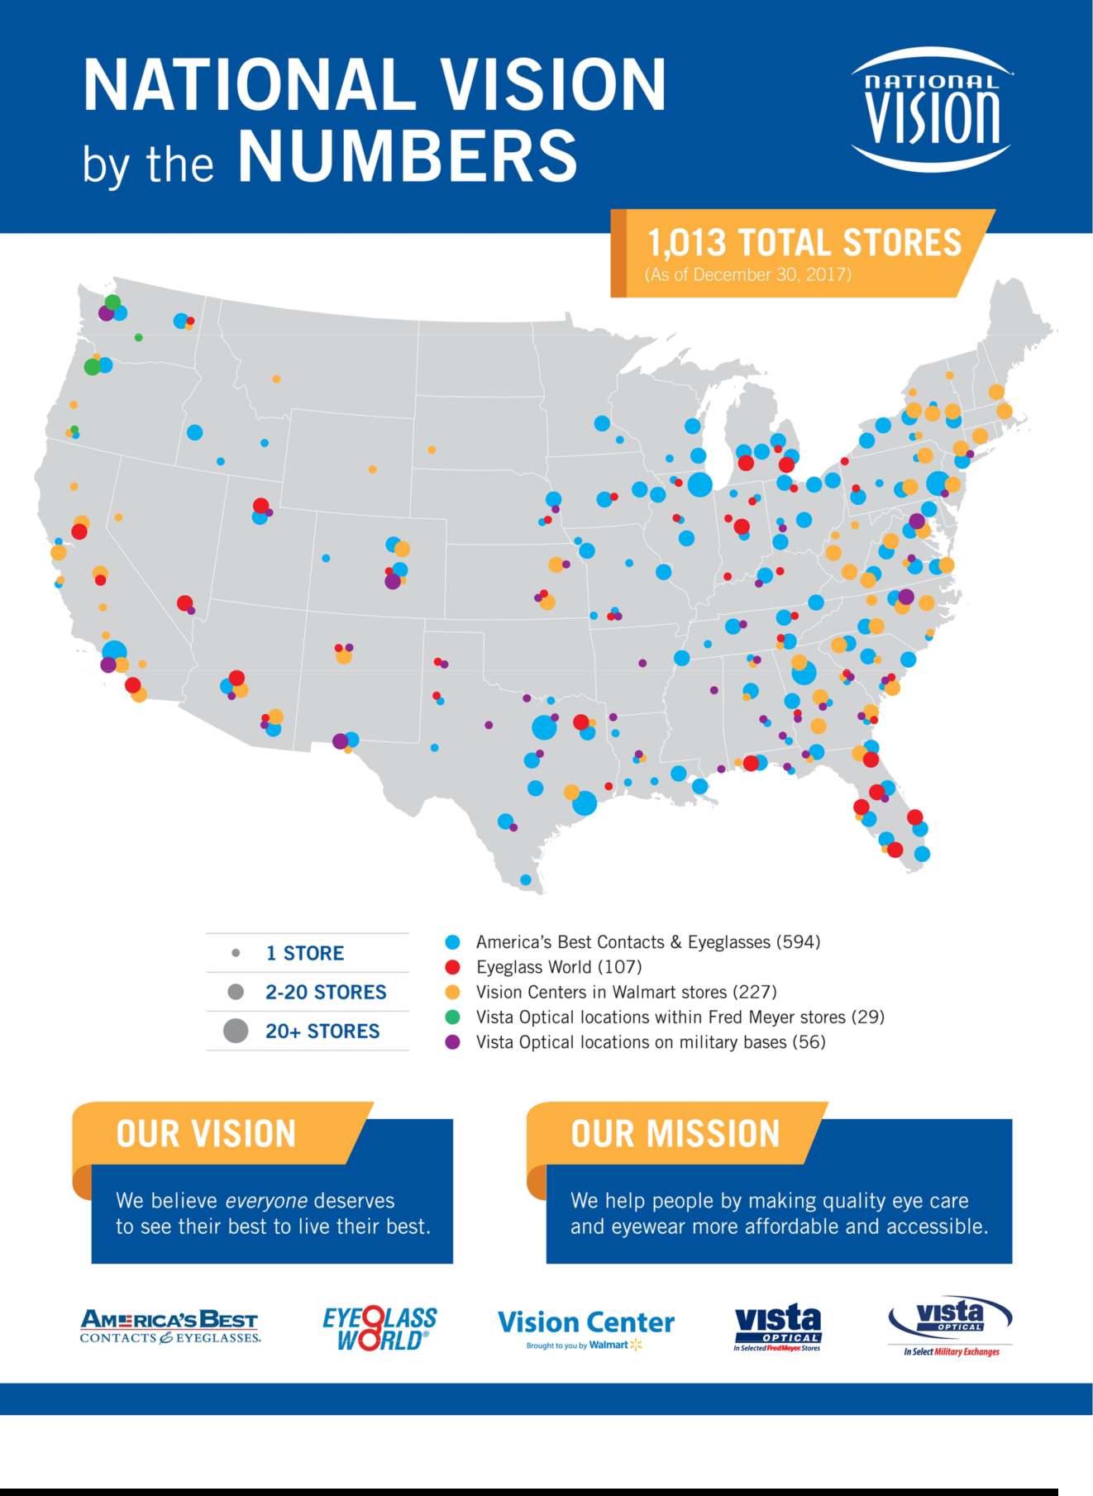

TABLE OF CONTENTS
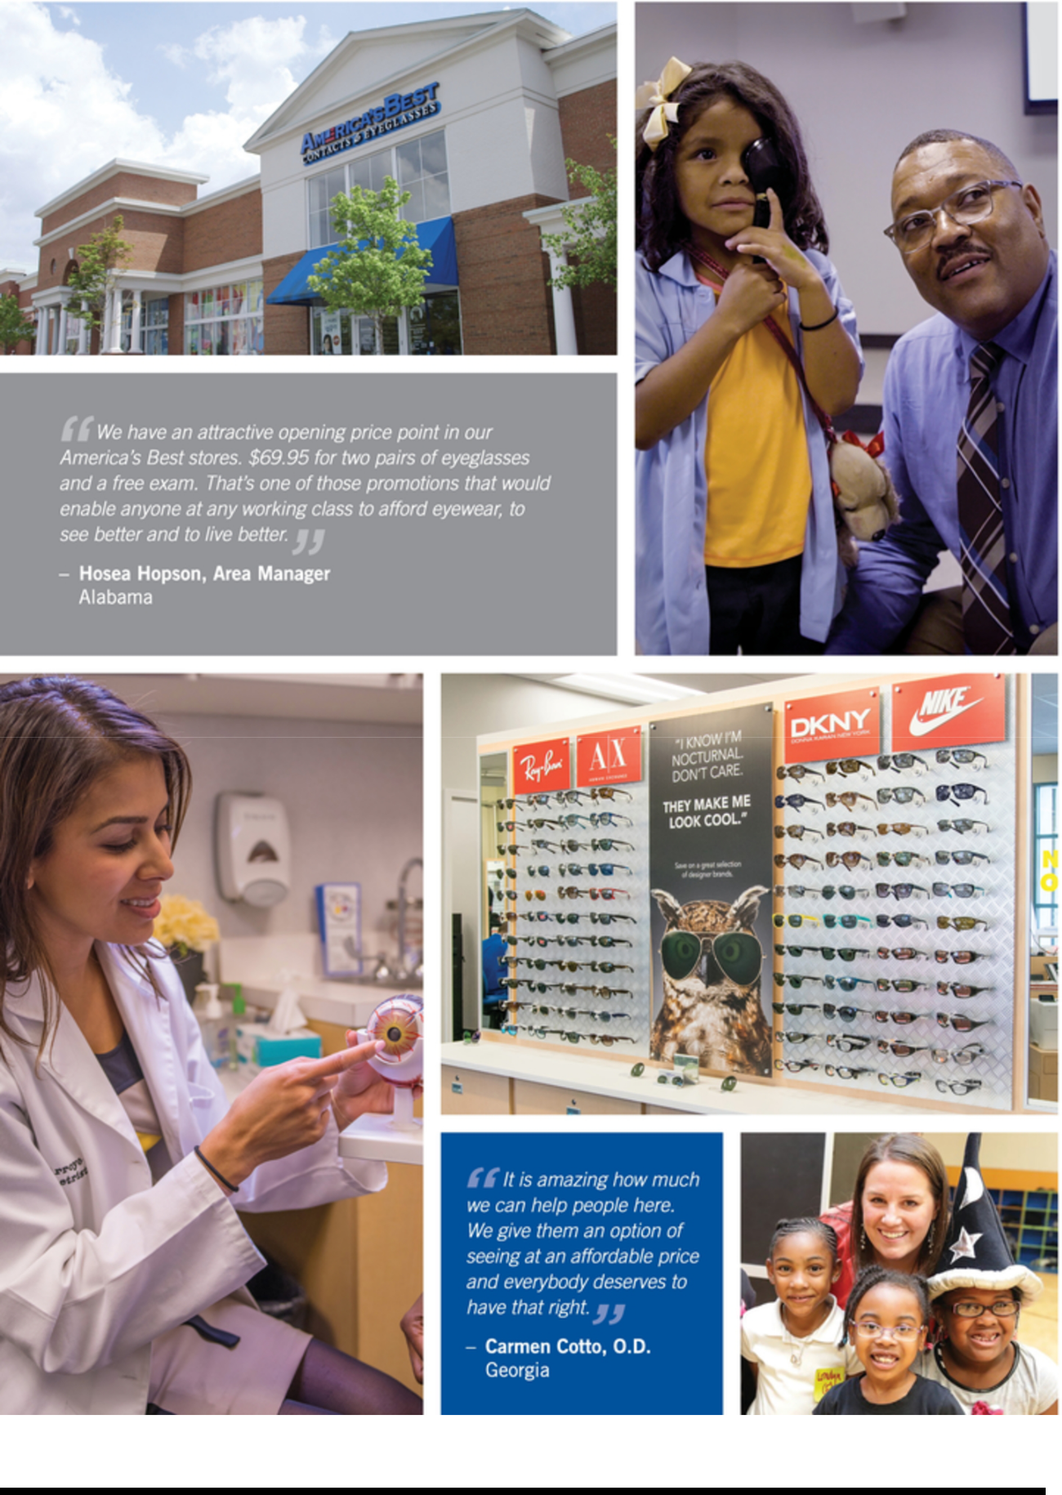

TABLE OF CONTENTS
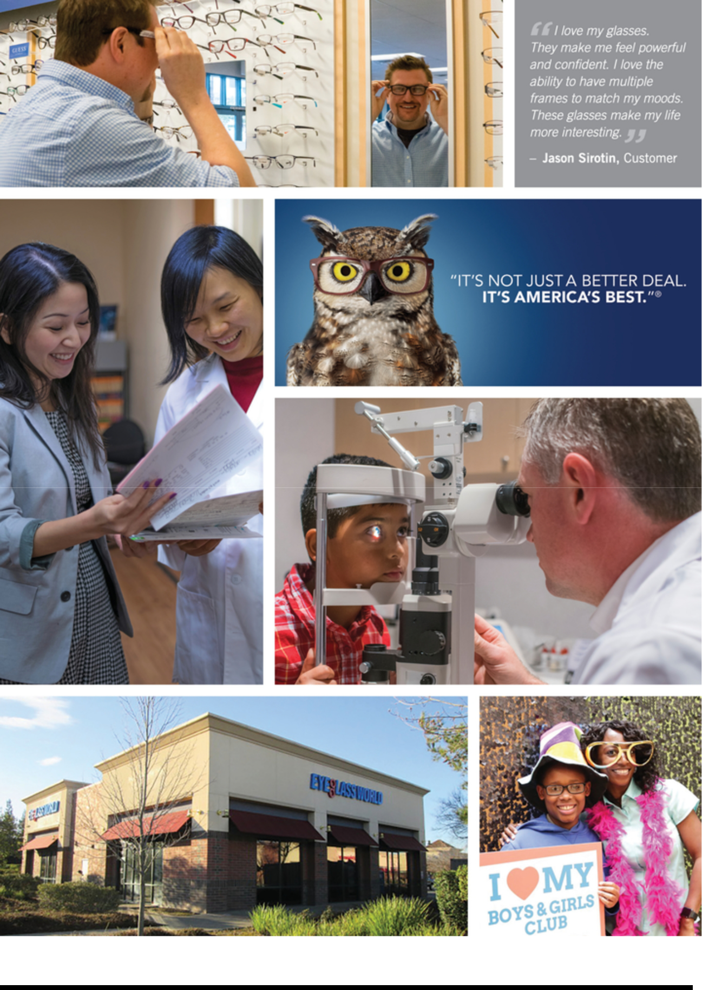

TABLE OF CONTENTS
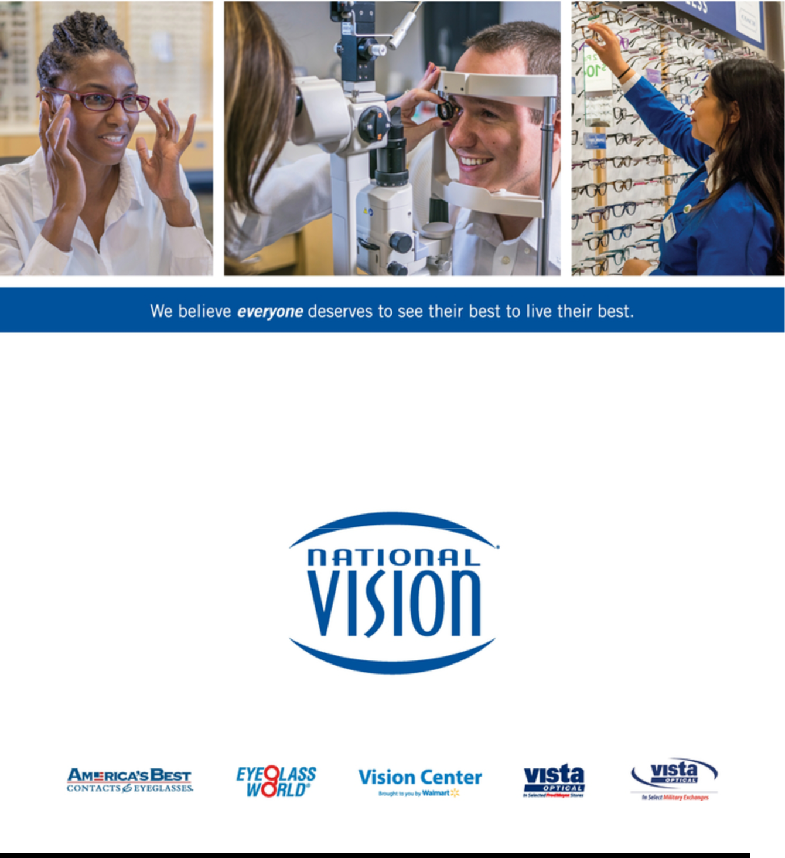

TABLE OF CONTENTS

You should rely only on the information contained, or incorporated by reference, in this prospectus or in any free writing prospectus that we authorize to be delivered to you. We, the selling stockholders and the underwriters have not authorized anyone to provide any information or to make any representations other than those contained, or incorporated by reference, in this prospectus or in any free writing prospectuses we have prepared. We, the selling stockholders and the underwriters take no responsibility for, and can provide no assurance as to the reliability of, any other information that others may provide you. The selling stockholders and the underwriters are offering to sell, and seeking offers to buy, these securities only in jurisdictions where offers and sales are permitted. You should assume that the information contained, or incorporated by reference, in this prospectus or any free writing prospectus prepared by us or on our behalf is accurate only as of their respective dates or on the date or dates which are specified in such documents, and that any information in documents that we have incorporated by reference is accurate only as of the date of such document incorporated by reference. Our business, financial condition, results of operations and prospects may have changed since that date.

For investors outside the United States: The selling stockholders and the underwriters are offering to sell, and seeking offers to buy, shares of our common stock only in jurisdictions where offers and sales are permitted. None of us, the selling stockholders or the underwriters have done anything that would permit this offering or possession or distribution of this prospectus in any jurisdiction where action for that purpose is required, other than in the United States. Persons outside the United States who come into possession of this prospectus must inform themselves about, and observe any restrictions relating to, the offering of the shares of common stock and the distribution of this prospectus outside the United States.

 |  |  |  |  |  |  |  |  |  |  |  |  |  |  |  |  |  | Table of Contents
 | Market, Ranking, and Other Industry Data |  |  |  |  |  |  |  |  |  |  |  |  |  |  |  |  |  |  |  |  | ii
 | Trademarks, Service Marks and Tradenames |  |  |  |  |  |  |  |  |  |  |  |  |  |  |  |  |  |  |  |  | ii
 | Basis of Presentation |  |  |  |  |  |  |  |  |  |  |  |  |  |  |  |  |  |  |  |  | ii
 | Glossary |  |  |  |  |  |  |  |  |  |  |  |  |  |  |  |  |  |  | iii
 | Non-GAAP Financial Measures |  |  |  |  |  |  |  |  |  |  |  |  |  |  |  |  |  |  |  | iv
 | Prospectus Summary |  |  |  |  |  |  |  |  |  |  |  |  |  |  |  |  |  |  |  | 1
 | Risk Factors |  |  |  |  |  |  |  |  |  |  |  |  |  |  |  |  |  |  | 17
 | Special Note Regarding Forward-Looking Statements |  |  |  |  |  |  |  |  |  |  |  |  |  |  |  |  |  |  | 25
 | Use of Proceeds |  |  |  |  |  |  |  |  |  |  |  |  |  |  |  |  |  |  | 27
 | Dividend Policy |  |  |  |  |  |  |  |  |  |  |  |  |  |  |  |  |  |  | 28
 | Price Range of Common Stock |  |  |  |  |  |  |  |  |  |  |  |  |  |  |  |  |  |  | 29
 | Capitalization |  |  |  |  |  |  |  |  |  |  |  |  |  |  |  |  |  |  | 30
 | Selling Stockholders |  |  |  |  |  |  |  |  |  |  |  |  |  |  |  |  |  |  | 31
 | Description of Capital Stock |  |  |  |  |  |  |  |  |  |  |  |  |  |  |  |  |  |  | 33
 | Shares Eligible for Future Sale |  |  |  |  |  |  |  |  |  |  |  |  |  |  |  |  |  |  | 40
 | Material United States Federal Income and Estate Tax Consequences to Non-U.S. Holders |  |  |  |  |  |  |  |  |  |  |  |  |  |  |  |  |  |  | 42
 | Underwriting (Conflicts of Interest) |  |  |  |  |  |  |  |  |  |  |  |  |  |  |  |  |  |  | 45
 | Legal Matters |  |  |  |  |  |  |  |  |  |  |  |  |  |  |  |  |  |  | 52
 | Experts |  |  |  |  |  |  |  |  |  |  |  |  |  |  |  |  |  |  | 52
 | Where You Can Find More Information |  |  |  |  |  |  |  |  |  |  |  |  |  |  |  |  |  |  | 52
 | Incorporation by Reference |  |  |  |  |  |  |  |  |  |  |  |  |  |  |  |  |  |  | 52

i

TABLE OF CONTENTS

MARKET, RANKING, AND OTHER INDUSTRY DATA

The data included, or incorporated by reference, in this prospectus regarding markets, ranking and other industry information are based on reports of government agencies or published industry sources, and our own internal estimates are based on our management’s knowledge and experience in the markets in which we operate. Data regarding the industry in which we compete and our market position and market share within this industry are inherently imprecise and are subject to significant business, economic and competitive uncertainties beyond our control, but we believe they generally indicate size, position and market share within this industry. Our own estimates are based on information obtained from our customers, suppliers, trade and business organizations and other contacts in the markets we operate. We are responsible for all of the disclosure included, or incorporated by reference, in this prospectus, and we believe these estimates to be accurate as of the date of this prospectus or such other date stated in this prospectus (or in documents we have incorporated by reference). However, this information may prove to be inaccurate because of the method by which we obtained some of the data for the estimates or because this information cannot always be verified with complete certainty due to the limits on the availability and reliability of raw data, the voluntary nature of the data gathering process and other limitations and uncertainties. While we believe that each of the publications used throughout this prospectus (or in documents we have incorporated by reference) are prepared by reputable sources, neither we nor the underwriters have independently verified market and industry data from third-party sources. While we believe our internal company research and estimates are reliable, such research and estimates have not been verified by any independent source. In addition, assumptions and estimates of our and our industry’s future performance are necessarily subject to a high degree of uncertainty and risk due to a variety of factors, including those described in “Risk Factors” in this prospectus and “Risk Factors” and “Management’s Discussion and Analysis of Financial Condition and Results of Operations” in our Annual Report (as defined herein), which is incorporated by reference in this prospectus. These and other factors could cause our future performance to differ materially from our assumptions and estimates. See “Special Note Regarding Forward-Looking Statements.” As a result, you should be aware that market, ranking, and other similar industry data included, or incorporated by reference, in this prospectus, and estimates and beliefs based on that data may not be reliable. None of us, the selling stockholders and the underwriters can guarantee the accuracy or completeness of any such information contained, or incorporated by reference, in this prospectus.

TRADEMARKS, SERVICE MARKS AND TRADENAMES

We own a number of registered and common law trademarks and pending applications for trademark registrations in the United States, primarily through our subsidiaries, including: America’s Best, America’s Best & design, America’s Best Contacts & Eyeglasses, America’s Best Contacts & Eyeglasses & design, America’s Best Vision Plan, America’s Best owl mascot image, the slogan, “It’s not just a better deal. It’s America’s Best.,” Eyeglass World, Eyeglass World logos, the slogans, “See yourself smile. See yourself save.,” “The world’s best way to buy glasses.” and “The world’s best way to buy contacts.,” the Eyeglass World mast image Mr. World, AC Lens, FirstSight, Vista Optical, Eyecare Club, Sofmed, Digimax, Neverglare, Neverglare Advantage and Neverglare Advantage & design. Solely for convenience, the trademarks, service marks and tradenames referred to in this prospectus (or in documents we have incorporated by reference) are presented without the ®, SM and ™ symbols, but such references are not intended to indicate, in any way, that we will not assert, to the fullest extent under applicable law, our rights or the rights of the applicable licensors to these trademarks, service marks and tradenames. All trademarks, service marks and tradenames appearing in this prospectus (or in documents we have incorporated by reference) are the property of their respective owners.

BASIS OF PRESENTATION

Unless otherwise indicated or the context otherwise requires, financial data included, or incorporated by reference, in this prospectus reflects the business and operations of National Vision Holdings, Inc. and its consolidated subsidiaries. Unless the context otherwise requires, all references herein to “National Vision Holdings, Inc.,” “National Vision,” the “Company,” “we,” “our” or “us” refer to National Vision Holdings, Inc. and its consolidated subsidiaries. National Vision Holdings, Inc. conducts substantially all of its activities through its direct, wholly-owned subsidiary, National Vision, Inc., which we refer to herein as “NVI,” and NVI’s subsidiaries.

We operate on a retail fiscal calendar pursuant to which our fiscal year consists of 52 or 53 weeks, ending on the Saturday closest to December 31. Unless otherwise indicated or the context otherwise requires, all references to years and quarters relate to fiscal periods rather than calendar periods.

ii

TABLE OF CONTENTS

References to “fiscal year 2015,” “fiscal year 2016” and “fiscal year 2017” relate to our fiscal year ended January 2, 2016, our fiscal year ended December 31, 2016 and our fiscal year ended December 30, 2017, respectively.

Amounts in this prospectus and the audited consolidated financial statements incorporated by reference in this prospectus are presented in U.S. dollars rounded to the nearest thousand, unless otherwise noted. Certain amounts presented in tables are subject to rounding adjustments and, as a result, the totals in such tables may not sum. The accounting policies set out in the audited consolidated financial statements incorporated by reference in this prospectus have been consistently applied to all periods presented.

GLOSSARY

The following are definitions of certain terms as used in this prospectus, unless otherwise noted or indicated by context.

- “AC Lens” means Arlington Contact Lens Service, Inc., our wholly-owned subsidiary.

- “Annual Report” means our Annual Report on Form 10-K for the fiscal year ended December 30, 2017, filed on March 8, 2018.

- “Berkshire” means Berkshire Partners LLC.

- “Centralized laboratory network” or “laboratory network” mean our three owned, full-service optical laboratories in the United States and two outsourced, third-party owned optical laboratories in Mexico and China.

- “E-commerce platform” means the technology that we use to conduct the online sale of optical goods and accessories, and includes our construction, management and operation of our proprietary websites and websites for third parties, such as Wal-Mart Stores, Inc., or Walmart, Sam’s Club and Giant Eagle, which we refer to herein as our “e-commerce business.”

- “E-commerce sales” means sales from our store, proprietary and partner websites, excluding AC Lens’ fulfilment orders for the Walmart and Sam’s Club websites and ship-to-home orders from our store websites fulfilled by AC Lens.

- “Eye care practitioners” means optometrists and ophthalmologists.

- “FirstSight” means FirstSight Vision Services, Inc., our wholly-owned subsidiary.

- “Host brands” means the Vista Optical brands we operate in Fred Meyer stores and on U.S. Army and Air Force military bases.

- “Host partners” means Fred Meyer, Inc., or Fred Meyer, and the U.S. Army and Air Force Exchange Service.

- “KKR Acquisition” means the acquisition of the Company by affiliates of KKR Sponsor in March 2014.

- “KKR Sponsor” means Kohlberg Kravis Roberts & Co. L.P.

- “Legacy brand” means the Vision Center brand we operate in Walmart stores.

- “Legacy partner” means Walmart.

- “Managed care” or “managed vision care” mean vision care programs and associated benefits (i) sponsored by employers or other groups, (ii) provided by insurers and managed care entities, such as health maintenance organizations, or HMOs, to individuals, and (iii) delivered, typically on a fee-for-service or capitated basis, by health care providers, such as ophthalmologists, optometrists and opticians.

- “Mature stores” means stores that have been in operation for longer than five years.

- “Omni-channel platform” means the technology supporting many of our physical and online retail functionalities and services, including online frame browsing and virtual frame try-on, scheduling of

iii

TABLE OF CONTENTS

appointments, ship to customer programs, geolocation of our retail locations and online ordering of optical goods. As of December 30, 2017, our omni-channel platform serves our America’s Best Contacts & Eyeglasses, or America’s Best, stores, Eyeglass World stores and Vista Optical operations on U.S. Army and Air Force military bases.

- “Owned brands” or “owned stores” mean our America’s Best and Eyeglass World brands or stores, as applicable.

- “Partner brands” means our host and legacy brands, collectively.

- “Sponsors” means affiliates of KKR Sponsor and private equity funds managed by Berkshire.

- “Value segment” or “value segment of the U.S. optical retail industry” consists of the Company, Walmart, Costco Wholesale and Eyemart Express, Ltd.

- “Vision care professionals” means optometrists (including optometrists employed by us or by professional corporations owned by eye care practitioners with which we have arrangements) and opticians.

NON-GAAP FINANCIAL MEASURES

This prospectus contains, or incorporates by reference, “non-GAAP financial measures” that are financial measures that either exclude or include amounts that are not excluded or included in the most directly comparable measures calculated and presented in accordance with accounting principles generally accepted in the United States, or GAAP. Specifically, we make use of the non-GAAP financial measures “EBITDA,” “Adjusted EBITDA” and “Adjusted Net Income.”

EBITDA, Adjusted EBITDA and Adjusted Net Income have been presented in this prospectus as supplemental measures of financial performance that are not required by, or presented in accordance with GAAP, because we believe they assist investors and analysts in comparing our operating performance across reporting periods on a consistent basis by excluding items that we do not believe are indicative of our core operating performance. Management believes EBITDA, Adjusted EBITDA and Adjusted Net Income are useful to investors in highlighting trends in our operating performance, while other measures can differ significantly depending on long-term strategic decisions regarding capital structure, the tax jurisdictions in which we operate and capital investments. Management uses EBITDA, Adjusted EBITDA and Adjusted Net Income to supplement GAAP measures of performance in the evaluation of the effectiveness of our business strategies, to make budgeting decisions, to establish discretionary annual incentive compensation and to compare our performance against that of other peer companies using similar measures. Management supplements GAAP results with non-GAAP financial measures to provide a more complete understanding of the factors and trends affecting the business than GAAP results alone.

EBITDA, Adjusted EBITDA and Adjusted Net Income are not recognized terms under GAAP and should not be considered as an alternative to net income or income from operations, as a measure of financial performance, or cash flows provided by operating activities, as a measure of liquidity, or any other performance measure derived in accordance with GAAP. Additionally, these measures are not intended to be a measure of free cash flow available for management’s discretionary use as they do not consider certain cash requirements such as interest payments, tax payments and debt service requirements. The presentations of these measures have limitations as analytical tools and should not be considered in isolation, or as a substitute for analysis of our results as reported under GAAP. Because not all companies use identical calculations, the presentations of these measures may not be comparable to other similarly titled measures of other companies and can differ significantly from company to company. For a discussion of the use of these measures and a reconciliation of the most directly comparable GAAP measures, see “Prospectus Summary―Summary Historical Consolidated Financial and Other Data.”

iv

TABLE OF CONTENTS


PROSPECTUS SUMMARY

This summary highlights certain significant aspects of our business and this offering, and it includes information contained elsewhere in this prospectus or incorporated by reference in this prospectus from our filings with the SEC listed under “Incorporation by Reference.” This summary is not complete and does not contain all of the information that you should consider before making your investment decision. You should carefully read this entire prospectus and the information incorporated by reference in this prospectus, including any free writing prospectus prepared by us or on our behalf, including the sections entitled “Special Note Regarding Forward-Looking Statements” and “Risk Factors” included in this prospectus and “Risk Factors,” “Management’s Discussion and Analysis of Financial Condition and Results of Operations” and the audited consolidated financial statements and related notes thereto in our Annual Report, which is incorporated by reference in this prospectus, before you decide to invest in shares of our common stock.

Our Company

We are one of the largest and fastest growing optical retailers in the United States and a leader in the attractive value segment of the U.S. optical retail industry. We believe that vision is central to quality of life and that people deserve to see their best to live their best, no matter what their budget. Our mission is to make quality eye care and eyewear affordable and accessible to all Americans. We achieve this by providing eye exams, eyeglasses and contact lenses to cost-conscious and low-income consumers. We deliver exceptional value and convenience to our customers, with an opening price point that strives to be among the lowest in the industry, enabled by our low-cost operating platform. We believe our focus on the value segment, breadth of product assortment, committed employees and consultative selling approach generate customer goodwill for our brands. Our long-serving and motivated management team of optical retail experts has delivered a highly-consistent track record of strong results.

We are well positioned to serve our new and existing customers through a diverse portfolio of 1,013 retail stores across five brands and 18 consumer websites as of December 30, 2017. We have two reportable segments: our owned & host segment and our legacy segment. Our owned & host segment includes our two owned brands, America’s Best and Eyeglass World, and our Vista Optical locations in Fred Meyer stores. Within this segment, we also provide low-cost vision care products and services to American military service members by operating Vista Optical locations on military bases across the country. Our legacy segment consists of our 27-year strategic relationship with Walmart to operate Vision Centers in select Walmart stores. In addition, our wholly-owned subsidiary, FirstSight, which is licensed as a single-service health plan under California law, issues individual vision care benefit plans in connection with our America’s Best operations in California and provides, or arranges for the provision of, optometric services at almost all of the optometric offices next to Walmart and Sam’s Club stores in California. We support our owned brands and our Vista Optical military operations through our ever-evolving omni-channel offerings and we also have an established standalone e-commerce business. Our e-commerce platform serves our proprietary e-commerce websites and the e-commerce websites of third parties, including Walmart, Sam’s Club and Giant Eagle. The following table provides an overview of our portfolio of brands:

1

TABLE OF CONTENTS
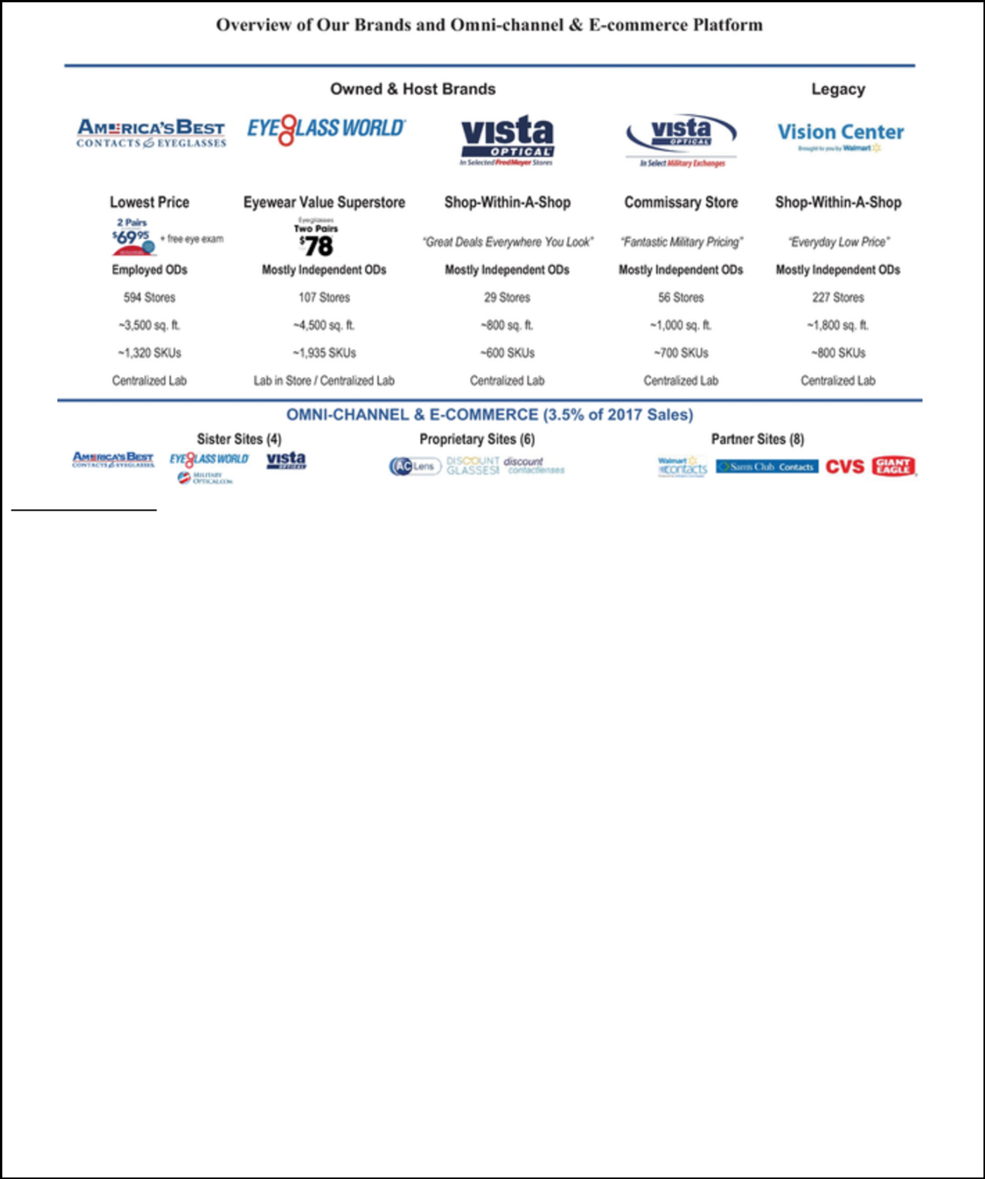

Note: Store count as of December 30, 2017. SKU figures refer to eyeglass frame SKUs. ODs are Doctors of Optometry.

- Vista Optical in Fred Meyer stores does not offer omni-channel services.

Our financial success has helped fuel our ever-growing philanthropic engine. Through multiple charitable partnerships, we have directly assisted approximately 900,000 individuals to see and have indirectly helped improve the vision of approximately 14 million individuals globally. Our philanthropic culture instills a sense of purpose and engagement in our employees, from in-store staff to senior management. Our employees feel pride in the positive work they are doing, which allows us to attract and retain both store associates and vision care professionals, thus improving the customer experience in our stores.

Our disciplined approach to new store openings, combined with our attractive store economics, has led to strong returns on investment. We believe these elements are the foundation for continued profitable growth from our existing store base, as well as a significant opportunity to deliver growth through new store openings. The fundamentals of our model are:

- Differentiated and Defensible Value Proposition. We believe our success is driven by our low prices, convenient locations, broad assortment of branded and private label merchandise and the high levels of in-store service provided by our well-trained and passionate store associates and vision care professionals. We believe our bundled offers, including two-pairs of eyeglasses plus an eye exam for $69.95 at America’s Best and two-pairs of eyeglasses for $78.00 at Eyeglass World, represent among the lowest price offerings of any national chain. Our ability to utilize national advertising for America’s Best allows us to communicate this value proposition to a meaningfully greater number of current and potential customers.

- Recurring Revenue Characteristics. Eye care purchases are predominantly a medical necessity and are therefore considered non-discretionary in nature. We estimate that optical consumers typically replace their eyeglasses every two to three years, while contact lens customers typically order new lenses every six to twelve months, reflecting the predictability of these recurring purchase behaviors. This is further demonstrated by the customer mix of our mature stores, with existing customers representing 63% of total customers in fiscal year 2017 and new customers representing the remaining 37% of total customers in fiscal year 2017.

- Attractive Store Economics and Embedded Earnings Growth. Our store economics are based on low capital investment, steady ramping of sales in new locations, low operating costs and consistent sales volume and earnings growth in mature stores, which result in attractive returns on capital. On average,

2

TABLE OF CONTENTS
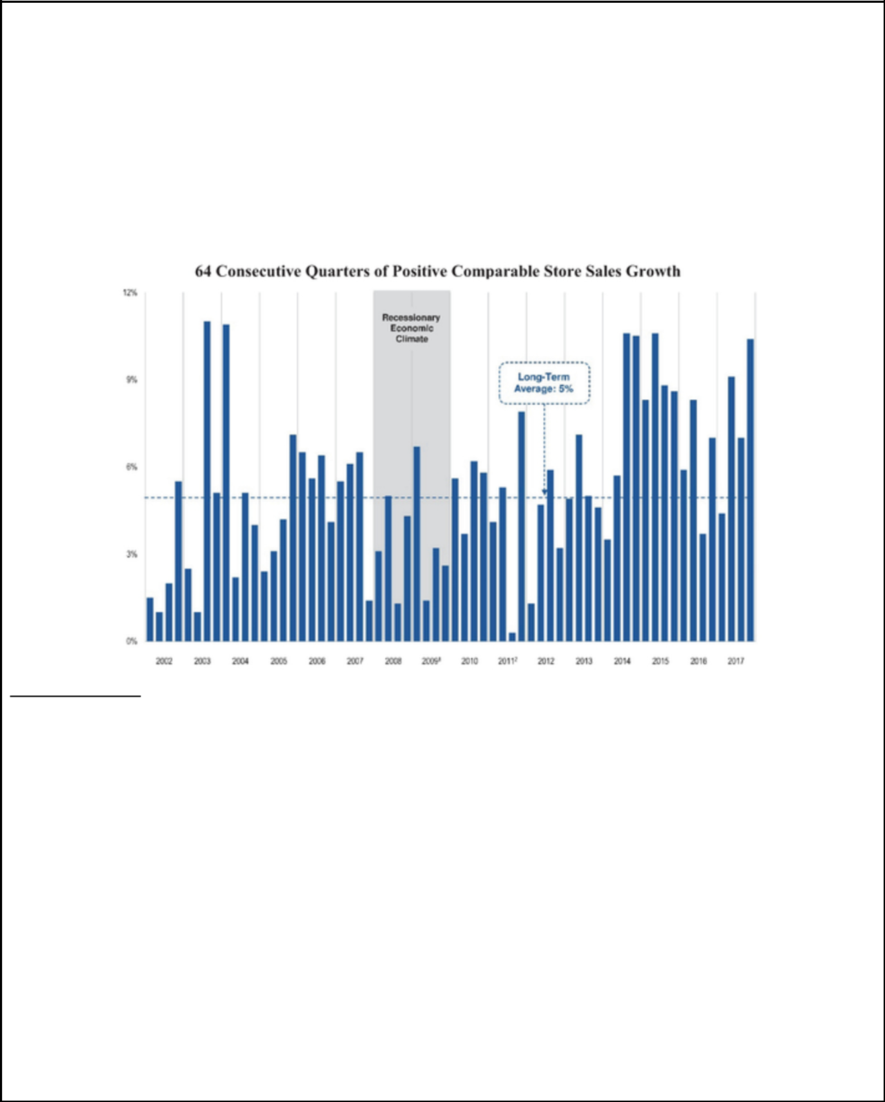

our owned stores achieve profitability shortly after their first-year opening anniversary and pay back invested capital in less than four years. By consistently replicating the key characteristics of our store model, we execute a formula-based approach to opening new stores and managing existing stores, which has delivered predictable store performance across vintages, diverse geographies and new and existing markets. We believe this leads to a high degree of visibility into the embedded earnings potential of our newly opened stores. For indicative purposes, assuming that each of our open but not mature America’s Best and Eyeglass World stores as of December 30, 2017 were able to attain the average fifth-year financial performance of our existing mature America’s Best and Eyeglass World stores, we would have generated an additional approximately $58 million of revenues and approximately $48 million of EBITDA for our owned & host segment in fiscal year 2017.

By targeting the high-growth value segment, we have grown revenue at three times the rate of the U.S. optical retail industry over the past five years, gained significant market share and generated a record 64 consecutive quarters of positive comparable store sales growth.

- 2009 comparable store sales exclude sales from the Eyeglass World stores for the first six-month “transition” period following our acquisition of Eyeglass World.

- Comparable store sales growth in the third quarter of fiscal year 2011 was impacted by the near U.S. federal government shutdown and subsequent adverse impact on the consumer environment.

For fiscal years 2015, 2016 and 2017, we generated total net revenue of $1.1 billion, $1.2 billion and $1.4 billion, respectively, representing a compound annual growth rate, or CAGR, of approximately 13.7% from fiscal year 2015 to fiscal year 2017. Our net income for these same periods was $4 million, $15 million and $46 million, respectively. Our Adjusted EBITDA for these same periods was $113 million, $138 million and $160 million, respectively, representing a CAGR of approximately

19.0% from fiscal year 2015 to fiscal year 2017. Our Adjusted Net Income for these same periods was $26 million, $33 million and $33 million, respectively, representing a CAGR of approximately 13.1% from fiscal year 2015 to fiscal year 2017. For definitions of Adjusted EBITDA and Adjusted Net Income and a reconciliation of Adjusted EBITDA and Adjusted Net Income to net income, see “―Summary Historical Consolidated Financial and Other Data.”

Our Industry

The U.S. optical retail industry, defined by Vision Monday to include optical retailers’ revenues from the sales of products (including managed vision care benefit revenues and omni-channel and e-commerce sales) and eye care services provided by vision care professionals, including eye exams, is a $35 billion industry that has exhibited consistent, stable growth across economic cycles. According to Vision Monday, over the period from

3

TABLE OF CONTENTS
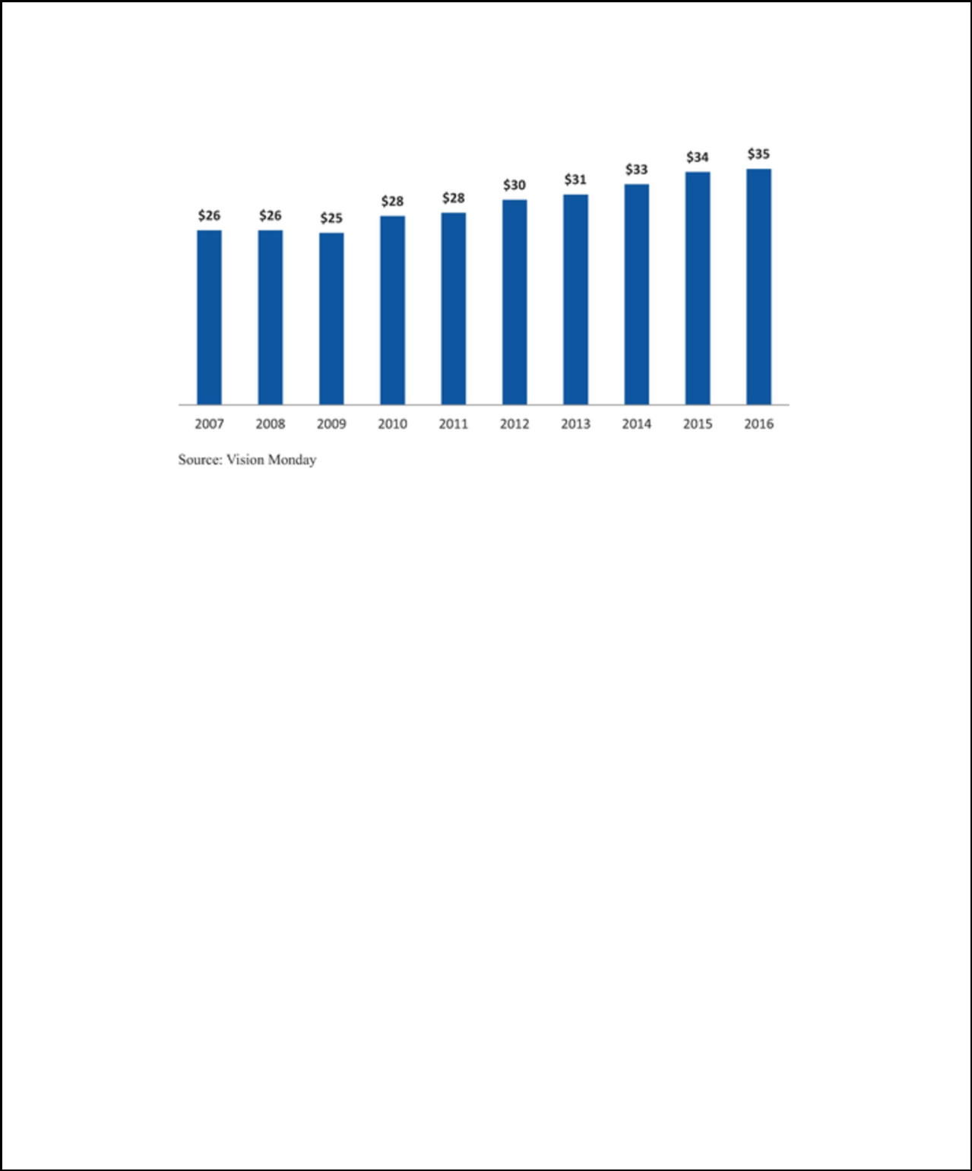

2007 to 2016, the industry grew from $26 billion to $35 billion in annual sales, representing a CAGR of 3.4%. The industry experienced only a modest decline of approximately 3.8% during the 2008 to 2009 recession and rebounded with robust post-recession sales growth of 4.6% CAGR from 2009 to 2016, according to Vision Monday. We believe the ability to see well is a necessity, not a discretionary decision. The steady growth of the industry and its resilience to economic cycles is due in large part to the medical, non-discretionary and recurring nature of eye care purchases. In short, eyesight continues to decline with age, regardless of economic conditions.

We anticipate that there are four key secular growth trends that will continue to contribute to the stability and growth of the

U.S. optical retail industry:

- Aging Population. According to The Vision Council, approximately 76% of adults in the United States used some form of vision correction as of September 2016. At age 45, the need for vision correction begins to increase significantly, with approximately 86% of adults in the United States between the ages of 45 and 54 and approximately 92% of adults in the United States aged 55 and older using vision correction, according to The Vision Council. As the U.S. population ages and life expectancy increases, the pool of potential customers and opportunities for repeat purchases in the optical retail industry are anticipated to rise. In 2014, the U.S. Census Bureau estimated that approximately 42% of the U.S. population would be 45 years old or older by 2020 (the 0.9% increase from 2015 population projections implies an additional 8.4 million adults will enter this 45-plus demographic by 2020). Given that eyesight deteriorates progressively with age, aging of the U.S. population should result in incremental sales of eyewear and related accessories.

- Frequent Replacement Cycle. The repetitive and predictable nature of customer behavior results in a significant volume of recurring revenue for the optical retail industry. The purchasing cycle of vision correction devices is closely tied to the frequency with which consumers obtain eye exams. Most optometrists recommend annual eye exams as a preventive measure against serious eye conditions and to help patients identify changes in their vision correction needs. According to The Vision Council, an estimated 189 million people in the United States using vision correction devices in 2015 received nearly 114 million eye exams that year, implying an average interval between exams of 20 months. The interval between exams contributes to the industry’s stability and shortening this interval represents an opportunity to increase the frequency of customer purchases.

- Increased Usage of Computer and Mobile Screens. Due to the proliferation of smartphones, laptops and tablets, the U.S. population has experienced a dramatic increase in the amount of time spent viewing electronic screens. This is anticipated to result in a larger percentage of the population suffering from screen-related vision problems, driving incremental sales of vision correction devices, such as traditional eyeglasses and contact lenses, as well as higher margin products designed specifically to counteract the effect of looking at screens for prolonged stretches of time.

- Growing Focus on Health and Wellness. The optical retail industry is poised to benefit from expansive trends underlying an increasing societal focus on health and wellness. Consumers want personalized solutions that allow them to make informed decisions about their health. Additionally,

4

TABLE OF CONTENTS

rising healthcare costs are driving a growing emphasis on preventative healthcare. Eye exams can detect a host of physical ailments, such as hypertension or diabetes, and are one of the most inexpensive and effective forms of detection for many of these conditions. As consumers continue to develop greater awareness of health and wellness issues, there is an opportunity for retailers that are able to offer personalized, inexpensive, health-oriented products and services that can increase quality of life and reduce an individual’s overall level of healthcare expenditures. Furthermore, this increased focus on health means that people are living longer, which increases the overall demand for vision care and the frequency with which people visit their eye care practitioners for vision care products and services.

Value Chains Gaining Market Share in Optical Retail Industry

Providing consumers with quality vision care and products involves multiple steps and several parties. In the process of purchasing vision care products a consumer will interact directly with eye care practitioners who prescribe (and may also dispense) products. Consumers may likewise interact with optical retail outlets, which dispense products and may offer on-site optometry services to increase customers’ convenience. Retailers also assist consumers in selecting and fitting vision care products, and directly or through third parties, manufacture and finish vision care products and their components. As part of the purchase, the consumer and retailer may interact with an insurance company or managed vision care provider. Further, vision care and optical retail require compliance with numerous regulations, which often vary by state. The industry experience and knowledge to initiate and maintain relationships across all of these parties is crucial to the success of optical retailers.

Several key factors drive the changing dynamics across the optical retail market:

- Optical Retail Chains Gaining Market Share From Independents. As a result of customers’ desire for the convenience of a one-stop shop with broad product selection, strong customer service and competitive prices, larger optical retailers have gained market share from independent practitioners over the past approximately 20 years, with total market share of the ten largest optical retailers in the United States increasing from 18% in 1992 to 32% in 2016 according to 20/20 Magazine and Vision Monday. Despite this growth, the top ten optical retailers still have a relatively small share of the overall market and the largest optical retailers are well-positioned to continue increasing their share.

- Value Chains Are Growing Faster Than Industry. According to Vision Monday estimates, from 2007 to 2016, the value segment of the U.S. optical retail industry grew at a CAGR of 6.6%, nearly twice the rate of the broader optical retail industry. Increased consumer cost consciousness has shifted market share toward value optical retail chains and mass merchants that serve the value segment. To the extent this trend continues, the value segment is expected to continue to outpace overall industry growth.

- E-commerce. The optical retail industry is underpenetrated in the e-commerce channel relative to other categories of retail. This is due to inherent penetration barriers that make optical retail better suited for omni-channel offerings rather than pure e-commerce. Although contact lenses lend themselves more to online purchases than do eyeglasses, users still generally need to visit an eye care practitioner or a store to update their prescription. Such visits are an opportunity to sell an annual supply of contact lenses to the customer.

5

TABLE OF CONTENTS
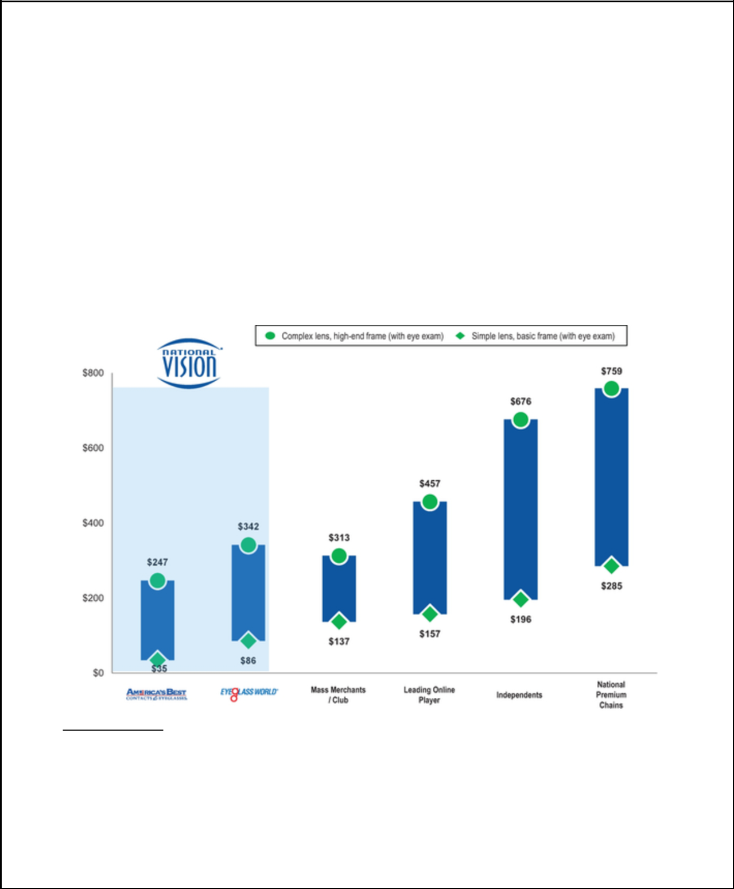

Our Competitive Advantages

Our history of profitable growth is founded on a commitment to a relatively simple business model: providing exceptional value and convenience to customers, enabled by our low-cost operating platform. This business model has multiple areas of competitive advantage:

- Highly-differentiated and Defensible Value Proposition. Our value price positioning extends across our entire portfolio of brands. We offer among the lowest price points in the optical retail industry and this highly-compelling customer value positioning has been a critical driver of our outsized market share gains and revenue growth. Through its arrangements with individual optometrists or professional corporations owned by eye care practitioners, America’s Best is able to offer customers two distinctive bundled eyewear pricing offers: (i) the two-pairs of eyeglasses offer for $69.95, including an eye exam, and (ii) the Eyecare Club program, which offers several years of eye exams plus a discount on products for a low price. In addition, Eyeglass World’s opening price point offer of two pairs of eyeglasses for $78.00 is among the lowest in our industry. Based on a recent study of leading optical retailers and based on these bundled offers, we believe that America’s Best and Eyeglass World’s opening price points for eyeglasses and an eye exam are 74% and 37% lower on a per-pair basis than the next lowest retailer surveyed and 82% and 56% lower than the average of independent retailers surveyed, respectively, each as indicated in the chart below:

Price for Exam + Single Pair of Glasses

Note: One-pair price for “two-pair shops” calculated by dividing “two-pair price” by two and adding back exam price. For retailers who do not provide eye exams, the average exam price of the other retailers shown has been used.

Source: Haynes and Company Research Study (2016); KKR Capstone analysis.

We are also committed to providing our customers with high levels of in-store customer service and a convenient and compelling shopping experience. On-site optometrists enable a convenient one-stop shop for the clinically-assisted sale of eye exams and eyewear and attract customers. We believe that the comprehensive proposition of our value pricing, the breadth and quality of our product mix and high levels of customer service drive repeat visits and customer loyalty, engagement and ambassadorship.

6

TABLE OF CONTENTS


Our optical retail offerings are also more defensible to potential e-commerce pressure relative to other categories of retail. This is due to inherent penetration barriers that make optical retail better suited for omni-channel offerings rather than pure e-commerce. Eye exams typically involve in-person visits to eye care practitioners or stores and customers generally want to try eyeglasses on before purchasing as slight changes in style, size and color can make a meaningful difference to the functionality and visual appeal of the eyeglass frame. Lastly, the service and sales consultations provided by our on-site vision care professionals and in-store associates are a key part of the vision correction product purchase process, which cannot be replicated online.

- Leading Low-cost Operating Model. Our low-cost structure allows us to maintain our low prices to our customers while generating attractive margins. This low-cost structure is a result of our highly-efficient laboratory network and manufacturing capabilities. Orders are routed via a centralized proprietary system to the appropriate processing laboratory, minimizing cost and delivery time. Through a combination of volume increases, continuous operating efficiency improvements and implementation of technological enhancements across our laboratory network, we have increased the number of orders processed through our laboratory network and reduced the cost per job. This has allowed us to maintain our introductory offer of two-pairs of eyeglasses and an eye exam for $69.95 at America’s Best for over ten years.

Our scale and business model allow us to benefit from procurement and real estate cost structure advantages as well as efficiencies in advertising spend and corporate management. As a result of these factors, we are able to drive attractive profitable growth, while maintaining industry-low prices for our customers.

- Best-in-class Management Team with Deep Optical Experience. Our company is led by a highly-accomplished and proven management team with deep expertise. The current team is one of the longest-tenured in the optical retail industry, averaging 21 years of optical or similar retail experience. Importantly, many of our management team members have come from the optical industry, providing great insight. Our management team has also been a cohesive unit, with an average of 13 years at National Vision and low senior management turnover. Collectively, this team has a wide range of experience across optical merchandising, store openings, customer engagement, operations, omni-channel platform and technology. Combining this operational expertise with a finely-tuned formulaic playbook, management has achieved an impressive long-term track record of significant industry outperformance and generated positive comparable store sales growth in every quarter since 2002, when this management team took over, including during periods of economic contraction.

- Diverse Portfolio of Attractive Brands. We have a differentiated collection of five complementary brands, four of which are supported by either our omni-channel or e-commerce platform, that all target the fast-growing value segment within the U.S. optical retail industry. America’s Best and Eyeglass World, our owned brands, have been the primary source of our store growth. Our partner brands (Vision Centers in Walmart and Vista Optical in Fred Meyer stores and on U.S. military bases) are based in well-known, high-traffic environments, exhibit low capital intensity and generate reliable cash flow. Our omni-channel and e-commerce platforms allow us to capture digital sales, deliver several customer convenience capabilities and serve as an educational resource for our customers. In the aggregate, we believe that this diverse combination of brands exhibits a strong economic profile that combines robust growth potential with significant free cash flow generation.

- Proven Real Estate Site Selection Process. We locate our owned stores in highly-desirable retail developments surrounded by dense concentrations of our target customers, resulting in strong performance across our store base. We have rarely closed or relocated a store due to underperformance, and our five-year rolling average new store success rate—defined as the percentage of stores opened in the last five years that are still open—was 99% as of December 30, 2017. We have long-standing relationships with many leading commercial real estate firms and believe that we are a preferred tenant given our brands and the high volume of customers that visit our stores. As a result, we believe we will continue to have access to desirable retail sites.

- Strong Partnerships with Retail Partners and Vendors. We have developed extensive and long-term strategic relationships with our frame and lens suppliers, our host and legacy partners and managed

7

TABLE OF CONTENTS


vision care companies. Our highly-experienced procurement team leverages long-standing relationships with our vendors to source all of our products. Our strong vendor relationships and scale allow us to maintain broad, on-trend assortments, competitive pricing and favorable payment terms. We have maintained and broadened relationships with our host and legacy partners over several decades. For example, in 2012, we expanded our relationship with Walmart to manage walmartcontacts.com and samsclubcontacts.com and to undertake the back-end logistics and fulfilment services for Walmart’s “ship-to-home” contact lens sales and for virtually all of Sam’s Club contact lens orders. We have also developed strong relationships with managed vision care companies through our network of stores, efficient billing and focus on value. We continually seek to partner with additional managed vision care payors and to increase participation in our partners’ networks. We believe that our above-market growth is also an attractive growth driver for our business partners and positions us as a preferred retailer for key vendors and industry partners.

- Deep Experience with the Regulatory Complexity of the Optical Industry. There are extensive and diverse sets of laws and regulations governing the provision of vision care. As a result, regulatory compliance for optical retailers in the United States is complicated and time-consuming, involving many regulatory bodies and licensing agencies at both the federal and state levels. We believe that our deep knowledge of the optical regulatory framework and our significant compliance experience provide us with an important competitive advantage. We also believe that these compliance and licensure requirements, and related costs, serve as a significant hurdle for potential new entrants into the optical retail industry.

Our Growth Strategies

We believe that we have the right strategy and execution capabilities to capitalize on the substantial growth opportunities afforded by our business model. We intend to further drive growth from five distinct sources:

- Grow Our Store Base. We believe that our expansion opportunities in the United States are significant. We have adopted a disciplined expansion strategy designed to leverage the strengths of our compelling and distinct value proposition and recognized America’s Best and Eyeglass World brand names to develop new stores successfully in an array of markets that are primed for growth, including new, existing, small and large markets. In the aggregate, we have opened 498 stores on a net basis (opened 566 new stores and closed 68 stores) since 2006 and, in the past three years, we have increased our new store growth to approximately 75 new stores per annum. We have an established partnership with a third party real estate firm to evaluate potential new America’s Best and Eyeglass World stores and our analysis suggests that we can grow America’s Best to at least 1,000 stores and Eyeglass World to at least 850 stores, inclusive of those already open. We believe that these two brands can accordingly grow from approximately 700 stores as of December 30, 2017 to a total of at least 1,850 stores, with similar economics to the existing store base. In the near term, our primary focus will continue to be to open new America’s Best stores, most notably in California as well as Northern New Jersey and parts of the New York metro area, with a longer-term focus on expanding our Eyeglass World store footprint. We believe that our consistent track record of successfully opening stores across vintages, geographies and markets demonstrates our ability to further increase our store count and, as a result, we believe that our current level of new store growth of approximately 75 stores per annum is sustainable for the foreseeable future.

- Drive Comparable Store Sales Growth. We expect that our value proposition will generate profitable comparable store sales growth. The vast majority of our comparable store sales growth over the past five years has been driven by increased traffic. The typical eyewear replacement cycle, which we estimate is two to three years, creates substantial opportunity for us to increase sales from our existing customer base. We continually strive to improve our in-store shopping experience and to enhance our solutions-based service approach to increase the volume of customer traffic to our stores. We also expect to increase customer traffic by improving marketing programs and omni-channel offerings, and by expanding our participation in managed vision care programs. We are currently underpenetrated in the managed vision care market relative to the broader optical retail industry. We expect that these initiatives collectively will help us to attract new customers to our stores and increase the frequency of purchases by our existing customers.

8

TABLE OF CONTENTS


- Improve Operating Productivity. We believe that our continued growth will provide further opportunities to improve operating margin over time. Growth, both in revenue and stores, will enable us to leverage corporate overhead, our centralized laboratory network and our advertising spend. We expect to benefit from our national network television advertising campaign for America’s Best, which we believe is more cost effective than local market campaigns. This national campaign has helped raise our brand awareness in both existing and new markets, allowing us to save advertising spend when entering new markets. We also believe that continued efficiencies in store operations and technological advancements in our centralized laboratory network will further enhance margins.

In the past three years, we have accelerated store openings of America’s Best and Eyeglass World to 75 stores per annum. Based on the consistency and predictability of the maturation process for our existing store base, we believe that there are significant embedded earnings in these maturing stores. For indicative purposes, assuming that each of our open but not mature America’s Best and Eyeglass World stores as of December 30, 2017 were able to attain the average fifth-year financial performance of our existing mature America’s Best and Eyeglass World stores, we would have generated an additional approximately $58 million of revenues and approximately $48 million of EBITDA for our owned & host segment in fiscal year 2017.

- Leverage Technology to Optimize and Expand the Business. Our experienced management team has consistently leveraged innovative strategies to grow our business and remain at the forefront of technological development in the optical retail industry. We have invested significantly in technological improvements to position us for future growth. We plan to continue investing in software solutions that further develop our omni-channel platform and enhance our customer engagement capabilities, and we will also continue to invest in tools to improve the quality of the in-store eye exam experience. Since eye exams are a critical service element of our business, we believe that investing in technology to improve this experience will aid in retention of both customers and optometric talent. We are regularly presented with opportunities to invest in technological innovators across the optical retail industry and we have invested $8.6 million in venture-backed emerging companies since June 2014. We believe that these investments provide direct access to optical technology innovators, giving us a deeper understanding of emerging trends and developments. We are thus in a better position to evolve our products and services to meet the needs of our customers.

- Explore Strategic Opportunities. We will selectively evaluate strategic acquisition opportunities from time to time as part of our growth strategy.

Risks Related to Our Business and this Offering

Investing in our common stock involves substantial risk, and our ability to successfully operate our business is subject to numerous risks, including those that are generally associated with operating in the optical retail industry. Below is a summary of some of the principal risks we face:

- our ability to open and operate new stores in a timely and cost-effective manner, and to successfully enter new markets;

- our ability to maintain sufficient levels of cash flow from our operations to grow;

- our ability to recruit and retain vision care professionals for our stores;

- our ability to adhere to extensive state, local and federal vision care and healthcare laws and regulations;

- our ability to develop and maintain relationships with managed vision care companies, vision insurance providers and other third-party payors;

- our ability to maintain our current operating relationships with our host and legacy partners;

- the loss of, or disruption in the operations of, one or more of our distribution centers and/or optical laboratories;

- risks associated with vendors from whom our products are sourced;

9

TABLE OF CONTENTS


- our ability to successfully compete in the highly competitive optical retail industry; and

- our dependence on a limited number of suppliers.

Any of the factors set forth under “Risk Factors” in this prospectus and under “Risk Factors” in our Annual Report, which is incorporated herein by reference, may limit our ability to successfully execute our business strategy. You should carefully consider all of the information set forth, or incorporated by reference, in this prospectus and, in particular, should evaluate the specific factors set forth under “Risk Factors” in this prospectus and under “Risk Factors” in our Annual Report, which is incorporated herein by reference, in deciding whether to invest in our common stock.

Corporate History and Information

Through its predecessors, NVI commenced operations in 1990. In 2005, private equity funds managed by Berkshire acquired both NVI and Consolidated Vision Group, Inc., which operated America’s Best stores, and merged these entities, with NVI surviving. In 2009, NVI acquired the Eyeglass World store chain. In 2011, after a multi-year partnership, NVI acquired AC Lens to bolster its e-commerce platform.

In March 2014, NVI was acquired by affiliates of KKR Sponsor. National Vision Holdings, Inc. was incorporated in Delaware on February 14, 2014 under the name “Nautilus Parent, Inc.” and NVI became our wholly-owned subsidiary in connection with the KKR Acquisition. We changed our name to “National Vision Holdings, Inc.” in June 2017. Our common stock began trading on NASDAQ under the symbol “EYE” on October 26, 2017 and we consummated our initial public offering of our common stock, or the IPO, on October 30, 2017.

Our principal executive offices are located at 2435 Commerce Avenue, Bldg. 2200, Duluth, Georgia 30096. The telephone number of our principal executive offices is (770) 822-3600. We maintain a website at www.nationalvision.com. The information contained on, or that can be accessed through, our corporate website or other company websites referenced elsewhere in this prospectus neither constitutes part of this prospectus nor is incorporated by reference herein.

About KKR & Co.

KKR & Co. L.P., which, together with its subsidiaries, we refer to as KKR & Co., is a leading global investment firm that manages multiple alternative asset classes including private equity, energy, infrastructure, real estate and credit, with its strategic manager partnerships that manage hedge funds. KKR & Co. aims to generate attractive investment returns for its fund investors by following a patient and disciplined investment approach, employing world-class people, and driving growth and value creation with its portfolio companies. KKR & Co. invests its own capital alongside the capital it manages for fund investors and provides financing solutions and investment opportunities through its capital markets business. KKR & Co. L.P. is listed on The New York Stock Exchange (NYSE: KKR).

About Berkshire

Berkshire, a Boston-based investment firm, has raised nine private equity funds with more than $16 billion in aggregate capital and has made over 120 investments in primarily middle market companies since its founding in 1986. Berkshire has developed specific industry experience in several areas including consumer and retail, communications, business services, industrials and healthcare. Berkshire has a strong history of partnering with management teams to grow companies in which it invests.

10

TABLE OF CONTENTS


 | The Offering
Common stock offered by the selling stockholders | 12,000,000 shares.
Underwriters’ option to purchase additional shares of | The selling stockholders have granted the underwriters a 30-day
common stock | option to purchase up to 1,800,000 additional shares of our common
 | stock at the public offering price, less underwriting discounts and
 | commissions.
Common stock outstanding | 74,656,175 shares (as of February 28, 2018)
Use of proceeds | We will not receive any proceeds from the sale of shares being sold in
 | this offering, including from any exercise by the underwriters of their
 | option to purchase additional shares. The selling stockholders will
 | receive all of the net proceeds and bear all commissions and
 | discounts, if any, from the sale of our common stock pursuant to this
 | prospectus. See “Use of Proceeds” and “Selling Stockholders.”
Risk factors | See “Risk Factors” beginning on page 17 and other information
 | included, and incorporated by reference, in this prospectus for a
 | discussion of factors you should carefully consider before deciding to
 | invest in our common stock.
Dividend policy | We do not currently anticipate paying any dividends on our common
 | stock and currently expect to retain all future earnings for use in the
 | operation and expansion of our business. Any decision to declare and
 | pay dividends in the future will be made at the sole discretion of our
 | Board of Directors and will depend on various factors. See “Dividend
 | Policy.”
Conflicts of Interest | Affiliates of KKR Sponsor beneficially own (through investment in
 | KKR Vision Aggregator L.P.) in excess of 10% of our issued and
 | outstanding common stock. Because KKR Capital Markets LLC, an
 | affiliate of KKR Sponsor, is an underwriter in this offering and its
 | affiliates own in excess of 10% of our issued and outstanding
 | common stock, KKR Capital Markets LLC is deemed to have a
 | “conflict of interest” under Rule 5121, or Rule 5121, of the Financial
 | Industry Regulatory Authority, Inc., or FINRA. Accordingly, this
 | offering is being made in compliance with the requirements of Rule
 | 5121. Pursuant to that rule, the appointment of a “qualified
 | independent underwriter” is not required in connection with this
 | offering as a bona fide public market exists in the shares, as that term
 | is defined in Rule 5121. See “Underwriting (Conflicts of Interest).”
NASDAQ ticker symbol | “EYE”

Unless we indicate otherwise or the context otherwise requires, all information in this prospectus reflects and assumes no exercise of the underwriters’ option to purchase 1,800,000 additional shares of our common stock.

11

TABLE OF CONTENTS


Additionally, the number of shares of our common stock to be outstanding after this offering is based on 74,656,175 of shares of our common stock outstanding as of February 28, 2018, including 8,720 shares of restricted stock outstanding, and does not reflect:

- 10,608,559 shares of common stock issuable upon the exercise of options outstanding as of February 28, 2018, (1) of which 1,843,550 were then vested and exercisable and (2) of which 4,084,407 were time-based options and 6,524,152 were performance-based options. The performance-based options (other than 217,390 performance-based options held by Jeff McAllister, which have different vesting terms and 43,478 of which have vested), have not previously vested, will not vest upon the consummation of this offering and are eligible to vest only upon affiliates of KKR Sponsor achieving certain internal rate of return threshold and multiples of invested capital. See “Executive Compensation— Narrative to Summary Compensation Table and 2017 Grants of Plan-Based Awards—Equity Awards” in our Annual Report, which is incorporated herein by reference, for additional details around vesting terms;

- 182,234 restricted stock units outstanding as of February 28, 2018;

- 3,794,775 shares of common stock available for issuance under our 2014 Stock Incentive Plan and our 2017 Omnibus Incentive Plan; and

- any exercises of vested options by the management selling stockholders in connection with this offering.

12

TABLE OF CONTENTS


Summary Historical Consolidated Financial and Other Data

Set forth below is our summary historical consolidated financial and other data as of the dates and for the periods indicated. The summary historical financial data as of December 31, 2016 and December 30, 2017 and for the years ended January 2, 2016, December 31, 2016 and December 30, 2017 has been derived from our audited consolidated financial statements and related notes thereto incorporated by reference in this prospectus, and the summary historical financial data as of January 2, 2016 has been derived from our audited consolidated financial statements and related notes thereto not included or incorporated by reference in this prospectus. The results of operations for any period are not necessarily indicative of the results to be expected for any future period. Share and per share data in the table below has been retroactively adjusted to give effect to the 1.96627-for-one reverse stock split, effected on October 24, 2017.

The summary historical consolidated financial and other data should be read in conjunction with, and are qualified by reference to, “Capitalization” in this prospectus, as well as the section entitled “Selected Financial Data,” “Management’s Discussion and Analysis of Financial Condition and Results of Operations” and our audited consolidated financial statements and related notes thereto incorporated by reference in this prospectus.

 |  |  |  |  |  |  |  | Year Ended |  |  | Year Ended
 |  |  |  |  | Year Ended |  |  | December 31, |  |  | December 30,
(In thousands, except per share amounts and store data) |  |  |  |  | January 2, 2016 |  |  | 2016 |  |  | 2017
 | Statement of Operations Data:
 | Net revenue |  | $ |  | 1,062,528 |  | $ | 1,196,195 |  | $ | 1,375,308
 | Costs applicable to revenue |  |  |  | 491,100 |  |  | 544,781 |  |  | 636,966
Operating expenses |  |  |  |  | 526,751 |  |  | 585,030 |  |  | 671,106
 | Income from operations |  |  |  | 44,677 |  |  | 66,384 |  |  | 67,236
 | Interest expense, net |  |  |  | 36,741 |  |  | 39,092 |  |  | 55,536
 | Debt issuance costs |  |  |  | 2,551 |  |  | — |  |  | 4,527
 | Earnings before income taxes |  |  |  | 5,385 |  |  | 27,292 |  |  | 7,173
 | Income tax (benefit) provision |  |  |  | 1,768 |  |  | 12,534 |  |  | (38,647)
Net income |  |  | $ |  | 3,617 |  | $ | 14,758 |  | $ | 45,820
 | Earnings per share:
 | Basic |  | $ |  | 0.06 |  | $ | 0.26 |  | $ | 0.77
 | Diluted |  | $ |  | 0.06 |  | $ | 0.26 |  | $ | 0.74
 | Weighted average shares outstanding:
 | Basic |  |  |  | 55,962 |  |  | 56,185 |  |  | 59,895
 | Diluted |  |  |  | 55,962 |  |  | 57,001 |  |  | 62,035
 | Statement of Cash Flow Data:
 | Net cash provided by operating activities |  | $ |  | 83,131 |  | $ | 97,588 |  | $ | 90,252
 | Net cash used for investing activities |  | $ |  | (80,051) |  | $ | (91,664) |  | $ | (94,827)
 | Net cash (used for) provided by financing activities |  | $ |  | (4,317) |  | $ | (6,574) |  | $ | 3,838
 | Balance Sheet Data (at period end):
 | Cash and cash equivalents |  | $ |  | 5,595 |  | $ | 4,945 |  | $ | 4,208
 | Total assets |  | $ |  | 1,475,595 |  | $ | 1,531,117 |  | $ | 1,583,791
 | Total debt |  | $ |  | 747,825 |  | $ | 745,625 |  | $ | 569,238
 | Total stockholders’ equity |  | $ |  | 386,230 |  | $ | 401,887 |  | $ | 659,588
 | Other Financial Data (unaudited):
 | Number of stores open at period end |  |  |  | 858 |  |  | 943 |  |  | 1,013
 | Adjusted EBITDA⁽¹⁾ |  | $ |  | 112,585 |  | $ | 137,774 |  | $ | 159,721
 | Adjusted Net Income⁽¹⁾ |  | $ |  | 26,184 |  | $ | 33,183 |  | $ | 33,081

- We define EBITDA as net income, plus interest expense, income tax (benefit) provision and depreciation and amortization. We define Adjusted EBITDA as EBITDA, further adjusted to exclude stock compensation expense, costs associated with debt refinancing, asset impairment, non-cash inventory write-offs, management fees, new store pre-opening expenses, non-cash rent, litigation settlement and other expenses. We describe these adjustments reconciling

13

TABLE OF CONTENTS


net income to EBITDA and Adjusted EBITDA in the tables below. We define Adjusted Net Income as net income, plus stock compensation expense, costs associated with debt refinancing, asset impairment, non-cash inventory write-offs, management fees, new store pre-opening expenses, non-cash rent, litigation settlement, amortization of acquisition intangibles and deferred financing costs, tax legislation adjustments and other expenses, less the tax effect of these adjustments. We describe these adjustments reconciling net income to Adjusted Net Income in the tables below.

EBITDA, Adjusted EBITDA and Adjusted Net Income have been presented in this prospectus as supplemental measures of financial performance that are not required by, or presented in accordance with GAAP, because we believe they assist investors and analysts in comparing our operating performance across reporting periods on a consistent basis by excluding items that we do not believe are indicative of our core operating performance. Management believes EBITDA, Adjusted EBITDA and Adjusted Net Income are useful to investors in highlighting trends in our operating performance, while other measures can differ significantly depending on long-term strategic decisions regarding capital structure, the tax jurisdictions in which we operate and capital investments. We also use EBITDA, Adjusted EBITDA and Adjusted Net Income to supplement GAAP measures of performance in the evaluation of the effectiveness of our business strategies, to make budgeting decisions, to establish discretionary annual incentive compensation and to compare our performance against that of other peer companies using similar measures. Management supplements GAAP results with non-GAAP financial measures to provide a more complete understanding of the factors and trends affecting the business than GAAP results alone.

EBITDA, Adjusted EBITDA and Adjusted Net Income are not recognized terms under GAAP and should not be considered as an alternative to net income or income from operations, as a measure of financial performance, or cash flows provided by operating activities, as a measure of liquidity, or any other performance measure derived in accordance with GAAP. Additionally, these measures are not intended to be a measure of free cash flow available for management’s discretionary use as they do not consider certain cash requirements such as interest payments, tax payments and debt service requirements. Our presentation of EBITDA, Adjusted EBITDA and Adjusted Net Income should not be construed to imply that our future results will be unaffected by unusual or non-recurring items. In evaluating EBITDA, Adjusted EBITDA and Adjusted Net Income, you should be aware that in the future we may incur expenses that are the same as or similar to some of the adjustments in this presentation. Our presentation of EBITDA, Adjusted EBITDA and Adjusted Net Income should not be construed to imply that our future results will be unaffected by any such adjustments. Management compensates for these limitations by primarily relying on our GAAP results in addition to using EBITDA, Adjusted EBITDA and Adjusted Net Income supplementally.

The presentations of these measures have limitations as analytical tools and should not be considered in isolation, or as a substitute for analysis of our results as reported under GAAP. Some of these limitations are:

- they do not reflect costs or cash outlays for capital expenditures or contractual commitments;

- they do not reflect changes in, or cash requirements for, our working capital needs;

- EBITDA and Adjusted EBITDA do not reflect the interest expense, or the cash requirements necessary to service interest or principal payments, on our debt;

- EBITDA and Adjusted EBITDA do not reflect period to period changes in taxes, income tax expense or the cash necessary to pay income taxes;

- they do not reflect the impact of earnings or charges resulting from matters we consider not to be indicative of our ongoing operations, including costs related to new store openings, which are incurred on a non-recurring basis with respect to any particular store when opened;

- although depreciation and amortization are non-cash charges, the assets being depreciated and amortized will often have to be replaced in the future, and EBITDA and Adjusted EBITDA do not reflect cash requirements for such replacements; and

- other companies in our industry may calculate these measures differently than we do, limiting their usefulness as comparative measures.

Because of these limitations, EBITDA, Adjusted EBITDA and Adjusted Net Income should not be considered as measures of discretionary cash available to invest in business growth or to reduce indebtedness.

14

TABLE OF CONTENTS


The following tables reconcile our net income to EBITDA, Adjusted EBITDA and Adjusted Net Income for the periods presented:

 |  |  |  |  | Year |  |  | Year Ended
 |  |  |  |  | Ended |  |  | December |  |  | Year Ended
 |  |  |  | January 2, |  |  |  | 31, |  | December 30,
($ in thousands) |  |  |  |  | 2016 |  |  | 2016 |  |  | 2017
 | Net income |  | $ |  | 3,617 |  | $ | 14,758 |  | $ | 45,820
Interest expense |  |  |  |  | 36,741 |  |  | 39,092 |  |  | 55,536
 | Income tax (benefit) provision |  |  |  | 1,768 |  |  | 12,534 |  |  | (38,647)
Depreciation and amortization |  |  |  |  | 44,069 |  |  | 51,993 |  |  | 61,115
 | EBITDA |  |  |  | 86,195 |  |  | 118,377 |  |  | 123,824
 | Stock compensation expense^{(a)} |  |  |  | 6,635 |  |  | 4,293 |  |  | 5,152
 | Debt issuance costs^{(b)} |  |  |  | 2,551 |  |  | — |  |  | 4,527
 | Asset impairment^{(c)} |  |  |  | 7,716 |  |  | 7,132 |  |  | 4,117
 | Non-cash inventory write-offs^{(d)} |  |  |  | — |  |  | — |  |  | 2,271
 | Management fees^{(e)} |  |  |  | 1,649 |  |  | 1,126 |  |  | 5,263
 | New store pre-opening expenses^{(f)} |  |  |  | 1,962 |  |  | 1,983 |  |  | 2,531
 | Non-cash rent^{(g)} |  |  |  | 1,233 |  |  | 1,343 |  |  | 1,112
 | Litigation settlement^{(h)} |  |  |  | — |  |  | — |  |  | 7,000
Other^{(i)} |  |  |  |  | 4,644 |  |  | 3,520 |  |  | 3,924
 | Adjusted EBITDA |  |  | $ | 112,585 |  | $ | 137,774 |  | $ | 159,721
 |  |  |  |  | Year |  |  | Year Ended
 |  |  |  |  | Ended |  |  | December |  |  | Year Ended
 |  |  |  | January 2, |  |  |  | 31, |  | December 30,
($ in thousands) |  |  |  |  | 2016 |  |  | 2016 |  |  | 2017
 | Net income |  | $ |  | 3,617 |  | $ | 14,758 |  | $ | 45,820
 | Stock compensation expense^{(a)} |  |  |  | 6,635 |  |  | 4,293 |  |  | 5,152
 | Debt issuance costs^{(b)} |  |  |  | 2,551 |  |  | — |  |  | 4,527
 | Asset impairment^{(c)} |  |  |  | 7,716 |  |  | 7,132 |  |  | 4,117
 | Non-cash inventory write-offs^{(d)} |  |  |  | — |  |  | — |  |  | 2,271
 | Management fees^{(e)} |  |  |  | 1,649 |  |  | 1,126 |  |  | 5,263
 | New store pre-opening expenses^{(f)} |  |  |  | 1,962 |  |  | 1,983 |  |  | 2,531
 | Non-cash rent^{(g)} |  |  |  | 1,233 |  |  | 1,343 |  |  | 1,112
 | Litigation settlement^{(h)} |  |  |  | — |  |  | — |  |  | 7,000
 | Other^{(i)} |  |  |  | 4,644 |  |  | 3,520 |  |  | 3,924
 | Amortization of acquisition intangibles and deferred financing costs^{(j)} |  |  |  | 11,221 |  |  | 11,311 |  |  | 14,481
 | Tax legislation adjustments^{(k)} |  |  |  | — |  |  | — |  |  | (42,965)
 | Tax effect of total adjustments^{(l)} |  |  |  | (15,044) |  |  | (12,283) |  |  | (20,152)
Adjusted Net Income |  |  | $ |  | 26,184 |  | $ | 33,183 |  | $ | 33,081

- Non-cash charges related to stock-based compensation programs, which vary from period to period depending on the timing of awards.

- Includes $2.6 million of fees associated with the borrowing of $150.0 million in additional principal under our first lien credit agreement during the second fiscal quarter of 2015, $2.7 million of fees associated with the borrowing of $175.0 million in additional principal under our first lien credit agreement in the first quarter of 2017 and $1.8 million of fees associated with the refinancing of our first lien credit agreement in the fourth quarter of 2017.

- Non-cash charges related to impairment of long-lived assets, primarily goodwill in our Vista Optical in Fred Meyer brand and our AC Lens business during fiscal years 2015 and 2016. Reflects write-off of a cost basis investment, and write-off of capitalized software and property and equipment for the fiscal year 2017.

- Reflects write-offs of inventory relating to the expiration of a specific type of contact lenses that could not be sold and required disposal.

- Reflects management fees paid to KKR Sponsor and Berkshire in accordance with our monitoring agreement with them. The monitoring agreement was terminated automatically in accordance with its terms upon the consummation of the IPO and we paid termination fees of approximately $3.6 million and $0.8 million to KKR Sponsor and Berkshire, respectively.

- Pre-opening expenses, which include marketing and advertising, labor and occupancy expenses incurred prior to opening a new store, are generally higher than comparable expenses incurred once such store is open and generating revenue. We believe that such higher pre-opening expenses are specific in nature and amount to opening a new store and as such, are not indicative of ongoing core operating performance. We adjust for these costs to facilitate comparisons of store operating performance from period to period. Pre-opening costs are permitted exclusions in our calculation of Adjusted EBITDA pursuant to the terms of our existing credit agreement.

15

TABLE OF CONTENTS


- Consists of the non-cash portion of rent expense, which reflects the extent to which our straight-line rent expense recognized under GAAP exceeds or is less than our cash rent payments. The adjustment can vary depending on the average age of our lease portfolio, which has been impacted by our significant growth in recent years. For newer leases, our rent expense recognized typically exceeds our cash rent payments, while for more mature leases, rent expense recognized under GAAP is typically less than our cash rent payments.

- Amounts accrued related to settlement of litigation. See “Legal Proceedings” and Note 12 in our audited consolidated financial statements, each in our Annual Report, incorporated by reference in this prospectus, for further details.

- Other adjustments include amounts that management believes are not representative of our operating performance (amounts in brackets represent reductions in Adjusted EBITDA and Adjusted Net Income), including our share of losses on equity method investments of $0.9 million, $1.4 million and $1.0 million for fiscal years 2015, 2016 and 2017, respectively; the amortization impact of the KKR Acquisition-related adjustments (e.g., fair value of leasehold interests) of $(1.3) million, $(0.7) million and $(0.3) million for fiscal years 2015, 2016 and 2017, respectively; expenses related to preparation for being an SEC registrant that were not directly attributable to the IPO and therefore not charged to equity of $0.5 million, $2.0 million and $1.8 million for fiscal years 2015, 2016 and 2017, respectively; differences between the timing of expense versus cash payments related to contributions to charitable organizations of $3.0 million, $(1.0) million and $(1.0) million for fiscal years 2015, 2016 and 2017, respectively; costs of severance and relocation of $0.5 million, $1.1 million and $1.4 million for fiscal years 2015, 2016 and 2017, respectively; non-cash write-down of property and equipment of $0.2 million, $0.2 million and $0.4 million for fiscal years 2015, 2016 and 2017, respectively; and other expenses and adjustments totaling $0.8 million, $0.6 million and $0.6 million for fiscal years 2015, 2016 and 2017, respectively.

- Amortization of acquisition intangibles related to the increase in the carrying values of definite-lived intangible assets resulting from the application of purchase accounting to the KKR Acquisition of $7.4 million for each of fiscal years 2015, 2016 and 2017. Amortization of deferred financing costs is primarily associated with the March 2014 term loan borrowings in connection with the KKR Acquisition and, to a lesser extent, amortization of debt discounts associated with the May 2015 and February 2017 incremental first lien term loans and the November 2017 first lien refinancing, aggregating to $3.8 million, $3.9 million and $7.1 million for fiscal years 2015, 2016 and 2017, respectively. The $7.1 million amortization of deferred financing costs in 2017 includes $3.3 million of the write-off of debt discounts associated with the repayment of all outstanding $125 million of second lien term loans in November 2017.

- The adjustment represents re-measuring and reassessing the net realizability of our deferred tax assets and liabilities during fiscal year 2017. See Note 6 “Income Taxes” in our audited consolidated financial statements incorporated by reference in this prospectus for additional information regarding the 2017 Tax Cuts and Jobs Act.

- Represents the income tax effect of the total adjustments at our estimated effective tax rate.

16

TABLE OF CONTENTS

RISK FACTORS

An investment in our common stock involves risk. You should carefully consider the risks and uncertainties described below, together with all of the other information included or incorporated by reference in this prospectus, including the risks and uncertainties discussed under the “Summary Historical Consolidated Financial and Other Data” contained elsewhere in this prospectus and “Risk Factors,” “Management’s Discussion and Analysis of Financial Condition and Results of Operations,” and our audited consolidated financial statements and related notes thereto in our Annual Report, which is incorporated by reference in this prospectus, before investing in our common stock. Any of the following risks could materially and adversely affect our business, financial condition, or results of operations. The selected risks described below or incorporated by reference in this prospectus, however, are not the only risks facing us. Additional risks and uncertainties not currently known to us or those we currently view to be immaterial may also materially and adversely affect our business, financial condition, or results of operations. In such a case, the trading price of our common stock could decline and you may lose all or part of your investment.

Risks Related to this Offering and Ownership of Our Common Stock

Our stock price may be volatile or may decline regardless of our operating performance, and you may not be able to resell shares of our common stock at or above the price you paid or at all, and you could lose all or part of your investment as a result.
We completed our IPO in October 2017. Since our IPO, the price of our common stock, as reported on NASDAQ, has ranged from a low of $27.19 on October 26, 2017 to a high of $43.80 on January 19, 2018. The trading price of our common stock may be volatile and may be adversely affected due to a number of factors, most of which we cannot control, including those listed under “Risk Factors” in our Annual Report, which is incorporated by reference in this prospectus, and the following:

- results of operations that vary from the expectations of securities analysts and investors;

- results of operations that vary from those of our competitors;

- changes in expectations as to our future financial performance, including financial estimates and investment recommendations by securities analysts and investors;

- changes in economic conditions for companies in our industry;

- changes in market valuations of, or earnings and other announcements by, companies in our industry;

- declines in the market prices of stocks generally, particularly those of optical retail companies;

- additions or departures of key management personnel;

- strategic actions by us or our competitors;

- announcements by us, our competitors, our suppliers or our host and legacy organizations of significant contracts, price reductions, new products or technologies, acquisitions, joint marketing relationships, joint ventures, other strategic relationships or capital commitments;

- changes in preference of our customers;

- changes in general economic or market conditions or trends in our industry or the economy as a whole and, in particular, in the consumer spending environment;

- changes in business or regulatory conditions;

- future sales of our common stock or other securities;

- investor perceptions of or the investment opportunity associated with our common stock relative to other investment alternatives;

- the public’s response to press releases or other public announcements by us or third parties, including our filings with the SEC;

- announcements relating to litigation or governmental investigations;

17

TABLE OF CONTENTS

- guidance, if any, that we provide to the public, any changes in this guidance or our failure to meet this guidance;

- the development and sustainability of an active trading market for our stock;

- changes in accounting principles; and

- other events or factors, including those resulting from informational technology system failures and disruptions, natural disasters, war, acts of terrorism or responses to these events.

Furthermore, the stock market may experience extreme volatility that, in some cases, may be unrelated or disproportionate to the operating performance of particular companies. These broad market and industry fluctuations may adversely affect the market price of our common stock, regardless of our actual operating performance. In addition, price volatility may be greater if the public float and trading volume of our common stock is low.

In the past, following periods of market volatility, stockholders have instituted securities class action litigation. If we were to become involved in securities litigation, it could have a substantial cost and divert resources and the attention of executive management from our business regardless of the outcome of such litigation.

Because we have no current plans to pay cash dividends on our common stock, you may not receive any return on investment unless you sell your common stock for a price greater than that which you paid for it.

We have no current plans to pay cash dividends on our common stock. The declaration, amount and payment of any future dividends on our common stock will be at the sole discretion of our Board of Directors. Our Board of Directors may take into account general and economic conditions, our financial condition and results of operations, our available cash and current and anticipated cash needs, capital requirements, contractual, legal, tax and regulatory restrictions and implications on the payment of dividends by us to our stockholders or by our subsidiaries to us, including restrictions under our credit agreement and other indebtedness we may incur, and such other factors as our Board of Directors may deem relevant. See “Dividend Policy.”

As a result, you may not receive any return on an investment in our common stock unless you sell our common stock for a price greater than your purchase price.

We are a holding company with no operations of our own and, as such, we depend on our subsidiaries for cash to fund all of our operations and expenses, including future dividend payments, if any.

Our operations are conducted entirely through our subsidiaries and our ability to generate cash to meet our debt service obligations or to make future dividend payments, if any, is highly dependent on the earnings and the receipt of funds from our subsidiaries via dividends or intercompany loans. We do not currently expect to declare or pay dividends on our common stock for the foreseeable future; however, to the extent that we determine in the future to pay dividends on our common stock, the agreements governing our indebtedness may restrict the ability of our subsidiaries to pay dividends or otherwise transfer assets to us.

If securities or industry analysts do not publish research or reports about our business or if they downgrade our stock or our sector, our stock price and trading volume could decline.

The trading market for our common stock relies in part on the research and reports that industry or financial analysts publish about us or our business. We do not control these analysts. Furthermore, if one or more of the analysts who do cover us downgrade our stock or our industry, or change their views regarding the stock of any of our competitors, or publish inaccurate or unfavorable research about our business, the price of our stock could decline. If one or more of these analysts stop covering us or fail to publish reports on us regularly, we could lose visibility in the market, which in turn could cause our stock price or trading volume to decline.

Maintaining the requirements of being a public company may strain our resources, divert management’s attention and affect our ability to attract and retain qualified board members.

As a public company, we incur significant legal, accounting, insurance and other expenses that we did not incur as a private company, including costs associated with public company governance and reporting requirements. We also have incurred and will continue to incur costs associated with our compliance with the

18

TABLE OF CONTENTS

Sarbanes-Oxley Act of 2002, or the Sarbanes-Oxley Act, and the Dodd-Frank Wall Street Reform and Consumer Protection Act, or the Dodd-Frank Act, as well as rules and regulations implemented by the SEC, and costs in connection with continued listing on NASDAQ. Our efforts to comply with these rules and regulations have significantly increased our legal and financial compliance costs, including costs associated with the hiring of additional personnel, and have made some activities more difficult, time-consuming or costly. Our management devote a substantial amount of time to ensure that we comply with all of these requirements, diverting the attention of management away from revenue-producing activities. The expenses incurred by public companies generally for reporting and corporate governance purposes have been increasing. These laws and regulations also could make it more difficult or costly for us to obtain certain types of insurance, including director and officer liability insurance, and we may be forced to accept reduced policy limits and coverage or incur substantially higher costs to obtain the same or similar coverage. These laws and regulations could also make it more difficult for us to attract and retain qualified persons to serve on our Board of Directors, our board committees or as our executive officers. Furthermore, if we are unable to satisfy our obligations as a public company, we could be subject to delisting of our common stock, fines, sanctions and other regulatory action and potentially civil litigation.

Failure to comply with requirements to design, implement and maintain effective internal controls could have a material adverse effect on our business and stock price, and any failure to maintain financial controls could result in our financial statements becoming unreliable. We currently have material weaknesses in our internal control over financial reporting.

As a public company, we have significant requirements for enhanced financial reporting and internal controls. We have made, and will continue to make, changes to our internal controls and procedures for financial reporting and accounting systems to meet our reporting obligations as a public company. The process of designing and implementing effective internal controls is a continuous effort that requires us to anticipate and react to changes in our business and the economic and regulatory environments and to expend significant resources to maintain a system of internal controls that is adequate to satisfy our reporting obligations as a public company. The measures we take may not be sufficient to satisfy our obligations as a public company and if we are unable to establish or maintain appropriate internal financial reporting controls and procedures, it could cause us to fail to meet our reporting obligations on a timely basis, result in material misstatements in our consolidated financial statements and harm our results of operations. In addition, we will be required, pursuant to Section 404(a) of the Sarbanes-Oxley Act, or Section 404, to furnish a report by management on, among other things, the effectiveness of our internal control over financial reporting in the annual report for the fiscal year ending December 29, 2018. This assessment will need to include disclosure of any material weaknesses identified by our management in our internal control over financial reporting. The rules governing the standards that must be met for our management to assess our internal control over financial reporting are complex and require significant documentation, testing and possible remediation. Testing and maintaining internal controls may divert our management’s attention from other matters that are important to our business. Our independent registered public accounting firm will be required to issue an attestation report on the effectiveness of our internal controls in the annual report for the fiscal year ending December 29, 2018.

In connection with the implementation of the necessary procedures and practices related to internal control over financial reporting, we have identified and may identify additional deficiencies that we may not be able to remediate in time to meet the deadline imposed by the Sarbanes-Oxley Act for compliance with the requirements of Section 404. In addition, we may encounter problems or delays in completing the remediation of any deficiencies identified by our independent registered public accounting firm in connection with the issuance of their attestation report.

As disclosed in the final prospectus for our IPO, management concluded that we have material weaknesses in our internal control over financial reporting. A material weakness is a deficiency, or a combination of deficiencies, in internal control over financial reporting, such that there is a reasonable possibility that a material misstatement of the company’s annual or interim consolidated financial statements will not be prevented or detected on a timely basis. We identified a deficiency in the design of controls related to the timely detection of damaged, expired or expiring contact lens inventory for purposes of recording inventory at net realizable value. We also identified a material weakness related to a deficiency in the design of entity level controls to identify and assess changes in our business environment that could significantly impact the system of internal control over financial reporting. As a result of these material weaknesses, we wrote off $2.3 million of inventory related to the expired or expiring contact lens inventory in fiscal year 2017. As a result of the material weakness in our

19

TABLE OF CONTENTS

entity level controls, we overstated net sales of services and plans in our legacy segment and consolidated net sales of services and plans and understated net product sales in our legacy segment and consolidated net product sales by $7.2 million and $7.6 million for fiscal years 2016 and 2015, respectively. We have designed and are implementing controls to remediate these material weaknesses. These remediation measures may be time consuming, costly, and may place significant demands on our financial and operational resources. Our efforts to remediate these material weaknesses may not be effective. If our efforts to remediate these material weaknesses are not successful, the remediated material weaknesses may reoccur or related material weaknesses could occur in the future.

Our testing, or the subsequent testing by our independent registered public accounting firm, may reveal deficiencies in our internal controls over financial reporting that are deemed to be material weaknesses in addition to the material weaknesses described above. The material weaknesses described above or any newly-identified material weaknesses could result in a material misstatement of our annual or quarterly consolidated financial statements or disclosures that may not be prevented or detected.

We may not be able to conclude on an ongoing basis that we have effective internal control over financial reporting in accordance with Section 404 or our independent registered public accounting firm may not issue an unqualified opinion. If either we are unable to conclude that we have effective internal control over financial reporting or our independent registered public accounting firm is unable to provide us with an unqualified report, investors could lose confidence in our reported financial information, which could have a material adverse effect on the trading price of our common stock.

Future sales, or the perception of future sales, by us or our existing stockholders in the public market following this offering could cause the market price for our common stock to decline.

After this offering, the sale of shares of our common stock in the public market, or the perception that such sales could occur, including sales by our existing stockholders, could harm the prevailing market price of shares of our common stock. These sales, or the possibility that these sales may occur, also might make it more difficult for us to sell equity securities in the future at a time and at a price that we deem appropriate.

Upon the consummation of this offering, we will have a total of 74,656,175 shares of our common stock outstanding. Of the outstanding shares, the 30,170,000 shares sold in the IPO and this offering (or 31,970,000 shares if the underwriters exercise in full their option to purchase additional shares in this offering) will be freely tradable without restriction or further registration under the Securities Act of 1933, as amended, or the Securities Act. Additionally, in connection with this offering, our board of directors, or the Board of Directors, will, pursuant to the management stockholder’s agreements, elect to waive the transfer restrictions with respect to the number of shares of our common stock that management stockholders not participating in this offering would have been eligible to sell in this offering if they had exercised their piggyback registration rights. Of these shares, 740,053 shares are held by non-executive officers and as such, may be sold during the 90-day lock-up period after this offering, subject to compliance with our securities trading policy and applicable securities laws.

The 43,533,321 shares of common stock (or 41,733,321 shares if the underwriters exercise in full their option to purchase additional shares) held by affiliates of KKR Sponsor, affiliates of Berkshire and our directors and executive officers after this offering, representing 58.3% (or 55.9% if the underwriters exercise in full their option to purchase additional shares) of the total outstanding shares of our common stock following this offering, will be “restricted securities” within the meaning of Rule 144 and subject to certain restrictions on resale. Restricted securities may be sold in the public market only if they are registered under the Securities Act or are sold pursuant to an exemption from registration such as Rule 144, as described in “Shares Eligible for Future Sale.”

In connection with this offering, we, our directors and executive officers and the selling stockholders have signed lock-up agreements with the underwriters that, subject to certain exceptions, restrict the disposition of, or hedging with respect to, the shares of our common stock or securities convertible into or exchangeable for shares of common stock, each held by them for days following the date of this prospectus, except with the prior written consent of any two of Merrill Lynch, Pierce, Fenner & Smith Incorporated, Citigroup Global Markets Inc. and Goldman Sachs & Co. LLC. See “Underwriting (Conflicts of Interest)” for a description of these lock-up agreements. In addition, holders of substantially all of our common stock outstanding prior to the IPO agreed to not transfer shares of their common stock, except in certain circumstances, until the date that is 180 days from the date of the final prospectus for the IPO. The representatives of the underwriters of the IPO have waived

20

TABLE OF CONTENTS

certain of such initial public offering lock-up agreements to permit the filing of this registration statement by the Company and the sale of our common stock in this offering by the selling stockholders (which include officers of the Company). In addition, at closing of this offering, the representatives of the underwriters of the IPO are expected to waive the restrictions in certain of the initial public offering lock-up agreements to permit officers who are not selling in the offering to sell or otherwise transfer an aggregate of 567,654 shares of common stock (subject, in the case of executive officers, to restrictions in the lock-up agreements entered into in connection with this offering).

We expect that KKR Sponsor and certain of its affiliates will be considered an affiliate upon the expiration of the lock-up period based on their expected share ownership, as well as their board nomination rights. We also expect that Berkshire and certain of its affiliates will be considered an affiliate upon the expiration of the lock-up period based on their expected share ownership, as well as their board nomination rights. Certain other of our stockholders may also be considered affiliates at that time.

In addition, pursuant to a registration rights agreement, each of the Sponsors has the right, subject to certain conditions, to require us to register the sale of their shares of our common stock under the Securities Act. By exercising its registration rights and selling a large number of shares, a Sponsor could cause the prevailing market price of our common stock to decline. Certain of our other stockholders have “piggyback” registration rights with respect to future registered offerings of our common stock. Following completion of this offering, the shares covered by registration rights would represent approximately 58.2% of our total common stock outstanding (or 55.6% if the underwriters exercise in full their option to purchase additional shares). Registration of any of these outstanding shares of common stock would result in such shares becoming freely tradable without compliance with Rule 144 upon effectiveness of the registration statement. See “Shares Eligible for Future Sale.”

14,585,568 shares of our common stock subject to our outstanding options or subject to issuance under our 2013 Equity Incentive Plan, our 2014 Stock Incentive Plan and our 2017 Omnibus Incentive Plan have been registered with a registration statement on Form S-8 and will be available for sale in the open market, subject to limitations in the management stockholder’s agreements. As of February 28, 2018, there were stock options outstanding to purchase a total of 10,608,559 shares of our common stock and 182,234 shares of our common stock subject to restricted stock units. In addition, as of February 28, 2018, 3,794,775 shares of our common stock were reserved for future issuance under our incentive plans.

As restrictions on resale end, or if the existing stockholders exercise their registration rights, the market price of our shares of common stock could drop significantly if the holders of these shares sell them or are perceived by the market as intending to sell them. These factors could also make it more difficult for us to raise additional funds through future offerings of our shares of common stock or other securities.

In the future, we may also issue our securities in connection with investments or acquisitions. The number of shares of our common stock issued in connection with an investment or acquisition could constitute a material portion of our then-outstanding shares of our common stock. Any issuance of additional securities in connection with investments or acquisitions may result in additional dilution to you.

We are a “controlled company” within the meaning of NASDAQ rules and the rules of the SEC and, as a result, qualify for, and rely on, exemptions from certain corporate governance requirements. You will not have the same protections afforded to stockholders of other companies that are subject to such requirements.

After completion of this offering, the Sponsors will continue to control a majority of the voting power of our outstanding common stock. As a result, we will continue to be a “controlled company” within the meaning of the corporate governance standards of NASDAQ. Under these rules, a company of which more than 50% of the voting power is held by an individual, group or another company is a “controlled company” and may elect not to comply with certain corporate governance requirements, including the requirements that:

- a majority of our Board of Directors consist of “independent directors” as defined under the rules of NASDAQ;

- our Board of Directors have a compensation committee that is composed entirely of independent directors with a written charter addressing the committee purpose and responsibilities; and

21

TABLE OF CONTENTS

- our director nominations be made, or recommended to the full Board of Directors, by our independent directors or by a nominations committee that is composed entirely of independent directors and that we adopt a written charter or board resolution addressing the nominations process.

Because we utilize these exemptions, we do not have a majority of independent directors, our compensation committee does not consist entirely of independent directors and our director nominations are not made, or recommended to the full Board of Directors, by our independent directors and we do not have a nominating/corporate governance committee. Accordingly, you will not have the same protections afforded to stockholders of companies that are subject to all of the corporate governance requirements of NASDAQ.

In addition, Rule 10C-1 under the Securities Exchange Act of 1934, as amended, or the Exchange Act, implements provisions of the Dodd-Frank Act pertaining to compensation committee independence and the role and disclosure of compensation consultants and other advisers to the compensation committee. The listing standards of the national securities exchanges (including NASDAQ) comply with provisions of Rule 10C-1 and require, among others, that:

- compensation committees be composed of fully independent directors, as determined pursuant to new and existing independence requirements;

- compensation committees be explicitly charged with hiring and overseeing compensation consultants, legal counsel and other committee advisers; and

- compensation committees be required to consider, when engaging compensation consultants, legal counsel or other advisers, certain independence factors, including factors that examine the relationship between the consultant or adviser’s employer and us.

As a “controlled company,” we are not subject to these compensation committee independence requirements.

Our Sponsors control us and their interests may conflict with ours or yours in the future.

Immediately following this offering, the Sponsors will beneficially own 55.9% of our common stock, or 53.6% if the underwriters exercise in full their option to purchase additional shares. As a result, the Sponsors will be able to continue to control the election and removal of our directors and thereby control our policies and operations, including the appointment of management, future issuances of our common stock or other securities, payment of dividends, if any, on our common stock, the incurrence or modification of indebtedness by us, amendment of our amended and restated certificate of incorporation and amended and restated bylaws and the entering into of extraordinary transactions, and their interests may not in all cases be aligned with your interests. In addition, the Sponsors and their affiliates may have an interest in pursuing acquisitions, divestitures and other transactions that, in their judgment, could enhance their investment, even though such transactions might involve risks to you. For example, the Sponsors could cause us to make acquisitions that increase our indebtedness or cause us to sell revenue-generating assets.

Our Sponsors and their affiliates are in the business of making investments in companies and may from time to time acquire and hold interests in businesses that compete directly or indirectly with us. Our amended and restated certificate of incorporation provides that none of the Sponsors, any of their affiliates or any director who is not employed by us (including any non-employee director who serves as one of our officers in both his director and officer capacities) or his or her affiliates have any duty to refrain from engaging, directly or indirectly, in the same business activities or similar business activities or lines of business in which we operate. The Sponsors and their affiliates also may pursue acquisition opportunities that may be complementary to our business and, as a result, those acquisition opportunities may not be available to us.

In addition, the Sponsors and their affiliates will be able to determine the outcome of all matters requiring stockholder approval and will be able to cause or prevent a change of control of our company or a change in the composition of our Board of Directors and could preclude any acquisition of our company. This concentration of voting control could deprive you of an opportunity to receive a premium for your shares of common stock as part of a sale of our company and ultimately might affect the market price of our common stock.

Anti-takeover provisions in our organizational documents could delay or prevent a change of control.

Certain provisions of our amended and restated certificate of incorporation and amended and restated bylaws may have an anti-takeover effect and may delay, defer or prevent a merger, acquisition, tender offer, takeover

22

TABLE OF CONTENTS

attempt, or other change of control transaction that a stockholder might consider in its best interest, including those attempts that might result in a premium over the market price for the shares held by our stockholders.

These provisions provide for, among other things:

- a classified board of directors, as a result of which our Board of Directors is divided into three classes, with each class serving for staggered three-year terms;

- the ability of our Board of Directors to issue one or more series of preferred stock;

- advance notice requirements for nominations of directors by stockholders and for stockholders to include matters to be considered at our annual meetings;

- certain limitations on convening special stockholder meetings;

- the removal of directors only for cause and only upon the affirmative vote of the holders of at least 66²⁄3% of the shares of common stock entitled to vote generally in the election of directors if the Sponsors and their affiliates cease to beneficially own at least 40% of shares of common stock entitled to vote generally in the election of directors; and

- that certain provisions may be amended only by the affirmative vote of at least 66²⁄3% of shares of common stock entitled to vote generally in the election of directors if the Sponsors and their affiliates cease to beneficially own at least 40% of shares of common stock entitled to vote generally in the election of directors.

These anti-takeover provisions could make it more difficult for a third party to acquire us, even if the third party’s offer may be considered beneficial by many of our stockholders. As a result, our stockholders may be limited in their ability to obtain a premium for their shares. See “Description of Capital Stock.”

Our Board of Directors is authorized to issue and designate shares of our preferred stock in additional series without stockholder approval.

Our amended and restated certificate of incorporation authorizes our Board of Directors, without the approval of our stockholders, to issue 50,000,000 shares of our preferred stock, subject to limitations prescribed by applicable law, rules and regulations and the provisions of our amended and restated certificate of incorporation, as shares of preferred stock in series, to establish from time to time the number of shares to be included in each such series and to fix the designation, powers, preferences and rights of the shares of each such series and the qualifications, limitations or restrictions thereof. The powers, preferences and rights of these additional series of preferred stock may be senior to or on parity with our common stock, which may reduce its value.

Our amended and restated certificate of incorporation provides, subject to limited exceptions, that the Court of Chancery of the State of Delaware will be the sole and exclusive forum for certain stockholder litigation matters, which could limit our stockholders’ ability to obtain a favorable judicial forum for disputes with us or our directors, officers, employees or stockholders.

Our amended and restated certificate of incorporation provides, subject to limited exceptions, that unless we consent to the selection of an alternative forum, the Court of Chancery of the State of Delaware shall, to the fullest extent permitted by law, be the sole and exclusive forum for any (i) derivative action or proceeding brought on behalf of our company, (ii) action asserting a claim of breach of a fiduciary duty owed by any director, officer, or other employee or stockholder of our company to the Company or our stockholders, creditors or other constituents, (iii) action asserting a claim against the Company or any director or officer of the Company arising pursuant to any provision of the Delaware General Corporation Law, or the DGCL, or our amended and restated certificate of incorporation or our amended and restated bylaws or as to which the DGCL confers jurisdiction on the Court of Chancery of the State of Delaware, or (iv) action asserting a claim against the Company or any director or officer of the Company governed by the internal affairs doctrine.

Any person or entity purchasing or otherwise acquiring any interest in shares of our capital stock shall be deemed to have notice of and consented to the forum provisions in our amended and restated certificate of incorporation. This choice of forum provision may limit a stockholder’s ability to bring a claim in a judicial forum that it finds favorable for disputes with us or any of our directors, officers, other employees or

23

TABLE OF CONTENTS

stockholders which may discourage lawsuits with respect to such claims. Alternatively, if a court were to find the choice of forum provision contained in our amended and restated certificate of incorporation to be inapplicable or unenforceable in an action, we may incur additional costs associated with resolving such action in other jurisdictions, which could harm our business, operating results and financial condition.

24

TABLE OF CONTENTS

SPECIAL NOTE REGARDING FORWARD-LOOKING STATEMENTS

Certain matters we discuss in this prospectus and in the documents we incorporate by reference herein may constitute forward-looking statements. You can identify forward-looking statements because they contain words such as “believes,” “expects,” “may,” “will,” “should,” “seeks,” “intends,” “plans,” “estimates,” or “anticipates,” or similar expressions which concern our strategy, plans, projections or intentions. These forward-looking statements relate to matters such as our industry, growth strategy, goals and expectations concerning our market position, future operations, margins, profitability, capital expenditures, liquidity and capital resources and other financial and operating information. By their nature, forward-looking statements: speak only as of the date they are made; are not statements of historical fact or guarantees of future performance; and are subject to risks, uncertainties, assumptions, or changes in circumstances that are difficult to predict or quantify. Our expectations, beliefs, and projections are expressed in good faith and we believe there is a reasonable basis for them. However, there can be no assurance that management’s expectations, beliefs and projections will result or be achieved and actual results may vary materially from what is expressed in or indicated by the forward-looking statements.

There are a number of risks, uncertainties, and other important factors, many of which are beyond our control, that could cause our actual results to differ materially from the forward-looking statements contained or incorporated by reference in this prospectus. Such risks, uncertainties, and other important factors include, among others, the risks, uncertainties and factors set forth under “Risk Factors” in this prospectus and “Risk Factors” in our Annual Report, which is incorporated herein by reference in this prospectus, and the following:

- our ability to open and operate new stores in a timely and cost-effective manner, and to successfully enter new markets;

- our ability to maintain sufficient levels of cash flow from our operations to grow;

- our ability to recruit and retain vision care professionals for our stores;

- our ability to adhere to extensive state, local and federal vision care and healthcare laws and regulations;

- our ability to develop and maintain relationships with managed vision care companies, vision insurance providers and other third-party payors;

- our ability to maintain our current operating relationships with our host and legacy partners;

- the loss of, or disruption in the operations of, one or more of our distribution centers and/or optical laboratories;

- risks associated with vendors from whom our products are sourced;

- our ability to successfully compete in the highly competitive optical retail industry;

- our dependence on a limited number of suppliers;

- our and our vendors’ ability to safeguard personal information and payment card data;

- any failure, inadequacy, interruption, security failure or breach of our information technology systems;

- overall decline in the health of the economy and consumer spending affecting consumer purchases;

- our growth strategy straining our existing resources and causing the performance of our existing stores to suffer;

- our ability to retain our existing senior management team and attract qualified new personnel;

- the impact of wage rate increases, inflation, cost increases and increases in raw material prices and energy prices;

- our ability to successfully implement our marketing, advertising and promotional efforts;

- risks associated with leasing substantial amounts of space;

- product liability, product recall or personal injury issues;

- our compliance with managed vision care laws and regulations;

25

TABLE OF CONTENTS

- our reliance on third-party reimbursement for a portion of our revenues;

- our ability to manage our inventory balances and inventory shrinkage;

- risks associated with our e-commerce business;

- seasonal fluctuations in our operating results and inventory levels;

- the impact of certain technological advances, and the greater availability of, or increased consumer preferences for, vision correction alternatives to prescription eyeglasses or contact lenses, and future drug development for the correction of vision-related problems;

- risks of losses arising from our investments in technological innovators in the optical retail industry;

- our failure to comply with, or changes in, laws, regulations, enforcement activities and other requirements;

- the impact of any adverse litigation judgments or settlements resulting from legal proceedings relating to our business operations;

- our ability to adequately protect our intellectual property;

- our leverage;

- restrictions in our credit agreement that limits our flexibility in operating our business; and

- our ability to generate sufficient cash flow to satisfy our significant debt service obligations.

There may be other factors that could cause our actual results to differ materially from the forward-looking statements, including factors disclosed under “Risk Factors” in this prospectus and under “Risk Factors” and “Management’s Discussion and Analysis of Financial Condition and Results of Operations” in our Annual Report, which is incorporated herein by reference. You should evaluate all forward-looking statements made, or incorporated by reference, in this prospectus in the context of these risks and uncertainties.

We caution you that the risks, uncertainties, and other factors referenced above may not contain all of the risks, uncertainties and other factors that are important to you. In addition, we cannot assure you that we will realize the results, benefits, or developments that we expect or anticipate or, even if substantially realized, that they will result in the consequences or affect us or our business in the way expected. All forward-looking statements in this prospectus or in the documents incorporated by reference herein apply only as of the date made and are expressly qualified in their entirety by the cautionary statements included in this prospectus or in the documents incorporated by reference herein. We undertake no obligation to publicly update or revise any forward-looking statements to reflect subsequent events or circumstances.

26

TABLE OF CONTENTS

USE OF PROCEEDS

The selling stockholders will receive all of the net proceeds from the sale of shares of our common stock offered pursuant to this prospectus. We will not receive any proceeds from the sale of shares being sold in this offering, including from any exercise by the underwriters of their option to purchase additional shares. The selling stockholders will bear the underwriting commissions and discounts, if any, attributable to their sale of our common stock, and we will bear the remaining expenses. See “Selling Stockholders.”

27

TABLE OF CONTENTS

DIVIDEND POLICY

We do not currently anticipate paying any dividends on our common stock and currently expect to retain all future earnings for use in the operation and expansion of our business. The declaration, amount and payment of any future dividends on our common stock will be at the sole discretion of our Board of Directors, which may take into account general and economic conditions, our financial condition and results of operations, our available cash and current and anticipated cash needs, capital requirements, contractual, legal, tax and regulatory restrictions and implications on the payment of dividends by us to our stockholders or by our subsidiaries to us, including restrictions under our credit agreement and other indebtedness we may incur, and such other factors as our Board of Directors may deem relevant. If we elect to pay such dividends in the future, we may reduce or discontinue entirely the payment of such dividends at any time.

Because a significant portion of our operations is through our subsidiaries, our ability to pay dividends depends in part on our receipt of cash dividends from our operating subsidiaries, which may further restrict our ability to pay dividends as a result of the laws of their jurisdiction of organization, agreements of our subsidiaries or covenants under any existing and future outstanding indebtedness we or our subsidiaries incur. In addition, our ability to pay dividends is limited by covenants in our credit agreement. See “Management’s Discussion and Analysis of Financial Condition and Results of Operations— Liquidity and Capital Resources —Debt” in our Annual Report, which is incorporated herein by reference in this prospectus, for a description of the restrictions on our ability to pay dividends.

28

TABLE OF CONTENTS

PRICE RANGE OF COMMON STOCK

Our common stock began trading publicly on NASDAQ under the symbol “EYE” as of October 26, 2017. Prior to that time, there was no public market for our common stock. As of February 28, 2018, there were 51 holders of record of our common stock. This stockholder figure does not include a substantially greater number of holders whose shares are held of record by banks, brokers, and other financial institutions. The following table sets forth the high and low intra-day sale prices per share for our common stock as reported on the NASDAQ for the period indicated:

 |  |  | Stock Price
 |  |  | High |  |  | Low
 | Fiscal Year Ended December 30, 2017:
 | Fourth Quarter ended December 30, 2017 (from October 26, 2017) | $ | 40.76 | $ |  | 27.19
 | Fiscal Year Ended December 29, 2018:
 | First Quarter ending March 31, 2018 (through March 14, 2018) | $ | 43.80 | $ |  | 32.62

The closing sale price per share of our common stock, as reported on the NASDAQ, on March 14, 2018 was $33.57.

Computershare Trust Company, N.A. is the transfer agent and registrar for our common stock.

29

TABLE OF CONTENTS

CAPITALIZATION

The following table sets forth our cash and cash equivalents and capitalization as of December 30, 2017:

You should read this table in conjunction with the information contained in “Summary Historical Consolidated Financial and Other Data” included elsewhere in this prospectus, as well as “Management’s Discussion and Analysis of Financial Condition and Results of Operations” and our audited consolidated financial statements and related notes thereto in our Annual Report, which is incorporated by reference in the prospectus.

 |  |  |  |  |  | As of
 |  |  |  |  |  | December 30,
(In thousands, except par value) |  |  |  |  |  | 2017
 | Cash and cash equivalents |  |  |  | $ | 4,208
 | Debt:
 | First lien term loans⁽¹⁾ |  | $ |  |  | 568,575
 | Revolving credit facility⁽²⁾ |  |  |  |  | —
 | Capital leases |  |  |  |  | 11,985
 | Unamortized debt transaction costs and prepayment premiums |  |  |  |  | (11,322)
 | Total debt |  |  | $ |  | 569,238
 | Stockholders’ equity:
 | Common stock, $0.01 par value (200,000 shares authorized and 74,654 shares issued and outstanding) |  | $ |  |  | 746
 | Additional paid-in capital |  |  |  |  | 631,798
 | Accumulated other comprehensive loss |  |  |  |  | (9,868)
 | Retained earnings |  |  |  |  | 37,145
 | Treasury stock, at cost (28 shares) |  |  |  |  | (233)
 | Total stockholders’ equity |  |  | $ |  | 659,588
 | Total capitalization |  | $ |  |  | 1,228,826

- Represents the aggregate face amount of our first lien term loans. The first lien term loans mature on November 20, 2024. For a further description of our first lien credit agreement, see “Management’s Discussion and Analysis of Financial Condition and Results of Operations— Liquidity and Capital Resources— Debt” in our Annual Report, which is incorporated herein by reference.

- As of December 30, 2017, we had no outstanding borrowings and $11.2 million in outstanding letters of credit under our first lien revolving credit facility, which matures on October 15, 2022. For a further description of our first lien credit agreement, see “Management’s Discussion and Analysis of Financial Condition and Results of Operations— Liquidity and Capital Resources—Debt” in our Annual Report, which is incorporated herein by reference.

30

TABLE OF CONTENTS

SELLING STOCKHOLDERS

The following table and accompanying footnotes set forth information with respect to the beneficial ownership of the selling stockholders, the number of shares of our common stock offered hereby by the selling stockholders and information with respect to shares to be beneficially owned by the selling stockholders after completion of this offering.

The number of shares and percentages of beneficial ownership provided in the table below are based on the beneficial ownership as of February 28, 2018 and are based on 74,656,175 shares of our common stock, par value $0.01 per share, outstanding as of February 28, 2018.

A person is a “beneficial owner” of a security if that person has or shares “voting power,” which includes the power to vote or to direct the voting of the security, or “investment power,” which includes the power to dispose of or to direct the disposition of the security or has the right to acquire such powers within 60 days.

To our knowledge, unless otherwise noted in the footnotes to the table below, and subject to applicable community property laws, the persons named in the table have sole voting and investment power with respect to their beneficially owned common stock.

Securities subject to option grants that have vested or will vest within 60 days are deemed outstanding for calculating the percentage ownership of the person holding the options, but are not deemed outstanding for calculating the percentage ownership of any other person.

Except as otherwise indicated in the footnotes below, the address of each beneficial owner is c/o National Vision Holdings, Inc., 2435 Commerce Avenue, Bldg. 2200, Duluth, Georgia 30096.

 |  |  |  |  |  | Shares to be Sold in this Offering |  |  |  | Shares Beneficially Owned After the Offering
 |  |  |  |  |  | Assuming No |  | Assuming Full
 |  | Shares Beneficially |  |  |  | Exercise of the |  | Exercise of the |  |  |  |  |  | Assuming Full Exercise
 |  | Owned Prior to the |  |  |  | Underwriters’ |  | Underwriters’ |  | Assuming No Exercise of |  |  |  | of the Underwriters’
 |  | Offering |  |  |  | Option |  | Option |  | the Underwriters’ Option |  |  |  | Option
 |  |  |  | Percentage |  |  |  |  |  |  |  | Percentage |  |  |  | Percentage
 |  |  |  | of Total |  |  |  |  |  |  |  | of Total |  |  |  | of Total
Name of Beneficial |  |  |  | Common |  |  |  |  |  |  |  | Common |  |  |  | Common
Owner |  | Number |  | Stock |  | Number |  | Number |  | Number |  | Stock |  | Number |  | Stock
Selling Stockholders:
KKR Vision
Aggregator L.P.⁽¹⁾ |  | 43,475,462 | 58.2% |  |  | 9,632,145 | 11,076,967 |  | 33,843,317 |  | 45.3% |  |  | 32,398,495 | 43.4%
Investment funds
affiliated with
Berkshire⁽²⁾⁽³⁾ |  | 10,171,541 | 13.6% |  |  | 2,253,542 | 2,591,573 |  | 7,917,999 |  | 10.6% |  |  | 7,579,968 | 10.2%
Jeff Busbee⁽⁴⁾ |  | 169,253 | * |  |  | 37,499 | 43,124 |  | 131,754 |  | * |  |  | 126,129 | *
Charlie Foell⁽⁴⁾ |  | 63,876 | * |  |  | 14,152 | 16,275 |  | 49,724 |  | * |  |  | 47,601 | *
Mitchell Goodman⁽⁴⁾ |  | 215,635 | * |  |  | 47,775 | 54,941 |  | 167,860 |  | * |  |  | 160,694 | *
John Vaught⁽⁴⁾ |  | 67,194 | * |  |  | 14,887 | 17,120 |  | 52,307 |  | * |  |  | 50,074 | *

- Less than one percent.

- Includes 43,475,462 shares directly owned by KKR Vision Aggregator L.P. KKR Vision Aggregator GP LLC, as the general partner of KKR Vision Aggregator L.P., KKR North America Fund XI L.P., as the sole member of KKR Vision Aggregator GP LLC, KKR Associates North America XI L.P., as the general partner of KKR North America Fund XI L.P., KKR North America XI Limited, as the general partner of KKR Associates North America XI L.P., KKR Fund Holdings L.P., as the sole shareholder of KKR North America XI Limited, KKR Fund Holdings GP Limited, as a general partner of KKR Fund Holdings L.P., KKR Group Holdings L.P., as the sole shareholder of KKR Fund Holdings GP Limited and a general partner of KKR Fund Holdings L.P., KKR Group Limited, as the general partner of KKR Group Holdings L.P., KKR & Co. L.P., as the sole shareholder of KKR Group Limited, KKR Management LLC, as the general partner of KKR & Co. L.P., and Messrs. Henry R. Kravis and George R. Roberts, as the designated members of KKR Management LLC, may be deemed to be the beneficial owners having shared voting and investment power with respect to the shares described in this footnote. The principal business address of each of the entities and persons identified in this paragraph, except Mr. Roberts, is c/o Kohlberg Kravis Roberts & Co. L.P., 9 West 57th Street, Suite 4200, New York, NY 10019. The principal business address for Mr. Roberts is c/o Kohlberg Kravis Roberts & Co. L.P., 2800 Sand Hill Road, Suite 200, Menlo Park, CA 94025. Each of Messrs. Taylor and Gernburd is a member of our Board of Directors and serves as an executive of Kohlberg Kravis Roberts & Co. L.P. and/or one or more of its affiliates. Each of Messrs. Kravis, Roberts, Taylor and Gernburd disclaims beneficial ownership of the shares held by KKR Vision Aggregator L.P. The principal business address of each of Messrs. Taylor and Gernburd is c/o Kohlberg Kravis Roberts & Co. L.P., 9 West 57th Street, New York, New York 10019.

31

TABLE OF CONTENTS

- Represents (i) 9,988,898 shares of common stock held by Berkshire Fund VI, Limited Partnership, or Fund VI, (ii) 129,780 shares of common stock held by Berkshire Investors LLC, or Berkshire Investors, and (iii) 52,863 shares of common stock held by Berkshire Investors III LLC, or Berkshire Investors III. Sixth Berkshire Associates LLC, or 6BA, is the general partner of Fund VI. 6BA is managed by a number of individuals who are managing directors of Berkshire, including D. Randolph Peeler who serves as one of our directors. Certain of the managing directors of Berkshire, including Mr. Peeler, are also the managing members of Berkshire Investors and Berkshire Investors III. Fund VI, Berkshire Investors and Berkshire Investors III often make acquisitions in, and dispose of, securities of an issuer on the same terms and conditions and at the same time. Berkshire is the investment adviser to Fund VI. Berkshire Partners Holdings LLC, or BPH, is the general partner of BPSP, L.P., or BPSP, which is the managing member of Berkshire. BPH, BPSP, Berkshire, Fund VI, 6BA, Berkshire Investors and Berkshire Investors III may be deemed to constitute a “group” for purposes of Section 13(d) of the Exchange Act although they do not admit to being part of a group nor have they agreed to act as part of a group. By virtue of the relationships described above, each of BPH, BPSP and 6BA may be deemed to share beneficial ownership with respect to the shares of common stock held by Fund VI. The principal business address of each of the entities identified in this paragraph is c/o Berkshire Partners LLC, 200 Clarendon St., 35th Floor, Boston, MA 02116.

- Of the shares being offered by the investment funds affiliated with Berkshire: (i) 2,213,077 shares are being sold in this offering by Fund VI, assuming the underwriters’ option is not exercised, and 2,545,038 are being sold in this offering by Fund VI, assuming the underwriters’ option is exercised in full; (ii) 28,753 shares are being sold in this offering by Berkshire Investors, assuming the underwriters’ option is not exercised, 33,066 shares are being sold in this offering by Berkshire Investors, assuming the underwriters’ option is exercised in full; and (iii) 11,712 shares are being sold in this offering by Berkshire Investors III, assuming the underwriters’ option is not exercised, 13,469 shares are being sold in this offering by Berkshire Investors III, assuming the underwriters’ option is exercised in full.

- The number of shares reported includes shares covered by options that are exercisable within 60 days as follows: Mr. Busbee, 65,911, Mr. Foell, 53,705, Mr. Goodman, 113,920; and Mr. Vaught, 67,194.

32

TABLE OF CONTENTS

DESCRIPTION OF CAPITAL STOCK

The following is a description of the material terms of, and is qualified in its entirety by, our amended and restated certificate of incorporation and amended and restated bylaws, each as in effect as of the date of this prospectus, copies of which are incorporated by reference as exhibits to the registration statement of which this prospectus is a part.

Our purpose is to engage in any lawful act or activity for which corporations may now or hereafter be organized under the DGCL. Our authorized capital stock consists of 200,000,000 shares of common stock, par value $0.01 per share, and 50,000,000 shares of preferred stock, par value $0.01 per share. No shares of preferred stock are issued or outstanding as of the date of this prospectus. Unless our Board of Directors determines otherwise, we will issue all shares of our capital stock in uncertificated form.

Common Stock

Holders of our common stock are entitled to one vote for each share held of record on all matters on which stockholders are entitled to vote generally, including the election or removal of directors, subject to certain limitations. The holders of our common stock do not have cumulative voting rights in the election of directors. Upon our liquidation, dissolution or winding up or the sale of all or substantially all of our assets and after payment in full of all amounts required to be paid to creditors and to the holders of preferred stock having liquidation preferences, if any, the holders of our common stock will be entitled to receive our remaining assets available for distribution on a pro rata basis. Holders of our common stock do not have preemptive, subscription, redemption or conversion rights. The common stock is not subject to further calls or assessment by us. There are no redemption or sinking fund provisions applicable to the common stock. All shares of our common stock outstanding as of the date of this prospectus are fully paid and non-assessable. The rights, powers, preferences and privileges of holders of our common stock will be subject to those of the holders of any shares of our preferred stock we may authorize and issue in the future.

Preferred Stock

Our amended and restated certificate of incorporation authorizes our Board of Directors to establish one or more series of preferred stock (including convertible preferred stock). Unless required by law or by NASDAQ, the authorized shares of preferred stock will be available for issuance without further action by you. Our Board of Directors is able to determine, with respect to any series of preferred stock, the terms and rights of that series, including:

- the designation of the series;

- the number of shares of the series, which our Board of Directors may, except where otherwise provided in the preferred stock designation, increase (but not above the total number of authorized shares of the class) or decrease (but not below the number of shares then outstanding);

- whether dividends, if any, will be cumulative or non-cumulative and the dividend rate of the series;

- the dates at which dividends, if any, will be payable;

- the redemption rights and price or prices, if any, for shares of the series;

- the terms and amounts of any sinking fund provided for the purchase or redemption of shares of the series;

- the amounts payable on shares of the series in the event of any voluntary or involuntary liquidation, dissolution or winding-up of the affairs of our company;

- whether the shares of the series will be convertible into shares of any other class or series, or any other security, of our company or any other corporation, and, if so, the specification of the other class or series or other security, the conversion price or prices or rate or rates, any rate adjustments, the date or dates as of which the shares will be convertible and all other terms and conditions upon which the conversion may be made;

- restrictions on the issuance of shares of the same series or of any other class or series; and

- the voting rights, if any, of the holders of the series.

33

TABLE OF CONTENTS

We could issue a series of preferred stock that could, depending on the terms of the series, impede or discourage an acquisition attempt or other transaction that some, or a majority, of you might believe to be in your best interests or in which you might receive a premium for your common stock over the market price of the common stock. Additionally, the issuance of preferred stock may adversely affect the holders of our common stock by restricting dividends on the common stock, diluting the voting power of the common stock or subordinating the liquidation rights of the common stock. As a result of these or other factors, the issuance of preferred stock could have an adverse impact on the market price of our common stock.

Dividends

The DGCL permits a corporation to declare and pay dividends out of “surplus” or, if there is no “surplus,” out of its net profits for the fiscal year in which the dividend is declared and/or the preceding fiscal year. “Surplus” is defined as the excess of the net assets of the corporation over the amount determined to be the capital of the corporation by the board of directors. The capital of the corporation is typically calculated to be (and cannot be less than) the aggregate par value of all issued shares of capital stock. Net assets equal the fair value of the total assets minus total liabilities. The DGCL also provides that dividends may not be paid out of net profits if, after the payment of the dividend, capital is less than the capital represented by the outstanding stock of all classes having a preference upon the distribution of assets.

Declaration and payment of any dividend will be subject to the discretion of our Board of Directors. The time and amount of dividends will be dependent upon our financial condition, operations, cash requirements and availability, debt repayment obligations, capital expenditure needs and restrictions in our debt instruments, industry trends, the provisions of Delaware law affecting the payment of dividends to stockholders and any other factors our Board of Directors may consider relevant.

Anti-Takeover Effects of Our Amended and Restated Certificate of Incorporation and Amended and Restated Bylaws and Certain Provisions of Delaware Law

Our amended and restated certificate of incorporation, amended and restated bylaws and the DGCL, which are summarized in the following paragraphs, contain provisions that are intended to enhance the likelihood of continuity and stability in the composition of our Board of Directors. These provisions are intended to avoid costly takeover battles, reduce our vulnerability to a hostile change of control and enhance the ability of our Board of Directors to maximize stockholder value in connection with any unsolicited offer to acquire us. However, these provisions may have an anti-takeover effect and may delay, deter or prevent a merger or acquisition of our company by means of a tender offer, a proxy contest or other takeover attempt that a stockholder might consider is in its best interest, including those attempts that might result in a premium over the prevailing market price for the shares of common stock held by stockholders.

Authorized but Unissued Capital Stock

Delaware law does not require stockholder approval for any issuance of authorized shares. However, the listing requirements of NASDAQ, which would apply if and so long as our common stock remains listed on NASDAQ, require stockholder approval of certain issuances equal to or exceeding 20% of the then outstanding voting power or then outstanding number of shares of common stock. These additional shares may be used for a variety of corporate purposes, including future public offerings, to raise additional capital or to facilitate acquisitions.

Our Board of Directors may issue shares of preferred stock on terms calculated to discourage, delay or prevent a change of control of our company or the removal of our management. Moreover, our authorized but unissued shares of preferred stock will be available for future issuances without stockholder approval and could be utilized for a variety of corporate purposes, including future offerings to raise additional capital, acquisitions and employee benefit plans.

One of the effects of the existence of unissued and unreserved common stock or preferred stock may be to enable our Board of Directors to issue shares to persons friendly to current management, which issuance could render more difficult or discourage an attempt to obtain control of our company by means of a merger, tender offer, proxy contest or otherwise, and thereby protect the continuity of our Board of Directors and our management and possibly deprive our stockholders of opportunities to sell their shares of common stock at prices higher than prevailing market prices.

34

TABLE OF CONTENTS

Classified Board

Our amended and restated certificate of incorporation provides that our Board of Directors be divided into three classes of directors, with the classes to be as nearly equal in number as possible, and with the directors serving three-year terms. As a result, approximately one-third of our Board of Directors is elected each year. The classification of directors has the effect of making it more difficult for stockholders to change the composition of our Board of Directors. Our amended and restated certificate of incorporation and amended and restated bylaws provide that, subject to any rights of holders of preferred stock to elect additional directors under specified circumstances, the number of directors will be fixed from time to time exclusively pursuant to a resolution adopted by the Board of Directors.

Business Combinations

We have opted out of Section 203 of the DGCL; however, our amended and restated certificate of incorporation contains similar provisions providing that we may not engage in certain “business combinations” with any “interested stockholder” for a three-year period following the time that the stockholder became an interested stockholder, unless:

- prior to such time, our Board of Directors approved either the business combination or the transaction which resulted in the stockholder becoming an interested stockholder;

- upon consummation of the transaction that resulted in the stockholder becoming an interested stockholder, the interested stockholder owned at least 85% of our voting stock outstanding at the time the transaction commenced, excluding certain shares; or

- at or subsequent to that time, the business combination is approved by our Board of Directors and by the affirmative vote of holders of at least 66²⁄3% of the outstanding voting stock that is not owned by the interested stockholder.

Generally, a “business combination” includes a merger, asset or stock sale or other transaction resulting in a financial benefit to the interested stockholder. Subject to certain exceptions, an “interested stockholder” is a person who, together with that person’s affiliates and associates, owns, or within the previous three years owned, 15% or more of our voting stock. For purposes of this section only, “voting stock” has the meaning given to it in Section 203 of the DGCL.

Under certain circumstances, this provision makes it more difficult for a person who would be an “interested stockholder” to effect various business combinations with a corporation for a three-year period. This provision may encourage companies interested in acquiring our company to negotiate in advance with our Board of Directors because the stockholder approval requirement would be avoided if our Board of Directors approves either the business combination or the transaction which results in the stockholder becoming an interested stockholder. These provisions also may have the effect of preventing changes in our Board of Directors and may make it more difficult to accomplish transactions which stockholders may otherwise deem to be in their best interests.

Our amended and restated certificate of incorporation provides that the Sponsors and their affiliates and any of their respective direct or indirect transferees and any group as to which such persons are a party do not constitute “interested stockholders” for purposes of this provision.

Removal of Directors; Vacancies

Under the DGCL, unless otherwise provided in our amended and restated certificate of incorporation, directors serving on a classified board may be removed by the stockholders only for cause. Our amended and restated certificate of incorporation and amended and restated bylaws provide that directors may be removed with or without cause upon the affirmative vote of a majority in voting power of all outstanding shares of stock entitled to vote generally in the election of directors, voting together as a single class; provided, however, at any time when the Sponsors and their affiliates beneficially own, in the aggregate, less than 40% of the voting power of all outstanding shares of stock entitled to vote generally in the election of directors, directors may only be removed for cause and only by the affirmative vote of holders of at least 66²⁄3% in voting power of all the then outstanding shares of stock entitled to vote generally in the election of directors, voting together as a single class. In addition, our amended and restated certificate of incorporation and our amended and restated bylaws also

35

TABLE OF CONTENTS

provide that, subject to the rights granted to one or more series of preferred stock then outstanding or the rights granted to the Sponsors under the stockholders agreement, any vacancies on our Board of Directors will be filled only by the affirmative vote of a majority of the remaining directors, even if less than a quorum, by a sole remaining director or by the stockholders; provided, however, at any time when the Sponsors and their affiliates beneficially own, in the aggregate, less than 40% of the voting power of all outstanding shares of stock entitled to vote generally in the election of directors, any newly created directorship on the Board of Directors that results from an increase in the number of directors and any vacancy occurring on the Board of Directors may only be filled by a majority of the directors then in office, even if less than a quorum, or by a sole remaining director (and not by the stockholders).

No Cumulative Voting

Under Delaware law, the right to vote cumulatively does not exist unless the certificate of incorporation specifically authorizes cumulative voting. Our amended and restated certificate of incorporation does not authorize cumulative voting. Therefore, stockholders holding a majority in voting power of the shares of our stock entitled to vote generally in the election of directors are able to elect all our directors.

Special Stockholder Meetings

Our amended and restated certificate of incorporation provides that special meetings of our stockholders may be called at any time only by or at the direction of the Board of Directors or the chairman of the Board of Directors; provided, however, that the Sponsors and their affiliates are permitted to call special meetings of our stockholders for so long as they hold, in the aggregate, at least 40% of the voting power of all outstanding shares of stock entitled to vote generally in the election of directors. Our amended and restated bylaws prohibits the conduct of any business at a special meeting other than as specified in the notice for such meeting. These provisions may have the effect of deferring, delaying or discouraging hostile takeovers, or changes in control or management of our company.

Requirements for Advance Notification of Director Nominations and Stockholder Proposals

Our amended and restated bylaws establishes advance notice procedures with respect to stockholder proposals and the nomination of candidates for election as directors, other than nominations made by or at the direction of the Board of Directors or a committee of the Board of Directors. In order for any matter to be “properly brought” before a meeting, a stockholder has to comply with advance notice requirements and provide us with certain information. Generally, to be timely, a stockholder’s notice must be received at our principal executive offices not less than 90 days nor more than 120 days prior to the first anniversary date of the immediately preceding annual meeting of stockholders. Our amended and restated bylaws also specifies requirements as to the form and content of a stockholder’s notice. These notice requirements do not apply to the Sponsors and their affiliates for as long as the stockholders agreement is in effect and/or the Sponsors and their affiliates hold, in the aggregate, at least 40% of the voting power of all outstanding shares of stock entitled to vote generally in the election of directors.

Our amended and restated bylaws allows the chairman of the meeting at a meeting of the stockholders to adopt rules and regulations for the conduct of meetings which may have the effect of precluding the conduct of certain business at a meeting if the rules and regulations are not followed. These provisions do not apply to the Sponsors and their affiliates for as long as the stockholders agreement is in effect and/or the Sponsors and their affiliates hold, in the aggregate, at least 40% of the voting power of all outstanding shares of stock entitled to vote generally in the election of directors. These provisions may defer, delay or discourage a potential acquirer from conducting a solicitation of proxies to elect the acquirer’s own slate of directors or otherwise attempting to influence or obtain control of our company.

Stockholder Action by Written Consent

Pursuant to Section 228 of the DGCL, any action required to be taken at any annual or special meeting of the stockholders may be taken without a meeting, without prior notice and without a vote if a consent or consents in writing, setting forth the action so taken, is signed by the holders of outstanding stock having not less than the minimum number of votes that would be necessary to authorize or take such action at a meeting at which all shares of our stock entitled to vote thereon were present and voted, unless our amended and restated

36

TABLE OF CONTENTS

certificate of incorporation provides otherwise. Our amended and restated certificate of incorporation precludes stockholder action by written consent once the Sponsors and their affiliates beneficially own, in the aggregate, less than 40% of the voting power of all outstanding shares of stock entitled to vote generally in the election of directors.

Supermajority Provisions

Our amended and restated certificate of incorporation and amended and restated bylaws provide that the Board of Directors is expressly authorized to make, alter, amend, change, add to, rescind or repeal, in whole or in part, our amended and restated bylaws without a stockholder vote in any matter not inconsistent with the laws of the State of Delaware or our amended and restated certificate of incorporation. For as long as the Sponsors and their affiliates own, in the aggregate, at least 40% of the voting power of all outstanding shares of stock entitled to vote generally in the election of directors, any amendment, alteration, change, addition, rescission or repeal of our amended and restated bylaws by our stockholders will require the affirmative vote of a majority in voting power of the outstanding shares of our stock present in person or represented by proxy at the meeting of stockholders and entitled to vote on such amendment, alteration, change, addition, rescission or repeal. At any time when the Sponsors and their affiliates beneficially own, in the aggregate, less than 40% of the voting power of all outstanding shares of stock entitled to vote generally in the election of directors, any amendment, alteration, change, addition, rescission or repeal of our amended and restated bylaws by our stockholders will require the affirmative vote of the holders of at least 66²⁄3% in voting power of all the then-outstanding shares of stock entitled to vote generally in the election of directors, voting together as a single class.

The DGCL provides generally that the affirmative vote of a majority of the outstanding shares entitled to vote thereon, voting together as a single class, is required to amend a corporation’s certificate of incorporation, unless the certificate of incorporation requires a greater percentage.

Our amended and restated certificate of incorporation provides that once the Sponsors and their affiliates own less than 40% of the voting power of all outstanding shares of stock entitled to vote generally in the election of directors, the following provisions in our amended and restated certificate of incorporation may be amended, altered, repealed or rescinded only by the affirmative vote of the holders of at least 66²⁄3% in the voting power of all outstanding shares of stock entitled to vote generally in the election of directors, voting together as a single class:

- the provision requiring a 66²⁄3% supermajority vote for stockholders to amend our amended and restated bylaws;

- the provisions providing for a classified board of directors (the election and term of our directors);

- the provisions regarding resignation and removal of directors;

- the provisions regarding competition and corporate opportunities;

- the provisions regarding entering into business combinations with interested stockholders;

- the provisions regarding stockholder action by written consent;

- the provisions regarding calling special meetings of stockholders;

- the provisions regarding filling vacancies on our Board of Directors and newly created directorships;

- the provisions eliminating monetary damages for breaches of fiduciary duty by a director; and

- the amendment provision requiring that the above provisions be amended only with a 66²⁄3% supermajority vote.

The combination of the classification of our Board of Directors, the lack of cumulative voting and the supermajority voting requirements makes it more difficult for our existing stockholders to replace our Board of Directors as well as for another party to obtain control of us by replacing our Board of Directors. Because our Board of Directors has the power to retain and discharge our officers, these provisions could also make it more difficult for existing stockholders or another party to effect a change in management.

These provisions may have the effect of deterring hostile takeovers, delaying, or preventing changes in control of our management or our company, such as a merger, reorganization or tender offer. These provisions

37

TABLE OF CONTENTS

are intended to enhance the likelihood of continued stability in the composition of our Board of Directors and its policies and to discourage certain types of transactions that may involve an actual or threatened acquisition of us. These provisions are designed to reduce our vulnerability to an unsolicited acquisition proposal. The provisions are also intended to discourage certain tactics that may be used in proxy fights. However, such provisions could have the effect of discouraging others from making tender offers for our shares and, as a consequence, they also may inhibit fluctuations in the market price of our shares that could result from actual or rumored takeover attempts. Such provisions may also have the effect of preventing changes in management.

Dissenters’ Rights of Appraisal and Payment

Under the DGCL, with certain exceptions, our stockholders will have appraisal rights in connection with a merger or consolidation of us. Pursuant to the DGCL, stockholders who properly request and perfect appraisal rights in connection with such merger or consolidation will have the right to receive payment of the fair value of their shares as determined by the Delaware Court of Chancery.

Stockholders’ Derivative Actions

Under the DGCL, any of our stockholders may bring an action in our name to procure a judgment in our favor, also known as a derivative action, provided that the stockholder bringing the action is a holder of our shares at the time of the transaction to which the action relates or such stockholder’s stock thereafter devolved by operation of law.

Exclusive Forum

Our amended and restated certificate of incorporation provides, subject to limited exceptions, that unless we consent to the selection of an alternative forum, the Court of Chancery of the State of Delaware shall, to the fullest extent permitted by law, be the sole and exclusive forum for any (i) derivative action or proceeding brought on behalf of our company, (ii) action asserting a claim of breach of a fiduciary duty owed by any director, officer, or other employee or stockholder of our company to the Company or our stockholders, creditors or other constituents, (iii) action asserting a claim against the Company or any director or officer of the Company arising pursuant to any provision of the DGCL or our amended and restated certificate of incorporation or our amended and restated bylaws or as to which the DGCL confers jurisdiction on the Court of Chancery of the State of Delaware, or (iv) action asserting a claim against the Company or any director or officer of the Company governed by the internal affairs doctrine, in each such case subject to said Court of Chancery having personal jurisdiction over the indispensable parties named as defendants therein. Any person or entity purchasing or otherwise acquiring any interest in shares of capital stock of our company shall be deemed to have notice of and consented to the forum provisions in our amended and restated certificate of incorporation. However, the enforceability of similar forum provisions in other companies’ certificates of incorporation has been challenged in legal proceedings, and it is possible that a court could find these types of provisions to be unenforceable.

Conflicts of Interest

Delaware law permits corporations to adopt provisions renouncing any interest or expectancy in certain opportunities that are presented to the corporation or its officers, directors or stockholders. Our amended and restated certificate of incorporation, to the maximum extent permitted from time to time by Delaware law, renounces any interest or expectancy that we have in, or right to be offered an opportunity to participate in, specified business opportunities that are from time to time presented to our officers, directors or stockholders or their respective affiliates, other than those officers, directors, stockholders or affiliates who are our or our subsidiaries’ employees. Our amended and restated certificate of incorporation provides that, to the fullest extent permitted by law, none of the Sponsors or any of their affiliates or any director who is not employed by us (including any non-employee director who serves as one of our officers in both his or her director and officer capacities) or his or her affiliates will have any duty to refrain from (i) engaging in a corporate opportunity in the same or similar lines of business in which we or our affiliates now engage or propose to engage or (ii) otherwise competing with us or our affiliates. In addition, to the fullest extent permitted by law, in the event that the Sponsors or any of their affiliates or any non-employee director acquires knowledge of a potential transaction or other business opportunity which may be a corporate opportunity for itself or himself or its or his affiliates or for us or our affiliates, such person will have no duty to communicate or offer such transaction or business opportunity to us or any of our affiliates and they may take any such opportunity for themselves or

38

TABLE OF CONTENTS

offer it to another person or entity. Our amended and restated certificate of incorporation does not renounce our interest in any business opportunity that is expressly offered to a non-employee director solely in his or her capacity as a director or officer of the Company. To the fullest extent permitted by law, no business opportunity will be deemed to be a potential corporate opportunity for us unless we would be permitted to undertake the opportunity under our amended and restated certificate of incorporation, we have sufficient financial resources to undertake the opportunity and the opportunity would be in line with our business.

Limitations on Liability and Indemnification of Officers and Directors

The DGCL authorizes corporations to limit or eliminate the personal liability of directors to corporations and their stockholders for monetary damages for breaches of directors’ fiduciary duties, subject to certain exceptions. Our amended and restated certificate of incorporation includes a provision that eliminates the personal liability of directors for monetary damages for any breach of fiduciary duty as a director, except to the extent such exemption from liability or limitation thereof is not permitted under the DGCL. The effect of these provisions is to eliminate the rights of us and our stockholders, through stockholders’ derivative suits on our behalf, to recover monetary damages from a director for breach of fiduciary duty as a director, including breaches resulting from grossly negligent behavior. However, exculpation does not apply to any director if the director has acted in bad faith, knowingly or intentionally violated the law, authorized illegal dividends or redemptions or derived an improper benefit from his or her actions as a director.

Our amended and restated bylaws provides that we must generally indemnify, and advance expenses to, our directors and officers to the fullest extent authorized by the DGCL. We also are expressly authorized to carry directors’ and officers’ liability insurance providing indemnification for our directors, officers and certain employees for some liabilities. We have entered into indemnification agreements with our directors, which agreements require us to indemnify these individuals to the fullest extent permitted under Delaware law against liabilities that may arise by reason of their service to us, and to advance expenses incurred as a result of any proceeding against them as to which they could be indemnified. We believe that these indemnification and advancement provisions and insurance are useful to attract and retain qualified directors and executive officers.

The limitation of liability, indemnification and advancement provisions in our amended and restated certificate of incorporation and amended and restated bylaws may discourage stockholders from bringing a lawsuit against directors for breach of their fiduciary duty. These provisions also may have the effect of reducing the likelihood of derivative litigation against directors and officers, even though such an action, if successful, might otherwise benefit us and our stockholders. In addition, your investment may be adversely affected to the extent we pay the costs of settlement and damage awards against directors and officers pursuant to these indemnification provisions.

There is currently no pending material litigation or proceeding involving any of our directors, officers or employees for which indemnification is sought.

Transfer Agent and Registrar

The transfer agent and registrar for our common stock is Computershare Trust Company, N.A.

Listing

Our common stock is listed on NASDAQ under the symbol “EYE.”

39

TABLE OF CONTENTS

SHARES ELIGIBLE FOR FUTURE SALE

General

Sales of substantial amounts of common stock, including shares issued upon the exercise of outstanding options, in the public market, or the perception that such sales could occur, could materially and adversely affect the market price of our common stock and could impair our future ability to raise capital through the sale of our equity or equity-related securities at a time and price that we deem appropriate. See “Risk Factors—Risks Related to this Offering and Ownership of Our Common Stock—Future sales, or the perception of future sales, by us or our existing stockholders in the public market following this offering could cause the market price for our common stock to decline.”

Upon the consummation of this offering, we will have a total of 74,656,175 shares of common stock outstanding. In addition, options to purchase an aggregate of approximately 10,608,559 shares of our common stock will be outstanding as of the consummation of this offering. Of the outstanding shares, the 30,170,000 shares sold in the IPO and this offering (or 31,970,000 shares if the underwriters exercise in full their option to purchase additional shares in this offering) will be freely tradable without restriction or further registration under the Securities Act. Additionally, in connection with this offering, the Board of Directors will, pursuant to the management stockholder’s agreements, elect to waive the transfer restrictions with respect to the number of shares of our common stock that management stockholders not participating in this offering would have been eligible to sell in this offering if they had exercised their piggyback registration rights. Of these shares, 740,053 shares are held by non-executive officers and as such, may be sold during the 90-day lock-up period after this offering, subject to compliance with our securities trading policy and applicable securities laws.

The 43,533,321 shares of common stock (or 41,733,321 shares if the underwriters exercise in full their option to purchase additional shares) held by affiliates of KKR Sponsor, affiliates of Berkshire and our directors and executive officers after this offering, representing 58.3% (or 55.9% if the underwriters exercise in full their option to purchase additional shares) of the total outstanding shares of our common stock following this offering, will be deemed “restricted securities” under the meaning of Rule 144 and may be sold in the public market only if registered under the Securities Act or if an exemption from registration is available, including the exemptions pursuant to Rule 144 and Rule 701 under the Securities Act, which we summarize below.

Rule 144

In general, under Rule 144, as currently in effect, a person (or persons whose shares are aggregated) who is not deemed to be or have been one of our affiliates for purposes of the Securities Act at any time during 90 days preceding a sale and who has beneficially owned the shares proposed to be sold for at least six months, including the holding period of any prior owner other than an affiliate, is entitled to sell such shares without complying with the manner of sale, volume limitation or notice provisions of Rule 144, subject to compliance with the public information requirements of Rule 144. If such a person has beneficially owned the shares proposed to be sold for at least one year, including the holding period of a prior owner other than an affiliate, then such person is entitled to sell such shares without complying with any of the requirements of Rule 144.

In general, under Rule 144, as currently in effect, our affiliates or persons selling shares of our common stock on behalf of our affiliates, who have met the six month holding period for beneficial ownership of “restricted shares” of our common stock, are entitled to sell upon the expiration of the lock-up agreements described below (but subject to restrictions in management stockholder’s agreements, if applicable), within any three-month period, a number of shares that does not exceed the greater of:

- 1% of the number of shares of our common stock then outstanding, which will equal approximately 746,562 shares immediately after this offering; or

- the average reported weekly trading volume of our common stock on NASDAQ during the four calendar weeks preceding the filing of a notice on Form 144 with respect to such sale.

Sales under Rule 144 by our affiliates or persons selling shares on behalf of our affiliates are also subject to certain manner of sale provisions and notice requirements and to the availability of current public information about us. The sale of these shares, or the perception that sales will be made, could adversely affect the price of our common stock after this offering because a great supply of shares would be, or would be perceived to be, available for sale in the public market.

40

TABLE OF CONTENTS

Rule 701

In general, under Rule 701 as currently in effect, any of our employees, directors, officers, consultants or advisors who received shares from us in connection with a compensatory stock or option plan or other written agreement before the effective date of the registration statement on Form S-1 for the IPO are entitled to sell such shares 90 days after the effective date of the registration statement on Form S-1 for the IPO in reliance on Rule 144, in the case of affiliates, without having to comply with the holding period requirements of Rule 144 and, in the case of non-affiliates, without having to comply with the public information, holding period, volume limitation or notice filing requirements of Rule 144.

Lock-Up Agreements

In connection with this offering, we, our directors and executive officers and the selling stockholders have signed lock-up agreements with the underwriters that, subject to certain exceptions, restrict the disposition of, or hedging with respect to, the shares of our common stock or securities convertible into or exchangeable for shares of our common stock, each held by them, during the period ending 90 days after the date of this prospectus, except with the prior written consent of any two of Merrill Lynch, Pierce, Fenner & Smith Incorporated, Citigroup Global Markets Inc. and Goldman Sachs & Co. LLC. See “Underwriting (Conflicts of Interest)” for a description of these lock-up agreements. In addition, holders of substantially all of our common stock outstanding prior to the IPO agreed to not transfer shares of their common stock, except in certain circumstances, until the date that is 180 days from the date of the final prospectus for the IPO. The representatives of the underwriters of the IPO have waived certain of such initial public offering lock-up agreements to permit the filing of this registration statement by the Company and the sale of our common stock in this offering by the selling stockholders (which include officers of the Company). In addition, at closing of this offering, the representatives of the underwriters of the IPO are expected to waive the restrictions in certain of the initial public offering lock-up agreements to permit officers who are not selling in the offering to sell or otherwise transfer an aggregate of 567,654 shares of common stock (subject, in the case of executive officers, to restrictions in the lock-up agreements entered into in connection with this offering).

Registration Rights

For a description of rights some holders of common stock have to require us to register the shares of common stock they own, see “Certain Relationships and Related Transactions and Director Independence—Registration Rights Agreement” and “Certain Relationships and Related Transactions and Director Independence—Management Stockholder’s Agreements” of our Annual Report, incorporated by reference herein. Registration of these shares under the Securities Act would result in these shares becoming freely tradable immediately upon effectiveness of such registration.

Following completion of this offering, the shares of our common stock covered by registration rights would represent approximately 58.2% of our outstanding common stock (or 55.6%, if the underwriters exercise in full their option to purchase additional shares). These shares also may be sold under Rule 144 under the Securities Act, depending on their holding period and subject to restrictions in the case of shares held by persons deemed to be our affiliates and restrictions in the management stockholder’s agreements.

Our 2013 Equity Incentive Plan, 2014 Stock Incentive Plan and 2017 Omnibus Incentive Plan

We have filed a registration statement on Form S-8 to register 14,585,568 shares of common stock subject to outstanding stock options or subject to issuance under our 2013 Equity Incentive Plan, our 2014 Stock Incentive Plan and our 2017 Omnibus Incentive Plan and such shares are available for sale in the open market, unless such shares are subject to Rule 144 limitations applicable to affiliates, vesting restrictions on transfer under the management stockholder’s agreement, or the lock-up restrictions described above. The management stockholder’s agreements impose significant restrictions on transfers of shares of our common stock held by management stockholders. See “Certain Relationships and Related Transactions and Director Independence—Management Stockholder’s Agreements” of our Annual Report, incorporated by reference herein.

41

TABLE OF CONTENTS

MATERIAL UNITED STATES FEDERAL INCOME AND ESTATE TAX CONSEQUENCES TO NON-U.S. HOLDERS

The following is a summary of the material United States federal income and estate tax consequences to a non-U.S. holder (as defined below) of the purchase, ownership and disposition of our common stock as of the date hereof. Except where noted, this summary deals only with common stock that is held as a capital asset.

A “non-U.S. holder” means a beneficial owner of our common stock (other than an entity treated as a partnership) that is not for United States federal income tax purposes any of the following:

- an individual citizen or resident of the United States;

- a corporation (or any other entity treated as a corporation for United States federal income tax purposes) created or organized in or under the laws of the United States, any state thereof or the District of Columbia;

- an estate the income of which is subject to United States federal income taxation regardless of its source; or

- a trust if it (1) is subject to the primary supervision of a court within the United States and one or more United States persons have the authority to control all substantial decisions of the trust or (2) has a valid election in effect under applicable United States Treasury regulations to be treated as a United States person.

This summary is based upon provisions of the Code, and regulations, rulings and judicial decisions as of the date hereof. Those authorities may be changed, perhaps retroactively, so as to result in United States federal income and estate tax consequences different from those summarized below. We cannot assure you that such a change in law will not alter significantly the tax considerations we describe in this summary. This summary does not address all aspects of United States federal income and estate taxes and does not deal with foreign, state, local or other tax considerations that may be relevant to non-U.S. holders in light of their particular circumstances (including the Medicare contribution tax on net investment income). In addition, it does not represent a detailed description of the United States federal income tax consequences applicable to you if you are subject to special treatment under the United States federal income tax laws including, without limitation if you are:

- a United States expatriate;

- a “controlled foreign corporation”;

- a “passive foreign investment company”;

- a bank, insurance company or other financial institution;

- a tax exempt organization or governmental organization;

- a broker, dealer or trader in securities;

- subject to the alternative minimum tax;

- a partnership or other pass-through entity for U.S. federal income tax purposes;

- a person who holds our common stock as part of a hedge, straddle, or other risk reduction strategy or as part of a conversion transaction or other integrated investment;

- a person who holds or receives our common stock pursuant to the exercise of any employee stock option or otherwise as compensation; or

- a person deemed to sell our common stock under the constructive sale provisions of the Code.

If a partnership (or other entity treated as a partnership for United States federal income tax purposes) holds our common stock, the tax treatment of a partner will generally depend upon the status of the partner and the activities of the partnership. If you are a partner of a partnership holding our common stock, you should consult your tax advisors.

42

TABLE OF CONTENTS

If you are considering the purchase of our common stock, you should consult your own tax advisors concerning the particular United States federal income and estate tax consequences to you of the ownership of the common stock, as well as the consequences to you arising under the laws of any other taxing jurisdiction.

Distributions

In the event that we make distributions of cash or property (other than certain pro rata distributions of our stock) in respect of our common stock, such distributions generally will constitute dividends for United States federal income tax purposes to the extent paid from our current or accumulated earnings and profits, as determined under United States federal income tax principles. If a distribution exceeds our current and accumulated earnings and profits, the excess generally will be treated first as a tax-free return of capital to the extent of the non-U.S. holder’s adjusted tax basis in our common stock, causing a reduction in the adjusted basis of the non-U.S. holder’s common stock. Any remaining excess will be treated as capital gain and will be treated as described below under “—Gain on Disposition of Common Stock.”

Dividends paid to a non-U.S. holder of our common stock generally will be subject to withholding of United States federal income tax at a 30% rate or such lower rate as may be specified by an applicable income tax treaty. However, dividends that are effectively connected with the conduct of a trade or business by the non-U.S. holder within the United States (and, if required by an applicable income tax treaty, are attributable to a United States permanent establishment of the non-U.S. holder) are not subject to such withholding tax, provided certain certification and disclosure requirements are satisfied. Instead, such dividends are subject to United States federal income tax on a net income basis in the same manner as if the non-U.S. holder were a United States person as defined under the Code. Any such effectively connected dividends received by a foreign corporation may be subject to an additional “branch profits tax” at a 30% rate or such lower rate as may be specified by an applicable income tax treaty.

A non-U.S. holder of our common stock who wishes to claim the benefit of an applicable treaty rate and avoid backup withholding, as discussed below, for dividends will be required (a) to complete the applicable IRS Form W-8 and certify under penalty of perjury that such holder is not a United States person as defined under the Code and is eligible for treaty benefits or (b) if our common stock is held through certain foreign intermediaries, to satisfy the relevant certification requirements of applicable United States Treasury regulations. Special certification and other requirements apply to certain non-U.S. holders that are pass-through entities rather than corporations or individuals.

A non-U.S. holder of our common stock eligible for a reduced rate of United States withholding tax pursuant to an income tax treaty may obtain a refund of any excess amounts withheld by timely filing an appropriate claim for refund with the IRS. Non-U.S. holders are urged to consult their own tax advisors regarding their entitlement to the benefits under any applicable income tax treaty.

Gain on Disposition of Common Stock

Subject to the discussion of backup withholding and FATCA (as defined below) below, any gain realized by a non-U.S. holder on the taxable disposition of our common stock generally will not be subject to United States federal income tax unless:

- the gain is effectively connected with a trade or business of the non-U.S. holder in the United States (and, if required by an applicable income tax treaty, is attributable to a United States permanent establishment of the non-U.S. holder);

- the non-U.S. holder is an individual who is present in the United States for a period or periods aggregating 183 days or more in the taxable year of the disposition, and certain other conditions are met; or

- we are or have been a “United States real property holding corporation” for United States federal income tax purposes and certain other conditions are met.

An individual non-U.S. holder described in the first bullet point immediately above will be subject to tax on the net gain derived from the sale under regular graduated United States federal income tax rates. An individual non-U.S. holder described in the second bullet point immediately above will be subject to a tax equal to 30% (or such lower rate as may be specified by an applicable income tax treaty) on the gain derived from the sale, which

43

TABLE OF CONTENTS

may be offset by United States source capital losses, even though the individual is not considered a resident of the United States, provided that the individual has timely filed United States federal income tax returns with respect to such losses. If a non-U.S. holder that is a foreign corporation falls under the first bullet point immediately above, it will be subject to tax on its net gain in the same manner as if it were a United States person as defined under the Code and, in addition, may be subject to the branch profits tax equal to 30% (or such lower rate as may be specified by an applicable income tax treaty) of its effectively connected earnings and profits, subject to adjustments.

We believe we are not and do not anticipate becoming a “United States real property holding corporation” for United States federal income tax purposes.

Federal Estate Tax

Common stock held by an individual non-U.S. holder at the time of death will be included in such holder’s gross estate for United States federal estate tax purposes, unless an applicable estate tax treaty provides otherwise.

Information Reporting and Backup Withholding

We must report annually to the IRS and to each non-U.S. holder the amount of dividends paid to such holder and the tax withheld with respect to such dividends, regardless of whether withholding was required. Copies of the information returns reporting such dividends and withholding may also be made available to the tax authorities in the country in which the non-U.S. holder resides under the provisions of an applicable income tax treaty.

A non-U.S. holder will be subject to backup withholding for dividends paid to such holder unless such holder certifies under penalty of perjury that it is a non-U.S. holder (and the payor does not have actual knowledge or reason to know that such holder is a United States person as defined under the Code), or such holder otherwise establishes an exemption.

Information reporting and, depending on the circumstances, backup withholding will apply to the proceeds of a sale of our common stock within the United States or conducted through certain United States-related financial intermediaries, unless the beneficial owner certifies under penalty of perjury that it is a non-U.S. holder (and the payor does not have actual knowledge or reason to know that the beneficial owner is a United States person as defined under the Code), or such owner otherwise establishes an exemption.

Backup withholding is not an additional tax, and any amounts withheld under the backup withholding rules may be allowed as a refund or a credit against a non-U.S. holder’s United States federal income tax liability provided the required information is timely furnished to the IRS.

Additional Withholding Requirements

Under Sections 1471 through 1474 of the Code, or such Sections commonly referred to as FATCA, a 30% United States federal withholding tax may apply to any dividends paid on our common stock and, for a disposition of our common stock occurring after December 31, 2018, the gross proceeds from such disposition, in each case paid to (i) a “foreign financial institution” (as specifically defined in the Code) which does not provide sufficient documentation, typically on IRS Form W-8BEN-E, evidencing either (x) an exemption from FATCA, or (y) its compliance (or deemed compliance) with FATCA (which may alternatively be in the form of compliance with an intergovernmental agreement with the United States) in a manner which avoids withholding, or (ii) a “non-financial foreign entity” (as specifically defined in the Code) which does not provide sufficient documentation, typically on IRS Form W-8BEN-E, evidencing either (x) an exemption from FATCA, or (y) adequate information regarding certain substantial United States beneficial owners of such entity (if any). If a dividend payment is both subject to withholding under FATCA and subject to the withholding tax discussed above under “—Distributions,” the withholding under FATCA may be credited against, and therefore reduce, such other withholding tax. You should consult your own tax advisor regarding these requirements and whether they may be relevant to your ownership and disposition of our common stock.

44

TABLE OF CONTENTS

UNDERWRITING (CONFLICTS OF INTEREST)

Subject to the terms and conditions set forth in an underwriting agreement among us, the selling stockholders and the underwriters, the selling stockholders have agreed to sell to the underwriters, and each of the underwriters has agreed, severally and not jointly, to purchase from the selling stockholders, the number of shares of common stock set forth opposite its name below. and Merrill Lynch, Pierce, Fenner & Smith Incorporated, Citigroup Global Markets Inc., Goldman Sachs & Co. LLC and Jefferies LLC are acting as the representatives of the underwriters.

 |  |  |  | Number
Underwriter |  |  |  | of Shares
 | Merrill Lynch, Pierce, Fenner & Smith
 | Incorporated | 2,040,000
 | Citigroup Global Markets Inc. | 2,040,000
 | Goldman Sachs & Co. LLC | 2,040,000
 | Jefferies LLC | 720,000
 | KKR Capital Markets LLC | 2,040,000
 | Morgan Stanley & Co. LLC | 720,000
 | UBS Securities LLC | 720,000
 | Wells Fargo Securities, LLC | 720,000
 | Guggenheim Securities, LLC | 360,000
 | Mizuho Securities USA LLC | 360,000
 | Macquarie Capital (USA) Inc. |  | 240,000
 | Total | 12,000,000

Subject to the terms and conditions set forth in the underwriting agreement, the underwriters have agreed, severally and not jointly, to purchase all of the shares sold under the underwriting agreement if any of these shares are purchased. If an underwriter defaults, the underwriting agreement provides that the purchase commitments of the non-defaulting underwriters may be increased or the underwriting agreement may be terminated.

We and the selling stockholders have agreed to indemnify the several underwriters against certain liabilities, including liabilities under the Securities Act, or to contribute to payments the underwriters may be required to make in respect of those liabilities.

The underwriters are offering the shares, subject to prior sale, when, as and if issued to and accepted by them, subject to approval of legal matters by their counsel, including the validity of the shares, and other conditions contained in the underwriting agreement, such as the receipt by the underwriters of officers’ certificates and legal opinions. The underwriters reserve the right to withdraw, cancel or modify offers to the public and to reject orders in whole or in part.

Commissions and Discounts

The representatives have advised us that the underwriters propose initially to offer the shares to the public at the public offering price set forth on the cover page of this prospectus and to dealers at that price less a concession not in excess of $0.79 per share. After the initial offering, the public offering price, concession or any other term of the offering may be changed.

The following table shows the public offering price, underwriting discounts and commissions, and proceeds before expenses to the selling stockholders. The information assumes either no exercise or full exercise by the underwriters of their option to purchase additional shares.

 |  |  |  |  | Per |  |  | Without |  |  | With
 |  |  |  |  | Share |  |  | Option |  |  | Option
 | Public offering price | $ |  |  | 33.00 | $ |  | 396,000,000 | $ |  | 455,400,000
Underwriting discounts and commissions |  |  | $ |  | 1.32 |  | $ | 15,840,000 |  | $ | 18,216,000
 | Proceeds, before expenses, to the selling stockholders | $ |  |  | 31.68 | $ |  | 380,160,000 | $ |  | 437,184,000
 |  | 45

TABLE OF CONTENTS

The expenses of the offering, not including the underwriting discounts and commissions for which the selling stockholders are responsible, are estimated at $856,000 and are payable by us. We have agreed to reimburse the underwriters for expenses relating to clearing of this offering with FINRA in an amount up to $25,000.

Option to Purchase Additional Shares

The underwriters have an option, exercisable for 30 days after the date of this prospectus, to purchase up to 1,800,000 additional shares at the public offering price, less the underwriting discount and commissions, from the selling stockholders. If the underwriters exercise this option, each will be obligated, subject to conditions contained in the underwriting agreement, to purchase a number of additional shares proportionate to that underwriter’s initial amount reflected in the above table.

No Sales of Similar Securities

We, our directors and executive officers and the selling stockholders have agreed, for 90 days after the date of this prospectus, without first obtaining the written consent of any two of Merrill Lynch, Pierce, Fenner & Smith Incorporated, Citigroup Global Markets Inc. and Goldman Sachs & Co. LLC, not to directly or indirectly, subject to certain exceptions:

- offer, sell, contract to sell, or otherwise dispose of (or enter into any transaction which is designed to, or might reasonably be expected to, result in the disposition of) any shares of our capital stock or any securities convertible into, or exercisable or exchangeable for such capital stock;

- publicly file or participate in the public filing of a registration statement with the SEC in respect of, or establish or increase a put equivalent position or liquidate or decrease a call equivalent position within the meaning of Section 16 of the Exchange Act and related rules and regulations, any shares of our capital stock or any securities convertible into, or exercisable or exchangeable for such capital stock; or

- publicly announce an intention to effect any such transaction.

This agreement does not apply to any existing employee benefit plans. Any two of Merrill Lynch, Pierce, Fenner & Smith Incorporated, Citigroup Global Markets Inc. and Goldman Sachs & Co. LLC may, in their sole discretion and at any time or from time to time before the termination of the 90-day period, release all or any portion of the securities subject to lock-up agreements. See “Shares Eligible for Future Sale” for a discussion of certain transfer restrictions.

Listing

Our common stock is listed on NASDAQ under the symbol “EYE.”

Price Stabilization, Short Positions and Penalty Bids

Until the distribution of the shares is completed, SEC rules may limit underwriters and selling group members from bidding for and purchasing our common stock. However, the underwriters may engage in transactions that stabilize the price of the common stock, such as bids or purchases to peg, fix or maintain that price.

In connection with the offering, the underwriters may purchase and sell our common stock in the open market. These transactions may include short sales, purchases on the open market to cover positions created by short sales and stabilizing transactions. Short sales involve the sale by the underwriters of a greater number of shares than they are required to purchase in the offering. “Covered” short sales are sales made in an amount not greater than the underwriters’ option to purchase additional shares described above. The underwriters may close out any covered short position by either exercising their option to purchase additional shares or purchasing shares in the open market. In determining the source of shares to close out the covered short position, the underwriters will consider, among other things, the price of shares available for purchase in the open market as compared to the price at which they may purchase shares through the option granted to them. “Naked” short sales are sales in excess of such option. The underwriters must close out any naked short position by purchasing shares in the open market. A naked short position is more likely to be created if the underwriters are concerned that there may

46

TABLE OF CONTENTS

be downward pressure on the price of our common stock in the open market after pricing that could adversely affect investors who purchase in the offering. Stabilizing transactions consist of various bids for or purchases of shares of common stock made by the underwriters in the open market prior to the completion of the offering.

The underwriters may also impose a penalty bid. This occurs when a particular underwriter repays to the underwriters a portion of the underwriting discount received by it because the other underwriters have repurchased shares sold by or for the account of such underwriter in stabilizing or short covering transactions.

Similar to other purchase transactions, the underwriters’ purchases to cover the syndicate short sales may have the effect of raising or maintaining the market price of our common stock or preventing or retarding a decline in the market price of our common stock. As a result, the price of our common stock may be higher than the price that might otherwise exist in the open market. The underwriters may conduct these transactions on NASDAQ, in the over-the-counter market or otherwise.

None of us, the selling stockholders and the underwriters make any representation or prediction as to the direction or magnitude of any effect that the transactions described above may have on the price of our common stock. In addition, none of us, the selling stockholders and the underwriters make any representation that the underwriters will engage in these transactions or that these transactions, once commenced, will not be discontinued without notice.

Electronic Distribution

In connection with the offering, certain of the underwriters or securities dealers may distribute prospectuses by electronic means, such as e-mail.

Other Relationships

The underwriters and their respective affiliates are full service financial institutions engaged in various activities, which may include securities trading, commercial and investment banking, financial advisory, investment management, investment research, principal investment, hedging, financial and brokerage activities.

Certain of the underwriters and their respective affiliates have provided, and may in the future provide, a variety of these services to us and to persons and entities with relationships with us, for which they received or will receive customary fees and expenses. An affiliate of Goldman Sachs & Co. LLC serves as administrative agent, collateral agent, swingline lender and a lender under our first lien credit agreement and Goldman Sachs & Co. LLC, Citigroup Global Markets Inc. and KKR Capital Markets LLC or their respective affiliates serve as joint lead arrangers and joint bookrunners under our first lien credit agreement. As of December 30, 2017, investment funds or accounts managed or advised by the global credit business of KKR & Co. held a portion of the outstanding principal balance of our first lien term loans. Additionally, an affiliate of KKR Capital Markets LLC has been a participating lender under our revolving credit facility. In addition, in the ordinary course of their business activities, the underwriters and their affiliates may make or hold a broad array of investments and actively trade debt and equity securities (or related derivative securities) and financial instruments (including bank loans) for their own account and for the accounts of their customers. Such investments and securities activities may involve securities and/or instruments of ours or our affiliates. The underwriters and their affiliates may also make investment recommendations and/or publish or express independent research views in respect of such securities or financial instruments and may hold, or recommend to clients that they acquire, long and/or short positions in such securities and instruments.

Conflicts of Interest

Affiliates of KKR Sponsor beneficially own (through investment in KKR Vision Aggregator L.P.) in excess of 10% of our issued and outstanding common stock. Because KKR Capital Markets LLC, an affiliate of KKR Sponsor, is an underwriter in this offering and its affiliates own in excess of 10% of our issued and outstanding common stock, KKR Capital Markets LLC is deemed to have a “conflict of interest” under Rule 5121. Accordingly, this offering is being made in compliance with the requirements of Rule 5121. Pursuant to that rule, the appointment of a “qualified independent underwriter” is not required in connection with this offering, because a bona fide public market exists in the shares, as that term is defined in Rule 5121. KKR Capital Markets LLC will not confirm sales of the securities to any account over which it exercises discretionary authority without the specific written approval of the account holder.

47

TABLE OF CONTENTS

Notice to Prospective Investors in the European Economic Area

In relation to each Member State of the European Economic Area which has implemented the Prospectus Directive, or each, a “Relevant Member State”, with effect from and including the date on which the Prospectus Directive is implemented in that Relevant Member State, no offer of shares may be made to the public in that Relevant Member State other than:

- to any legal entity which is a qualified investor as defined in the Prospectus Directive;

- to fewer than 150 natural or legal persons (other than qualified investors as defined in the Prospectus Directive), subject to obtaining the prior consent of the representatives; or

- in any other circumstances falling within Article 3(2) of the Prospectus Directive,

provided that no such offer of shares shall require the Company or any underwriter to publish a prospectus pursuant to Article 3 of the Prospectus Directive or supplement a prospectus pursuant to Article 16 of the Prospectus Directive and each person who initially acquires any shares or to whom any offer is made will be deemed to have represented, acknowledged and agreed to and with each of the underwriters and the Company that it is a “qualified investor” within the meaning of the law in that Relevant Member State implementing Article 2(1)(e) of the Prospectus Directive.

In the case of any shares being offered to a financial intermediary as that term is used in Article 3(2) of the Prospectus Directive, each such financial intermediary will be deemed to have represented, acknowledged and agreed that the shares acquired by it in the offer have not been acquired on a non-discretionary basis on behalf of, nor have they been acquired with a view to their offer or resale to, persons in circumstances which may give rise to an offer of any shares to the public other than their offer or resale in a Relevant Member State to qualified investors as so defined or in circumstances in which the prior consent of the representatives have been obtained to each such proposed offer or resale.

For the purposes of this provision, the expression an “offer of shares to the public” in relation to any shares in any Relevant Member State means the communication in any form and by means of sufficient information on the terms of the offer and the shares to be offered so as to enable an investor to decide to purchase shares, as the same may be varied in that Member State by any measure implementing the Prospectus Directive in that Member State, the expression “Prospectus Directive” means Directive 2003/71/EC (as amended, including by Directive 2010/73/EU), and includes any relevant implementing measure in the Relevant Member State.

Notice to Prospective Investors in the United Kingdom

In addition, in the United Kingdom, this document is being distributed only to, and is directed only at, and any offer subsequently made may only be directed at persons who are “qualified investors” (as defined in the Prospectus Directive) (i) who have professional experience in matters relating to investments falling within Article 19(5) of the Financial Services and Markets Act 2000 (Financial Promotion) Order 2005, as amended, or the “Order,” and/or (ii) who are high net worth companies (or persons to whom it may otherwise be lawfully communicated) falling within Article 49(2)(a) to (d) of the Order (all such persons together being referred to as “relevant persons”) or otherwise in circumstances which have not resulted and will not result in an offer to the public of the shares in the United Kingdom within the meaning of the Financial Services and Markets Act 2000.

Any person in the United Kingdom that is not a relevant person should not act or rely on the information included in this document or use it as basis for taking any action. In the United Kingdom, any investment or investment activity that this document relates to may be made or taken exclusively by relevant persons.

Notice to Prospective Investors in Canada

The shares may be sold only to purchasers purchasing, or deemed to be purchasing, as principal that are accredited investors, as defined in National Instrument 45-106 Prospectus Exemptions or subsection 73.3(1) of the Securities Act (Ontario), and are permitted clients, as defined in National Instrument 31-103 Registration Requirements, Exemptions and Ongoing Registrant Obligations. Any resale of the shares must be made in accordance with an exemption from, or in a transaction not subject to, the prospectus requirements of applicable securities laws.

48

TABLE OF CONTENTS

Securities legislation in certain provinces or territories of Canada may provide a purchaser with remedies for rescission or damages if this prospectus (including any amendment thereto) contains a misrepresentation, provided that the remedies for rescission or damages are exercised by the purchaser within the time limit prescribed by the securities legislation of the purchaser’s province or territory. The purchaser should refer to any applicable provisions of the securities legislation of the purchaser’s province or territory for particulars of these rights or consult with a legal advisor.

Pursuant to section 3A.3 of National Instrument 33-105 Underwriting Conflicts (NI 33-105), the underwriters are not required to comply with the disclosure requirements of NI 33-105 regarding underwriter conflicts of interest in connection with this offering.

Notice to Prospective Investors in Switzerland

The shares may not be publicly offered in Switzerland and will not be listed on the SIX Swiss Exchange (“SIX”) or on any other stock exchange or regulated trading facility in Switzerland. This document has been prepared without regard to the disclosure standards for issuance prospectuses under art. 652a or art. 1156 of the Swiss Code of Obligations or the disclosure standards for listing prospectuses under art. 27 ff. of the SIX Listing Rules or the listing rules of any other stock exchange or regulated trading facility in Switzerland. Neither this document nor any other offering or marketing material relating to the shares or the offering may be publicly distributed or otherwise made publicly available in Switzerland.

Neither this document nor any other offering or marketing material relating to the offering, the Company, the shares have been or will be filed with or approved by any Swiss regulatory authority. In particular, this document will not be filed with, and the offer of shares will not be supervised by, the Swiss Financial Market Supervisory Authority FINMA (FINMA), and the offer of shares has not been and will not be authorized under the Swiss Federal Act on Collective Investment Schemes (“CISA”). The investor protection afforded to acquirers of interests in collective investment schemes under the CISA does not extend to acquirers of shares.

Notice to Prospective Investors in the Dubai International Financial Centre

This prospectus relates to an Exempt Offer in accordance with the Offered Securities Rules of the Dubai Financial Services Authority (“DFSA”). This prospectus is intended for distribution only to persons of a type specified in the Offered Securities Rules of the DFSA. It must not be delivered to, or relied on by, any other person. The DFSA has no responsibility for reviewing or verifying any documents in connection with Exempt Offers. The DFSA has not approved this prospectus nor taken steps to verify the information set forth herein and has no responsibility for the prospectus. The shares to which this prospectus relates may be illiquid and/or subject to restrictions on their resale. Prospective purchasers of the shares offered should conduct their own due diligence on the shares. If you do not understand the contents of this prospectus you should consult an authorized financial advisor.

Notice to Prospective Investors in Australia

No placement document, prospectus, product disclosure statement or other disclosure document has been lodged with the Australian Securities and Investments Commission (“ASIC”), in relation to the offering. This prospectus does not constitute a prospectus, product disclosure statement or other disclosure document under the Corporations Act 2001 (the “Corporations Act”), and does not purport to include the information required for a prospectus, product disclosure statement or other disclosure document under the Corporations Act.

Any offer in Australia of the shares may only be made to persons (the “Exempt Investors”) who are “sophisticated investors” (within the meaning of section 708(8) of the Corporations Act), “professional investors” (within the meaning of section 708(11) of the Corporations Act) or otherwise pursuant to one or more exemptions contained in section 708 of the Corporations Act so that it is lawful to offer the shares without disclosure to investors under Chapter 6D of the Corporations Act.

The shares applied for by Exempt Investors in Australia must not be offered for sale in Australia in the period of 12 months after the date of allotment under the offering, except in circumstances where disclosure to investors under Chapter 6D of the Corporations Act would not be required pursuant to an exemption under section 708 of the Corporations Act or otherwise or where the offer is pursuant to a disclosure document which complies with Chapter 6D of the Corporations Act. Any person acquiring shares must observe such Australian on-sale restrictions.

49

TABLE OF CONTENTS

This prospectus contains general information only and does not take account of the investment objectives, financial situation or particular needs of any particular person. It does not contain any securities recommendations or financial product advice. Before making an investment decision, investors need to consider whether the information in this prospectus is appropriate to their needs, objectives and circumstances, and, if necessary, seek expert advice on those matters.

Notice to Prospective Investors in Hong Kong

The shares have not been offered or sold and will not be offered or sold in Hong Kong, by means of any document, other than

- to “professional investors” as defined in the Securities and Futures Ordinance (Cap. 571) of Hong Kong and any rules made under that Ordinance; or (b) in other circumstances which do not result in the document being a “prospectus” as defined in the Companies Ordinance (Cap. 32) of Hong Kong or which do not constitute an offer to the public within the meaning of that Ordinance. No advertisement, invitation or document relating to the securities has been or may be issued or has been or may be in the possession of any person for the purposes of issue, whether in Hong Kong or elsewhere, which is directed at, or the contents of which are likely to be accessed or read by, the public of Hong Kong (except if permitted to do so under the securities laws of Hong Kong) other than with respect to shares which are or are intended to be disposed of only to persons outside Hong Kong or only to “professional investors” as defined in the Securities and Futures Ordinance and any rules made under that Ordinance.

Notice to Prospective Investors in Japan

The shares have not been and will not be registered under the Financial Instruments and Exchange Law of Japan (Law No. 25 of 1948, as amended) and, accordingly, will not be offered or sold, directly or indirectly, in Japan, or for the benefit of any Japanese Person or to others for re-offering or resale, directly or indirectly, in Japan or to any Japanese Person, except in compliance with all applicable laws, regulations and ministerial guidelines promulgated by relevant Japanese governmental or regulatory authorities in effect at the relevant time. For the purposes of this paragraph, “Japanese Person” shall mean any person resident in Japan, including any corporation or other entity organized under the laws of Japan.

Notice to Prospective Investors in Singapore

This prospectus has not been registered as a prospectus with the Monetary Authority of Singapore. Accordingly, this prospectus and any other document or material in connection with the offer or sale, or invitation for subscription or purchase, of shares may not be circulated or distributed, nor may the shares be offered or sold, or be made the subject of an invitation for subscription or purchase, whether directly or indirectly, to persons in Singapore other than (i) to an institutional investor under Section 274 of the Securities and Futures Act, Chapter 289 of Singapore (the “SFA”), (ii) to a relevant person pursuant to Section 275(1), or any person pursuant to Section 275(1A), and in accordance with the conditions specified in Section 275, of the SFA, or (iii) otherwise pursuant to, and in accordance with the conditions of, any other applicable provision of the SFA.

Where the shares are subscribed or purchased under Section 275 of the SFA by a relevant person which is:

- a corporation (which is not an accredited investor (as defined in Section 4A of the SFA)) the sole business of which is to hold investments and the entire share capital of which is owned by one or more individuals, each of whom is an accredited investor; or

- a trust (where the trustee is not an accredited investor) whose sole purpose is to hold investments and each beneficiary of the trust is an individual who is an accredited investor,

securities (as defined in Section 239(1) of the SFA) of that corporation or the beneficiaries’ rights and interest (howsoever described) in that trust shall not be transferred within six months after that corporation or that trust has acquired the shares pursuant to an offer made under Section 275 of the SFA except:

- to an institutional investor or to a relevant person defined in Section 275(2) of the SFA, or to any person arising from an offer referred to in Section 275(1A) or Section 276(4)(i)(B) of the SFA;

- where no consideration is or will be given for the transfer;

- where the transfer is by operation of law;

50

TABLE OF CONTENTS

- as specified in Section 276(7) of the SFA; or

- as specified in Regulation 32 of the Securities and Futures (Offers of Investments) (Shares and Debentures) Regulations 2005 of Singapore.

Notice to Prospective Investors in Brazil

For purposes of Brazilian law, this offer of securities is addressed to you personally, upon your request and for your sole benefit, and is not to be transmitted to anyone else, to be relied upon elsewhere or for any other purpose either quoted or referred to in any other public or private document or to be filed with anyone, without our prior express and written consent.

This offering does not constitute or form part of any public offering of shares in Brazil and, accordingly, has not been and will not be registered under Brazilian Federal Law No. 6385 of December 7, 1976, as amended, Brazilian Securities Commission (CVM) Rule (Instrução) No. 400 of December 29, 2003, as amended, or under any other Brazilian securities law or regulation. Furthermore, our shares and we have not been and will not be registered before the CVM under CVM Rule (Instrução) No. 480 of December 7, 2009, as amended.

Therefore, the shares offered hereby have not been, will not be and may not be offered for sale or sold in Brazil except in circumstances that do not constitute a public offering or other unauthorized distribution under applicable Brazilian laws and regulations. Documents relating to the shares, as well as the information contained therein, may not be supplied to the public as a public offering in Brazil or be used in connection with any offer for subscription or sale of the shares to the public in Brazil.

51

TABLE OF CONTENTS

LEGAL MATTERS

The validity of the shares of common stock offered by this prospectus will be passed upon for us by Simpson Thacher & Bartlett LLP, New York, New York. Certain legal matters in connection with the offering will be passed upon for the underwriters by Latham & Watkins LLP, New York, New York.

Certain partners of Simpson Thacher & Bartlett LLP, members of their respective families, related persons, and others have an indirect interest, through limited partnerships that are investors in funds affiliated with KKR & Co., in less than 1% of our common stock.

EXPERTS

The consolidated financial statements, and the related financial statement schedule, incorporated in this prospectus by reference from the Company’s Annual Report on Form 10-K for the fiscal year ended December 30, 2017, have been audited by Deloitte & Touche LLP, an independent registered public accounting firm, as stated in their report, which is incorporated herein by reference. Such consolidated financial statements and financial statement schedule have been so incorporated in reliance upon the report of such firm given upon their authority as experts in accounting and auditing.

WHERE YOU CAN FIND MORE INFORMATION

We have filed with the SEC a registration statement on Form S-1 under the Securities Act with respect to the common stock offered by this prospectus. This prospectus is a part of the registration statement and does not contain all of the information set forth in the registration statement and its exhibits and schedules, portions of which have been omitted as permitted by the rules and regulations of the SEC. For further information about us and our common stock, you should refer to the registration statement and its exhibits and schedules. Statements in this prospectus about the contents of any contract, agreement or other document are not necessarily complete and in each instance that a copy of such contract, agreement or document has been filed as an exhibit to the registration statement, we refer you to the copy that we have filed as an exhibit.

We file annual, quarterly and special reports and other information with the SEC. Our filings with the SEC, including the filings that are incorporated by reference to this prospectus, are available to the public on the SEC’s website at www.sec.gov. Those filings will also be available to the public on, or accessible through, our corporate website at www.nationalvision.com. The information we file with the SEC or contained on or accessible through our corporate website or any other website that we may maintain is not part of this prospectus or the registration statement of which this prospectus is a part. You may also read and copy, at SEC prescribed rates, any document we file with the SEC, including the registration statement (and its exhibits) of which this prospectus is a part, at the SEC’s Public Reference Room located at 100 F Street, N.E., Washington, D.C. 20549. You can call the SEC at 1-800-SEC-0330 to obtain information on the operation of the Public Reference Room.

INCORPORATION BY REFERENCE

The rules of the SEC allow us to incorporate by reference into this prospectus the information we file with the SEC. This means that we are disclosing important information to you by referring to other documents. The information incorporated by reference is considered to be part of this prospectus, except for any information superseded by information contained directly in this prospectus. We incorporate by reference the documents listed below (other than any portions thereof, which under the Securities Exchange Act of 1934, as amended, or the Exchange Act, and applicable SEC rules, are not deemed “filed” under the Exchange Act):

- our Annual Report on Form 10-K for the fiscal year ended December 30, 2017, filed on March 8, 2018;

- our Current Report on Form 8-K filed on January 23, 2018; and

- the description of our common stock contained in the Registration Statement on Form 8-A filed on October 24, 2017, including any amendments or reports filed for the purposes of updating such description.

If we have incorporated by reference any statement or information in this prospectus and we subsequently modify that statement or information with information contained in this prospectus, the statement or information previously incorporated in this prospectus is also modified or superseded in the same manner.

52

TABLE OF CONTENTS

We will provide without charge to each person, including any beneficial owner, to whom a copy of this prospectus is delivered, upon written or oral request of such person, a copy of any or all of the documents referred to above which have been incorporated by reference in this prospectus. You should direct requests for those documents to National Vision Holdings, Inc., 2435 Commerce Avenue, Bldg. 2200, Duluth, Georgia 30096; Attention: Corporate Secretary (telephone: 770-822-3600).

Exhibits to any documents incorporated by reference in this prospectus will not be sent, however, unless those exhibits have been specifically referenced in this prospectus.

53

TABLE OF CONTENTS

12,000,000 Shares
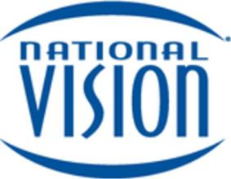

National Vision Holdings, Inc.

Common Stock

Prospectus

March 14, 2018

 |  | Joint Book-Running Managers
BofA Merrill Lynch | Citigroup | Goldman Sachs Co. LLC | Jefferies | KKR
Morgan Stanley | UBS Investment Bank |  | Wells Fargo Securities
 |  | Co-Managers
Guggenheim Securities |  | Mizuho Securities | Macquarie Capital

