TABLE OF CONTENTS

UNITED STATES
SECURITIES AND EXCHANGE COMMISSION​

WASHINGTON, D.C. 20549

SCHEDULE 14A​

Proxy Statement Pursuant to Section 14(a) of

the Securities Exchange Act of 1934

(Amendment No. )

Filed by the Registrant ☒ Filed by a Party other than the Registrant ☐

Check the appropriate box:

- Preliminary Proxy Statement

- Confidential, for Use of the Commission Only (as permitted by Rule 14a-6(e)(2)) ☒ Definitive Proxy Statement

- Definitive Additional Materials

- Soliciting Material under §240.14a-12

NATIONAL VISION HOLDINGS, INC.​

(Name of Registrant as Specified In Its Charter)​

(Name of Person(s) Filing Proxy Statement, if other than the Registrant)​

Payment of Filing Fee (Check all boxes that apply):

- No fee required.

- Fee paid previously with preliminary materials.

- Fee computed on table in exhibit required by Item 25(b) per Exchange Act Rules 14a-6(i)(1) and 0-11

TABLE OF CONTENTS

National Vision Holdings, Inc.

2022 Proxy Statement

Notice of Annual Meeting of Stockholders
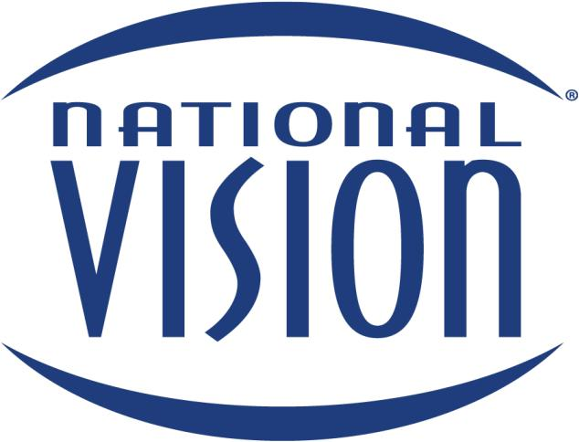

Wednesday, June 15, 2022

1:00 p.m. Eastern Time​

TABLE OF CONTENTS​

TABLE OF CONTENTS

Letter to Stockholders from our Chairman of the Board of Directors and |  |  |  |  |  |  | ​ ​​ |  |  |  | ​
​Chief Executive Officer |  |  |  |  |  |  |  |  |  | 1
Notice​ | of Annual Meeting of Stockholders |  |  |  |  |  | ​ ​ | ​ |  |  | ​
 |  |  |  |  |  |  |  |  |  | 2
​Proxy Statement Summary |  |  |  |  |  |  | ​ ​​ |  |  | 3 |  | ​
​Proxy Statement |  |  |  |  |  |  | ​ ​​ |  | 10 |  |  | ​
​Board of Directors and Certain Governance Matters |  |  |  |  |  |  | ​ ​​ |  | 10 |  |  | ​

- Proposal No. 1—Election of Directors

- Board Oversight

- Director Independence

- Composition of the Board of Directors

- Director Nomination Process

- Leadership Structure of the Board of Directors

- Board Oversight of Risk Management

- Management Succession Planning

- Executive Sessions

- Board and Committee Evaluations

- Communications with the Board

- Board Committees and Meetings

- Committee Charters & Corporate Governance Guidelines

- Code of Conduct

- Hedging & Pledging Policies

- Transactions with Related Persons

- Stockholder Engagement

- Corporate Responsibility

- Human Capital Management

- Compensation of Directors

Executive​ Compensation

- Proposal No. 2—Non-Binding Advisory Vote on Executive Compensation

- Compensation Discussion and Analysis

- Compensation Committee Report

- Summary Compensation Table

- Grants of Plan-Based Awards

- Outstanding Equity Awards at Fiscal Year End

- Option Exercises and Stock Vested

- Pension Benefits

- Non-Qualified Deferred Compensation

- Potential Payments on Termination or Change in Control

- Compensation Committee Interlocks and Insider Participation

- Equity Compensation Plan Information

- CEO Pay Ratio

​ ​​ 10​

​ ​​ 14​

​ ​​ 14​

​ ​​ 14​

​ ​​ 14​

​ ​​ 16​

​ ​​ 17​

​ ​​ 18​

​ ​​ 18​

​ ​​ 18​

​ ​​ 18​

​ ​​ 19​

​ ​​ 20​

​ ​​ 20​

​ ​​ 20​

​ ​​ 20​

​ ​​ 21​

​ ​​ 22​

​ ​​ 23​

​ ​​ 25​

​ ​​27​

​ ​​ 27​

​ ​​ 28​

​ ​​ 38​

​ ​​ 39​

​ ​​ 41​

​ ​​ 42​

​ ​​ 43​

​ ​​ 43​

​ ​​ 43​

​ ​​ 44​

​ ​​ 46​

​ ​​ 47​

​ ​​ 48​

2022 Proxy Statement  i

TABLE OF CONTENTS​

 |  |  |  |  |  |  |  |  |  |  |  |  |  |  |  | ​
​Ownership of Our Securities |  |  |  |  |  |  |  |  |  |  |  |  |  | ​ ​​ | 49 | ​
​ Delinquent Section 16(a) Reports |  |  |  |  |  |  |  |  |  |  |  |  |  | ​ ​​ 49​
​ Beneficial Ownership of National Vision Common Stock |  |  |  |  |  |  |  |  |  |  |  |  |  | ​ ​​ 49 |  | ​
​Audit Committee Matters |  |  |  |  |  |  |  |  |  |  |  |  |  | ​ ​​ | 52 | ​
​ Proposal No. 3—Ratification of Independent Registered Public Accounting Firm |  |  |  |  |  |  |  |  |  |  |  |  |  | ​ ​​ 52 |  | ​
​ Report of the Audit Committee |  |  |  |  |  |  |  |  |  |  |  |  |  | ​ ​​ 53​
​Important Information About Voting at the Annual Meeting |  |  |  |  |  |  |  |  |  |  |  |  |  | ​ ​​ | 54 | ​
​Other Information for Stockholders |  |  |  |  |  |  |  |  |  |  |  |  |  | ​ ​​ | 56 | ​
​ Stockholder Proposals for the 2023 Annual Meeting |  |  |  |  |  |  |  |  |  |  |  |  |  | ​ ​​ 56 |  | ​
​ Householding of Proxy Materials |  |  |  |  |  |  |  |  |  |  |  |  |  | ​ ​​ 56​
​ Other Business |  |  |  |  |  |  |  |  |  |  |  |  |  | ​ ​​ 56 |  | ​
​ Questions and Answers About the Annual Meeting and Voting |  |  |  |  |  |  |  |  |  |  |  |  |  | ​ ​​ 57​
​Appendix A—Non-GAAP Financial Measures |  |  |  |  |  |  |  |  |  |  |  |  |  | ​ ​​ | 60 | ​

This proxy statement includes links to websites, which are provided solely for convenience purposes. The information contained or linked on these websites or otherwise connected thereto are not, and will not be deemed to be, a part of or incorporated by reference into this proxy statement or any other Company filings with the Securities and Exchange Commission (the “SEC”).

This proxy statement contains forward-looking statements. All statements, other than statements of historical facts included in this proxy statement, including statements concerning our plans, objectives, goals, beliefs, business strategies, future events, business conditions, results of operations, financial position, business outlook, business trends and other information, may be forward-looking statements. Words such as “believes,” “expects,” “may,” “will,” “should,” “seeks,” “intends,” “plans,” “estimates,” or “anticipates,” and variations of such words or similar expressions are intended to identify forward-looking statements. The forward-looking statements are not historical facts, or guarantees of future performance and are based upon our current expectations, beliefs, estimates and projections, and various assumptions, many of which, by their nature, are inherently uncertain and beyond our control. Our expectations, beliefs, and projections are expressed in good faith and we believe there is a reasonable basis for them. However, there can be no assurance that management’s expectations, beliefs and projections will result or be achieved and actual results may vary materially from what is expressed in or indicated by the forward-looking statements. All forward-looking statements in this proxy statement, apply only as of the date of this proxy statement or as of the date they were made and, except as required by applicable law, we undertake no obligation to publicly update or revise any forward-looking statement, whether as a result of new information, future developments or otherwise. There are a number of risks, uncertainties and other important factors, many of which are beyond our control, that could cause our actual results to differ materially from the forward-looking statements contained in this proxy statement. These risks and uncertainties include, but are not limited to, those described in Part I. Item 1A. “Risk Factors” in our Annual Report on Form 10-K for the year ended January 1, 2022 (the “2021 10-K”) and those described from time to time in our future reports filed with the SEC.

ii 2022 Proxy Statement

TABLE OF CONTENTS​

LETTER TO STOCKHOLDERS​

Dear Stockholders:

We are pleased to invite you to attend the National Vision Holdings, Inc. 2022 Annual Meeting of Stockholders on Wednesday, June 15, 2022, at 1:00 p.m., Eastern Time. Due to continued concerns related to the coronavirus (COVID-19) pandemic, we will be holding a virtual Annual Meeting, as described further below.

Year in Review

2021 was another year testing our Company’s ability to navigate the continued uncertainty and challenges of the ongoing COVID-19 pandemic. National Vision has been resilient in difficult times, including economic crises, and we are proud that we continued to adapt to the unknown, while staying true to our mission, prioritizing the health and safety of our associates, doctors, patients and customers, and serving our local communities. Most importantly, our associates and doctors continued to meet every challenge that came their way and we are grateful for their resilience and dedication to customer and patient care. Despite the continued volatility in 2021, we delivered another year of record annual sales and profitability, along with an increase in our overall store count by 6.1%, ending the year with 1,278 stores. Although the macro-economic environment remains dynamic, we remain confident in our ability to deliver consistent, long-term sustainable growth and capitalize on future opportunities.

Our Commitment to Corporate Responsibility—A World Worth Seeing

We are excited to have published our first Corporate Responsibility Report in 2021, allowing us to highlight our strong mission-focused culture, pursuant to which we believe everyone deserves to see their best to live their best. The report highlights our approach to environmental, social and governance (ESG) topics from a broad perspective. Our “SEE + G” framework outlines our key Corporate Responsibility pillars of social, employees, environment, and governance and serves as the foundation of our Corporate Responsibility efforts to ensure we focus on the areas in which we have the greatest opportunity to create positive impacts in our local and global communities while we grow a resilient business. We look forward to reporting on our progress through our website’s Corporate Responsibility page and future Corporate Responsibility reports.

We believe the foundation of Corporate Responsibility is responsible corporate governance. We are proud that our Board of Directors, a group of industry-leading experts with diverse genders, ethnicities, skills, experiences and backgrounds, who oversee the Company’s strategy and drive long-term value for our stockholders, reflects our commitment to diversity, with four women and two directors of racial/ethnic diversity.

Looking Ahead

The safety and health of our associates, doctors, patients, and customers remains our highest priority as we continue to navigate the pandemic and provide reliable and quality low cost eye care and eyewear to our patients and customers. Despite the uncertainty created by the continued pandemic and the volatility in the global economy, we remain focused on delivering value for you, our stockholders, over the long term.

Our 2022 Annual Meeting

Whether you own a few shares or many, and whether or not you plan to attend the virtual Annual Meeting, your vote is important to us. We encourage you to review the proxy materials and submit your vote today. Detailed information concerning the Annual Meeting is set forth in the Notice of Annual Meeting of Stockholders, Notice of Internet Availability of Proxy Materials and proxy statement, which describe the business to be conducted at the meeting. Whether or not you plan to attend, it is important that your shares be represented and voted during the meeting. Instructions for voting your shares are set forth in the proxy statement as well as in the Notice of Internet Availability of Proxy Materials you received in the mail. The Notice of Internet Availability of Proxy Materials, the proxy statement, and the enclosed proxy card and annual report are first being sent to stockholders on or about April 26, 2022.

On behalf of the Board of Directors and everyone at National Vision, we are grateful for your continued support.
Thank you for being a stockholder of National Vision Holdings, Inc.

Sincerely,
​ | ​ ​ |  | ​
​ | ​ ​ | L. Reade Fahs | ​
D. Randolph Peeler |  | L. Reade Fahs
Chairman of the Board of Directors |  | Chief Executive Officer
April 26, 2022
 |  | 2022 Proxy Statement | 1
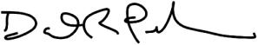
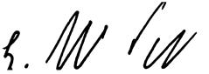

TABLE OF CONTENTS​

NOTICE OF ANNUAL MEETING OF STOCKHOLDERS

DATE​ & TIME

​VIRTUAL MEETING INFORMATION

​

​ITEMS OF BUSINESS

​

​

​

​RECORD DATE

​ ​ 1:00 p.m. Eastern Time, on Wednesday, June 15, 2022. ​

​ ​ The virtual Annual Meeting will be held exclusively online at meetnow.global/MYH4QL4. ​ While you will not be able to attend the Annual Meeting at a physical location, we are committed to ensuring that stockholders will be afforded the same rights and opportunities to participate as they would at an in-person meeting. You will be able to attend and participate in the Annual Meeting online, vote your shares electronically and submit questions to be addressed during the meeting. To attend the meeting virtually, please visit the meeting website and enter your control number.
​ ​ We are continuing to leverage the latest technology to provide expanded access, |  | ​
improved communication and cost savings for our stockholders and the Company.
Thus, it is very important that you retain your Notice, proxy card and related materials,
including your control number, through the date of the virtual Annual Meeting.
​ ​ _{1.} | To elect the three director nominees listed in the Proxy Statement, each for a term | ​
 | of one year.
​ ​ _{2.} | To approve, in a non-binding advisory vote, the compensation paid to the named | ​
 | executive officers.
​ ​ _{3.} | To ratify the appointment of Deloitte & Touche LLP as our independent registered | ​
 | public accounting firm for fiscal 2022.
​ ​ _{4.} | To consider such other business as may properly come before the Annual Meeting ​
 | and any adjournments or postponements thereof.
​ ​ You may vote at the virtual Annual Meeting if you were a stockholder of record at the |  | ​
close of business on April 18, 2022.

​ | ​ ​ | You may vote your shares on the Internet, by telephone or by completing, signing and |  | ​
VOTING
 |  | promptly returning a proxy card or you may attend the Annual Meeting online, vote your
 |  | shares and submit questions during the live meeting by visiting
 |  | meetnow.global/MYH4QL4. Voting online, by telephone or by returning your proxy card
 |  | does not deprive you of your right to attend the Annual Meeting online. If you do attend
 |  | the Annual Meeting online and wish to vote your shares online during the Annual
 |  | Meeting, you may do so and such vote will supersede any prior vote recorded. Voting
 |  | procedures are described on the following page and on the Notice of Internet
 |  | Availability of Proxy Materials and the proxy card.
 |  |  | By Order of the Board of Directors,
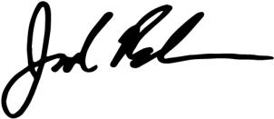

Jared Brandman

Senior Vice President, General Counsel and Secretary

​ | Important Notice Regarding the Availability of Proxy Materials for the Stockholder Meeting |  |  | ​
 | to Be Held on Wednesday, June 15, 2022: This Proxy Statement and our Annual Report
 | are available free of charge at www.edocumentview.com/EYE.

2 2022 Proxy Statement

TABLE OF CONTENTS​

PROXY STATEMENT SUMMARY​

PROXY STATEMENT SUMMARY

We are providing this proxy statement to you in connection with the solicitation of proxies by the Board of Directors (the “Board of Directors” or the “Board”) of National Vision Holdings, Inc. (the “Company”) for the 2022 Annual Meeting of Stockholders (the “Annual Meeting”) and for any adjournment or postponement of the Annual Meeting. This summary highlights information contained elsewhere in this proxy statement. This summary does not contain all the information you should consider, and you should read the entire proxy statement carefully before voting.

2022 ANNUAL MEETING OF STOCKHOLDERS

 | ​ | Date & Time | ​ | ​ |  | Location |  | ​ | ​ | Record Date | ​
 | ​ | June 15, 2022 | ​ | ​ | The Annual Meeting will be held |  |  | ​ | ​ | Record holders as of April 18, | ​
 |  | 1:00 p.m., Eastern Time |  |  |  | exclusively online at |  |  |  | 2022 are entitled to notice of, and
 |  |  |  |  |  | meetnow.global/MYH4QL4 |  |  |  | to vote at, the Annual Meeting
 | ​ On or about April 26, 2022, we started mailing the Notice of Internet Availability of Proxy Materials to our |  |  |  |  |  |  |  |  |  | ​
 |  | stockholders.

AGENDA AND VOTING RECOMMENDATIONS

​Company Proposals

​Proposal 1: Elect the Three Director Nominees of the Company, each for a term of one year

​Proposal 2: Non-Binding Advisory Vote to Approve Our Executive Compensation

​Proposal 3: Ratification of Deloitte & Touche LLP as Our Independent Auditor for 2022

 | Board
​ | ​ Recommendation | ​
​ | ​ FOR EACH NOMINEE​
​
​ | ​ FOR | ​
​ | ​ FOR | ​

HOW TO VOTE

If at the close of business on April 18, 2022, you were a stockholder of record or held shares through a broker or bank, you may vote your shares by proxy at the virtual Annual Meeting. You may vote your shares over the Internet, by telephone or by mail, or you may vote online during the Annual Meeting. See full instructions under the Important Information About Voting at the Annual Meeting section of this proxy statement on page 54.

If you are a stockholder of record and you would like to vote in any manner other than online during the virtual Annual Meeting, your vote must be received by 11:59 p.m., Eastern Time, on June 14, 2022 to be counted. If you hold shares through a broker, bank or other nominee, please refer to information from your bank, broker or nominee for voting instructions.

2022 Proxy Statement | 3

TABLE OF CONTENTS

PROXY STATEMENT SUMMARY

2021 BUSINESS HIGHLIGHTS

Financial Highlights

In 2021, we made meaningful progress on our long-term strategy, all while navigating the COVID-19 pandemic with a safety-first approach in mind and continuing to deliver low cost eye care and eyewear, a medical necessity, to the communities we serve. While impacts of the pandemic continued, we have been resilient as reflected in our strong financial performance in fiscal 2021. Our fiscal 2021 financial and operational highlights included:

- Overall store count grew 6.1% to 1,278 stores

- Comparable store sales growth was 22.4%, and Adjusted Comparable Store Sales Growth¹ was 23.0%

- Net revenue increased 21.5% to $2.08 billion

- Net income increased 254% to $128.2 million

- Adjusted EBITDA¹ increased 34.8% to $294.35 million

- Adjusted Operating Income¹ increased 52.6% to $204.7 million

- Diluted EPS increased 227% to $1.43; Adjusted Diluted EPS¹ increased 62.6% to $1.48

- Operating cash flows increased from $235.0 million in 2020 to $258.9 million in 2021

- We paid down $167.4 million of our term loan and returned $69.9 million to stockholders through share repurchases

- Our cash balance was $305.8 million as of January 1, 2022
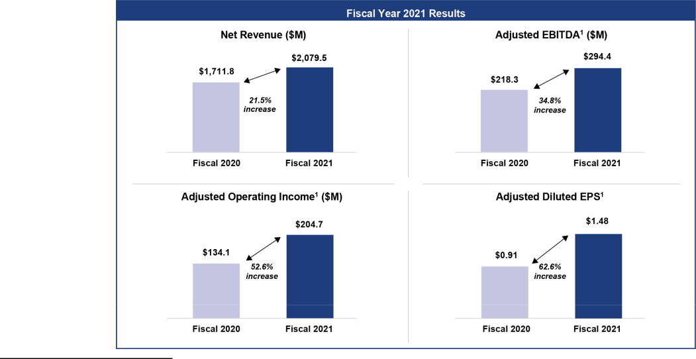

- For an explanation of our non-GAAP financial measures and a reconciliation of Adjusted Comparable Store Sales Growth, Adjusted EBITDA, Adjusted Operating Income and Adjusted Diluted EPS to the most directly comparable GAAP measures, see Appendix A to this proxy statement.

Continued COVID-19 Response

Throughout these challenging times, the Company has continued with a safety-first approach in supporting its associates, doctors, patients and customers and responding to the associated business impacts from the pandemic, while continuing to provide low cost eye care and eye wear to our patients and customers. In 2021, this included:

- Enhanced health and safety measures for patients, customers, doctors and associates;

- Enhanced health, wellness and family resources for our doctors and associates; and

- Support for our communities with community giving, including in-kind and cash donations.

4 2022 Proxy Statement

TABLE OF CONTENTS

PROXY STATEMENT SUMMARY​

CORPORATE GOVERNANCE AND BOARD HIGHLIGHTS

​Governance Highlights
​✓Phase-out of classified Board structure

- Independent, non-executive Chair of the Board

- All independent directors, except our CEO

- 100% independent Board committees

- 6 new independent directors since IPO

- 6 experienced current and former CEOs/CFOs

- 5 diverse directors, including 2 directors of racial/​ ethnic diversity

- ​ ✓Robust director and executive stock ownership guidelines

  - Anti-hedging and pledging policy

  - Strong stockholder engagement program

  - Formal disclosure committee for financial reporting purposes

  - Annual robust Board and Committee self-assessments

  - Regular Board executive sessions without management


​
​

Set forth below is a snapshot of our current National Vision Board, their independence, diversity and skills/​ qualifications. See Proposal 1 beginning on page 10 for more details on the election of the three directors named in this proxy statement for a term of one year.

CURRENT NATIONAL VISION BOARD

 |  |  |  | ​ Age |  |  |  | Director |  |  |  |  |  |  |  | Director |  |  |  | Committee
​ | Directors |  | ​ |  |  | ​ | ​ |  | Since | ​ | ​ |  | Occupation | ​ | ​ Class⁽¹⁾ |  | ​ | ​ |  | Membership | ​
​L. Reade Fahs⁽²⁾​ |  |  | ​ | ​ | 61 | ​ | ​ |  | 2014 | ​ | ​ Chief Executive Officer, National |  |  | ​ | ​ | I | ​ | ​ — |  |  | ​
 |  |  |  |  |  |  |  |  |  |  |  | Vision
​ |  | (3) | ​ | ​ | 57 | ​ | ​ |  | 2014 | ​ | ​ | Managing Director, Berkshire |  | ​ | ​ | II | ​ | ​ | Nominating & Corporate |  | ​
D. Randolph Peeler |  | ​ |  |  | 57 |  |  |  | 2014 |  |  |  |  |  |  | II
 |  |  |  |  |  |  |  |  |  |  |  | Partners LLC |  |  |  |  |  |  | Governance Committee
 |  |  |  |  |  |  |  |  |  |  |  |  |  |  |  |  |  |  | Compensation Committee
​Jose Armario |  |  | ​ | ​ | 63 | ​ | ​ |  | 2021 | ​ | ​ CEO, Bojangles’, Inc. |  |  | ​ | ​ | II | ​ | ​ Nominating & Corporate |  |  | ​
 |  |  |  |  |  |  |  |  |  |  |  |  |  |  |  |  |  |  | Governance Committee
​Heather Cianfrocco |  |  | ​ | ​ | 48 | ​ | ​ |  | 2019 | ​ | ​ CEO, OptumRX at UnitedHealth |  |  | ​ | ​ | II | ​ | ​ Compensation Committee |  |  | ​
 |  |  |  |  |  |  |  |  |  |  |  | Group
​Virginia Hepner |  |  | ​ | ​ | 64 | ​ | ​ |  | 2018 | ​ | ​ Retired CEO, The Woodruff Arts |  |  | ​ | ​ | III | ​ | ​ Nominating & Corporate |  |  | ​
 |  |  |  |  |  |  |  |  |  |  |  | Center |  |  |  |  |  |  | Governance Committee
 |  |  |  |  |  |  |  |  |  |  |  |  |  |  |  |  |  |  | (Chair)
 |  |  |  |  |  |  |  |  |  |  |  |  |  |  |  |  |  |  | Audit Committee
​Susan S. Johnson |  |  | ​ | ​ | 56 | ​ | ​ |  | 2020 | ​ | ​ Chief Marketing Officer, Prudential |  |  | ​ | ​ | I | ​ | ​ Audit Committee |  |  | ​
 |  |  |  |  |  |  |  |  |  |  |  | Financial, Inc.
​Naomi Kelman |  |  | ​ | ​ | 63 | ​ | ​ |  | 2020 | ​ | ​ Former President and CEO, Willow ​ |  |  |  | ​ | I | ​ | ​ Audit Committee |  |  | ​
​Thomas V. Taylor, Jr. |  |  | ​ | ​ | 56 | ​ | ​ |  | 2018 | ​ | ​ CEO, Floor & Decor |  |  | ​ | ​ | III | ​ | ​ Compensation Committee ​
 |  |  |  |  |  |  |  |  |  |  |  |  |  |  |  |  |  |  | (Chair)
​David M. Tehle |  |  | ​ | ​ | 65 | ​ | ​ |  | 2017 | ​ | ​ Retired CFO, Dollar General |  |  | ​ | ​ | III | ​ | ​ Audit Committee (Chair) |  |  | ​

- At the 2021 annual meeting, stockholders approved an amendment to our certificate of incorporation to phase out the classified structure of the Board. Under the prior classified structure, our Board included three directors in Class I (Mr. Fahs, Ms. Johnson and Ms. Kelman), three directors in Class II (Messrs. Armario and Peeler and Ms. Cianfrocco), and three directors in Class III (Messrs. Tehle and Taylor and Ms. Hepner). Beginning with this Annual Meeting, the Class II directors are standing for re-election for one-year terms and one class of directors will stand for election at each annual meeting of stockholders for a one-year term until our prior classified structure is phased out. By the 2024 annual meeting, the Board will be completely declassified and all directors will stand for election annually.

- All directors are independent, except for Mr. Fahs.

- Mr. Peeler serves as the independent Chair of the Board.

2022 Proxy Statement | 5

TABLE OF CONTENTS

PROXY STATEMENT SUMMARY

The fundamental duty of the Board is to oversee the Company’s strategy and the long-term interests of its stockholders. The following snapshots provide summary information about our Board and the range of backgrounds and skills of the directors that allow for their sound and prudent guidance. Additionally, the following provides diversity information for the members of our Board on an aggregate basis.
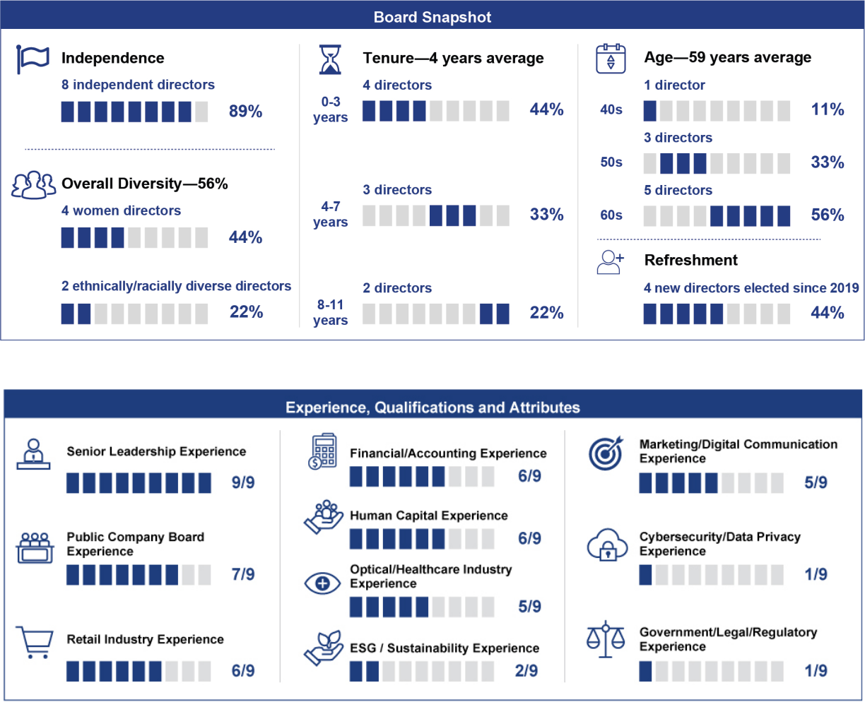

6 2022 Proxy Statement

TABLE OF CONTENTS

PROXY STATEMENT SUMMARY​

CORPORATE RESPONSIBILITY & HUMAN CAPITAL MANAGEMENT

Corporate Responsibility is foundational to who we are as a company, including our commitment to balancing the social, economic, human capital management and environmental aspects of our business. In October 2021, we achieved a significant milestone with the publication of our first-ever Corporate Responsibility Report for fiscal year 2020 detailing our corporate responsibility framework of social, employees, environment and governance (SEE+G) and our key focus areas to create positive impacts in our local and global communities.
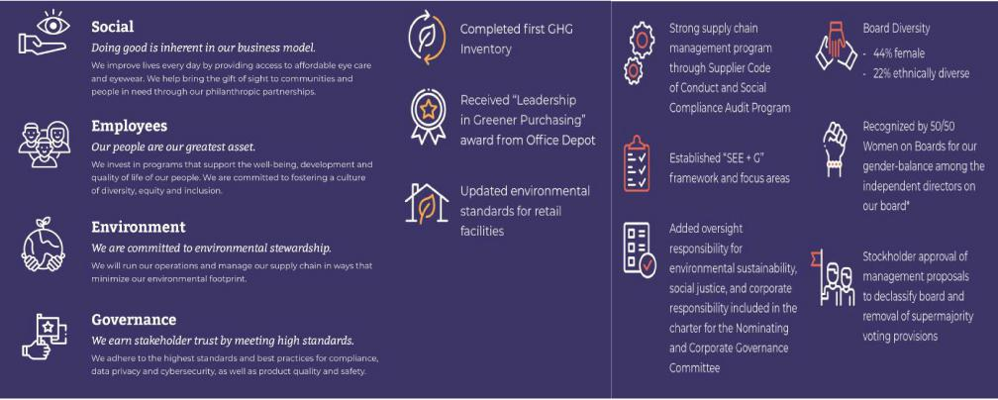

With an inclusive and people-first culture, we have taken meaningful steps to foster, celebrate and respect our associates’ diverse backgrounds, empower, reward and develop our associates and aim to give back to the communities in which we serve. Our human capital initiatives are focused on attracting highly qualified individuals and providing them with continued opportunities for growth and development in a diverse, equitable and inclusive work environment. Our long-standing commitment to diversity is embodied by the fact that National Vision is a majority minority company with Black, Indigenous, and People of Color (“BIPOC”) individuals representing the majority of associates.

2022 Proxy Statement | 7

TABLE OF CONTENTS

PROXY STATEMENT SUMMARY

We also strive to help people with the greatest of needs in a variety of ways, including providing free eye exams and

glasses to those for whom even our low-cost products are unaffordable. On a broader national and international scale, we have contributed both financially and operationally to a wide variety of efforts to help those in need

throughout America and around the world.
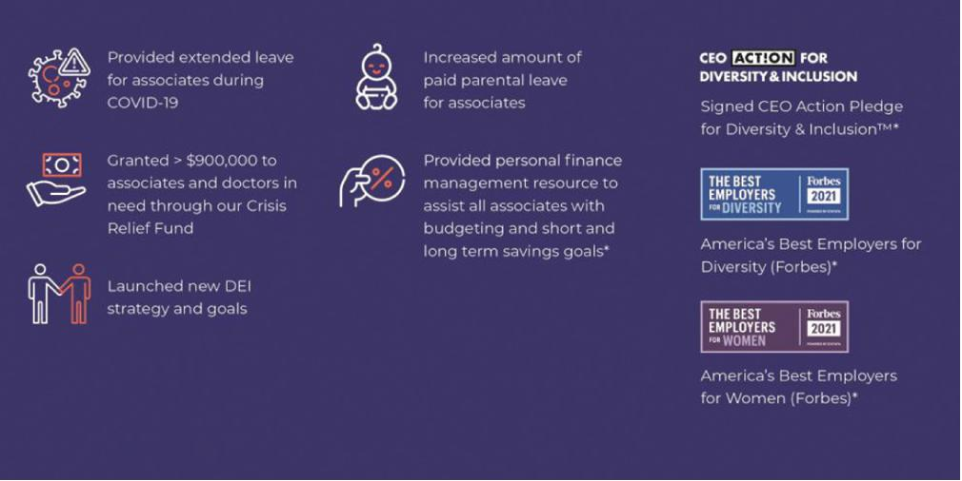

See Corporate Responsibility and Human Capital Management on pages 22 and 23, respectively, for more details.

EXECUTIVE COMPENSATION HIGHLIGHTS

We strive to create an executive compensation program that strikes the right balance of pay for performance with an overarching goal to motivate our leaders to contribute to the achievement of our financial goals and focus on long-term value for our stockholders without taking undue risk. Our executive compensation program has three main components: (1) base salary; (2) annual cash incentive compensation; and (3) long-term incentive awards. Each component is designed to be consistent with the Company’s compensation philosophy.

The compensation and governance practices that support these principles include the following:

​What We Do:

- ✓Pay for performance

  - Maintain robust stock ownership guidelines for our named executive officers (“NEOs”)

  - Require our NEOs to retain 50% of vested awards net of tax withholdings until they have met our ownership guidelines

  - Engage an independent compensation consultant to advise us on matters surrounding our compensation plans

  - Review our compensation programs annually to prevent undue risk taking

  - Hold an annual say-on-pay vote

  - Establish target and maximum awards under our annual cash incentive program

  - Maintain an established stockholder engagement program

  - Require “Double-Trigger” vesting for Change in Control in equity awards

​ ​ What We Don’t Do:
​ ​ ✗No excise tax gross-ups upon a Change in Control

- No hedging of the Company’s stock by NEOs or directors

- No supplemental executive retirement plans

- No re-pricing of stock options without stockholder approval

- No significant perquisites for executive officers

​
​

8 2022 Proxy Statement

TABLE OF CONTENTS

PROXY STATEMENT SUMMARY​

The discussion beginning on page 28 more fully describes the design and evolution of our executive compensation program, including the Company’s performance for fiscal 2021 and its connection to executive officer compensation as well as certain changes to the Company’s long-term incentive mix for fiscal 2022. See Proposal 2 beginning on page 27.

RATIFICATION OF APPOINTMENT OF INDEPENDENT REGISTERED PUBLIC ACCOUNTING FIRM

The audit committee of the Board has selected Deloitte & Touche LLP as our independent registered public accounting firm for fiscal 2022. Each year the audit committee evaluates the qualifications and performance of the Company’s independent registered public accountants and determines whether to re-engage the current independent registered public accountants. Based on this evaluation, the audit committee believes the continued retention of Deloitte & Touche LLP is in the best interests of the Company and its stockholders. See Proposal 3 beginning on page 52.

2022 Proxy Statement | 9

TABLE OF CONTENTS​

BOARD OF DIRECTORS AND CERTAIN GOVERNANCE MATTERS

PROXY STATEMENT

PROPOSAL NO. 1—ELECTION OF DIRECTORS

- WHAT AM I VOTING ON? Stockholders are being asked to elect each of the three director nominees named in this proxy statement to hold office until the 2023 annual meeting and until their respective successors are elected and qualified.

- VOTING RECOMMENDATION. Our Board of Directors recommends stockholders vote FOR the election of each director nominee named in this proxy statement. The nominating and corporate governance committee evaluated and recommended the director nominees in accordance with its charter and our Corporate Governance Guidelines.

- VOTE REQUIRED. To be elected, a director must receive a plurality of the votes cast in respect of the shares present in person or represented by proxy at the meeting and entitled to vote on the election of directors, which means that the director nominees with the greatest number of FOR votes cast will be elected.


​

​

​

Our Board of Directors oversees or directs our business and affairs, as provided by Delaware law, and conducts its business through meetings of the Board and three standing committees: the audit committee, the nominating and corporate governance committee and the compensation committee. The Board is currently comprised of nine directors, eight of whom are independent.

Last year our stockholders approved the amendment of our certificate of incorporation to phase out the classified structure of the Board. Under the prior classified structure, our Board included three directors in Class I (Mr. Fahs, Ms. Johnson and Ms. Kelman), three directors in Class II (Messrs. Armario and Peeler and Ms. Cianfrocco), and three directors in Class III (Messrs. Tehle and Taylor and Ms. Hepner). One class of directors will stand for election at each annual meeting of stockholders for a one-year term until our prior classified structure is phased out. By the 2024 annual meeting, the Board will be completed declassified and all directors will stand for election annually. The three Class II directors standing at this Annual Meeting will be re-elected for a one-year term.

The terms of our three current director nominees expire on the date of the Annual Meeting, subject to the election and qualification of their successors. Upon the recommendation of the nominating and corporate governance committee, the Board has nominated D. Randolph Peeler, Jose Armario and Heather Cianfrocco for re-election as directors for a one-year term expiring at the 2023 annual meeting.

Unless otherwise instructed, the persons named in the form of proxy card (the “proxyholders”) included with this proxy statement intend to vote the proxies held by them “FOR” the election of D. Randolph Peeler, Jose Armario and Heather Cianfrocco. We have no reason to believe that Messrs. Peeler and Armario and Ms. Cianfrocco will be unable or unwilling to serve if elected. If Mr. Peeler, Mr. Armario and Ms. Cianfrocco cease to be candidates for election by the time of the Annual Meeting (a contingency which the Board does not expect to occur), such proxies may be voted by the proxyholders in accordance with the recommendation of the Board.

10 2022 Proxy Statement

TABLE OF CONTENTS

BOARD OF DIRECTORS AND CERTAIN GOVERNANCE MATTERS​

Nominees for Election to the Board of Directors

Set forth below is certain information regarding each director nominee. Beneficial ownership of equity securities of each director nominee is shown under “Ownership of Our Securities” later in this proxy statement.
​ | ​​D. Randolph Peeler |  | ​
 | ​ | Director since: March 2014 | ​
 |  | Age: 57
 |  | Other Public Boards: 0
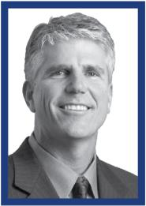

PRINCIPAL OCCUPATION AND OTHER INFORMATION

Mr. Peeler joined Berkshire Partners LLC (“Berkshire”) in 1996 and became a Managing Director in 2000. Before joining Berkshire, Mr. Peeler co-founded a privately-owned healthcare services company and also served as Special Assistant for the Assistant Secretary for Economic Policy in the U.S. Department of the Treasury. Mr. Peeler previously worked as a consultant with Cannon Associates and Bain & Co. Mr. Peeler is or has been a director of several Berkshire portfolio companies, including Affordable Care, Inc. and Curriculum Associates, LLC. Mr. Peeler also serves on the boards of DVx Ventures and Milk Street Kitchen and on the boards of multiple non-profit organizations including Boys and Girls Club of Boston, Huntington Theater Company and Unite America Institute. In addition, Mr. Peeler is on the board of visitors for the Sanford School of Public Policy, Duke University. Mr. Peeler has an A.B. from Duke University and an M.B.A. from Harvard Business School. Mr. Peeler brings to our Board of Directors acquisition and capital market transactions knowledge from years of experience in the private equity industry, along with board experience from serving as a director of several of Berkshire’s current or former portfolio companies, industry experience in the optical/healthcare and retail industries, financial/accounting experience and human capital experience.

​ | ​​Heather Cianfrocco |  | ​
 | ​ | Director since: July 2019 | ​
 |  | Age: 48
 |  | Other Public Boards: 0


PRINCIPAL OCCUPATION AND OTHER INFORMATION

Ms. Cianfrocco is the Chief Executive Officer, OptumRX at UnitedHealth Group and has served in that role since April 2021. Ms. Cianfrocco previously served as the Chief Executive Officer of OptumHealth Services from July 2020 until April 2021 and as the Chief Executive Officer of UnitedHealthcare Community & State from February 2018 until July 2020. From July 2017 until February 2018, Ms. Cianfrocco served as Senior Vice President of Health Advancement and Clinical Transformation for UnitedHealthcare Medicare & Retirement. From June 2016 until July 2017, she served as senior vice president of Clinical Strategy and Operations for UnitedHealthcare Community & State. Prior to that, Ms. Cianfrocco was the Northeast Region President for UnitedHealthcare Community & State from June 2012 until June 2016. Throughout her time with UnitedHealthcare, she has held other leadership positions within Community & State in legal, compliance, operations, and contracting. Before joining UnitedHealthcare, Ms. Cianfrocco worked in private legal practices in Pittsburgh, Pennsylvania where she concentrated on corporate and securities law, representing health care entities in mergers and acquisitions. In addition, Ms. Cianfrocco is an advisory board member of Pharmaceutical Care Management Associates and serves as an advisory board member of UnitedHealth Foundation as well as The Salvation Army of Western Pennsylvania—Allegheny County. Ms. Cianfrocco has a Bachelor of Arts degree from Pennsylvania State University, a Juris Doctorate from Duquesne University School of Law, and a Masters in Health Care Delivery Science from Dartmouth College. Ms. Cianfrocco brings to our Board of Directors senior leadership, healthcare industry and government/​regulatory experience from her position as CEO of a large, national, multiple market healthcare company.

​ | ​​Jose Armario |  | ​
 | ​ | Director since: February 2021 | ​
 |  | Age: 63
 |  | Other Public Boards: 0


PRINCIPAL OCCUPATION AND OTHER INFORMATION

Mr. Armario is the Chief Executive Officer and President of Bojangles’, Inc., a restaurant operator and franchisor, and has served in this role since January 2019. From January 2016 until January 2019, Mr. Armario was the founder and Chief Executive Officer of Armario Enterprises, LLC and PowerC, LLC. He retired as Executive Vice President of Worldwide Supply Chain, Development, and Franchising of McDonald’s Corporation in October 2015, after having held that position since August 2011. Mr. Armario has over 38 years of experience turning around key markets and geographies. Currently, Mr. Armario serves as a director at Bojangles’, Inc. and as a director for Golden State Foods and The Greg Olsen Foundation. He is also a member of the President’s Council of the University of Miami. He earned his Associate of Arts degree in Business Administration from Miami-Dade Community College. He holds a Master of Science degree in Management from the University of Miami and a CEO Perspective Course completion from Northwestern University. Mr. Armario brings to our Board of Directors senior leadership, public company board and retail industry experience from his role as CEO of Bojangles, prior executive positions and board work, along with optical/healthcare industry, marketing ESG/sustainability and human capital experience.

2022 Proxy Statement | 11

TABLE OF CONTENTS

BOARD OF DIRECTORS AND CERTAIN GOVERNANCE MATTERS

Continuing Members of the Board of Directors

Set forth below is certain information regarding each director whose term continues beyond the Annual Meeting and who is not subject to election this year. Beneficial ownership of equity securities for these directors is also shown under “Ownership of Our Securities” later in this proxy statement.

​ | ​​Thomas V. Taylor, Jr. |  | ​
 | ​ | Director since: September 2018 | ​
 |  | Age: 56
 |  | Other Public Boards: 1
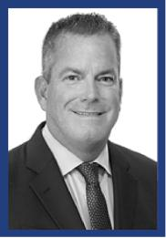

PRINCIPAL OCCUPATION AND OTHER INFORMATION

Mr. Taylor has served as Floor & Decor’s Chief Executive Officer and as a director since December 2012, including during its 2017 IPO. Starting his retail career working at a Miami Home Depot store in 1983 at the age of 16, Mr. Taylor worked his way up through various operations roles to eventually serve as Executive Vice President of Operations responsible for all 2,200 Home Depot Stores; he also held the role of Executive Vice President of Merchandising and Marketing again for all stores. From 2006 to 2012, Mr. Taylor was Managing Director at Sun Capital Partners, during which time he served as a board member for more than 20 portfolio companies domestically and in Europe. Mr. Taylor also serves on the board of directors of Cooper’s Hawk, a differentiated wine club and restaurant concept. Mr. Taylor brings to our Board of Directors extensive experience as a director and senior leader, along with retail industry knowledge, from his position as CEO of Floor & Decor and past board work, along with financial/accounting, marketing and human capital experience.

​ | ​​Virginia A. Hepner |  | ​
 | ​ | Director since: January 2018 | ​
 |  | Age: 64
 |  | Other Public Boards: 2
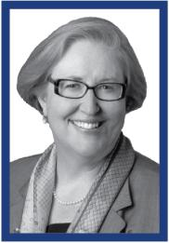

PRINCIPAL OCCUPATION AND OTHER INFORMATION

Ms. Hepner is the former President and Chief Executive Officer of The Woodruff Arts Center in Atlanta, Georgia, having served in that position from July 2012 to July 2017. Ms. Hepner has over 25 years of corporate banking experience with Wachovia Bank and its predecessors, having held numerous positions in corporate finance and capital markets until retiring in 2005 as an Executive Vice President. With the merger between Bancorp South and Cadence Bank in October 2021, Ms. Hepner became Chair of the audit committee and a member of the executive compensation committee of the new Cadence Bank. Her board service with predecessor banks of Cadence Bank began in September 2010 with State Bank & Trust Company. Additionally, Ms. Hepner joined the board of directors of Oxford Industries, Inc. in 2016, serving on its nominating, compensation and governance committee. Ms. Hepner holds a bachelor’s degree in finance from The Wharton School of the University of Pennsylvania and attended the Kellogg School of Management at Northwestern University. In addition, Ms. Hepner serves on multiple non-profit boards including, the Westside Future Fund, The Community Foundation for Greater Atlanta Investment Committee, PennIUR Advisory Board of the University of Pennsylvania, Reach Foundation of Georgia advisory board, Agnes Scott College advisory board, and the Georgia Chapter of the International Women’s Forum. Ms. Hepner also was elected a Life Trustee of The Woodruff Arts Center. Ms. Hepner brings to our Board of Directors senior leadership experience and public company board knowledge from her time as CEO of The Woodruff Arts Center and positions on the boards of Cadence Bank and Oxford Industries, along with and extensive corporate finance knowledge and ESG and human capital experience.

​ | ​​David M. Tehle |  | ​
 | ​ | Director since: July 2017 | ​
 |  | Age: 65
 |  | Other Public Boards: 2


PRINCIPAL OCCUPATION AND OTHER INFORMATION

Mr. Tehle retired from Dollar General Corporation in July 2015 as Executive Vice President and Chief Financial Officer, having served in that role since 2004. Dollar General Corporation is a value discount retailer. Mr. Tehle has been a director of Jack in the Box Inc. since December 2004, serving on the audit and finance committees. Additionally, he joined the board of directors of US Foods Holding Corp. in 2016, and serves on the audit and compensation committees. From 2016 until 2019, he was a member of the board of directors of Genesco, Inc. and he also served on the audit committee. Mr. Tehle holds a B.S. from the University of Wisconsin-Oshkosh and an M.B.A. from the University of Michigan’s Ross School of Business. Mr. Tehle brings to our Board of Directors senior leadership, financial/accounting, retail and cybersecurity and data/privacy experience from his time as CFO of Dollar General Corporation and public company board experience and retail industry knowledge from his prior and current board service.

12 2022 Proxy Statement

TABLE OF CONTENTS

​
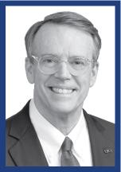

​


​


 |  | BOARD OF DIRECTORS AND CERTAIN GOVERNANCE MATTERS​
​​L. Reade Fahs |  |  | ​
​ | Director since: March 2014 |  | ​
 | Age: 61
 | Other Public Boards: 0

PRINCIPAL OCCUPATION AND OTHER INFORMATION

Mr. Fahs has served as the Chief Executive Officer of National Vision, Inc. (“NVI”) since January 2003, having joined NVI in April 2002 as the President and Chief Operating Officer, and was appointed the Chief Executive Officer of National Vision Holdings, Inc. in March 2014. Prior to joining NVI, Mr. Fahs served as the Chief Executive Officer of First Tuesday and was Managing Director of Vision Express U.K. Previously, Mr. Fahs worked at LensCrafters, which he joined in 1986 for a decade of their most rapid growth. Mr. Fahs is the chairman of the board of directors of VisionSpring and a long-term Board member of RestoringVision. Mr. Fahs also serves on the boards of RestoringVision, Ditto Technologies, Inc., Affordable Care, Inc. and Atlanta’s Alliance Theatre. Mr. Fahs holds a B.A. degree in English Literature from Harvard College. Mr. Fahs brings to our Board extensive knowledge of the Company, its operations, business and the optical and retail industries and provides a unique perspective as our CEO.

​​Susan Somersille Johnson |  | ​
​ | Director since: October 2020 | ​
 | Age: 56
 | Other Public Boards: 1

PRINCIPAL OCCUPATION AND OTHER INFORMATION

Ms. Johnson is the Chief Marketing Officer for Prudential Financial, Inc. From 2014 to 2020, Ms. Johnson previously served as Executive Vice President and Chief Marketing Officer of Truist Financial, the bank holding company formed in 2019 following the merger of SunTrust Bank and BB&T. Ms. Johnson began her career as an engineer at Apple before taking on a series of high-profile global marketing leadership roles at organizations including NCR Corporation and Nokia. She served as the Vice President of Global Marketing at NCR Corp. from 2012 to 2014 and the Global Head of Operator Marketing at Nokia from 2007 to 2012. Ms. Johnson is a member of the board of directors of Constellation Brands, a leading beverage alcohol company, serving on its compensation committee. She also serves as a board member of United Way U.S.A. and Operation Hope. Ms. Johnson has a bachelor’s degree in engineering sciences from Harvard University and an M.B.A. in finance from The Wharton School of The University of Pennsylvania. Ms. Johnson brings to our Board of Directors extensive marketing, technology and retail experience and senior leadership experience from her current role at Prudential Financial and prior roles at Truist, NCR and Nokia.

​​Naomi Kelman |  | ​
​ | Director since: September 2020 | ​
 | Age: 63
 | Other Public Boards: 0

PRINCIPAL OCCUPATION AND OTHER INFORMATION

Ms. Kelman is the former President and Chief Executive Officer of Willow, a revolutionary new women’s health company, having served in that role from 2014 to 2019. From 2011 to 2012, Ms. Kelman served as the Global Division Head of Novartis OTC. Prior to that, Ms. Kelman served in a number of executive roles during her time at Johnson & Johnson from 2000 to 2011, including as President of Vistakon Americas (Acuvue contact lenses) from 2004 to 2009 and as President of LifeScan (OneTouch diabetes monitor) from 2009 to 2011. Before joining J&J, Ms. Kelman worked at Clairol, where she worked on a broad range of CPG personal care categories and was based in Europe for five years. Ms. Kelman started her career in finance at American Express. Ms. Kelman is a member of the board of directors of Mirvie, Brilliant Home Technology, Inc., Binx Health, Inc. and Blue River PetCare, serving as its board chair. Ms. Kelman has a Bachelor of Arts degree and an M.B.A. from Cornell University. Ms. Kelman brings to our Board of Directors extensive knowledge of the healthcare industry and senior leadership and human capital knowledge from her time as CEO of Willow and prior leadership roles in the optical and healthcare industries.

2022 Proxy Statement 13

TABLE OF CONTENTS​

BOARD OF DIRECTORS AND CERTAIN GOVERNANCE MATTERS

Board Oversight

The primary responsibility of our Board is to oversee the management of the business and the affairs of the Company for the benefit of our stockholders and other stakeholders. As part of its responsibility, the Board oversees critical matters such as strategy, management succession planning, financial and other internal controls, corporate governance, risk management and compliance. To assist it in fulfilling its duties, our Board has delegated certain authority to its standing committees—the audit committee, the nominating and corporate governance committee and the compensation committee. The duties and responsibilities of these standing committees are described below under “Board Committees and Meetings.”

Director Independence

We believe the Company benefits from having a strong and independent Board. Under our Corporate Governance Guidelines and the Nasdaq Listing Rules, a director is not independent unless the Board affirmatively determines that he or she does not have a relationship with management that, in the opinion of the Board, would interfere with the exercise of independent judgment in carrying out the responsibilities of a director.

Our Corporate Governance Guidelines define independence in accordance with the independence standards in the current Nasdaq Listing Rules. Our Corporate Governance Guidelines require the Board to review the independence of all directors at least annually.

Our Board has affirmatively determined that all of the directors and nominees for director, except Mr. Fahs, are independent under the guidelines for director independence set forth in the Corporate Governance Guidelines and under all applicable Nasdaq guidelines. Mr. Fahs is not considered an independent director because of his employment as Chief Executive Officer of the Company. All members of the audit committee, compensation committee and nominating and corporate governance committee are independent.

In making its independence determinations, the Board considered and reviewed all information known to it, including information identified through annual directors’ questionnaires.

Composition of the Board of Directors

We currently have nine directors on our Board. Our certificate of incorporation provides that the authorized number of directors may be changed only by resolution of our Board of Directors.

At the 2021 annual meeting, the stockholders approved an amendment of our certificate of incorporation to phase out the classified structure of the Board and allow for the annual election of our directors. Under the prior classified structure, our Board included three directors in Class I (Mr. Fahs, Ms. Johnson and Ms. Kelman), three directors in Class II (Messrs. Armario and Peeler and Ms. Cianfrocco), and three directors in Class III (Messrs. Tehle and Taylor and Ms. Hepner). One class of directors will stand for election at each annual meeting of stockholders for a one-year term until our prior classified structure is phased out. By the 2024 annual meeting, the Board will be completed declassified and all directors will stand for election annually.

Director Nomination Process

The nominating and corporate governance committee weighs the characteristics, experience, independence and skills of potential candidates for election to the Board and recommends nominees for director to the Board for election by our stockholders in accordance with our Corporate Governance Guidelines. As the application of these factors involves the exercise of judgment, the nominating and corporate governance committee does not have a standard set of fixed qualifications that is applicable to all director candidates, although the nominating and corporate governance committee does at a minimum assess each candidate’s integrity, accountability, skills, experience, independence, other outside commitments and ability to work collegially with the other members of the Board of Directors.

14 2022 Proxy Statement

TABLE OF CONTENTS

BOARD OF DIRECTORS AND CERTAIN GOVERNANCE MATTERS​

Diversity, Qualifications, Skills and Experiences of our Directors

In addition, although the Board considers and fully appreciates the value of a diversity of viewpoints, background and experiences (including age, gender, race and ethnicity) as important to the selection of directors to enhance the Board’s cognitive diversity and quality of dialogue in the Boardroom, the Board does not have a formal diversity policy. The nominating and corporate governance committee believes that the current members of the Board provide a demonstrated executive leadership ability and are representative of diverse backgrounds.

When considering whether directors and nominees have the experience, qualifications, attributes or skills, taken as a whole, to enable our Board of Directors to satisfy its oversight responsibilities effectively in light of our business and structure and address areas where additional expertise or skills may be needed, the Board of Directors focused primarily on each person’s background and experience as reflected in the information discussed in each of the directors’ individual biographies set forth above. We believe that our directors provide an appropriate mix of experience and skills relevant to the size and nature of our business. In particular, the members of our Board of Directors considered the following important characteristics, among others, as key qualifications, attributes or skills to provide Board oversight of the Company’s business operations and strategy.
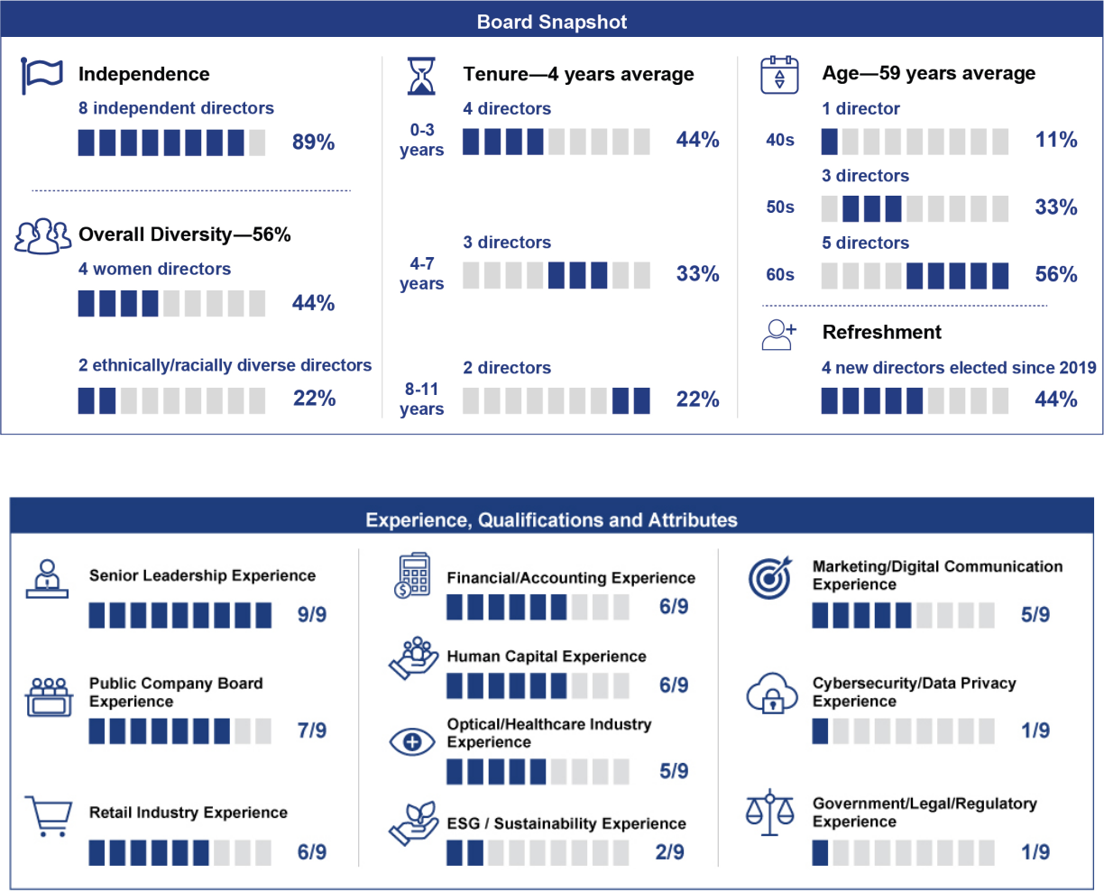

2022 Proxy Statement 15

TABLE OF CONTENTS​

BOARD OF DIRECTORS AND CERTAIN GOVERNANCE MATTERS

 | ​ | Board Diversity Matrix (As of January 1, 2022) |  |  |  |  |  |  |  |  |  |  | ​
 | ​Total Number of Directors |  | ​​ |  |  |  |  |  |  | 9 |  |  | ​
 |  |  |  |  |  |  |  |  |  |  |  | Did Not
 | ​​ |  |  | ​​Female​​Male​​Non |  |  |  |  | -Binary​​ |  |  | Disclose | ​
 | ​​ |  |  |  |  |  |  |  |  |  |  | Gender | ​
 | ​Part I: Gender Identity |  | ​​ |  | ​ | ​​ | ​ | ​​ |  | ​ | ​​ | ​ | ​
 | ​Directors |  |  | ​​ | 4 | ​​ | 5 | ​​ |  | 0 | ​​ | 0 | ​
 | ​Part II: Demographic Background |  | ​​ |  | ​ | ​​ | ​ | ​​ |  | ​ | ​​ | ​ | ​
 | ​ | African American or Black |  | ​​ | 1 | ​​ | 0 | ​​ |  | 0 | ​​ | 0 | ​
 | ​ | Alaskan Native or Native American | ​​ |  | 0 | ​​ | 0 | ​​ |  | 0 | ​​ | 0 | ​
 | ​ | Asian |  | ​​ | 0 | ​​ | 0 | ​​ |  | 0 | ​​ | 0 | ​
 | ​ | Hispanic or Latinx | ​​ |  | 0 | ​​ | 1 | ​​ |  | 0 | ​​ | 0 | ​
 | ​ | Native Hawaiian or Pacific Islander |  | ​​ | 0 | ​​ | 0 | ​​ |  | 0 | ​​ | 0 | ​
 | ​ | White | ​​ |  | 3 | ​​ | 4 | ​​ |  | 0 | ​​ | 0 | ​
 | ​ | Two or More Races or Ethnicities |  | ​​ | 0 | ​​ | 0 | ​​ |  | 0 | ​​ | 0 | ​
 | ​ | LGBTQ+ | ​​ |  |  |  |  |  |  | 0 |  |  | ​
 | ​ | Did Not Disclose Demographic Background | ​​ |  |  |  |  |  |  | 0 |  |  | ​


Nomination Process

The nominating and corporate governance committee may identify candidates for election to the Board of Directors on its own, or by considering recommendations from stockholders, officers and employees of the Company and other sources that the nominating and corporate governance committee deems appropriate. The nominating and corporate governance committee may also retain a third-party search firm to assist in the identification of possible candidates for election to the Board of Directors. The nominating and corporate governance committee will consider director candidates recommended by stockholders on the same basis as recommendations from other sources. Any recommendation submitted to the Secretary of the Company should be in writing and should include any supporting material the stockholder considers appropriate in support of that recommendation, but must include information that would be required under the rules of the SEC to be included in a proxy statement soliciting proxies for the election of such candidate and a written consent of the candidate to serve as one of our directors if elected. Stockholders wishing to recommend a candidate for consideration may do so by submitting the required information to the attention of the Secretary, National Vision Holdings, Inc., 2435 Commerce Ave, Building 2200, Duluth, Georgia 30096. All recommendations for nomination received by the Secretary that satisfy our bylaw requirements relating to director nominations will be presented to the nominating and corporate governance committee for its consideration. If stockholders want to formally nominate a director candidate for election, they must satisfy the notification, timeliness, consent and information requirements set forth in our bylaws. These requirements are also described under “Stockholder Proposals for the 2023 Annual Meeting.”

Leadership Structure of the Board of Directors

As described in our Corporate Governance Guidelines, our Board directs and oversees the management of the business and the affairs of the Company using its business judgment to act in the best interests of the Company and its stockholders. As part of this oversight role, the Board selects and oversees the members of senior management who are charged by the Board with conducting the business of the Company. While our Corporate Governance Guidelines provide our Board with flexibility to combine or separate the positions of Chairman of the Board and Chief Executive Officer in accordance with its determination that utilizing one or the other structure would be in the best interests of our Company, our Board currently believes that having these positions separated, with Mr. Peeler serving as Chairman of the Board and Mr. Fahs serving as our Chief Executive Officer and also as a director, is the appropriate leadership structure at this time and demonstrates our commitment to good corporate governance. However, our Board of Directors will continue to periodically review our leadership structure and may make such changes in the future as it deems appropriate. Under our Corporate Governance Guidelines, should the Board determine that such positions should not be separated and the Chairperson of the Board is also the Chief Executive Officer or a director who does not qualify as an independent director, the independent directors may annually elect from among themselves a lead independent director.

16 2022 Proxy Statement

TABLE OF CONTENTS​

BOARD OF DIRECTORS AND CERTAIN GOVERNANCE MATTERS​

Board Oversight of Risk Management

Management is responsible for the day-to-day management of risk, while the Board, as a whole and through its committees has extensive involvement in the oversight of the Company’s risk management. The Board engages in risk oversight throughout the year as a matter of course in fulfilling its role overseeing management and business operations, including receiving reports from management on the strategic plans and related risks facing the Company which range from financial risks to regulatory, legal, supply chain, COVID-19 pandemic-related, sustainability, competitive and information technology risks. Significant operational risks that relate to ongoing business operations are the subject of regularly scheduled reports to either the full Board or one of its committees.

The Board has delegated to its committees certain elements of its risk oversight function to better coordinate with management and serve the long-term interests of our stockholders. The risks periodically reviewed by committees are also reviewed by the entire Board when a committee or the Board determines this is appropriate. The independent chair of the Board promotes effective communication and consideration of matters presenting significant risks to the Company through his role in developing the Board’s meeting agendas, chairing meetings of the Board and facilitating communications between independent directors of the Board and the Chief Executive Officer. We believe that the leadership structure of our Board of Directors, along with the allocation of risk management responsibilities described below by appropriate committee oversight, provides appropriate risk oversight of our activities.

The audit committee oversees our risk management process with a specific focus on internal controls, financial statement integrity, compliance programs, fraud risk, legal matters and related risk mitigation. Along with the Board, the audit committee also receives regular reports from management to help ensure effective and efficient oversight and to assist in proper risk management, including with respect to cybersecurity and data security risks, and the ongoing evaluation of management controls and procedures. Through its regular meetings with management, including the finance, legal, internal audit, and compliance functions and discussions, as appropriate, with our independent registered public accounting firm and internal auditors, the audit committee reviews and discusses significant areas of our business, including areas of risk and appropriate mitigating factors. Internal audit reports functionally and administratively to our Chief Accounting Officer and directly to the audit committee. The audit committee receives reports on information technology risks, including data security and cybersecurity. The audit committee reviews cybersecurity and data security risks and mitigation strategies, along with program assessments, planned improvements and the status of information technology initiatives, with the Chief Technology Officer quarterly. See the Cybersecurity and Data Privacy Oversight section below for additional details.

The compensation committee reviews the risk profile of the Company’s compensation policies and practices, including a review of a risk assessment of our compensation programs and managing risk associated with human capital management, including employee recruitment and retention.

The nominating and corporate governance committee monitors risks relating to governance matters, including environmental, social and governance (ESG) risks, and recommends appropriate actions in response to those risks. See the Corporate Responsibility (ESG) Oversight section below for additional details.

Cybersecurity and Data Privacy Oversight

Our Chief Technology Officer is ultimately responsible for our cybersecurity and data privacy programs, which include the implementation of controls to identify threats, detect attacks and protect our data. We implement technologies and programs designed to ensure our systems are effective and prepared for cybersecurity and data privacy risks, including ongoing security monitoring for internal and external threats. We regularly perform evaluations of our security program and continue to invest in capabilities to protect our data. In addition, we have implemented regular mandatory trainings regarding cybersecurity risks to increase awareness throughout the Company. We carry insurance that provides protection against potential losses arising from a cybersecurity incident (see our risk factors in our 2021 10-K relating to cybersecurity and cybersecurity insurance).

Corporate Responsibility (ESG) Oversight

Our Board is highly engaged in our Corporate Responsibility strategy and ESG matters (including sustainability policies and initiatives), especially given that societal impact is intricately linked to the mission of our business— making eye care and eyewear more affordable and accessible. Our nominating and corporate governance committee is responsible for overseeing the effectiveness of our ESG strategies, policies, goals, initiatives and programs, including the review of our annual Corporate Responsibility Report. Our compensation committee is responsible for overseeing the development and implementation of human capital and succession plans and considering how best to incorporate ESG matters

2022 Proxy Statement 17

TABLE OF CONTENTS​

BOARD OF DIRECTORS AND CERTAIN GOVERNANCE MATTERS

into our executive compensation plans. Our audit committee is responsible for overseeing the Company’s enterprise risk management program, which includes ESG topics. See the Corporate Responsibility section at page 22.

Management Succession Planning

The Board believes that one of its primary responsibilities is to oversee the development and retention of senior talent and to ensure that an appropriate succession plan is in place for our Chief Executive Officer and other members of senior management. Management develops ideas and presents plans for identification, mentoring and continuing development of potential internal candidates for executive leadership positions. The Board and compensation committee, together with the Chief Executive Officer, regularly reviews senior management talent and succession planning.

Executive Sessions

Executive sessions, which are meetings of the independent directors of the Board, are regularly scheduled throughout the year, typically at the time of each regular Board meeting and as frequently as such independent directors deem appropriate.

Board and Committee Evaluations

As a part of the Board’s commitment to continual corporate governance improvement, the nominating and corporate governance committee supervises an annual review and self-evaluation of the performance of the Board, its committees and individual directors. The evaluation is typically conducted through a range of questions related to topics including structure of the Board and its committees, overall Board and committee effectiveness, oversight and risk management, strategy and Board access to information and resources. In 2021, an evaluation was conducted and completed with each director providing direct feedback. The evaluations were reviewed and discussed by the nominating and corporate governance committee as well as the full Board. As appropriate, these evaluations result in updates or changes to our practices as well as commitments to continue existing practices that our directors believe contribute positively to the effective functioning of our Board and its committees.

Communications with the Board

As described in our Corporate Governance Guidelines, stockholders and other interested parties who wish to communicate with a member or members of our Board of Directors, including the chairperson of our Board of Directors, the chairperson of any of the audit, compensation and nominating and corporate governance committees, or to the non-management or independent directors as a group, may do so by addressing such communications or concerns to the Secretary of the Company, 2435 Commerce Ave, Building 2200, Duluth, GA 30096, who will forward such communication to the appropriate party.

18 2022 Proxy Statement

TABLE OF CONTENTS​

BOARD OF DIRECTORS AND CERTAIN GOVERNANCE MATTERS​

Board Committees and Meetings

Our Board of Directors has an audit committee, a nominating and corporate governance committee and a compensation committee, each of which operates under a charter that has been approved by our Board.

The following table summarizes the current membership of each of the Board’s committees.


 | ​​ |  |  |  |  | Audit |  |  | Nominating and Corporate
 | ​​ |  | ​​ |  |  | Committee | ​​ |  | Governance Committee
 | ​L. Reade Fahs |  | ​​ |  |  | ​ | ​​ |  | ​
 | ​D. Randolph Peeler |  | ​​ |  |  | ​ | ​​ |  | X
 | ​Jose Armario |  | ​​ |  |  | ​ | ​​ |  | X
 | ​Heather Cianfrocco |  | ​​ |  |  | ​ | ​​ |  | ​
 | ​Virginia A. Hepner |  | ​​ |  |  | X | ​​ |  | Chair
 | ​Susan S. Johnson |  | ​​ |  |  | X | ​​ |  | ​
 | ​Naomi Kelman |  | ​​ |  |  | X | ​​ |  | ​
 | ​Thomas V. Taylor, Jr. |  | ​​ |  |  | ​ | ​​ |  | ​
 | ​David M. Tehle |  | ​​ |  |  | Chair | ​​ |  | ​

 | Compensation
​​ | Committee | ​
​​ | ​ | ​
​​ | X | ​
​​ | ​ | ​
​​ | X | ​
​​ | ​ | ​
​​ | ​ | ​
​​ | ​ | ​
​​ | Chair | ​
​​ | ​ | ​

All directors are expected to make every effort to attend all meetings of the Board of Directors, meetings of the committees of which they are members and the annual meeting of stockholders. Each of our directors that were members of our Board at the time attended the 2021 annual meeting. During the fiscal year ended January 1, 2022, the Board held fourteen meetings, the audit committee held eight meetings, the compensation committee held four meetings and the nominating and corporate governance committee held four meetings. In addition, the Board, the audit committee, the compensation committee and the nominating and corporate governance committee acted by unanimous written consent several times during fiscal 2021. Each of our directors attended 100% of all of the meetings of the Board and committees on which he or she served at the time they served on the Board or such Committees.

Audit Committee

Our audit committee consists of David M. Tehle, who serves as the Chair, Virginia A. Hepner, Susan S. Johnson and Naomi Kelman. Mr. Tehle and Mses. Hepner, Johnson and Kelman each qualify as an independent director under Nasdaq corporate governance standards and the independence requirements of Rule 10A-3 of the Securities Exchange Act of 1934 (the “Exchange Act”). Our Board of Directors has determined that Mr. Tehle and Ms. Hepner each qualify as an “audit committee financial expert” as such term is defined in Item 407(d)(5) of Regulation S-K.

The audit committee is responsible for, among other things, preparing the audit committee report required by the SEC to be included in our proxy statement and assisting our Board of Directors with respect to its oversight of

- our risk management policies and procedures, (2) the audits and integrity of our financial statements, and the effectiveness of internal control over financial reporting, (3) our compliance with legal and regulatory requirements, including SEC filings, (4) the qualifications, engagement, performance and independence of the outside auditors, including approving all auditing and non-auditing services performed by our outside auditors and (5) approving the annual audit plans and the performance of our internal audit function.

Nominating and Corporate Governance Committee

Our nominating and corporate governance committee consists of Virginia Hepner, who serves as the Chair, D. Randolph Peeler and Jose Armario. Each member of the nominating and corporate governance committee has been determined to be independent under the applicable listing standards of Nasdaq and our Corporate Governance Guidelines.

The primary purpose of the nominating and corporate governance committee is to provide assistance to the Board of Directors by, among other things, determining the size, structure, composition, processes and practices of the Board and its committees and assessing director independence and qualifications. The committee also identifies, recommends and assists the Board in recruiting individuals qualified to become Board members, oversees the Board’s director education practices, and takes a leadership role in shaping the corporate governance of the Company through its review and development of our Corporate Governance Guidelines and practices and guidance of the annual Board evaluation. The committee, along with the Board as whole, retains oversight responsibility for the Company’s Corporate

2022 Proxy Statement 19

TABLE OF CONTENTS​

BOARD OF DIRECTORS AND CERTAIN GOVERNANCE MATTERS

Responsibility/ESG strategy and provides oversight and guidance on environmental sustainability, social justice and corporate responsibility issues and opportunities for the Company.

Compensation Committee

Our compensation committee consists of Thomas Taylor, Jr., who serves as the Chair, D. Randolph Peeler and Heather Cianfrocco. Each member of the compensation committee has been determined to be independent under the applicable listing standards of Nasdaq and our Corporate Governance Guidelines.

The primary purpose of the compensation committee is to assist our Board of Directors in discharging its responsibilities relating to (1) setting our compensation philosophy and compensation of our executive officers and directors, (2) monitoring our equity-based and certain incentive compensation plans and (3) preparing the compensation committee report required to be included in our proxy statement or annual report under the rules and regulations of the SEC.

Committee Charters and Corporate Governance Guidelines

Our commitment to good corporate governance is reflected in our Corporate Governance Guidelines, which describe our Board of Directors’ views and policies on a wide range of governance topics. These Corporate Governance Guidelines are reviewed from time to time by our Board of Directors and, to the extent deemed appropriate in light of emerging practices, revised accordingly, upon recommendation to and approval by our Board of Directors.

Our Corporate Governance Guidelines, audit, nominating and corporate governance and compensation committee charters, and other corporate governance information are available in the investors section of our website,
www.nationalvision.com.

Code of Conduct

We are committed to ensuring our business is conducted ethically and legally. We maintain a written code of conduct that applies to our directors, officers and employees, including our principal executive officer, principal financial officer, principal accounting officer, or persons performing similar functions, which we call our Code of Conduct. Our Code of Conduct is a “code of ethics” as defined in Item 406(b) of Regulation S-K and is posted in the investors section of our website, www.nationalvision.com.

We intend to make any legally required disclosures regarding amendments to, or waivers of, provisions of our Code of Conduct on our website.

Hedging and Pledging Policies

The Company’s Securities Trading Policy requires executive officers and directors to consult the Company’s General Counsel prior to engaging in transactions involving the Company’s securities. Directors and executive officers are prohibited from hedging or monetization transactions including, but not limited to, variable forward contracts, equity swaps, collars and exchange funds, or from trading in options, warrants, puts and calls or similar instruments on the Company’s securities or establishing a short position in the Company’s securities. The Company’s Securities Trading Policy discourages employees from purchasing the Company’s securities on margin, or borrowing against any account in which the Company’s securities are held, or pledging the Company’s securities as collateral for a loan. For directors and officers, the pledging of Company securities is limited to those situations approved by the Company’s General Counsel.

Transactions with Related Persons

The Board has adopted a written related person transaction policy that sets forth the policies and procedures for the review and approval or ratification of related person transactions. This policy covers, with certain exceptions set forth in Item 404 of Regulation S-K under the Securities Act, any transaction, arrangement or relationship, or any series of similar transactions, arrangements or relationships, in which we were or are to be a participant, where the amount involved exceeds $120,000 and a related person had or will have a direct or indirect material interest, including, without limitation, purchases of goods or services by or from the related person or entities in which the related person has a material interest, indebtedness, guarantees of indebtedness and employment by us of a related person. It is our policy that no related person transaction will be executed without the approval or ratification of the disinterested members of the Board or a committee of the Board.

20 2022 Proxy Statement

TABLE OF CONTENTS​

BOARD OF DIRECTORS AND CERTAIN GOVERNANCE MATTERS​

There are no related persons transactions in fiscal 2021 required to be reported in this proxy statement under the applicable SEC rules.

Stockholder Engagement

Since our initial public offering (IPO), we have been committed to stockholder engagement and we greatly value the input we receive from our stockholders. We believe strong corporate governance should include year-round engagement with our stockholders. Our investor relations team and members of our senior management are in frequent communication with stockholders on a variety of matters, including our operations and financial performance. Our Chief Executive Officer and Chief Financial Officer are engaged in meaningful dialogue with our stockholders through our quarterly earnings calls and investor-related outreach events. In addition, a cross-functional team conducts our off-season stockholder outreach and engagement program through which we solicit feedback focused on corporate governance, executive compensation, corporate social responsibility and other ESG matters of interest to our stockholders. Stockholder engagement and feedback is regularly shared with our Board of Directors.

In 2021, as part of our off-season stockholder engagement efforts, we engaged with the Company’s top institutional investors representing over 60% of our outstanding shares following outreach to stockholders representing 95% of our outstanding shares. Many of these stockholders expressed the view that they were supportive of the continued progress and evolution of the Company’s Corporate Responsibility strategy and disclosure, including the publication of its first Corporate Responsibility Report (as detailed further below). Our stockholders also expressed the view that they were aligned with the Company’s phase out of its classified Board structure and elimination of supermajority voting provisions in the Company’s organizational documents. Finally, stockholders also expressed support of the Company’s continued Board diversity efforts and its executive compensation program.
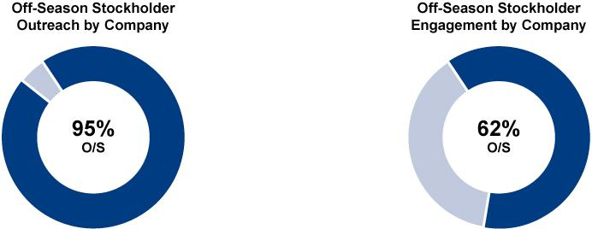

2022 Proxy Statement 21

TABLE OF CONTENTS​

BOARD OF DIRECTORS AND CERTAIN GOVERNANCE MATTERS

Corporate Responsibility

Our commitment to corporate responsibility is a core part of who we are as a Company, as is evidenced by our mission—“We help people by making quality eye care and eyewear more affordable and accessible.” We understand the importance of acting responsibly as a business, employer and corporate citizen. Engagement on corporate responsibility is important to us and our stakeholders and we are committed to balancing the social, economic, human capital management and environmental aspects of our business with disclosure highlighting our aspirations and achievements in these areas.

SEE + G Framework

In 2021, we achieved a significant milestone with the publication of our first Corporate Responsibility Report, in which we outlined our approach and focus on the most relevant ESG topics to the Company. We began the process of developing a formal Corporate Responsibility strategy by conducting a materiality assessment to identify our priority areas of focus, along with gaps and opportunities for us to address. From the outcomes of our assessment and a benchmarking and value chain exercise, we established our “SEE + G” framework outlining our key Corporate Responsibility pillars of social, employees, environment, and governance. This framework will serve as the foundation of our Corporate Responsibility efforts to ensure we focus on the areas where we have the greatest opportunity to create positive impacts in our local and global communities while we grow a resilient business.
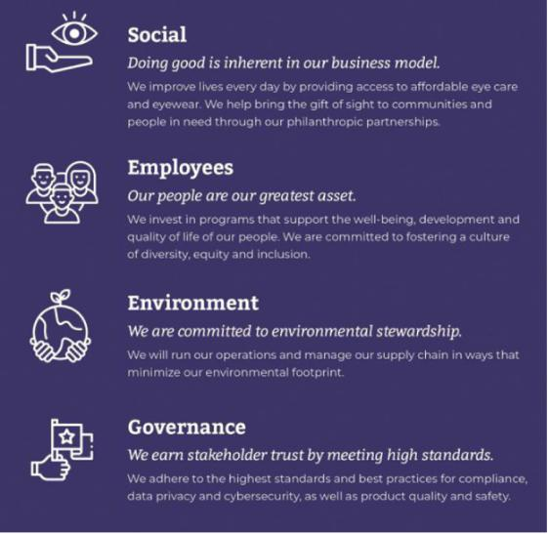

Corporate Responsibility Governance Structure

To help drive progress on our focus areas, we developed an internal corporate responsibility governance structure that begins with oversight by the Board through its nominating and corporate governance committee and executive leadership from our Chief Executive Officer. Our General Counsel serves as the executive sponsor of our corporate responsibility strategy, chairs the steering committee and provides regular updates to the Board and its nominating and corporate governance committee.
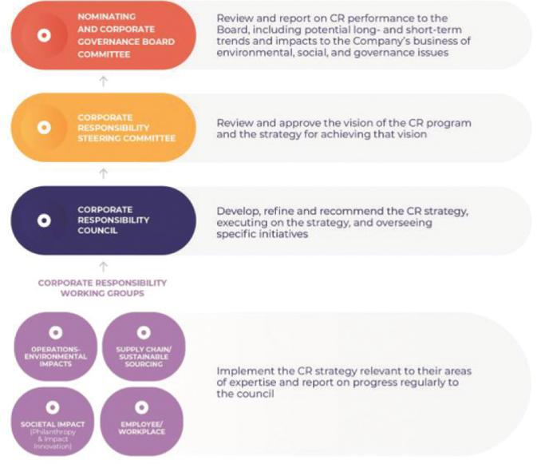

22 2022 Proxy Statement

TABLE OF CONTENTS​

BOARD OF DIRECTORS AND CERTAIN GOVERNANCE MATTERS​

2021 Corporate Responsibility highlights include:
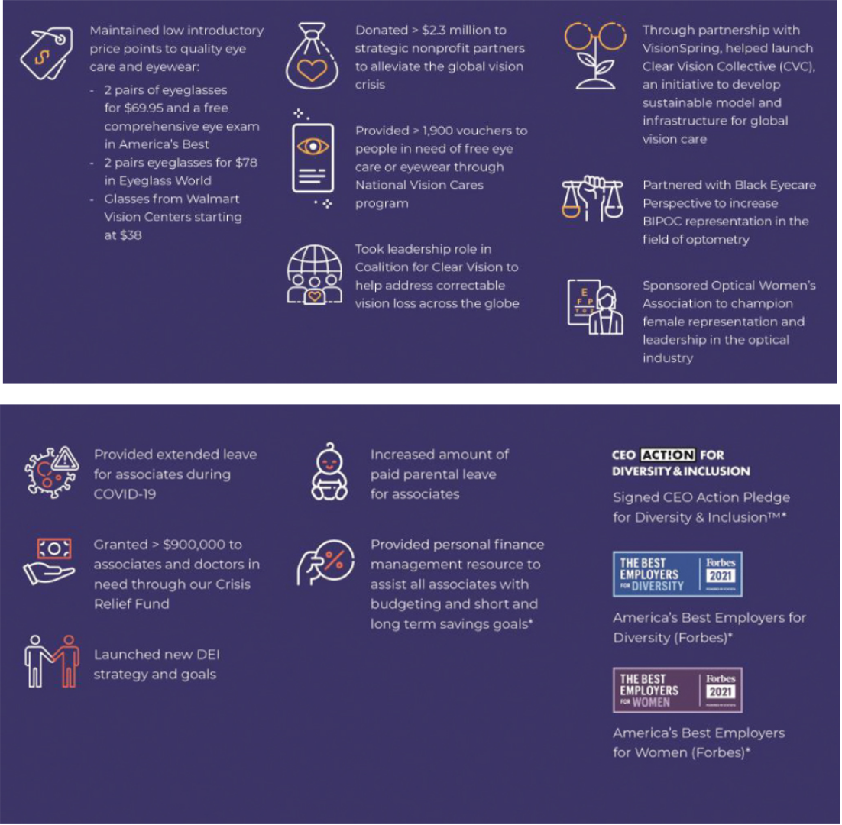

Moving forward, we are developing a detailed road map to integrate our corporate responsibility strategy into our business. This will include formalizing management processes, defining key performance indicators and supporting metrics, and considering appropriate goals to drive further progress. We are also committed to disclosing our progress each year, including in our Corporate Responsibility Report and on the Corporate Responsibility page of our website, www.nationalvision.com. The information on our website is not, and will not be deemed to be, a part of this proxy statement or incorporated into any other filings with the SEC.

Human Capital Management

With an inclusive and people-first culture, we are focused on celebrating and respecting our associates’ diverse backgrounds, empowering, rewarding and developing our associates and aiming to give back to the communities in which we serve. Our human capital initiatives are focused on attracting highly qualified individuals and providing them with continued opportunities for growth and development. As of January 1, 2022, we had 13,735 full-time and part-time associates. In addition, the professional corporations or similar entities with which we contract employed 1,256 optometrists as of January 1, 2022.

2022 Proxy Statement 23

TABLE OF CONTENTS

BOARD OF DIRECTORS AND CERTAIN GOVERNANCE MATTERS

Talent Acquisition

At National Vision, we are committed to attracting talent aligned with our Vision, Mission and Values. We have invested in key leadership roles within the talent organization to refine our approach and have incorporated new technology to improve both the candidate and hiring manager experience. In addition, we have partnered with schools and other organizations to promote the profession of optometry, including continuing our multi-year sponsorship of the Association of Schools and Colleges of Optometry campaign “Optometry Gives Me Life” targeted at high school and college students, and ensuring that graduating optometrists are educated on the variety of career options available to them. Additionally, we increased accessibility to our own internal National Vision Doctor of Optometry Tuition Reimbursement program, which provides for the reimbursement of education expenses to associates attending optometry school. To mitigate the impact the COVID-19 pandemic and temporary closure of our stores had on our traditional recruiting efforts and hiring cycles in 2020, we transitioned to online platforms for job fairs and on-campus events, selectively offered key incentives, such as a student loan repayment program, and educated applicants on the health and safety protocols implemented in our stores. We have continued with both online platform recruitment as well as in person events as part of our recruitment and hiring efforts in 2021.

Talent Development

We have a proven record of opening new stores with high-quality training support. As a result of the COVID-19 pandemic, we adapted our new store training approach by introducing and enhancing virtual instructor-led training classes, allowing for a continuation of high touch training to prepare stores to open safely and effectively. We also increased ongoing training, especially in the areas of safety protocol procedures and customer interactions. We provide associates and optometrists with several opportunities and mechanisms through which they can provide feedback and allow us to continue developing programs for training and growth.

Benefits and Wellness

We strive to ensure our people always feel supported so they can bring their best selves to work every day. We demonstrate this commitment through many of our benefits and wellness offerings. Programs like our health plan, wellness and disease management programs, including personalized programs for diabetes and hypertension, and a financial protection resource, provide the needed resources essential for helping our people care for themselves and their families. We also offer free on-demand mental and behavioral health resources, to provide needed guidance when work and personal challenges affect an associate’s overall well-being.

Shortly after our IPO, we established the National Vision Crisis Relief Fund to help support associates who are facing financial hardship as a result of a natural disaster, family emergency or other unexpected events. Donations made to the Crisis Relief Fund are matched by the Company. Since its creation, over $1.1 million have been provided to associates for assistance, with over 95% provided since the beginning of the COVID-19 pandemic.

Diversity, Equity and Inclusion

We are committed to a diverse and inclusive culture and in 2020, we formed a new Diversity, Equity and Inclusion (“DEI”) department within the Company. As we move forward in our DEI journey, we are focused on advancing diversity in our recruitment, training, career mentorship and development, employment, branding and community service. In 2021, we continued our focus on reviewing best practices and initiatives and conducted listen and learn sessions with associates and optometrists to solicit feedback and identify opportunity areas. As a part of these efforts, we collaborated with non-profit and educational institutions with the goal of increasing the percentage of Black doctors in the industry, including sponsoring and participating in the “Impact HBCU” event sponsored by Black Eyecare Perspectives with the goal of increasing awareness in the field among historically black college and university (“HBCU”) students. In 2021, our Chief Executive Officer became a signatory to the CEO Action for Diversity and Inclusion pledge, committing to a series of actions related to diversity, equity and inclusion across the Company, industry and communities. We were named one of Forbes’ Best Employers for Women and one of Forbes’ Best Employers for Veterans in 2021 and received the highest ranking given by 50/50 Women on Boards for balanced gender representation among the independent members of the Company’s Board of Directors. We were also recognized as one of Forbes’ Best Employers for Diversity in 2021 for, among other things, our proactive diversity and inclusion initiatives.

COVID-19 Response

The COVID-19 pandemic has presented unique challenges for our associates, doctors, customers and patients. We prioritized the safety of our associates, optometrists, customers and patients by voluntarily closing our stores to the public for a temporary period of time in 2020 to implement enhanced safety and cleaning protocols in order to serve

24 2022 Proxy Statement

TABLE OF CONTENTS​

BOARD OF DIRECTORS AND CERTAIN GOVERNANCE MATTERS​

our customers and patients with everyone’s health and safety in mind. Health and safety remain at the forefront for us as the pandemic and variants continue to evolve and present challenges for us.

Beginning in 2020, we created multiple resources for associates, including frequent and transparent communication tools, additional leave of absence and paid leave options, and centralized support to address COVID-19 questions and concerns, including regarding the availability of vaccines. We paid one-time appreciation bonuses to customer-facing associates, granted additional company holidays in the fourth quarter of fiscal year 2020 and paid benefits for associates furloughed in response to the COVID-19 pandemic. In addition, contributions to our Crisis Relief Fund more than tripled, reflecting the empathetic nature of our community.

Compensation of Directors

Directors who are our employees do not receive remuneration for serving on our Board. In 2021, our director compensation program consisted of the following:

- Annual cash retainer of $75,000, paid quarterly, in arrears.

- The Chair of the audit committee, compensation committee and nominating and corporate governance committee received annual cash retainers of $20,000, $15,000 and $10,000, respectively, paid quarterly, in arrears.

- Annual $100,000 restricted stock grant, which will vest on the first anniversary of the grant date, subject to continued service through the applicable vesting date.

Our directors are not paid any fees for attending meetings. However, our directors are reimbursed for reasonable travel and related expenses associated with attendance at Board or committee meetings.

The following table reflects all cash compensation paid and the aggregate market value of stock awards granted to our non-employee directors for service in fiscal 2021:

 |  |  |  |  |  | Fees earned or |  |  |  |  | Stock |  |  |  | All other |  |  |  | Total
 |  |  |  |  |  | paid in cash |  |  |  | awards |  |  |  |  | compensation |  |  |  | Total
 | ​ | Name | ​​ |  |  | ($)⁽¹⁾ | ​​ |  |  |  | ($)⁽²⁾ | ​​ |  |  | ($) | ​​ |  |  | ($) | ​
 | ​D. Randolph Peeler⁽³⁾ |  | ​​ |  |  | ​75,000 | ​​​ |  |  | ​ | — | ​​​ |  |  | ​— | ​​​ |  |  | ​ 75,000 | ​​
 | ​Heather Cianfrocco⁽⁴⁾ |  | ​​ |  |  | ​75,000 | ​​​ |  |  | ​100,000 |  | ​​​ |  |  | ​— | ​​​ |  |  | ​175,000 | ​​
 | ​Virginia A. Hepner |  | ​​ |  |  | ​85,000 | ​​​ |  |  | ​100,000 |  | ​​​ |  |  | ​— | ​​​ |  |  | ​185,000 | ​​
 | ​Susan S. Johnson |  | ​​ |  |  | ​75,000 | ​​​ |  |  | ​100,000 |  | ​​​ |  |  | ​— | ​​​ |  |  | ​175,000 | ​​
 | ​Naomi Kelman |  | ​​ |  |  | ​75,000 | ​​​ |  |  | ​100,000 |  | ​​​ |  |  | ​— | ​​​ |  |  | ​175,000 | ​​
 | ​Thomas V. Taylor, Jr. |  | ​​ |  |  | ​90,000 | ​​​ |  |  | ​100,000 |  | ​​​ |  |  | ​— | ​​​ |  |  | ​190,000 | ​​
 | ​David M. Tehle |  | ​​ |  |  | ​95,000 | ​​​ |  |  | ​100,000 |  | ​​​ |  |  | ​— | ​​​ |  |  | ​195,000 | ​​
 | ​Jose Armario |  | ​​ |  |  | ​68,750 | ​​​ |  |  | ​100,000 |  | ​​​ |  |  | ​— | ​​​ |  |  | ​168,750 | ​​
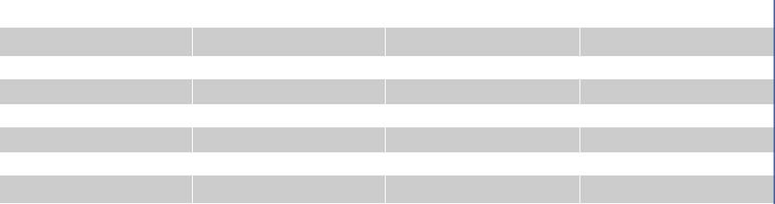

- Includes all annual retainer fees paid in cash to the directors, including the prorated annual retainer fee for Mr. Armario upon him joining the Board in February 2021. In lieu of receiving cash retainers, Mr. Peeler donated his cash retainer to 20/20 Quest, a National Vision sponsored charitable foundation. Ms. Cianfrocco donated $37,500 of her cash retainer to 20/20 Quest.

- The amount reported reflects the grant date fair value calculated in accordance with Financial Accounting Standards Board Accounting Standards Codification Topic 718, Compensation—Stock Compensation (“ASC Topic 718”) associated with the grant to each director as of such grant date. See Note 5 of the Notes to Consolidated Financial Statements contained in the Company’s 2021 10-K for an explanation of the assumptions made in the valuation of these awards. The grant date fair value of the annual award that was granted on June 9, 2021 for all directors was $100,000 for the 2,061 shares of restricted stock granted to such directors. The grant date fair value of the 2,112 shares of restricted stock granted to Mr. Armario in February 2021 was $100,000. As of January 1, 2022, Mr. Armario held 4,173 shares of unvested restricted stock, Ms. Cianfrocco held 2,061 shares of unvested restricted stock, Ms. Hepner held 2,061 shares of unvested restricted stock, Ms. Johnson held 2,061 shares of unvested restricted stock, Ms. Kelman held 2,061 shares of unvested restricted stock, Mr. Taylor held 2,061 shares of unvested restricted stock and Mr. Tehle held 2,061 shares of unvested restricted stock.

- At the request of Mr. Peeler, the compensation committee approved in June 2019 a program in which (i) in lieu of paying his cash retainer for Board service and any committee chairperson service, if applicable, directly to Mr. Peeler, the Company would instead

make a quarterly donation of such retainer in Mr. Peeler’s name to the Company’s foundation or another charity of its choosing and

  - Mr. Peeler would not receive the restricted stock award to which non-employee directors are entitled under the director compensation program.

- At the request of Ms. Cianfrocco, the compensation committee approved in July 2021 a program in which in lieu of paying a portion of her cash retainer for Board service and any committee chairperson service, if applicable, directly to Ms. Cianfrocco, the Company would instead make a quarterly donation of such retainer in Ms. Cianfrocco’s name to the Company’s foundation or another charity of its choosing.

2022 Proxy Statement 25

TABLE OF CONTENTS

BOARD OF DIRECTORS AND CERTAIN GOVERNANCE MATTERS

Fiscal 2022 Director Compensation Updates. The compensation committee, with assistance from its independent compensation consultant, reviews the director compensation program regularly to ensure the program is structured consistent with best practices and current trends. As part of this review, the director compensation program is benchmarked against the same compensation peer group used for executive compensation benchmarking, as described later in the Compensation Discussion & Analysis section. The compensation committee last reviewed director compensation in February 2022 and made changes that will go into effect on June 15, 2022.

For fiscal 2022, the compensation committee updated the following elements of annual director compensation to better align with market practices. Prior to this update, the Board had not increased its director compensation since 2018.

- Annual cash retainer of $80,000, paid quarterly, in arrears.

- The Chair of the audit committee, compensation committee and nominating and corporate governance committee will receive annual cash retainers of $22,500, $18,750 and $15,000, respectively, paid quarterly, in arrears.

- Annual $140,000 restricted stock units grant, which will vest on the first anniversary of the grant date, subject to continued service through the applicable vesting date.

In addition, beginning in 2022, directors were given the option to elect to receive all or a portion of their annual Board cash retainer and annual committee chair cash retainer, if applicable, in equity in the form of restricted stock units, which would vest on the first anniversary of the grant date, subject to continued service through the applicable vesting date.

Director Stock Ownership Guidelines. In February 2019, the Board of Directors adopted stock ownership guidelines (the “Guidelines”) applicable to our executive officers and directors who are not members of management (the “Covered Directors”). Under the Guidelines, Covered Directors are required to hold a specific level of equity ownership, as a multiple of annual cash retainer. The Guidelines currently require Covered Directors to hold 5x the annual cash retainer. There is no required time frame within which a Covered Director must attain the applicable stock ownership level under the Guidelines. However, until the applicable ownership level is achieved, Covered Directors must retain 50% of vested shares net of stock option exercise and tax withholding. Shares that count toward these ownership guidelines include shares owned outright, shares held in the Company’s 401(k) or other retirement plan and shares of time-based restricted stock (whether vested or unvested). The retention requirement applies to all prior and future grants. As of January 1, 2022, Messrs. Peeler and Tehle have met or exceeded their current ownership requirements and the remaining directors are subject to the restrictions in the Guidelines until their ownership requirements are met.

26 2022 Proxy Statement

TABLE OF CONTENTS​

EXECUTIVE COMPENSATION​

PROPOSAL NO.2—NON-BINDING ADVISORY VOTE ON EXECUTIVE COMPENSATION

​WHAT AM I VOTING ON? As required pursuant to Section 14A of the Exchange Act, stockholders are being asked to ​ approve, on an advisory basis, the compensation of our named executive officers as described in the Compensation Discussion and Analysis below.

​VOTING RECOMMENDATION. Our Board of Directors recommends stockholders vote FOR the non-binding advisory ​ vote to approve our named executive officer compensation.

​VOTE REQUIRED. The proposal must be approved by a majority of the voting power of the shares of stock present in​ person or represented by proxy and entitled to vote at the Annual Meeting. Although this vote is advisory in nature, the compensation committee takes very seriously its role in the governance of the Company’s compensation programs and values thoughtful input from stockholders. The compensation committee will take into account the outcome of the advisory vote when considering future executive compensation decisions.

Our stockholders are being asked to approve, in a non-binding advisory vote, the compensation of our named executive officers as disclosed pursuant to Item 402 of Regulation S-K, including the Compensation Discussion and Analysis, compensation tables and narrative discussion. While the results of the vote are non-binding and advisory in nature, the Board intends to carefully consider the results of this vote.

The text of the resolution in respect of Proposal No. 2 is as follows:

“RESOLVED, that the compensation paid to the Company’s named executive officers, as disclosed in this proxy statement pursuant to the rules of the SEC, including the Compensation Discussion and Analysis, compensation tables and any related narrative discussion is hereby APPROVED.”

In considering their vote, stockholders may wish to review the information on our compensation policies and decisions regarding the named executive officers presented in Compensation Discussion and Analysis on pages 28-37, the compensation tables and narrative discussion on pages 39-46, and the discussion regarding the compensation committee on page 39.

2022 Proxy Statement 27

TABLE OF CONTENTS​

EXECUTIVE COMPENSATION

EXECUTIVE COMPENSATION

Compensation Discussion and Analysis

Executive Summary

We design our compensation programs to attract and retain a talented and experienced executive team with the skills and qualifications to manage and lead the Company effectively. We strive to create an executive compensation program that strikes the right balance of paying for performance, motivating our leaders to contribute to the achievement of our financial goals and focusing on long-term value creation for our stockholders, all without taking undue risk.

This Compensation Discussion and Analysis contains a discussion of the material elements of compensation awarded to, earned by or paid to our named executive officers (“NEOs”), which include our Chief Executive Officer, Chief Financial Officer and our three other most highly compensated executive officers during fiscal 2021, which ended January 1, 2022. Our NEOs for fiscal 2021 were:

 | ​ | Name | ​ | ​ | Position | ​
 | ​L. Reade Fahs |  | ​ | ​ Chief Executive Officer and Director |  | ​
 | ​Patrick R. Moore |  | ​ | ​ Senior Vice President, Chief Financial Officer |  | ​
 | ​Roger Francis |  | ​ | ​ Senior Vice President, Chief Stores Officer |  | ​
 | ​Jared Brandman |  | ​ | ​ Senior Vice President, General Counsel and Secretary |  | ​
 | ​Bill Clark |  | ​ | ​ Senior Vice President, Chief People Officer |  | ​

Mr. Francis joined the Company in 2021 as our Chief Stores Officer and is responsible for overseeing operations for more than 1,200 stores across all National Vision brands.

The following information summarizes the Company’s key executive compensation actions and decisions for fiscal 2021. Additional information about our compensation programs and the Company’s 2021 performance can be found in the Company’s 2021 Form 10-K and this proxy statement.

2021 Business Highlights

2021 was another challenging year with the continuation of the COVID-19 pandemic and the resulting impact on economic activity and businesses. Even with these challenges, the Company had a great year in 2021, delivering record annual sales and profitability, and continues to navigate through the pandemic with a safety-first approach in mind while continuing to deliver low cost eye care and eyewear, a medical necessity, to the communities we serve.

Fiscal 2021 financial and operational highlights include:

- Overall store count grew 6.1% to 1,278 stores

- Comparable store sales growth was 22.4%, and Adjusted Comparable Store Sales Growth¹ was 23.0%

- Net revenue increased 21.5% to $2.08 billion

- Net income increased 254% to $128.2 million

- Adjusted EBITDA¹ increased 34.8% to $294.4 million

- Adjusted Operating Income¹ increased 52.6% to $204.7 million

- Diluted EPS increased 227% to $1.43; Adjusted Diluted EPS¹ increased 62.6% to $1.48

- Operating cash flows increased from $235.0 million in 2020 to $258.9 million in 2021

- We paid down $167.4 million of our term loan and returned $69.9 million to stockholders through share repurchases

- Our cash balance was $305.8 million as of January 1, 2022

28 2022 Proxy Statement

TABLE OF CONTENTS

EXECUTIVE COMPENSATION​
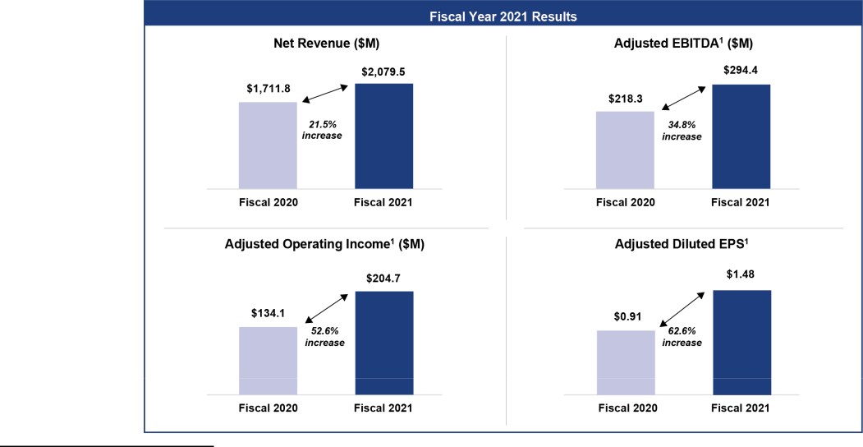

- For an explanation of our non-GAAP financial measures and a reconciliation of Adjusted Comparable Store Sales Growth, Adjusted EBITDA, Adjusted Operating Income and Adjusted Diluted EPS to the most directly comparable GAAP measures, see Appendix A to this proxy statement.

2021 Compensation Highlights

As noted above, we are committed to aligning executive compensation to the Company’s performance. As illustrated in the charts below, the majority of our NEOs’ 2021 compensation was performance-based.
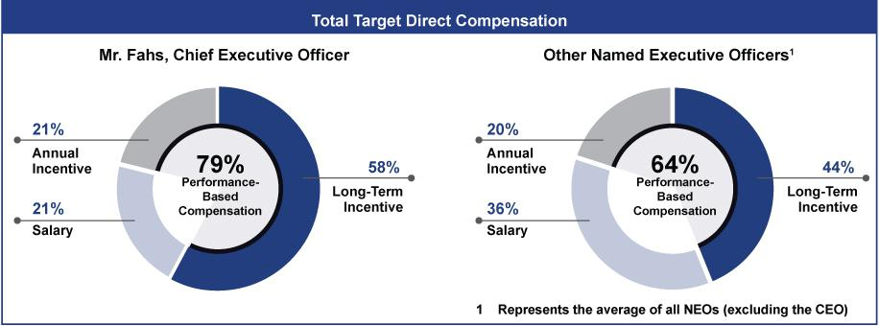

Our 2021 compensation programs were aligned with the competitive market to continue attracting and retaining high-quality executives capable of executing the Company’s strategy and delivering value for stockholders. Key actions taken by the compensation committee include the following:

- Base Salary

  - In February 2021, the compensation committee approved executive officer salary increases ranging from 3% to 10%, to more closely align compensation opportunities with the competitive market. These increases took effect in April 2021.

- Annual Cash Incentive Program (“STIP”)

  - In February 2021, the compensation committee approved a change in the performance measure under our annual cash incentive program to Adjusted Operating Income from Adjusted EBITDA. Annual cash incentive awards pay out between 0% and 200% of target, based on performance against our Adjusted

2022 Proxy Statement 29

TABLE OF CONTENTS

EXECUTIVE COMPENSATION

Operating Income target. Based on Adjusted Operating Income performance of $223 million (as defined under the fiscal 2021 Short-Term Incentive Plan (“STIP”)), the fiscal 2021 STIP funded at 200% of target.

- Long-Term Incentive Program (“LTIP”)

  - In February 2021, the compensation committee approved a grant to each of our NEOs of time-vesting stock options, time-vesting restricted stock units (“RSUs”), and performance-based restricted stock units (“PSUs”). The compensation committee approved new performance metrics for the PSUs, which vest between 0% and 200% based on performance against three-year growth targets. The PSUs are based off two performance growth measures, Adjusted Operating Income and return on invested capital (“ROIC”), which are weighted, 75% and 25%, respectively.

  - In February 2022, the compensation committee certified the level of achievement of the performance criteria of the 2019 PSU awards, which paid out at 155% of the target based on three year Adjusted EBITDA performance.

Compensation Philosophy and Approach

Our mission is making quality eye care and eyewear more accessible and affordable. In order to do this, we must attract, engage and retain highly talented individuals who are committed to our core values of doing what is right, creating happiness every day and being energized to serve. Our compensation programs are designed to help us achieve these goals. We expect our executive team to possess and demonstrate strong leadership and management capabilities and continue to execute against our strategic growth initiative. To reward and retain our leaders, including our NEOs, we have designed a total compensation approach that rewards both short-term and long-term success.

Compensation Objectives

Our compensation program for executives is currently designed to support the following objectives:

- Motivate executives to meet or exceed Company performance goals. A significant portion of each NEO’s total compensation is directly tied to the achievement of the Company’s overall financial and strategic goals.

- Attract and retain talented executives. The Company seeks to provide overall levels of compensation that are market competitive to attract, retain and motivate highly qualified executives to continue to enhance long-term equity value.

- Link the financial interests of executives and stockholders. In order to foster a strong relationship between stockholder value and executive compensation, a significant portion of compensation is composed of equity-based incentive awards. Additionally, 50% of NEOs long-term incentives are granted in the form of PSUs which are directly tied to the Company’s financial performance. NEOs are subject to stock ownership guidelines that ensure they retain a significant portion of their vested equity awards.

Our compensation packages are designed to promote integrity, leadership, teamwork, ownership and initiative by our employees whose performance and responsibilities directly affect our results. We strive to create competitive compensation packages for all employees that encourage them to achieve our long-term business goals without taking unnecessary risks. We believe that, to attract and retain talented senior executives, we must provide them with a competitive level of predictable compensation that rewards their continued service. We also believe that performance-based compensation plays a significant role in aligning senior executives’ interests with those of our stockholders and should be emphasized in the overall program structure. We motivate and reward NEOs for successfully executing our business strategy and believe that a combination of both short-term and long-term compensation creates an optimal pay-for-performance environment.

30 2022 Proxy Statement

TABLE OF CONTENTS

EXECUTIVE COMPENSATION​

​ | What We Do: | ​ | ​ What We Don’t Do: | ​
​ ✓Pay for performance |  | ​ | ​ ✗No excise tax gross-ups upon a | ​
 | ✓Maintain robust stock ownership guidelines for our named |  | Change in Control
 | executive officers (“NEOs”) |  | ✗No hedging of the Company’s stock
 | ✓Require our NEOs to retain 50% of vested awards net of tax |  | by NEOs or directors
 | withholdings until they have met our ownership guidelines |  | ✗No supplemental executive
 | ✓Engage an independent compensation consultant to advise us on |  | retirement plans
 | matters surrounding our compensation plans |  | ✗No re-pricing of stock options
 | ✓Review our compensation programs annually to prevent undue |  | without stockholder approval
 | risk taking |  | ✗No significant perquisites for
 | ✓Hold an annual say-on-pay vote |  | executive officers
 | ✓Establish target and maximum awards under our annual cash
 | incentive program
 | ✓Maintain an established stockholder engagement program
 | ✓Require “Double-Trigger” vesting for Change in Control in equity
 | awards

Consideration of Say on Pay Votes

We are pleased that stockholders representing over 97.5% of the shares voted for the Say on Pay Proposal at the 2021 annual meeting, expressing their support and approval of our NEO compensation described in our 2021 proxy statement. During 2021, we continued our stockholder engagement program and sought feedback from stockholders on a range of topics, including executive compensation. See Stockholder Engagement on page 21 for additional details of our stockholder engagement program.

As is its practice, the compensation committee took into account the results of the Say on Pay Proposal, as well as feedback received as part of our stockholder engagement program and the other factors discussed in more detail in “—Our Annual Compensation-Setting Process” below, when considering updates to our compensation programs. Given the strong 2021 Say on Pay vote outcome and feedback from our stockholder engagement, the committee did not believe any material changes were necessary to our compensation programs.

Our Annual Compensation-Setting Process

Role of the Compensation Committee

Our executive compensation plans and programs are administered by our compensation committee. Our compensation committee is responsible for reviewing and approving, or recommending to our full Board of Directors, equity compensation grants and other aspects of compensation, including base salaries and the administration of our annual cash incentive program under our Short-Term Incentive Plan, or STIP, for employees. Our compensation committee is also responsible for recommending to the full Board of Directors the compensation of our CEO and determining and approving the compensation of other executive officers, as recommended by our CEO and Chief People Officer. At the beginning of each performance cycle, the compensation committee or the Board of Directors, as applicable, approves financial goals designed to align executive pay with company performance and stockholder interests, provide competitive pay opportunities dependent on performance, retain talent, create optimal stockholder value and mitigate material risk. These approvals include reviewing and setting performance goals under the STIP and Long-Term Incentive Program, or LTIP, and reviewing and approving awards (including the terms and conditions of such awards) under the STIP and LTIP for all executive officers (other than the CEO).

Role of Independent Members of the Board of Directors

Independent members of our Board assist in setting executive compensation by assessing the performance of the CEO, reviewing the compensation committee’s assessment of the CEO’s performance and approving the compensation of the CEO based on the recommendation of the compensation committee.

Role of Management

Our CEO and our Chief People Officer work closely with the compensation committee in managing our executive compensation program, along with gathering information for, and attending meetings of, the compensation committee.

2022 Proxy Statement 31

TABLE OF CONTENTS

EXECUTIVE COMPENSATION

Our CEO makes recommendations to the compensation committee regarding compensation for the executive officers (other than himself), including base salary amounts and equity compensation grants. Our CEO and CFO also provide input in discussions regarding the development of annual Company performance goals for which annual cash incentive payouts under our STIP and PSU awards under LTIP could be earned.

Role of the Compensation Consultant

The compensation committee has engaged Meridian Compensation Partners, LLC (“Meridian”) to assist the committee regarding various executive compensation matters and to serve as its independent compensation consulting firm. In connection with this appointment, in 2021 the compensation committee reviewed Meridian’s independence, including considering the factors specified in the NASDAQ listing standards and receiving confirmation by Meridian of its independent status. The compensation committee believes that Meridian is independent and that there is no conflict of interest between Meridian and the compensation committee. Meridian assists the compensation committee in reviewing the effectiveness and competitiveness of the Company’s executive compensation program, including an annual risk assessment of the program, and makes recommendations consistent with the Company’s pay philosophy, market trends, legal and regulatory considerations and the Company’s overall business needs. In addition to providing advice regarding executive compensation best practices, Meridian also provides market data as a background for recommendations regarding CEO and other executive base salary and annual and long-term incentives.

Use of Comparative Market Data

We aim to compensate our executive officers competitively. To gain a general understanding of current market compensation practices, our compensation committee reviewed the findings as presented in a market study conducted by Meridian in December 2020. The external market data reviewed included proxy data from the peer group companies described below and survey data. The compensation committee reviewed the peer group in August 2020 and determined that no changes were necessary from 2020 to 2021. The peer group reflects a mix of companies in various industries that together represent the retail and health care aspects of our business and scope of operations (as measured by annual revenue, market capitalization and number of employees). At the time of the review the Company was near the 39th percentile of the peer group in revenue and the 36th percentile in market capitalization. The 2021 compensation peer group consisted of the following 15 companies:

​ | Align Technology, Inc. | ​ ​ | Merit Medical Systems, Inc. | ​
 | At Home Group, Inc.⁽¹⁾ |  | Ollie’s Bargain Outlet Holdings, Inc.
 | Caleres, Inc. |  | Oxford Industries, Inc.
 | Columbia Sportswear Co. |  | Surgery Partners Inc.
 | Dentsply Sirona Inc. |  | The Container Store Group, Inc.
 | Five Below, Inc. |  | The Cooper Companies, Inc.
 | Floor & Decor Holdings, Inc. |  | West Pharmaceutical Services, Inc.
 | ICU Medical, Inc.

- At Home Group, Inc. was acquired by Hellman & Friedman in 2021. The compensation committee considered the inclusion of additional peers and decided to maintain the existing 14 company group of remaining peers for 2022.

As more fully described below under “—Compensation Elements,” the data from the peer group above was reviewed by the compensation committee in connection with compensation decisions for 2021. The compensation committee did not target a specific percentile with respect to the peer group in determining our NEOs’ total compensation, nor did it establish a prescribed mix of pay for our executives.

Compensation Elements

Program Design. Our executive compensation program has three main components: (1) base salary; (2) annual cash incentive compensation (STIP); and (3) long-term incentive awards (LTIP). Each component is designed to be consistent with the Company’s compensation philosophy.

Each element of the compensation program complements the others and, together, these elements are intended to achieve the compensation committee’s principal compensation objectives. When decisions about compensation for an executive officer are made, the impact on the total value of all these elements of compensation for the individual is considered. For executives, the compensation committee reviews competitive market data and establishes target total direct compensation opportunities (i.e., salary, annual cash incentive and annual long-term incentive targets) based on the following factors: corporate performance, competitive market data and the circumstances surrounding the executive’s initial hiring or promotion to a position with increased responsibilities.

32 2022 Proxy Statement

TABLE OF CONTENTS

EXECUTIVE COMPENSATION​

Base Salary

We believe it is important to provide a competitive fixed level of pay to attract and retain talented and experienced executives capable of driving the Company’s business strategy. In determining the amount of base salary that each NEO receives, we look to the executive’s current compensation, time in position, any change in the executive’s position or responsibilities (including complexity and scope), and the relation of his or her position to those of other executives within the Company and in similar positions at peer companies. Base salaries are reviewed annually or at other times when appropriate and may be increased from time to time pursuant to such review. Base salary increases were approved for 2021 as outlined below.


 |  |  | ​​2020 Base Salary |  |  |  |  |  | Percentage |  |  |  |  | 2021
 | ​ | Named Executive Officer |  |  |  |  |  | ​​ |  | Increase |  | ​​Base Salary⁽¹⁾ ​
 | ​L. Reade Fahs |  | ​​ |  | ​$955,000 |  | ​​​ |  |  | ​​3.0% | ​​​ |  |  | ​$983,650 | ​​
 | ​Patrick R. Moore |  | ​​ |  | ​$500,000 |  | ​ | ​​ |  | ​​3.0% | ​ | ​​ ​$515,000 |  |  | ​​
 | ​Roger Francis |  | ​​ |  | ​ ​ | N/A | ​​​ |  |  | ​​N/A | ​​​ |  |  | ​$450,000 | ​​
 | ​Jared Brandman |  | ​​ |  | ​$350,000 |  | ​ | ​​ |  | ​​ 10% | ​ | ​​ ​$385,000 |  |  | ​​
 | ​Bill Clark |  | ​​ |  | ​$350,000 |  | ​​​ |  |  | ​3.0% | ​​​ |  |  | ​$360,500 | ​​


- In February 2021, the compensation committee approved adjustments to the base salaries of Messrs. Fahs, Moore, Brandman, and Clark, which were effective in April 2021. As reflected in the table above, the compensation committee approved a salary of $450,000 for Mr. Francis when he joined the Company in May 2021.

Annual Cash Incentive Program—Short Term Incentive Plan (STIP)

In fiscal year 2021, our executives participated in the STIP, which is our annual cash incentive program. The primary purpose of the STIP is to focus management on key measures that drive financial performance and to provide competitive bonus opportunities tied to the achievement of our annual financial and strategic growth objectives. We believe that tying NEO bonuses to Company performance goals encourages collaboration across the executive leadership team.

For fiscal 2021, the compensation committee approved a new performance metric for the STIP awards under the 2017 Omnibus Plan. For fiscal 2021, STIP awards were based on achievement of a STIP Adjusted Operating Income goal (as defined on Appendix A) instead of STIP Adjusted EBITDA, the metric used in prior years. The compensation committee moved to Adjusted Operating Income as the performance metric for the 2021 STIP awards following the introduction of this non-GAAP measure in our Fiscal 2020 Outlook as it is a common profitability measure for companies and injects heightened accountability for our executive officers for sound investment decisions and returns on those investments.

The compensation committee approved the STIP design, targets and STIP Adjusted Operating Income goal in February 2021 as part of the annual compensation setting process. Each NEO’s target annual bonus under the STIP is expressed as a percentage of base salary with the payouts ranging from 50% to 200% for 2021. Actual STIP award payouts were calculated by multiplying each NEO’s target bonus percentage by the payout percentage. For 2021, the STIP included threshold, target, and maximum levels of performance and corresponding payouts. Awards could be earned at more or less than target based on the pre-established scale set forth in the following table below. For performance percentages between the specified threshold, target, and maximum levels, payouts were interpolated on a straight-line basis.


 |  |  |  |  | STIP Adjusted Operating
 |  |  |  |  | Income⁽¹⁾ |  |  |  | Payout
 | ​​ | ​​ |  |  | ($million) | ​​ |  |  | (% of Target) | ​
 | ​Maximum | ​​ |  |  | ​$175.2 | ​​​ |  |  | ​200% | ​​
 | ​Target | ​​ |  |  | ​$159.3 | ​​​ |  |  | ​100% | ​​
 | ​Threshold | ​​ |  |  | ​$143.4 | ​​​ |  |  | ​ 50% | ​​
 | ​Actual | ​​ |  |  | ​$223.0 | ​​​ |  |  | ​200% | ​​


- See Appendix A to this proxy statement for an explanation of STIP Adjusted Operating Income and a reconciliation to the most directly comparable GAAP measure.

2022 Proxy Statement 33

TABLE OF CONTENTS

EXECUTIVE COMPENSATION

For fiscal 2021, the Company’s STIP Adjusted Operating Income achieved was $223 million, resulting in a formulaic payout percentage of 200%. Pursuant to the STIP, the compensation committee has the ability to exercise positive or negative discretion and award a greater or lesser amount to our NEOs than the amount determined by the scale above if it determines that circumstances so warrant. The compensation committee did not exercise any discretion in the determination of our 2021 STIP awards for our NEOs.

The NEOs earned STIP awards for fiscal 2021 as follows, which are included in the “Non-Equity Incentive Plan Compensation” column of the “Summary Compensation Table” later in this proxy statement.


- Named Executive Officer ​L. Reade Fahs

​Patrick R. Moore ​Roger Francis ​Jared Brandman ​Bill Clark

 | 2021 |  |  | Target STIP |  | Achievement
Base Salary |  |  |  | (as a |  | Factor (as a | Final STIP
 | as of |  | percentage of |  | percentage of |  |  | Payout
​​April 4, 2021 |  |  | ​​ Base Salary) |  | ​​ Base Salary) |  | ​​ | Amount ​
​​ | ​$983,650 | ​​​ |  | ​100% | ​​​ | ​200% | ​​​​$1,967,300​​
​​ ​$515,000 |  | ​ | ​​ | ​ 65% | ​​​ | ​130% | ​​​​$ | 669,500​​
​​ | ​$450,000 | ​​​ |  | ​ 50% | ​​​ | ​100% | ​​​​$ | 450,000​​
​​ ​$385,000 |  | ​ | ​​ | ​ 50% | ​​​ | ​100% | ​​​​$ | 385,000​​
​​ | ​$360,500 | ​​​ |  | ​ 50% | ​​​ | ​100% | ​​​​$ | 360,500​​

Long-Term Incentive Program

Long-term incentive awards are granted under our 2017 Omnibus Incentive Plan (the “2017 Omnibus Plan”). We believe granting equity-based long-term incentive awards strengthens the commitment of our executives to the Company’s long-term success and aligns their interests with those of our stockholders.

LTIP Awards

In February 2021, following its evaluation, with the assistance of Meridian, of the equity-based incentives for our executive officers, the compensation committee adopted a new long-term incentive program (LTIP) under the 2017 Omnibus Plan. As part of our annual compensation cycle, all of our NEOs were granted the following awards:

- time-vesting stock options (representing 25% of the total target value of fiscal 2021 LTIP awards for each NEO),

- time-vesting restricted stock units (“RSUs”) (representing 25% of the total target value of fiscal 2021 LTIP awards for each NEO), and (3) performance-vesting restricted stock units (“PSUs”) (representing the remaining 50% of the total target value of fiscal 2021 LTIP awards for each NEO).

For fiscal year 2021, the compensation committee issued PSU awards with two performance growth measures, Adjusted Operating Income and ROIC, which are weighted 75% and 25%, respectively, for the three-year performance period (2021-2023), instead of using the single three-year Adjusted EBITDA growth performance measure used in prior years. In making this change, the compensation committee took into account feedback from stockholders and the evolution of our public reporting and fiscal outlook measures. See Stockholder Engagement on page 21 above for more details. As described above, Adjusted Operating Income is a common profitability measure. ROIC is a standard measure of a company’s ability to produce profitable return on all aspects of investment necessary to generate those returns and is a key measure for investor assessment of company performance.

The following table reflects the target grant value and division of stock options, PSUs and RSUs granted to each NEO in March 2021.


 |  |  |  |  |  |  |  |  |  |  |  |  |  |  | Performance-Vesting |  |  |  | Time-Vesting
 |  |  |  |  |  |  | Target |  |  |  | Time-Vesting |  |  | Restricted Stock Units |  |  |  | Restricted Stock
 |  |  |  |  |  | Grant Value |  |  |  | Stock Options |  |  |  |  | (PSUs) |  |  |  | Units (RSUs)
 | ​ | Named Executive Officer |  | ​​ |  |  | ($) |  | ​​ |  | (#) | ​​ |  |  | (#) | ​​ |  |  | (#) | ​
 | ​L. Reade Fahs |  |  | ​​​$ 2,750,000 ​​​ |  |  |  |  |  |  | ​29,685 | ​​​ |  |  | ​​30,114 | ​​​ |  |  | ​​15,057 | ​​
 | ​Patrick R. Moore |  | ​​​$ |  |  |  | 700,000 | ​ | ​​ |  | ​ 7,557 | ​​​ |  |  | ​​ 7,666 | ​​​ |  |  | ​​ 3,833 | ​​
 | ​Roger Francis |  | ​​​$ |  |  |  | 700,000 | ​​​ |  |  | ​ 6,685 | ​​​ |  |  | ​​ 6,717 | ​​​ |  |  | ​​ 3,359 | ​​
 | ​Jared Brandman |  | ​​​$ |  |  |  | 350,000 | ​ | ​​ |  | ​ 3,779 | ​​​ |  |  | ​​ 3,833 | ​​​ |  |  | ​​ 1,917 | ​​
 | ​Bill Clark |  | ​​​$ |  |  |  | 350,000 | ​​​ |  |  | ​ 3,779 | ​​​ |  |  | ​ 3,833 | ​​​ |  |  | ​ 1,917 | ​​
 | 34 | 2022 Proxy Statement


TABLE OF CONTENTS

EXECUTIVE COMPENSATION​

Stock Option Awards. The options granted in fiscal 2021 vest in three equal annual installments, with one-third of the total number of shares underlying the options vesting on each of the first, second, and third anniversaries of March 5, 2021, subject to the executive’s continued employment through the applicable vesting date.

RSU Awards. The RSUs granted in fiscal 2021 to Messrs. Fahs, Moore, Brandman, and Clark will vest in three equal annual installments, with one-third of the total number of shares underlying the RSUs vesting on each of the first, second, and third anniversaries of March 5, 2021, subject to the executive’s continued employment through the applicable vesting period.

The RSUs granted in fiscal 2021 to Mr. Francis will vest over two years, with 66% of the shares underlying the RSUs vesting on the first anniversary of May 3, 2021 and the remaining 34% of the shares underlying the RSUs vesting on the second anniversary of May 3, 2021, subject to Mr. Francis’s continued employment through the applicable vesting period as per his onboarding agreement.

PSU Awards. PSU awards are earned over a three-year performance period and, for the 2021 PSU awards, are conditioned on the Company’s achievement of certain Adjusted Operating Income and Adjusted ROIC growth targets, as set forth in the PSU award agreement. 75% of the target PSUs shall be subject to performance goals relating to Adjusted Operating Income (the “AOI PSUs”), and 25% of the target PSUs shall be subject to performance goals relating to ROIC (the “ROIC PSUs”). Each of these performance metrics will be measured independently. Vesting is based on an achievement factor which, in each case, ranges from 50% payout for threshold performance, 100% for target performance, and 200% for maximum performance. To the extent that performance falls between the applicable threshold, target or maximum levels, payouts will be determined using linear interpolation.

The PSU awards granted in fiscal 2021 will be settled after the end of the respective three-year performance period, which began on the first day of our 2021 fiscal year and ends on the last day of our 2023 fiscal year. For each metric, the compensation committee believes that the goals set are appropriately challenging, yet reasonably attainable. The actual goals are not being disclosed before the end of the performance period because we believe such disclosure would be competitively harmful. As a note, the 2020 PSUs remain subject to an Adjusted EBITDA performance measure.

PSUs granted in 2019 (based on the three-year 2019-2021 performance period), vested and were payable in February 2022. The compensation committee certified the level of achievement of the performance criteria for the 2019 PSUs based on the Company’s achievement of certain annual Adjusted EBITDA growth targets (set at the beginning of the three-year performance period) over the performance period, as set forth in the PSU agreement.
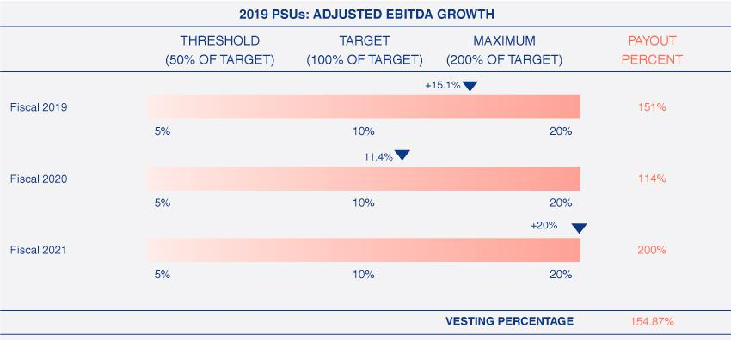

Accordingly, based on the Company’s actual Adjusted EBITDA growth rate during the three-year performance period ending January 1, 2022, the vesting percentage of the PSU awards granted in fiscal 2019 to our NEOs, and which vested on February 24, 2022, was 154.87% of the target shares underlying those awards.

2022 Proxy Statement 35

TABLE OF CONTENTS

EXECUTIVE COMPENSATION

 | ​ | Vesting of PSU Awards (2019 LTIP) |  |  |  |  |  | Number | ​
 |  |  | Number |  |  |  |  | of Shares
 |  |  | of Target |  | Vesting |  |  | delivered
 | ​ | Named Executive Officer | ​​ Shares | ​​Percentage |  |  | ​​upon Vesting ​
 | ​L. Reade Fahs |  | ​​ ​31,970 | ​​​ | ​154.87% ​​​ |  |  | ​49,512 | ​​
 | ​Patrick R. Moore |  | ​​ ​ 8,526 | ​​​ | ​154.87% ​ | ​​ |  | ​13,205 | ​​
 | ​Roger Francis⁽¹⁾​ |  | ​​ ​ N/A | ​​​ | ​ N/A ​​​ |  |  | ​ N/A | ​​
 | ​Jared Brandman |  | ​​ ​ 3,553 | ​​​ | ​154.87% ​ | ​​ |  | ​ 5,503 | ​​
 | ​Bill Clark |  | ​​ ​ 8,779 | ​​​ | ​154.87% ​​​ |  |  | ​13,597 | ​​


- As Mr. Francis joined the Company in 2021, he did not receive a 2019 PSU award.

Changes for 2022

For fiscal 2022, the compensation committee approved a different LTIP vehicle mix than in 2021, with 50% in PSUs and 50% in time-based RSUs. The 2022 PSUs will be based off the same two performance growth measures as the 2021 PSUs, Adjusted Operating Income and ROIC, which will be weighted 75% and 25%, respectively, for the three-year performance period. The compensation committee believes these changes provide an appropriate balance of performance-based and time-based incentive awards, consistent with the compensation philosophy and objectives described above.

Perquisites and Other Benefits

The benefits and perquisites provided to our NEOs are not a material part of executive compensation and are largely limited to those offered to our employees generally, or that we have otherwise determined are necessary or appropriate to attract and retain talented executives. Our NEOs are eligible for specified benefits, such as group health, dental, disability and life insurance. These benefits are intended to provide competitive and adequate protection in case of sickness, and the NEOs participate in these plans on the same basis as all other employees.

We provide specified perquisites to our NEOs when appropriate, including relocation as required. We also provide our executives, including our NEOs, with additional basic life insurance coverage and supplemental long-term disability and accidental death insurance. In addition, we provide our CEO with tax accounting services and a Young Presidents’ Organization (“YPO”) membership. The value of these perquisites and other personal benefits are reflected in the “All Other Compensation” column to the “Summary Compensation Table” and the accompanying footnotes below.

401(k) Savings Plan. Our eligible U.S. employees, including our NEOs, participate in the National Vision, Inc. 401(k) Retirement Savings Plan (the “401(k) Plan”). Eligible employees are eligible to enroll in the 401(k) Plan during the first month following three months of service with the Company. Under the 401(k) Plan, we match 50% of the first 3% of a participant’s contributions. The Company’s matching contributions vest pro rata over each of the following four years of employment with the Company. In 2021, all eligible employees who participated in the 401(k) Plan were awarded an additional contribution of 16.6% of their contributions. In short, the Company matched up to 2% of their annual salary instead of 1.5% for all 2021 contributions.

Associate Stock Purchase Plan. We have maintained an Associate Stock Purchase Plan (the “ASPP”) since 2018. The ASPP provides all our eligible U.S. employees, including our NEOs, the opportunity to purchase up to $25,000 in our common stock annually at a 10% discount to the market price of our stock.

Severance Benefits

The Company provides severance benefits to its executives in order to offer competitive total compensation packages and to be competitive in the Company’s executive attraction and retention efforts. On December 11, 2018, the Board of Directors adopted and approved the National Vision Holdings, Inc. Executive Severance Plan (the “Executive Severance Plan”), which replaced our prior severance plan. The Executive Severance Plan provides for severance payments and benefits to eligible executives, including our NEOs, upon a termination of employment by the Company without cause or by the executive for good reason (each as defined in the Executive Severance Plan), in each case, subject to the (i) executive’s execution and non-revocation of a release of claims in favor of the Company and (ii) continued compliance with the executive’s confidentiality, non-interference and invention assignment obligations to the Company. See “Potential Payments upon Termination or Change in Control,” which describes the payments to which each of the NEOs may be entitled under the Executive Severance Plan.

36 2022 Proxy Statement

TABLE OF CONTENTS​

EXECUTIVE COMPENSATION​

Restrictive Covenants

Our NEOs are subject to specified restrictive covenants, including confidentiality and non-disparagement covenants and covenants related to non-competition and non-solicitation of our employees, consultants and independent contractors at all times during the NEO’s employment, and for specific periods following the termination of employment for any reason. The post-employment restricted time periods are as follows: Mr. Fahs for twenty-four months after termination; Messrs. Moore and Brandman for eighteen months after termination; and Messrs. Clark and Francis for twelve months after termination.

Stock Ownership Guidelines

Our Board of Directors have adopted stock ownership guidelines (the “Guidelines”) applicable to our executive officers. These Guidelines align the interests of our management and directors with those of our stockholders. Such executive officers will be required to hold a specific level of equity ownership, as a multiple of annual base salary or annual cash retainer, as applicable, as follows:

- Chief Executive Officer: 6x annual base salary.

- Other Executive Officers: 3x annual base salary.

There is no required time period within which an executive officer must attain the applicable stock ownership level under the Guidelines. However, until the applicable ownership level is achieved, executive officers must retain 50% of vested shares net of stock option exercise and tax withholding.

As of the end of fiscal 2021, shares that counted toward these ownership guidelines included shares owned outright, shares held in the Company’s 401(k) Plan or other retirement plan, shares of time-based restricted stock (whether vested or unvested) and vested stock options issued prior to the Company’s IPO. The retention requirement for shares applies to all prior and future grants. As of January 1, 2022, Messrs. Fahs, Moore and Brandman have met or exceeded their current ownership requirements and the remaining executive officers are subject to the restrictions in the guidelines until their ownership requirements are met.

In February 2022, the compensation committee amended the Guidelines to clarify that vested stock options issued prior to the Company’s IPO do not count towards the ownership guidelines.

Hedging and Pledging Policies

Our NEOs are subject to our hedging and pledging policies as outlined in the Company’s Securities Trading Policy described on page 20.

Compensation Risk Assessment

The compensation committee, with the assistance of Meridian, reviewed our incentive programs to assess whether the programs encourage inappropriate risk-taking. Based on its review, the compensation committee concluded that risks arising from the company’s compensation plans, programs and policies, considered as a whole, including applicable risk-mitigation features, are not reasonably likely to have a material adverse effect on the company.

Tax and Accounting Considerations

We consider the effect of tax, accounting and other regulatory requirements in designing and implementing compensation programs so that our programs meet regulatory requirements and efficiently deliver compensation. While these factors may impact plan designs, ultimately, decisions reflect the pay strategy of the Company and the intent of our programs.

2022 Proxy Statement 37

TABLE OF CONTENTS​

EXECUTIVE COMPENSATION

Compensation Committee Report

The compensation committee has reviewed and discussed the Compensation Discussion and Analysis with management. Based on its review and discussion with management, the compensation committee recommended to the Board of Directors that the Compensation Discussion and Analysis be included in this proxy statement and incorporated by reference in the Annual Report on Form 10-K for the fiscal year ended January 1, 2022 filed with the Securities and Exchange Commission.

Compensation Committee

Thomas V. Taylor, Jr., Chair

Heather Cianfrocco

Randy Peeler

38 2022 Proxy Statement

TABLE OF CONTENTS​

EXECUTIVE COMPENSATION​

Compensation Tables

Summary Compensation Table

The following table presents summary information regarding the total compensation awarded to, earned by, or paid to each of our NEOs for services rendered in all capacities for the fiscal years ended January 1, 2022, January 2, 2021, and December 28, 2019.


 |  |  |  |  |  |  |  |  |  |  |  |  |  |  |  | Stock |  |  |  |  | Option |  |  | Non-Equity
 |  | Name and Principal |  |  |  |  |  |  | Salary |  |  |  | Bonus |  |  | Stock |  |  |  |  | Option |  |  | Incentive Plan
 |  | Name and Principal |  |  |  |  |  |  | Salary |  |  |  | Bonus |  |  | Awards |  |  |  |  | Awards |  |  | Compensation
 | ​ | Position | ​​ |  |  | Year | ​​ ($)⁽²⁾ |  |  | ​​ |  |  | _{($)}(3) | ​​ |  | _{($)}(4) | ​​ |  |  |  | _{($)}(5) | ​​ |  |  |  | _{($)}(6)
 |  |  |  |  |  |  |  |  |  |  |  |  |  |  |  |  |  |  |  |  |  |  |  | ​1,967,300
 | ​L. Reade Fahs |  | ​​ |  | ​2021 |  | ​​ ​975,386 |  |  | ​​ ​ |  |  | — | ​​​2,062,508 |  |  | ​​​​ |  |  |  | 687,505 | ​​​
 |  | Chief Executive |  | ​ | ​2020 |  | ​​ ​743,827 |  |  | ​​ ​ 83,849 |  |  |  | ​​​1,687,551 |  |  | ​​​​ |  |  |  | 562,508 | ​​​ |  | ​ |  | 871,151
 |  | Officer |  | ​ | ​2019 |  | ​​ ​919,211 |  |  | ​​ ​ |  |  | — | ​​​1,125,024 |  |  | ​​​​1,125,001 ​​​ |  |  |  |  |  |  | ​1,281,776
 |  |  |  |  | ​​2021 |  | ​​ ​510,673 |  |  | ​​ ​ |  |  |  |  |  |  | ​​​​​ |  |  |  |  |  |  | ​​
 | ​Patrick R. Moore |  | ​​ |  |  |  |  |  |  |  |  |  | — |  | ​​​​ | 525,044 |  |  |  |  | 175,020 | ​​​ |  |  |  | 669,500
 |  | Senior Vice |  | ​ |  | ​2020 | ​​ |  | ​447,115 | ​​ |  | ​ 28,550 |  | ​ | ​​ | 750,023 | ​​​ |  |  | ​ | 250,007 | ​​​ |  |  | ​ | 296,450
 |  | President and Chief |  | ​ |  | ​2019 | ​​ |  |  | ​​ |  |  |  | ​​ |  |  | ​​​ |  |  | ​ |  | ​​​ |  |  | ​
 |  | President and Chief |  | ​ |  | ​2019 |  |  | ​444,231 |  |  | ​ | — |  |  | 600,031 |  |  |  | ​ | 300,014 |  |  |  | ​ | 371,669
 |  | Financial Officer |  |  |  | ​2019 |  |  | ​444,231 |  |  | ​ | — |  | ​ | 600,031 |  |  |  | ​ | 300,014 |  |  |  | ​ | 371,669
 | ​Roger Francis⁽¹⁾ |  | ​​ ​2021 |  |  |  | ​​ ​285,577 |  |  | ​​ ​145,307 |  |  |  | ​​​ |  | 525,060​​​​ |  |  |  |  | 175,013 | ​​​ |  | ​ |  | 450,000
 |  | Senior Vice
 |  | President, Chief
 |  | Stores Officer | ​​ ​​2021 |  |  |  | ​​ ​374,904 |  |  | ​​ ​ |  |  |  |  |  |  | ​​​​​ |  |  |  |  |  |  | ​​
 | ​Jared Brandman⁽¹⁾ |  |  |  |  |  |  |  |  |  |  |  | — |  | ​​​​ | 262,545 |  |  |  |  | 87,522 | ​​​ |  |  |  | 385,000
 |  | Senior Vice |  | ​ |  | ​2020 | ​​ |  | ​328,462 | ​​ |  | ​ 15,365 |  | ​ | ​​ | 187,506 | ​​​ |  |  | ​ | 62,509 | ​​​ |  |  | ​ | 159,635
 |  | President, General |  | ​ |  | ​2019 | ​​ |  |  | ​​ |  |  |  | ​​​ |  | 425,031 | ​​​ |  |  | ​ | 125,008 | ​​​ |  |  | ​ | 208,409
 |  | President, General |  |  |  | ​2019 |  |  | ​298,915 |  |  | ​ | — |  |  |  |  |  |  |  |  |  |  |  | ​ | 208,409
 |  | Counsel and
 |  | Secretary |  |  |  |  |  |  |  |  |  |  |  | ​​​​ |  |  | ​​​​​ |  |  |  |  |  |  | ​​
 | ​Bill Clark⁽¹⁾ |  | ​​ ​​2021 |  |  |  | ​​ ​357,471 |  |  | ​​ ​ |  |  | — |  |  | 262,545 |  |  |  |  | 87,522 | ​​​ |  |  |  | 360,500
 |  | Senior Vice |  | ​ ​2020 |  |  | ​​ ​315,385 |  |  | ​​ ​ 15,365 |  |  |  | ​​​ |  | 240,049 | ​​​​ |  |  |  | 80,004 | ​​​ |  | ​ |  | 159,635
 |  | President, Chief |  | ​ ​2019 |  |  | ​​ ​171,077 |  |  | ​​ ​ 50,000 |  |  |  | ​​​ |  | 550,027 | ​​​​ |  |  |  | 250,005 | ​​​ |  | ​ |  | 119,278
 |  | People Officer

 |  | Change in
 |  | Pension Value
 | and Nonqualified
 |  | Deferred |  |  |  | All Other
 |  | Compensation |  |  |  |  |  |  |  |  |  |  | Total
 |  | Earnings |  |  |  | Compensation |  |  |  |  |  |  | Total
​​ |  | ($) |  | ​​ |  |  |  | _{($)}(7) |  | ​​ |  |  | ($) | ​
​​​ |  | ​— |  | ​​​ |  |  | ​ 35,791 |  |  | ​​​5,728,490​​
​​​ |  | ​— |  | ​​​ |  |  | ​ 27,442 |  |  | ​​​3,976,328​​
​​​ |  | ​— |  | ​​​ |  |  | ​ 36,815 |  |  | ​​​4,487,827​​
​​​ |  | ​ ​ |  | ​​​ |  |  | ​ 11,437 |  |  |  | ​​​​1,891,674​​
​​​ |  |  | ​— | ​​​ |  |  | ​ | 7,287 | ​​​1,779,432​​
​​​ |  |  | ​— | ​​​ |  |  |  |  |  |  |  | ​1,724,098​​
 |  |  | ​— |  |  |  | ​ | 8,153 |  | ​​
​​​ |  | ​— |  | ​​​ |  |  | ​190,981 |  | ​​​1,771,938​​
​​​ |  | ​​— |  | ​​​ |  |  | ​ 11,724 |  |  |  | ​​​​1,121,695​​
​​​ |  |  | ​— | ​​​ |  |  | ​ | 6,809 | ​​​ 760,286​​
​​​ |  |  | ​— | ​​​
 |  |  | ​— |  |  |  | ​ | 5,550 |  | ​​ |  | ​1,062,913​​
 |  | ​​—
​​​ |  |  |  | ​​​ |  |  | ​ | 8,522 | ​​​​1,076,560​​
​​​ |  | ​— |  | ​​​ |  |  | ​ | 7,375 | ​​​ |  |  |  | 817,813​​
​​​ |  | ​— |  | ​​​ |  |  | ​162,646 |  | ​​​1,303,033​​

- Mr. Francis joined the Company in May 2021, Mr. Brandman was appointed as an executive officer at the Company effective February 2019, and Mr. Clark joined the Company in June 2019.

- The Salary column reflects salaries paid in the years indicated to each of the NEOs.

- The Bonus column reflects the discretionary bonus amount approved by the compensation committee in connection with its approval of the 2020 STIP Award that brought the total annual bonus amount for each NEO with the Company at that time to be paid out at the 2020 Target STIP amount for executive officers. The 2019 amount for Mr. Clark represents his cash sign-on bonuses. The 2021 amount for Mr. Francis also represents his cash sign-on bonuses.

- The values in the Stock Awards column represent the aggregate grant date fair value for the stock awards granted in the applicable year, computed in accordance with FASB ASC Topic 718. These awards include PSUs, RSUs, one-time 2019 special retention RSU awards and 2019 sign-on awards of PSUs and RSUs. Awards with performance conditions are computed based on the probable outcome of the performance condition as of the grant date for the award. Information about the assumptions used to value these awards can be found in Note 5 “Stock Incentive Plans” in our 2021 Form 10-K. The amounts reported for these awards may not represent the amounts that the individuals will actually receive. The amounts received, if any, ultimately will depend on Company performance and the change in our stock price over time. For PSU awards granted to Messrs. Fahs, Moore, Francis, Brandman, and Clark, the maximum shares payable and the grant date value assuming maximum performance are 60,228 or $2,750,010; 15,332 or $700,060; 13,424 or $700,046; 7,666 or $350,030; and 7,666 or $350,030, respectively.

- The values in the Option Awards column represent the aggregate grant date fair value for the option awards granted in the applicable year, computed in accordance with FASB ASC Topic 718. The assumptions used to value these awards can be found in Note 5 “Stock Incentive Plans” in our 2021 Form 10-K. The amounts reported for these awards may not represent the amounts that the individuals will actually receive. The amounts received, if any, ultimately will depend on the change in our stock price over time.

- The Non-Equity Incentive Plan Compensation column reflects the cash incentive awards paid under the STIP for the applicable year. The Company pays these amounts, if any, in the month of March following the year in which they are earned. The cash incentive awards under the 2021 STIP were earned at 200% of target. Additional explanation of the non-equity incentive plan compensation for each NEO appears in “Annual Cash Incentive Program” in the Compensation Discussion and Analysis section above and below in the footnotes to the 2021 Grants of Plan-Based Awards table.

2022 Proxy Statement 39

TABLE OF CONTENTS

EXECUTIVE COMPENSATION

- All Other Compensation for 2021 included:


 |  |  |  |  |  | Employer |  |  |  | Life |  |  |  | Disability
 |  |  |  |  |  | Employer |  |  |  | Life |  |  |  | and AD&D
 |  |  |  |  | 401(k) Matching |  |  |  |  | Insurance |  |  |  | Insurance |  |  |  |  | Other |  |  |  | Total
 |  |  |  |  |  | Contributions |  |  |  | Premiums |  |  |  | Premiums |  |  |  |  | Other |  |  |  | Total
 | ​ | NEO | ​​ |  |  | _{($)}(a) | ​​ |  |  | _{($)}(b) | ​​ |  |  | _{($)}(c) | ​​ |  |  |  | _{($)}(d) | ​​ |  |  | ($) | ​
 | ​L. Reade Fahs |  | ​​ |  |  | ​​17,333 | ​​​ |  |  | ​​480 | ​​​ |  |  | ​​3,316 | ​​​ |  |  | ​​ 14,662 |  | ​​​ |  |  | ​​ 35,791 | ​​
 | ​Patrick R. Moore |  | ​​ |  |  | ​​ 5,460 | ​​​ |  |  | ​​480 | ​​​ |  |  | ​​ 920 | ​​​ |  |  | ​​ | 4,578 | ​​​ |  |  | ​​ 11,437 | ​​
 | ​Roger Francis |  | ​​ |  |  | ​​ 3,115 | ​​​ |  |  | ​​200 | ​​​ |  |  | ​​1,164 | ​​​ |  |  | ​​186,502 |  | ​​​ |  |  | ​​190,981 | ​​
 | ​Jared Brandman |  | ​​ |  |  | ​​ 4,846 | ​​​ |  |  | ​​480 | ​​​ |  |  | ​​2,716 | ​​​ |  |  | ​​ | 3,683 | ​​​ |  |  | ​​ 11,724 | ​​
 | ​Bill Clark |  | ​​ |  |  | ​ 6,510 | ​​​ |  |  | ​480 | ​​​ |  |  | ​ 920 | ​​​ |  |  | ​ | 612 | ​​​ |  |  | ​ 8,522 | ​​

- Our 401(k) Plan provides for a 50% matching contribution on the first 3% of participants’ pre-tax contributions up to IRS limits. In 2021, all eligible employees who participated in our 401(k) Plan were awarded an additional contribution of 16.6% of their contributions. The Company matched up to 2% of their annual salary instead of 1.5% for all 2021 contributions.

- Each of our NEOs is entitled to basic life insurance coverage of up to two times base salary up to a maximum of $500,000 of basic life insurance coverage.

- Each of our NEOs is entitled to supplemental long-term disability and accidental death insurance coverage. The total benefit maximum of both the basic and supplemental disability insurance coverage is $10,000 per month, and the maximum accidental death benefit is up to the lesser of two times base salary or $500,000.

- This column reflects $4,000 for YPO membership, $10,050 for reasonable cost of tax accounting services, $343 for a virtual reality device, $250 for associate eyewear coupon and $19 for a financial wellness program for Mr. Fahs; $3,966 for an executive physical, $343 for a virtual reality device, $250 for associate eyewear coupon and $19 for a financial wellness program for Mr. Moore; $185,890 for relocation, $343 for a virtual reality device, $250 for associate eyewear coupon and $19 for a financial wellness program for Mr. Francis; $3,071 for an executive physical, $343 for a virtual reality device, $250 for associate eyewear coupon and $19 for a financial wellness program for Mr. Brandman; and $343 for a virtual reality device, $250 for associate eyewear coupon and $19 for a financial wellness program for Mr. Clark.

40 2022 Proxy Statement

TABLE OF CONTENTS​

EXECUTIVE COMPENSATION​

2021 Grants of Plan-Based Awards

The following table sets forth information concerning NEO grants of plan-based awards during the fiscal year ended January 1, 2022.


 |  |  |  |  |  |  |  |  |  |  |  |  |  |  |  |  |  |  |  |  |  |  |  |  |  |  |  |  |  |  |  |  |  | All Other |  |  |  |  |  |  | All Other
 |  |  |  |  |  |  |  |  |  |  | Estimated Possible |  |  |  |  |  |  |  |  |  |  |  | Estimated Possible |  |  |  |  |  |  |  |  |  |  |  | Stock |  |  |  |  |  |  | Option |  |  |  | Exercise or
 |  |  |  |  |  |  |  |  |  |  |  |  |  |  |  |  |  |  |  |  |  |  |  |  |  |  |  |  |  |  |  |  |  | Awards: |  |  |  |  |  |  |  | Award:
 |  |  |  |  |  |  |  |  | ​ |  | Payouts Under Non-Equity |  |  |  |  |  |  |  |  | ​​ |  |  | Payouts Under Equity |  |  |  |  |  |  |  |  |  | Number of |  |  |  |  |  |  | Number of |  |  |  |  |  |  |  | Base |  |  |  | Grant Date
 |  |  |  |  |  |  |  |  |  |  | Incentive Plan Awards(1) |  |  |  |  |  |  |  |  |  |  |  | Incentive Plan Awards(2) |  |  |  |  |  |  | ​ |  |  |  | Shares or |  |  |  |  |  |  | Securities |  |  |  |  |  | Price of
 |  |  |  |  |  |  |  |  | Threshold |  |  |  |  |  | Target |  |  | Maximum |  |  | Threshold |  |  |  |  | Target |  | Maximum |  |  |  |  |  |  | Stock |  |  |  |  | Underlying |  |  |  |  |  |  | Option |  |  |  |  | Fair Value
 |  |  |  |  |  |  |  |  |  |  |  |  |  |  | Target |  |  |  |  |  |  |  |  |  |  | Target |  |  |  |  |  |  |  |  | Units |  |  |  |  |  | Options |  |  |  |  |  | Awards |  |  |  |  |  | of Award
 | ​ | NEO | ​​Grant Date |  |  |  |  | ​​ |  |  | ($) |  |  | ​​ ($) |  |  | ​​ |  | ($) | ​​ |  | (#) |  |  | ​​ (#) |  | ​​ (#) |  |  |  | ​​ |  |  | (#)(3) |  |  |  | ​​ |  |  | (#)(4) |  |  | ​​ |  |  |  | ($/Sh) |  | ​ | ​ |  | _{($)}(5) | ​
 | ​L. Reade Fahs |  | ​​ ​ |  |  |  | ​​​​ ​491,825 ​​​​​983,650 |  |  |  |  |  |  |  |  |  | ​​​​1,967,300​​ |  |  |  |  | ​ |  | ​ | ​​​​ |  | ​​ ​ |  |  | ​ ​​​ |  |  |  | ​ |  | ​ | ​​​ |  |  |  | ​ |  | ​ | ​​​ |  |  | ​ |  | ​ | ​​​​ |  |  |  | ​​​
 |  |  |  | ​ ​​3/5/2021 ​​​ ​ |  |  |  |  |  |  |  | ​​​​​ |  |  |  | ​​​ |  |  |  | ​​ |  | ​​15,057 |  |  | ​​​​​30,114​​ ​​60,228 |  |  |  |  | ​​​ |  |  |  | ​ |  | ​ | ​​​ |  |  |  | ​ |  | ​ | ​​​ |  |  | ​ |  | ​ | ​​​​​1,375,005​​
 |  |  |  | ​ ​​3/5/2021 ​​​ ​ |  |  |  |  |  |  |  | ​​​​​ |  |  |  | ​​​ |  |  |  | ​​ |  | ​ |  | ​ | ​​​​ |  | ​​ ​ |  |  | ​ ​​​ |  |  |  | ​​15,057 |  |  | ​​​ |  |  |  | ​ |  | ​ | ​​​ |  |  | ​ |  | ​ | ​​​​​ |  |  | 687,503 | ​​
 |  |  |  | ​ ​​3/5/2021 ​​​ ​ |  |  |  |  |  |  |  | ​​​​​ |  |  |  | ​​​ |  |  |  | ​​ |  | ​ |  | ​ | ​​​​ |  | ​​ ​ |  |  | ​ ​​​ |  |  |  | ​ |  | ​ | ​​​ |  |  |  | ​​29,685 |  |  | ​​​ |  |  | ​​45.66 |  |  | ​​​​​ |  |  | 687,505 | ​​
 |  |  |  |  |  |  |  | ​​ ​​167,375 ​ |  |  |  |  |  |  |  |  | ​​​​ |  | 669,500​​
 | ​Patrick R. Moore |  | ​​ ​ |  |  |  | ​​ |  |  |  |  |  |  | ​​​​334,750 |  |  |  |  |  |  |  | ​ |  | ​ | ​​​​ |  | ​​ ​ |  |  | ​ ​​​ |  |  |  | ​ |  | ​ | ​​​ |  |  |  | ​ |  | ​ | ​​​ |  |  | ​ |  | ​ | ​​​ |  | ​ |  | ​​​
 |  |  |  | ​ |  | ​​3/5/2021 ​ |  | ​​ |  | ​ |  | ​​​​ |  |  | ​ | ​​ |  | ​ |  | ​​ |  |  | ​​ 3,833 |  | ​​​​_{​ 7,666}​​ |  |  |  | ​​15,332 | ​​​ |  |  |  |  | ​ | ​ | ​​​ |  |  |  |  | ​ | ​ | ​​​ |  |  |  | ​ | ​ | ​​​​ |  | ​ | 350,030 | ​​
 |  |  |  | ​ |  | ​​3/5/2021 | ​ | ​​ |  | ​ |  | ​​​​ |  |  | ​ | ​​ |  | ​ |  | ​​ |  |  | ​ | ​ | ​​​ | ​ | ​​ |  | ​ | ​ ​​​ |  |  |  |  | ​​ 3,833 |  | ​ | ​​ |  |  |  | ​ | ​ | ​​​ |  |  |  | ​ | ​ | ​​​​ |  | ​ | 175,015 | ​​
 |  |  |  | ​ |  | ​​3/5/2021 | ​​​ |  |  | ​ |  | ​​​​ |  |  | ​ | ​​ |  | ​ |  | ​​ |  |  | ​ | ​ | ​​​ | ​ | ​​ |  | ​ | ​ ​​​ |  |  |  |  | ​ | ​ | ​​​ |  |  |  |  | ​​ 7,557 |  | ​​​ |  |  |  | ​​45.66 |  | ​​​​ |  | ​ | 175,020 | ​​
 | ​Roger Francis |  | ​​ ​ |  |  |  | ​​​​ ​​112,500 ​​​​​225,000​​​​ |  |  |  |  |  |  |  |  |  |  |  | 450,000​​ |  |  | ​ |  | ​ | ​​​​ |  | ​​ ​ |  |  | ​ ​​​ |  |  |  | ​ |  | ​ | ​​​ |  |  |  | ​ |  | ​ | ​​​ |  |  | ​ |  | ​ | ​​​​ |  |  |  | ​​​
 |  |  |  | ​ ​​5/3/2021 ​​​ ​ |  |  |  |  |  |  |  | ​​​​​ |  |  |  | ​​​ |  |  |  | ​​ |  | ​​ 3,359 |  |  | ​​​​​ 6,717​​ ​​13,434 |  |  |  |  | ​​​ |  |  |  | ​ |  | ​ | ​​​ |  |  |  | ​ |  | ​ | ​​​ |  |  | ​ |  | ​ | ​​​​​ |  |  | 350,023 | ​​
 |  |  |  | ​ ​​5/3/2021 ​​​ ​ |  |  |  |  |  |  |  | ​​​​​ |  |  |  | ​​​ |  |  |  | ​​ |  | ​ |  | ​ | ​​​​ |  | ​​ ​ |  |  | ​ ​​​ |  |  |  | ​​ 3,359 |  |  | ​​​ |  |  |  | ​ |  | ​ | ​​​ |  |  | ​ |  | ​ | ​​​​​ |  |  | 175,037 | ​​
 |  |  |  | ​ ​​5/3/2021 ​​​ ​ |  |  |  |  |  |  |  | ​​​​​ |  |  |  | ​​​ |  |  |  | ​​ |  | ​ |  | ​ | ​​​​ |  | ​​ ​ |  |  | ​ ​​​ |  |  |  | ​ |  | ​ | ​​​ |  |  |  | ​​ 6,685 |  |  | ​​​ |  |  | ​​52.11 |  |  | ​​​​​ |  |  | 175,013 | ​​
 |  |  |  |  |  |  |  |  |  |  |  |  |  |  |  |  |  |  | 385,000​​ |  |  |  |  |  |  |  |  |  |  |  |  |  |  |  |  |  |  |  |  |  |  |  |  |  |  |  |  |  |  | ​​​​​ |  |  |  | ​​​
 | ​Jared Brandman |  | ​​ ​ |  |  |  | ​​​​ |  | ​​ 96,250 ​​​​​192,500 |  |  |  |  |  |  |  | ​​​​ |  |  |  |  | ​ |  | ​ | ​​​​ |  | ​​ ​ |  |  | ​ ​​​ |  |  |  | ​ |  | ​ | ​​​ |  |  |  | ​ |  | ​ | ​​​ |  |  | ​ |  | ​ |  |  |  |  | ​​​
 |  |  |  | ​ |  | ​​3/5/2021 ​ |  | ​​ |  | ​ |  | ​​​​ |  |  | ​ | ​​ |  | ​ |  | ​​ |  |  | ​​ 1,917 |  | ​​​​_{​ 3,833}​​ |  |  |  | ​​ 7,666 | ​​​ |  |  |  |  | ​ | ​ | ​​​ |  |  |  |  | ​ | ​ | ​​​ |  |  |  | ​ | ​ | ​​​​ |  | ​ | 175,015 | ​​
 |  |  |  | ​ |  | ​​3/5/2021 | ​ | ​​ |  | ​ |  | ​​​​ |  |  | ​ | ​​ |  | ​ |  | ​​ |  |  | ​ | ​ | ​​​ | ​ | ​​ |  | ​ | ​ ​​​ |  |  |  |  | ​​ 1,917 |  | ​ | ​​ |  |  |  | ​ | ​ | ​​​ |  |  |  | ​ | ​ | ​​​​ |  | ​ | 87,530 | ​​
 |  |  |  | ​ |  | ​​3/5/2021 | ​​​ |  |  | ​ |  | ​​​​ |  |  | ​ | ​​ |  | ​ |  | ​​ |  |  | ​ | ​ | ​​​ | ​ | ​​ |  | ​ | ​ ​​​ |  |  |  |  | ​ | ​ | ​​​ |  |  |  |  | ​​ 3,779 |  | ​​​ |  |  |  | ​​45.66 |  | ​​​​ |  | ​ | 87,522 | ​​
 | ​Bill Clark |  | ​​ ​ |  |  |  | ​​​​ ​​ 90,125 |  |  |  |  |  | ​​​​​180,250​​​​ |  |  |  |  |  | 360,500​​ |  |  | ​ |  | ​ | ​​​​ |  | ​​ ​ |  |  | ​ ​​​ |  |  |  | ​ |  | ​ | ​​​ |  |  |  | ​ |  | ​ | ​​​ |  |  | ​ |  | ​ | ​​​​ |  |  |  | ​​​
 |  |  |  | ​ ​​3/5/2021 ​​​ ​ |  |  |  |  |  |  |  | ​​​​​ |  |  |  | ​​​ |  |  |  | ​​ |  | ​​ 1,917 |  |  | ​​​​​ 3,833​​ ​​ 7,666 |  |  |  |  | ​​​ |  |  |  | ​ |  | ​ | ​​​ |  |  |  | ​ |  | ​ | ​​​ |  |  | ​ |  | ​ | ​​​​​ |  |  | 175,015 | ​​
 |  |  |  | ​ ​​3/5/2021 ​​​ ​ |  |  |  |  |  |  |  | ​​​​​ |  |  |  | ​​​ |  |  |  | ​​ |  | ​ |  | ​ | ​​​​ |  | ​​ ​ |  |  | ​ ​​​ |  |  |  | ​​ 1,917 |  |  | ​​​ |  |  |  | ​ |  | ​ | ​​​ |  |  | ​ |  | ​ | ​​​​​ |  |  | 87,530 | ​​
 |  |  |  | ​ ​​3/5/2021 ​​​ ​ |  |  |  |  |  |  |  | ​​​​​ |  |  |  | ​​​ |  |  |  | ​​ |  | ​ |  | ​ | ​​​​ |  | ​​ ​ |  |  | ​ ​​​ |  |  |  | ​ |  | ​ | ​​​ |  |  |  | ​​ 3,779 |  |  | ​​​ |  |  | ​​45.66 |  |  | ​​​​​ |  |  | 87,522 | ​​
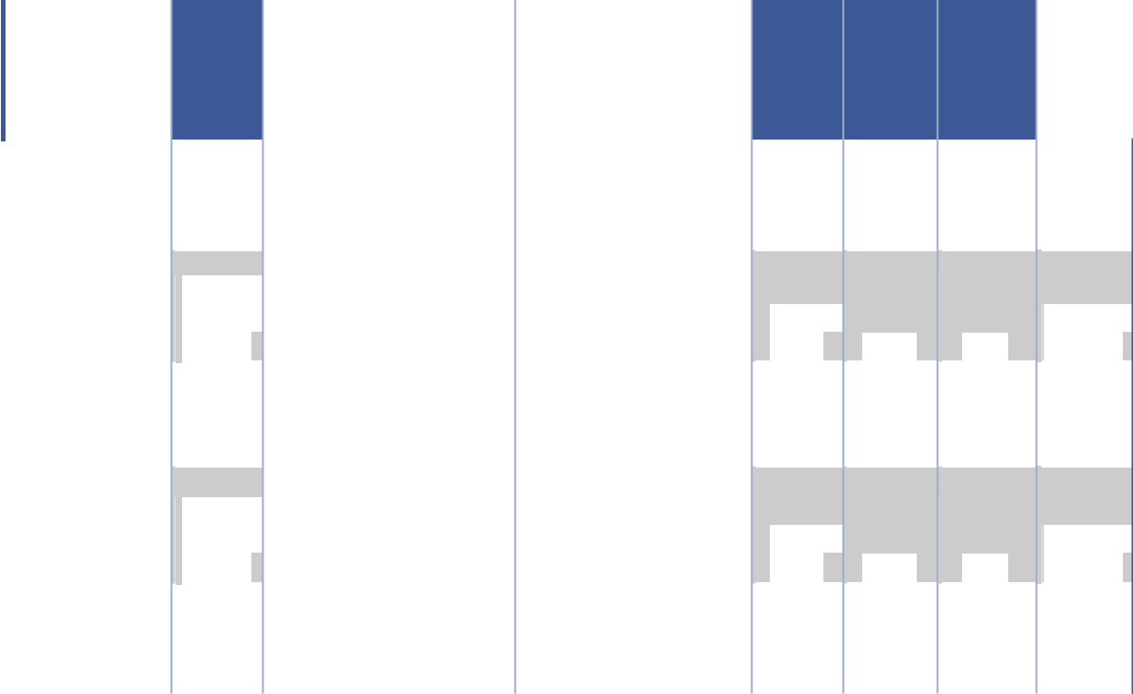

- Reflects the possible payouts of cash incentive compensation under the STIP. See “Annual Cash Incentive Program” in the Compensation Discussion and Analysis section above for a description of the STIP. Potential payouts under the STIP were based on performance in 2021 and resulted in a payout percentage of 200% of the target bonus. The actual amounts paid are described in the “Non-Equity Incentive Plan Compensation” column of the “Summary Compensation Table.”

- Reflects the number of PSUs granted in 2021 to the NEOs under the LTIP. The target number of shares in the table for the PSUs reflects the number of shares that will be awarded if, for the PSUs granted in 2021, the three-year total performance conditions are met at the target level. Actual shares, if any, will be awarded in March 2024 and may range from 50% to 200% of the target. See “2021 PSU Awards” in the Compensation Discussion and Analysis section above for additional information on the PSUs. For PSU awards granted in 2021 to Messrs. Fahs, Moore, and Francis, the grant date value of the PSUs assuming minimum, or target, or maximum performance are $687,503 or, $1,375,005, or $2,750,010; $175,015, or $350,030, or $700,060; $175,011, or $350,023, or $700,046 respectively. The grant date value of the PSUs assuming minimum, or target, or maximum performance for Messrs. Brandman and Clark are $87,507, or $175,015, or $350,030.

- Reflects the number of time-based RSUs granted to NEOs under the LTIP. The RSUs generally vest over a three-year period, with one-third of the total number of shares underlying the RSUs vesting on each of the first, second and third anniversaries of the 2021 grant date, subject to the executive’s continued employment through the applicable vesting date. The RSUs for Mr. Francis will vest over a 2 year period with 66% vesting after year one and 34% vesting after year two subject to his continued employment through the applicable vesting date.

- Reflects the number of stock options granted in 2021. See “2021 Option Awards” in the Compensation Discussion and Analysis section above for additional information on the 2021 stock option awards.

- Reflects the grant date fair value of awards of PSUs, RSUs, and stock options granted to each of the NEOs in 2021 under FASB ASC Topic 718. The grant date fair values are calculated using the NASDAQ closing price of our common stock on the date of grant for PSUs and RSUs and the Black-Scholes option pricing model for stock options. The grant date fair value of the PSUs, which have performance conditions, are computed based on the probable outcome of the performance condition as of the grant date for the award.

2022 Proxy Statement 41

TABLE OF CONTENTS​

EXECUTIVE COMPENSATION

Outstanding Equity Awards at 2021 Fiscal Year End

The following table sets forth information regarding outstanding equity awards held by our NEOs as of January 1, 2022.


​​

- Name

​L. Reade Fahs⁽⁶⁾

​Patrick R. Moore⁽⁶⁾

​Roger Francis

​Jared Brandman⁽⁶⁾

​Bill Clark

 | ​​​ |  | ​​ |  |  |  |  |  |  |  |  | Option Awards |  |  |  |  |  |  |  |  |  |  |  | ​​ |  |  |  |  |  |  |  |  | Stock Awards |  |  |  |  |  |  |  |  |  |  | Equity | ​
 |  |  |  |  |  |  |  |  |  |  |  |  |  |  |  |  |  |  |  |  |  |  |  |  |  |  |  |  |  |  |  |  |  |  |  |  |  |  |  |  |  |  | Incentive
 |  |  |  |  |  |  |  |  |  |  |  |  |  |  |  |  |  |  |  |  |  |  |  |  |  |  |  |  |  |  |  |  |  |  |  |  |  |  |  |  |  |  |  | Plan
 |  |  |  |  |  |  |  |  |  |  |  |  |  |  |  |  |  |  |  |  |  |  |  |  |  |  |  |  |  |  |  |  |  |  |  |  |  |  |  |  |  |  |  | Awards:
 |  |  |  |  |  |  |  |  |  |  |  |  |  |  |  |  |  |  |  |  |  |  |  |  |  |  |  |  |  |  |  |  |  |  |  |  |  | Equity |  |  |  |  | Market or
 |  |  |  |  |  |  |  |  |  |  |  |  |  | Equity |  |  |  |  |  |  |  |  |  |  |  |  |  |  |  |  |  |  |  |  |  |  | Incentive |  |  |  |  |  |  | Payout
 |  |  |  |  |  |  |  |  |  |  |  |  |  | Incentive |  |  |  |  |  |  |  |  |  |  |  |  |  |  |  |  |  |  |  |  |  |  |  |  | Plan |  |  |  |  | Value of
 |  |  |  |  |  |  |  |  |  |  |  |  |  | Plan |  |  |  |  |  |  |  |  |  |  |  |  |  |  |  |  |  |  |  |  |  |  | Awards: |  |  |  |  |  | Unearned
 |  |  |  |  |  |  |  |  |  |  |  |  |  | Awards: |  |  |  |  |  |  |  |  |  |  |  |  |  |  |  |  |  |  | Market |  |  |  | Number of |  |  |  |  |  |  | Shares,
 |  |  |  |  | Number of |  |  |  |  | Number of |  |  |  | Number of |  |  |  |  |  |  |  |  |  |  | Number of |  |  |  |  |  |  | Value of |  |  |  |  | Unearned |  |  |  |  |  |  | Units or
 |  |  |  |  | Securities |  |  |  |  | Securities |  |  |  | Securities |  |  |  |  |  |  |  |  |  |  |  | Shares or |  |  |  |  | Shares or |  |  |  |  |  |  | shares, |  |  |  |  |  | Other
 |  |  |  |  | Underlying |  |  |  |  | Underlying |  |  |  | Underlying |  |  |  |  |  |  |  |  |  |  |  | Units of |  |  |  |  |  | Units of |  |  |  |  | Units or |  |  |  |  |  |  | Rights
 |  |  |  | Unexercised |  |  |  |  |  | Unexercised |  |  | Unexercised |  |  |  | Option |  |  |  |  |  |  |  | Stock That |  |  |  |  |  | Stock That |  |  |  |  | Other Rights |  |  |  |  |  |  |  | That
 |  |  |  |  | Options |  |  |  |  | Options |  |  |  | Unearned |  |  | Exercise |  |  |  |  |  | Option |  |  | Have Not |  |  |  |  | Have Not |  |  |  |  |  | That Have |  |  |  |  |  | Have Not
 |  | Grant |  | Exercisable |  |  |  |  | Unexercisable |  |  |  |  | Options |  |  |  | Price |  |  |  | Expiration |  |  |  |  | Vested |  |  |  |  |  | Vested |  |  |  | Not Vested |  |  |  |  |  |  | Vested
​​ |  | Date | ​​ |  | (#) |  |  | ​​ |  | _{(#)}(1) |  |  | ​​ | (#) |  | ​​ |  |  | ($) |  | ​​ |  | Date⁽²⁾ | ​​ |  |  |  | _{(#)}(3) |  |  | ​​ |  | _{($)}(4) |  |  | ​​ |  |  | (#)⁽⁵⁾ |  |  | ​​ |  | ($) | ​
​​ |  | 3/1/2019 | ​​ |  | ​52,742 |  |  | ​​​ |  | ​26,372 |  |  | ​​​ | ​ |  | ​​ ​35.19 |  |  |  |  | ​​​ |  | 3/1/2029 | ​​ |  | ​ |  |  | ​ | ​​​ ​ |  |  |  | ​ ​​​ |  |  |  | ​ |  | ​ | ​​​​ |  |  |  | ​​
 | ​ | 3/1/2019 | ​​ |  | ​ |  | ​ | ​​​ |  | ​ |  | ​ | ​​​ | ​ |  | ​​ ​ |  |  |  | ​ | ​​​ |  |  | ​​ |  | ​ |  |  | ​ | ​​​ ​ |  |  |  | ​ ​​​ |  |  |  | ​31,970 |  |  | ​​​​1,534,240​​
 | ​ 2/28/2020 |  | ​​ |  | ​13,696 |  |  | ​​​ |  | ​27,393 |  |  | ​​​ | ​ |  | ​​ ​34.82 |  |  |  |  | ​​​ 2/28/2030 |  |  | ​​ |  | ​ |  |  | ​ | ​​​ ​ |  |  |  | ​ ​​​ |  |  |  | ​ |  | ​ | ​​​​ |  |  |  | ​​
 | ​ 2/28/2020 |  | ​​ |  | ​ |  | ​ | ​​​ |  | ​ |  | ​ | ​​​ | ​ |  | ​​ ​ |  |  |  | ​ | ​​​ |  |  | ​​ |  | ​ |  |  | ​ | ​​​ ​ |  |  |  | ​ ​​​ |  |  |  | ​32,310 |  |  | ​​​​1,550,557​​
 | ​ 2/28/2020 |  | ​​ |  | ​ |  | ​ | ​​​ |  | ​ |  | ​ | ​​​ | ​ |  | ​​ ​ |  |  |  | ​ | ​​​ |  |  | ​​ |  | ​10,770 |  |  |  | ​​​ ​516,852 |  |  |  | ​​​ |  |  |  | ​ |  | ​ | ​​​​ |  |  |  | ​​
 | ​ | 3/5/2021 | ​​ |  | ​ |  | ​ | ​​​ |  | ​29,685 |  |  | ​​​ | ​ |  | ​​ ​48.68 |  |  |  |  | ​​​ |  | 3/5/2031 | ​​ |  | ​ |  |  | ​ | ​​​ ​ |  |  |  | ​ ​​​ |  |  |  | ​ |  | ​ | ​​​​ |  |  |  | ​​
 | ​ | 3/5/2021 | ​​ |  | ​ |  | ​ | ​​​ |  | ​ |  | ​ | ​​​ | ​ |  | ​​ ​ |  |  |  | ​ | ​​​ |  |  | ​​ |  | ​ |  |  | ​ | ​​​ ​ |  |  |  | ​ ​​​ |  |  |  | ​30,114 |  |  | ​​​​1,445,171​​
 | ​ | 3/5/2021 | ​​ |  | ​ |  | ​ | ​​​ |  | ​ |  | ​ | ​​​ | ​ |  | ​​ ​ |  |  |  | ​ | ​​​ |  |  | ​​ |  | ​15,057 |  |  |  | ​​​ ​722,585 |  |  |  | ​​​ |  |  |  | ​ |  | ​ | ​​​​ |  |  |  | ​​
​ | ​ 9/16/2014 |  | ​ | ​ | ​21,360 |  |  | ​​​ |  | ​ |  | ​ | ​​​ | ​ |  | ​​ ​ |  |  | 7.25 |  | ​​ | ​ 9/16/2024 |  | ​ | ​ | ​ |  |  | ​ | ​​​ ​ |  |  |  | ​ ​​​ |  |  |  | ​ |  | ​ | ​​​​ |  |  |  | ​​
 |  |  | ​ |  |  | ​92,443 |  | ​​​ |  |  | ​ | ​ | ​​​ | ​ |  | ​ | ​ | ​22.00 |  |  | ​​ |  |  | ​ |  |  | ​ |  | ​ | ​​​ |  | ​ |  | ​ ​​​ |  |  |  | ​ |  | ​ | ​​​ |  | ​ |  | ​​
 | ​10/25/2017 |  | ​ | ​ |  | ​92,443 |  |  |  |  |  |  |  |  |  |  |  |  |  |  |  | ​10/25/2027 |  | ​ | ​ |  | ​ |  | ​ |  |  | ​ |  |  |  |  |  | ​ |  | ​ |  |  | ​ |  | ​​
 | ​ |  | ​ | ​ |  |  |  | ​​​ |  |  |  |  | ​​​ | ​ |  | ​​ |  |  |  |  | ​​ | ​ | 3/1/2029 | ​ | ​ |  |  |  | ​ | ​​​ |  |  |  | ​ ​​​ |  |  |  |  |  | ​ | ​​​ |  |  |  | ​​
 | ​ | 3/1/2019 | ​ | ​ |  | ​14,065 |  |  |  |  | ​ 7,033 |  | ​​​ | ​ |  |  |  | ​35.19 |  |  |  |  |  |  |  |  | ​ |  | ​ |  |  | ​ |  |  |  |  |  | ​ |  | ​ |  |  | ​ |  | ​​
 | ​ | 3/1/2019 | ​ | ​ |  | ​ | ​ | ​​​ |  |  | ​ | ​ | ​​​ | ​ |  | ​​ |  | ​ |  |  | ​​ | ​ |  | ​ | ​ |  | ​ |  |  |  |  | ​ |  |  |  |  |  | ​ | 8,526 |  | ​​​ |  | ​ | 409,163​​
 |  |  |  |  |  |  |  |  |  |  |  |  |  |  |  |  |  |  |  | ​ | ​​ | ​ |  |  |  |  |  |  | ​ | ​ | ​​ | ​ |  | ​ | ​ | ​​ |  | ​ | 8,526 |  |  |  | ​ | 409,163​​
 | ​11/18/2019 |  | ​ | ​ |  | ​ | ​ | ​​​ |  |  | ​ | ​ | ​​​ | ​ |  | ​​ |  | ​ |  | ​ | ​​ | ​ |  | ​ | ​ |  | ​ | 5,489 |  | ​​​ |  | ​263,417 |  |  | ​​​ |  |  | ​ |  | ​ | ​​​ |  | ​ |  | ​​
 | ​ 2/28/2020 |  | ​ | ​ |  | ​ 6,087 |  | ​​​ |  |  | ​12,175 |  | ​​​ | ​ |  | ​​ |  | ​34.82 |  |  | ​​ | ​ 2/28/2030 |  | ​ | ​ |  | ​ |  | ​ | ​​​ |  | ​ |  | ​ | ​​​ |  |  | ​ |  | ​ | ​​​ |  | ​ |  | ​​
 | ​ 2/28/2020 |  | ​ | ​ |  | ​ | ​ | ​​​ |  |  | ​ | ​ | ​​​ | ​ |  | ​​ |  | ​ |  | ​ | ​​ | ​ |  | ​ | ​ |  | ​ |  | ​ | ​​​ |  | ​ |  | ​ | ​​​ |  |  | ​14,360 |  |  | ​​​ |  | ​ | 689,136​​
 | ​ 2/28/2020 |  | ​ | ​ |  | ​ | ​ | ​​​ |  |  | ​ | ​ | ​​​ | ​ |  | ​​ |  | ​ |  | ​ | ​​ | ​ |  | ​ | ​ |  | ​ | 4,787 |  | ​​​ |  | ​229,728 |  |  | ​​​ |  |  | ​ |  | ​ | ​​​ |  | ​ |  | ​​
 | ​ | 3/5/2021 | ​ | ​ |  | ​ | ​ | ​​​ |  |  | ​ 7,557 |  | ​​​ | ​ |  | ​​ |  | ​45.66 |  |  | ​​ | ​ | 3/5/2031 | ​ | ​ |  | ​ |  | ​ | ​​​ |  | ​ |  | ​ | ​​​ |  |  | ​ |  | ​ | ​​​ |  | ​ |  | ​​
 | ​ | 3/5/2021 | ​ | ​ |  | ​ | ​ | ​​​ |  |  | ​ | ​ | ​​​ | ​ |  | ​​ |  | ​ |  | ​ | ​​ | ​ |  | ​ | ​ |  | ​ |  | ​ | ​​​ |  | ​ |  | ​ | ​​​ |  |  | ​ | 7,666 |  | ​​​ |  | ​ | 367,891​​
 | ​ | 3/5/2021 | ​ | ​ |  | ​ | ​ | ​​​ |  |  | ​ | ​ | ​​​ | ​ |  | ​​ |  | ​ |  | ​ | ​​ | ​ |  | ​ | ​ |  | ​ | 3,833 |  | ​​​ |  | ​183,946 |  |  | ​​​ |  |  | ​ |  | ​ | ​​​ |  | ​ |  | ​​
​ | ​ | 5/3/2021 | ​​ |  | ​ |  | ​ | ​​​ |  | ​ 6,685 |  |  | ​​​ | ​ |  | ​​ ​52.11 |  |  |  |  | ​​​ |  | 5/3/2031 | ​​ |  | ​ |  |  | ​ | ​​​ ​ |  |  |  | ​ ​​​ |  |  |  | ​ |  | ​ | ​​​​ |  |  |  | ​​
 | ​ | 5/3/2021 | ​​ |  | ​ |  | ​ | ​​​ |  | ​ |  | ​ | ​​​ | ​ |  | ​​ ​ |  |  |  | ​ | ​​​ |  |  | ​​ |  | ​ |  |  | ​ | ​​​ ​ |  |  |  | ​ ​​​ |  |  |  | ​ | 6,717 |  | ​​​​ |  |  | 322,349​​
 | ​ | 5/3/2021 | ​​ |  | ​ |  | ​ | ​​​ |  | ​ |  | ​ | ​​​ | ​ |  | ​​ ​ |  |  |  | ​ | ​​​ |  |  | ​​ |  | ​ |  | 3,359 |  | ​​​ ​161,198 |  |  |  | ​​​ |  |  |  | ​ |  | ​ | ​​​​ |  |  |  | ​​
​ | ​ 8/14/2017 |  | ​ | ​ | ​32,549 |  |  | ​​​ |  | ​ 8,137 |  |  | ​​​ | ​ |  | ​​ ​15.74 |  |  |  |  | ​​ | ​ 8/14/2027 |  | ​ | ​ | ​ |  |  | ​ | ​​​ ​ |  |  |  | ​ ​​​ |  |  |  | ​ |  | ​ | ​​​​ |  |  |  | ​​
 |  |  | ​ |  |  |  |  |  |  |  |  |  | ​​​ | ​ |  |  |  |  |  |  | ​​ |  |  | ​ |  |  |  |  | ​ |  |  |  |  | ​ ​​​ |  |  |  | ​ |  | ​ |  |  |  |  | ​​
 | ​ | 3/1/2019 | ​ | ​ |  | ​ 5,860 |  | ​​ | ​ |  | ​ 2,931 |  | ​​​ | ​ |  | ​ | ​ | ​35.19 |  |  | ​​ | ​ | 3/1/2029 | ​ | ​ |  | ​ |  | ​ | ​​​ |  | ​ |  |  |  |  |  | ​ |  | ​ | ​​​ |  | ​ |  | ​​
 | ​ |  | ​ | ​ |  |  | ​ | ​​​ |  |  |  | ​ | ​​​ | ​ |  | ​​ |  |  |  | ​ | ​​ | ​ |  | ​ | ​ |  |  |  | ​ | ​​​ |  |  |  | ​ ​​​
 | ​ | 3/1/2019 | ​ | ​ |  | ​ | ​ |  |  |  | ​ | ​ | ​​​ | ​ |  |  |  | ​ |  | ​ | ​​ | ​ |  | ​ | ​ |  | ​ |  | ​ |  |  | ​ |  |  |  |  |  | ​ | 3,553 |  | ​ | ​​ | ​ 170,508​ |  | ​
 | ​11/18/2019 |  | ​ | ​ |  | ​ | ​ | ​​​ |  |  | ​ | ​ | ​​​ | ​ |  | ​​ |  | ​ |  |  |  | ​ |  | ​ | ​ |  | ​ | 5,489 |  |  |  | ​263,417 |  |  |  |  |  | ​ |  | ​ |  | ​​ | ​ |  | ​​
 |  |  |  |  |  |  |  |  |  |  |  |  |  |  |  |  |  |  |  | ​ | ​​ | ​ |  |  |  |  |  |  |  | ​​​ |  |  |  |  | ​​​ |  |  | ​ |  | ​ | ​ | ​​ | ​ |  | ​​
 | ​ 2/28/2020 |  | ​ | ​ |  | ​ 1,522 |  | ​​​ |  |  | ​ 3,044 |  | ​​​ | ​ |  | ​​ |  | ​34.82 |  |  | ​​ | ​ 2/28/2030 |  | ​ | ​ |  | ​ |  | ​ | ​​​ |  | ​ |  | ​ | ​​​ |  |  | ​ |  | ​ | ​​​ |  | ​ |  | ​​
 | ​ 2/28/2020 |  | ​ | ​ |  | ​ | ​ | ​​​ |  |  | ​ | ​ | ​​​ | ​ |  | ​​ |  | ​ |  | ​ | ​​ | ​ |  | ​ | ​ |  | ​ |  | ​ | ​​​ |  | ​ |  | ​ | ​​​ |  |  | ​ | 3,590 |  | ​​​ |  | ​ | 172,284​​
 | ​ 2/28/2020 |  | ​ | ​ |  | ​ | ​ | ​​​ |  |  | ​ | ​ | ​​​ | ​ |  | ​​ |  | ​ |  | ​ | ​​ | ​ |  | ​ | ​ |  | ​ | 1,197 |  | ​​​ |  | ​ | 57,444 |  | ​​​ |  |  | ​ |  | ​ | ​​​ |  | ​ |  | ​​
 | ​ | 3/5/2021 | ​ | ​ |  | ​ | ​ | ​​​ |  |  | ​ 3,779 |  | ​​​ | ​ |  | ​​ |  | ​45.66 |  |  | ​​ | ​ | 3/5/2031 | ​ | ​ |  | ​ |  | ​ | ​​​ |  | ​ |  | ​ | ​​​ |  |  | ​ |  | ​ | ​​​ |  | ​ |  | ​​
 | ​ | 3/5/2021 | ​ | ​ |  | ​ | ​ | ​​​ |  |  | ​ | ​ | ​​​ | ​ |  | ​​ |  | ​ |  | ​ | ​​ | ​ |  | ​ | ​ |  | ​ |  | ​ | ​​​ |  | ​ |  | ​ | ​​​ |  |  | ​ | 3,833 |  | ​​​ |  | ​ | 183,946​​
 | ​ | 3/5/2021 | ​ | ​ |  | ​ | ​ | ​​​ |  |  | ​ | ​ | ​​​ | ​ |  | ​​ |  | ​ |  | ​ | ​​ | ​ |  | ​ | ​ |  | ​ | 1,917 |  | ​​​ |  | ​ | 91,997 |  | ​​​ |  |  | ​ |  | ​ | ​​​ |  | ​ |  | ​​
​ | ​ 6/11/2019 |  | ​​ |  | ​15,753 |  |  | ​​​ |  | ​ 7,877 |  |  | ​​​ | ​ |  | ​​ ​28.48 |  |  |  |  | ​​​ 6/11/2029 |  |  | ​​ |  | ​ |  |  | ​ | ​​​ ​ |  |  |  | ​ ​​​ |  |  |  | ​ |  | ​ | ​​​​ |  |  |  | ​​
 | ​ | 6/11/2019 | ​​ |  | ​ |  | ​ | ​​​ |  | ​ |  | ​ | ​​​ | ​ |  | ​​ ​ |  |  |  | ​ | ​​​ |  |  | ​​ |  | ​ |  |  | ​ | ​​​ ​ |  |  |  | ​ ​​​ |  |  |  | ​ | 8,779 |  | ​​​​ |  |  | 421,304​​
 | ​11/18/2019 |  | ​​ |  | ​ |  | ​ | ​​​ |  | ​ |  | ​ | ​​​ | ​ |  | ​​ ​ |  |  |  | ​ | ​​​ |  |  | ​​ |  | ​ |  | 5,489 |  | ​​​ ​263,417 |  |  |  | ​​​ |  |  |  | ​ |  | ​ | ​​​​ |  |  |  | ​​
 | ​ 2/28/2020 |  | ​​ |  | ​ 1,948 |  |  | ​​​ |  | ​ 3,896 |  |  | ​​​ | ​ |  | ​​ ​34.82 |  |  |  |  | ​​​ 2/28/2030 |  |  | ​​ |  | ​ |  |  | ​ | ​​​ ​ |  |  |  | ​ ​​​ |  |  |  | ​ |  | ​ | ​​​​ |  |  |  | ​​
 | ​ 2/28/2020 |  | ​​ |  | ​ |  | ​ | ​​​ |  | ​ |  | ​ | ​​​ | ​ |  | ​​ ​ |  |  |  | ​ | ​​​ |  |  | ​​ |  | ​ |  |  | ​ | ​​​ ​ |  |  |  | ​ ​​​ |  |  |  | ​ | 4,596 |  | ​​​​ |  |  | 220,562​​
 | ​ 2/28/2020 |  | ​​ |  | ​ |  | ​ | ​​​ |  | ​ |  | ​ | ​​​ | ​ |  | ​​ ​ |  |  |  | ​ | ​​​ |  |  | ​​ |  | ​ |  | 1,532 |  | ​​​ ​ |  |  | 73,521 | ​​​ |  |  |  | ​ |  | ​ | ​​​​ |  |  |  | ​​
 | ​ | 3/5/2021 | ​​ |  | ​ |  | ​ | ​​​ |  | ​ 3,779 |  |  | ​​​ | ​ |  | ​​ ​45.66 |  |  |  |  | ​​​ |  | 3/5/2031 | ​​ |  | ​ |  |  | ​ | ​​​ ​ |  |  |  | ​ ​​​ |  |  |  | ​ |  | ​ | ​​​​ |  |  |  | ​​
 | ​ | 3/5/2021 | ​​ |  | ​ |  | ​ | ​​​ |  | ​ |  | ​ | ​​​ | ​ |  | ​​ ​ |  |  |  | ​ | ​​​ |  |  | ​​ |  | ​ |  |  | ​ | ​​​ ​ |  |  |  | ​ ​​​ |  |  |  | ​ | 3,833 |  | ​​​​ |  |  | 183,946​​
 | ​ | 3/5/2021 | ​​ |  | ​ |  | ​ | ​​​ |  | ​ |  | ​ | ​​​ | ​ |  | ​​ ​ |  |  |  | ​ | ​​​ |  |  | ​​ |  | ​ |  | 1,917 |  | ​​​ ​ |  |  | 91,997 | ​​​ |  |  |  | ​ |  | ​ | ​​​​ |  |  |  | ​​

42 2022 Proxy Statement

TABLE OF CONTENTS​

EXECUTIVE COMPENSATION​

- The numbers in this column represent unvested outstanding time-based options. The pre-IPO options granted to Mr. Brandman vest as to 20% of the shares subject to such option on each anniversary of the grant date, subject to continued employment through the applicable vesting date. The time-based options granted to NEOs in 2019 and 2020 and 2021 vest in three substantially equal installments on each of the first, second and third anniversaries of the grant date, subject to continued employment through the applicable vesting date.

- The expiration date shown is the normal expiration date occurring on the tenth anniversary of the grant date. Options may terminate earlier in certain circumstances, such as in connection with a NEO’s termination of employment or in connection with certain corporate transactions, including a change in control of the Company.

- The numbers in this column represent unvested outstanding time-based RSUs. The RSUs granted in 2019 vest in three installments over four years, one-half on the second anniversary of the grant date and one-quarter on each of the third and fourth anniversaries of the grant date, subject to continued employment through the applicable vesting date. The RSUs granted in 2020 and 2021 vest in three annual installments on the anniversary date of the grant. Mr. Francis’s sign-on RSU grant will vest in two installments; 66% after year one and the remaining 34% after year two.

- The market value is based on the NASDAQ closing price on December 31, 2021.

- The numbers in this column represent unvested outstanding PSUs. The PSUs granted in 2019 and 2020 are earned over a three-year performance period and will vest on the third anniversary of the grant date based on the Company’s achievement of certain Adjusted EBITDA growth targets, as set forth in the 2019 or 2020 PSU award agreement, as applicable. Mr. Clark and Mr. Francis also received a special sign-on equity award when they joined the Company. The PSUs granted in 2021 are earned over a three-year performance period and will vest on the third anniversary of the grant date based on the Company’s achievement of certain Adjusted Operating Income and ROIC growth targets, as set forth in the 2021 PSU award agreement. 75% of the Target PSUs shall be subject to performance goals relating to Adjusted Operating Income (the “AOI PSUs”), and 25% of the Target PSUs shall be subject to performance goal relating to ROIC (the “ROIC PSUs”). For all PSUs, the actual value of the PSUs that become vested based on the applicable performance measure(s) is based on an achievement factor which, in each case, ranges from a 50% payout for threshold performance, to 100% for target performance, to 200% for maximum performance. To the extent that performance falls between the applicable threshold, target or maximum levels, payouts will be determined using linear interpolation.

- Messrs. Fahs, Moore and Brandman are party to a Management Stockholder’s Agreement with the Company. The Management Stockholder’s Agreement, along with an applicable option agreement, generally govern each such NEO’s rights with respect to shares of common stock of the Company held by such NEO prior to our IPO, including such NEO’s stock option awards and contain certain rights and obligations of the parties thereto. The pre-IPO options are subject to certain put and call rights pursuant to the Management Stockholder’s Agreement.

2021 Option Exercises and Stock Vested

The following table provides information regarding options exercised by and stock vested for the NEOs during the fiscal year ended January 1, 2022.


 |  |  | ​ |  | Option Awards |  |  |  |  |  | ​​ | Restricted Stock Units |  |  |  | ​
 |  |  |  | Number of |  |  |  |  |  |  |  | Number of
 |  |  | Shares Acquired |  |  |  |  | Value Realized |  |  |  | Shares Acquired |  | Value Realized
 | Name |  |  | on Exercise |  |  |  | on Exercise |  |  |  | on Vesting |  | on Vesting
​ | Name | ​​ |  |  | (#) |  | ​​ | ($)⁽¹⁾ |  |  | ​​ | (#) | ​​ |  | ($)⁽²⁾ | ​
​L. Reade Fahs |  | ​​ |  | ​976,470 |  | ​​​ |  | ​46,543,336 |  | ​​​ |  | ​5,385 | ​​​ | ​255,734 |  | ​​
​Patrick R. Moore |  |  | ​​ | ​ | 64,080 | ​ | ​​ | ​ 3,186,698 |  | ​ | ​​ | ​7,881 | ​​​ | ​378,879 |  | ​​
​Roger Francis |  | ​​ |  | ​ | — | ​​​ |  | ​ | — | ​​​ |  | ​ — | ​​​ | ​ | — | ​​
​Jared Brandman |  |  | ​​ | ​ | 28,824 | ​ | ​​ | ​ 1,106,544 |  | ​ | ​​ | ​6,086 | ​​​ | ​293,634 |  | ​​
​Bill Clark |  | ​​ |  | ​ | — | ​​​ |  | ​ | — | ​​​ |  | ​6,254 | ​​​ | ​301,612 |  | ​​

- Represents the difference between the fair market value of the shares acquired on the exercise date and the exercise price of the options, multiplied by the number of options exercised.

- Represents the fair market value of the RSUs on the vesting date.

2021 Pension Benefits

We have no defined benefit pension plans for our executive officers.

2021 Non-Qualified Deferred Compensation

We have no non-qualified defined contribution or other non-qualified deferred compensation plans for our executive officers.

2022 Proxy Statement 43

TABLE OF CONTENTS​

EXECUTIVE COMPENSATION

Potential Payments upon Termination or Change in Control

The following section describes the payments and benefits that may become payable to the NEOs in connection with their termination of employment and/or a change in control. All such payments and benefits will be paid or provided by us or National Vision, Inc.

Executive Severance Plan

The Executive Severance Plan provides for severance payments and benefits to eligible employees, including our NEOs, upon a termination of employment by the Company without cause or by the executive for good reason (each as defined in the Executive Severance Plan, and each of which we refer to as a Qualifying Termination). In the event of a Qualifying Termination of employment, the Executive Severance Plan provides, in addition to certain accrued obligations, for the following payments and benefits:

- A lump-sum pro-rata bonus for the year of termination of employment, based on actual performance;

- An amount equal to the sum of the executive’s (x) annual base salary and (y) bonus based on target performance, which we refer to collectively as the cash severance amount, times the multiplier applicable to such executive, which is 2.0 for Mr. Fahs, 1.5 for Messrs. Moore and Brandman, and 1.0 for Messrs. Francis and Clark, payable over a period of 24 months for Mr. Fahs, 18 months for Messrs. Moore and Brandman, and 12 months for Messrs. Francis and Clark; and

- Continued health insurance coverage at substantially the same level as provided immediately prior to the termination of employment, at the same cost as generally provided to our similarly situated active employees, which we refer to as the welfare benefit, for a period of 24 months for Mr. Fahs, 18 months for Messrs. Moore and Brandman, and 12 months for Messrs. Francis and Clark.

In addition, upon a Qualifying Termination that occurs within the two-year period following a change in control (as defined in the Executive Severance Plan), the Executive Severance Plan provides, in addition to certain accrued obligations, for the following payments and benefits:

- A lump-sum pro-rata bonus for the year of termination of employment, based on target performance;

- The cash severance amount, times the multiplier applicable to such executive, which is 2.5 for Mr. Fahs, 2.0 for Messrs. Moore and Brandman, and 1.5 for Messrs. Francis and Clark, payable in a lump sum within 60 days following the covered termination;

- The welfare benefit for a period of 30 months for Mr. Fahs, 24 months for Messrs. Moore and Brandman, and 18 months for Messrs. Francis and Clark; and

- Payment of, or reimbursement for, up to $20,000 in outplacement services within the six-month period following termination of employment.

Any outstanding awards granted to NEOs under the Company’s equity plans will vest in accordance with the terms of the respective Equity Plan and the applicable award agreement, as detailed further below.

Payments and benefits under the Executive Severance Plan are subject to (i) the executive’s execution and non-revocation of a release of claims in favor of the Company and (ii) continued compliance with the executive’s confidentiality, non-interference and invention assignment obligations to the Company.

2019, 2020, and 2021 Options

Effect of Change in Control on Vesting. Upon a Qualifying Termination within the two-year period following a change in control (as defined in the 2017 Omnibus Plan), unvested time-based options would become immediately vested and exercisable. Vested and exercisable options will remain exercisable until the earlier of 90 days from the termination date or the expiration of the option period, as defined in the grant agreement.

Effect of Death or Disability on Vesting. Upon a termination of a NEO’s employment with the Company by reason of death or disability, unvested time-based options will become vested and exercisable. Vested and exercisable options will remain exercisable until the earlier of one year from the termination date or the expiration of the option period, as defined in the grant agreement.

44 2022 Proxy Statement

TABLE OF CONTENTS

EXECUTIVE COMPENSATION​

Effect of Qualifying Termination or Retirement on Vesting.Upon a termination of a NEO’s employment with the Company without cause or by the executive for good reason (as defined in the 2017 Plan), a pro rata portion of the options that would have vested on the next vesting date following the termination date would become immediately vested and exercisable. Vested and exercisable options will remain exercisable until the earlier of 90 days from the termination date or the expiration of the option period, as defined in the grant agreement.

Effect of Other Terminations of Employment. Except as set forth above with respect to the effect of death, disability, retirement or a Qualifying Termination on vesting of time-based options, unvested options will not become vested and exercisable following termination of employment with us for any reason and any option that is unvested as of the date of termination of employment will immediately expire. Vested and exercisable options will remain exercisable until the earlier of 90 days from the termination date or the expiration of the option period, as defined in the grant agreement.

Performance Stock Units

Effect of Change in Control on Vesting. Upon a change in control (as defined in the 2017 Omnibus Plan), unvested PSUs will be converted into time-based restricted stock equal to the greater of the target number of PSUs or the number of PSUs that would have been earned based on the actual performance as of the date of the change in control. If a successor does not assume, convert, or replace the award in connection with the change in control, or upon a Qualifying Termination within the two-year period following a change in control, the converted award would become fully vested.

Effect of Death or Disability on Vesting. Upon a termination of a NEO’s employment with the Company by reason of death or disability, the outstanding and unvested PSUs would become vested assuming a payout at 100% of the target award.

Effect of Qualifying Termination on Vesting. Upon a Qualifying Termination of a NEO’s employment with the Company without cause or by the executive for good reason (as defined in the 2017 Omnibus Plan), subject to compliance with applicable restrictive covenants during the performance period, a pro rata portion of the PSUs will remain outstanding and eligible to vest based on actual performance on the last day of the performance period.

Effect of Retirement on Vesting: Upon retirement of a NEO, unvested PSUs will not become vested and any PSU that is unvested as of the date of termination of employment or retirement will immediately be forfeited.

Effect of Other Terminations of Employment. Except as set forth above with respect to the effect of death or disability on vesting of PSUs, unvested PSUs will not become vested following termination of employment with us for any reason, and any PSU that is unvested as of the date of termination of employment will immediately be forfeited.

Restricted Stock Units

Effect of Change in Control on Vesting. Upon a Qualifying Termination within the two-year period following a change in control (as defined in the 2017 Omnibus Plan), unvested time-based RSUs would become vested.

Effect of Death or Disability on Vesting. Upon a termination of a NEO’s employment with the Company by reason of death or disability, unvested time-based RSUs would become vested.

Effect of Qualifying Termination on Vesting. Upon a Qualifying Termination of a NEO’s employment with the Company without cause or by the executive for good reason (as defined in the 2017 Omnibus Plan), a pro rata portion of the RSUs that would have vested on the next vesting date following the termination date would become vested.

Effect of Other Terminations of Employment. Except as set forth above with respect to the effect of death, disability, or a Qualifying Termination on vesting of time-based RSUs, unvested RSUs will not become vested following termination of employment with us for any reason and any RSU that is unvested as of the date of termination of employment will immediately be forfeited.

Quantification of Payments upon Termination or Change in Control

The following table lists the payments and benefits that would have been triggered for each of our NEOs under the circumstances described below assuming that the applicable triggering event occurred on January 1, 2022. Consistent with SEC requirements, these estimated amounts have been calculated as if the NEO’s employment had been terminated as of January 1, 2022, the last day of fiscal 2021, and using the closing market price of our common stock on December 31, 2021, the last trading day in fiscal 2021 ($47.99 per share). For purposes of this section, we have assumed that (1) we do not exercise any discretion to accelerate the vesting of outstanding options in connection with

2022 Proxy Statement 45

TABLE OF CONTENTS​

EXECUTIVE COMPENSATION

a change in control, and (2) the value of any stock options that may be accelerated is equal to the full value of such awards (i.e., the full “spread” value for stock options as of January 1, 2022).


 |  |  |  |  |  |  |  |  |  |  |  |  | Continuation
 |  |  |  |  |  | Severance |  |  |  |  |  |  |  | of Health |  |  |  |  |  |  |  |  | Stock |  |  | Performance |  |  |  |  |  |  | Restricted
 |  |  |  |  |  |  |  | Benefit |  |  |  |  |  | Benefits |  |  |  |  |  |  | Options |  |  |  |  |  | Stock Units |  |  |  |  |  | Stock Units
 | ​ | NEO |  | ​​ |  |  |  | ($)⁽¹⁾ |  |  | ​​ |  |  |  |  | ($)⁽²⁾ |  |  | ​​ |  |  |  | ($)⁽³⁾ | ​​ |  |  |  |  | ($)⁽⁴⁾ |  | ​​ |  |  |  | ($)⁽⁵⁾ |  | ​
 | ​L. Reade Fahs |  |  | ​​​ |  |  |  |  |  | ​​​​ |  |  |  | ​ |  |  | ​ | ​​​​ |  |  |  |  |  | ​​​​ |  |  |  | ​ |  | ​ | ​​​ ​ |  |  |  |  | ​ | ​​
 | Qualifying Termination of Employment |  |  |  | ​​3,901,543 ​​​ |  |  |  |  |  |  |  |  | ​ |  | 2,351 |  | ​​​​434,711 ​​​ |  |  |  |  |  |  |  |  |  | ​ | — |  | ​​​ ​ |  |  |  | 416,650 |  | ​​
 |  |  |  |  | ​​4,896,928 ​​​ |  |  |  |  |  |  |  |  | ​ |  | 2,939 |  | ​​​​698,327 ​​​ |  |  |  |  |  |  |  |  |  | ​2,804,542 |  |  | ​​​ ​1,239,438 |  |  |  |  |  | ​​
 | Qualifying Termination following Change in Control |  |  |  |  |  |  |  |  |  |  |  |  |  |  |  |  |  |  |  |  |  |  |  |  |  |  |  |  |  |  |  |  |  |  |  | ​​
 | Termination Upon Death or Disability |  |  |  | ​​ |  |  |  | — ​​​ |  |  |  |  | ​ |  | — |  | ​​​​698,327 ​​​ |  |  |  |  |  |  |  |  |  | ​4,529,968 |  |  | ​​​ ​1,239,438 |  |  |  |  |  | ​​
 |  |  |  | ​​​ |  |  |  |  |  | ​​​​ |  |  |  |  |  |  |  | ​​​​ |  |  |  |  |  | ​​​​ |  |  |  |  |  |  | ​​​ ​
 | ​Patrick R. Moore |  |  |  |  |  |  |  |  |  |  |  |  | ​ |  |  | ​ |  |  |  |  |  |  |  |  |  |  | ​ |  | ​ |  |  |  |  |  | ​ | ​​
 | Qualifying Termination of Employment |  |  |  | ​ |  | ​1,263,916 ​​​ |  |  |  |  |  |  |  | ​ | — |  | ​​​​142,887 ​​​ |  |  |  |  |  |  |  |  |  | ​ | — |  | ​​​ |  |  | ​ | 163,171 |  | ​​
 | Qualifying Termination following Change in Control |  |  |  | ​ |  | ​1,705,221 |  |  | ​​​ |  |  |  |  | ​ | — |  | ​ | ​​ |  |  | ​250,367 |  | ​​​ |  |  |  | ​ | 912,506 |  | ​​​ |  |  | ​ | 677,091 |  | ​​
 | Termination Upon Death or Disability |  |  |  | ​ |  | ​ |  | — | ​​​ |  |  |  |  | ​ | — |  | ​​​ |  |  |  | ​250,367 |  | ​​​ |  |  |  | ​1,466,190 |  |  | ​​​ |  |  | ​ | 677,091 |  | ​​
 | ​Roger Francis |  |  | ​​​ |  |  |  |  |  | ​​​​ |  |  |  | ​ |  |  | ​ | ​​​​ |  |  |  |  |  | ​​​​ |  |  |  | ​ |  | ​ | ​​​ ​ |  |  |  |  | ​ | ​​
 | Qualifying Termination of Employment |  |  |  | ​​ |  |  | 428,366 ​​​ |  |  |  |  |  | ​23,926 |  |  |  | ​​​​ |  |  |  |  | — ​​​ |  |  |  |  | ​ | — |  | ​​​ ​ |  |  |  | 71,535 |  | ​​
 |  |  |  |  | ​​ |  |  | 662,548 ​​​ |  |  |  |  |  | ​35,890 |  |  |  | ​​​​ |  |  |  |  | — ​​​ |  |  |  |  | ​ | 71,535 |  | ​​​ ​ |  |  |  | 161,198 |  | ​​
 | Qualifying Termination following Change in Control
 | Termination Upon Death or Disability |  |  |  | ​​ |  |  |  | — ​​​ |  |  |  |  | ​ |  | — |  | ​​​​ |  |  |  |  | — ​​​ |  |  |  |  | ​ | 322,349 |  | ​​​ ​ |  |  |  | 161,198 |  | ​​
 |  |  |  | ​​​ |  |  |  |  |  | ​​​​ |  |  |  |  |  |  |  | ​​​​ |  |  |  |  |  | ​​​​ |  |  |  |  |  |  | ​​​ ​
 | ​Jared Brandman |  |  |  |  |  |  |  |  |  |  |  |  | ​ |  |  | ​ |  |  |  |  |  |  |  |  |  |  | ​ |  | ​ |  |  |  |  |  | ​ | ​​
 | Qualifying Termination of Employment |  |  |  | ​ |  | ​ | 843,534 ​​​ |  |  |  |  |  |  | ​23,926 |  |  | ​​​​143,171 ​​​ |  |  |  |  |  |  |  |  |  | ​ | — |  | ​​​ |  |  | ​ | 81,259 |  | ​​
 | Qualifying Termination following Change in Control |  |  |  | ​ |  | ​1,144,712 |  |  | ​​​ |  |  |  |  | ​35,890 |  |  | ​ | ​​ |  |  | ​340,025 |  | ​​​ |  |  |  | ​ | 318,097 |  | ​​​ |  |  | ​ | 412,858 |  | ​​
 | Termination Upon Death or Disability |  |  |  | ​ |  | ​ |  | — | ​​​ |  |  |  |  | ​ | — |  | ​​​ |  |  |  | ​340,025 |  | ​​​ |  |  |  | ​ | 526,738 |  | ​​​ |  |  | ​ | 412,858 |  | ​​
 | ​Bill Clark |  |  | ​​​ |  |  |  |  |  | ​​​​ |  |  |  | ​ |  |  | ​ | ​​​​ |  |  |  |  |  | ​​​​ |  |  |  | ​ |  | ​ | ​​​ ​ |  |  |  |  | ​ | ​​
 | Qualifying Termination of Employment |  |  |  | ​​ |  |  | 536,207 ​​​ |  |  |  |  |  | ​23,926 |  |  |  | ​​​​107,471 ​​​ |  |  |  |  |  |  |  |  |  | ​ | — |  | ​​​ ​ |  |  |  | 72,166 |  | ​​
 |  |  |  |  | ​​ |  |  | 824,310 ​​​ |  |  |  |  |  | ​35,890 |  |  |  | ​​​​204,991 ​​​ |  |  |  |  |  |  |  |  |  | ​ | 546,036 |  | ​​​ ​ |  |  |  | 428,935 |  | ​​
 | Qualifying Termination following Change in Control
 |  |  |  |  | ​​ |  |  |  | — ​​​ |  |  |  |  | ​ |  | — |  | ​​​​204,991 ​​​ |  |  |  |  |  |  |  |  |  | ​ | 825,812 |  | ​​​ ​ |  |  |  | 428,935 |  | ​​
 | Termination Upon Death or Disability



- Amounts reported for Messrs. Fahs, Moore, Francis, Brandman and Clark represent (i) upon a Qualifying Termination of employment (A) a lump-sum pro-rata bonus for the year of termination, based on actual performance and (B) the cash severance amount, times the multiplier applicable to such executive (2.0 for Mr. Fahs; 1.5 for Messrs. Moore and Brandman; 1.0 for Messrs. Francis and Clark), payable over 24 months (Mr. Fahs), 18 months (Messrs. Moore and Brandman) and 12 months (Messrs. Francis and Clark) and (ii) upon a Qualifying Termination of employment in the two-year period following a change in control (A) a lump-sum pro-rata bonus for the year of termination, based on target performance, (B) the cash severance amount, times the multiplier applicable to such executive (2.5 for Mr. Fahs; 2.0 for Messrs. Moore and Brandman; 1.5 for Messrs. Francis and Clark),

payable over 30 months (Mr. Fahs), 24 months (Messrs. Moore and Brandman,) and 18 months (Messrs. Francis and Clark) and

(C) payment of, or reimbursement for, up to $20,000 in outplacement services within the six-month period following termination of employment.

- The amounts reported represent the cost of providing each applicable NEO with the welfare benefit (i) upon a Qualifying Termination of employment, for 24 months (Mr. Fahs), 18 months (Messrs. Moore and Brandman), and 12 months (Messrs. Francis and Clark) and (ii) upon a Qualifying Termination of employment in the two-year period following a change in control, for 30 months (Mr. Fahs), 24 months (Messrs. Moore and Brandman), and 18 months (Messrs. Francis and Clark).

- The amounts reported represent accelerated vesting of unvested options upon a Qualifying Termination of employment, a Qualifying Termination of employment following a change in control and as a result of termination upon death or disability, as applicable, and are based on the closing price of our common stock of $47.99 per share on December 31, 2021, the last trading day in fiscal 2021.

- The amounts reported represent vesting of PSUs upon a Qualifying Termination of employment, a Qualifying Termination of employment following a change in control, and as a result of termination upon death or disability, as applicable, and are based on the closing price of our common stock of $47.99 per share on December 31, 2021, the last trading day in fiscal 2021.

- The amounts reported represent vesting of RSUs upon a Qualifying Termination of employment, a Qualifying Termination of employment following a change in control and as a result of termination upon death or disability, as applicable, and are based on the closing price of our common stock of $47.99 per share on December 31, 2021, the last trading day in fiscal 2021.

Compensation Committee Interlocks and Insider Participation

During fiscal 2021, none of the members of our compensation committee has at any time been one of our executive officers or employees or, other than as noted herein and in the Transactions with Related Persons section above, had any relationship requiring disclosure by the Company. During 2021, none of our executive officers served as a member of the compensation committee (or other committee serving an equivalent function) or as a director of any other entity whose executive officers served on our compensation committee or Board of Directors.

46 2022 Proxy Statement

TABLE OF CONTENTS​

EXECUTIVE COMPENSATION​

Equity Compensation Plan Information

All numbers in the following table are as of January 1, 2022.


- Plan category

Equity compensation plans approved by ​ security holders

Equity compensation plans not approved

- by security holders ​Total

 | Number of |  |  | Weighted- |  | Number of securities
 |  |  |  | Weighted- | remaining available for
 | securities to be |  |  | average exercise |  | future issuance under
 | issued upon |  |  | price of |  | equity compensation
 | exercise of |  |  | outstanding |  |  | plans
outstanding options, |  |  | options, warrants |  |  | (excluding securities
 | warrants and rights |  |  | and rights | reflected in column (a))
​​ |  | (a) | ​​ | (b) | ​​ |  | (c)
​​ | ​1,459,556 |  | ​​​ | ​$28.06 | ​​​ | ​12,014,960
​​ | ​ | — | ​​​ | ​ ​ N/A | ​​​ | ​ | —
​​ | ​1,459,556 |  | ​​​ | ​$28.06 | ​​​ | ​12,014,960

​

​​

​​

​​

- Includes 247,607 shares issuable under the 2014 Stock Incentive Plan. The weighted-average exercise price of such options within this plan is $14.28. Includes 1,217,331 shares issuable under the 2017 Omnibus Incentive Plan. Included within the 1,217,331 shares are 316,744 shares that could be issued upon the vesting of PSU awards, assuming target level of achievement. The weighted-average exercise price of such options within this plan is $34.52.

- The weighted-average exercise price excludes shares in of common stock that may be issued upon the settlement of restricted stock, RSUs or PSUs.

- Includes 8,804,155 shares that can be issued pursuant to future awards under the 2014 Stock Incentive Plan. Also includes 2,372,335 shares that can be issued pursuant to future awards under the 2017 Omnibus Incentive Plan. Includes 738,470 shares that can be issued under our ASPP. Total does not include (i) 9,632 shares purchased during our ASPP offering period ended February 28, 2022 and (ii) 11,229 shares subject to purchase during our current ASPP offering period ending May 28, 2022, which are estimated based on the closing price of the Company’s common stock of $36.46 on March 1, 2022, the first day in the current ASPP offering period, including the 10% discount.

2022 Proxy Statement 47

TABLE OF CONTENTS​

EXECUTIVE COMPENSATION

CEO Pay Ratio

The Dodd-Frank Wall Street Reform Act and Consumer Protection Act of 2010 and the compensation disclosure rules of the SEC require the Company to disclose the ratio of the annual total compensation of Mr. Fahs, our CEO, to the median of the annual total compensation of the employees of the Company (other than our CEO) (the “CEO Pay Ratio”).

For fiscal 2021:

- the median of the annual total compensation of all our employees (other than Mr. Fahs, our CEO), was $22,798; and

- the annual total compensation of Mr. Fahs, our CEO, as reported in the Summary Compensation Table was $5,728,490.

Based on this information, the ratio of the annual total compensation of our CEO to the median of the annual total compensation of all our employees was 251:1.

To determine this pay ratio, we identified our median employee using our employee population as of November 1, 2021, which consisted of approximately 13,497 full-time and part-time employees, with 100% of these individuals located in the United States. No methodology was changed in determining the pay ratio. To identify our median employee, we used salary/wages and annual incentive/bonus from our payroll records in fiscal 2021 as our consistently applied compensation measure. In making this determination, we annualized the compensation of full-time and part-time employees who were hired or separated in fiscal 2021 but did not work for us for the entire fiscal year. After identifying our median employee, we calculated the median employee’s compensation for fiscal 2021 in accordance with the requirements of Item 402(c)(2)(x) of Regulation S-K of the Exchange Act. Compensation amounts were determined from our human resources and payroll systems of record.

Our CEO Pay Ratio is a reasonable estimate calculated in a manner consistent with Item 402(u) of Regulation S-K. Due to the flexibility afforded by Item 402(u) in allowing companies to adopt a wide range of methodologies and to make reasonable estimates and assumptions that reflect their compensation practices to identify the median employee and calculate the CEO Pay Ratio, our CEO Pay Ratio may not be comparable to the CEO pay ratios reported by other companies.

48 2022 Proxy Statement

TABLE OF CONTENTS​

OWNERSHIP OF OUR SECURITIES​

OWNERSHIP OF OUR SECURITIES

Delinquent Section 16(a) Reports

Section 16(a) of the Exchange Act, requires our directors, executive officers, and persons who beneficially own more than 10% of our common stock to file reports of holdings and transactions in our common stock with the SEC. Based solely on a review of the copies of reports furnished to the Company and written representations from our executive officers and directors that no other reports were required to be filed, the Company believes that during 2021 all reports required by Section 16(a) were timely filed.

Beneficial Ownership of National Vision Common Stock

The following table and accompanying footnotes set forth information with respect to the beneficial ownership of our common stock as of April 18, 2022 by (1) each individual or entity known by us to beneficially own more than 5% of our outstanding common stock, (2) each of our named executive officers, (3) each of our directors and director nominees and (4) all of our directors and our executive officers as a group. As of April 18, 2022, there were 81,596,628 shares of our common stock, par value $0.01 per share, outstanding.

A person is a “beneficial owner” of a security if that person has or shares “voting power,” which includes the power to vote or to direct the voting of the security, or “investment power,” which includes the power to dispose of or to direct the disposition of the security or has the right to acquire such powers within 60 days.

To our knowledge, unless otherwise noted in the footnotes to the following table, and subject to applicable community property laws, the persons named in the table have sole voting and investment power with respect to their beneficially owned common stock.

Securities subject to option grants that have vested or will vest within 60 days are deemed outstanding for calculating the percentage ownership of the person holding the options, but are not deemed outstanding for calculating the percentage ownership of any other person.

Except as otherwise indicated in the footnotes below, the address of each beneficial owner is c/o National Vision Holdings, Inc., 2435 Commerce Avenue, Bldg. 2200, Duluth, Georgia 30096.

2022 Proxy Statement 49

TABLE OF CONTENTS

OWNERSHIP OF OUR SECURITIES


 | ​ | Name of Beneficial Owner | ​​ |  | Number⁽¹⁾ |  | ​​
 | ​Greater than 5% Stockholders: |  | ​​ |  | ​ | ​ | ​​​
 | ​JPMorgan Chase & Co.⁽²⁾ |  | ​​ |  | ​8,167,809 |  | ​​​
 | ​The Vanguard Group⁽³⁾ |  | ​​ |  | ​7,649,021 |  | ​​​
 | ​BlackRock, Inc.⁽⁴⁾ |  | ​​ |  | ​6,191,002 |  | ​​​
 | ​William Blair Investment Management, LLC⁽⁵⁾ |  | ​​ |  | ​4,920,741 |  | ​​​
 | ​AllianceBernstein, L.P.⁽⁶⁾ |  | ​​ |  | ​4,806,964 |  | ​​​
 | ​Adage Capital Partners, L.P.⁽⁷⁾ |  | ​​ |  | ​4,220,332 |  | ​​​
 | ​ClearBridge Investments, LLC⁽⁸⁾ |  | ​​ |  | ​4,180,982 |  | ​​​
 | ​Named Executive Officers and Directors: |  | ​​ |  | ​ | ​ | ​​​
 | ​L. Reade Fahs⁽⁹⁾ |  | ​​ |  | ​ | 945,244 | ​​​
 | ​Patrick R. Moore |  | ​​ |  | ​ | 169,926 | ​​​
 | ​Jared Brandman |  | ​​ |  | ​ | 59,331 | ​​​
 | ​Bill Clark |  | ​​ |  | ​ | 39,642 | ​​​
 | ​Roger Francis⁽¹⁰⁾ |  | ​​ |  | ​ | 4,467 | ​​​
 | ​D. Randolph Peeler⁽¹¹⁾⁽¹²⁾ |  | ​​ |  | ​ | 71,277 | ​​​
 | ​David M. Tehle⁽¹²⁾ |  | ​​ |  | ​ | 17,214 | ​​​
 | ​Virginia A. Hepner⁽¹²⁾ |  | ​​ |  | ​ | 11,588 | ​​​
 | ​Thomas V. Taylor, Jr.⁽¹²⁾ |  | ​​ |  | ​ | 15,032 | ​​​
 | ​Heather Cianfrocco⁽¹²⁾ |  | ​​ |  | ​ | 8,809 | ​​​
 | ​Naomi Kelman⁽¹²⁾ |  | ​​ |  | ​ | 4,748 | ​​​
 | ​Susan S. Johnson⁽¹²⁾ |  | ​​ |  | ​ | 4,429 | ​​​
 | ​Jose Armario⁽¹²⁾ |  | ​​ |  | ​ | 4,173 | ​​​
 | ​All directors and executive officers as a group (16 persons) |  | ​​ |  | ​1,374,614 |  | ​​​

Percentage of
Total Common

Stock ​

​ ​ | ​​
​​10.0% | ​​
​​ 9.4% | ​​
​​ 7.6% | ​​
​​ 6.0% | ​​
​​ 5.9% | ​​
​​ 5.2% | ​​
​​ 5.1% | ​​

​ | ​ | ​​
​​ 1.2% |  | ​​
​​ | * | ​​
​​ | * | ​​
​​ | * | ​​
​​ | * | ​​
​​ | * | ​​
​​ | * | ​​
​​ | * | ​​
​​ | * | ​​
​​ | * | ​​
​​ | * | ​​
​​ | * | ​​
​​ | * | ​​
​ 1.7% |  | ​​

- Less than one percent.

- The number of shares reported includes shares covered by options that are exercisable within 60 days as follows: Mr. Fahs, 91,410; Mr. Moore, 149,594; Mr. Brandman, 45,634; Mr. Clark, 28,785; Mr. Francis, 2,228; and all directors and executive officers as a group, 271,443.

- The information is based on a Schedule 13G filed by JPMorgan Chase & Co. with the SEC on January 14, 2022, reporting beneficial ownership as of December 31, 2021. JPMorgan Chase & Co. reported that it has sole voting power with respect to 7,641,420 shares of common stock and sole dispositive power with respect to 8,167,727 shares of common stock.

- The information is based on a Schedule 13G filed by The Vanguard Group with the SEC on February 10, 2022, reporting beneficial ownership as of December 31, 2021. The Vanguard Group reported that it has shared voting power with respect to 154,425 shares of common stock, sole dispositive power with respect to 7,423,242 shares of common stock, and shared dispositive power with respect to 225,779 shares of common stock.

- The information is based on a Schedule 13G filed by BlackRock, Inc. with the SEC on February 3, 2022, reporting beneficial ownership as of December 31, 2021. BlackRock, Inc. reported that it has sole voting power with respect to 6,001,078 shares of common stock and sole dispositive power with respect to 6,191,002 shares of common stock.

- The information is based on a Schedule 13G/A filed by William Blair Investment Management, LLC with the SEC on February 9, 2022, reporting beneficial ownership as of December 31, 2021. William Blair Investment Management, LLC reported that it has sole voting power with respect to 4,321,847 shares of common stock and sole dispositive power with respect to 4,920,741 shares of common stock.

- The information is based on a Schedule 13G filed by AllianceBernstein, L.P. with the SEC on February 14, 2022, reporting beneficial ownership as of December 31, 2021. AllianceBernstein, L.P. reported that it has sole voting power with respect to 4,553,311 shares of common stock, sole dispositive power with respect to 4,806,964 shares of common stock and shared dispositive power with respect to 41,990 shares of common stock

- The information is based on a Schedule 13G/A filed by Adage Capital Partners, L.P. with the SEC on February 10, 2022, reporting beneficial ownership as of date of the filing of the Schedule 13G/A. Each of Adage Capital Partners, L.P., Adage Capital

50 2022 Proxy Statement

TABLE OF CONTENTS

OWNERSHIP OF OUR SECURITIES​

Partners GP, L.L.C., Adage Capital Advisors, L.L.C., Robert Atchinson and Phillip Gross reported that it has shared voting power and shared dispositive power with respect to 4,220,332 shares of common stock.

- The information is based on a Schedule 13G/A filed by ClearBridge Investments, LLC with the SEC on February 10, 2022, reporting beneficial ownership as of December 31, 2021. ClearBridge Investments, LLC reported that it has shared voting power and shared dispositive power with respect to 4,180,982 shares of common stock.

- Includes shares held by the Fahs Family Trust.

- This includes 2,228 stock options and 2,239 restricted stock units that will vest on May 3, 2022.

- Includes shares held by The David Randolph Peeler Trust—2001.

- For Mr. Tehle, Ms. Hepner, Mr. Taylor, Ms. Cianfrocco, Ms. Kelman, Ms. Johnson and Mr. Armario this table includes grants of restricted stock made on June 9, 2021 which will vest within 60 days of the record date.

2022 Proxy Statement 51

TABLE OF CONTENTS​

AUDIT COMMITTEE MATTERS

PROPOSAL NO. 3—RATIFICATION OF INDEPENDENT REGISTERED PUBLIC ACCOUNTING FIRM

​WHAT AM I VOTING ON? Stockholders are being asked to ratify the appointment of Deloitte & Touche LLP to serve ​ as the Company’s independent registered public accounting firm for fiscal 2022.

​VOTING RECOMMENDATION. Our Board of Directors recommends stockholders vote FOR the ratification of Deloitte & ​ Touche LLP as our independent auditors for fiscal 2022.

​VOTE REQUIRED. Although the audit committee has sole authority to appoint the Company’s independent ​ registered public accounting firm, the Board submits its selection to our stockholders for ratification as a matter of good corporate governance. The proposal must be approved by a majority of the voting power of the shares of stock present in person or represented by proxy and entitled to vote at the Annual Meeting. If our stockholders should not ratify the appointment of Deloitte & Touche LLP, the audit committee will reconsider the appointment.

The audit committee has selected Deloitte & Touche LLP to serve as our independent registered public accounting firm for fiscal 2022.

Although ratification is not required by our Bylaws or otherwise, the Board is submitting the selection of Deloitte & Touche LLP to our stockholders for ratification because we value our stockholders’ views on the Company’s independent registered public accounting firm. If our stockholders fail to ratify the selection, it will be considered as notice to the Board and the audit committee to consider the selection of a different firm. Even if the selection is ratified, the audit committee, in its discretion, may select a different independent registered public accounting firm at any time during the year if it determines that such a change would be in the best interests of the Company and its stockholders. One or more representatives of Deloitte & Touche LLP are expected to be present at the Annual Meeting. The representative(s) will have an opportunity to make a statement if they desire and will be available to respond to questions from stockholders.

The shares represented by your proxy will be voted “FOR” the ratification of the selection of Deloitte & Touche LLP unless you specify otherwise.

Audit and Non-Audit Fees

The following table presents fees for professional services rendered by our independent registered public accounting firm, Deloitte & Touche LLP for the audit of our financial statements for fiscal 2021 and fiscal 2020 and for fees billed for other services rendered by Deloitte during those periods.

 | ​ | ​ | ​​ |  | Fiscal Year 2021 |  | ​​ |  |  | Fiscal Year 2020 |  | ​
 | ​Audit fees⁽¹⁾ |  | ​​ |  | ​$1,985,642 |  | ​​​ |  |  | ​$1,972,656 |  | ​​
 | ​Audit-related fees⁽²⁾ |  | ​​ |  | ​ ​ | — | ​​​ |  |  | ​ ​ | 104,520 | ​​
 | ​Tax fees⁽³⁾ |  | ​​ |  | ​ ​ | — | ​​​ |  |  | ​ ​ | 17,375 | ​​
 | ​All other fees |  | ​​ |  | ​ ​ | — | ​​​ |  |  | ​ ​ | — | ​​
 | ​Total |  | ​​ |  | ​$1,985,642 |  | ​​​ |  |  | ​$2,094,551 |  | ​​


- Includes the aggregate fees for professional services rendered for the audit of the Company’s annual financial statements and the quarterly reviews of its financial statements, and assistance with documents filed with the SEC

- Includes aggregate fees for professional services performed in connection with the issuance of comfort letters.

- Includes the aggregate fees for professional services rendered for tax compliance, and tax consultation and planning.

Audit Committee Pre-Approval of Audit and Permissible Non-Audit Services

Consistent with SEC policies regarding auditor independence and the audit committee’s charter, the audit committee has responsibility for engaging, setting compensation for and reviewing the performance of the independent registered public accounting firm. In exercising this responsibility, the audit committee has adopted policies and procedures relating to the approval of all audit and non-audit services that are to be performed by our independent registered public accounting firm and pre-approves all audit and permitted non-audit services provided by any independent registered public accounting firm prior to each engagement. The audit committee, prior to such engagement, pre-approves independent public accounting firm services within each category and the fees of each category are budgeted. During the year, circumstances may arise when it may become necessary to engage the independent registered public accounting firm for additional services not contemplated in the original pre-approval categories. In those instances, the audit committee requires specific pre-approval before engaging the independent registered public accounting firm.

52 2022 Proxy Statement

TABLE OF CONTENTS​

AUDIT COMMITTEE MATTERS​

Report of the Audit Committee

The audit committee operates pursuant to a charter which is reviewed annually by the audit committee. Additionally, a brief description of the primary responsibilities of the audit committee is included in this proxy statement under “The Board of Directors and Certain Governance Matters—Board Committees and Meetings—Audit Committee.” Under the audit committee charter, our management is responsible for the preparation, presentation and integrity of our financial statements, the application of accounting and financial reporting principles and our internal controls and procedures designed to assure compliance with accounting standards and applicable laws and regulations. The independent registered public accounting firm is responsible for auditing our financial statements and expressing an opinion as to their conformity with accounting principles generally accepted in the United States of America.

In the performance of its oversight function, the audit committee reviewed and discussed the audited financial statements of the Company with management and with the independent registered public accounting firm. The audit committee also discussed with the independent registered public accounting firm the matters required to be discussed by Public Company Accounting Oversight Board Auditing Standard No. 1301 “Communications with Audit Committees.” In addition, the audit committee received the written disclosures and the letter from the independent registered public accounting firm required by applicable requirements of the Public Company Accounting Oversight Board regarding the independent registered public accounting firm’s communications with the audit committee concerning independence, and discussed with the independent registered public accounting firm their independence.

Based upon the review and discussions described in the preceding paragraph, the audit committee recommended to the Board that the audited financial statements of the Company be included in the Annual Report on Form 10-K for the fiscal year ended January 1, 2022 filed with the SEC.

Submitted by the audit committee of the Company’s Board of Directors:

Audit Committee

David M. Tehle, Chair

Virginia A. Hepner

Susan S. Johnson

Naomi Kelman

2022 Proxy Statement 53

TABLE OF CONTENTS​

IMPORTANT INFORMATION ABOUT VOTING AT THE ANNUAL MEETING

IMPORTANT INFORMATION ABOUT VOTING AT THE ANNUAL MEETING

The Annual Meeting

The Annual Meeting will be conducted entirely by means of a virtual meeting format only due to the pandemic and to support the health and safety of our stockholders, associates, directors and officers. While you will not be able to attend the Annual Meeting at a physical location, we are committed to ensuring that stockholders will be afforded the same rights and opportunities to participate as they would at an in-person meeting. You will be able to attend the meeting online, vote your shares electronically and submit questions during the virtual Annual Meeting.

The Annual Meeting will be a virtual meeting only and will be conducted exclusively by webcast. To attend the virtual Annual Meeting, please visit meetnow.global/MYH4QL4 and enter your control number included on your Notice of Internet Availability of Proxy Materials, proxy card or voting instruction form. The Annual Meeting will begin promptly at 1:00 p.m., Eastern Time, on June 15, 2022. We encourage you to access the Annual Meeting webcast 15 minutes prior to the start time.

During the Annual Meeting, you may vote and submit questions by following the instructions provided on the meeting website. We will endeavor to answer as many questions submitted by stockholders as time permits. We reserve the right to exclude questions regarding topics that are not pertinent to meeting matters or Company business or are inappropriate. Additional information regarding the rules of conduct for the Annual Meeting and other materials, including our list of stockholders, will be available during the Annual Meeting on the meeting website.

If you encounter technical difficulties accessing the Annual Meeting or during the check-in or meeting time, please call the technical support number that will be posted on the meeting log-in page for assistance. Technical support will be available beginning approximately 15 minutes prior to the start of the Annual Meeting through its conclusion.

Even if you plan to attend and participate in the Annual Meeting, we encourage you to vote your shares in advance using one of the methods described in this proxy statement to ensure your vote will be represented at the Annual Meeting.

Voting in Advance of the Annual Meeting

If at the close of business on April 18, 2022, you were a stockholder of record or held shares through a broker or bank, you may vote your shares during the Annual Meeting.

Except as set forth below, if you wish to vote in advance of the Annual Meeting using one of the following methods, your vote must be received prior to 11:59 p.m., Eastern Time, on June 14, 2022.

To vote by proxy if you are a stockholder of record:

BY INTERNET

- Go to the website www.investorvote.com/EYE and follow the instructions, 24 hours a day, seven days a week.

- You will need the control number included on your Notice of Internet Availability of Proxy Materials, proxy card or related materials to obtain your records and to create an electronic voting instruction form.

BY TELEPHONE

- From a touch-tone telephone, dial 1-800-652-VOTE (8683) and follow the recorded instructions, 24 hours a day, seven days a week.

- You will need the control number included on your Notice of Internet Availability of Proxy Materials, proxy card or related materials in order to vote by telephone.

54 2022 Proxy Statement

TABLE OF CONTENTS

IMPORTANT INFORMATION ABOUT VOTING AT THE ANNUAL MEETING​

BY MAIL

- Mark your selections on the proxy card.

- Date and sign your name exactly as it appears on your proxy card.

- Mail the proxy card in the enclosed postage-paid envelope provided to you.

- If you received a Notice of Internet Availability of Proxy Materials and would like to vote in writing, please follow the instructions in the notice to obtain paper proxy materials.

To vote by proxy if you are a beneficial owner of shares held through a broker, bank or other nominee, you may submit voting instructions to your broker, bank or other nominee. Please refer to information from your broker, bank or other nominee on how to submit voting instructions.

If you are a stockholder of record and you would like to vote in any manner other than online during the virtual Annual Meeting, your vote must be received by 11:59 p.m., Eastern Time, on June 14, 2022 to be counted. If you hold shares through a broker, bank or other nominee, please refer to information from your bank, broker or nominee for voting instructions.

Voting During the Annual Meeting

If you are a stockholder of record or a beneficial owner of shares held through a broker, bank or other nominee, you may vote online during the Annual Meeting. You will need the control number included on your Notice of Internet Availability of Proxy Materials, proxy card or voting instruction form to log into the virtual Annual Meeting platform at meetnow.global/MYH4QL4. Voting electronically at the Annual Meeting will replace any previous votes.

2022 Proxy Statement 55

TABLE OF CONTENTS​

OTHER INFORMATION FOR STOCKHOLDERS

OTHER INFORMATION FOR STOCKHOLDERS

Stockholder Proposals for the 2023 Annual Meeting

If any stockholder wishes to propose a matter for consideration at our 2023 Annual Meeting of Stockholders, the proposal should be mailed by certified mail return receipt requested, to our Secretary, National Vision Holdings, Inc., 2435 Commerce Avenue, Building 2200, Duluth, Georgia 30096. To be eligible under the SEC’s stockholder proposal rule (Rule 14a-8(e) of the Exchange Act) for inclusion in our proxy statement for the 2023 Annual Meeting, a proposal must be received by our Secretary on or before December 27, 2022. Failure to deliver a proposal in accordance with this procedure may result in it not being deemed timely received.

In addition, our Bylaws permit stockholders to nominate candidates for director and present other business for consideration at our Annual Meeting of Stockholders. To make a director nomination or present other business for consideration at the 2023 Annual Meeting, you must submit a timely notice in accordance with the procedures described in our Bylaws. To be timely, a stockholder’s notice must be delivered to the Secretary at the principal executive offices of our Company not less than 90 days nor more than 120 days prior to the first anniversary of the preceding year’s Annual Meeting. Therefore, to be presented at our 2023 Annual Meeting, such a proposal must be received on or after February 15, 2023, but not later than March 17, 2023. In the event that the date of the 2023 Annual Meeting is advanced by more than 30 days, or delayed by more than 70 days, from the anniversary date of this year’s Annual Meeting of Stockholders, notice by the stockholder to be timely must be so delivered not earlier than the 120th day prior to the 2023 Annual Meeting and not later than the close of business on the later of the 90th day prior to the 2023 Annual Meeting or the tenth day following the day on which public announcement of the date of the 2023 Annual Meeting is first made. Any such proposal will be considered timely only if it is otherwise in compliance with the requirements set forth in our Bylaws. Notwithstanding the foregoing, if the number of directors to be elected to the Board of Directors at the 2023 Annual Meeting is increased and there is no public announcement by the Company naming all of the nominees for director or specifying the size of the increased Board of Directors at least 100 calendar days prior to the first anniversary of the 2022 Annual Meeting (i.e. prior to March 7, 2023), then notice by a stockholder shall be considered timely, but only with respect to nominees for any new positions created by such increase, if it is received by the Secretary not later than the close of business on 10th calendar day following the day on which such public announcement is first made by the Company. Any such proposal will be considered timely only if it is otherwise in compliance with the requirements set forth in our Bylaws.

Householding of Proxy Materials

SEC rules permit companies and intermediaries such as brokers to satisfy delivery requirements for proxy statements and notices with respect to two or more stockholders sharing the same address by delivering a single proxy statement or a single notice addressed to those stockholders. This process, which is commonly referred to as “householding,” provides cost savings for companies and helps the environment by conserving natural resources. Some brokers household proxy materials, delivering a single proxy statement or notice to multiple stockholders sharing an address unless contrary instructions have been received from the affected stockholders. Once you have received notice from your broker that they will be householding materials to your address, householding will continue until you are notified otherwise or until you revoke your consent. If, at any time, you no longer wish to participate in householding and would prefer to receive a separate proxy statement or notice, or if your household is receiving multiple copies of these documents and you wish to request that future deliveries be limited to a single copy, please notify your broker. You can also request prompt delivery of a copy of this proxy statement and our Annual Report on Form 10-K for the fiscal year ended January 1, 2022 by contacting the Secretary, National Vision Holdings, Inc., 2435 Commerce Avenue, Building 2200, Duluth, Georgia 30096 or by telephone at (770) 822-3600.

Other Business

The Board of Directors does not know of any other matters to be brought before the meeting. If other matters are properly presented, the proxy holders have discretionary authority to vote all proxies in accordance with their best judgment.

56 2022 Proxy Statement

TABLE OF CONTENTS​

OTHER INFORMATION FOR STOCKHOLDERS​

Questions and Answers About the Annual Meeting and Voting

Why am I being provided with these materials?

We have delivered these proxy materials to you in connection with the solicitation by the Board of Directors of National Vision Holdings, Inc. of proxies to be voted at our Annual Meeting of Stockholders to be held on June 15, 2022, and at any postponements or adjournments of the Annual Meeting.

What am I voting on?

There are three proposals scheduled to be voted on at the Annual Meeting:

- Proposal No. 1: Election of the director nominees listed in this proxy statement.

- Proposal No. 2: Approval, in a non-binding advisory vote, of the compensation paid to our named executive officers.

- Proposal No. 3: Ratification of the appointment of Deloitte & Touche LLP as our independent registered public accounting firm for fiscal 2022.

Who is entitled to vote?

Stockholders as of the close of business on April 18, 2022 (the “Record Date”) may vote at the Annual Meeting. As of that date, there were 81,596,628 shares of common stock outstanding. You have one vote for each share of common stock held by you as of the Record Date, including shares:

- Held directly in your name as “stockholder of record” (also​ referred to as “registered stockholder”);

- Held for you in an account with a broker, bank or other nominee (shares held in “street name”)—Street name holders generally cannot vote their shares directly and instead must instruct the brokerage firm, bank or nominee how to vote their shares; and

- Held for you by us as restricted securities under either our 2014 Stock Plan or our 2017 Omnibus Plan.

Important Notice Regarding the Availability of Proxy Materials for the Stockholder Meeting to be held on Wednesday, June 15, 2022

This Proxy Statement and our Annual Report on Form 10-K for the year ended January 1, 2022 are available free of charge at www.edocumentview.com/EYE.

What constitutes a quorum?

The holders of record of a majority of the voting power of the issued and outstanding shares of capital stock entitled to vote at the Annual Meeting must be present in person or represented by proxy to constitute a quorum for the Annual Meeting. Abstentions and “broker non-votes” are counted as present for purposes of determining a quorum.

What is a “broker non-vote”?

A broker non-vote occurs when shares held through a broker are not voted with respect to a proposal because

- the broker has not received voting instructions from the stockholder who beneficially owns the shares and (2) the broker lacks the authority to vote the shares at its discretion. Proposal Nos. 1, and 2 are considered non-routine matters, and a broker will lack the authority to vote uninstructed shares at their discretion on such proposals. Proposal No. 3 is considered a routine matter, and a broker will be permitted to exercise its discretion to vote uninstructed shares on this proposal.

How many votes are required to approve each proposal?

Under our Bylaws, directors are elected by a plurality of the votes cast in respect of the shares present in person or represented by proxy at the Annual Meeting and entitled to vote on the election of directors, which means that the director nominees with the greatest number of FOR votes cast, even if less than a majority, will be elected until all open positions of the Board have been filled. There is no cumulative voting.

2022 Proxy Statement 57

TABLE OF CONTENTS

OTHER INFORMATION FOR STOCKHOLDERS

For any other proposal being considered at the virtual Annual Meeting, under our Bylaws, approval of the proposal requires the vote of the holders of a majority of the voting power of the shares of stock present in person or represented by proxy at the Annual Meeting and entitled to vote on such proposal. While Proposal No. 2, the vote on executive compensation, is advisory in nature and non-binding, the Board will review the voting results and expects to take them into consideration when making future decisions regarding executive compensation.

How are votes counted?

With respect to the election of directors (Proposal No. 1), you may vote “FOR” or “WITHHOLD” with respect to the nominees. Votes that are “withheld” will have the same effect as an abstention and will not count as a vote “FOR” or “AGAINST” a director because directors are elected by plurality voting. Broker non-votes will have no effect on the outcome of Proposal No. 1.

With respect to the advisory vote to approve the compensation of our named executive officers (Proposal No. 2) and the approval of the ratification of our independent registered public accounting firm (Proposal No. 3), you may vote “FOR,” “AGAINST” or “ABSTAIN.” For each of Proposal Nos. 2 and 3, abstentions will have the effect of a vote “against” the proposal. For Proposal No. 2, broker non-votes will have no effect on the outcome of the proposal.

If you just sign and submit your proxy card without voting instructions, your shares will be voted in accordance with the recommendation of the Board with respect to the proposals and in accordance with the discretion of the holders of the proxy with respect to any other matters that may be voted upon.

How does the Board recommend that I vote?

Our Board recommends that you vote your shares:

- “FOR” the director nominees set forth in this proxy statement.

- “FOR” the approval, on a non-binding, advisory basis, of the compensation paid to our named executive officers.

- “FOR” the ratification of the appointment of Deloitte & Touche LLP as our independent registered public accounting firm for fiscal 2022.

Who will count the vote?

Representatives of Computershare Trust Company, N.A., our transfer agent, will tabulate the votes and act as inspectors of election.

How do I vote my shares without attending the Annual Meeting?

If you are a stockholder of record, you may vote by authorizing a proxy to vote on your behalf at the Annual Meeting.

Specifically, you may authorize a proxy:

- By Internet—If you have Internet access, you may submit your proxy by going to www.investorvote.com/EYE and by following the instructions on how to complete an electronic proxy card. You will need the control number included on your Notice of Internet Availability of Proxy Materials, proxy card or related materials in order to vote by Internet.

- By Telephone—If you have access to a touch-tone telephone, you may submit your proxy by dialing 1-800-652-VOTE (8683) and by following the recorded instructions. You will need the control number included on your notice, proxy card or related materials in order to vote by telephone.

- By Mail—You may vote by mail by signing and dating the enclosed proxy card where indicated and by mailing or otherwise returning the card in the postage-paid envelope provided to you. You should sign your name exactly as it appears on the proxy card. If you are signing in a representative capacity (for example, as guardian, executor, trustee, custodian, attorney or officer of a corporation), indicate your name and title or capacity.

Internet and telephone voting will close at 11:59 p.m., Eastern Time, on June 14, 2022. Proxy cards with respect to shares held of record must be received no later than June 4, 2022.

If you hold your shares in street name, you may submit voting instructions to your broker, bank or other nominee. In most instances, you will be able to do this over the Internet, by telephone or by mail. Please refer to information from your bank, broker or other nominee on how to submit voting instructions.

58 2022 Proxy Statement

TABLE OF CONTENTS

OTHER INFORMATION FOR STOCKHOLDERS​

What does it mean if I receive more than one proxy card on or about the same time?

It generally means you hold shares registered in more than one account. To ensure that all your shares are voted, please sign and return each proxy card or, if you vote by Internet or telephone, vote once for each proxy card you receive.

May I change my vote or revoke my proxy?

Yes. Whether you have voted by Internet, telephone or mail, if you are a stockholder of record, you may change your vote and revoke your proxy by:

- sending a written statement to that effect to our Secretary, provided such statement is received no later than June 14, 2022;

- voting by Internet or telephone at a later time than your previous vote and before the closing of those voting facilities at 11:59 p.m., Eastern Time, on June 14, 2022;

- submitting a properly signed proxy card, which has a later date than your previous vote, and that is received no later than June 14, 2022; or

- attending the virtual Annual Meeting and voting online during the meeting.

If you hold shares in street name, please refer to information from your bank, broker or other nominee on how to revoke or submit new voting instructions.

Could other matters be decided at the Annual Meeting?

As of the date of this proxy statement, we do not know of any matters to be raised at the Annual Meeting other than those referred to in this proxy statement. If other matters are properly presented at the Annual Meeting for consideration and you are a stockholder of record and have submitted a proxy card, the persons named in your proxy card will have the discretion to vote on those matters for you.

Who will pay for the cost of this proxy solicitation?

We will pay the cost of soliciting proxies. Proxies may be solicited on our behalf by directors, officers or employees of the Company (for no additional compensation) in person or by telephone, electronic transmission and facsimile transmission. We have also retained Alliance Advisors, LLC to aid in the solicitation of proxies for an estimated fee of $22,500 plus expenses. Brokers and other nominees will be requested to solicit proxies or authorizations from beneficial owners and will be reimbursed for their reasonable expenses.

How can I view copies of the Company’s corporate documents and SEC filings, including the Proxy Statement and Annual Report?

Our website contains the Company’s Certificate of Incorporation, Bylaws, Corporate Governance Guidelines, Committee Charters, Code of Conduct and the Company’s SEC filings. To view these documents, go to www.nationalvision.com and click on “Investors.” Copies of our Annual Report on Form 10-K for the year ended January 1, 2022 are also available without charge to stockholders upon written request addressed to:

Secretary

2435 Commerce Avenue

Building 2200

Duluth, Georgia 30096

2022 Proxy Statement 59

TABLE OF CONTENTS​

APPENDIX A

APPENDIX A

Non-GAAP Financial Measures

The Proxy Statement Summary and Compensation Discussion and Analysis sections of our proxy statement contain Non-GAAP financial measures within the meaning of Regulation G promulgated by the SEC. The Company uses certain Non-GAAP financial measures to supplement the Company’s financial information presented in accordance with GAAP and aid understanding of the Company’s business performance. Management uses these Non-GAAP financial measures to supplement GAAP measures of performance in the evaluation of the effectiveness of our business strategies, to make budgeting decisions, to establish discretionary annual incentive compensation and to compare our performance against that of other peer companies using similar measures. Management supplements GAAP results with Non-GAAP financial measures to provide a more complete understanding of the factors and trends affecting the business than GAAP results alone. For additional details regarding our Non-GAAP financial measures below, see the Company’s Current Report on Form 8-K filed with the SEC on February 28, 2022. This information is also available in the investors section of the Company’s website, www.nationalvision.com.

We define Adjusted Operating Income as net income, plus interest expense and income tax provision (benefit), further adjusted to exclude stock compensation expense, loss on extinguishment of debt, asset impairment, litigation settlement, secondary offering expenses, management realignment expenses, long-term incentive plan expenses, amortization of acquisition intangibles and other expenses.

We define STIP Adjusted Operating Income as Adjusted Operating Income, further adjusted to exclude margin on unearned revenue and short-term incentive plan expenses.

We define Adjusted EBITDA as net income, plus interest expense, income tax provision (benefit), and depreciation and amortization, further adjusted to exclude stock compensation expense, loss on the extinguishment of debt, asset impairment, litigation settlement, secondary offering expenses, management realignment expenses, long-term incentive plan expenses, and other expenses.

We measure Adjusted Comparable Store Sales Growth as the increase or decrease in sales recorded by the comparable store base in any reporting period, compared to sales recorded by the comparable store base in the prior reporting period, which we calculate as follows: (i) sales are recorded on a cash basis (i.e., when the order is placed and paid for or submitted to a managed care payor, compared to when the order is delivered), utilizing cash basis point of sale information from stores; (ii) stores are added to the calculation during the 13th full fiscal month following the store’s opening; (iii) closed stores are removed from the calculation for time periods that are not comparable; (iv) sales from partial months of operation are excluded when stores do not open or close on the first day of the month; and (v) when applicable, we adjust for the effect of the 53rd week. Quarterly, year-to-date and annual adjusted comparable store sales are aggregated using only sales from all whole months of operation included in both the current reporting period and the prior reporting period. When a partial month is excluded from the calculation, the corresponding month in the subsequent period is also excluded from the calculation. There may be variations in the way in which some of our competitors and other retailers calculate comparable store sales. As a result, our adjusted comparable store sales may not be comparable to similar data made available by other retailers. We did not adjust our calculation of Adjusted Comparable Store Sales Growth for the temporary closure of our stores to the public as a result of the COVID-19 pandemic.

We define Adjusted Diluted EPS as diluted earnings per share, adjusted for the per share impact of stock compensation expense, loss on extinguishment of debt, asset impairment, litigation settlement, secondary offering expenses, management realignment expenses, long-term incentive plan expenses, amortization of acquisition intangibles, amortization of debt discounts and deferred financing costs of the term loan borrowings, amortization of the conversion feature and deferred financing costs related to the 2025 Notes when not required under U.S. GAAP to be added back for diluted earnings per share, losses (gains) on change in fair value of derivatives, other expenses, and tax benefit of stock option exercises, less the tax effect of these adjustments. We adjust for amortization of costs related to the 2025 Notes only when adjustment for these costs is not required in the calculation of diluted earnings per share according to U.S. GAAP.

Adjusted EBITDA, Adjusted Operating Income, STIP Adjusted Operating Income, Adjusted Diluted EPS and Adjusted Comparable Store Sales Growth are not recognized terms under GAAP and should not be considered as an alternative to net income or comparable store sales growth as a measure of operating performance, or any other performance

60 2022 Proxy Statement

TABLE OF CONTENTS

APPENDIX A​

measure derived in accordance with GAAP. The presentations of these measures have limitations as analytical tools and should not be considered in isolation, or as a substitute for analysis of our results as reported under GAAP. Because not all companies use identical calculations, the presentations of these measures may not be comparable to other similarly titled measures of other companies and can differ significantly from company to company.

2022 Proxy Statement 61

TABLE OF CONTENTS

APPENDIX A

National Vision Holdings, Inc. and Subsidiaries

Reconciliation of GAAP and Non-GAAP Financial Measures For the Fiscal Years Ended January 1, 2022 and January 2, 2021 In Thousands, Except Earnings Per Share

(Unaudited)

Reconciliation of Adjusted Operating Income and STIP Adjusted Operating Income to Net income


 |  | In thousands |  |  |  |  | Fiscal Year |  |  |  |  |  |  | Fiscal Year
 | ​ | In thousands |  | ​​ |  |  | 2021 |  |  | ​​ |  |  |  | 2020
 | ​Net income |  |  | ​​ ​$128,244 ​​​ |  |  |  |  | ​​ 6.2% | ​​​ |  | ​$ |  | 36,277 | ​​​ |  | ​2.1%
 | ​Interest expense |  | ​​ ​ ​ 25,612 ​​​ |  |  |  |  |  | ​​ 1.2% | ​​​ |  | ​ | ​ 48,327 ​ |  |  | ​​ | ​2.8%
 | ​Income tax provision (benefit) |  | ​​ ​ ​ 21,081 ​​​ |  |  |  |  |  | ​​ 1.0% | ​​​ |  | ​ | ​ | 2,403 | ​​​ |  | ​0.1%
 | ​Stock compensation expense^{(a)} |  | ​​ ​ ​ 14,886 ​​​ |  |  |  |  |  | ​​ 0.7% | ​​​ |  | ​ | ​ 10,740 ​ |  |  | ​​ | ​0.6%
 | ​Asset impairment^{(b)} |  | ​​ ​ ​ |  |  |  | 4,427 | ​​​ | ​​ 0.2% | ​​​ |  | ​ | ​ 22,004 ​​​ |  |  |  | ​1.3%
 | ​Litigation settlement^{(c)} |  | ​​ ​ ​ |  |  |  | 1,500 | ​​​ | ​​ 0.1% | ​​​ |  | ​ | ​ | 4,395 | ​ | ​​ | ​0.3%
 | ​Amortization of acquisition intangibles^{(d)} |  | ​​ ​ ​ |  |  |  | 7,488 | ​​​ | ​​ 0.4% | ​​​ |  | ​ | ​ | 7,426 | ​​​ |  | ​0.4%
 | ​Other^{(g)} |  | ​​ ​ ​ |  |  |  | 1,511 | ​​​ | ​​ 0.1% | ​​​ |  | ​ | ​ | 2,576 | ​ | ​​ | ​0.2%
 | ​ | Adjusted Operating Income / Adjusted Operating Margin | ​​ ​$204,749 ​​​ |  |  |  |  |  | ​​ 9.8% | ​​​ |  | ​$134,148 ​​​ |  |  |  |  | ​7.8%
 | ​Margin on unearned revenue |  | ​​ ​ ​ |  |  |  | (2,249)​​​ |  | ​​(0.1)% | ​​​ |  | ​ ​ |  | 3,551 | ​ | ​​ | ​0.2%
 | ​STIP |  | ​​ ​ ​ 20,466 ​​​ |  |  |  |  |  | ​​ 1.0% | ​​​ ​ ​ |  |  |  | 8,653 | ​​​ |  | ​0.5%
 |  | STIP Adjusted Operating Income / Adjusted Operating
 | ​ | Margin |  | ​​ ​$222,966 ​​​ |  |  |  |  | ​10.7% | ​​​ ​$146,352 ​​​ |  |  |  |  |  |  | ​8.5%

Note: Fiscal year 2021 includes 52 weeks. Fiscal year 2020 includes 53 weeks.

Percentages reflect line item as a percentage of net revenue, adjusted for rounding.

Some of the percentage totals in the table above do not foot due to rounding differences.

​

​

​

​

​

​

​

​

​

​

​

​

​

62 2022 Proxy Statement

TABLE OF CONTENTS

APPENDIX A​

Reconciliation of EBITDA and Adjusted EBITDA to Net Income


​ In thousands
​Net income
​Interest expense
​Income tax provision (benefit)
​Depreciation and amortization
​ EBITDA
​Stock compensation expense^{(a)}
​Asset impairment^{(b)}
​Litigation settlement^{(c)}
​Other^{(g)}

- Adjusted EBITDA / Adjusted EBITDA Margin

 |  |  | Fiscal Year |  |  |  |  |  |  |  |  |  | Fiscal Year
​​ |  |  | 2021 |  |  |  |  |  |  | ​​ |  |  | 2020 |  |  |  |  |  |  | ​
​​ ​$128,244 ​​​ |  |  |  |  |  | ​ 6.2% |  |  | ​​​ |  |  | ​$ | 36,277 |  | ​​​ |  | ​ 2.1% |  |  | ​​
​​ ​ ​ 25,612 ​​​ |  |  |  |  |  | ​ 1.2% |  |  | ​​​ |  |  | ​ ​ 48,327 ​ |  |  |  | ​​ | ​ 2.8% |  |  | ​​
​​ ​ ​ 21,081 ​​​ |  |  |  |  |  | ​ 1.0% |  |  | ​​​ |  |  | ​ ​ | 2,403 |  | ​​​ |  | ​ 0.1% |  |  | ​​
​​ ​ ​ 97,089 ​​​ |  |  |  |  |  | ​ 4.7% |  |  | ​​​ |  |  | ​ ​ 91,585 ​ |  |  |  | ​​ | ​ 5.4% |  |  | ​​
​​ ​ ​272,026 ​​​ |  |  |  |  |  | ​13.1% |  |  | ​​​ |  |  | ​ ​178,592 ​​​ |  |  |  |  | ​10.4% |  |  | ​​
​​ ​ ​ 14,886 ​​​ |  |  |  |  |  | ​ 0.7% |  |  | ​​​ |  |  | ​ ​ 10,740 ​ |  |  |  | ​​ | ​ 0.6% |  |  | ​​
​​ ​ ​ |  |  | 4,427 |  | ​​​ | ​ 0.2% |  |  | ​​​ |  |  | ​ ​ 22,004 ​​​ |  |  |  |  | ​ 1.3% |  |  | ​​
​​ ​ ​ |  |  | 1,500 |  | ​​​ | ​ 0.1% |  |  | ​​​ |  |  | ​ ​ | 4,395 |  | ​ | ​​ | ​ 0.3% |  |  | ​​
​​ ​ ​ |  |  | 1,511 |  | ​​​ | ​ 0.1% |  |  | ​​​ |  |  | ​ ​ | 2,576 |  | ​​​ |  | ​ 0.2% |  |  | ​​
​​ ​$294,350 |  |  |  |  | ​​​ | ​14.2% |  |  | ​​​ |  |  | ​$218,307 ​ |  |  |  | ​​ | ​12.8% |  |  | ​​

Note: Fiscal year 2021 includes 52 weeks. Fiscal year 2020 includes 53 weeks.

Percentages reflect line item as a percentage of net revenue, adjusted for rounding.

Some of the percentage totals in the table above do not foot due to rounding differences.

2022 Proxy Statement 63

TABLE OF CONTENTS

APPENDIX A

Reconciliation of Adjusted Diluted EPS to Diluted EPS
 |  |  |  |  |  |  | Fiscal Year |  |  |  |  | Fiscal Year
 | ​ | Shares in thousands |  | ​​ |  |  | 2021 |  |  | ​​ |  | 2020 |  | ​
 | ​Diluted EPS |  |  | ​​ |  |  | ​$ | 1.43 | ​​​ |  |  | ​$ | 0.44 | ​​
 | ​Stock compensation expense^{(a)} |  | ​​ |  |  |  | ​ ​ | 0.15 | ​ | ​​ |  | ​ ​ | 0.13 | ​​
 | ​Asset impairment^{(b)} |  | ​​ |  |  |  | ​ ​ | 0.05 | ​​​ |  |  | ​ ​ | 0.27 | ​​
 | ​Litigation settlement^{(c)} |  | ​​ |  |  |  | ​ ​ | 0.02 | ​ | ​​ |  | ​ ​ | 0.05 | ​​
 | ​Amortization of acquisition intangibles^{(d)} |  | ​​ |  |  |  | ​ ​ | 0.08 | ​​​ |  |  | ​ ​ | 0.09 | ​​
 | ​Amortization of debt discounts and deferred financing costs^{(e)} |  | ​​ |  |  |  | ​ ​ | 0.02 | ​ | ​​ |  | ​ ​ | 0.14 | ​​
 | ​Losses (gains) on change in fair value of derivatives^{(f)} |  | ​​ |  |  |  | ​ ​ | (0.03) | ​​​ |  |  | ​ ​ | 0.05 | ​​
 | ​Other^{(j)} |  | ​​ |  |  |  | ​ ​ | (0.01) | ​ | ​​ |  | ​ ​ | 0.03 | ​​
 | ​Tax benefit of stock option exercises^{(h)} |  | ​​ |  |  |  | ​ ​ | (0.15) | ​​​ |  |  | ​ ​ | (0.10) | ​​
 | ​Tax effect of total adjustments^{(i)} |  | ​​ |  |  |  | ​ ​ | (0.08) | ​ | ​​ |  | ​ ​ | (0.19) | ​​
 | ​Adjusted Diluted EPS |  | ​​ |  |  |  | ​$ | 1.48 | ​​​ |  |  | ​$ | 0.91 | ​​
 | ​Weighted average diluted shares outstanding |  | ​​ |  |  |  | ​ ​96,134 |  | ​ | ​​ |  | ​ ​82,793 |  | ​​
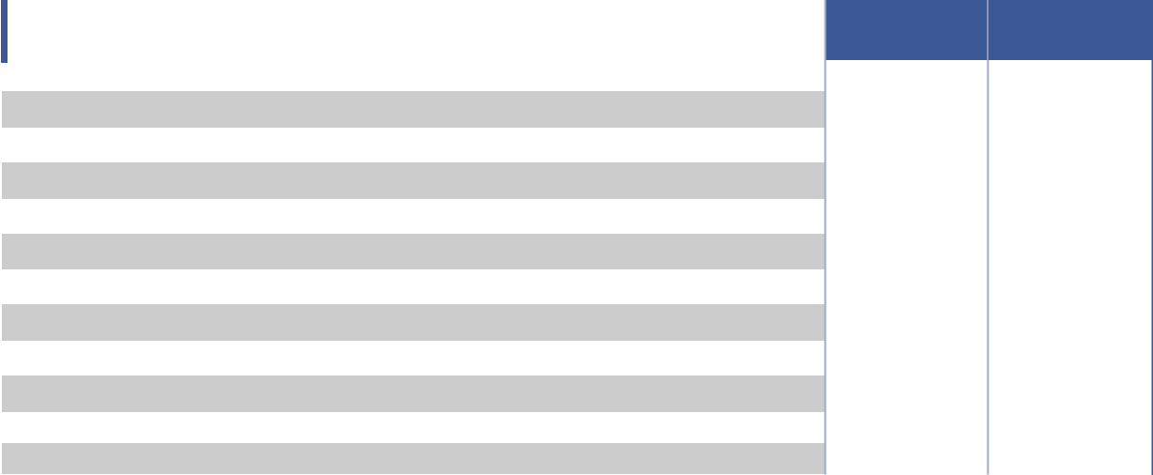

Note: Fiscal year 2021 includes 52 weeks. Fiscal year 2020 includes 53 weeks.

Some of the totals in the table above do not foot due to rounding differences

- Non-cash charges related to stock-based compensation programs, which vary from period to period depending on the timing of awards and performance vesting conditions.

- Reflects write-off of primarily property, equipment and lease related assets on closed or underperforming stores.

- Expenses associated with settlement of certain litigation.

- Amortization of the increase in carrying values of finite-lived intangible assets resulting from the application of purchase accounting to the acquisition of the Company by affiliates of KKR & Co. Inc.

- Amortization of deferred financing costs and other non-cash charges related to our long-term debt, including amortization of the conversion feature related to the 2025 Notes of $10.0 million for fiscal year 2020. We adjust for amortization of deferred financing costs related to the 2025 Notes only when adjusting these costs is not required in the calculation of diluted earnings per share in accordance with the if-converted method under U.S. GAAP. Amortization of debt discount and deferred financing costs total $2.1 million and $11.9 million for fiscal years 2021 and 2020, respectively.

- Reflects losses (gains) recognized in interest expense on change in fair value of de-designated hedges of $(3.3) million and $4.0 million for fiscal years end 2021 and 2020, respectively.
- Other adjustments include the following amounts that management believes are not representative of our operating performance (amounts in brackets represent reductions in Adjusted Operating Income, Adjusted Diluted EPS and Adjusted EBITDA) including our share of (gains) losses on equity method investments of $(2.4) million for fiscal year 2021, and other expenses and adjustments which are primarily related to excess payroll taxes on stock option exercises, executive severance and relocation.

- Tax benefit associated with accounting guidance requiring excess tax benefits related to stock option exercises to be recorded in earnings as discrete items in the reporting period in which they occur.

- Represents the income tax effect of the total adjustments at our combined statutory federal and state income tax rates.

- Reflects other expenses in (g) above, including the impact of stranded tax effect of $(2.1) million for fiscal year 2021 associated with our interest rate swaps that matured in 2021.

64 2022 Proxy Statement

TABLE OF CONTENTS

APPENDIX A​

Reconciliation of Adjusted Comparable Store Sales Growth to Total Comparable Store Sales Growth


 |  |  | Comparable store sales
​​ | ​​ |  | growth^{(a)} |  |  |  | ​
 |  |  | Fiscal Year |  | Fiscal Year
​​ |  | ​​ | 2021 | ​​ | 2020 |  | ​
​Owned & Host segment | ​​ |  | ​ ​ | ​​​ | ​ | ​ | ​​
​America’s Best |  | ​​ | ​​23.5% | ​​​ | ​ | (5.2)% | ​​
​Eyeglass World | ​​ |  | ​​25.2% | ​​​ | ​ | (2.7)% | ​​
​Military |  | ​​ | ​​15.8% | ​​​ | ​(15.5)% |  | ​​
​Fred Meyer | ​​ |  | ​​13.4% | ​​​ | ​(21.6)% |  | ​​
​Legacy segment |  | ​​ | ​​19.3% | ​​​ | ​(12.3)% |  | ​​
​Total comparable store sales growth | ​​ |  | ​​22.4% | ​​​ | ​ | (5.6)% | ​​
​Adjusted Comparable Store Sales Growth^{(b)} |  | ​​ | ​23.0% | ​​​ | ​ | (6.1)% | ​​

Note: Fiscal year 2021 includes 52 weeks. Fiscal year 2020 includes 53 weeks.

- Total comparable store sales is calculated based on consolidated net revenue excluding the impact of (i) Corporate/Other segment net revenue, (ii) sales from stores opened less than 13 months, (iii) stores closed in the periods presented, (iv) sales from partial months of operation when stores do not open or close on the first day of the month, and (v) if applicable, the impact of a 53rd week in a fiscal year. Brand-level comparable store sales growth is calculated based on cash basis revenues consistent with what the CODM reviews, and consistent with reportable segment revenues presented in Note 14. “Segment Reporting” in our consolidated financial statements in our 2021 Form 10-K, with the exception of the Legacy segment, which is adjusted as noted in

  - (ii) below.

- There are two differences between total comparable store sales growth based on consolidated net revenue and Adjusted Comparable Store Sales Growth: (i) Adjusted Comparable Store Sales Growth includes the effect of deferred and unearned revenue as if such revenues were earned at the point of sale, resulting in an increase of 0.7% and a decrease of 0.4% from total comparable store sales growth based on consolidated net revenue for fiscal year 2021 and fiscal year 2021 respectively; and

  - Adjusted Comparable Store Sales Growth includes retail sales to the Legacy partner’s customers (rather than the revenues

recognized consistent with the management & services agreement with the Legacy partner), resulting in a decrease of 0.1% and a decrease of 0.1% from total comparable store sales growth based on consolidated net revenue for the fiscal years 2021 and 2020, respectively.

2022 Proxy Statement 65

TABLE OF CONTENTS

Thank You​

for being a stockholder​
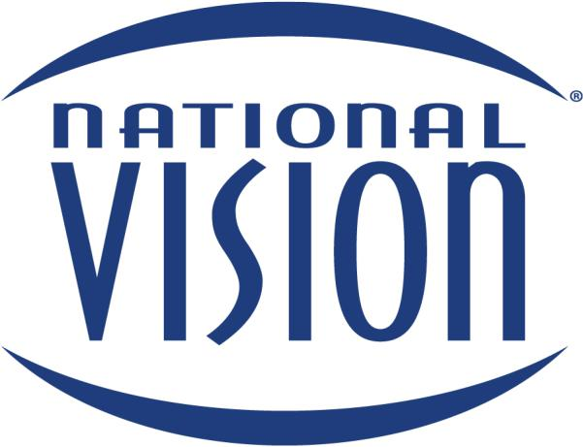


Learn more at www.nationalvision.com

TABLE OF CONTENTS
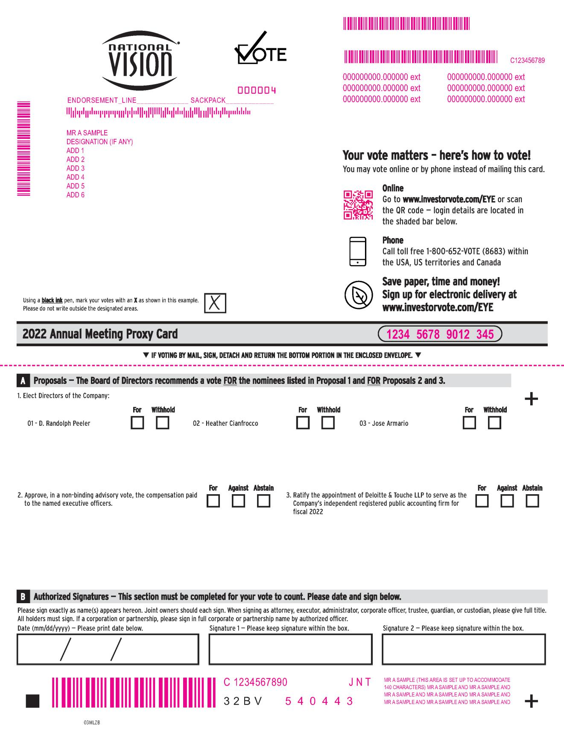

TABLE OF CONTENTS


