TABLE OF CONTENTS
UNITED STATES
SECURITIES AND EXCHANGE COMMISSION
WASHINGTON, D.C. 20549
SCHEDULE 14A​
Proxy Statement Pursuant to Section 14(a) of
the Securities Exchange Act of 1934
(Amendment No. )
Filed by the Registrant ☒ Filed by a Party other than the Registrant ☐
Check the appropriate box:
Preliminary Proxy Statement
☐
​
Confidential, for Use of the Commission Only (as permitted by Rule 14a-6(e)(2))
☐
​
Definitive Proxy Statement
☒
​
Definitive Additional Materials
☐
​
Soliciting Material under §240.14a-12
☐
​
NATIONAL VISION HOLDINGS, INC.​
​
(Name of Registrant as Specified In Its Charter)​

​
(Name of Person(s) Filing Proxy Statement, if other than the Registrant)​
Payment of Filing Fee (Check all boxes that apply):
No fee required.
☒
​
Fee paid previously with preliminary materials.
☐
​
Fee computed on table in exhibit required by Item 25(b) per Exchange Act Rules 14a-6(i)(1) and 0-11
☐
​

TABLE OF CONTENTS
National Vision Holdings, Inc.
2024 Proxy Statement and
Notice of Annual Meeting of Stockholders

Wednesday, June 12, 2024
1:00 p.m. Eastern Time​

TABLE OF CONTENTS
LETTER TO STOCKHOLDERS​
Dear Fellow Stockholders:
Year in Review
​
2023 was a year in which we began to transform our business to better compete in today’s marketplace and we finished the year quite strong with results above our expectations for the year. These results reflect the strength of America’s Best and a noteworthy improvement in Eyeglass World further supported by crisp execution from our teams and successful marketing campaigns at the end of the year. When we started the year, we set out to enhance the foundation for ongoing profitable growth and have made great progress.
We opened 70 new stores in 2023, continuing to capitalize on white space opportunities as store openings remain an important part of our strategic growth initiatives.
•
​
We delivered improved retention of Optometrists and record Optometrist recruitment, with over 10% of all Optometric graduates from the entire class of 2023 joining our network in 2023.
•
​
We expanded our remote care offering into over 200 additional America’s Best locations, and as of year-end we had nearly 550 America’s Best locations remote enabled.
•
​
We continued our store digitization efforts aimed at improving efficiency and productivity. The roll out of Electronic Health Records, or EHR, in America’s Best locations continues to advance and in our corporate office we began the first phase implementation of the back-office ERP project to upgrade our financial systems.
•
​
We made progress in our objective to leverage omni-channel capabilities by continuing to test and progress programs that attract consumers across omni-channel offerings.
•
​
We took actions to adapt our business and cost structure as we enter 2024 and embark on the first chapter of our post-Walmart era.
•
​
Finally, we have continued to implement strategic initiatives to build upon our mission of providing affordable and accessible eyecare and eyewear to all Americans and are very proud that our philanthropic efforts helped 1.4 million people around the world to see better.
•
​
We are grateful to our team’s dedication and focus on driving our initiatives to date and believe we remain well positioned to deliver our objectives including driving value for our shareholders.
Our 2024 Annual Meeting
​
We are pleased to invite you to attend the National Vision Holdings, Inc. 2024 Annual Meeting of Stockholders on Wednesday, June 12, 2024, at 1:00 p.m. Eastern Time. Detailed information concerning the Annual Meeting is set forth in this proxy statement.
Whether you own a few shares or many, and whether or not you plan to attend the Annual Meeting, your vote is important to us, and it is important that your shares be represented and voted during the meeting. We encourage you to review the proxy materials and submit your vote today.
On behalf of the Board of Directors and everyone at National Vision, we are grateful for your continued support. Thank you for being a stockholder of National Vision Holdings, Inc.
Sincerely,
​ | 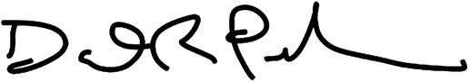 | ​ | ​ | 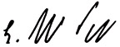 | ​
​ | D. Randolph Peeler  Chairman of the Board of Directors | ​ | ​ | L. Reade Fahs  Chief Executive Officer | ​
April 25, 2024
2024 Proxy Statement i

TABLE OF CONTENTS

Notice of Annual Meeting of Stockholders
​ | Date & Time | ​ | ​ | Wednesday, June 12, 2024, at 1:00 p.m. Eastern Time | ​
​ | Place | ​ | ​ | National Vision Headquarters  2435 Commerce Avenue  Building 2200  Duluth, Georgia 30096 | ​
​ | Items of Business | ​ | ​ | Election of the eight director nominees listed in this proxy statement.  1.  ​ | ​
​ | ​ | ​ | ​ | Advisory vote to approve the compensation of our named executive officers (“Say-on-Pay”).  2.  ​ | ​
​ | ​ | ​ | ​ | Advisory vote on the frequency of future Say-on-Pay votes.  3.  ​ | ​
​ | ​ | ​ | ​ | Approval of amendment and restatement of the 2017 Omnibus Incentive Plan.  4.  ​ | ​
​ | ​ | ​ | ​ | Ratification of the appointment of Deloitte & Touche LLP as our independent registered public accounting firm for 2024.  5.  ​ | ​
​ | ​ | ​ | ​ | To consider such other business as may properly come before the Annual Meeting and any adjournments or postponements thereof.  6.  ​ | ​
​ | Record Date | ​ | ​ | Stockholders of record at the close of business on April 15, 2024, may vote at the Annual Meeting. | ​
​ | How to Vote | ​ | ​ | You may vote your shares prior to June 12, 2024, on the Internet, by telephone or by completing, signing and promptly returning a proxy card, or you may vote in person at the Annual Meeting. | ​
By Order of the Board of Directors,
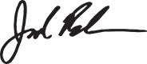
Jared Brandman
Senior Vice President, General Counsel and Secretary
April 25, 2024
​ | ​ | Important Notice Regarding the Availability of Proxy Materials for the Annual Meeting of Stockholders  to be held on Wednesday, June 12, 2024: | ​ | ​
​ | ​ | This Proxy Statement and our Annual Report on Form 10-K for the fiscal year ended December 30, 2023, are available free of charge at www.edocumentview.com/EYE. | ​ | ​
​ | ​ | We made this proxy statement available to stockholders beginning on April 25, 2024. | ​ | ​
ii 2024 Proxy Statement

TABLE OF CONTENTS​

Table of Contents
​ | Proxy Statement Summary | ​ | ​ | ​ | ​ | 1 | ​ | ​
​ | 2024 Annual Meeting of Stockholders | ​ | ​ | ​ | ​ | 1 | ​ | ​
​ | Voting Recommendations | ​ | ​ | ​ | ​ | 1 | ​ | ​
​ | How to Vote | ​ | ​ | ​ | ​ | 1 | ​ | ​
​ | 2023 Business Highlights | ​ | ​ | ​ | ​ | 2 | ​ | ​
​ | Our Board of Directors | ​ | ​ | ​ | ​ | 3 | ​ | ​
​ | Corporate Governance Highlights | ​ | ​ | ​ | ​ | 5 | ​ | ​
​ | Sustainability & Human Capital Management | ​ | ​ | ​ | ​ | 6 | ​ | ​
​ | Executive Compensation Highlights | ​ | ​ | ​ | ​ | 7 | ​ | ​
​ | Corporate Governance Matters | ​ | ​ | ​ | ​ | 8 | ​ | ​
​ | Proposal 1—Election of Directors | ​ | ​ | ​ | ​ | 8 | ​ | ​
​ | Nominees for Election to the Board of Directors | ​ | ​ | ​ | ​ | 8 | ​ | ​
​ | Corporate Governance Highlights | ​ | ​ | ​ | ​ | 15 | ​ | ​
​ | Board and Committee Governance | ​ | ​ | ​ | ​ | 16 | ​ | ​
​ | Board Committees | ​ | ​ | ​ | ​ | 17 | ​ | ​
​ | Board Oversight | ​ | ​ | ​ | ​ | 18 | ​ | ​
​ | Board and Committee Evaluations | ​ | ​ | ​ | ​ | 20 | ​ | ​
​ | Code of Conduct | ​ | ​ | ​ | ​ | 20 | ​ | ​
​ | Hedging and Pledging Policies | ​ | ​ | ​ | ​ | 21 | ​ | ​
​ | Transactions with Related Persons | ​ | ​ | ​ | ​ | 21 | ​ | ​
​ | Director Compensation | ​ | ​ | ​ | ​ | 21 | ​ | ​
​ | Communications with the Board | ​ | ​ | ​ | ​ | 24 | ​ | ​
​ | Stockholder Engagement | ​ | ​ | ​ | ​ | 24 | ​ | ​
​ | Sustainability & Human Capital Management | ​ | ​ | ​ | ​ | 25 | ​ | ​
​ | Sustainability | ​ | ​ | ​ | ​ | 25 | ​ | ​
​ | Human Capital Management | ​ | ​ | ​ | ​ | 27 | ​ | ​
​ | Executive Compensation | ​ | ​ | ​ | ​ | 30 | ​ | ​
​ | Proposal 2—Advisory Vote to Approve the Compensation of our Named Executive Officers | ​ | ​ | ​ | ​ | 30 | ​ | ​
​ | Compensation Discussion and Analysis | ​ | ​ | ​ | ​ | 31 | ​ | ​
​ | Compensation Committee Report | ​ | ​ | ​ | ​ | 41 | ​ | ​
​ | Executive Compensation Tables | ​ | ​ | ​ | ​ | 42 | ​ | ​
​ | Compensation Committee Interlocks and Insider Participation | ​ | ​ | ​ | ​ | 49 | ​ | ​
​ | Equity Compensation Plan Information | ​ | ​ | ​ | ​ | 49 | ​ | ​
​ | CEO Pay Ratio | ​ | ​ | ​ | ​ | 50 | ​ | ​
​ | Pay Versus Performance | ​ | ​ | ​ | ​ | 51 | ​ | ​
​ | Proposal 3—Advisory Vote on the Frequency of Future Say-on-Pay Votes | ​ | ​ | ​ | ​ | 55 | ​ | ​
​ | Ownership of Our Securities | ​ | ​ | ​ | ​ | 56 | ​ | ​
​ | Beneficial Ownership of National Vision Common Stock | ​ | ​ | ​ | ​ | 56 | ​ | ​
2024 Proxy Statement iii

TABLE OF CONTENTS​

​ | Proposal 4—Approval of Amendment and Restatement of the 2017 Omnibus Incentive Plan | ​ | ​ | ​ | ​ | 58 | ​ | ​
​ | Increasing the Number of Shares Reserved for Issuance under the Equity Plan | ​ | ​ | ​ | ​ | 58 | ​ | ​
​ | Summary of the Equity Plan | ​ | ​ | ​ | ​ | 60 | ​ | ​
​ | New Plan Benefits; Market Value of Securities | ​ | ​ | ​ | ​ | 66 | ​ | ​
​ | Awards Granted under the Equity Plan | ​ | ​ | ​ | ​ | 67 | ​ | ​
​ | Audit Committee Matters | ​ | ​ | ​ | ​ | 68 | ​ | ​
​ | Proposal 5—Ratification of the Appointment of Deloitte & Touche LLP as our Independent Registered Public Accounting Firm for 2024 | ​ | ​ | ​ | ​ | 68 | ​ | ​
​ | Audit and Non-Audit Fees | ​ | ​ | ​ | ​ | 69 | ​ | ​
​ | Audit Committee Pre-Approval of Audit and Permissible Non-Audit Services | ​ | ​ | ​ | ​ | 69 | ​ | ​
​ | Report of the Audit Committee | ​ | ​ | ​ | ​ | 69 | ​ | ​
​ | Important Information About Voting at the Annual Meeting | ​ | ​ | ​ | ​ | 71 | ​ | ​
​ | Proposals to be Voting on and Voting Recommendations | ​ | ​ | ​ | ​ | 71 | ​ | ​
​ | Other Business | ​ | ​ | ​ | ​ | 71 | ​ | ​
​ | Who Can Vote | ​ | ​ | ​ | ​ | 71 | ​ | ​
​ | Quorum | ​ | ​ | ​ | ​ | 71 | ​ | ​
​ | Vote Required | ​ | ​ | ​ | ​ | 72 | ​ | ​
​ | Voting in Advance of the Annual Meeting | ​ | ​ | ​ | ​ | 72 | ​ | ​
​ | Voting During the Annual Meeting | ​ | ​ | ​ | ​ | 72 | ​ | ​
​ | How to Vote if a Bank, Broker, or Other Nominee is the Record Holder of Your Stock | ​ | ​ | ​ | ​ | 72 | ​ | ​
​ | Broker Voting and Broker Non-Votes | ​ | ​ | ​ | ​ | 73 | ​ | ​
​ | How to Change or Revoke Your Proxy | ​ | ​ | ​ | ​ | 73 | ​ | ​
​ | How Votes are Counted | ​ | ​ | ​ | ​ | 73 | ​ | ​
​ | Proxies | ​ | ​ | ​ | ​ | 73 | ​ | ​
​ | Other Information for Stockholders | ​ | ​ | ​ | ​ | 74 | ​ | ​
​ | Attending the Annual Meeting | ​ | ​ | ​ | ​ | 74 | ​ | ​
​ | Stockholder Proposals for the 2025 Annual Meeting | ​ | ​ | ​ | ​ | 74 | ​ | ​
​ | Householding of Proxy Materials | ​ | ​ | ​ | ​ | 75 | ​ | ​
​ | Solicitation of Proxies | ​ | ​ | ​ | ​ | 75 | ​ | ​
​ | Important Notice Regarding the Availability of Proxy Materials | ​ | ​ | ​ | ​ | 75 | ​ | ​
​ | Forward-Looking Statements | ​ | ​ | ​ | ​ | 76 | ​ | ​
​ | Appendix A | ​ | ​ | ​ | ​ | 77 | ​ | ​
​ | Non-GAAP Financial Measures | ​ | ​ | ​ | ​ | 77 | ​ | ​
​ | Appendix B | ​ | ​ | ​ | ​ | 82 | ​ | ​
​ | National Vision Holdings, Inc. 2017 Omnibus Incentive Plan (marked) | ​ | ​ | ​ | ​ | 82 | ​ | ​
iv 2024 Proxy Statement

TABLE OF CONTENTS​​​​
PROXY STATEMENT SUMMARY​
Proxy Statement Summary
We are providing this proxy statement to you in connection with the solicitation of proxies by the Board of Directors (the “Board of Directors,” or the “Board”) of National Vision Holdings, Inc. (the “Company”) for the 2024 Annual Meeting of Stockholders (the “Annual Meeting”) and for any adjournment or postponement of the Annual Meeting. This summary highlights information contained elsewhere in this proxy statement. This summary does not contain all of the information you should consider and you should read the entire proxy statement carefully before voting.
2024 Annual Meeting of Stockholders
​
​ | ​ | Date & Time | ​ | ​ | ​ | Location | ​ | ​ | ​ | Record Date | ​ | ​
​ | ​ | June 12, 2024  1:00 p.m. Eastern Time | ​ | ​ | ​ | National Vision’s Headquarters  2435 Commerce Avenue  Building 2200  Duluth, Georgia 30096 | ​ | ​ | ​ | April 15, 2024 | ​ | ​
Voting Recommendations
​
​ | ​ | Company Proposals | ​ | ​ | ​ | Board Vote  Recommendation | ​ | ​ | ​ | For Further  Details | ​ | ​
​ | ​ | Election of the eight director nominees listed in this proxy statement.  Proposal 1:  ​ | ​ | ​ | ​ | FOR  all nominees | ​ | ​ | ​ | Page 8 | ​ | ​
​ | ​ | Advisory vote to approve the compensation of our named executive officers (“Say-on-Pay”).  Proposal 2:  ​ | ​ | ​ | ​ | FOR | ​ | ​ | ​ | Page 30 | ​ | ​
​ | ​ | Advisory vote on the frequency of future Say-on-Pay votes.  Proposal 3:  ​ | ​ | ​ | ​ | ONE YEAR | ​ | ​ | ​ | Page 55 | ​ | ​
​ | ​ | Approval of amendment and restatement of the 2017 Omnibus Incentive Plan.  Proposal 4:  ​ | ​ | ​ | ​ | FOR | ​ | ​ | ​ | Page 58 | ​ | ​
​ | ​ | Ratification of the appointment of Deloitte & Touche LLP as our independent registered public accounting firm for 2024.  Proposal 5:  ​ | ​ | ​ | ​ | FOR | ​ | ​ | ​ | Page 68 | ​ | ​
How to Vote
​
​ | ​ | By Internet | ​ | ​ | ​ | By Telephone | ​ | ​ | ​ | By Mail | ​ | ​ | ​ | In Person | ​ | ​
​ | ​ | Visit www.investorvote.com/EYE | ​ | ​ | ​ | Dial 1-800-652-VOTE | ​ | ​ | ​ | Sign, date and return your proxy card by mail | ​ | ​ | ​ | Attend our Annual Meeting and cast your vote during the meeting | ​ | ​
Stockholders of record at the close of business on April 15, 2024, may vote at the Annual Meeting.
See full instructions under the heading “Important Information About Voting at the Annual Meeting.”
If you are a stockholder of record and you would like to vote in any manner other than in person during the Annual Meeting, your vote must be received by 11:59 p.m. Eastern Time, on June 11, 2024, to be counted. If you hold shares through a broker, bank or other nominee, please refer to information from your bank, broker or nominee for voting instructions.
2024 Proxy Statement 1

TABLE OF CONTENTS​
PROXY STATEMENT SUMMARY
2023 Business Highlights
​
2023 was a year in which we began to transform our business to better compete in today’s marketplace and adapt our business and cost structure. When we started, we set out to enhance the foundation for ongoing profitable growth and we have made great progress, finishing the year with results above our expectations for the year.
As we enter 2024, we are building on the progress made with our 2023 key strategic initiatives, including continuing to expand exam capacity, furthering the digitization of our stores and corporate office, leveraging our omni-channel capabilities and capitalizing on our whitespace opportunity. The Company’s store partnership with Walmart Inc. ended as of February 2024, and the transition of 229Walmart Vision Center stores has been completed. While the uncertain macro environment, inflationary pressures and our investments in key initiatives will weigh on profitability in the near-term, we expect to be well positioned for continued success and improved market position longer term. 2023 business highlights included the following:
Overall store count grew 4.4% to 1,413 stores
•
​
Comparable store sales growth was 3.1%, and Adjusted Comparable Store Sales Growth was 2.9%
•
​
Net revenue increased 6% over 2022 to $2,126.5 million
•
​
Net income (loss) of $(65.9) million and Diluted EPS of $(0.84), inclusive of non-cash impairment charges of $79.7 million and $7.0 million in expenses related to the termination of the Walmart partnership
•
​
Adjusted Operating Income of $72.3 million compared with $87.8 million in fiscal year 2022
•
​
Adjusted Diluted EPS of $0.64 compared with $0.65 in fiscal year 2022
•
​
We returned $25.0 million to stockholders through share repurchases
•
​
Cash flows from operating activities were $173.0 million, compared to $119.2 million in fiscal year 2022
•
​
​ | 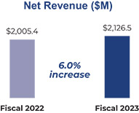 | ​ | ​ | 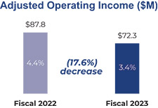 | ​ | ​ | 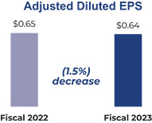 | ​
In this proxy statement, we discuss financial measures that are referred to as non-GAAP financial measures, including adjusted comparable store sales growth, adjusted operating income, adjusted diluted EPS and annual incentive adjusted operating income. See Appendix A to this proxy statement for more information regarding these measures and reconciliations to the most directly comparable GAAP measures.
These financial highlights are reproduced from our Annual Report on Form 10-K for the fiscal year ended December 30, 2023, and speak as of February 27, 2024, the date we filed our Form 10-K with the SEC, unless clearly indicated otherwise.
2 2024 Proxy Statement

TABLE OF CONTENTS​
PROXY STATEMENT SUMMARY​
Our Board of Directors
​
The fundamental duty of the Board is to oversee our strategy and the long-term interests of our stockholders. The following provides summary information about our current directors, individually, and our nominees for director in the aggregate. See “Proposal 1—Election of Directors” for more details on our director nominees’ qualifications, skills and experience.
​ | ​ | ​ | ​ | ​ | ​ | ​ | ​ | ​ | ​ | ​ | ​ | ​ | ​ | ​ | ​ | ​ | ​ | ​ | ​ | ​ | ​ | Committee Membership |  |  |  |  |  |  |  |  | ​ | ​
​ | ​ | Directors | ​ | ​ | ​ | Occupation | ​ | ​ | ​ | Age | ​ | ​ | ​ | Director  Since | ​ | ​ | ​ | Independent | ​ | ​ | ​ | Audit  Committee | ​ | ​ | ​ | Compensation  Committee | ​ | ​ | ​ | Nominating  and  Corporate  Governance  Committee | ​ | ​
​ | ​ | L. Reade Fahs | ​ | ​ | ​ | Chief Executive Officer, National Vision Holdings, Inc. | ​ | ​ | ​ | 63 | ​ | ​ | ​ | 2014 | ​ | ​ | ​ | ​ | ​ | ​ | ​ | ​ | ​ | ​ | ​ | ​ | ​ | ​ | ​ | ​ | ​ | ​
​ | ​ | D. Randolph Peeler | ​ | ​ | ​ | Managing Director, Berkshire Partners, LLC | ​ | ​ | ​ | 59 | ​ | ​ | ​ | 2014 | ​ | ​ | ​ |  | ​ | ​ | ​ | ​ | ​ | ​ | ​ |  | ​ | ​ | ​ |  | ​ | ​
​ | ​ | Jose Armario | ​ | ​ | ​ | Chief Executive Officer, Bojangles’, Inc. | ​ | ​ | ​ | 65 | ​ | ​ | ​ | 2021 | ​ | ​ | ​ |  | ​ | ​ | ​ | ​ | ​ | ​ | ​ | ​ | ​ | ​ | ​ |  | ​ | ​
​ | ​ | Virginia A. Hepner | ​ | ​ | ​ | Retired Chief Executive Officer, The Woodruff Arts Center | ​ | ​ | ​ | 66 | ​ | ​ | ​ | 2018 | ​ | ​ | ​ |  | ​ | ​ | ​ |  | ​ | ​ | ​ | ​ | ​ | ​ | ​ |  | ​ | ​
​ | ​ | Susan S. Johnson | ​ | ​ | ​ | Retired Chief Marketing Officer, Prudential Financial, Inc. | ​ | ​ | ​ | 58 | ​ | ​ | ​ | 2020 | ​ | ​ | ​ |  | ​ | ​ | ​ |  | ​ | ​ | ​ | ​ | ​ | ​ | ​ | ​ | ​ | ​
​ | ​ | Naomi Kelman | ​ | ​ | ​ | Retired President & Chief Executive Officer, Willow | ​ | ​ | ​ | 65 | ​ | ​ | ​ | 2020 | ​ | ​ | ​ |  | ​ | ​ | ​ |  | ​ | ​ | ​ |  | ​ | ​ | ​ | ​ | ​ | ​
​ | ​ | Susan O’Farrell | ​ | ​ | ​ | Retired Chief Financial Officer, Bluelinx Holdings, Inc. | ​ | ​ | ​ | 60 | ​ | ​ | ​ | 2024 | ​ | ​ | ​ |  | ​ | ​ | ​ |  | ​ | ​ | ​ | ​ | ​ | ​ | ​ | ​ | ​ | ​
​ | ​ | Thomas V.  Taylor, Jr. | ​ | ​ | ​ | Chief Executive Officer, Floor & Decor Holdings, Inc. | ​ | ​ | ​ | 58 | ​ | ​ | ​ | 2018 | ​ | ​ | ​ |  | ​ | ​ | ​ | ​ | ​ | ​ | ​ |  | ​ | ​ | ​ | ​ | ​ | ​
​ | ​ | David M. Tehle | ​ | ​ | ​ | Retired Executive Vice President and Chief Financial Officer, Dollar General Corporation | ​ | ​ | ​ | 67 | ​ | ​ | ​ | 2017 | ​ | ​ | ​ |  | ​ | ​ | ​ |  | ​ | ​ | ​ | ​ | ​ | ​ | ​ | ​ | ​ | ​
Chair
2024 Proxy Statement 3

TABLE OF CONTENTS
PROXY STATEMENT SUMMARY
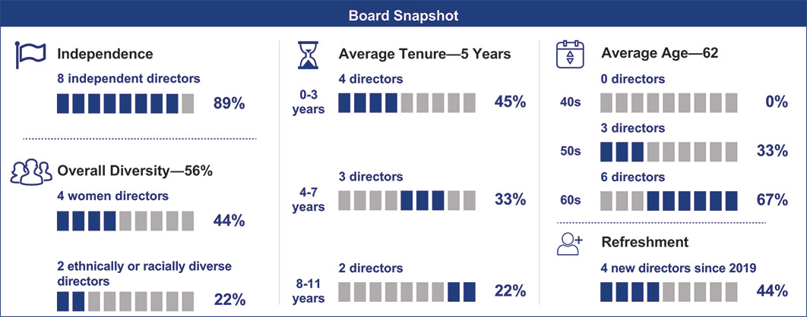
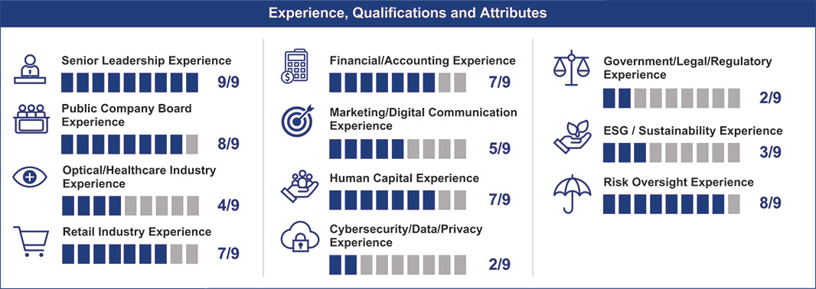
4 2024 Proxy Statement

TABLE OF CONTENTS​
PROXY STATEMENT SUMMARY​
Corporate Governance Highlights
​
We maintain robust governance and Board practices that promote independence, accountability and effectiveness in the boardroom.
Key Governance Developments
​ | Board Refreshment | ​ | ​ | In the last year, we added one new director while another longer-tenured director transitioned off the Board. We also refreshed our committee composition. | ​
​ | Majority Voting | ​ | ​ | In 2023, our Board of Directors amended our bylaws to provide for majority voting in uncontested director elections. | ​
​ | Declassified Board | ​ | ​ | Following the stockholder approval of an amendment to our certificate of incorporation in 2021, we have completed the phase out of the classified structure of the Board. Beginning with the Annual Meeting, all directors will stand for election annually. | ​
​ | Enhanced Governance | ​ | ​ | In addition to implementing a majority vote standard, our bylaws were amended in 2023 to enhance our corporate governance practices by, among other items:  Permitting special meetings of the Board to be called on less than 24 hours’ notice  •  ​  Enhancing procedures for Board review of related party transactions  •  ​  Aligning with new universal proxy rules and recent amendments to the DGCL  •  ​ | ​
​ | Clawback Policy | ​ | ​ | In October 2023, the compensation committee adopted the Incentive Compensation Recovery Policy, which is compliant with SEC and Nasdaq requirements. | ​
​ | ​ | Corporate Governance and Board Practices |  |  |  |  | ​ | ​
​ | ​ | All directors are elected annually  ✓  ​  Majority voting in uncontested director elections  ✓  ​  Updated bylaws to enhance corporate governance practices  ✓  ​  Independent Chair of the Board  ✓  ​  Seven of eight director nominees are independent  ✓  ​  All committee members are independent  ✓  ​  Seven new independent directors since IPO  ✓  ​  Seven experienced current and former CEOs/​CFOs  ✓  ​  Of our eight director nominees, four are female and two are racially or ethnically diverse  ✓  ​ | ​ | ​ | ​ | Regular review of committee charters and Corporate Governance Guidelines incorporating evolving best practices  ✓  ​  Strong stockholder engagement program  ✓  ​  Annual Board and committee self-assessments  ✓  ​  Regular Board executive sessions without management  ✓  ​  Formal Board and committee oversight of our business strategy, enterprise risk management, compensation strategy, and sustainability program and strategy  ✓  ​  Robust director and executive stock ownership guidelines  ✓  ​ | ​ | ​
2024 Proxy Statement 5

TABLE OF CONTENTS​
PROXY STATEMENT SUMMARY
Sustainability & Human Capital Management
​
Sustainability is foundational to who we are as a company, including our commitment to balancing the social, economic, human capital management and environmental aspects of our business. In October 2023, we published our second Sustainability Report, for fiscal year 2022, detailing our corporate sustainability framework of societal impact, employees, environment and governance (SEE+G) and our progress during 2022. Our SEE+G framework guides our efforts.
SEE+G Highlights
Below are just a few of the efforts we highlighted in our 2022 Sustainability Report.
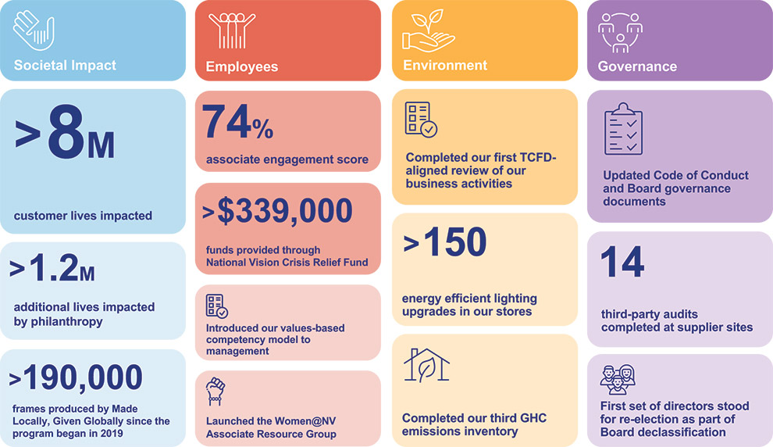
See “Corporate Governance Matters—Sustainability & Human Capital Management” for a more detailed discussion of our SEE+G and ESG governance frameworks.
We focused our efforts in 2023 on continuing to build a strong foundation for the success of our business and, by extension, our philanthropic impact.
We drove positive Societal Impact by expanding our remote care offering, continuing to work with Americares to progress our goal of helping 500,000 of the country’s most vulnerable see and furthering our philanthropic efforts toward helping 5 million people see through the end of 2025. In 2023, 2020 Quest, National Vision’s charitable foundation, was selected to serve on the SPECS network, the World Health Organizations initiative to end the Global Vision Crisis.
•
​
We supported our Employees by continuing to survey associates and optometrists and using their feedback to inform our business plans and investing in the training and development of our store teams to help them become better optical leaders.
•
​
We continued our commitment to the Environment by completing both our energy efficient lighting upgrade and waste audit programs in 2023 and identifying ways to automate processes to further increase our efficient, including by beginning our transition to an electronic healthcare record platform, which we expect to be implemented in all America’s Best locations by the end of 2024.
•
​
6 2024 Proxy Statement

TABLE OF CONTENTS​
PROXY STATEMENT SUMMARY​
We enhanced our Governance practices by taking key actions to advance our commitment to good corporate governance as highlighted under “Corporate Governance—Key Governance Developments” and continuing to develop our supply chain strategy.
•
​
Moving forward, we will continue to strategically progress our SEE+G initiatives, partnerships and infrastructure, while remaining focused on areas that will help us help others to see better.
Executive Compensation Highlights
​
We strive to create an executive compensation program that strikes the right balance of pay for performance with an overarching goal to motivate our leaders to contribute to the achievement of our financial goals and focus on long-term value for our stockholders. Our executive compensation program has three main components: (1) base salary; (2) annual cash incentive compensation; and (3) long-term incentive awards. Each component is designed to be consistent with our compensation philosophy.
The compensation and governance practices that support these principles include the following:
​ | ​ | What We Do: | ​ | ​ | ​ | What We Don’t Do: | ​ | ​
​ | ​ | Pay for performance, with high percentages of performance-based and long-term equity compensation  ✓  ​  Grant performance stock units that vest based on the achievement of performance goals over a three-year performance period  ✓  ​  Award annual cash incentives based on performance against predefined performance metrics  ✓  ​  Maintain robust stock ownership guidelines for our NEOs and directors  ✓  ​  Chief Executive Officer—6x annual base salary  •  ​  Other NEOs—3x annual base salary  •  ​  Directors—5x annual cash retainer  •  ​  Review our compensation programs and strategy annually with robust Board and committee oversight  ✓  ​  Hold an annual Say-on-Pay vote supported by a strong stockholder engagement strategy  ✓  ​  Require “Double-Trigger” vesting for change in control provisions  ✓  ​  Maintain an incentive compensation recovery (“clawback”) policy  ✓  ​  Retain an independent compensation consultant  ✓  ​ | ​ | ​ | ​ | No excise tax gross-ups  ✗  ​  No hedging of the Company’s stock by NEOs or directors  ✗  ​  No supplemental executive retirement plans  ✗  ​  No option repricing without stockholder approval  ✗  ​  No significant perquisites for executive officers  ✗  ​ | ​ | ​
See “Executive Compensation” for a detailed discussion of the design and evolution of our executive compensation program.
2024 Proxy Statement 7

TABLE OF CONTENTS​​​
CORPORATE GOVERNANCE MATTERS
CORPORATE GOVERNANCE MATTERS
Proposal 1—Election of Directors
​ | ​ | The Board recommends that you vote “FOR” all of the director nominees listed.​ |  |  |  |  | ​ | ​
​ | ​ | What Am I  Voting on? | ​ | ​ | ​ | We are asking stockholders to elect the eight director nominees listed below for election at the Annual Meeting for a term of one year. If elected, each director will hold office until the 2025 annual meeting and until their respective successors are elected and qualified. | ​ | ​
​ | ​ | Vote  Required | ​ | ​ | ​ | To be elected, a director must receive a majority of the votes cast in respect of the shares present in person or represented by proxy at the meeting and entitled to vote on the election of directors (meaning the number of shares voted “FOR” a nominee must exceed the number of shares voted “AGAINST” such nominee). “Abstentions” and “broker non-votes” will not be counted as a vote cast either “FOR” or “AGAINST” a nominee’s election. | ​ | ​
Nominees for Election to the Board of Directors
​
Presented on the following pages are the eight director nominees recommended by the Board of Directors for election at the Annual Meeting.
Upon the recommendation of the nominating and corporate governance committee, the Board has nominated D. Randolph Peeler, L. Reade Fahs, Jose Armario, Virginia A. Hepner, Susan S. Johnson, Naomi Kelman, Susan O’Farrell and Thomas V. Taylor, Jr. for re-election as directors for a one-year term expiring at the 2025 annual meeting. Mr. Tehle will not stand for re-election and his term will expire at the Annual Meeting.
All of the nominees listed in this proxy statement are incumbent directors, whose terms expire on the date of the Annual Meeting. With the exception of Mr. Fahs, our Chief Executive Officer, all are independent directors. The nominating and corporate governance committee evaluated and recommended each director nominee in accordance with its charter and our Corporate Governance Guidelines. We have no reason to believe that any of the director nominees will be unable or unwilling to serve if elected; however, in the unlikely event that any of them ceases to be a candidate for election by the time of the Annual Meeting, proxies may be voted for a substitute nominee recommended by the Board, or the Board may elect to reduce its size.
Board Refreshment
Susan O’Farrell was appointed to the Board in February 2024 and serves on the audit committee. She brings a wealth of both retail and multi-industry knowledge to the Board and her nomination was based on her financial and operational experience encompassing IT, procurement, supply chain and logistics in growth and transformational environments. Ms. O’Farrell was identified and evaluated through a director search process overseen by the nominating and corporate governance committee.
•
​
David M. Tehle, who joined the Board in 2017, will not stand for reelection at the Annual Meeting and will be departing as a director immediately following the Annual Meeting. The Board thanks Mr. Tehle for his years of service and commitment to the Company and its stockholders. He has made meaningful contributions to the Board throughout his tenure, including as chair of the audit committee.
•
​
Mr. Tehle’s departure is in no way due to any disagreement with the Company, nor is it the result of a removal “for cause.” As a result, the size of the Board will be reduced from nine to eight. Following the Annual Meeting, it is expected that the Company will have no open director seats.
8 2024 Proxy Statement

TABLE OF CONTENTS
CORPORATE GOVERNANCE MATTERS​
Biographical Information
The following pages set forth biographical information, including a description of their principal occupation, business experience, and the primary qualifications, attributes, and skills (represented by the icons below) that the nominating and corporate governance committee considered in recommending them as director nominees, as well as the Board committees on which each director nominee will serve as of the Annual Meeting.
​ |   Director since: 2014  Age: 59  Independent  Committees:  Compensation Committee  Nominating and Corporate  Governance Committee | ​ | ​ | D. Randolph Peeler  Board Chair  ​  Mr. Peeler has served as the Chair of our Board of Directors since 2020. Mr. Peeler is a Senior Advisor at Berkshire Partners LLC (“Berkshire”), a private equity firm. Mr. Peeler joined Berkshire in 1996 and became a Managing Director in 2000. Mr. Peeler brings to our Board of Directors acquisition and capital market transactions knowledge from years of experience in the private equity industry, along with board experience from serving as a director of several of Berkshire’s current or former portfolio companies, industry experience in the optical/healthcare and retail industries, senior leadership experience, financial/accounting experience, human capital experience and public company board and risk oversight experience.  Prior Experience  Co-founded a privately-owned healthcare services company  •  ​  Special Assistant for the Assistant Secretary for Economic Policy in the U.S. Department of the Treasury  •  ​  Consultant with Cannon Associates and Bain & Co.  •  ​  Other Directorships  DVx Ventures, a venture studio with a unique approach to building companies from concept to scale (private)  •  ​  CPK Media, LLC d/b/a Christopher Kimball’s Milk Street Kitchen, a multi-channel food media company (private)  •  ​ | ​
​ |   Director since: 2014  Age: 63 | ​ | ​ | L. Reade Fahs  ​  Mr. Fahs has served as the Chief Executive Officer of the Company since 2014. Prior to our initial public offering, Mr. Fahs served as the President and Chief Executive officer of National Vision, Inc. (“NVI”) beginning in 2003, having joined NVI in 2002 as President and Chief Operating Officer. Mr. Fahs brings a unique perspective to our Board as our CEO and with his extensive knowledge of the Company, its operations, and business, along with senior leadership, public company board and risk oversight experience, in additional to his optical and retail industry knowledge, marketing and human capital experience.  Prior Experience  Chief Executive Officer of First Tuesday, a professional networking forum for established technology entrepreneurs and companies (1999-2001)  •  ​  Managing Director of Vision Express U.K., a leading optical retailer (1997-1999)  •  ​  Various positions at LensCrafters, a leading eyewear retailer (1986-1996)  •  ​  Other Directorships  Board Observer and Roving Ambassador (February 2024-present) and Chairman (2006-2024) of VisionSpring, a social enterprise that works to ensure affordable access to eyewear  •  ​  Restoring Vision, a nonprofit organization committed to ending the global vision crisis  •  ​  PetVet Care Centers, a network of locally owned general practice, specialty, emergency and equine veterinary hospitals (private)  •  ​ | ​
2024 Proxy Statement 9

TABLE OF CONTENTS
CORPORATE GOVERNANCE MATTERS
​ |   Director since: 2021  Age: 65  Independent  Committees:  Nominating and Corporate Governance Committee | ​ | ​ | Jose Armario  ​  Mr. Armario has served as the Chief Executive Officer and President and a member of the board of directors of Bojangles’, Inc. (“Bojangles”), a restaurant operator and franchisor, since 2019. Mr. Armario brings to our Board senior leadership, public company board, financial and accounting, risk oversight and retail industry experience from his role as Chief Executive Officer of Bojangles, prior executive positions and board work, along with optical and healthcare industry, marketing, ESG and sustainability, and human capital management experience.  Prior Experience  Founder and Chief Executive Officer of consulting firms Armario Enterprises, LLC and PowerC,LLC, (2016-2019)  •  ​  Corporate Executive Vice President, Supply Chain, Development and Franchising of McDonald’s Corporation (2011-2015)  •  ​  Various leadership positions at McDonald’s Corporation (1996-2011)  •  ​  Other Directorships  Bojangles, Inc. (private)  •  ​  Golden State Foods, a global food services and logistics company specializing in quick-service restaurants (private)  •  ​ | ​
​ |   Director since: 2018  Age: 66  Independent  Committees:  Nominating and Corporate  Governance Committee (Chair)  Audit Committee | ​ | ​ | Virginia A. Hepner  ​  Ms. Hepner most recently served as the President and Chief Executive Officer, and is a Life Trustee, of The Woodruff Arts Center in Atlanta, Georgia, from 2012 to 2017. Ms. Hepner brings to our Board senior leadership experience, public company board knowledge and risk oversight experience from her time as CEO of The Woodruff Arts Center and other board positions, government/regulatory experience and ESG/sustainability and human capital experience, along with over 25 years of financial and accounting experience.  Prior Experience  Investor in GHL, Inc., a real estate partnership for commercial properties in metro Atlanta (2005-2022)  •  ​  Strategic Advisor at DMI Music & Media Solutions, a full-service entertainment and music company (2011-2019)  •  ​  Executive Vice President and various other leadership positions at Wachovia Bank and its predecessors (1979-2005)  •  ​  Other Directorships  Oxford Industries, a leader in the apparel industry (public)  •  ​  Cadence Bancorporation, a commercial banking company (public) (audit committee chair)  •  ​  State Bank & Trust Company, now a division of Cadence Bank (2010-2019)  •  ​ | ​
10 2024 Proxy Statement

TABLE OF CONTENTS
CORPORATE GOVERNANCE MATTERS​
​ |   Director since: 2020  Age: 58  Independent  Committees:  Audit Committee | ​ | ​ | Susan Somersille Johnson  ​  Ms. Johnson most recently served as the Chief Marketing Officer for Prudential Financial, Inc., a provider of financial products and services, from 2020 to 2024. Ms. Johnson brings to our Board of Directors extensive marketing and digital communication, retail, ESG and sustainability, and financial and accounting experience, along with senior leadership, public company board and risk oversight experience.  Prior Experience  Executive Vice President and Chief Marketing Officer of Truist Financial, a bank holding company, a full-service entertainment and music company (2014-2020)  •  ​  Vice President, Global Marketing, of NCR Corporation, a software, consulting and technology company (2012-2014)  •  ​  Global Head of Customer Marketing; Head of Software Marketing Programs, of Nokia Corporation, a telecommunications company (2007-2012)  •  ​  Other Directorships  Constellation Brands, a leading international producer and marketer of beer, wine, and spirits (public) (2017-2024)  •  ​ | ​
​ |   Director since: 2020  Age: 65  Independent  Committees:  Audit Committee  Compensation Committee | ​ | ​ | Naomi Kelman  ​  Ms. Kelman most recently served as President and Chief Executive Officer of Willow Innovations, Inc., a revolutionary women’s health company, from 2014 to 2019. Ms. Kelman brings to our Board of Directors extensive knowledge of the healthcare industry and senior leadership, marketing and digital communication, government/regulatory and human capital knowledge from her time as CEO of Willow and prior leadership roles in the optical and healthcare industries.  Prior Experience  Global Division Head of Novartis OTC, a division of Novartis, a healthcare company (2011-2012)  •  ​  Various executive roles at Johnson & Johnson, a focused healthcare company (2000-2011)  •  ​  President, Lifescan North America, One Touch diabetes business (2009-2011)  •  ​  President, Vistakon Americas (Acuvue Contact Lenses), a division of Johnson & Johnson Vision Care (2004-2009)  •  ​  Other Directorships  Mirvie, a biotechnology company (private)  •  ​  Brilliant Home Technology, Inc., a smart home technology company (private)  •  ​  Blue River PetCare (Chair), a leading operator of veterinary hospitals (private)  •  ​ | ​
2024 Proxy Statement 11

TABLE OF CONTENTS
CORPORATE GOVERNANCE MATTERS
​ |   Director since: 2024  Age: 60  Independent  Committees:  Audit Committee | ​ | ​ | Susan O’Farrell​  ​  Ms. O’Farrell most recently served as Chief Financial Officer, Principal Accounting Officer and Treasurer at BlueLinx Holdings, Inc., a wholesale distributor of building and industrial products from 2014 to 2020. Ms. O’Farrell brings to the Board a wealth of financial and operational experience encompassing IT, procurement, supply chain and logistics in growth and transformational environments and is qualified financial expert and a holder of the CERT Certificate in Cybersecurity Oversight from Carnegie Mellon. Ms. O’Farrell was identified and evaluated through a director search process overseen by the nominating and corporate governance committee.  Prior Experience  Senior financial executive in various roles at The Home Depot, a leading home improvement omni-channel retailer (1999-2014)  •  ​  Director of Southern Company Gas, formerly AGL Resources, an American Fortune 500 energy services holding company (1996-1999)  •  ​  Other Directorships  Savers Value Village, Inc., the largest for-profit thrift operator in the U.S. and Canada (public)  •  ​  Leslie’s Inc., a specialty retailer of pool supplies (public) (audit committee chair)  •  ​ | ​
​ |   Director since: 2018  Age: 58  Independent  Committees:  Compensation Committee  (Chair) | ​ | ​ | Thomas V. Taylor, Jr.​  ​  Mr. Taylor has served as Chief Executive Officer, and a member of the board of directors, of Floor & Decor Holdings, Inc. (“Floor & Decor”), a specialty retailer of hard surface flooring and related products, since 2012. Mr. Taylor brings to our Board of Directors experience as a senior leader and public company board member, in addition to risk oversight and retail industry knowledge, from his experience as CEO and a director of Floor & Decor, along with financial and accounting, marketing and human capital experience.  Prior Experience  Managing Director at Sun Capital Partners, a private equity firm (2006-2012)  •  ​  Executive Vice President of Operations, Executive Vice President of Merchandising and Marketing, and various other manager, district manager, vice president, president, and senior vice president roles, at The Home Depot, a leading home improvement omni-channel retailer (1983-2006)  •  ​  Other Directorships  Floor & Decor Holdings, Inc. (public)  •  ​  Cooper’s Hawk, a differentiated wine club and restaurant concept (private)  •  ​ | ​
12 2024 Proxy Statement

TABLE OF CONTENTS
CORPORATE GOVERNANCE MATTERS​
Diversity, Qualifications, Skills and Experiences of our Directors
The nominating and corporate governance committee weighs the characteristics, experience, independence and skills of potential candidates for election to the Board and recommends nominees for director to the Board for election by our stockholders in accordance with our Corporate Governance Guidelines. The application of these factors involves the exercise of judgment. The committee does not have a standard set of fixed qualifications applicable to all director candidates but at a minimum assesses each candidate’s integrity, accountability, skills, experience, independence, other outside commitments and ability to work collegially with the other members of the Board.
While the Board does not have a formal diversity policy, the Board considers and appreciates the value that a diversity of viewpoints, background and experiences (including age, sex, gender identity, sexual orientation, race and ethnicity) brings to the boardroom, it does not have a formal diversity policy.
The Board regularly evaluates the experience, qualifications, attributes or skills, taken as a whole, of our current directors and nominees, to ensure that our Board is able satisfy its oversight responsibilities effectively in light of our business and structure. As part of this evaluation, the Board considers areas where additional expertise or skills may be needed. In recommending the director nominees listed in this proxy statement, the Board focused primarily on each person’s background and experience as reflected in the information discussed in the individual biographies set forth above. We believe that our director nominees provide an appropriate mix of experience and skills relevant to the size and nature of our business and are representative of diverse backgrounds. The following highlights some of the important characteristics, key qualifications, attributes or skills of our current directors that allow our Board to provide effective oversight of our business operations and strategy.
2024 Proxy Statement 13

TABLE OF CONTENTS
CORPORATE GOVERNANCE MATTERS
Self-Identified Background
Below is our Nasdaq Board Diversity Matrix for the fiscal year ended December 30, 2023, which sets forth certain self-identified personal demographic characteristics of our current directors. Last year’s Board Diversity Matrix is available in our 2023 proxy statement filed with the Securities and Exchange Commission (the “SEC”) on April 26, 2023.
​ | ​ | Board Diversity Matrix (As of April 25, 2024) |  |  |  |  |  |  |  |  | ​ | ​
​ | ​ | Total Number of Directors | ​ | ​ | ​ | 9 |  |  |  |  | ​ | ​
​ | ​ | ​ | ​ | ​ | ​ | Female | ​ | ​ | ​ | Male | ​ | ​
​ | ​ | Part I: Gender Identity | ​ | ​ | ​ | ​ | ​ | ​ | ​ | ​ | ​ | ​
​ | ​ | Directors | ​ | ​ | ​ | 4 | ​ | ​ | ​ | 5 | ​ | ​
​ | ​ | Part II: Demographic Background | ​ | ​ | ​ | ​ | ​ | ​ | ​ | ​ | ​ | ​
​ | ​ | African American or Black | ​ | ​ | ​ | 1 | ​ | ​ | ​ | 0 | ​ | ​
​ | ​ | Hispanic or Latinx | ​ | ​ | ​ | 0 | ​ | ​ | ​ | 1 | ​ | ​
​ | ​ | White | ​ | ​ | ​ | 3 | ​ | ​ | ​ | 4 | ​ | ​
Identifying Director Nominees
The nominating and corporate governance committee may identify, recommend and assist in recruiting candidates for election to the Board of Directors on its own, or by considering recommendations from stockholders, officers and employees of the Company and other sources that the committee deems appropriate. The nominating and corporate governance committee may also retain a third-party search firm to assist in the identification of possible candidates for election to the Board.
Stockholder Recommendations of Director Candidates
The committee will consider director candidates recommended by stockholders on a substantially similar basis as recommendations from other sources. Any recommendation submitted to the Secretary of the Company should be in writing and should include any supporting material the stockholder considers appropriate in support of that recommendation, but must include information that would be required under the rules of the SEC to be included in a proxy statement soliciting proxies for the election of such candidate and a written consent of the candidate to serve as one of our directors if elected. Stockholders wishing to recommend a candidate for consideration may do so by submitting the required information to the attention of the Secretary, National Vision Holdings, Inc., 2435 Commerce Ave, Building 2200, Duluth, Georgia 30096. All recommendations for nomination received by the Secretary that satisfy our bylaw requirements relating to director nominations will be presented to the nominating and corporate governance committee for its consideration. If stockholders want to formally nominate a director candidate for election, they must satisfy the notification, timeliness, consent and information requirements set forth in our bylaws. These requirements are also described under “Stockholder Proposals for the 2025 Annual Meeting.”
14 2024 Proxy Statement

TABLE OF CONTENTS​
CORPORATE GOVERNANCE MATTERS​
Corporate Governance Highlights
​
Our commitment to good corporate governance is reflected in our Corporate Governance Guidelines, which describe our Board’s views and policies on a wide range of governance topics. These Corporate Governance Guidelines are reviewed from time to time by our Board of Directors and, to the extent deemed appropriate in light of emerging practices, revised accordingly, upon recommendation to and approval by our Board of Directors, and are available in the investors section of our website, www.nationalvision.com.
​ | ​ | Corporate Governance and Board Practices |  |  |  |  | ​ | ​
​ | ​ | All directors are elected annually  ✓  ​  Majority voting in uncontested director elections  ✓  ​  Updated bylaws to enhance corporate governance practices  ✓  ​  Independent Chair of the Board  ✓  ​  Seven of eight director nominees are independent  ✓  ​  All committee members are independent  ✓  ​  Seven new independent directors since IPO  ✓  ​  Seven experienced current and former CEOs/​CFOs  ✓  ​  Of our eight director nominees, four are female and two are racially or ethnically diverse  ✓  ​ | ​ | ​ | ​ | Regular review of committee charters and Corporate Governance Guidelines incorporating evolving best practices  ✓  ​  Strong stockholder engagement program  ✓  ​  Annual Board and committee self-assessments  ✓  ​  Regular Board executive sessions without management  ✓  ​  Formal Board and committee oversight of our business strategy, enterprise risk management, compensation strategy, and sustainability program and strategy  ✓  ​  Robust director and executive stock ownership guidelines  ✓  ​ | ​ | ​
Key Governance Developments
In 2023, we took action to further our commitment to good governance, resulting in the following key developments.
​ | Board Refreshment | ​ | ​ | In the last year, we added one new director while another longer-tenured director transitioned off the Board. We also refreshed our committee composition. | ​
​ | Majority Voting | ​ | ​ | In 2023, our Board of Directors amended our bylaws to provide for majority voting in uncontested director elections. | ​
​ | Declassified Board | ​ | ​ | Following the stockholder approval of an amendment to our certificate of incorporation in 2021, we have completed the phase out of the classified structure of the Board. Beginning with the Annual Meeting, all directors will stand for election annually. | ​
​ | Enhanced Governance | ​ | ​ | In addition to implementing a majority vote standard, our bylaws were amended in 2023 to enhance our corporate governance practices by, among other items:  Permitting special meetings of the Board to be called on less than 24 hours’ notice  •  ​  Enhancing procedures for Board review of related party transactions  •  ​  Aligning with new universal proxy rules and recent amendments to the DGCL  •  ​ | ​
​ | Clawback Policy | ​ | ​ | In October 2023, the compensation committee adopted the Incentive Compensation Recovery Policy, which is compliant with SEC and Nasdaq requirements. | ​
2024 Proxy Statement 15

TABLE OF CONTENTS​
CORPORATE GOVERNANCE MATTERS
Board and Committee Governance
​
Board Composition
The Board is currently comprised of nine directors. Our certificate of incorporation provides that the authorized number of directors may be changed only by resolution of our Board of Directors. At the 2021 annual meeting, our stockholders approved an amendment of our certificate of incorporation to phase out the classified structure of the Board and, beginning with the Annual Meeting, all directors will stand for election annually. Because Mr. Tehle is not standing for reelection at the Annual Meeting, the size of the Board will be reduced from nine to eight. Following the Annual Meeting, it is expected that the Company will have no open director seats.
Director Independence
We believe the Company benefits from having a Board that is independent from management. Under our Corporate Governance Guidelines and SEC and Nasdaq Listing Rules, a director is not independent unless the Board affirmatively determines that he or she does not have a relationship with management that, in the opinion of the Board, would interfere with the exercise of independent judgment in carrying out the responsibilities of a director.
Our Corporate Governance Guidelines define independence in accordance with the independence standards in the current SEC and Nasdaq Listing Rules and require the Board to review the independence of all directors at least annually.
Our Board has determined that, other than Mr. Fahs, all of the director nominees listed in this proxy statement and all of the individuals who served during the fiscal year ended December 30, 2023, are independent under the guidelines for director independence set forth in the Corporate Governance Guidelines and under all applicable Nasdaq guidelines. Mr. Fahs is not independent because of his current employment as our Chief Executive Officer. All members of the audit committee, compensation committee and nominating and corporate governance committee are independent.
In making its independence determinations, the Board considered and reviewed relevant information provided by the directors and the Company, including information identified through annual director questionnaires.
Executive Sessions
Executive sessions, or meetings of the independent directors of the Board, are scheduled regularly throughout the year, typically at the time of each regular Board meeting and as frequently as such independent directors deem appropriate.
Leadership Structure
While our Corporate Governance Guidelines provide our Board with flexibility to combine or separate the positions of Chair of the Board and Chief Executive Officer in accordance with its determination that utilizing one or the other structure would be in the best interests of our Company, the Board currently believes that having these positions separated, with Mr. Peeler serving as Chair of the Board and Mr. Fahs serving as our Chief Executive Officer and also as a director, is the appropriate leadership structure at this time and demonstrates our commitment to good corporate governance. The Board will continue to periodically review our leadership structure and may make such changes in the future as it deems appropriate. Under our Corporate Governance Guidelines, should the Board determine that such positions should not be separated, such that the Chair of the Board is also the Chief Executive Officer or another director who is not independent, the independent directors may annually elect from among themselves a lead independent director.
Meetings and Attendance
All directors are expected to make every effort to attend all meetings of the Board and of the committees of which they are members, as well as the annual meeting of stockholders. During the fiscal year ended December 30, 2023, the Board held eight meetings. During 2023, each of our directors attended 75%
16 2024 Proxy Statement

TABLE OF CONTENTS​
CORPORATE GOVERNANCE MATTERS​
or more of the aggregate number of meetings of the Board and committees on which he or she served, in each case while they served on the Board or such committees, and all of our directors that were members of our Board at the time attended the 2023 annual meeting.
Board Committees
​
Our Board of Directors has three standing committees: the audit committee, the nominating and corporate governance committee, and the compensation committee. All members of our committees are independent directors. Each of these committees is governed by its written charter approved by our Board. We make copies of these charters available free of charge on the investors section of our website, www.nationalvision.com. Other than the text of the charters, we are not including the information contained on or available through our website as a part of, or incorporating such information by reference into, this proxy statement. The following further describes the membership, duties and responsibilities of each of the Board’s committees.
​ | ​ | Audit Committee |  |  |  |  | ​ | ​
​ | ​ | David M. Tehle (Chair)  Virginia A. Hepner  Susan S. Johnson  Naomi Kelman  Susan O’Farrell  8 Meetings held in 2023 | ​ | ​ | ​ | The audit committee is responsible for, among other things, preparing the audit committee report required by the SEC to be included in our proxy statement and assisting the Board with respect to its oversight of:  our risk management policies and procedures  •  ​  the audits and integrity of our financial statements, and the effectiveness of internal control over financial reporting  •  ​  our compliance with legal and regulatory requirements, including SEC filings  •  ​  the qualifications, engagement, performance and independence of the outside auditors, including approving all auditing and non-auditing services performed by our outside auditors  •  ​  approving the annual audit plans and the performance of our internal audit function  •  ​  The Board has determined that each of Mr. Tehle and Mses. Hepner, Johnson, Kelman and O’Farrell qualify as an independent director under Nasdaq corporate governance standards and the independence requirements of Rule 10A-3 of the Securities Exchange Act of 1934 (the “Exchange Act”), and that Mr. Tehle and Mses. Hepner and O’Farrell each qualify as an “audit committee financial expert” as such term is defined in Item 407(d)(5) of Regulation S-K. | ​ | ​
​ | ​ | Compensation Committee |  |  |  |  | ​ | ​
​ | ​ | Thomas V. Taylor, Jr. (Chair)  Naomi Kelman  D. Randolph Peeler  4 Meetings held in 2023 | ​ | ​ | ​ | The primary purpose of the compensation committee is to assist our Board of Directors in discharging its responsibilities relating to:  setting our compensation philosophy and compensation of our executive officers and directors  •  ​  monitoring our equity-based and certain incentive compensation plans  •  ​  preparing the compensation committee report required to be included in our proxy statement or annual report under the rules and regulations of the SEC  •  ​  The Board has determined that each of Ms. Kelman, Mr. Peeler and Mr. Taylor are independent under the applicable listing standards of Nasdaq and our Corporate Governance Guidelines. | ​ | ​
2024 Proxy Statement 17

TABLE OF CONTENTS​
CORPORATE GOVERNANCE MATTERS
​ | ​ | Nominating and Corporate Governance Committee |  |  |  |  | ​ | ​
​ | ​ | Virginia A. Hepner (Chair)  Jose Armario  D. Randolph Peeler  4 Meetings held in 2023 | ​ | ​ | ​ | The primary purpose of the nominating and corporate governance committee is to provide assistance to the Board by, among other things:  determining the size, structure, composition, processes and practices of the Board and its committees  •  ​  assessing director independence and qualifications  •  ​  identifying and recommending, and assisting the Board in recruiting, qualified director candidates  •  ​  overseeing the Board’s director education practices  •  ​  taking a leadership role in shaping the corporate governance of the Company through its review and development of our Corporate Governance Guidelines and practices and guidance of the annual Board evaluation  •  ​  retaining, along with the Board, oversight responsibility for our sustainability strategy and providing oversight and guidance on environmental sustainability, social justice and corporate responsibility issues and opportunities  •  ​  The Board has determined that each of Messrs. Peeler and Armario and Ms. Hepner are independent under the applicable listing standards of Nasdaq and our Corporate Governance Guidelines. | ​ | ​
Board Oversight
​
The primary responsibility of our Board is to oversee the management of the business and the affairs of the Company for the benefit of our stockholders and other stakeholders, using its business judgment to act in the best interests of the Company and its stockholders. As part of its responsibility, the Board oversees critical matters such as strategy, management succession planning, financial and other internal controls, corporate governance, risk management and compliance, and selects and oversees the members of senior management who are charged by the Board with conducting the business of the Company.
Our Board of Directors oversees or directs our business and affairs, as provided by Delaware law, and conducts its business through meetings of the Board. To assist in fulfilling its duties, our Board has delegated certain authority to its four standing committees—the audit committee, the nominating and corporate governance committee and the compensation committee. The duties and responsibilities of these standing committees are described under the heading “Board Committees.”
The Board’s role in oversight is further described below and in our Corporate Governance Guidelines.
Management Succession Planning
A primary responsibility of the Board is planning for CEO succession, overseeing the development and retention of senior talent, and monitoring management’s succession planning for other senior executives. Succession planning and management development are discussed regularly by the Board. As part of the succession planning review process, the Board reviews and discusses the capabilities of, as well as succession planning and potential successors for, both our CEO and other executive officers. The Board and compensation committee consider, among other things, organizational and operational needs, competitive challenges, leadership and management potential and development, and planning for emergency situations. Management also develops ideas and presents plans for identification, mentoring and continuing development of potential internal candidates for executive leadership positions and ensures that directors have substantial opportunities to engage with successor candidates, including emerging leaders. The Board also has access to external consultants, as needed.
Board Oversight of Risk Management
Management is responsible for the day-to-day management of risk, while the Board, as a whole and through its committees is responsible for oversight of the Company’s ongoing assessment and
18 2024 Proxy Statement

TABLE OF CONTENTS
CORPORATE GOVERNANCE MATTERS​
management of material risks impacting the business, including assessing whether management has an appropriate risk management framework to manage risks and whether that framework is operating effectively. The Board engages in risk oversight throughout the year as a matter of course in fulfilling its role overseeing management and business operations, including receiving regular reports from management on the strategic plans and related risks facing the Company which range from financial risks to regulatory, legal, supply chain, sustainability, competitive and information technology risks. Significant operational risks that relate to ongoing business operations are the subject of regularly scheduled reports to either the full Board or one of its committees.
The Board has delegated to its committees certain elements of its risk oversight function to better coordinate with management and serve the long-term interests of our stockholders. The risks periodically reviewed by committees are also reviewed by the entire Board when deemed appropriate by the Board or its committees. The independent Chair of the Board promotes effective communication and consideration of matters presenting significant risk to the Company through his role in developing the Board’s meeting agendas, chairing meetings of the Board, and facilitating communications between independent directors of the Board and the Chief Executive Officer. We believe that the leadership structure of our Board, along with the allocation of risk management responsibilities described below by appropriate committee oversight, provides appropriate risk oversight of our activities.
Audit Committee
The audit committee oversees our risk management process with a specific focus on internal controls, financial statement integrity, compliance programs, fraud risk, legal matters and related risk mitigation. Along with the Board, the audit committee receives regular reports from management to help ensure effective and efficient oversight and to assist in proper risk management, including with respect to cybersecurity and data security risks, and the ongoing evaluation of management controls and procedures. Through its regular meetings with management, including the finance, legal, internal audit, and compliance functions, and discussions, as appropriate, with our independent registered public accounting firm and internal auditors, the audit committee reviews and discusses significant areas of our business, including areas of risk and appropriate mitigating factors. The internal audit function reports functionally and administratively to our Chief Financial Officer and directly to the audit committee. The audit committee receives reports on information technology risks, including data security and cybersecurity. The audit committee reviews cybersecurity and data security risks and mitigation strategies, along with program assessments, planned improvements and the status of information technology initiatives, with the Chief Technology Officer quarterly. These risks and mitigation strategies are also periodically reviewed by the entire Board. See Item IC. Cybersecurity in our Annual Report on Form 10-K for additional details.
Compensation Committee
The compensation committee reviews the risk profile of our compensation policies and practices, including a review of a risk assessment of our compensation programs and managing risk associated with human capital management, including employee recruitment and retention.
Nominating and Corporate Governance Committee
The nominating and corporate governance committee monitors risks relating to governance matters, including sustainability risks and the potential risks, impacts and opportunities posed by climate change, and reports to the Board on these risks and any recommended appropriate actions in response to those risks, as further described below under “Board Oversight of Corporate Sustainability.”
Board Oversight of Corporate Sustainability
Our Board is highly engaged in our corporate sustainability strategy, particularly given that societal impact is intricately linked to the mission of our business—making eye care and eyewear more affordable and accessible. Our nominating and corporate governance committee is responsible for overseeing the effectiveness of our sustainability strategies, policies, goals, initiatives and programs, including the review of our annual Corporate Sustainability Report, while our compensation committee is responsible for overseeing the development and implementation of human capital and succession plans and considering how best to incorporate human capital matters into our executive compensation plans. Our audit
2024 Proxy Statement 19

TABLE OF CONTENTS​​
CORPORATE GOVERNANCE MATTERS
committee is responsible for overseeing our enterprise risk management program, which includes sustainability topics. See “Corporate Governance Matters—Sustainability” for a detailed discussion of our corporate sustainability strategy.
Board and Committee Evaluations
​
As a part of the Board’s commitment to corporate governance, the nominating and corporate governance committee coordinates an annual review and self-evaluation of the performance of the Board, its committees and individual directors. In addition, the nominating and corporate governance committee regularly reviews the Board’s composition and skillset and makes recommendations to the Board accordingly.
Process
The evaluation is typically conducted through a written questionnaire asking directors for feedback on a range of topics developed by the nominating and corporate governance committee with input and support from the Company’s General Counsel. Topics generally include:
The structure and leadership of the Board and its committees
•
​
Overall Board and committee effectiveness, including meeting agendas and content, flow and organization of Board and committee meetings, allocations and priorities of Board and committee topics
•
​
Board oversight, particularly of strategy and risk management
•
​
CEO, senior leadership, and organizational talent and succession planning
•
​
Board access to information and resources
•
​
Management responsiveness to requests for information and updates
•
​
In 2023, the chair of the nominating and corporate governance committee reviewed prior assessment processes and determined that this written questionnaire continues to be the best methodology to meet the Board’s desired goals for the evaluation process and the evaluation was conducted and completed with each director providing direct feedback. The questionnaire was anonymous and provided for both numerical ratings and narrative responses.
Review
The evaluations were reviewed, and the numeric ratings and narrative comments were aggregated and summarized with results provided to the nominating and corporate governance committee as well as the full Board. The chair of the nominating and corporate governance committee led a discussion regarding the evaluations, and directors and followed up with individual directors as appropriate.
Feedback and Action
The annual evaluation process provides the Board with valuable insight regarding areas where the Board believes it functions effectively and areas where the Board believes it can continue to improve its effectiveness and oversight. As appropriate, these evaluations result in updates or changes to our practices as well as commitments to continue existing practices that our directors believe contribute positively to the effective functioning of our Board and its committees. For example, input by directors in recent years has informed the practices of the Board and its committees in areas such as meeting agendas and content, risk oversight, communication between the Board and management and director education focus areas.
Code of Conduct
​
We are committed to ensuring our business is conducted ethically and legally. We maintain a written code of conduct that applies to our directors, officers and employees, including our principal executive officer, principal financial officer, principal accounting officer, or persons performing similar functions,
20 2024 Proxy Statement

TABLE OF CONTENTS​​​
CORPORATE GOVERNANCE MATTERS​
which we call our Code of Conduct. Our Code of Conduct is a “code of ethics” as defined in Item 406(b) of Regulation S-K and is posted in the investors section of our website, www.nationalvision.com.
We intend to make any legally required disclosures regarding amendments to, or waivers of, provisions of our Code of Conduct on our website.
Hedging and Pledging Policies
​
Our Securities Trading Policy requires executive officers and directors to consult the Company’s General Counsel prior to engaging in transactions involving Company securities. Directors and executive officers are prohibited from hedging or monetization transactions including, but not limited to, variable forward contracts, equity swaps, collars and exchange funds, or from trading in options, warrants, puts and calls or similar instruments on the Company’s securities or establishing a short position in Company securities. Our Securities Trading Policy discourages employees from purchasing Company securities on margin, or borrowing against any account in which Company securities are held, or pledging Company securities as collateral for a loan. For directors and officers, the pledging of Company securities is limited to those situations approved by the Company’s General Counsel.
Transactions with Related Persons
​
The Board has adopted a written related person transaction policy that sets forth the policies and procedures for the review and approval or ratification of related person transactions. This policy covers, with certain exceptions set forth in Item 404 of Regulation S-K under the Securities Act, any transaction, arrangement or relationship, or any series of similar transactions, arrangements or relationships, in which we were or are to be a participant, where the amount involved exceeds $120,000 and a related person had or will have a direct or indirect material interest, including, without limitation, purchases of goods or services by or from the related person or entities in which the related person has a material interest, indebtedness, guarantees of indebtedness and employment by us of a related person. It is our policy that no related person transaction will be executed without the approval or ratification of the disinterested members of the Board or a committee of the Board.
There were no related persons transactions since the beginning of fiscal year 2023 required to be reported in this proxy statement under the applicable SEC rules.
Director Compensation
​
Our director compensation program is designed to attract qualified, independent directors and align with our overall compensation philosophy. The compensation committee, with assistance from its independent compensation consultant, reviews our director compensation program regularly to ensure the program is structured consistent with best practices and current trends. As part of this review, the director compensation program is benchmarked against the same compensation peer group used for executive compensation benchmarking. Our employee directors do not receive payment for their service on the Board in addition to their regular employee compensation. The committee did not recommend, and the board did not make, any changes to the director compensation program in 2023.
2024 Proxy Statement 21

TABLE OF CONTENTS
CORPORATE GOVERNANCE MATTERS
Elements of Director Compensation
In 2023, our director compensation program consisted of the following:
​ | ​ | ​ | ​ | ​
Annual Cash Retainer  Annual cash retainer paid quarterly, in arrears.  •  ​  Non-employee directors are given the option to elect, prior to the end of the calendar year immediately preceding the calendar year in which such cash retainer fees would otherwise be paid, to receive all or any portion of their annual cash retainer in equity, in the form of restricted stock units, which vest in full on the first anniversary of the grant date, subject to continued service through the vesting date.  •  ​ | ​ | ​ | $80,000 | ​
Annual Equity Grant | ​ | ​ | $140,000 | ​
Annual equity grant in the form of restricted stock units, which vest on the first anniversary of the grant date, subject to continued service through the applicable vesting date. | ​ | ​ | ​ | ​
Additional Compensation for Committee Chairs | ​ | ​ | ​ | ​
Committee chairs receive an additional annual cash retainer paid quarterly, in arrears. | ​ | ​ | ​ | ​
Audit Committee | ​ | ​ | $22,500 | ​
Compensation Committee | ​ | ​ | $18,750 | ​
Nominating and Corporate Governance Committee | ​ | ​ | $15,000 | ​
Our directors are not paid any fees for attending meetings. However, our directors are reimbursed for reasonable travel and related expenses associated with attendance at Board or committee meetings.
22 2024 Proxy Statement

TABLE OF CONTENTS
CORPORATE GOVERNANCE MATTERS​
2023 Director Compensation
The following table reflects all cash compensation paid and the aggregate market value of stock awards granted to our non-employee directors for service in fiscal 2023:
​ | ​ | Name | ​ | ​ | ​ | Fees earned or  paid in cash(1)(2)  ($) | ​ | ​ | ​ | Stock  awards(3)  ($) | ​ | ​ | ​ | All other  compensation  ($) | ​ | ​ | ​ | Total  ($) | ​ | ​
​ | ​ | D. Randolph Peeler(1) | ​ | ​ | ​ | 80,000 | ​ | ​ | ​ | — | ​ | ​ | ​ | — | ​ | ​ | ​ | 80,000 | ​ | ​
​ | ​ | Jose Armario | ​ | ​ | ​ | 80,000 | ​ | ​ | ​ | 140,008 | ​ | ​ | ​ | — | ​ | ​ | ​ | 220,008 | ​ | ​
​ | ​ | Heather Cianfrocco | ​ | ​ | ​ | 80,000 | ​ | ​ | ​ | 140,008 | ​ | ​ | ​ | — | ​ | ​ | ​ | 220,008 | ​ | ​
​ | ​ | Virginia A. Hepner | ​ | ​ | ​ | 95,000 | ​ | ​ | ​ | 140,008 | ​ | ​ | ​ | — | ​ | ​ | ​ | 235,008 | ​ | ​
​ | ​ | Susan S. Johnson | ​ | ​ | ​ | 80,000 | ​ | ​ | ​ | 140,008 | ​ | ​ | ​ | — | ​ | ​ | ​ | 220,008 | ​ | ​
​ | ​ | Naomi Kelman | ​ | ​ | ​ | 80,000 | ​ | ​ | ​ | 140,008 | ​ | ​ | ​ | — | ​ | ​ | ​ | 220,008 | ​ | ​
​ | ​ | Susan O’Farrell(4) | ​ | ​ | ​ | — | ​ | ​ | ​ | — | ​ | ​ | ​ | — | ​ | ​ | ​ | — | ​ | ​
​ | ​ | Thomas V. Taylor, Jr. | ​ | ​ | ​ | 98,750 | ​ | ​ | ​ | 140,008 | ​ | ​ | ​ | — | ​ | ​ | ​ | 238,758 | ​ | ​
​ | ​ | David M. Tehle | ​ | ​ | ​ | 102,500 | ​ | ​ | ​ | 140,008 | ​ | ​ | ​ | — | ​ | ​ | ​ | 242,508 | ​ | ​
​
At the request of Mr. Peeler, the compensation committee approved in February 2023 a program in which (i) in lieu of paying any cash retainer earned for Board or committee service directly to Mr. Peeler, the Company will instead make a quarterly donation of such retainer in Mr. Peeler’s name to our foundation or another charity of its choosing, and (ii) Mr. Peeler will not receive the restricted stock unit award to which non-employee directors are entitled under the director compensation program.
(1)
​
Includes all annual retainer fees earned by the directors in 2023. Mr. Peeler donated his cash retainer to 20/20 Quest, a Company-sponsored charitable foundation. Mr. Armario, Ms. Johnson, Ms. Kelman, and Mr. Taylor elected to receive 100% of their cash retainer in equity and Ms. Cianfrocco elected to receive 66% of her cash retainer in equity, resulting in a grant of restricted stock units on June 14, 2023, as follows: Mr. Armario (3,059), Ms. Cianfrocco (2,019), Ms. Johnson (3,059), Ms. Kelman (3,059), and Mr. Taylor (3,775). The grant date fair value of these awards, calculated in accordance with Financial Accounting Standards Board Accounting Standards Codification Topic 718, Compensation—Stock Compensation (“ASC Topic 718”) is as follows: Mr. Armario—$80,023, Ms. Cianfrocco—$52,817, Ms. Johnson—​$80,023, Ms. Kelman—$80,023, and Mr. Taylor—$98,754. Information about the assumptions used to value these awards is set forth in our Annual Report on Form 10-K in Note 6 to our Consolidated Financial Statements for the year ended December 30, 2023.
(2)
​
On June 14, 2023, we granted each of our non-employee directors such number of restricted stock units determined by dividing $140,000 by $26.16, the closing price of our common stock on June 14, 2023, the date of grant, rounded up to the next whole restricted stock unit. Accordingly, each director received 5,352 restricted stock units. Amounts in this column reflect the grant date fair value of these awards calculated in accordance with ASC Topic 718 on June 14, 2023, the date of the grant. Information about the assumptions used to value these awards is set forth in our Annual Report on Form 10-K in Note 6 to our Consolidated Financial Statements for the year ended December 30, 2023.
(3)
​
As of December 30, 2023, the non-employee directors listed held the following number of unvested restricted units: Mr. Armario (8,410), Ms. Cianfrocco (0), Ms. Hepner (5,352), Ms. Johnson (8,410), Ms. Kelman (8,410), Ms. O’Farrell (0), Mr. Taylor (9,127) and Mr. Tehle (5,352).
Ms. O’Farrell joined our Board in February 2024 and did not receive compensation in 2023.
(4)
​
Director Stock Ownership Guidelines
Under our stock ownership guidelines (the “Guidelines”), non-employee directors are required to hold common stock and restricted stock units having a market value equal to at least five time (5x) the annual cash retainer. There is no required time frame within which a director must attain the applicable stock ownership level; however, the Guidelines provide that until the applicable ownership level is achieved, directors must retain 50% of vested shares net of stock option exercise and tax withholding, as applicable. Shares that count toward these ownership guidelines include shares owned outright, shares held in our 401(k) plan or other retirement plan and shares of time-based restricted stock and restricted stock units (whether vested or unvested). The retention requirement applies to all prior and future grants. As of January 1, 2024, all non-employee directors were in compliance with the guidelines.
2024 Proxy Statement 23

TABLE OF CONTENTS​​
CORPORATE GOVERNANCE MATTERS
Communications with the Board
​
As described in our Corporate Governance Guidelines, stockholders and other interested parties who wish to communicate with a member or members of our Board , including the chairperson of our Board , the chairperson of any of the audit, compensation and nominating and corporate governance committees, or the non-management or independent directors as a group, may do so by addressing such communications or concerns to the Secretary of the Company, 2435 Commerce Ave, Building 2200, Duluth, GA 30096, who will forward such communication to the appropriate party or parties.
Stockholder Engagement
​
We are committed to stockholder engagement and greatly value the input we receive from our stockholders. We believe strong corporate governance should include year-round engagement with our stockholders. Our investor relations team and members of our senior management are in frequent communication with stockholders on a variety of matters, including our operations and financial performance. Our Chief Executive Officer, Chief Financial Officer and Chief Operating Officer are engaged in meaningful dialogue with our stockholders through our quarterly earnings calls and investor-related outreach events. In addition, a cross-functional team conducts our off-season stockholder outreach and engagement program through which we solicit feedback focused on corporate governance, executive compensation, corporate social responsibility and other sustainability matters of interest to our stockholders. Stockholder engagement and feedback is regularly shared with our Board of Directors.
In 2023, as part of our off-season stockholder engagement efforts, we engaged with our top institutional investors representing approximately 50% of our outstanding shares following outreach to stockholders representing 80% of our outstanding shares. Many of these stockholders expressed support for the continued progress of our Sustainability strategy and other topics covered included business operations, governance, human capital and our executive compensation program.
24 2024 Proxy Statement

TABLE OF CONTENTS​​
CORPORATE GOVERNANCE MATTERS​
Sustainability & Human Capital Management
Sustainability
​
Our commitment to sustainability is a core part of who we are as a Company, as is evidenced by our mission—“We help people by making quality eye care and eyewear more affordable and accessible.” We understand the importance of acting responsibly as a business, employer and corporate citizen. Engagement on sustainability is important to us and our stakeholders and we are committed to balancing the social, economic, human capital management and environmental aspects of our business with disclosure highlighting our aspirations and achievements in these areas. In 2023, we published our second Sustainability Report covering the 2022 fiscal year, in which we enhanced our disclosure on how our ESG approach links to both stakeholder impact and to business success.
SEE+G Framework
Our SEE+G framework guides our ESG efforts. The framework aligns with our priority topics and is organized according to four pillars:
​ | ​ | ​ | ​ | ​
Societal Impact | ​ | ​ | We focus on making high-quality eye care and eyewear accessible and affordable for all. Our philanthropic giving and partnerships expand access to affordable eye care for those in need around the world. | ​
Employees | ​ | ​ | We invest in programs that support the well-being, development and quality of life of our people. We are committed to fostering a culture of diversity, equity and inclusion. | ​
Environment | ​ | ​ | We work to understand the impacts of our activities, increase the efficiency of our operations and minimize our environmental footprint. | ​
Governance | ​ | ​ | We strive to adhere to the highest standards and best practices for compliance, data privacy and cybersecurity, as well as product quality and safety. | ​
2024 Proxy Statement 25

TABLE OF CONTENTS
CORPORATE GOVERNANCE MATTERS
SEE+G Highlights
Below are just a few of the efforts we highlighted in our 2022 Sustainability Report.
We focused our efforts in 2023 on continuing to build a strong foundation for the success of our business and, by extension, our philanthropic impact.
We drove positive Societal Impact by expanding our remote care offering, continuing to work with Americares to progress our goal of helping 500,000 of the country’s most vulnerable see and furthering our philanthropic efforts toward helping 5 million people see through the end of 2025. In 2023, 2020 Quest, National Vision’s charitable foundation, was selected to serve on the SPECS network, the World Health Organizations initiative to end the Global Vision Crisis.
•
​
We supported our Employees by continuing to survey associates and optometrists and using their feedback to inform our business plans and investing in the training and development of our store teams to help them become better optical leaders.
•
​
We continued our commitment to the Environment by completing both our energy efficient lighting upgrade and waste audit programs in 2023 and identifying ways to automate processes to further increase our efficient, including by beginning our transition to an electronic healthcare record platform, which we expect to be implemented in all America’s Best locations by the end of 2024.
•
​
We enhanced our Governance practices by taking key actions to advance our commitment to good corporate governance as highlighted under “Corporate Governance—Key Governance Developments” and continuing to develop our supply chain strategy.
•
​
Moving forward, we will continue to strategically progress our SEE+G initiatives, partnerships and infrastructure, while remaining focused on areas that will help us help others to see better.
26 2024 Proxy Statement

TABLE OF CONTENTS​
CORPORATE GOVERNANCE MATTERS​
Sustainability Governance Structure
We have developed an internal sustainability governance structure that begins with oversight by the Board through the nominating and corporate governance committee and executive leadership from our Chief Executive Officer. Our General Counsel serves as the executive sponsor of our sustainability strategy, chairs the steering committee and provides regular updates to the Board and its nominating and corporate governance committee.
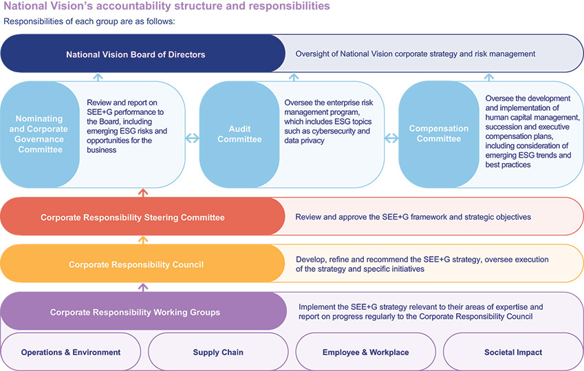
Human Capital Management
​
With an inclusive and people-first culture, we are focused on celebrating and respecting our associates’ diverse backgrounds, empowering, rewarding and developing our associates and aiming to give back to the communities in which we serve. Our human capital initiatives are focused on attracting highly qualified individuals and providing them with continued opportunities for growth and development. As of December 30, 2023, we had 13,998 full-time and part-time associates, including 582 directly employed optometrists. As of December 30, 2023, our network of optometrists included 2,645 optometrists, which consists of the 582 directly employed optometrists, 1,621 optometrists employed by professional corporations or similar entities with which we contract, and 442 optometrists who sublease in our store locations.
Talent Acquisition
We are committed to attracting talent aligned with our Vision, Mission and Values. We continue to refine our technology to improve both the candidate and hiring manager experience. In addition, we have established critical partnerships with outside vendors that provide us with additional resources to drive candidate flow for key roles. We are continuing our multi-year sponsorship of the Association of Schools and Colleges of Optometry campaign “Optometry Gives Me Life” targeted at high school and college students, and ensuring that graduating optometrists are educated on the variety of career options available to them. Additionally, we support our associates’ interest in attending Optometry school through our internal National Vision Doctor of Optometry Tuition Reimbursement program, which provides for the reimbursement of education expenses to associates attending optometry school. We utilize both in-person events and online platforms for job fairs and on-campus events, and selectively offer key incentives, such as a student loan repayment program.
2024 Proxy Statement 27

TABLE OF CONTENTS
CORPORATE GOVERNANCE MATTERS
Talent Development
We have a proven record of opening new stores with high-quality training support. We have adapted our new store training approach by introducing and enhancing virtual instructor-led training classes, allowing for high-touch training in a remote setting to prepare stores to open safely and effectively. We have also increased ongoing training in recent years, especially in the areas of safety protocol procedures and customer interactions. We provide associates and optometrists with several opportunities and mechanisms through which they can provide feedback and that allows us to continue developing programs for training and growth. We have invested in supporting our store managers through a Training Store Manager program, which provides training during their critical first steps as new managers. The program offers high-performing store managers the opportunity to certify as Training Store Managers through a five-week certification process focused on coaching, self-awareness, giving and receiving feedback, and time management. Once participants are certified as Training Store Managers, they provide onboarding and training support to store managers across their district. In addition to providing valuable support to new managers and new store teams, the program provides our associates with a new avenue for leadership opportunities and professional development. We continued to grow and invest in the Training Store Manager Program in 2023, building on our culture of developing and promoting our associates.
Benefits and Wellness
We strive to ensure our people always feel supported so they can bring their best selves to work every day. We demonstrate this commitment through many of our benefits and wellness offerings. Programs like our 401(k) plan, core and supplemental life insurance, health plan, short and long-term disability, wellness and disease management programs, including personalized programs for diabetes and hypertension, vacation pay, parental and adoption leave, accident, critical illness, group legal and identity theft programs, and a financial protection resource, provide the needed resources essential for helping our people care for themselves and their families. We also offer free on-demand mental and behavioral health resources, to provide needed guidance when work and personal challenges affect an associate’s overall well-being. Additionally, our associates receive an annual associate eyewear ticket and eyewear gift tickets that provide them, along with their friends and family, discounted eyewear purchases in our stores.
Our college scholarship program was established to assist associates with children age 24 or under, who are high school seniors or graduates and planning to enroll in a full-time undergraduate course of study at an accredited U.S. college or university. Each year, ten recipients are granted an award of $2,500 each and awards are renewable for up to three years for a total scholarship of $10,000. We also provide current and former associates who are in pursuit of a Doctor of Optometry degree with financial support through a tuition reimbursement program.
Our compensation programs are designed to reinforce our growth agenda and talent acquisition strategy. In addition to competitive base pay, we seek to reward associates with annual incentive awards, recognition programs and equity awards for associates at certain levels.
In 2019, we established the National Vision Crisis Relief Fund to help support associates who are facing financial hardship as a result of a natural disaster, family emergency or other unexpected events. Since its creation, the fund has provided over $1.7 million to associates for assistance.
Diversity, Equity and Inclusion
We are committed to promoting an inclusive culture and in 2020, we formed a Diversity, Equity and Inclusion department within the Company. We remain focused on advancing diversity in our recruitment, training, career mentorship and development, employment, branding and community service. We were named one of Newsweek’s America’s Most Responsible Companies for 2023 for our corporate responsibility and citizenship.
We continue to partner with external organizations to strengthen diversity in our communities and the eye care industry. A few of our key collaborations include the Optical Women’s Association, Black Eyecare Perspective and the Pennsylvania College of Optometry Summer Enrichment Program.
28 2024 Proxy Statement

TABLE OF CONTENTS
CORPORATE GOVERNANCE MATTERS​
Our Senior Vice President, Talent and Development; Diversity, Equity and Inclusion; Culture; and Philanthropy leads the administration of training and development activities and our Senior Vice President, Chief Medical Officer, in consultation with the independent practices, oversees training and development of the optometrists in our network. Our Board receives regular updates related to employee matters and succession planning.
Health and Safety
Our health and well-being efforts are built on a foundational commitment to the safety of our associates and the doctors in our network. We believe that we are in material compliance with applicable Occupational Safety and Health Administration guidelines and state regulations. At each of our labs and distribution centers, there are specific leaders responsible for the management of associate safety. For example, lab directors organize and run safety trainings for local associates, some of which are conducted through our Learning Management System and others through in-person instruction. In our retail locations, we support managers and field leaders in understanding and complying with applicable laws and regulations.
The COVID-19 pandemic presented unique challenges for our associates, doctors, customers and patients. We prioritized the safety of our associates, optometrists, customers and patients by voluntarily closing our stores to the public for a temporary period of time in 2020 to implement enhanced safety and cleaning protocols in order to serve our customers and patients with everyone’s health and safety in mind. Health and safety remain at the forefront for us.
2024 Proxy Statement 29

TABLE OF CONTENTS​​
Executive Compensation
Executive Compensation
Proposal 2—Advisory Vote to Approve the Compensation of our Named Executive Officers
​ | ​ | The Board recommends that you vote “FOR” Proposal 2. |  |  |  |  | ​ | ​
​ | ​ | What Am I  Voting on? | ​ | ​ | ​ | We are conducting a non-binding, advisory vote to approve the compensation of our named executive officers as described in this proxy statement, commonly referred to as “Say-on-Pay.” | ​ | ​
​ | ​ | Vote  Required | ​ | ​ | ​ | The proposal must be approved by a majority of votes cast at the Annual Meeting. | ​ | ​
Background
As required pursuant to Section 14A of the Exchange Act, we are conducting a non-binding, advisory vote to approve the compensation of our named executive officers as described in the Compensation Discussion and Analysis section of this proxy statement. This vote is commonly referred to as “Say-on-Pay.” Our stockholders have previously voted to hold a Say-on-Pay vote every year, and our Board therefore determined to hold Say-on-Pay votes annually until the next required advisory vote on the frequency of future Say-on-Pay votes, which will occur at the Annual Meeting.
Although this vote is advisory in nature, the compensation committee takes very seriously its role in the governance of our compensation programs and values thoughtful input from stockholders. The compensation committee will take into account the outcome of the advisory vote when considering future executive compensation decisions.
In considering your vote, we encourage you to review the information about our compensation policies and decisions regarding our named executive officers presented under the heading “Compensation Discussion and Analysis,” and the compensation tables and narrative discussion under the heading “Executive Compensation.”
Proposed Resolution
The text of the resolution in respect of Proposal 2 is as follows:
“RESOLVED, that the compensation paid to the Company’s named executive officers, as disclosed in this proxy statement pursuant to the rules of the SEC, including the Compensation Discussion and Analysis, compensation tables and any related narrative discussion is hereby APPROVED.”
30 2024 Proxy Statement

TABLE OF CONTENTS​
EXECUTIVE COMPENSATION​
Compensation Discussion and Analysis
​
Executive Summary
This Compensation Discussion and Analysis contains a discussion of the material elements of compensation awarded to, earned by or paid to our named executive officers (“NEOs”). Our NEOs for the fiscal year ended December 30, 2023, were:
​ | ​ | Named Executive Officer | ​ | ​ | ​ | Title | ​ | ​
​ | ​ | L. Reade Fahs | ​ | ​ | ​ | Chief Executive Officer and Director | ​ | ​
​ | ​ | Melissa Rasmussen | ​ | ​ | ​ | Senior Vice President, Chief Financial Officer | ​ | ​
​ | ​ | Patrick R. Moore | ​ | ​ | ​ | Senior Vice President, Chief Operating Officer | ​ | ​
​ | ​ | Jared Brandman | ​ | ​ | ​ | Senior Vice President, General Counsel and Secretary | ​ | ​
​ | ​ | Bill Clark | ​ | ​ | ​ | Senior Vice President, Chief People Officer | ​ | ​
2023 Business Highlights
2023 was a year in which we began to transform our business to better compete in today’s marketplace and adapt our business and cost structure. When we started, we set out to enhance the foundation for ongoing profitable growth and we have made progress, finishing the year with results above our expectations for the year. Certain of our financial results and operational highlights for fiscal 2023 are summarized below. NEO compensation for 2023 was paid or awarded in the context of these results.
Overall store count grew 4.4% to 1,413 stores
•
​
Comparable store sales growth was 3.1%, and Adjusted Comparable Store Sales Growth was 2.9%
•
​
Net revenue increased 6% over 2022 to $2,126.5 million
•
​
Net income (loss) of $(65.9) million and Diluted EPS of $(0.84), inclusive of non-cash impairment charges of $79.7 million and $7.0 million in expenses related to the termination of the Walmart partnership
•
​
Adjusted Operating Income of $72.3 million compared with $87.8 million in fiscal year 2022
•
​
Adjusted Diluted EPS of $0.64 compared with $0.65 in fiscal year 2022
•
​
We returned $25.0 million to stockholders through share repurchases
•
​
Cash flows from operating activities were $173.0 million, compared to $119.2 million in fiscal year 2022
•
​
​ |  | ​ | ​ |  | ​ | ​ |  | ​
In this proxy statement, we discuss financial measures that are referred to as non-GAAP financial measures, including adjusted comparable store sales growth, adjusted operating income, adjusted diluted EPS and annual incentive adjusted operating income. See Appendix A to this proxy statement for more information regarding these measures and reconciliations to the most directly comparable GAAP measures.
These financial highlights are reproduced from our Annual Report on Form 10-K for the fiscal year ended December 30, 2023.
2024 Proxy Statement 31

TABLE OF CONTENTS
EXECUTIVE COMPENSATION
Key Features of our Compensation Program
​ | ​ | What We Do: | ​ | ​ | ​ | What We Don’t Do: | ​ | ​
​ | ​ | Pay for performance, with high percentages of performance-based and long-term equity compensation  ✓  ​  Grant performance stock units that vest based on the achievement of performance goals over a three-year performance period  ✓  ​  Award annual cash incentives based on performance against predefined performance metrics  ✓  ​  Maintain robust stock ownership guidelines for our NEOs and directors  ✓  ​  Chief Executive Officer—6x annual base salary  •  ​  Other NEOs—3x annual base salary  •  ​  Directors—5x annual cash retainer  •  ​  Review our compensation programs and strategy annually with robust Board and committee oversight  ✓  ​  Hold an annual Say-on-Pay vote supported by a strong stockholder engagement strategy  ✓  ​  Require “Double-Trigger” vesting for change in control provisions  ✓  ​  Maintain an incentive compensation recovery (“clawback”) policy  ✓  ​  Retain an independent compensation consultant  ✓  ​ | ​ | ​ | ​ | No excise tax gross-ups  ✗  ​  No hedging of the Company’s stock by NEOs or directors  ✗  ​  No supplemental executive retirement plans  ✗  ​  No option repricing without stockholder approval  ✗  ​  No significant perquisites for executive officers  ✗  ​ | ​ | ​
Compensation Philosophy and Approach
Our mission is making quality eye care and eyewear more accessible and affordable. In order to do this, we must attract, engage and retain highly talented individuals who are committed to our core values of doing what is right, creating happiness every day and being energized to serve. We design our compensation programs to attract and retain a talented and experienced executive team with the skills and qualifications to manage and lead the Company effectively and help us achieve these goals. We strive to create the right balance of pay for performance and long-term value creation for our stockholders, while rewarding short-term success and motivating our leaders to execute against our strategic growth initiatives without taking unnecessary risks. We believe our current compensation programs strike this balance.​
Compensation Objectives
Our executive compensation program supports the following objectives:
Motivate executives to meet or exceed performance goals. A significant portion of each NEO’s total compensation is directly tied to the achievement of the Company’s overall financial and strategic goals.
•
​
Attract and retain talented executives. The Company seeks to provide overall levels of compensation that are market-competitive to attract, retain and motivate highly qualified executives to continue to enhance long-term equity value.
•
​
Link the financial interests of executives and stockholders. In order to foster a strong relationship between stockholder value and executive compensation, a significant portion of executive compensation is composed of long-term equity incentive awards. Additionally, 50% of the long-term incentive awards granted to our NEOs is in the form of performance stock units directly tied to the Company’s financial performance.
•
​
32 2024 Proxy Statement

TABLE OF CONTENTS
EXECUTIVE COMPENSATION​
NEO Compensation Overview
Key Elements of 2023 Compensation
​ | ​ | ​ | ​ | ​ | ​ | Compensation  Elements | ​ | ​ | ​ | Purpose | ​ | ​ | ​ | Characteristics | ​ | ​ | ​ | 2023 Actions and  Results | ​ | ​
​ | ​ | Fixed Pay | ​ | ​ | ​ | Base Salary | ​ | ​ | ​ | Provide a competitive level of fixed pay to attract and retain talented and experienced executives | ​ | ​ | ​ | Based on individual role, skill set, market data, and internal pay equity  •  ​  Base salaries are reviewed at least annually may be increased from time to time  •  ​ | ​ | ​ | ​ | In 2023, we did not increase the base salary of our CEO  •  ​  We increased the base salaries of our other NEOs as further described under “Base Salaries” below  •  ​ | ​ | ​
​ | ​ | At-Risk Pay | ​ | ​ | ​ | Annual Cash Incentive Awards (“STIP” Awards) | ​ | ​ | ​ | Incentivize management to achieve our short-term strategic and financial objectives consistent with our long-term goals | ​ | ​ | ​ | Based on annual, quantitative financial performance objectives established by the compensation committee  •  ​  STIP awards pay out between 0% and 200% of target based on Company performance against a corporate performance metric  •  ​  In 2023, the compensation committee set Annual Incentive Adjusted Operating Income (“STIP AOI”) as the corporate performance metric for STIP awards  •  ​ | ​ | ​ | ​ | Based on STIP AOI performance of $95.8 million, the STIP funded at 157.89% of target | ​ | ​
 |  |  |  |  | ​ | Long-Term Incentive Awards  (“LTIP” Awards) | ​ | ​ | ​ | Align the interests of our executives and stockholders | ​ | ​ | ​ | ​ | ​ | ​ | ​ | ​ | ​ | ​
 |  |  |  |  | ​ | 50% Restricted Stock Units (“RSUs”) | ​ | ​ | ​ | Facilitate stock ownership and retain talented executives | ​ | ​ | ​ | RSUs vest in three equal annual installments  •  ​ | ​ | ​ | ​ | ​ | ​ | ​
 |  |  |  |  | ​ | 50% Performance Stock Units (“PSUs”) | ​ | ​ | ​ | Reward long-term performance | ​ | ​ | ​ | Three-year performance period  •  ​  Vest between 0% and 200% based on Company performance against qualitative performance objectives established by the compensation committee  •  ​  PSUs granted in 2023 will vest based on:  •  ​  Adjusted Operating Income (“AOI”)—75% weighting  —  ​  Return on Invested Capital (“ROIC”)—25% weighting  —  ​ | ​ | ​ | ​ | In February 2024, the compensation committee certified the level of achievement for the PSUs granted in 2021, resulting in vesting at approximately, 67% of target based on three-year AOI and ROIC performance | ​ | ​
Each of these elements is further described under the heading “Elements of Compensation” below.
2024 Proxy Statement 33

TABLE OF CONTENTS
EXECUTIVE COMPENSATION
Pay for Performance Philosophy
Our executive compensation program reflects our commitment to pay for performance and long-term stockholder value creation by tying the majority of compensation for executives to performance-based metrics aligned to our growth strategy. Our program emphasizes at-risk, performance-based compensation in the form of annual cash incentive awards and long-term incentive awards comprised of 50% restricted stock units and 50% performance stock units. The chart below shows the 2023 target total direct compensation for our CEO, Mr. Fahs, and the average 2023 target total direct compensation for all other NEOs.
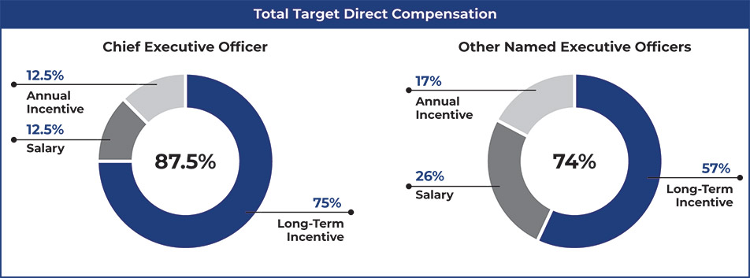
Our Annual Compensation-Setting Process
Consideration of Say-on-Pay Votes
We are pleased that our executive compensation program was supported by stockholders at our 2023 annual meeting with over 96.76% of votes cast in favor of the Say-on-Pay proposal. During 2023, we continued our stockholder engagement program and sought feedback from stockholders on a range of topics, including executive compensation. See “Corporate Governance Matters—Stockholder Engagement” for additional details.
In considering updates to our compensation programs, the compensation committee took into account the results of prior Say-on-Pay votes, feedback received from stockholders through our engagement program and the other factors discussed in more detail in “Our Annual Compensation-Setting Process” below, when. Given the strong Say-on-Pay vote outcome and feedback from our stockholder engagement, the committee did not believe any material changes were necessary to our compensation programs for 2023.
Role of the Compensation Committee
Our executive compensation plans and programs are administered by our compensation committee. Our compensation committee is responsible for:
Reviewing and approving, and making recommendations to the Board regarding, executive compensation, including plan design and performance goals related to STIP and LTIP incentive awards
•
​
Making recommendations to the Board regarding the compensation of our CEO
•
​
Determining and approving the compensation of other executive officers, as recommended by our CEO and Chief People Officer
•
​
Administering our equity incentive plans
•
​
At the beginning of each performance cycle, the compensation committee or the Board of Directors, as applicable, approves the payment of STIP and LTIP awards, sets base salaries and approves performance goals and targets related to the STIP and LTIP programs for all executive officers.
34 2024 Proxy Statement

TABLE OF CONTENTS
EXECUTIVE COMPENSATION​
The independent directors are responsible for assessing the performance of our CEO, reviewing the compensation committee’s assessment of CEO performance and approving CEO compensation in consideration of the recommendation of the compensation committee. Our CEO does not attend any portion of the compensation committee meeting during which the committee deliberates on matters related specifically to his compensation.
Role of Management
Our CEO and our Chief People Officer work closely with the compensation committee in managing our executive compensation program, along with gathering information for, and attending meetings of, the compensation committee.
Our CEO and our Chief People Officer compile market data and information and makes recommendations to the compensation committee concerning the compensation of executive officers other than themselves, including base salary amounts and incentive compensation plans. Our CEO and CFO also provide input regarding annual performance goals for our executive compensation programs.
Role of the Compensation Consultant
In 2023, the compensation committee engaged Meridian Compensation Partners, LLC (“Meridian”) to assist the committee regarding various executive compensation matters. Meridian assisted the compensation committee in reviewing the effectiveness and competitiveness of the Company’s executive compensation program, including an annual risk assessment of the program, and made recommendations consistent with the Company’s compensation philosophy, market trends, legal and regulatory considerations, and the Company’s overall business strategy. Meridian also provided the Company with market data as one point of consideration in making recommendations regarding executive compensation. The compensation committee reviewed Meridian’s independence procedures, along with the factors specified in the Nasdaq listing rules, and determined that Meridian was able to provide independent advice to the compensation committee without giving rise to any conflict of interest.
Peer Group
In setting the compensation of our executive officers, the compensation committee considers, among other factors, the compensation of similarly situated executives at companies in our peer group, including by reviewing publicly available proxy information and survey data of the peer companies listed below. The compensation committee did not target a specific percentile with respect to the peer group in determining our executives’ total compensation, nor did it establish a prescribed compensation mix. The compensation committee reviewed the peer group in September 2022 and removed The Container Store, and also added Acadia Healthcare Company and Cano Health, to the peer group for fiscal year 2023. The peer group that the compensation committee considered in setting 2023 compensation is set forth below:
​ | Align Technology, Inc.  Caleres, Inc.  Columbia Sportswear Co.  Dentsply Sirona Inc.  Five Below, Inc.  Floor & Decor Holdings, Inc.  ICU Medical, Inc.  Acadia Healthcare Company | ​ | ​ | Merit Medical Systems, Inc.  Ollie’s Bargain Outlet Holdings, Inc.  Oxford Industries, Inc.  Surgery Partners Inc.  Cano Health  The Cooper Companies, Inc.  West Pharmaceutical Services, Inc. | ​
We believe our peer group reflects a mix of companies in various industries that together appropriately represent the retail and health care aspects of our business and scope of operations, and are of a similar size as measured by annual revenue, market capitalization and number of employees.
In December 2023, the compensation committee reviewed the peer group and removed Floor & Decor Holdings, Inc. and added Fossil Group, Inc., Embecta Corp., Tandem Diabetes Care, Inc., and Warby Parker Inc. for fiscal year 2024.
2024 Proxy Statement 35

TABLE OF CONTENTS
EXECUTIVE COMPENSATION
Compensation Elements
Our executive compensation program has three main components: (1) base salary; (2) annual cash incentive compensation (STIP); and (3) long-term incentive awards (LTIP). Each component is designed to be consistent with the Company’s compensation philosophy and, when taken together, are intended to achieve the compensation committee’s principal compensation objectives. When making decisions about each component of compensation for an executive officer, the impact on the value of target total direct compensation for the individual is considered. Additionally, when making current compensation decisions, the compensation committee does not consider existing equity ownership or realized compensation from prior equity awards because we do not want to discourage executive officers from holding significant amounts of our common stock and believe that if the value of equity awards granted in prior years increases significantly in future years, this positive development should not impact current compensation decisions.
Base Salary
We believe it is important to provide a competitive level of fixed pay to attract and retain talented and experienced executives capable of driving the Company’s business strategy. In determining the amount of base salary that each NEO receives, we look to the executive’s current compensation, time in position, any change in the executive’s position or responsibilities, including complexity and scope, and the compensation of similarly situated executives, both within the Company and at the companies in our peer group. Base salaries are reviewed at least annually and may be increased from time to time. In February 2023, the compensation committee approved adjustments to the base salaries of Ms. Rasmussen and Messrs. Moore, Brandman, and Clark to reflect the scope of each of their responsibilities in line with the growth of the Company and to align their base salaries to executive officers at peer group companies with a similar scope of responsibility. These increases took effect in July 2023. The compensation committee did not increase Mr. Fahs’ base salary for 2023.
​ | ​ | Named Executive Officer | ​ | ​ | ​ | 2022 Base Salary | ​ | ​ | ​ | Percentage  Increase(1) | ​ | ​ | ​ | 2023  Base Salary | ​ | ​
​ | ​ | L. Reade Fahs | ​ | ​ | ​ | $1,000,000 | ​ | ​ | ​ | 0% | ​ | ​ | ​ | $1,000,000 | ​ | ​
​ | ​ | Melissa Rasmussen | ​ | ​ | ​ | $ 400,000 | ​ | ​ | ​ | 3.0% | ​ | ​ | ​ | $ 412,000 | ​ | ​
​ | ​ | Patrick R. Moore | ​ | ​ | ​ | $ 600,000 | ​ | ​ | ​ | 3.0% | ​ | ​ | ​ | $ 618,000 | ​ | ​
​ | ​ | Jared Brandman | ​ | ​ | ​ | $ 400,000 | ​ | ​ | ​ | 12.5% | ​ | ​ | ​ | $ 450,000 | ​ | ​
​ | ​ | Bill Clark | ​ | ​ | ​ | $ 390,000 | ​ | ​ | ​ | 3.0% | ​ | ​ | ​ | $ 401,700 | ​ | ​
Annual Cash Incentive Awards
In fiscal year 2023, our executives were eligible for awards under our Short Term Incentive Plan (“STIP”), which is our annual cash incentive program. The primary purpose of the STIP is to incentivize management to achieve our short-term strategic and financial objectives consistent with our long-term goals. We believe that tying annual incentive compensation for our NEOs to the achievement of our annual financial and strategic growth objectives encourages collaboration across the executive leadership team.
In February 2023, the compensation committee approved the 2023 STIP design. STIP award payouts for 2023 were calculated as follows:
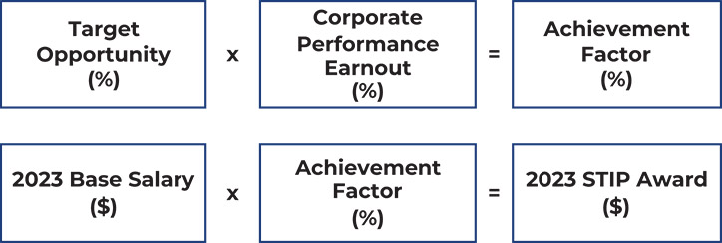
36 2024 Proxy Statement

TABLE OF CONTENTS
EXECUTIVE COMPENSATION​
For our NEOs, the compensation committee approved Annual Incentive Adjusted Operating Income (“STIP AOI”) as the corporate performance metric for determining STIP awards. The committee selected STIP AOI because Adjusted Operating Income is a key performance indicator that the Company considers when evaluating Company performance as a whole. The committee set performance goals for STIP AOI that it believed would be challenging but achievable under the then-current economic assumptions and conditions. A discussion of how STIP AOI is calculated from GAAP revenue is provided in Appendix A to this proxy statement.
The performance objectives approved by the compensation committee and actual results for 2023 were as follows:
​ | ​ | ($ in thousands) | ​ | ​ | ​ | STIP AOI |  |  |  | ​ | ​ | ​ | Achievement Factor(1) | ​ | ​
​ | ​ | Maximum | ​ | ​ | ​ | ​ | $ | 111.5 | ​ | ​ | ​ | ​ | 200% | ​ | ​
​ | ​ | Target | ​ | ​ | ​ | ​ | $ | 74.3 | ​ | ​ | ​ | ​ | 100% | ​ | ​
​ | ​ | Threshold(2) | ​ | ​ | ​ | ​ | $ | 70.6 | ​ | ​ | ​ | ​ | 50% | ​ | ​
​ | ​ | Actual | ​ | ​ | ​ | ​ | $ | 95.8 | ​ | ​ | ​ | ​ | 157.89% | ​ | ​
​
Payouts were capped at 200% of target opportunity and achievement factor percentages between outcomes were interpolated on a straight-line basis.
(1)
​
Threshold performance was required to fund the STIP.
(2)
​
Each NEO’s target opportunity and actual 2023 STIP award, each as approved by the compensation committee is set forth in the table below.
​ | ​ | Named Executive Officer | ​ | ​ | ​ | 2023  Base Salary(1)  ($) | ​ | ​ | ​ | Target  Opportunity(2)  (%) | ​ | ​ | ​ | Corporate  Performance  Earnout  (%) | ​ | ​ | ​ | Achievement  Factor(2)  (%) | ​ | ​ | ​ | 2023 STIP  Award  ($) | ​ | ​
​ | ​ | L. Reade Fahs | ​ | ​ | ​ | $1,000,000 | ​ | ​ | ​ | 100% | ​ | ​ | ​ | 157.89% | ​ | ​ | ​ | 157.89% | ​ | ​ | ​ | $1,578,900 | ​ | ​
​ | ​ | Melissa Rasmussen | ​ | ​ | ​ | $ 412,000 | ​ | ​ | ​ | 60% | ​ | ​ | ​ | 157.89% | ​ | ​ | ​ | 94.73% | ​ | ​ | ​ | $ 390,304 | ​ | ​
​ | ​ | Patrick R. Moore | ​ | ​ | ​ | $ 618,000 | ​ | ​ | ​ | 75% | ​ | ​ | ​ | 157.89% | ​ | ​ | ​ | 118.42% | ​ | ​ | ​ | $ 731,820 | ​ | ​
​ | ​ | Jared Brandman | ​ | ​ | ​ | $ 450,000 | ​ | ​ | ​ | 60% | ​ | ​ | ​ | 157.89% | ​ | ​ | ​ | 94.73% | ​ | ​ | ​ | $ 426,303 | ​ | ​
​ | ​ | Bill Clark | ​ | ​ | ​ | $ 401,700 | ​ | ​ | ​ | 60% | ​ | ​ | ​ | 157.89% | ​ | ​ | ​ | 94.73% | ​ | ​ | ​ | $ 380,546 | ​ | ​
​
Base salary as of July 2, 2023.
(1)
​
Expressed as a percentage of base salary.
(2)
​
Long-Term Incentive Awards
Long-term incentive awards are granted under our 2017 Omnibus Incentive Plan (the “2017 Omnibus Plan”). We believe granting equity-based, long-term incentive awards strengthens the commitment of our executives to the Company’s long-term success and aligns their interests with those of our stockholders. We refer to these awards as “LTIP” awards.
2023 LTIP Awards
In February 2023, as part of our annual compensation cycle, the compensation committee granted equity awards to our NEOs in the form of restricted stock units (“RSUs”) and performance stock units (“PSUs”), each representing 50% of the total target value of the 2023 LTIP awards for each NEO. This equity mix is consistent with our objective of emphasizing performance-based compensation and aligning the economic interests of our executive officers with those of our stockholders. The RSUs vest in equal installments on the first three anniversaries of the grant date, subject to continued employment on the vesting date. The PSUs may be earned based on our achievement measured against specified performance metrics over a three-year period as further described below under “Performance Stock Units.”
2024 Proxy Statement 37

TABLE OF CONTENTS
EXECUTIVE COMPENSATION
The following table reflects the target grant value approved by the compensation committee and the number of RSUs and PSUs granted to each NEO in 2023.
​ | ​ | Named Executive Officer | ​ | ​ | ​ | Target  Grant Value  ($) | ​ | ​ | ​ | Performance  Stock Units  (#) | ​ | ​ | ​ | Restricted  Stock Units  (#) | ​ | ​
​ | ​ | L. Reade Fahs | ​ | ​ | ​ | $6,000,000 | ​ | ​ | ​ | 134,469 | ​ | ​ | ​ | 134,469 | ​ | ​
​ | ​ | Melissa Rasmussen | ​ | ​ | ​ | $ 875,000 | ​ | ​ | ​ | 19,611 | ​ | ​ | ​ | 19,611 | ​ | ​
​ | ​ | Patrick R. Moore | ​ | ​ | ​ | $1,500,000 | ​ | ​ | ​ | 33,618 | ​ | ​ | ​ | 33,618 | ​ | ​
​ | ​ | Jared Brandman | ​ | ​ | ​ | $ 850,000 | ​ | ​ | ​ | 19,050 | ​ | ​ | ​ | 19,050 | ​ | ​
​ | ​ | Bill Clark | ​ | ​ | ​ | $ 850,000 | ​ | ​ | ​ | 19,050 | ​ | ​ | ​ | 19,050 | ​ | ​
Performance Stock Units
The PSUs granted in 2023 have a three-year performance period beginning on the first day of the 2023 fiscal year and ending on the last day of the fiscal year in 2025. PSU awards may be earned based on achievement of two performance metrics. The payout opportunity is 0% to 200% of the target number of PSUs granted.
Performance Metrics and Weighting
​ | ​ | Performance Metric | ​ | ​ | ​ | Weighting | ​ | ​
​ | ​ | Adjusted Operating Income | ​ | ​ | ​ | 75% | ​ | ​
​ | ​ | Return on Invested Capital | ​ | ​ | ​ | 25% | ​ | ​
Each of these performance metrics is measured separately for each fiscal year in the three-year performance period, and the compensation committee determines separate performance multipliers with respect to each metric for each such fiscal year. The average performance multiplier, calculated by taking the numeric average of the performance multipliers earned with respect to each fiscal year in the three-year performance period, will be used to calculate the number of units earned based on each metric.
The goals for each of these performance metrics were set by the compensation committee at the time of grant, with the performance conditions for the second and third years being based on achievement of goals relating to growth in AOI and ROIC. For each metric, the compensation committee believes that the goals set are appropriately challenging, yet reasonably attainable. Actual performance goals are not being disclosed before the end of the performance period because we believe such disclosure would be competitively harmful.
Vesting and Payout of 2021 PSU Awards
The PSUs granted in 2021, with a three-year performance period ended on December 30, 2023, vested and were payable in March 2024. The compensation committee certified the level of achievement for the 2021 PSUs based on the Company’s achievement over the three-year performance period of Adjusted Operating Income and ROIC as set forth below.
​ | ​ | ​ | ​ | ​ | ​ | 2021 |  |  |  |  | ​ | ​ | ​ | 2022 |  |  |  |  | ​ | ​ | ​ | 2023 |  |  |  |  | ​ | ​ | ​ | Three-  year  Average | ​ | ​
​ | ​ | ($ in millions) | ​ | ​ | ​ | Actual | ​ | ​ | ​ | Performance  Multiplier | ​ | ​ | ​ | Actual | ​ | ​ | ​ | Performance  Multiplier | ​ | ​ | ​ | Actual | ​ | ​ | ​ | Performance  Multiplier | ​ | ​
​ | ​ | Adjusted Operating Income (75% Weighting) | ​ | ​ | ​ | $205.5 | ​ | ​ | ​ | 200% | ​ | ​ | ​ | $96.5 | ​ | ​ | ​ | 0% | ​ | ​ | ​ | $77.0 | ​ | ​ | ​ | 0% | ​ | ​ | ​ | 66.67% | ​ | ​
​ | ​ | ROIC (25% Weighting) | ​ | ​ | ​ | 23.7% | ​ | ​ | ​ | 200% | ​ | ​ | ​ | 15.6% | ​ | ​ | ​ | 0% | ​ | ​ | ​ | 13.2% | ​ | ​ | ​ | 0% | ​ | ​ | ​ | 66.67% | ​ | ​
​ | ​ | Payout Level | ​ | ​ | ​ | ​ | ​ | ​ | ​ | ​ | ​ | ​ | ​ | ​ | ​ | ​ | ​ | ​ | ​ | ​ | ​ | ​ | ​ | ​ | ​ | ​ | ​ | ​ | ​ | 66.67% | ​ | ​
38 2024 Proxy Statement

TABLE OF CONTENTS
EXECUTIVE COMPENSATION​
Upon vesting based on a level of achievement over the three-year performance period of 66.67% of the target award level, and subject to required tax withholding, our NEOs received shares of our common stock as follows:
​ | ​ | Named Executive Officer | ​ | ​ | ​ | Shares Vested | ​ | ​
​ | ​ | L. Reade Fahs | ​ | ​ | ​ | 20,078 | ​ | ​
​ | ​ | Melissa Rasmussen | ​ | ​ | ​ | 1,279 | ​ | ​
​ | ​ | Patrick R. Moore | ​ | ​ | ​ | 5,111 | ​ | ​
​ | ​ | Jared Brandman | ​ | ​ | ​ | 2,556 | ​ | ​
​ | ​ | Bill Clark | ​ | ​ | ​ | 2,556 | ​ | ​
Other Elements of Compensation
Perquisites and Other Benefits
The benefits and perquisites provided to our NEOs are not a material part of executive compensation and are largely limited to those offered to our employees generally, or that we have otherwise determined are necessary or appropriate to attract and retain talented executives.
We also provide executives, including our NEOs, with additional basic life insurance coverage and supplemental long-term disability and accidental death insurance. In addition, Mr. Fahs receives assistance with tax accounting services and a Young Presidents’ Organization (“YPO”) membership. The value of these perquisites and other personal benefits are reflected in the “All Other Compensation” column to the “Summary Compensation Table” and the accompanying footnotes.
Health and Welfare Benefits
We provide health and welfare benefits to our NEOs, which include medical, dental, life insurance, disability insurance and paid time off, on the same terms generally available to all salaried employees, subject to limitations under applicable law.
401(k) Savings Plan. Our eligible U.S. employees, including our NEOs, participate in the National Vision, Inc. 401(k) Retirement Savings Plan (the “401(k) Plan”). Eligible employees may enroll in the 401(k) Plan during the first month following three months of service with the Company. Under the 401(k) Plan, we match 50% of the first 3% of a participant’s contributions. The Company’s matching contributions vest pro rata over each of the following four years of employment with the Company.
Associate Stock Purchase Plan. We have maintained an Associate Stock Purchase Plan (the “ASPP”) since 2018. The ASPP provides all our eligible U.S. employees, including our NEOs, the opportunity to purchase up to $25,000 in our common stock annually at a 10% discount to the market price of our stock.
Severance Benefits
The Company provides severance protections to our NEOs under the National Vision Holdings, Inc. Executive Severance Plan (the “Executive Severance Plan”) in order to offer competitive total compensation packages and to be competitive in the Company’s executive attraction and retention efforts. The Executive Severance Plan provides for severance payments and benefits to our NEOs, upon a termination of employment by the Company without cause or by the executive for good reason (each as defined in the Executive Severance Plan), in each case, subject to (i) the executive’s execution and non-revocation of a release of claims in favor of the Company and (ii) the executive’s continued compliance with the covenants in the executive’s agreements with the Company pertaining to confidentiality, non-interference and invention assignment. The payments to which each NEO may be entitled under the Executive Severance Plan are further described under “Potential Payments upon Termination or Change in Control.”
Additional Compensation Policies
Restrictive Covenants
Our NEOs are subject to specified restrictive covenants, including confidentiality and non-disparagement covenants and covenants related to non-competition and non-solicitation of our employees, consultants
2024 Proxy Statement 39

TABLE OF CONTENTS
EXECUTIVE COMPENSATION
and independent contractors at all times during the NEO’s employment, and for specific periods following the termination of employment for any reason. The post-employment restricted time periods are as follows: Mr. Fahs for twenty-four months after termination; Messrs. Moore and Brandman for eighteen months after termination; and Mr. Clark and Ms. Rasmussen for twelve months after termination.
Stock Ownership Guidelines
Our Board of Directors has adopted stock ownership guidelines (the “Guidelines”) applicable to our executive officers and directors. These Guidelines align the interests of our management and directors with those of our stockholders. Executive officers are required to hold shares having a market value equal to at least:
Chief Executive Officer: 6x annual base salary
•
​
Other Executive Officers: 3x annual base salary
•
​
There is no required time period within which an executive officer must attain the applicable stock ownership level under the Guidelines. However, until the applicable ownership level is achieved, executive officers must retain 50% of vested shares net of stock option exercise and tax withholding.
Shares that count toward these ownership requirements include shares owned outright, shares held in the Company’s 401(k) Plan or other retirement plan and RSUs (whether vested or unvested). As of December 30, 2023, Messrs. Fahs and Moore have met or exceeded their current ownership requirements and the remaining NEOs are subject to the restrictions in the guidelines until their ownership requirements are met. The retention requirement for shares applies to all prior and future grants.
Securities Trading Policy; Hedging and Pledging
Our Securities Trading Policy requires executive officers and directors to consult the Company’s General Counsel prior to engaging in transactions involving Company securities. Directors and executive officers are prohibited from hedging or monetization transactions including, but not limited to, variable forward contracts, equity swaps, collars and exchange funds, or from trading in options, warrants, puts and calls or similar instruments on the Company’s securities or establishing a short position in Company securities. Our Securities Trading Policy discourages employees from purchasing Company securities on margin, or borrowing against any account in which Company securities are held, or pledging Company securities as collateral for a loan. For directors and officers, the pledging of Company securities is limited to those situations approved by the Company’s General Counsel.
Clawback Policy
In October 2023, the compensation committee adopted the Incentive Compensation Recovery Policy (the “Clawback Policy”), which is compliant with SEC and Nasdaq requirements. Pursuant to the Clawback Policy, if the Company is required to prepare an accounting restatement due to material noncompliance with financial reporting requirements under the U.S. securities laws, then we will seek to recover reasonably promptly from any current or former executive officer any erroneously paid incentive-based compensation (including equity compensation) received during the three-year period preceding the date on which the accounting restatement was required to be made, regardless of whether the executive officer engaged in misconduct or otherwise caused or contributed to the requirement for the restatement. The amount to be recovered is the excess of the amount paid calculated by reference to the erroneous data, over the amount that would have been paid to the executive officer calculated using the corrected accounting statement data. This mandatory recoupment provision is subject to certain limited exceptions, as provided in the Clawback Policy and permitted under SEC and Nasdaq requirements.
In addition to the mandatory recoupment provision described above, the Clawback Policy also includes a discretionary recoupment provision, which allows the compensation committee to apply the Clawback Policy to additional employees and to recover additional amounts from an executive officer, former executive officer, or other covered employee if the compensation committee determines that incentive compensation was based on financial results or operating metrics that were satisfied as a result of such person’s fraud, willful misconduct or gross negligence, or such person engaged in any intentional misconduct that caused the Company financial or reputational harm. For purposes of these discretionary provisions, the term “intentional misconduct” means an intentional violation of law, an intentional violation of the
40 2024 Proxy Statement

TABLE OF CONTENTS​
EXECUTIVE COMPENSATION​
Company’s Code of Conduct, or an intentional violation of a written ethics or compliance policy of the Company. The Clawback Policy is filed as an exhibit to the Company’s Annual Report on Form 10-K for the fiscal year ended December 30, 2023.
Compensation Risk Assessment
The compensation committee, with the assistance of Meridian, reviewed our incentive programs to assess whether the programs encourage inappropriate risk-taking. Based on its review, the compensation committee concluded that any risks arising from the Company’s compensation plans, programs and policies, considered as a whole, including applicable risk-mitigation features, are not reasonably likely to have a material adverse effect on the company.
Tax and Accounting Considerations
We consider the effect of tax, accounting and other regulatory requirements in designing and implementing compensation programs so that our programs meet regulatory requirements and efficiently deliver compensation. While these factors may impact plan designs, ultimately, decisions reflect the pay strategy of the Company and the intent of our programs.
Compensation Committee Report
​
The compensation committee has reviewed and discussed the Compensation Discussion and Analysis with management. Based on its review and discussion with management, the compensation committee recommended to the Board of Directors that the Compensation Discussion and Analysis be included in this proxy statement and incorporated by reference in the Annual Report on Form 10-K for the fiscal year ended December 30, 2023, filed with the Securities and Exchange Commission.
Compensation Committee
Thomas V. Taylor, Jr., Chair
D. Randolph Peeler
2024 Proxy Statement 41

TABLE OF CONTENTS​
EXECUTIVE COMPENSATION
Executive Compensation Tables
Summary Compensation Table
The following table presents summary information about the total compensation earned by or paid to our NEOs for the fiscal years ended December 30, 2023, December 31, 2022, and January 1, 2022.
​ | ​ | Name and Principal Position | ​ | ​ | ​ | Year |  |  |  | ​ | ​ | ​ | Salary  ($) | ​ | ​ | ​ | Bonus  ($) | ​ | ​ | ​ | Stock  Awards(1)(2)  ($) | ​ | ​ | ​ | Option  Awards(3)  ($) | ​ | ​ | ​ | Non-Equity  Incentive Plan  Compensation(4)  ($) | ​ | ​ | ​ | All Other  Compensation(5)  ($) | ​ | ​ | ​ | Total  ($) | ​ | ​
​ | ​ | L. Reade Fahs  Chief Executive Officer | ​ | ​ | ​ | ​ | ​ | 2023 | ​ | ​ | ​ | ​ | 1,000,000 | ​ | ​ | ​ | — | ​ | ​ | ​ | 6,000,007 | ​ | ​ | ​ | — | ​ | ​ | ​ | 1,578,900 | ​ | ​ | ​ | 38,531 | ​ | ​ | ​ | 8,617,438 | ​ | ​
 |  |  |  |  | ​ | ​ | ​ | 2022 | ​ | ​ | ​ | ​ | 991,196 | ​ | ​ | ​ | — | ​ | ​ | ​ | 3,250,006 | ​ | ​ | ​ | — | ​ | ​ | ​ | — | ​ | ​ | ​ | 32,100 | ​ | ​ | ​ | 4,273,302 | ​ | ​
 |  |  |  |  | ​ | ​ | ​ | 2021 | ​ | ​ | ​ | ​ | 975,386 | ​ | ​ | ​ | — | ​ | ​ | ​ | 2,062,508 | ​ | ​ | ​ | 687,505 | ​ | ​ | ​ | 1,967,300 | ​ | ​ | ​ | 35,791 | ​ | ​ | ​ | 5,728,490 | ​ | ​
​ | ​ | Melissa Rasmussen﻿(6)  Senior Vice President, Chief Financial Officer | ​ | ​ | ​ | ​ | ​ | 2023 | ​ | ​ | ​ | ​ | 405,539 | ​ | ​ | ​ | — | ​ | ​ | ​ | 875,043 | ​ | ​ | ​ | — | ​ | ​ | ​ | 390,304 | ​ | ​ | ​ | 7,274 | ​ | ​ | ​ | 1,678,160 | ​ | ​
​ | ​ | Patrick R. Moore  Senior Vice President,  Chief Operating Officer | ​ | ​ | ​ | ​ | ​ | 2023 | ​ | ​ | ​ | ​ | 608,308 | ​ | ​ | ​ | — | ​ | ​ | ​ | 1,500,035 | ​ | ​ | ​ | — | ​ | ​ | ​ | 731,820 | ​ | ​ | ​ | 9,808 | ​ | ​ | ​ | 2,849,971 | ​ | ​
 |  |  |  |  | ​ | ​ | ​ | 2022 | ​ | ​ | ​ | ​ | 623,885 | ​ | ​ | ​ | — | ​ | ​ | ​ | 1,000,067 | ​ | ​ | ​ | — | ​ | ​ | ​ | — | ​ | ​ | ​ | 6,219 | ​ | ​ | ​ | 1,630,171 | ​ | ​
 |  |  |  |  | ​ | ​ | ​ | 2021 | ​ | ​ | ​ | ​ | 510,673 | ​ | ​ | ​ | — | ​ | ​ | ​ | 525,044 | ​ | ​ | ​ | 175,020 | ​ | ​ | ​ | 669,500 | ​ | ​ | ​ | 11,437 | ​ | ​ | ​ | 1,891,674 | ​ | ​
​ | ​ | Jared Brandman  Senior Vice President, General Counsel and Secretary | ​ | ​ | ​ | ​ | ​ | 2023 | ​ | ​ | ​ | ​ | 423,077 | ​ | ​ | ​ | — | ​ | ​ | ​ | 850,011 | ​ | ​ | ​ | — | ​ | ​ | ​ | 426,303 | ​ | ​ | ​ | 5,417 | ​ | ​ | ​ | 1,704,808 | ​ | ​
 |  |  |  |  | ​ | ​ | ​ | 2022 | ​ | ​ | ​ | ​ | 391,923 | ​ | ​ | ​ | — | ​ | ​ | ​ | 475,030 | ​ | ​ | ​ | — | ​ | ​ | ​ | — | ​ | ​ | ​ | 10,291 | ​ | ​ | ​ | 877,244 | ​ | ​
 |  |  |  |  | ​ | ​ | ​ | 2021 | ​ | ​ | ​ | ​ | 374,904 | ​ | ​ | ​ | — | ​ | ​ | ​ | 262,545 | ​ | ​ | ​ | 87,522 | ​ | ​ | ​ | 385,000 | ​ | ​ | ​ | 11,724 | ​ | ​ | ​ | 1,121,695 | ​ | ​
​ | ​ | Bill Clark  Senior Vice President, Chief People Officer | ​ | ​ | ​ | ​ | ​ | 2023 | ​ | ​ | ​ | ​ | 395,400 | ​ | ​ | ​ | — | ​ | ​ | ​ | 850,011 | ​ | ​ | ​ | — | ​ | ​ | ​ | 380,546 | ​ | ​ | ​ | 7,367 | ​ | ​ | ​ | 1,633,324 | ​ | ​
 |  |  |  |  | ​ | ​ | ​ | 2022 | ​ | ​ | ​ | ​ | 374,115 | ​ | ​ | ​ | — | ​ | ​ | ​ | 475,030 | ​ | ​ | ​ | — | ​ | ​ | ​ | — | ​ | ​ | ​ | 8,256 | ​ | ​ | ​ | 857,401 | ​ | ​
 |  |  |  |  | ​ | ​ | ​ | 2021 | ​ | ​ | ​ | ​ | 357,471 | ​ | ​ | ​ | — | ​ | ​ | ​ | 262,545 | ​ | ​ | ​ | 87,522 | ​ | ​ | ​ | 360,500 | ​ | ​ | ​ | 8,522 | ​ | ​ | ​ | 1,076,560 | ​ | ​
​
Reflects the aggregate grant date fair value of the stock awards granted in the applicable year, computed in accordance with FASB ASC Topic 718. Awards with performance conditions are computed based on the probable outcome of the performance condition as of the grant date for the award. Information about the assumptions used to value these awards is set forth in our Annual Report on Form 10-K in Note 6 to our Consolidated Financial Statements for the year ended December 30, 2023.
(1)
​
For 2023, amounts reflect the aggregate grant date fair value of performance stock units granted to Mr. Fahs ($3,000,003), Ms. Rasmussen ($437,521), Mr. Moore ($750,018), Mr. Brandman ($425,006) and Mr. Clark ($425,006) in 2023 at the target award level and restricted stock units. With respect to performance stock units, the value realized by each of them at the end of the three-year performance period will depend on the company’s achievement of Adjusted Operating Income and Return on Invested Capital over the performance period and will range from 0% to 200%. If the highest level of performance conditions is met, the grant date fair value of these awards would be as follows: Mr. Fahs ($6,000,007), Ms. Rasmussen ($875,043), Mr. Moore ($1,500,035), Mr. Brandman ($850,011) and Mr. Clark ($850,011).
(2)
​
Reflects the aggregate grant date fair value for the option awards granted in the applicable year, computed in accordance with FASB ASC Topic 718. The assumptions used to value these awards can be found in Note 6 “Stock Incentive Plans” in our 2023 Form 10-K. The amounts reported for these awards may not represent the amounts that the individuals will actually receive. The amounts received, if any, ultimately will depend on the change in our stock price over time.
(3)
​
These cash incentive payments were earned for the year listed and paid in the following year.
(4)
​
All Other Compensation for 2023 included:
(5)
​
​ | ​ | Named Executive Officer | ​ | ​ | ​ | Employer  401(k)  Matching  Contributions(a)  ($) | ​ | ​ | ​ | Life Insurance  Premiums(b)  ($) | ​ | ​ | ​ | Disability and  AD&D  Insurance  Premiums(c)  ($) | ​ | ​ | ​ | Other(d)  ($) | ​ | ​ | ​ | Total  ($) | ​ | ​
​ | ​ | L. Reade Fahs | ​ | ​ | ​ | 15,000 | ​ | ​ | ​ | 480 | ​ | ​ | ​ | 920 | ​ | ​ | ​ | 22,131 | ​ | ​ | ​ | 38,531 | ​ | ​
​ | ​ | Melissa Rasmussen | ​ | ​ | ​ | 5,608 | ​ | ​ | ​ | 480 | ​ | ​ | ​ | 920 | ​ | ​ | ​ | 266 | ​ | ​ | ​ | 7,274 | ​ | ​
​ | ​ | Patrick R. Moore | ​ | ​ | ​ | 4,500 | ​ | ​ | ​ | 480 | ​ | ​ | ​ | 920 | ​ | ​ | ​ | 3,908 | ​ | ​ | ​ | 9,808 | ​ | ​
​ | ​ | Jared Brandman | ​ | ​ | ​ | 3,751 | ​ | ​ | ​ | 480 | ​ | ​ | ​ | 920 | ​ | ​ | ​ | 266 | ​ | ​ | ​ | 5,417 | ​ | ​
​ | ​ | Bill Clark | ​ | ​ | ​ | 5,701 | ​ | ​ | ​ | 480 | ​ | ​ | ​ | 920 | ​ | ​ | ​ | 266 | ​ | ​ | ​ | 7,367 | ​ | ​
​
Our 401(k) Plan provides for a 50% matching contribution on the first 3% of participants’ pre-tax contributions up to IRS limits.
(a)
​
Each of our NEOs is entitled to basic life insurance coverage of up to the lesser of two times base salary or $500,000.
(b)
​
42 2024 Proxy Statement

TABLE OF CONTENTS
EXECUTIVE COMPENSATION​
Each of our NEOs is entitled to supplemental long-term disability and accidental death insurance coverage. The total benefit maximum of both the basic and supplemental disability insurance coverage is $10,000 per month, and the maximum accidental death benefit is up to the lesser of two times base salary or $500,000.
(c)
​
Reflects $4,765 for YPO membership, $17,100 for the cost of tax accounting services, and amounts below $500 for associate eyewear coupon and financial wellness program for Mr. Fahs; $3,641 for an Executive Physical and amounts below $500 for associate eyewear coupon, and financial wellness program for Mr. Moore, and amounts below $500 for associate eyewear coupon and financial wellness program for each of Ms. Rasmussen and Messrs. Brandman, and Clark.
(d)
​
Compensation for Ms. Rasmussen is provided only for 2023 because she was not an NEO for 2022 or 2021.
(6)
​
Grants of Plan-Based Awards in 2023
The following table sets forth information about the non-equity incentive awards and equity-based awards granted to our NEOs in the fiscal year ended December 30, 2023.
​ | ​ | Named Executive  Officer | ​ | ​ | ​ | Grant  Date |  |  |  | ​ | ​ | ​ | Approval  Date(1) |  |  |  | ​ | ​ | ​ | Estimated Possible  Payouts Under Non-Equity  Incentive Plan Awards(2) |  |  |  |  |  |  |  |  | ​ | ​ | ​ | Estimated Future Payouts  Under Equity Incentive Plan  Awards(3)(4) |  |  |  |  |  |  |  |  | ​ | ​ | ​ | All Other  Stock  Awards:  Number of  Shares or  Stock or  Units(5)  (#) | ​ | ​ | ​ | Grant Date  Fair Value  of Stock  and Option  Awards(6)  ($) | ​ | ​
 |  |  |  |  |  |  |  |  |  |  |  |  |  |  |  |  |  |  | ​ | Threshold  ($) | ​ | ​ | ​ | Target  ($) | ​ | ​ | ​ | Maximum  ($) | ​ | ​ | ​ | Threshold  (#) | ​ | ​ | ​ | Target  (#) | ​ | ​ | ​ | Maximum  (#) | ​ | ​
​ | ​ | L. Reade Fahs | ​ | ​ | ​ | ​ | ​ | ​ | ​ | ​ | ​ | ​ | ​ | ​ | ​ | ​ | ​ | ​ | ​ | 500,000 | ​ | ​ | ​ | 1,000,000 | ​ | ​ | ​ | 2,000,000 | ​ | ​ | ​ | ​ | ​ | ​ | ​ | ​ | ​ | ​ | ​ | ​ | ​ | ​ | ​ | ​ | ​ | ​ | ​ | ​ | ​ | ​
 |  |  |  |  | ​ | ​ | ​ | 3/3/2023 | ​ | ​ | ​ | ​ | ​ | ​ | 2/13/2023 | ​ | ​ | ​ | ​ | ​ | ​ | ​ | ​ | ​ | ​ | ​ | ​ | ​ | ​ | ​ | ​ | 67,235 | ​ | ​ | ​ | 134,469 | ​ | ​ | ​ | 268,938 | ​ | ​ | ​ | ​ | ​ | ​ | ​ | 3,000,003 | ​ | ​
 |  |  |  |  | ​ | ​ | ​ | 3/3/2023 | ​ | ​ | ​ | ​ | ​ | ​ | 2/13/2023 | ​ | ​ | ​ | ​ | ​ | ​ | ​ | ​ | ​ | ​ | ​ | ​ | ​ | ​ | ​ | ​ | ​ | ​ | ​ | ​ | ​ | ​ | ​ | ​ | ​ | ​ | ​ | ​ | 134,469 | ​ | ​ | ​ | 3,000,003 | ​ | ​
​ | ​ | Melissa Rasmussen | ​ | ​ | ​ | ​ | ​ | ​ | ​ | ​ | ​ | ​ | ​ | ​ | ​ | ​ | ​ | ​ | ​ | 123,600 | ​ | ​ | ​ | 247,200 | ​ | ​ | ​ | 494,400 | ​ | ​ | ​ | ​ | ​ | ​ | ​ | ​ | ​ | ​ | ​ | ​ | ​ | ​ | ​ | ​ | ​ | ​ | ​ | ​ | ​ | ​
 |  |  |  |  | ​ | ​ | ​ | 3/3/2023 | ​ | ​ | ​ | ​ | ​ | ​ | 2/13/2023 | ​ | ​ | ​ | ​ | ​ | ​ | ​ | ​ | ​ | ​ | ​ | ​ | ​ | ​ | ​ | ​ | 9,806 | ​ | ​ | ​ | 19,611 | ​ | ​ | ​ | 39,222 | ​ | ​ | ​ | ​ | ​ | ​ | ​ | 437,521 | ​ | ​
 |  |  |  |  | ​ | ​ | ​ | 3/3/2023 | ​ | ​ | ​ | ​ | ​ | ​ | 2/13/2023 | ​ | ​ | ​ | ​ | ​ | ​ | ​ | ​ | ​ | ​ | ​ | ​ | ​ | ​ | ​ | ​ | ​ | ​ | ​ | ​ | ​ | ​ | ​ | ​ | ​ | ​ | ​ | ​ | 19,611 | ​ | ​ | ​ | 437,521 | ​ | ​
​ | ​ | Patrick R. Moore | ​ | ​ | ​ | ​ | ​ | ​ | ​ | ​ | ​ | ​ | ​ | ​ | ​ | ​ | ​ | ​ | ​ | 231,750 | ​ | ​ | ​ | 463,500 | ​ | ​ | ​ | 927,000 | ​ | ​ | ​ | ​ | ​ | ​ | ​ | ​ | ​ | ​ | ​ | ​ | ​ | ​ | ​ | ​ | ​ | ​ | ​ | ​ | ​ | ​
 |  |  |  |  | ​ | ​ | ​ | 3/3/2023 | ​ | ​ | ​ | ​ | ​ | ​ | 2/13/2023 | ​ | ​ | ​ | ​ | ​ | ​ | ​ | ​ | ​ | ​ | ​ | ​ | ​ | ​ | ​ | ​ | 16,809 | ​ | ​ | ​ | 33,618 | ​ | ​ | ​ | 67,236 | ​ | ​ | ​ | 33,618 | ​ | ​ | ​ | 750,018 | ​ | ​
 |  |  |  |  | ​ | ​ | ​ | 3/3/2023 | ​ | ​ | ​ | ​ | ​ | ​ | 2/13/2023 | ​ | ​ | ​ | ​ | ​ | ​ | ​ | ​ | ​ | ​ | ​ | ​ | ​ | ​ | ​ | ​ | ​ | ​ | ​ | ​ | ​ | ​ | ​ | ​ | ​ | ​ | ​ | ​ | ​ | ​ | ​ | ​ | 750,018 | ​ | ​
​ | ​ | Jared Brandman | ​ | ​ | ​ | ​ | ​ | ​ | ​ | ​ | ​ | ​ | ​ | ​ | ​ | ​ | ​ | ​ | ​ | 135,000 | ​ | ​ | ​ | 270,000 | ​ | ​ | ​ | 540,000 | ​ | ​ | ​ | ​ | ​ | ​ | ​ | ​ | ​ | ​ | ​ | ​ | ​ | ​ | ​ | ​ | ​ | ​ | ​ | ​ | ​ | ​
 |  |  |  |  | ​ | ​ | ​ | 3/3/2023 | ​ | ​ | ​ | ​ | ​ | ​ | 2/13/2023 | ​ | ​ | ​ | ​ | ​ | ​ | ​ | ​ | ​ | ​ | ​ | ​ | ​ | ​ | ​ | ​ | 9,525 | ​ | ​ | ​ | 19,050 | ​ | ​ | ​ | 38,100 | ​ | ​ | ​ | ​ | ​ | ​ | ​ | 425,006 | ​ | ​
 |  |  |  |  | ​ | ​ | ​ | 3/3/2023 | ​ | ​ | ​ | ​ | ​ | ​ | 2/13/2023 | ​ | ​ | ​ | ​ | ​ | ​ | ​ | ​ | ​ | ​ | ​ | ​ | ​ | ​ | ​ | ​ | ​ | ​ | ​ | ​ | ​ | ​ | ​ | ​ | ​ | ​ | ​ | ​ | 19,050 | ​ | ​ | ​ | 425,006 | ​ | ​
​ | ​ | Bill Clark | ​ | ​ | ​ | ​ | ​ | ​ | ​ | ​ | ​ | ​ | ​ | ​ | ​ | ​ | ​ | ​ | ​ | 120,510 | ​ | ​ | ​ | 241,020 | ​ | ​ | ​ | 482,040 | ​ | ​ | ​ | ​ | ​ | ​ | ​ | ​ | ​ | ​ | ​ | ​ | ​ | ​ | ​ | ​ | ​ | ​ | ​ | ​ | ​ | ​
 |  |  |  |  | ​ | ​ | ​ | 3/3/2023 | ​ | ​ | ​ | ​ | ​ | ​ | 2/13/2023 | ​ | ​ | ​ | ​ | ​ | ​ | ​ | ​ | ​ | ​ | ​ | ​ | ​ | ​ | ​ | ​ | 9,525 | ​ | ​ | ​ | 19,050 | ​ | ​ | ​ | 38,100 | ​ | ​ | ​ | ​ | ​ | ​ | ​ | 425,006 | ​ | ​
 |  |  |  |  | ​ | ​ | ​ | 3/3/2023 | ​ | ​ | ​ | ​ | ​ | ​ | 2/13/2023 | ​ | ​ | ​ | ​ | ​ | ​ | ​ | ​ | ​ | ​ | ​ | ​ | ​ | ​ | ​ | ​ | ​ | ​ | ​ | ​ | ​ | ​ | ​ | ​ | ​ | ​ | ​ | ​ | 19,050 | ​ | ​ | ​ | 425,006 | ​ | ​
​
This column indicates if the date on which our compensation committee approved the award differs from the award grant date.
(1)
​
The amounts in this column represent the possible awards under the Short Term Incentive Plan. Actual payments under these awards were determined in February 2024, paid in March 2024, and are included in the Non-Equity Incentive Plan Compensation column of the 2023 Summary Compensation Table.
(2)
​
All of the awards reported in this table were made under the 2017 Omnibus Plan.
(3)
​
The performance stock units reported in this table at the target level have a three-year performance period. The number of shares issued at vesting will be determined as described above under “Compensation Discussion and Analysis—Elements of Compensation—Long-Term Incentive Awards—Performance Stock Units,” and will range from 0% to 200% of the target award.
(4)
​
One third of the restricted stock units reported in the table vest on the first three anniversaries of the grant date.
(5)
​
Reflects the grant date fair value of the restricted stock unit awards under FASB ASC Topic 718. Information about the assumptions used to value these awards is set forth in our Annual Report on Form 10-K in Note 6 to our Consolidated Financial Statements for the year ended December 30, 2023.
(6)
​
2024 Proxy Statement 43

TABLE OF CONTENTS
EXECUTIVE COMPENSATION
Outstanding Equity Awards at December 30, 2023
​ | ​ | ​ | ​ | ​ | ​ | ​ | ​ | ​ | ​ | Option Awards |  |  |  |  |  |  |  |  |  |  |  |  | ​ | ​ | ​ | Stock Awards |  |  |  |  |  |  |  |  |  |  |  |  | ​ | ​
​ | ​ | Named Executive  Officer | ​ | ​ | ​ | Grant Date | ​ | ​ | ​ | Number of  Securities  Underlying  Unexercised  Options  Exercisable  (#) | ​ | ​ | ​ | Number of  Securities  Underlying  Unexercised  Options  Un-exercisable  (#) | ​ | ​ | ​ | Option  Exercise  Price  ($) | ​ | ​ | ​ | Option  Expiration  Date | ​ | ​ | ​ | Number of  Shares or  Units of  Stock That  Have Not  Vested  (#) | ​ | ​ | ​ | Market  Value of  Shares or  Units of  Stock That  Have Not  Vested(1)  ($) | ​ | ​ | ​ | Equity  Incentive  Plan  Awards:  Number of  Unearned  Shares,  Units, or  Other Rights  That Have  Not Vested  (#) | ​ | ​ | ​ | Equity  Incentive  Plan  Awards:  Market or  Payout  Value of  Unearned  Shares,  Units, or  Other  Rights  That  Have Not  Vested  ($) | ​ | ​
​ | ​ | L. Reade Fahs | ​ | ​ | ​ | 3/1/2019 | ​ | ​ | ​ | 54,114 | ​ | ​ | ​ | ​ | ​ | ​ | ​ | 35.19 | ​ | ​ | ​ | 3/1/2029 | ​ | ​ | ​ | ​ | ​ | ​ | ​ | ​ | ​ | ​ | ​ | ​ | ​ | ​ | ​ | ​ | ​ | ​
 |  |  |  |  | ​ | 2/28/2020 | ​ | ​ | ​ | 41,089 | ​ | ​ | ​ | ​ | ​ | ​ | ​ | 34.82 | ​ | ​ | ​ | 2/28/2030 | ​ | ​ | ​ | ​ | ​ | ​ | ​ | ​ | ​ | ​ | ​ | ​ | ​ | ​ | ​ | ​ | ​ | ​
 |  |  |  |  | ​ | 3/5/2021 | ​ | ​ | ​ | 19,790 | ​ | ​ | ​ | 9,895(2) | ​ | ​ | ​ | 45.66 | ​ | ​ | ​ | 3/5/2031 | ​ | ​ | ​ | ​ | ​ | ​ | ​ | ​ | ​ | ​ | ​ | ​ | ​ | ​ | ​ | ​ | ​ | ​
 |  |  |  |  | ​ | 3/5/2021 | ​ | ​ | ​ | ​ | ​ | ​ | ​ | ​ | ​ | ​ | ​ | ​ | ​ | ​ | ​ | ​ | ​ | ​ | ​ | ​ | ​ | ​ | ​ | ​ | ​ | ​ | ​ | 30,114(3) | ​ | ​ | ​ | 630,286 | ​ | ​
 |  |  |  |  | ​ | 3/5/2021 | ​ | ​ | ​ | ​ | ​ | ​ | ​ | ​ | ​ | ​ | ​ | ​ | ​ | ​ | ​ | ​ | ​ | ​ | ​ | 5,019(4) | ​ | ​ | ​ | 105,048 | ​ | ​ | ​ | ​ | ​ | ​ | ​ | ​ | ​ | ​
 |  |  |  |  | ​ | 3/2/2022 | ​ | ​ | ​ | ​ | ​ | ​ | ​ | ​ | ​ | ​ | ​ | ​ | ​ | ​ | ​ | ​ | ​ | ​ | ​ | ​ | ​ | ​ | ​ | ​ | ​ | ​ | ​ | 21,326(5) | ​ | ​ | ​ | 446,343 | ​ | ​
 |  |  |  |  | ​ | 3/2/2022 | ​ | ​ | ​ | ​ | ​ | ​ | ​ | ​ | ​ | ​ | ​ | ​ | ​ | ​ | ​ | ​ | ​ | ​ | ​ | 28,434(6) | ​ | ​ | ​ | 595,124 | ​ | ​ | ​ | ​ | ​ | ​ | ​ | ​ | ​ | ​
 |  |  |  |  | ​ | 3/3/2023 | ​ | ​ | ​ | ​ | ​ | ​ | ​ | ​ | ​ | ​ | ​ | ​ | ​ | ​ | ​ | ​ | ​ | ​ | ​ | ​ | ​ | ​ | ​ | ​ | ​ | ​ | ​ | 268,938(7) | ​ | ​ | ​ | 5,628,872 | ​ | ​
 |  |  |  |  | ​ | 3/3/2023 | ​ | ​ | ​ | ​ | ​ | ​ | ​ | ​ | ​ | ​ | ​ | ​ | ​ | ​ | ​ | ​ | ​ | ​ | ​ | 134,469(8) | ​ | ​ | ​ | 2,814,436 | ​ | ​ | ​ | ​ | ​ | ​ | ​ | ​ | ​ | ​
​ | ​ | Melissa Rasmussen | ​ | ​ | ​ | 7/29/2019 | ​ | ​ | ​ | 4,586 | ​ | ​ | ​ | ​ | ​ | ​ | ​ | 31.73 | ​ | ​ | ​ | 7/29/2029 | ​ | ​ | ​ | ​ | ​ | ​ | ​ | ​ | ​ | ​ | ​ | ​ | ​ | ​ | ​ | ​ | ​ | ​
 |  |  |  |  | ​ | 2/28/2020 | ​ | ​ | ​ | 1,948 | ​ | ​ | ​ | ​ | ​ | ​ | ​ | 34.82 | ​ | ​ | ​ | 2/28/2030 | ​ | ​ | ​ | ​ | ​ | ​ | ​ | ​ | ​ | ​ | ​ | ​ | ​ | ​ | ​ | ​ | ​ | ​
 |  |  |  |  | ​ | 3/5/2021 | ​ | ​ | ​ | 1,260 | ​ | ​ | ​ | 630(2) | ​ | ​ | ​ | 45.66 | ​ | ​ | ​ | 3/5/2031 | ​ | ​ | ​ | ​ | ​ | ​ | ​ | ​ | ​ | ​ | ​ | ​ | ​ | ​ | ​ | ​ | ​ | ​
 |  |  |  |  | ​ | 3/5/2021 | ​ | ​ | ​ | ​ | ​ | ​ | ​ | ​ | ​ | ​ | ​ | ​ | ​ | ​ | ​ | ​ | ​ | ​ | ​ | ​ | ​ | ​ | ​ | ​ | ​ | ​ | ​ | 1,917(3) | ​ | ​ | ​ | 40,123 | ​ | ​
 |  |  |  |  | ​ | 3/5/2021 | ​ | ​ | ​ | ​ | ​ | ​ | ​ | ​ | ​ | ​ | ​ | ​ | ​ | ​ | ​ | ​ | ​ | ​ | ​ | 320(4) | ​ | ​ | ​ | 6,698 | ​ | ​ | ​ | ​ | ​ | ​ | ​ | ​ | ​ | ​
 |  |  |  |  | ​ | 3/2/2022 | ​ | ​ | ​ | ​ | ​ | ​ | ​ | ​ | ​ | ​ | ​ | ​ | ​ | ​ | ​ | ​ | ​ | ​ | ​ | ​ | ​ | ​ | ​ | ​ | ​ | ​ | ​ | 2,297(5) | ​ | ​ | ​ | 48,076 | ​ | ​
 |  |  |  |  | ​ | 3/2/2022 | ​ | ​ | ​ | ​ | ​ | ​ | ​ | ​ | ​ | ​ | ​ | ​ | ​ | ​ | ​ | ​ | ​ | ​ | ​ | 3,063(6) | ​ | ​ | ​ | 64,109 | ​ | ​ | ​ | ​ | ​ | ​ | ​ | ​ | ​ | ​
 |  |  |  |  | ​ | 3/3/2023 | ​ | ​ | ​ | ​ | ​ | ​ | ​ | ​ | ​ | ​ | ​ | ​ | ​ | ​ | ​ | ​ | ​ | ​ | ​ | ​ | ​ | ​ | ​ | ​ | ​ | ​ | ​ | 39,222(7) | ​ | ​ | ​ | 820,916 | ​ | ​
 |  |  |  |  | ​ | 3/3/2023 | ​ | ​ | ​ | ​ | ​ | ​ | ​ | ​ | ​ | ​ | ​ | ​ | ​ | ​ | ​ | ​ | ​ | ​ | ​ | 19,611(8) | ​ | ​ | ​ | 410,458 | ​ | ​ | ​ | ​ | ​ | ​ | ​ | ​ | ​ | ​
​ | ​ | Patrick R. Moore | ​ | ​ | ​ | 9/16/2014 | ​ | ​ | ​ | 21,360 | ​ | ​ | ​ | ​ | ​ | ​ | ​ | 7.25 | ​ | ​ | ​ | 9/16/2024 | ​ | ​ | ​ | ​ | ​ | ​ | ​ | ​ | ​ | ​ | ​ | ​ | ​ | ​ | ​ | ​ | ​ | ​
 |  |  |  |  | ​ | 10/25/2017 | ​ | ​ | ​ | 92,443 | ​ | ​ | ​ | ​ | ​ | ​ | ​ | 22.00 | ​ | ​ | ​ | 10/25/2027 | ​ | ​ | ​ | ​ | ​ | ​ | ​ | ​ | ​ | ​ | ​ | ​ | ​ | ​ | ​ | ​ | ​ | ​
 |  |  |  |  | ​ | 3/1/2019 | ​ | ​ | ​ | 21,098 | ​ | ​ | ​ | ​ | ​ | ​ | ​ | 35.19 | ​ | ​ | ​ | 3/1/2029 | ​ | ​ | ​ | ​ | ​ | ​ | ​ | ​ | ​ | ​ | ​ | ​ | ​ | ​ | ​ | ​ | ​ | ​
 |  |  |  |  | ​ | 2/28/2020 | ​ | ​ | ​ | 18,262 | ​ | ​ | ​ | ​ | ​ | ​ | ​ | 34.82 | ​ | ​ | ​ | 2/28/2030 | ​ | ​ | ​ | ​ | ​ | ​ | ​ | ​ | ​ | ​ | ​ | ​ | ​ | ​ | ​ | ​ | ​ | ​
 |  |  |  |  | ​ | 3/5/2021 | ​ | ​ | ​ | 5,038 | ​ | ​ | ​ | 2,519(2) | ​ | ​ | ​ | 45.66 | ​ | ​ | ​ | 3/5/2031 | ​ | ​ | ​ | ​ | ​ | ​ | ​ | ​ | ​ | ​ | ​ | ​ | ​ | ​ | ​ | ​ | ​ | ​
 |  |  |  |  | ​ | 3/5/2021 | ​ | ​ | ​ | ​ | ​ | ​ | ​ | ​ | ​ | ​ | ​ | ​ | ​ | ​ | ​ | ​ | ​ | ​ | ​ | ​ | ​ | ​ | ​ | ​ | ​ | ​ | ​ | 7,666(3) | ​ | ​ | ​ | 160,449 | ​ | ​
 |  |  |  |  | ​ | 3/5/2021 | ​ | ​ | ​ | ​ | ​ | ​ | ​ | ​ | ​ | ​ | ​ | ​ | ​ | ​ | ​ | ​ | ​ | ​ | ​ | 1,278(4) | ​ | ​ | ​ | 26,749 | ​ | ​ | ​ | ​ | ​ | ​ | ​ | ​ | ​ | ​
 |  |  |  |  | ​ | 3/2/2022 | ​ | ​ | ​ | ​ | ​ | ​ | ​ | ​ | ​ | ​ | ​ | ​ | ​ | ​ | ​ | ​ | ​ | ​ | ​ | ​ | ​ | ​ | ​ | ​ | ​ | ​ | ​ | 4,594(5) | ​ | ​ | ​ | 96,142 | ​ | ​
 |  |  |  |  | ​ | 3/2/2022 | ​ | ​ | ​ | ​ | ​ | ​ | ​ | ​ | ​ | ​ | ​ | ​ | ​ | ​ | ​ | ​ | ​ | ​ | ​ | 6,125(6) | ​ | ​ | ​ | 128,196 | ​ | ​ | ​ | ​ | ​ | ​ | ​ | ​ | ​ | ​
 |  |  |  |  | ​ | 10/5/2022 | ​ | ​ | ​ | ​ | ​ | ​ | ​ | ​ | ​ | ​ | ​ | ​ | ​ | ​ | ​ | ​ | ​ | ​ | ​ | 5,778(9) | ​ | ​ | ​ | 120,934 | ​ | ​ | ​ | ​ | ​ | ​ | ​ | ​ | ​ | ​
 |  |  |  |  | ​ | 3/3/2023 | ​ | ​ | ​ | ​ | ​ | ​ | ​ | ​ | ​ | ​ | ​ | ​ | ​ | ​ | ​ | ​ | ​ | ​ | ​ | ​ | ​ | ​ | ​ | ​ | ​ | ​ | ​ | 67,236(7) | ​ | ​ | ​ | 1,407,249 | ​ | ​
 |  |  |  |  | ​ | 3/3/2023 | ​ | ​ | ​ | ​ | ​ | ​ | ​ | ​ | ​ | ​ | ​ | ​ | ​ | ​ | ​ | ​ | ​ | ​ | ​ | 33,618(8) | ​ | ​ | ​ | 703,625 | ​ | ​ | ​ | ​ | ​ | ​ | ​ | ​ | ​ | ​
​ | ​ | Jared Brandman | ​ | ​ | ​ | 8/14/2017 | ​ | ​ | ​ | 40,686 | ​ | ​ | ​ | ​ | ​ | ​ | ​ | 15.74 | ​ | ​ | ​ | 8/14/2027 | ​ | ​ | ​ | ​ | ​ | ​ | ​ | ​ | ​ | ​ | ​ | ​ | ​ | ​ | ​ | ​ | ​ | ​
 |  |  |  |  | ​ | 3/1/2019 | ​ | ​ | ​ | 8,791 | ​ | ​ | ​ | ​ | ​ | ​ | ​ | 35.19 | ​ | ​ | ​ | 3/1/2029 | ​ | ​ | ​ | ​ | ​ | ​ | ​ | ​ | ​ | ​ | ​ | ​ | ​ | ​ | ​ | ​ | ​ | ​
 |  |  |  |  | ​ | 2/28/2020 | ​ | ​ | ​ | 4,566 | ​ | ​ | ​ | ​ | ​ | ​ | ​ | 34.82 | ​ | ​ | ​ | 2/28/2030 | ​ | ​ | ​ | ​ | ​ | ​ | ​ | ​ | ​ | ​ | ​ | ​ | ​ | ​ | ​ | ​ | ​ | ​
 |  |  |  |  | ​ | 3/5/2021 | ​ | ​ | ​ | 2,519 | ​ | ​ | ​ | 1,260(2) | ​ | ​ | ​ | 45.66 | ​ | ​ | ​ | 3/5/2031 | ​ | ​ | ​ | ​ | ​ | ​ | ​ | ​ | ​ | ​ | ​ | ​ | ​ | ​ | ​ | ​ | ​ | ​
 |  |  |  |  | ​ | 3/5/2021 | ​ | ​ | ​ | ​ | ​ | ​ | ​ | ​ | ​ | ​ | ​ | ​ | ​ | ​ | ​ | ​ | ​ | ​ | ​ | ​ | ​ | ​ | ​ | ​ | ​ | ​ | ​ | 3,833(3) | ​ | ​ | ​ | 80,225 | ​ | ​
 |  |  |  |  | ​ | 3/5/2021 | ​ | ​ | ​ | ​ | ​ | ​ | ​ | ​ | ​ | ​ | ​ | ​ | ​ | ​ | ​ | ​ | ​ | ​ | ​ | 639(4) | ​ | ​ | ​ | 13,374 | ​ | ​ | ​ | ​ | ​ | ​ | ​ | ​ | ​ | ​
 |  |  |  |  | ​ | 3/2/2022 | ​ | ​ | ​ | ​ | ​ | ​ | ​ | ​ | ​ | ​ | ​ | ​ | ​ | ​ | ​ | ​ | ​ | ​ | ​ | ​ | ​ | ​ | ​ | ​ | ​ | ​ | ​ | 3,117(5) | ​ | ​ | ​ | 65,239 | ​ | ​
 |  |  |  |  | ​ | 3/2/2022 | ​ | ​ | ​ | ​ | ​ | ​ | ​ | ​ | ​ | ​ | ​ | ​ | ​ | ​ | ​ | ​ | ​ | ​ | ​ | 4,156(6) | ​ | ​ | ​ | 86,985 | ​ | ​ | ​ | ​ | ​ | ​ | ​ | ​ | ​ | ​
 |  |  |  |  | ​ | 3/3/2023 | ​ | ​ | ​ | ​ | ​ | ​ | ​ | ​ | ​ | ​ | ​ | ​ | ​ | ​ | ​ | ​ | ​ | ​ | ​ | ​ | ​ | ​ | ​ | ​ | ​ | ​ | ​ | 38,100(7) | ​ | ​ | ​ | 797,434 | ​ | ​
 |  |  |  |  | ​ | 3/3/2023 | ​ | ​ | ​ | ​ | ​ | ​ | ​ | ​ | ​ | ​ | ​ | ​ | ​ | ​ | ​ | ​ | ​ | ​ | ​ | 19,050(8) | ​ | ​ | ​ | 398,717 | ​ | ​ | ​ | ​ | ​ | ​ | ​ | ​ | ​ | ​
​ | ​ | Bill Clark | ​ | ​ | ​ | 6/11/2019 | ​ | ​ | ​ | 23,630 | ​ | ​ | ​ | ​ | ​ | ​ | ​ | 28.48 | ​ | ​ | ​ | 6/11/2029 | ​ | ​ | ​ | ​ | ​ | ​ | ​ | ​ | ​ | ​ | ​ | ​ | ​ | ​ | ​ | ​ | ​ | ​
 |  |  |  |  | ​ | 2/28/2020 | ​ | ​ | ​ | 5,844 | ​ | ​ | ​ | ​ | ​ | ​ | ​ | 34.82 | ​ | ​ | ​ | 2/28/2030 | ​ | ​ | ​ | ​ | ​ | ​ | ​ | ​ | ​ | ​ | ​ | ​ | ​ | ​ | ​ | ​ | ​ | ​
 |  |  |  |  | ​ | 3/5/2021 | ​ | ​ | ​ | 2,519 | ​ | ​ | ​ | 1,260(2) | ​ | ​ | ​ | 45.66 | ​ | ​ | ​ | 3/5/2031 | ​ | ​ | ​ | ​ | ​ | ​ | ​ | ​ | ​ | ​ | ​ | ​ | ​ | ​ | ​ | ​ | ​ | ​
 |  |  |  |  | ​ | 3/5/2021 | ​ | ​ | ​ | ​ | ​ | ​ | ​ | ​ | ​ | ​ | ​ | ​ | ​ | ​ | ​ | ​ | ​ | ​ | ​ | ​ | ​ | ​ | ​ | ​ | ​ | ​ | ​ | 3,833(3) | ​ | ​ | ​ | 80,225 | ​ | ​
 |  |  |  |  | ​ | 3/5/2021 | ​ | ​ | ​ | ​ | ​ | ​ | ​ | ​ | ​ | ​ | ​ | ​ | ​ | ​ | ​ | ​ | ​ | ​ | ​ | 639(4) | ​ | ​ | ​ | 13,374 | ​ | ​ | ​ | ​ | ​ | ​ | ​ | ​ | ​ | ​
 |  |  |  |  | ​ | 3/2/2022 | ​ | ​ | ​ | ​ | ​ | ​ | ​ | ​ | ​ | ​ | ​ | ​ | ​ | ​ | ​ | ​ | ​ | ​ | ​ | ​ | ​ | ​ | ​ | ​ | ​ | ​ | ​ | 3,117(5) | ​ | ​ | ​ | 65,239 | ​ | ​
 |  |  |  |  | ​ | 3/2/2022 | ​ | ​ | ​ | ​ | ​ | ​ | ​ | ​ | ​ | ​ | ​ | ​ | ​ | ​ | ​ | ​ | ​ | ​ | ​ | 4,156(6) | ​ | ​ | ​ | 86,985 | ​ | ​ | ​ | ​ | ​ | ​ | ​ | ​ | ​ | ​
 |  |  |  |  | ​ | 3/3/2023 | ​ | ​ | ​ | ​ | ​ | ​ | ​ | ​ | ​ | ​ | ​ | ​ | ​ | ​ | ​ | ​ | ​ | ​ | ​ | ​ | ​ | ​ | ​ | ​ | ​ | ​ | ​ | 38,100(7) | ​ | ​ | ​ | 797,434 | ​ | ​
 |  |  |  |  | ​ | 3/3/2023 | ​ | ​ | ​ | ​ | ​ | ​ | ​ | ​ | ​ | ​ | ​ | ​ | ​ | ​ | ​ | ​ | ​ | ​ | ​ | 19,050(8) | ​ | ​ | ​ | 398,717 | ​ | ​ | ​ | ​ | ​ | ​ | ​ | ​ | ​ | ​
44 2024 Proxy Statement

TABLE OF CONTENTS
EXECUTIVE COMPENSATION​
The amounts in this column were calculated by multiplying, $20.93 the closing market price of our common stock on December 29, 2023, the last trading day of the calendar year, by the number of unvested shares or units.
(1)
​
These stock options vested on March 5, 2024.
(2)
​
Represents the number of PSUs granted in 2021, which were earned upon the end of the performance period on December 30, 2023, but subject to continued employment, and were payable in March 2024 upon certification of results by the compensation committee. The PSUs were settled and paid in shares on March 5, 2024, and are thus no longer outstanding.
(3)
​
These RSUs vested on March 5, 2024.
(4)
​
For the PSUs granted in 2022, performance through December 30, 2023, was below the applicable threshold level and, in accordance with SEC rules, such units are included in this table at the threshold level.
(5)
​
Includes RSUs representing 33% of the original grant that vested on March 2, 2024, as follows: Mr. Fahs (14,217), Mr. Moore (3,062), Ms. Rasmussen (1,531), Mr. Brandman (2,078) and Mr. Clark (2,078). The remaining RSUs will vest on March 2, 2025.
(6)
​
For the PSUs granted in 2023, performance through December 30, 2023, was above the applicable target level and, in accordance with SEC rules, such units are included in this table at the maximum level.
(7)
​
Includes RSUs representing 33% of the original grant that vested on March 3, 2024, as follows: Mr. Fahs (44,823), Mr. Moore (11,206), Ms. Rasmussen (6,537), Mr. Brandman (6,350) and Mr. Clark (6,350). Half of the remaining RSUs will vest on each of March 3, 2025, and March 3, 2026.
(8)
​
Half of the remaining RSUs will vest on each of October 5, 2024, and October 5, 2025.
(9)
​
Option Exercises and Stock Vested in 2023
The following table provides information regarding options exercised by and restricted stock units or performance stock units vested for the NEOs during the fiscal year ended December 30, 2023.
​ | ​ | Named Executive Officer | ​ | ​ | ​ | Option Awards |  |  |  |  | ​ | ​ | ​ | Restricted Stock Units  and Performance Stock Units |  |  |  |  | ​ | ​
 |  |  |  |  | ​ | Number of  Shares  Acquired  on Exercise  (#) | ​ | ​ | ​ | Value Realized  on Exercise  ($) | ​ | ​ | ​ | Number of  Shares  Acquired  on Vesting  (#) | ​ | ​ | ​ | Value Realized  on Vesting(1)  ($) | ​ | ​
​ | ​ | L. Reade Fahs | ​ | ​ | ​ | — | ​ | ​ | ​ | — | ​ | ​ | ​ | 59,568 | ​ | ​ | ​ | 1,438,030 | ​ | ​
​ | ​ | Melissa Rasmussen | ​ | ​ | ​ | — | ​ | ​ | ​ | — | ​ | ​ | ​ | 7,465 | ​ | ​ | ​ | 166,418 | ​ | ​
​ | ​ | Patrick R. Moore | ​ | ​ | ​ | — | ​ | ​ | ​ | — | ​ | ​ | ​ | 27,899 | ​ | ​ | ​ | 640,312 | ​ | ​
​ | ​ | Jared Brandman | ​ | ​ | ​ | — | ​ | ​ | ​ | — | ​ | ​ | ​ | 9,944 | ​ | ​ | ​ | 226,083 | ​ | ​
​ | ​ | Bill Clark | ​ | ​ | ​ | — | ​ | ​ | ​ | — | ​ | ​ | ​ | 11,200 | ​ | ​ | ​ | 257,239 | ​ | ​
​
The “Value Realized on Vesting” was calculated in accordance with Securities and Exchange Commission rules by multiplying the gross number of shares underlying the vested restricted stock units times the closing price of our common stock on the vesting date. The “Value Realized on Vesting” and “Number of Shares Acquired on Vesting” have not been reduced to account for any shares withheld by the company to satisfy the tax liability incident to the vesting of restricted stock units.
(1)
​
Potential Payments upon Termination or Change in Control
The following section describes the payments and benefits that may become payable to the NEOs in connection with their termination of employment and/or a change in control. All such payments and benefits will be paid or provided by us or National Vision, Inc.
Executive Severance Plan
The Executive Severance Plan provides for severance payments and benefits to eligible employees, including our NEOs, upon a termination of employment by the Company without cause or by the executive for good reason (each as defined in the Executive Severance Plan, and both of which we refer to as a Qualifying Termination). In the event of a Qualifying Termination, the Executive Severance Plan provides, in addition to certain accrued obligations, for the following payments and benefits:
A lump-sum pro-rata bonus for the year of termination of employment, based on actual performance;
•
​
2024 Proxy Statement 45

TABLE OF CONTENTS
EXECUTIVE COMPENSATION
An amount equal to the sum of the executive’s (x) annual base salary and (y) bonus based on target performance, which we refer to collectively as the “cash severance amount,” times the multiplier applicable to such executive, which is 2.0 for Mr. Fahs, 1.5 for Messrs. Moore and Brandman, and 1.0 for Mr. Clark and Ms. Rasmussen, payable over a period of 24 months for Mr. Fahs, 18 months for Messrs. Moore and Brandman, and 12 months for Mr. Clark and Ms. Rasmussen; and
•
​
Continued health insurance coverage at substantially the same level as provided immediately prior to the termination of employment, at the same cost as generally provided to our similarly situated active employees, which we refer to as the welfare benefit, for a period of 24 months for Mr. Fahs, 18 months for Messrs. Moore and Brandman, and 12 months for Mr. Clark and Ms. Rasmussen.
•
​
Upon a Qualifying Termination that occurs within the two-year period following a change in control (as defined in the Executive Severance Plan), the Executive Severance Plan provides, in addition to certain accrued obligations, for the following payments and benefits:
A lump-sum pro-rata bonus for the year of termination of employment, based on target performance;
•
​
The cash severance amount, times the multiplier applicable to such executive, which is 2.5 for Mr. Fahs, 2.0 for Messrs. Moore and Brandman, and 1.5 for Mr. Clark and Ms. Rasmussen, payable in a lump sum within 60 days following the covered termination;
•
​
Health and welfare benefits for a period of 30 months for Mr. Fahs, 24 months for Messrs. Moore and Brandman, and 18 months for Mr. Clark and Ms. Rasmussen; and
•
​
Payment of, or reimbursement for, up to $20,000 in outplacement services within the six-month period following termination of employment.
•
​
Any outstanding awards granted to NEOs under the Company’s equity plans will vest in accordance with the terms of the respective plan and the applicable award agreement, as detailed further below.
Payments and benefits under the Executive Severance Plan are subject to (i) the executive’s execution and non- revocation of a release of claims in favor of the Company and (ii) continued compliance with the executive’s confidentiality, non-interference and invention assignment obligations to the Company.
2020 and 2021 Options
Effect of Change in Control on Vesting. If a successor does not assume, convert, or replace the award in connection with the change in control (as defined in the 2017 Omnibus Plan), or upon a Qualifying Termination within the two-year period following a change in control, unvested time-based options would become immediately vested and exercisable. Vested and exercisable options will remain exercisable until the earlier of 90 days from the termination date or the expiration of the option period, as defined in the grant agreement.
Effect of Death or Disability on Vesting. Upon a termination of a NEO’s employment with the Company by reason of death or disability, unvested time-based options will become vested and exercisable. Vested and exercisable options will remain exercisable until the earlier of one year from the termination date or the expiration of the option period, as defined in the grant agreement.
Effect of Qualifying Termination or Retirement on Vesting. Upon a termination of a NEO’s employment with the Company without cause or by the executive for good reason (as defined in the 2017 Plan), or upon a NEO’s retirement (as defined in the option agreement), a pro rata portion of the options that would have vested on the next vesting date following the termination date would become immediately vested and exercisable. Vested and exercisable options will remain exercisable until the earlier of 90 days from the termination date or the expiration of the option period, as defined in the grant agreement.
Effect of Other Terminations of Employment. Except as set forth above with respect to the effect of death, disability, retirement or a Qualifying Termination on vesting of time-based options, unvested options will not become vested and exercisable following termination of employment with us for any reason and any option that is unvested as of the date of termination of employment will immediately expire. Vested and exercisable options will remain exercisable until the earlier of 90 days from the termination date or the expiration of the option period, as defined in the grant agreement.
46 2024 Proxy Statement

TABLE OF CONTENTS
EXECUTIVE COMPENSATION​
Performance Stock Units
Effect of Change in Control on Vesting. Upon a change in control (as defined in the 2017 Omnibus Plan), performance stock units will be converted into a number of restricted stock units equal to the greater of the target number of performance stock units or the number of performance stock units that would have been earned based on the actual performance as of the date of the change in control. If a successor does not assume, convert, or replace the award in connection with the change in control, or upon a Qualifying Termination within the two-year period following a change in control, the converted award will become fully vested.
Effect of Death or Disability on Vesting. Upon a termination of a NEO’s employment with the Company by reason of death or disability, the outstanding and unvested performance stock units will become vested assuming a payout at 100% of the target award.
Effect of Qualifying Termination on Vesting. Upon a Qualifying Termination of a NEO’s employment with the Company without cause or by the executive for good reason (as defined in the 2017 Omnibus Plan), subject to compliance with applicable restrictive covenants during the performance period, a pro rata portion of the performance stock units will remain outstanding and eligible to vest based on actual performance on the last day of the performance period.
Effect of Other Terminations of Employment. Except as set forth above with respect to the effect of death or disability or a Qualifying Termination on vesting of performance stock units, unvested performance stock units will not become vested following termination of employment with us for any reason, including retirement, and any performance stock units that are unvested as of the date of termination of employment will immediately be forfeited.
Restricted Stock Units
Effect of Change in Control on Vesting. If a successor does not assume, convert, or replace the award in connection with the change in control (as defined in the 2017 Omnibus Plan), or upon a Qualifying Termination within the two-year period following a change in control (as defined in the 2017 Omnibus Plan), unvested restricted stock units will become vested.
Effect of Death or Disability on Vesting. Upon a termination of a NEO’s employment with the Company by reason of death or disability, unvested restricted stock units will become vested.
Effect of Qualifying Termination or Retirement on Vesting. Upon a Qualifying Termination of a NEO’s employment with the Company without cause or by the executive for good reason (as defined in the 2017 Omnibus Plan), or upon a NEO’s retirement (as defined in the option agreement), a pro rata portion of the restricted stock units that would have vested on the next vesting date following the termination date will become vested.
Effect of Other Terminations of Employment. Except as set forth above with respect to the effect of death, disability, retirement or a Qualifying Termination on vesting of restricted stock units, unvested restricted stock units will not become vested following termination of employment with us for any reason and any restricted stock units that are unvested as of the date of termination of employment will immediately be forfeited.
Potential Payment upon Termination of Employment
The following table lists the payments and benefits that would have been triggered for each of our NEOs under the circumstances described below assuming that the applicable triggering event occurred on December 30, 2023. Consistent with SEC requirements, these estimated amounts have been calculated as if the NEO’s employment had been terminated as of December 30, 2023, the last day of fiscal 2023, and using the closing market price of our common stock on December 29, 2023, the last trading day in fiscal 2023 ($20.93 per share). For purposes of this section, we have assumed that (1) we do not exercise any discretion to accelerate the vesting of outstanding options in connection with a change in control, and (2) the value of any stock options that may be accelerated is equal to the full value of such awards (i.e., the full “spread” value for stock options as of December 30, 2023).
2024 Proxy Statement 47

TABLE OF CONTENTS
EXECUTIVE COMPENSATION
​ | ​ | Named Executive Officer | ​ | ​ | ​ | Severance  Benefit(1)  ($) | ​ | ​ | ​ | Continuation  of Health  Benefits(2)  ($) | ​ | ​ | ​ | Stock  Options(3)  ($) | ​ | ​ | ​ | Performance  Stock Units(4)  ($) | ​ | ​ | ​ | Restricted  Stock Units(5)  ($) | ​ | ​
​ | ​ | L. Reade Fahs | ​ | ​ | ​ | ​ | ​ | ​ | ​ | ​ | ​ | ​ | ​ | ​ | ​ | ​ | ​ | ​ | ​ | ​ | ​ | ​ | ​ | ​
​ | ​ | Qualifying Termination of Employment | ​ | ​ | ​ | 4,000,000 | ​ | ​ | ​ | 1,428 | ​ | ​ | ​ | — | ​ | ​ | ​ | 630,286 | ​ | ​ | ​ | 86,053 | ​ | ​
​ | ​ | Qualifying Termination following Change in Control | ​ | ​ | ​ | 5,020,000 | ​ | ​ | ​ | 1,786 | ​ | ​ | ​ | — | ​ | ​ | ​ | 2,156,784 | ​ | ​ | ​ | 3,514,607 | ​ | ​
​ | ​ | Termination Upon Death or Disability | ​ | ​ | ​ | ​ | ​ | ​ | ​ | ​ | ​ | ​ | ​ | — | ​ | ​ | ​ | 4,337,408 | ​ | ​ | ​ | 3,514,607 | ​ | ​
​ | ​ | Retirement(6) | ​ | ​ | ​ | ​ | ​ | ​ | ​ | ​ | ​ | ​ | ​ | — | ​ | ​ | ​ | ​ | ​ | ​ | ​ | 1,492,728 | ​ | ​
​ | ​ | Melissa Rasmussen | ​ | ​ | ​ | ​ | ​ | ​ | ​ | ​ | ​ | ​ | ​ | ​ | ​ | ​ | ​ | ​ | ​ | ​ | ​ | ​ | ​ | ​
​ | ​ | Qualifying Termination of Employment | ​ | ​ | ​ | 659,200 | ​ | ​ | ​ | 16,762 | ​ | ​ | ​ | — | ​ | ​ | ​ | 114,927 | ​ | ​ | ​ | 5,487 | ​ | ​
​ | ​ | Qualifying Termination following Change in Control | ​ | ​ | ​ | 1,008,800 | ​ | ​ | ​ | 25,143 | ​ | ​ | ​ | — | ​ | ​ | ​ | 178,853 | ​ | ​ | ​ | 481,264 | ​ | ​
​ | ​ | Termination Upon Death or Disability | ​ | ​ | ​ | ​ | ​ | ​ | ​ | ​ | ​ | ​ | ​ | — | ​ | ​ | ​ | 621,537 | ​ | ​ | ​ | 481,624 | ​ | ​
​ | ​ | Retirement(6) | ​ | ​ | ​ | ​ | ​ | ​ | ​ | ​ | ​ | ​ | ​ | — | ​ | ​ | ​ | ​ | ​ | ​ | ​ | ​ | ​ | ​
​ | ​ | Patrick R. Moore | ​ | ​ | ​ | ​ | ​ | ​ | ​ | ​ | ​ | ​ | ​ | ​ | ​ | ​ | ​ | ​ | ​ | ​ | ​ | ​ | ​ | ​
​ | ​ | Qualifying Termination of Employment | ​ | ​ | ​ | 1,622,250 | ​ | ​ | ​ | ​ | ​ | ​ | ​ | — | ​ | ​ | ​ | 160,449 | ​ | ​ | ​ | 21,912 | ​ | ​
​ | ​ | Qualifying Termination following Change in Control | ​ | ​ | ​ | 2,183,000 | ​ | ​ | ​ | ​ | ​ | ​ | ​ | — | ​ | ​ | ​ | 521,544 | ​ | ​ | ​ | 979,503 | ​ | ​
​ | ​ | Termination Upon Death or Disability | ​ | ​ | ​ | ​ | ​ | ​ | ​ | ​ | ​ | ​ | ​ | — | ​ | ​ | ​ | 1,056,358 | ​ | ​ | ​ | 979,503 | ​ | ​
​ | ​ | Retirement(6) | ​ | ​ | ​ | ​ | ​ | ​ | ​ | ​ | ​ | ​ | ​ | — | ​ | ​ | ​ | ​ | ​ | ​ | ​ | ​ | ​ | ​
​ | ​ | Jared Brandman | ​ | ​ | ​ | ​ | ​ | ​ | ​ | ​ | ​ | ​ | ​ | ​ | ​ | ​ | ​ | ​ | ​ | ​ | ​ | ​ | ​ | ​
​ | ​ | Qualifying Termination of Employment | ​ | ​ | ​ | 1,080,000 | ​ | ​ | ​ | 36,592 | ​ | ​ | ​ | — | ​ | ​ | ​ | 80,225 | ​ | ​ | ​ | 10,956 | ​ | ​
​ | ​ | Qualifying Termination following Change in Control | ​ | ​ | ​ | 1,460,000 | ​ | ​ | ​ | 48,790 | ​ | ​ | ​ | — | ​ | ​ | ​ | 299,149 | ​ | ​ | ​ | 499,076 | ​ | ​
​ | ​ | Termination Upon Death or Disability | ​ | ​ | ​ | ​ | ​ | ​ | ​ | ​ | ​ | ​ | ​ | — | ​ | ​ | ​ | 609,419 | ​ | ​ | ​ | 499,076 | ​ | ​
​ | ​ | Retirement(6) | ​ | ​ | ​ | ​ | ​ | ​ | ​ | ​ | ​ | ​ | ​ | — | ​ | ​ | ​ | ​ | ​ | ​ | ​ | ​ | ​ | ​
​ | ​ | Bill Clark | ​ | ​ | ​ | ​ | ​ | ​ | ​ | ​ | ​ | ​ | ​ | ​ | ​ | ​ | ​ | ​ | ​ | ​ | ​ | ​ | ​ | ​
​ | ​ | Qualifying Termination of Employment | ​ | ​ | ​ | 642,720 | ​ | ​ | ​ | 24,395 | ​ | ​ | ​ | — | ​ | ​ | ​ | 80,225 | ​ | ​ | ​ | 10,956 | ​ | ​
​ | ​ | Qualifying Termination following Change in Control | ​ | ​ | ​ | 984,080 | ​ | ​ | ​ | 36,592 | ​ | ​ | ​ | — | ​ | ​ | ​ | 299,149 | ​ | ​ | ​ | 499,076 | ​ | ​
​ | ​ | Termination Upon Death or Disability | ​ | ​ | ​ | ​ | ​ | ​ | ​ | ​ | ​ | ​ | ​ | — | ​ | ​ | ​ | 609,419 | ​ | ​ | ​ | 499,076 | ​ | ​
​ | ​ | Retirement(6) | ​ | ​ | ​ | ​ | ​ | ​ | ​ | ​ | ​ | ​ | ​ | — | ​ | ​ | ​ | ​ | ​ | ​ | ​ | ​ | ​ | ​
​
Amounts reported represent (i) upon a Qualifying Termination of employment (A) a lump-sum pro-rata bonus for the year of termination, based on actual performance and (B) the cash severance amount, times the multiplier applicable to such executive (2.0 for Mr. Fahs; 1.0 for Ms. Rasmussen; 1.5 for Messrs. Moore and Brandman; 1.0 for Mr. Clark) payable over 24 months (Mr. Fahs) 12 months (Ms. Rasmussen and Mr. Clark) and 18 months (Messrs. Moore and Brandman) and (ii) upon a Qualifying Termination of employment in the two-year period following a change in control (A) a lump-sum pro-rata bonus for the year of termination, based on target performance, (B) the cash severance amount, times the multiplier applicable to such executive (2.5 for Mr. Fahs; 1.5 for Ms. Rasmussen, 2.0 for Messrs. Moore and Brandman; 1.5 for Mr. Clark), in a lump sum and (C) payment of, or reimbursement for, up to $20,000 in outplacement services within the six-month period following termination of employment.
(1)
​
The amounts reported represent the cost of providing each applicable NEO with the welfare benefit (i) upon a Qualifying Termination of employment, for 24 months (Mr. Fahs), 12 months (Ms. Rasmussen), 18 months (Messrs. Moore and Brandman), and 12 months (Mr. Clark) and (ii) upon a Qualifying Termination of employment in the two-year period following a change in control, for 30 months (Mr. Fahs), 18 months (Ms. Rasmussen) 24 months (Messrs. Moore and Brandman), and 18 months (Mr. Clark).
(2)
​
The amounts reported represent accelerated vesting of unvested options upon a Qualifying Termination of employment, a Qualifying Termination of employment following a change in control, as a result of termination upon death or disability, and upon retirement, as applicable, and are based on the closing price of our common stock of $20.93 per share on December 29, 2023, the last trading day in fiscal 2023.
(3)
​
48 2024 Proxy Statement

TABLE OF CONTENTS​​
EXECUTIVE COMPENSATION​
The amounts reported represent vesting of PSUs upon a Qualifying Termination of employment, a Qualifying Termination of employment following a change in control, and as a result of termination upon death or disability, as applicable, and are based on the closing price of our common stock of $20.93 per share on December 29, 2023, the last trading day in fiscal 2023.
(4)
​
The amounts reported represent vesting of RSUs upon a Qualifying Termination of employment, a Qualifying Termination of employment following a change in control, as a result of termination upon death or disability, and upon retirement as applicable, and are based on the closing price of our common stock of $20.93 per share on December 29, 2023, the last trading day in fiscal 2023.
(5)
​
Retirement as used in the grant agreements means the participant’s voluntary resignation from employment, other than while grounds for Cause exist, when (1) (x) the participant’s age is at least (60) years old and (y) the participant’s number of years with the Company and its predecessors is at least (10) years or (2) the participants age is at least sixty-five (65)) years old.
(6)
​
Compensation Committee Interlocks and Insider Participation
​
During the fiscal year ended December 30, 2023, none of the members of our compensation committee has at any time been one of our executive officers or employees or, other than as noted herein and in the Transactions with Related Persons section above, had any relationship requiring disclosure by the Company. During the same period, none of our executive officers served as a member of the compensation committee (or other committee serving an equivalent function) or as a director of any other entity whose executive officers served on our Board or compensation committee.
Equity Compensation Plan Information
​
All numbers in the following table are as of December 30, 2023.
​ | ​ | Plan category | ​ | ​ | ​ | Number of  securities to be  issued upon  exercise of  outstanding options,  warrants and rights  (a) | ​ | ​ | ​ | Weighted-  average exercise  price of  outstanding  options, warrants  and rights  (b) | ​ | ​ | ​ | Number of securities  remaining available for  future issuance under  equity compensation  plans  (excluding securities  reflected in column (a))  (c) | ​ | ​
​ | ​ | Equity compensation plans approved by security holders | ​ | ​ | ​ | 2,350,998 | ​ | ​ | ​ | $28.18 | ​ | ​ | ​ | 10,103,801 | ​ | ​
​ | ​ | Equity compensation plans not approved by security holders | ​ | ​ | ​ | — | ​ | ​ | ​ | — | ​ | ​ | ​ | — | ​ | ​
​ | ​ | Total | ​ | ​ | ​ | 2,350,998 | ​ | ​ | ​ | $28.18 | ​ | ​ | ​ | 10,103,801 | ​ | ​
​
Includes 193,012 shares issuable under the 2014 Stock Incentive Plan. The weighted-average exercise price of such options within this plan is $14.52. Includes 2,157,986 shares issuable under the 2017 Omnibus Incentive Plan. Included within the 2,157,986 shares are 642,708 shares that could be issued upon the vesting of PSU awards, assuming target level of achievement, other than for the 2021 PSU awards which have been incorporated here at their actual level of achievement. The weighted-average exercise price of such options within this plan is $33.97.
(a)
​
The weighted-average exercise price excludes shares in of common stock that may be issued upon the settlement of RSUs or PSUs.
(b)
​
Includes 8,810,258 shares that can be issued pursuant to future awards under the 2014 Stock Incentive Plan, 670,027 shares that can be issued pursuant to future awards under the 2017 Omnibus Incentive Plan and 623,516 shares that can be issued under our ASPP. Total does not include (i) 13,509 shares purchased during our ASPP offering period ended February 29, 2024, and (ii) 13,176 shares subject to purchase during our current ASPP offering period ending May 31, 2024, which are estimated based on the closing price of the Company’s common stock of $23.54 on March 1, 2024, the first day in the current ASPP offering period, including the 10% discount.
(c)
​
2024 Proxy Statement 49

TABLE OF CONTENTS​
EXECUTIVE COMPENSATION
CEO Pay Ratio
​
The Dodd-Frank Wall Street Reform Act and Consumer Protection Act of 2010 and the compensation disclosure rules of the SEC require the Company to disclose the ratio of the annual total compensation of Mr. Fahs, our CEO, to the median of the annual total compensation of the employees of the Company (other than our CEO) (the “CEO Pay Ratio”).
For fiscal 2023:
the median of the annual total compensation of all our employees (other than Mr. Fahs, our CEO), was $30,050; and
•
​
the annual total compensation of Mr. Fahs, our CEO, as reported in the Summary Compensation Table was $8,617,438.
•
​
Based on this information, the ratio of the annual total compensation of our CEO to the median of the annual total compensation of all our employees was 287:1.
To determine this pay ratio, we identified our median employee using our employee population as of November 1, 2023, which consisted of approximately 14,137 full-time and part-time employees, with 100% of these individuals located in the United States. To identify our median employee, we used salary/​wages and annual incentive/bonus from our payroll records in fiscal 2023 as our consistently applied compensation measure. In making this determination, we annualized the compensation of full-time and part-time employees who were hired or separated in fiscal 2023 but did not work for us for the entire fiscal year. This methodology of identifying the median employee was the same as the methodology we used in determining our pay ratio disclosure for fiscal 2022. After identifying our median employee, we calculated the median employee’s compensation for fiscal 2023 in accordance with the requirements of Item 402(c)(2)(x) of Regulation S-K of the Exchange Act. Compensation amounts were determined from our human resources and payroll systems of record.
Our CEO Pay Ratio is a reasonable estimate calculated in a manner consistent with Item 402(u) of Regulation S-K. Due to the flexibility afforded by Item 402(u) in allowing companies to adopt a wide range of methodologies and to make reasonable estimates and assumptions that reflect their compensation practices to identify the median employee and calculate the CEO Pay Ratio, our CEO Pay Ratio may not be comparable to the CEO pay ratios reported by other companies.
50 2024 Proxy Statement

TABLE OF CONTENTS​
EXECUTIVE COMPENSATION​
Pay Versus Performance
​
The Dodd-Frank Wall Street Reform Act and Consumer Protection Act of 2010 and the compensation disclosure rules of the SEC require us to disclose the following information regarding “compensation actually paid” to our NEOs and certain financial performance measures. The dollar amounts for “compensation actually paid” are calculated in accordance with Item 402(v) of Regulation S-K and do not necessarily reflect the actual amount of compensation earned by or paid to our NEOs in the applicable year. For information on our compensation policies and decisions regarding our named executive officers, including how we align executive compensation with Company performance, see “Compensation Discussion and Analysis.”
​ | ​ | Year(1) | ​ | ​ | ​ | Summary  Compensation  Table Total for  PEO  ($) | ​ | ​ | ​ | Compensation  Actually Paid  to PEO(2)(3)  ($) | ​ | ​ | ​ | Average  Summary  Compensation  Table Total for  Non-PEO  Named  Executive  Officers  ($) | ​ | ​ | ​ | Average  Compensation  Actually Paid to  Non-PEO Named  Executive  Officers(2)(4)  ($) | ​ | ​ | ​ | Value of Initial Fixed  $100 Investment  Based On: |  |  |  |  | ​ | ​ | ​ | Net Income  (000s)  ($) | ​ | ​ | ​ | Adjusted  Operating  Income(4)  (000s)  ($) | ​ | ​
 |  |  |  |  |  |  |  |  |  |  |  |  |  |  |  |  |  |  |  |  | ​ | Total  Shareholder  Return  ($) | ​ | ​ | ​ | Peer Group  Total  Shareholder  Return  ($) | ​ | ​
​ | ​ | 2023 | ​ | ​ | ​ | 8,617,438 | ​ | ​ | ​ | 6,870,250 | ​ | ​ | ​ | 1,966,566 | ​ | ​ | ​ | 1,596,276 | ​ | ​ | ​ | 63.23 | ​ | ​ | ​ | 151.91 | ​ | ​ | ​ | (65,901) | ​ | ​ | ​ | 72,321 | ​ | ​
​ | ​ | 2022 | ​ | ​ | ​ | 4,273,302 | ​ | ​ | ​ | 757,223 | ​ | ​ | ​ | 1,083,585 | ​ | ​ | ​ | 619,971 | ​ | ​ | ​ | 117.10 | ​ | ​ | ​ | 110.82 | ​ | ​ | ​ | 42,122 | ​ | ​ | ​ | 87,795 | ​ | ​
​ | ​ | 2021 | ​ | ​ | ​ | 5,728,490 | ​ | ​ | ​ | 7,851,512 | ​ | ​ | ​ | 1,465,467 | ​ | ​ | ​ | 1,896,550 | ​ | ​ | ​ | 144.98 | ​ | ​ | ​ | 164.38 | ​ | ​ | ​ | 128,244 | ​ | ​ | ​ | 204,749 | ​ | ​
​ | ​ | 2020 | ​ | ​ | ​ | 3,976,328 | ​ | ​ | ​ | 6,500,375 | ​ | ​ | ​ | 1,026,347 | ​ | ​ | ​ | 2,021,763 | ​ | ​ | ​ | 136.83 | ​ | ​ | ​ | 139.14 | ​ | ​ | ​ | 36,277 | ​ | ​ | ​ | 134,148 | ​ | ​
​
The table below shows who were the Principal Executive Officer (“PEO”) and Non-PEO NEOs for the indicated year:
(1)
​
​ | ​ | Year | ​ | ​ | ​ | PEO | ​ | ​ | ​ | Non-PEO NEOs | ​ | ​
​ | ​ | 2023 | ​ | ​ | ​ | L. Reade Fahs | ​ | ​ | ​ | Melissa Rasmussen, Patrick R. Moore, Jared Brandman, Bill Clark | ​ | ​
​ | ​ | 2022 | ​ | ​ | ​ | L. Reade Fahs | ​ | ​ | ​ | Patrick R. Moore, Jared Brandman, Bill Clark, Joseph VanDette, Roger Francis | ​ | ​
​ | ​ | 2021 | ​ | ​ | ​ | L. Reade Fahs | ​ | ​ | ​ | Patrick R. Moore, Roger Francis, Jared Brandman, Bill Clark | ​ | ​
​ | ​ | 2020 | ​ | ​ | ​ | L. Reade Fahs | ​ | ​ | ​ | Patrick R. Moore, Bill Clark, Jared Brandman, Joan Blackwood | ​ | ​
​
Fair value or change in fair value, as applicable, of equity awards in the “Compensation Actually Paid” columns was determined by reference to (1) for stock options, the fair value calculated using the Black-Scholes-Merton option pricing model as of the applicable year-end or vesting date(s), determined based on the same methodology as used to determine grant date fair values but using the closing stock price on the applicable revaluation date as the current market price and the volatility, dividend rates, expected term and risk free interest rates determined as of the revaluation date, (2) for RSU awards, closing price on applicable year-end dates or, in the case of vesting dates, the actual vesting price, and (3) for PSU awards, the same valuation methodology as RSU awards above except year-end and vesting date values are multiplied by the probability of achievement as of each such date. The estimated probability of achievement of the 2019 PSUs, which were based on Adjusted EBITDA growth, was 117% at fiscal year end (“FYE”) 2019, 122% at FYE 2020, and 155% at FYE 2021, and the actual achievement at vesting in 2022 was 155%. The estimated probability of achievement of the 2020 PSUs, which were based on Adjusted EBITDA growth, was 108% at FYE 2020, 108% at FYE 2021, and 108% at FYE 2022, and the actual achievement at vesting in 2023 was 108%. The estimated probability of achievement of the 2021 PSUs which are based on growth in Adjusted Operating Income and ROIC, was 100% at FYE 2021, 67% at FYE 2022, 67% at FYE 2023, and the actual achievement at vesting in 2024 was 67%. The estimated probability of achievement of the 2022 PSUs, which are based on growth in Adjusted Operating Income and ROIC, was 33% at FYE 2022 and 33% at FYE 2023. The estimated probability of achievement of the 2023 PSUs, which are based on growth in Adjusted Operating Income and ROIC, was 133% at FYE 2023.
(2)
​
2024 Proxy Statement 51

TABLE OF CONTENTS
EXECUTIVE COMPENSATION
As required by SEC rules, “compensation actually paid” to our PEO for the fiscal year ended December 30, 2023, reflect the following adjustments from Total Compensation reported in the Summary Compensation Table:
(3)
​
​ | ​ | Total Reported in 2023 Summary Compensation Table (SCT) | ​ | ​ | ​ | ​ | $ | 8,617,438 | ​ | ​ | ​
​ | ​ | Less, Value of Stock and Option Awards Reported in SCT | ​ | ​ | ​ | ​ | ​ | 6,000,007 | ​ | ​ | ​
​ | ​ | Plus, Fiscal Year-End Value of Awards Granted in Fiscal Year that are Unvested and Outstanding | ​ | ​ | ​ | ​ | ​ | 6,566,924 | ​ | ​ | ​
​ | ​ | Plus/Minus, Change in Fair Value of Prior Year Awards that are Unvested and Outstanding | ​ | ​ | ​ | ​ | ​ | (1,323,197) | ​ | ​ | ​
​ | ​ | Plus, Fair Market Value of Awards Granted this Year that Vested this Year | ​ | ​ | ​ | ​ | ​ | — | ​ | ​ | ​
​ | ​ | Plus/Minus, Change in Fair Value (from Prior Fiscal Year-End) of Prior Year Awards that Vested this Year | ​ | ​ | ​ | ​ | ​ | (990,908) | ​ | ​ | ​
​ | ​ | Minus, Prior Fiscal Year-End Fair Value of Prior Year Awards that Failed to Vest this Year | ​ | ​ | ​ | ​ | ​ | — | ​ | ​ | ​
​ | ​ | Total Adjustments | ​ | ​ | ​ | ​ | ​ | (1,747,188) | ​ | ​ | ​
​ | ​ | “Compensation Actually Paid” for the fiscal year ended December 30, 2023 | ​ | ​ | ​ | ​ | $ | 6,870,250 | ​ | ​ | ​
​
As required by SEC rules, “compensation actually paid” to our non-PEO NEOs for the fiscal year ended December 30, 2023, reflect the following adjustments from Total Compensation reported in the Summary Compensation Table:
(4)
​
​ | ​ | Total Reported in 2023 Summary Compensation Table (SCT) | ​ | ​ | ​ | ​ | $ | 1,966,566 | ​ | ​ | ​
​ | ​ | Less, Value of Stock and Option Awards Reported in SCT | ​ | ​ | ​ | ​ | ​ | (1,018,775) | ​ | ​ | ​
​ | ​ | Plus, Fiscal Year-End Value of Awards Granted in Fiscal Year that are Unvested and Outstanding | ​ | ​ | ​ | ​ | ​ | 1,115,035 | ​ | ​ | ​
​ | ​ | Plus/Minus, Change in Fair Value of Prior Year Awards that are Unvested and Outstanding | ​ | ​ | ​ | ​ | ​ | (223,356) | ​ | ​ | ​
​ | ​ | Plus, Fair Market Value of Awards Granted this Year that Vested this Year | ​ | ​ | ​ | ​ | ​ | — | ​ | ​ | ​
​ | ​ | Plus/Minus, Change in Fair Value (from Prior Fiscal Year-End) of Prior Year Awards that Vested this Year | ​ | ​ | ​ | ​ | ​ | (243,194) | ​ | ​ | ​
​ | ​ | Minus, Prior Fiscal Year-End Fair Value of Prior Year Awards that Failed to Vest this Year | ​ | ​ | ​ | ​ | ​ | — | ​ | ​ | ​
​ | ​ | Minus, Forfeited Awards in Fiscal Year | ​ | ​ | ​ | ​ | ​ | — | ​ | ​ | ​
​ | ​ | Total Adjustments | ​ | ​ | ​ | ​ | ​ | (370,290) | ​ | ​ | ​
​ | ​ | “Compensation Actually Paid” for the fiscal year ended December 30, 2023 | ​ | ​ | ​ | ​ | $ | 1,596,276 | ​ | ​ | ​
​
Company and Peer Group Total Shareholder Return for each year represents what the cumulative value of $100 would be, including the reinvestment of dividends, if such amount were invested on December 27, 2019. The peer group used for this purpose is the Nasdaq US Benchmark Retail Index, which is the same peer group as reflected in the Performance Graph included in our 2023 10-K pursuant to Item 201(e) of Regulation S-K.
(5)
​
Adjusted Operating Income is a non-GAAP measure that we define as net income, plus interest expense (income) and income tax provision (benefit), further adjusted to exclude stock compensation expense, loss on extinguishment of debt, asset impairment, litigation settlement, secondary offering expenses, management realignment expenses, long-term incentive plan expenses, amortization of acquisition intangibles, ERP implementation expenses and other expenses. For an explanation of our non-GAAP financial measures and a reconciliation of Adjusted Operating Income to the most directly comparable GAAP measures, see Appendix A to this proxy statement. We chose Adjusted Operating Income as our company selected measure because it was the most important financial performance measure used to link compensation actually paid to our PEO and Non-PEO NEOs to Company performance for the most recently completed fiscal year.
(6)
​
Financial Performance Measures
The table below lists our most important performance measures used to link “compensation actually paid” for our NEOs to Company performance during the fiscal year ending December 30, 2023. Adjusted Operating Income and ROIC were the performance metrics for our 2021 PSUs for which the performance period ended in 2023, and are also the performance metrics for our 2022 and 2023 PSUs. Annual Incentive Adjusted Operating Income is the performance metric for our STIP awards. The performance measures included in this table are not ranked by relative importance.
​ | ​ | Most Important Financial Measures | ​ | ​
​ | ​ | Adjusted Operating Income  Annual Incentive Adjusted Operating Income  Adjusted Comparable Store Sales Growth  Adjusted Diluted EPS  Share Price  ROIC | ​ | ​
52 2024 Proxy Statement

TABLE OF CONTENTS
EXECUTIVE COMPENSATION​
Relationship Between Pay and Financial Performance
The charts below describe the relationship between “compensation actually paid” to our PEO and Non-PEO NEOs, as calculated above, and our financial and stock performance. As indicated in the charts, compensation actually paid is directionally aligned with the Company’s cumulative TSR, Net Income and Adjusted Operating Income.
Compensation Actually Paid and Cumulative Total Shareholder Return (TSR)
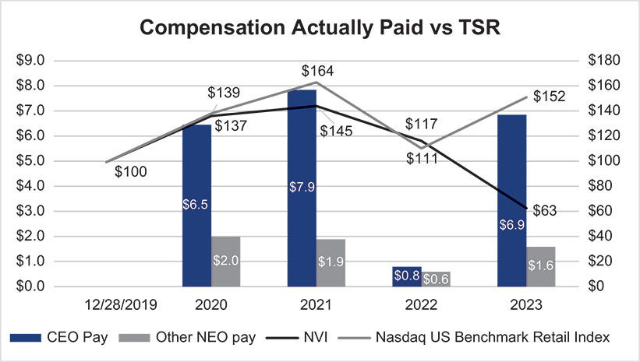
Compensation Actually Paid and Net Income
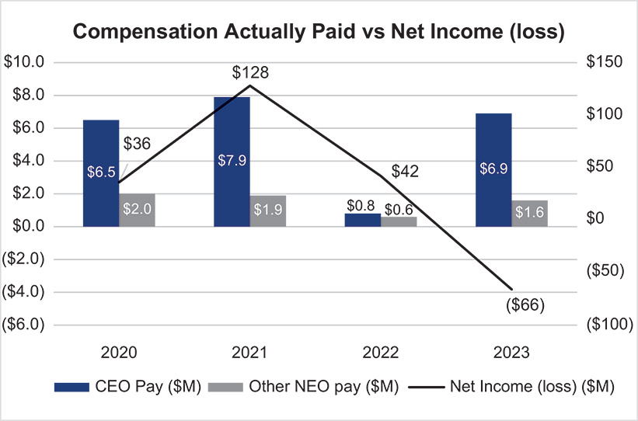
2024 Proxy Statement 53

TABLE OF CONTENTS
EXECUTIVE COMPENSATION
Compensation Actually Paid and Adjusted Operating Income
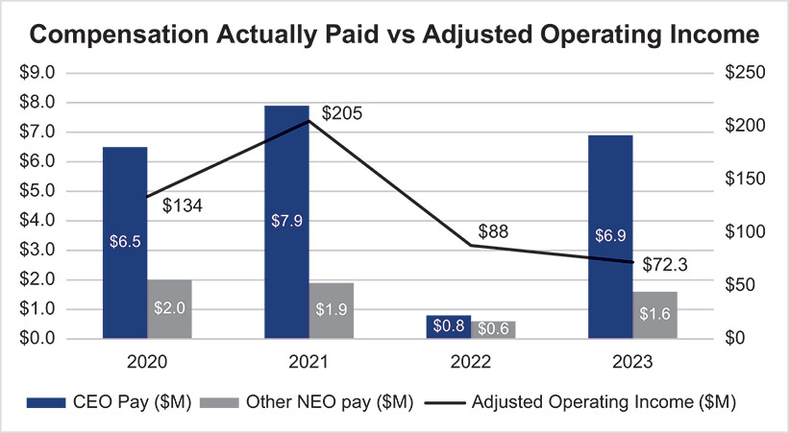
54 2024 Proxy Statement

TABLE OF CONTENTS​
EXECUTIVE COMPENSATION​
Proposal 3—Advisory Vote on the Frequency of Future Say-on-Pay Votes
​ | ​ | The Board recommends that you vote “ONE YEAR” on the frequency of future  Say-on Pay votes.​ |  |  |  |  | ​ | ​
​ | ​ | What Am I Voting on? | ​ | ​ | ​ | We are conducting a non-binding, advisory vote to approve the frequency of future advisory votes to approve the compensation of our named executive officers, commonly referred to as “Say-on-Pay.” | ​ | ​
​ | ​ | Vote Required | ​ | ​ | ​ | The proposal must be approved by a majority of votes cast at the Annual Meeting. | ​ | ​
Background
The US federal securities law that requires each US public company to hold a Say-on-Pay advisory vote also requires that stockholders be asked to vote on the frequency of future Say-on-Pay votes. Pursuant to this requirement in Section 14A of the Securities Exchange Act of 1934, as amended, we are asking stockholders to vote on whether future Say-on-Pay votes, such as the one in Proposal 2 above, should occur every year, every two years, or every three years. This vote on the frequency of Say-on-Pay votes is advisory in nature and must be held at least once every six years. We have conducted annual Say-on-Pay votes annually since our initial public offering, but we welcome the opportunity to submit the three alternative frequencies to our stockholders for consideration.
Recommendation of the Board
The Board believes that an advisory Say-on-Pay vote every year should be continued as it will enable our stockholders to provide us with direct input on our compensation philosophy, policies and practices as disclosed in the proxy statement each year, leading to a more meaningful and coherent communication between the Company and our stockholders on the compensation of our NEOs. Additionally, an annual Say-on-Pay vote is consistent with our policy of seeking input from our stockholders on corporate governance matters and our executive compensation philosophy, policies and practices even though it is not required by applicable law. The Board’s determination was further based on the premise that this recommendation could be modified in future years if it becomes apparent that an annual frequency vote is not meaningful, is burdensome, or is more frequent than recommended by corporate governance best practices.
Based on the factors discussed, the Board recommends that future Say-on-Pay votes occur every year until the next advisory vote on the frequency of future Say-on-Pay votes. Stockholders are not being asked to approve or disapprove the Board’s recommendation, but rather will be able to specify one of four choices for this proposal on the proxy card: one year, two years, three years, or abstain.
How the Board Considers Stockholder Feedback
This advisory vote is non-binding on the Board, but the Board will give careful consideration to the voting results on this proposal and expects to be guided by the alternative that receives the greatest number of votes, even if that alternative does not receive a majority of the votes cast.
The next advisory vote on the frequency of future Say-on-Pay votes will occur at the 2030 annual meeting of stockholders.
2024 Proxy Statement 55

TABLE OF CONTENTS​​
OWNERSHIP OF OUR SECURITIES
Ownership of Our Securities
Beneficial Ownership of National Vision Common Stock
The following table sets forth information with respect to the beneficial ownership of our common stock as of April 1, 2024, by each current director and director nominee, each NEO, all directors and executive officers as a group, and each individual or entity known by us to beneficially own more than 5% of our outstanding common stock based on our review of the reports regarding ownership filed with the Securities and Exchange Commission.
​ | ​ | Name of Beneficial Owner(1) | ​ | ​ | ​ | Shares of  Common Stock  Beneficially  Owned(2) | ​ | ​ | ​ | Percent of  Class(3) | ​ | ​
​ | ​ | Greater than 5% Stockholders: | ​ | ​ | ​ | ​ | ​ | ​ | ​ | ​ | ​ | ​
​ | ​ | BlackRock, Inc.﻿(4)  50 Hudson Yards  New York, New York 10001 | ​ | ​ | ​ | 12,603,822 | ​ | ​ | ​ | 16.1% | ​ | ​
​ | ​ | William Blair Investment Management, LLC﻿(5)  150 North Riverside Plaza  Chicago, Illinois 60606 | ​ | ​ | ​ | 9,839,344 | ​ | ​ | ​ | 12.6% | ​ | ​
​ | ​ | The Vanguard Group﻿(6)  100 Vanguard Boulevard  Malvern, Pennsylvania 19355 | ​ | ​ | ​ | 8,882,529 | ​ | ​ | ​ | 11.4% | ​ | ​
​ | ​ | ClearBridge Investments, LLC﻿(7)  620 8th Avenue  New York, New York 10018 | ​ | ​ | ​ | 4,329,234 | ​ | ​ | ​ | 5.5% | ​ | ​
​ | ​ | ArrowMark Colorado Holdings, LLC﻿(8)  100 Fillmore Street, Suite 325  Denver, Colorado 80206 | ​ | ​ | ​ | 4,004,799 | ​ | ​ | ​ | 5.1% | ​ | ​
​ | ​ | Named Executive Officers and Directors: | ​ | ​ | ​ | ​ | ​ | ​ | ​ | ​ | ​ | ​
​ | ​ | L. Reade Fahs(9) | ​ | ​ | ​ | 1,101,415 | ​ | ​ | ​ | 1.4% | ​ | ​
​ | ​ | Melissa Rasmussen | ​ | ​ | ​ | 29,731 | ​ | ​ | ​ | * | ​ | ​
​ | ​ | Patrick R. Moore | ​ | ​ | ​ | 223,902 | ​ | ​ | ​ | * | ​ | ​
​ | ​ | Jared Brandman | ​ | ​ | ​ | 93,089 | ​ | ​ | ​ | * | ​ | ​
​ | ​ | Bill Clark | ​ | ​ | ​ | 65,415 | ​ | ​ | ​ | * | ​ | ​
​ | ​ | D. Randolph Peeler(10) | ​ | ​ | ​ | 191,747 | ​ | ​ | ​ | * | ​ | ​
​ | ​ | Jose Armario | ​ | ​ | ​ | 12,005 | ​ | ​ | ​ | * | ​ | ​
​ | ​ | Virginia A. Hepner | ​ | ​ | ​ | 17,624 | ​ | ​ | ​ | * | ​ | ​
​ | ​ | Susan S. Johnson | ​ | ​ | ​ | 12,261 | ​ | ​ | ​ | * | ​ | ​
​ | ​ | Naomi Kelman | ​ | ​ | ​ | 12,580 | ​ | ​ | ​ | * | ​ | ​
​ | ​ | Susan O’Farrell | ​ | ​ | ​ | — | ​ | ​ | ​ | * | ​ | ​
​ | ​ | Thomas V. Taylor, Jr. | ​ | ​ | ​ | 25,556 | ​ | ​ | ​ | * | ​ | ​
​ | ​ | David M. Tehle | ​ | ​ | ​ | 26,466 | ​ | ​ | ​ | * | ​ | ​
​ | ​ | All directors and current executive officers as a group (15 persons) | ​ | ​ | ​ | 1,842,610 | ​ | ​ | ​ | 2.3% | ​ | ​
​
Less than one percent.
(*)
​
Except as otherwise indicated, the address of each beneficial owner is c/o National Vision Holdings, Inc., 2435 Commerce Avenue, Bldg. 2200, Duluth, Georgia 30096.
(1)
​
56 2024 Proxy Statement

TABLE OF CONTENTS
OWNERSHIP OF OUR SECURITIES​
A person is a “beneficial owner” of a security if that person has or shares “voting power,” which includes the power to vote or to direct the voting of the security, or “investment power,” which includes the power to dispose of or to direct the disposition of the security or has the right to acquire such powers within 60 days. All information with respect to beneficial ownership is based upon filings made by the respective beneficial owners with the Securities and Exchange Commission or information provided to us by such beneficial owners. To our knowledge, unless otherwise noted in the footnotes to the following table, and subject to applicable community property laws, the persons named in the table have sole voting and investment power with respect to their beneficially owned common stock.
(2)
​
Includes shares underlying stock options that are exercisable currently or within 60 days as follows: Mr. Fahs (124,888); Mr. Moore (160,720); Ms. Rasmussen (8,424); Mr. Brandman (57,822); Mr. Clark (33,253) and all directors and executive officers as a group (390,974).
For all directors and executive officers as a group, includes 2,986 shares underlying restricted stock units that will vest within 60 days.
As of April 1, 2024, there were 78,557,722 shares of our common stock, par value $0.01 per share, outstanding. Percentages are calculated pursuant to Rule 13d-3(d) under the Exchange Act. Shares not outstanding that are subject to options exercisable by the holder thereof within 60 days, shares due upon vesting of restricted stock units within 60 days, and shares deferred pursuant to vested restricted stock units and shares eligible for issuance pursuant to the non-employee director deferred compensation plan that may be distributed within 60 days, are deemed outstanding for the purposes of calculating the number and percentage owned by such shareholder but not deemed outstanding for the purpose of calculating the percentage of any other person.
(3)
​
Based on a Schedule 13G filed by BlackRock, Inc. (“BlackRock”) with the SEC on January 22, 2024, which indicates that various persons have the right to receive or the power to direct the receipt of dividends from, or the proceeds from the sale of, these securities. BlackRock reported that it has sole voting power with respect to 12,376,566 shares of common stock and sole dispositive power with respect to 12,603,822 shares of common stock.
(4)
​
Based on a Schedule 13G filed by William Blair Investment Management, LLC (“William Blair”) with the SEC on February 12, 2024, which indicates that various persons have the right to receive or the power to direct the receipt of dividends from, or the proceeds from the sale of, these securities. William Blair reported that it has sole voting power with respect to 8,598,776 shares of common stock and sole dispositive power with respect to 9,839,344 shares of common stock.
(5)
​
Based on a Schedule 13G filed by The Vanguard Group (“Vanguard”) with the SEC on February 13, 2024, which indicates that various persons have the right to receive or the power to direct the receipt of dividends from, or the proceeds from the sale of, these securities. Vanguard reported that it has shared voting power with respect to 57,172 shares of common stock, sole dispositive power with respect to 8,741,417 shares of common stock, and shared dispositive power with respect to 141,112 shares of common stock.
(6)
​
Based on a Schedule 13G filed by ClearBridge Investments, LLC (“ClearBridge”) with the SEC on February 2, 2024, which indicates that various persons have the right to receive or the power to direct the receipt of dividends from, or the proceeds from the sale of, these securities. ClearBridge reported that it has sole voting power with respect to 4,328,380 shares of common stock and sole dispositive power with respect to 4,329,234 shares of common stock.
(7)
​
Based on a Schedule 13G/A filed by ArrowMark Colorado Holdings, LLC (“Arrowmark”) with the SEC on February 14, 2024, which indicates that various persons have the right to receive or the power to direct the receipt of dividends from, or the proceeds from the sale of, these securities. ArrowMark reported that it has sole voting power with respect to 4,004,799 shares of common stock and sole dispositive power with respect to 4,004,799 shares of common stock.
(8)
​
Includes 363,430 shares held by the Fahs Family Trust.
(9)
​
Includes 148,880 shares held by The David Randolph Peeler Trust—2001.
(10)
​
2024 Proxy Statement 57

TABLE OF CONTENTS​​
PROPOSAL 4—APPROVAL OF AMENDMENT AND RESTATEMENT OF THE 2017 OMNIBUS INCENTIVE PLAN
Proposal 4—Approval of Amendment and Restatement of the 2017 Omnibus Incentive Plan
​ | ​ | The Board recommends that you vote “FOR” Proposal 4.​ |  |  |  |  | ​ | ​
​ | ​ | What Am I Voting on? | ​ | ​ | ​ | We are seeking stockholder approval to amend and restate our 2017 Omnibus Incentive Plan to increase the number of shares of the Company’s common stock reserved for issuance under the plan by an additional 5.6 million shares. | ​ | ​
​ | ​ | Vote Required | ​ | ​ | ​ | The proposal must be approved by a majority of votes cast at the Annual Meeting. | ​ | ​
Background
The Board is requesting that stockholders vote in favor of amending our 2017 Omnibus Incentive Plan (the “Equity Plan”) to increase the number of shares of the Company’s common stock reserved for issuance under the plan by an additional 5.6 million shares. We believe that our ability to continue offering equity incentive awards under the Equity Plan is critical to our ability to attract, retain and reward employees, non-employee directors and other persons providing services to the Company. If this proposal is approved, the amendment and restatement of the Equity Plan will become effective as of the date of stockholder approval, and the 5.6 million additional shares, minus the number of any shares subject to an equity award granted under the Equity Plan after the Record Date but prior to the date of stockholder approval, will be available for grant under the Equity Plan. If our stockholders do not approve this proposal, the amendment and restatement of the Equity Plan and the additional shares reserved for issuance will not take effect, and our Equity Plan will continue to be administered in its current form.
The Company has a long-standing practice of granting equity awards not only to its executives and directors, but also broadly among its employees. As of April 15, 2024, we had 13,228 full-time and part-time associates, all of whom are eligible to receive awards under the Equity Plan. Approximately 1.8% of eligible associates received an equity award in 2023. See “Eligible Participants” below for information on the individuals eligible to receive awards under the Equity Plan. The Equity Plan authorizes us to grant four types of equity awards: stock options, stock appreciation rights (“SARs”), restricted stock, and restricted stock units (“RSUs”). In practice, we have only granted time-based RSUs, performance-based RSUs (“performance stock units” or “PSUs”), restricted stock and stock options under the Equity Plan.
As of March 8, 2024, 271,683 shares remained available for grant under the Equity Plan. The Board believes that additional shares are necessary to meet the Company’s anticipated equity compensation needs. Following the proposed share increase, we expect that shares under the Equity Plan will last approximately five years, based on our average burn rate over the past three years. However, the actual duration of this share reserve will depend upon a number of currently unknown factors such as changes in employee headcount, award type mix, future forfeitures and cancellations of awards, competitive market practices and our stock price.
Increasing the Number of Shares Reserved for Issuance under the Equity Plan
​
Shares Available for Future Awards
The following table summarizes the number of shares subject to outstanding awards and that would be authorized for issuance as of March 8, 2024, under the Equity Plan, if this proposal is approved. In addition to the Equity Plan, there are outstanding awards under our 2014 Stock Incentive Plan for Key Employees of National Vision Holdings, Inc. and its Subsidiaries. As of April 15, 2024, the Equity Plan and the National
58 2024 Proxy Statement

TABLE OF CONTENTS
PROPOSAL 4—APPROVAL OF AMENDMENT AND RESTATEMENT OF THE 2017 OMNIBUS INCENTIVE PLAN
Vision Holdings, Inc. 2018 Associate Stock Purchase Plan (“ASPP”) are our only active equity plans, and no future grants may be made under the 2014 Stock Incentive Plan.
​ | ​ | Share Reservation under the Equity Plan | ​ | ​ | ​ | ​ | ​ | ​ | ​ | ​ | ​
​ | ​ | Outstanding awards as of March 8, 2024(1) | ​ | ​ | ​ | ​ | ​ | 2,463,183 | ​ | ​ | ​
​ | ​ | Outstanding Options/SARs(2) | ​ | ​ | ​ | ​ | ​ | 644,443 | ​ | ​ | ​
​ | ​ | Outstanding RSUs and PSUs | ​ | ​ | ​ | ​ | ​ | 1,818,740 | ​ | ​ | ​
​ | ​ | Shares available for new grants as of March 8, 2024, under the Equity Plan(1) | ​ | ​ | ​ | ​ | ​ | 271,683 | ​ | ​ | ​
​ | ​ | Total number of shares issuable as of March 8, 2024  (outstanding awards plus potential new grants) | ​ | ​ | ​ | ​ | ​ | 2,734,866 | ​ | ​ | ​
​ | ​ | Additional shares requested under this proposal | ​ | ​ | ​ | ​ | ​ | 5,600,000 | ​ | ​ | ​
​ | ​ | Total shares authorized for issuance as of March 8, 2024﻿(3)  (if this proposal is approved) | ​ | ​ | ​ | ​ | ​ | 8,334,866 | ​ | ​ | ​
​
This number assumes that PSUs outstanding as of March 8, 2024, will convert at 100% of their target amount upon vesting. PSUs are granted at a target share amount and can convert into shares of our common stock anywhere from 0% to 200% of that target amount upon vesting, depending on achieving specified performance criteria. For more information on PSUs, see “Executive Compensation—Executive Compensation Tables—Grants of Plan-Based Awards in 2023.”
(1)
​
The weighted average exercise price is $38.83. The weighted average remaining term is 5.84 years.
(2)
​
The shares available for new grants under the Equity Plan may increase due to cancellations and expirations and decrease due to new grants between March 8, 2024, and the effective date of the Equity Plan amendment and restatement.
(3)
​
Reasons to Vote for the Proposal
Long-Term Equity is a Key Component of our Compensation Program​
Our equity incentive program is designed to enable us to attract, retain and reward our employees, non-employee directors, consultants and advisors. The Board also believes that equity compensation is essential to link executive compensation with long-term stockholder value creation. Equity compensation represents a significant portion of the compensation package for our key employees, including a significant portion of the total compensation of our NEOs. Our equity awards generally vest over three years, and the value ultimately realized from these awards depends on the value of our shares at the time of vesting or the performance of the Company against pre-defined financial objectives. We strongly believe that granting equity awards motivates employees to think and act like owners, rewarding them when value is created for stockholders.
We Manage our Equity Incentive Program Thoughtfully​
We manage our long-term stockholder dilution by closely managing the number of equity awards granted annually and regularly engaging with our compensation consultant. We grant what we believe is an appropriate amount of equity necessary to attract, reward and retain employees. Our three-year average burn rate, which we define as the number of shares subject to equity awards granted under the Equity Plan in a fiscal year divided by the weighted average shares outstanding for that fiscal year, was 0.99% for fiscal years 2021 through 2023.
Our equity plan dilution rate (or overhang) as of March 8, 2024, was 3.48% (calculated by dividing (1) the number of shares subject to awards outstanding plus the number of shares remaining available for issuance, by (2) the total number of common shares outstanding. If shareholders approve our share request, the issuance of 5.6 million additional shares would increase our dilution rate by 7.13% to 10.61%.
2024 Proxy Statement 59

TABLE OF CONTENTS​
PROPOSAL 4—APPROVAL OF AMENDMENT AND RESTATEMENT OF THE 2017 OMNIBUS INCENTIVE PLAN
The Equity Plan Incorporates Good Compensation and Governance Practices​
​ | No Liberal Share Recycling | ​ | ​ | Shares used to pay the exercise price or withholding taxes for an outstanding award, unissued shares resulting from the net settlement of outstanding SARs, and shares purchased by us in the open market using the proceeds of option exercises do not become available for issuance as future awards. | ​
​ | No Evergreen Provision | ​ | ​ | The Equity Plan does not contain an “evergreen” feature that automatically replenishes the shares available for future grants under the plan. | ​
​ | No Repricing Without Stockholder Approval | ​ | ​ | The Equity Plan prohibits the repricing, cash-out or other exchange of underwater stock options and stock appreciation rights without prior stockholder approval. | ​
​ | Clawback Policy | ​ | ​ | Any incentive awards granted under the Equity Plan, and any cash or property delivered pursuant to incentive awards, are subject to forfeiture, recovery, or other action by the Company as necessary for compliance with any Company policy or as required by law. See “Compensation Discussion and Analysis—Additional Compensation Policies—Clawback Policy.” | ​
​ | Double-Trigger | ​ | ​ | In the event of a change in control, accelerated vesting of awards under the Equity Plan requires both a change of control and a qualifying termination of employment. | ​
​ | Administered by 100% Independent Compensation Committee | ​ | ​ | The Equity Plan is administered by the compensation committee of the Board, which is comprised entirely of independent non-employee directors. | ​
​ | No Automatic Grants | ​ | ​ | The Equity Plan does not provide for automatic grants to any participant. | ​
​ | No Tax Gross-Ups | ​ | ​ | The Equity Plan does not provide for any tax gross-ups. | ​
​ | One-Year Minimum Vesting Period | ​ | ​ | In addition to increasing the share reserve, the amended and restated Equity Plan incorporates a one-year minimum vesting period such that no portion of any award granted under the Equity Plan may vest before the one-year anniversary of the date of grant, subject to certain exceptions, as discussed in further detail below. The foregoing is subject to a 5% carve-out and does not restrict the compensation committee’s ability to provide for accelerated vesting upon a participant’s death or disability, or in connection with a change in control. | ​
​ | Annual limits on non-employee director awards | ​ | ​ | The Equity Plan limits the value of equity that may be granted under non-employee director awards each fiscal year. | ​
Summary of the Equity Plan
​
The Equity Plan was initially adopted by the Board and approved by stockholders in October 2017 in connection with the Company’s initial public offering. Please note that the following summary of major features of the amended and restated Equity Plan is qualified in its entirety by reference to the actual text of the amended and restated Equity Plan, which is included as Appendix B to this proxy statement.
Purpose
The compensation committee and the Board believe that it is in the best interests of the Company and its stockholders to provide, through the Equity Plan, a comprehensive equity incentive program designed to enable the Company to attract, retain and reward employees, non-employee directors, consultants
60 2024 Proxy Statement

TABLE OF CONTENTS
PROPOSAL 4—APPROVAL OF AMENDMENT AND RESTATEMENT OF THE 2017 OMNIBUS INCENTIVE PLAN
and advisors providing services to the Company. The Board also believes that equity compensation is essential to link executive compensation with long-term stockholder value creation. Equity compensation represents a significant portion of the compensation package for our key employees. We strongly believe that granting equity awards motivates employees to think and act like owners, rewarding them when value is created for stockholders.
Administration
The compensation committee, which consists solely of independent directors, has the exclusive authority to administer the Equity Plan. The Equity Plan grants broad authority to the plan administrator to do all things necessary or desirable, in its sole discretion, in connection with the administration of the Equity Plan, including the power to determine eligibility, the types and sizes of awards, the price and timing of awards, the acceleration or waiver of any vesting restriction and the authority to delegate such administrative responsibilities. To the extent permitted by applicable law, the compensation committee may delegate to a committee of one or more of our directors or one or more of our officers the authority to grant or amend awards to participants other than non-employee directors and our executives who are subject to Section 16 of the Exchange Act. Pursuant to this provision, our compensation committee’s current practice is to delegate to our Chief Executive Officer, in his capacity as a Board member, the authority to determine and make a limited number of individual grants to our employees who are not subject to Section 16 of the Exchange Act.
Eligible Participants
All of our full-time and part-time employees of the Company or any subsidiary of the Company, and our non-employee directors, are eligible to receive awards under the Equity Plan, as are consultants and advisors to the Company or any subsidiary of the Company who may be offered securities under a registration statement on Form S-8. As of April 15, 2024, we had 13,228 full-time and part-time associates and eight non-employee directors, all of whom are eligible to receive awards under the Equity Plan. The Company’s current practice is to not grant equity awards to our Optometrists or consultants.
Authorized Shares
Under the Equity Plan, four million shares were originally authorized for issuance. We are asking our stockholders to approve an additional 5.6 million shares to be available for issuance under the Equity Plan, which will increase the aggregate number of shares authorized under the Equity Plan to 9.6 million. As of March 8, 2024, we had approximately 271,683 shares available for issuance under the Equity Plan. Based solely on the closing price of the Company’s common stock, as reported on the Nasdaq on March 8, 2024, which was $23.81 per share, the maximum aggregate market value of the 271,683 shares that could be issued under the Equity Plan is $6,468,772.
Share Recycling
To the extent an award expires or is canceled, forfeited or terminated without issuing the full number of shares subject to the award, the unissued shares will again be available for grant under the Equity Plan. Shares will be deemed to have been issued in settlement of awards if the fair market value equivalent of such shares is paid in cash in connection with the settlement, provided that no shares will be deemed to have been issued upon settlement of a SAR or RSU that provides for settlement only in cash, or in respect of a cash-based incentive award. Shares used to pay the exercise price or withholding taxes for an outstanding award, unissued shares resulting from the net settlement of outstanding SARs that by their terms may settle in shares, and shares purchased by us in the open market using the proceeds of option exercises do not become available for issuance as future awards.
Limitation on Non-Employee Director Compensation
Pursuant to the Equity Plan, the maximum number of shares subject to awards granted during a single fiscal year to any non-employee director, taken together with any cash fees paid to such non-employee director during the fiscal year, may not exceed $500,000 in total value (calculating the value of any such awards based on the grant date fair value of such Awards for financial reporting purposes).
2024 Proxy Statement 61

TABLE OF CONTENTS
PROPOSAL 4—APPROVAL OF AMENDMENT AND RESTATEMENT OF THE 2017 OMNIBUS INCENTIVE PLAN
Award Types
The Equity Plan authorizes us to grant four types of equity awards: stock options, stock appreciation rights, restricted stock, and restricted stock units. In practice, we currently use the Equity Plan to grant time-based RSUs and PSUs. See “Compensation Discussion and Analysis—Compensation Elements” for a discussion of these award types.
Stock Options​
Stock options, including incentive stock options as defined under Section 422 of the Code and non-qualified stock options, may be granted pursuant to the Equity Plan. The option exercise price of all stock options granted pursuant to the Equity Plan will not be less than 100% of the fair market value of a share on the date of grant. Stock options may be exercised as determined by the compensation committee, but in no event may a stock option have a term extending beyond ten years from the date of grant. Notwithstanding the foregoing, incentive stock options granted to any person who owns, as of the date of grant, stock possessing more than ten percent of the total combined voting power of all classes of our stock will have an exercise price that is not less than 110% of the fair market value of a share on the date of grant and may not have a term extending beyond the fifth anniversary of the date of grant. The aggregate fair market value of a share with respect to which options intended to be incentive stock options are exercisable for the first time by an employee in any calendar year may not exceed $100,000 or such other amount as the Code provides. The compensation committee has the authority to determine the methods by which an option holder may pay the exercise price of an option or the related taxes, including, without limitation: (1) in cash or its equivalent at the time the stock option is exercised; (2) in shares having a fair market value equal to the aggregate exercise price for the shares being purchased and satisfying any requirements that may be imposed by the committee (provided that such shares have been held by the participant for at least six months or such other period established by the committee to avoid adverse accounting treatment); or (3) by such other method as the committee may permit in its sole discretion, including, without limitation, (A) in other property having a fair market value on the date of exercise equal to the purchase price, (B) if there is a public market for the shares at such time, through the delivery of irrevocable instructions to a broker to sell the shares being acquired upon the exercise of the stock option and to deliver to us the amount of the proceeds of such sale equal to the aggregate exercise price for the shares being purchased or (C) through a “net exercise” procedure effected by withholding the minimum number of shares needed to pay the exercise price. Any fractional shares of common stock will be settled in cash. No participant who is a member of the Board or an “executive officer” of the Company within the meaning of Section 13(k) of the Exchange Act will be permitted to pay the exercise price of an option in any method which would violate the prohibitions on loans made or arranged by us as set forth in Section 13(k) of the Exchange Act.
Stock Appreciation Rights​
SARs may be granted pursuant to the Equity Plan. The strike price of all SARs granted pursuant to the Equity Plan will not be less than 100% of the fair market value of a share on the date of grant. SARs may be exercised as determined by the compensation committee.
Restricted Stock Awards​
Restricted stock may be granted pursuant to the Equity Plan. A restricted stock award is the grant of shares at a price, if any, determined by the compensation committee, that is nontransferable and may be subject to substantial risk of forfeiture until specific conditions are met. During the period of restriction, participants holding shares of restricted stock may have full voting and dividend rights with respect to such shares; provided, however, that any dividends will be subject to the same vesting conditions as the underlying shares of restricted stock. The restrictions will lapse in accordance with a schedule or other conditions determined by the compensation committee.
Restricted Stock Units​
RSUs may be granted pursuant to the Equity Plan. An RSU award provides for the issuance of common stock at a future date upon the satisfaction of specific performance conditions as set forth in the applicable award agreement (commonly referred to as PSUs) and/or subject to continuing employment as set
62 2024 Proxy Statement

TABLE OF CONTENTS
PROPOSAL 4—APPROVAL OF AMENDMENT AND RESTATEMENT OF THE 2017 OMNIBUS INCENTIVE PLAN
forth in the applicable award agreement. The vesting and maturity dates will be established at the time of grant and may provide for the deferral of receipt of the common stock beyond the vesting date. On or following the maturity date, we will transfer to the participant one unrestricted, fully transferable share of common stock for each RSU scheduled to be paid out and not previously forfeited (subject to applicable tax withholding requirements), or, in the sole discretion of the committee, cash.
Other Equity-Based Awards​
Other equity-based awards may be granted under the Equity Plan in the compensation committee’s sole discretion so long as they are payable by delivery of common stock and/or measured by reference to the value of common stock, evidenced by an award agreement, and subject to conditions not inconsistent with the Equity Plan.
Cash-Based Incentive Awards​
Cash-based incentive awards may be granted pursuant to the Equity Plan. Cash-based incentive awards are cash awards payable upon the attainment of performance goals that are pre-established and then evaluated by the compensation committee and may relate to performance over any periods as determined by the committee.
Dividends
The compensation committee in its sole discretion may provide part of an award with dividends or dividend equivalents, on such terms and conditions as may be determined by the committee in its sole discretion. Unless otherwise provided in the award agreement, any dividend payable in respect of any share of restricted stock that remains subject to vesting conditions at the time of payment of such dividend will be retained by the Company and remain subject to the same vesting conditions as the share of restricted stock to which the dividend relates.
Transferability
Awards granted under the Equity Plan are transferable only by will or the laws of descent and distribution, or to certain permitted transferees to the extent otherwise determined by the compensation committee. Permitted transferees, other than for incentive stock options, generally include a participant’s family members, any trust established solely for the benefit of a participant or such participant’s family members, any partnership or limited liability company of which a participant, or such participant and such participant’s family members, are the sole member(s), and a beneficiary to whom donations are eligible to be treated as “charitable contributions” for tax purposes.
Prohibition on Repricing
The compensation committee may not, without stockholder approval, (i) reduce the exercise price of any option or the strike price of any SAR; (ii) cancel any outstanding option or SAR and replace it with a new option or SAR with a lower exercise price or strike price, as the case may be, or other award or cash payment that is greater than the intrinsic value (if any) of the cancelled option or SAR; or (iii) take any other action which is considered a “repricing” for purposes of the Nasdaq stockholder approval rules.
Minimum Vesting
Except in the case of shares issued in lieu of vested cash awards and substitute awards granted in a business combination, no portion of any equity-based award granted under the Equity Plan will vest before the one-year anniversary of the date of grant, except where vesting occurs due to a participant’s death or disability, or solely in connection with a change in control or with respect to awards which in aggregate to do exceed 5% of the total number of shares available under the Equity Plan. For awards issued to non-employee directors, the minimum vesting period may be the approximately one-year period between annual meetings.
Awards Subject to Clawback
Any incentive awards granted under the Equity Plan, and any cash or property delivered pursuant to incentive awards, are subject to reduction, cancellation, forfeiture or recoupment to the extent necessary
2024 Proxy Statement 63

TABLE OF CONTENTS
PROPOSAL 4—APPROVAL OF AMENDMENT AND RESTATEMENT OF THE 2017 OMNIBUS INCENTIVE PLAN
to comply with any clawback, forfeiture or other similar policy adopted by our board of directors or the Committee and as in effect from time to time or as required by law.
Adjustments
In the event of (1) a stock dividend, recapitalization, stock split, combination of shares, extraordinary dividend of cash or assets, reorganization, or exchange of our common stock, or any similar equity restructuring transaction (as that term is used in FASB ASC Topic 718) affecting our common stock, or (2) unusual or nonrecurring events affecting the Company, including changes in applicable rules, rulings, regulations or other requirements, that the committee determines, in its sole discretion, could result in substantial dilution or enlargement of the rights intended to be granted to, or available for, participants, the committee will equitably adjust: the number and kind of shares available for grant under the Equity Plan; the number and kind of shares subject to the various limitations set forth in the Equity Plan and subject to outstanding awards under the Equity Plan; and the exercise or settlement price of outstanding stock options and of other awards.
Change in Control
A “change in control” generally means a transaction in which any person or group acquires more than 50% of our voting securities, a change in a majority of the Board over a one-year period that is not approved by at least two-thirds of the incumbent Board members, a sale or other disposition of all or substantially all of our assets, a merger or consolidation in which we are not the surviving corporation or a reverse merger in which we are the surviving corporation but the shares of our stock outstanding immediately preceding the merger are converted by virtue of the merger into other property or the Company’s stockholders approval of a liquidation or dissolution of the Company.
Outstanding awards do not automatically terminate in the event of a change in control. In the event of a change in control, the surviving corporation or acquiring corporation does not either assume or continue outstanding awards or substitute similar awards, the compensation committee may provide for full acceleration of the vesting, exercisability or lapse of restrictions on such awards. The unexercised portion of outstanding awards may terminate upon the change in control. If a change in control occurs during a performance period with respect to an outstanding award that vests based on performance goals or other performance-based objectives, the performance period of the award will end as of the date of the change in control and the performance goals will be deemed to have been satisfied at the actual level of performance as of the date of the change in control, as determined by the compensation committee as constituted immediately prior to the change in control, without proration, and such award, to the extent deemed earned by the compensation committee, will continue to be subject to time-based vesting following the change in control in accordance with the original vesting schedule; provided, however, that if the awards are not converted, assumed or replaced by a successor entity, then immediately prior to the change in control, such award will become fully vested, as described in the paragraph above.
Termination or Amendment
The Equity Plan will automatically terminate ten years from the most recent approval of the Equity Plan by the Company’s stockholders, unless terminated at an earlier time by the Board. The compensation committee may terminate or amend the Equity Plan at any time, subject to stockholder approval for any amendment (i) to the extent necessary to comply with any applicable law, regulation, or stock exchange rule, (ii) to increase the number of shares available under the Equity Plan, (iii) to materially modify the requirements for participation in the Equity Plan, or (iv) to amend the repricing provisions in the Equity Plan. No termination or amendment of the Equity Plan may adversely affect in any material respect any Award previously granted pursuant to the Equity Plan without the consent of the participant, holder or beneficiary.
Summary of U.S. Federal Income Tax Consequences
The following is a general summary under current law of the material federal income tax consequences to participants in the Equity Plan under U.S. law. This summary deals with the general tax principles that apply and is provided only for general information. Certain types of taxes, such as state and local income taxes and taxes imposed by jurisdictions outside the U.S., are not discussed. Tax laws are complex and
64 2024 Proxy Statement

TABLE OF CONTENTS
PROPOSAL 4—APPROVAL OF AMENDMENT AND RESTATEMENT OF THE 2017 OMNIBUS INCENTIVE PLAN
subject to change and may vary depending on individual circumstances and from locality to locality. The summary does not discuss all aspects of income taxation that may be relevant to a participant in light of his or her personal investment circumstances. This summarized tax information is not tax advice.
Incentive Stock Options​
An option granted as an “incentive stock option,” or ISO, under Section 422 of the Code may qualify for special tax treatment. The Code requires that, for treatment of an option as an ISO, common stock acquired through the exercise of the option cannot be disposed of before the later of: (i) two years from the date of grant of the option or (ii) one year from the date of exercise. Holders of ISOs will generally incur no federal income tax liability at the time of grant or upon exercise of those options. However, the option “spread value” at the time of exercise will be an “item of tax preference,” which may give rise to “alternative minimum tax” liability for the taxable year in which the exercise occurs. If the holder does not dispose of the shares before two years following the date of grant and one year following the date of exercise, the difference between the exercise price and the amount realized upon disposition of the shares will constitute long-term capital gain or loss, as applicable. Assuming both holding periods are satisfied, we will not be allowed a deduction for federal income tax purposes in connection with the grant or exercise of the ISO. If, within two years following the date of grant or within one year following the date of exercise, the holder of shares acquired through the exercise of an ISO disposes of those shares, with certain exceptions, the holder will generally realize ordinary income at the time of such disposition equal to the difference between the exercise price and the fair market value of a share on the date of exercise and that amount will generally be deductible by us for federal income tax purposes, subject to the possible limitations on deductibility under Sections 280G and 162(m) of the Code for compensation paid to executives designated in those Sections. Any additional gain or loss recognized upon a subsequent sale or exchange of the shares is treated as capital gain or loss, as applicable, for which we are not entitled to a deduction. Finally, if an otherwise qualified ISO first becomes exercisable in any one year for shares having an aggregate value in excess of $100,000 (based on the grant date value), the portion of the ISO in respect of those excess shares will be treated as a non-qualified stock option for federal income tax purposes.
Non-qualified Stock Options​
In general, in the case of a non-qualified stock option, the holder has no federal income tax liability at the time of grant but realizes ordinary income upon exercise of the option in an amount equal to the excess, if any, of the fair market value of the shares acquired upon exercise over the exercise price. We will be able to deduct this same amount for federal income tax purposes, but such deduction may be limited under Sections 280G and 162(m) of the Code for compensation paid to certain executives designated in those Sections. Any gain or loss recognized upon a subsequent sale or exchange of the shares is treated as capital gain or loss, as applicable, for which we are not entitled to a deduction.
Stock Appreciation Rights​
No federal income tax liability will be realized by a holder upon the grant of a stock appreciation right, or SAR. Upon the exercise of a SAR, the holder will recognize ordinary income in an amount equal to the fair market value of the shares of stock or cash payment received in respect of the SAR. We will be able to deduct this same amount for federal income tax purposes, but such deduction may be limited under Sections 280G and 162(m) of the Code for compensation paid to certain executives designated in those Sections. Any gain or loss recognized upon a subsequent sale or exchange of the shares is treated as capital gain or loss, as applicable, for which we are not entitled to a deduction.
Restricted Stock​
A holder will not have any federal income tax liability upon the grant of an award of restricted stock unless the holder otherwise elects to be taxed at the time of grant pursuant to Section 83(b) of the Code. On the date an award of restricted stock becomes transferable or is no longer subject to a substantial risk of forfeiture, the holder will have ordinary income equal to the difference between the fair market value of the shares on that date over the amount the holder paid for such shares, if any, unless the holder made an election under Section 83(b) of the Code to be taxed at the time of grant. If the holder makes
2024 Proxy Statement 65

TABLE OF CONTENTS​
PROPOSAL 4—APPROVAL OF AMENDMENT AND RESTATEMENT OF THE 2017 OMNIBUS INCENTIVE PLAN
an election under Section 83(b) of the Code, the holder will have ordinary income at the time of grant equal to the difference between the fair market value of the shares on the date of grant over the amount the holder paid for such shares, if any. Any future appreciation in the common stock will be taxable to the holder at capital gains rates. However, if the restricted stock award is later forfeited, the holder will not be able to recover the tax previously paid pursuant to his Section 83(b) election. We will be able to deduct, at the same time as it is recognized by the holder, the amount of ordinary income to the holder for federal income tax purposes, but such deduction may be limited under Sections 280G and 162(m) of the Code for compensation paid to certain executives designated in those Sections. Special rules apply to the receipt and disposition of restricted stock received by officers and directors who are subject to Section 16(b) of the Exchange Act.
Restricted Stock Units​
A holder will not have any federal income tax liability at the time a restricted stock unit is granted. Rather, upon the delivery of shares (or cash) pursuant to a restricted stock unit award, the holder will have ordinary income equal to the fair market value of the number of shares (or the amount of cash) the holder actually receives with respect to the award. We will be able to deduct the amount of ordinary income to the holder for federal income tax purposes, but the deduction may be limited under Sections 280G and 162(m) of the Code for ordinary income paid to certain executives designated in those Sections. Any gain or loss recognized upon a subsequent sale or exchange of the stock (if settled in stock) is treated as capital gain or loss for which we are not entitled to a deduction.
Stock Bonus Awards​
A holder will have ordinary income equal to the difference between the fair market value of the shares on the date the common stock subject to the award is transferred to the holder over the amount the holder paid for such shares, if any. We will be able to deduct, at the same time as it is recognized by the holder, the amount of ordinary income to the holder for federal income tax purposes, but such deduction may be limited under Sections 280G and 162(m) of the Code for compensation paid to certain executives designated in those Sections. Any gain or loss recognized upon a subsequent sale or exchange of the stock is treated as capital gain or loss for which we are not entitled to a deduction.
Other Stock-Based Awards​
A holder will have ordinary income equal to the difference between the fair market value of the shares on the date the common stock subject to another stock-based award is transferred to the holder over the amount the holder paid for such shares, if any. We will be able to deduct, at the same time as it is recognized by the holder, the amount of ordinary income to the holder for federal income tax purposes, but such deduction may be limited under Sections 280G and 162(m) of the Code for compensation paid to certain executives designated in those Sections. Any gain or loss recognized upon a subsequent sale or exchange of the stock is treated as capital gain or loss for which we are not entitled to a deduction.
Code Section 409A​
The Equity Plan permits the grant of various types of awards, which may or may not be exempt from Code Section 409A. If an award is subject to Section 409A, and if the requirements of Section 409A are not met, the taxable events as described above could apply earlier than described and could result in the imposition of additional taxes and penalties. Restricted stock awards, stock options, and SARs granted under the Plan, are generally designed to be exempt from the application of Code Section 409A. RSUs and PSUs granted under the Plan may be subject to Section 409A unless they are designed to satisfy the short-term deferral exemption from such law.
New Plan Benefits; Market Value of Securities
​
The compensation committee has the discretion to grant awards under the Equity Plan, and the compensation committee has not determined future awards or who might receive them. Accordingly, the benefits that will be granted or paid under the amended and restated Equity Plan are not currently determinable. However, each non-employee director is expected to receive an annual RSU grant on the
66 2024 Proxy Statement

TABLE OF CONTENTS​
PROPOSAL 4—APPROVAL OF AMENDMENT AND RESTATEMENT OF THE 2017 OMNIBUS INCENTIVE PLAN
date of the 2024 Annual Meeting with a target value of approximately $140,000. Non-employee directors may also elect to receive RSUs in lieu of their cash fees.
As of April 15, 2024, the closing price of a share of our common stock was $19.22.
Awards Granted under the Equity Plan
​
Pursuant to SEC rules, the following table lists the number of PSUs (at target), RSUs, and stock options granted under the Equity Plan since its inception and through March 8, 2024 (whether or not outstanding, vested, or forfeited, as applicable).
​ | ​ | Name of Individual or Group | ​ | ​ | ​ | Stock Options | ​ | ​ | ​ | RSAs | ​ | ​ | ​ | RSUs | ​ | ​ | ​ | PSUs | ​ | ​
​ | ​ | 2023 NEOs | ​ | ​ | ​ | ​ | ​ | ​ | ​ | ​ | ​ | ​ | ​ | ​ | ​ | ​ | ​ | ​ | ​ | ​
​ | ​ | L. Reade Fahs | ​ | ​ | ​ | 149,888 | ​ | ​ | ​ | — | ​ | ​ | ​ | 293,294 | ​ | ​ | ​ | 366,619 | ​ | ​
​ | ​ | Melissa Rasmussen | ​ | ​ | ​ | 11,691 | ​ | ​ | ​ | — | ​ | ​ | ​ | 36,934 | ​ | ​ | ​ | 42,497 | ​ | ​
​ | ​ | Patrick R. Moore | ​ | ​ | ​ | 139,360 | ​ | ​ | ​ | — | ​ | ​ | ​ | 83,725 | ​ | ​ | ​ | 97,894 | ​ | ​
​ | ​ | Jared Brandman | ​ | ​ | ​ | 17,136 | ​ | ​ | ​ | — | ​ | ​ | ​ | 39,617 | ​ | ​ | ​ | 47,847 | ​ | ​
​ | ​ | Bill Clark | ​ | ​ | ​ | 33,253 | ​ | ​ | ​ | — | ​ | ​ | ​ | 39,589 | ​ | ​ | ​ | 56,499 | ​ | ​
​ | ​ | All current executive officers as a group | ​ | ​ | ​ | 361,370 | ​ | ​ | ​ | — | ​ | ​ | ​ | 671,409 | ​ | ​ | ​ | 689,733 | ​ | ​
​ | ​ | All current non-employee directors as a group | ​ | ​ | ​ | — | ​ | ​ | ​ | 48,218 | ​ | ​ | ​ | 87,074 | ​ | ​ | ​ | — | ​ | ​
​ | ​ | Associates of any such directors, executive officers or nominees | ​ | ​ | ​ | 297,531 | ​ | ​ | ​ | — | ​ | ​ | ​ | 1,195,903 | ​ | ​ | ​ | 307,923 | ​ | ​
​ | ​ | Other persons who received or is to receive 5% of such options or rights | ​ | ​ | ​ | 149,888 | ​ | ​ | ​ | — | ​ | ​ | ​ | 293,294 | ​ | ​ | ​ | 366,619 | ​ | ​
​ | ​ | All employees as a group (excluding executive officers) | ​ | ​ | ​ | 11,691 | ​ | ​ | ​ | — | ​ | ​ | ​ | 36,934 | ​ | ​ | ​ | 42,497 | ​ | ​
​
2024 Proxy Statement 67

TABLE OF CONTENTS​​
AUDIT COMMITTEE MATTERS
Audit Committee Matters
Proposal 5—Ratification of the Appointment of Deloitte & Touche LLP as our Independent Registered Public Accounting Firm for 2024
​ | ​ | The Board recommends that you vote “FOR” Proposal 5.​ |  |  |  |  | ​ | ​
​ | ​ | What Am I Voting on? | ​ | ​ | ​ | Stockholders are being asked to ratify the appointment of Deloitte & Touche LLP to serve as the Company’s independent registered public accounting firm for fiscal 2024. | ​ | ​
​ | ​ | Vote Required | ​ | ​ | ​ | The proposal must be approved by a majority of votes cast at the Annual Meeting. | ​ | ​
Background
The audit committee has sole authority and direct responsibility to appoint, hire, evaluate and, if appropriate, replace the Company’s independent registered public accounting firm. The audit committee has selected Deloitte & Touche LLP (“Deloitte”) to serve as our independent registered public accounting firm for fiscal 2024.
Each year the audit committee evaluates the qualifications and performance of the Company’s independent registered public accountants and determines whether to re-engage the current independent registered public accounting firm. In connection with the committee’s assessment, Deloitte makes an annual presentation to the audit committee regarding the services it provides, and our chief financial officer provides the committee with his assessment of the firm’s performance. In addition, when evaluating whether to continue to retain Deloitte, the audit committee assesses the factors described in “Audit Committee Report” below. Based on this evaluation, the audit committee believes the continued retention of Deloitte is in the best interests of the Company and its stockholders.
One or more representatives of Deloitte are expected to be present at the Annual Meeting, will be available to respond to appropriate questions from stockholders and will have an opportunity to make a statement if desired.
Reason for the Proposal
Although ratification is not required by our Bylaws or otherwise, the Board is submitting its selection to our stockholders for ratification as a matter of good corporate governance and because we value our stockholders’ views on the Company’s independent registered public accounting firm.
If our stockholders fail to ratify the selection, it will be considered as notice to the Board and the audit committee to consider the selection of a different firm. Even if the selection is ratified, the audit committee, in its discretion, may select a different independent registered public accounting firm at any time during the year if it determines that such a change would be in the best interests of the Company and its stockholders.
68 2024 Proxy Statement

TABLE OF CONTENTS​​​
AUDIT COMMITTEE MATTERS​
Audit and Non-Audit Fees
​
The following table presents the aggregate fees billed for professional services rendered by our independent registered public accounting firm, Deloitte & Touche LLP during the 2023 and 2022 fiscal years.
​ | ​ | ​ | ​ | ​ | ​ | Fiscal Year 2023 | ​ | ​ | ​ | Fiscal Year 2022 | ​ | ​
​ | ​ | Audit fees(1) | ​ | ​ | ​ | $2,421,344 | ​ | ​ | ​ | $2,102,346 | ​ | ​
​ | ​ | Audit-related fees(2) | ​ | ​ | ​ | — | ​ | ​ | ​ | — | ​ | ​
​ | ​ | Tax fees(3) | ​ | ​ | ​ | — | ​ | ​ | ​ | — | ​ | ​
​ | ​ | All other fees | ​ | ​ | ​ | — | ​ | ​ | ​ | — | ​ | ​
​ | ​ | Total | ​ | ​ | ​ | $2,421,344 | ​ | ​ | ​ | $2,102,346 | ​ | ​
​
Includes the aggregate fees for professional services rendered for the audit of the Company’s annual financial statements and the quarterly reviews of its financial statements, and assistance with documents filed with the SEC.
(1)
​
Includes any aggregate fees for professional services performed in connection with the issuance of comfort letters.
(2)
​
Includes any aggregate fees for professional services rendered for tax compliance, and tax consultation and planning.
(3)
​
Audit Committee Pre-Approval of Audit and Permissible Non-Audit Services
​
Consistent with SEC policies regarding auditor independence and the audit committee’s charter, the audit committee has responsibility for engaging, setting compensation for and reviewing the performance of the independent registered public accounting firm. In exercising this responsibility, the audit committee has adopted policies and procedures relating to the approval of all audit and non-audit services that are to be performed by our independent registered public accounting firm and pre-approves all audit and permitted non-audit services provided by any independent registered public accounting firm prior to each engagement. The audit committee, prior to such engagement, pre-approves independent public accounting firm services within each category and the fees of each category are budgeted. During the year, circumstances may arise when it may become necessary to engage the independent registered public accounting firm for additional services not contemplated in the original pre-approval categories. In those instances, the audit committee requires specific pre-approval before engaging the independent registered public accounting firm.
Report of the Audit Committee
​
The audit committee operates pursuant to a charter which is reviewed annually by the audit committee. Additionally, a brief description of the primary responsibilities of the audit committee is included in this proxy statement under “Corporate Governance Matters—Board Committees—Audit Committee.” Under the audit committee charter, our management is responsible for the preparation, presentation and integrity of our financial statements, the application of accounting and financial reporting principles and our internal controls and procedures designed to assure compliance with accounting standards and applicable laws and regulations. The independent registered public accounting firm is responsible for auditing our financial statements and expressing an opinion as to their conformity with accounting principles generally accepted in the United States of America.
In the performance of its oversight function, the audit committee reviewed and discussed the audited financial statements of the Company with management and with the independent registered public accounting firm. The audit committee also discussed with the independent registered public accounting firm the matters required to be discussed by Public Company Accounting Oversight Board Auditing Standard No. 1301 “Communications with Audit Committees.” In addition, the audit committee received the written disclosures and the letter from the independent registered public accounting firm required by applicable requirements of the Public Company Accounting Oversight Board regarding the independent registered public accounting firm’s communications with the audit committee concerning independence, and discussed with the independent registered public accounting firm their independence.
2024 Proxy Statement 69

TABLE OF CONTENTS
AUDIT COMMITTEE MATTERS
Based upon the review and discussions described in the preceding paragraph, the audit committee recommended to the Board that the audited financial statements of the Company be included in the Annual Report on Form 10-K for the fiscal year ended December 30, 2023, filed with the SEC.
Submitted by the audit committee of the Company’s Board of Directors:
Audit Committee
David M. Tehle, Chair
Virginia A. Hepner
Susan S. Johnson
Naomi Kelman
70 2024 Proxy Statement

TABLE OF CONTENTS​​​​​
IMPORTANT INFORMATION ABOUT VOTING AT THE ANNUAL MEETING​
Important Information About Voting at the Annual Meeting
Proposals to be Voted on and Voting Recommendations
​
There are five proposals scheduled to be voted on at the Annual Meeting. These proposals and our Board’s voting recommendations are set forth below. If you sign and submit your proxy card without voting instructions, your shares will be voted in accordance with the recommendation of the Board with respect to the proposals and in accordance with the discretion of the holders of the proxy with respect to any other matters that may be voted upon.
​ | ​ | Company Proposals | ​ | ​ | ​ | Board Vote  Recommendation | ​ | ​ | ​ | For Further  Details | ​ | ​
​ | ​ | Election of the eight director nominees listed in this proxy statement.  Proposal 1:  ​ | ​ | ​ | ​ | FOR  all nominees | ​ | ​ | ​ | Page 8 | ​ | ​
​ | ​ | Advisory vote to approve the compensation of our named executive officers (“Say-on-Pay”).  Proposal 2:  ​ | ​ | ​ | ​ | FOR | ​ | ​ | ​ | Page 30 | ​ | ​
​ | ​ | Advisory vote on the frequency of future Say-on-Pay votes.  Proposal 3:  ​ | ​ | ​ | ​ | ONE YEAR | ​ | ​ | ​ | Page 55 | ​ | ​
​ | ​ | Approval of amendment and restatement of the 2017 Omnibus Incentive Plan.  Proposal 4:  ​ | ​ | ​ | ​ | FOR | ​ | ​ | ​ | Page 58 | ​ | ​
​ | ​ | Ratification of the appointment of Deloitte & Touche LLP as our independent registered public accounting firm for 2024.  Proposal 5:  ​ | ​ | ​ | ​ | FOR | ​ | ​ | ​ | Page 68 | ​ | ​
Other Business
​
The Board of Directors does not know of any other matters to be brought before the meeting. If other matters are properly presented, the proxy holders have discretionary authority to vote all proxies in accordance with their best judgment.
Who Can Vote
​
The Board of Directors has fixed the close of business on April 15, 2024, as the record date for determining the stockholders entitled to notice of, to attend and to vote at the Annual Meeting. As of the record date, there were 78,560,994 shares of common stock outstanding and entitled to vote, with no other classes of stock outstanding. All of these shares are to be voted as a single class and you are entitled to one vote for each share of common stock held by you as of the Record Date, including shares:
Held directly in your name as “stockholder of record” ​(also referred to as “registered stockholder”);
•
​
Held for you in an account with a broker, bank or other nominee. For more information, see “How to Vote if a Bank, Broker, or Other Nominee is the Record Holder of Your Stock” below.
•
​
Held for you by us as restricted securities under either our 2014 Stock Plan or our 2017 Omnibus Incentive Plan.
•
​
Quorum
​
In order for there to be a vote on any matter at the Annual Meeting, there must be a quorum. In order to have a quorum, the holders of record of a majority of the voting power of the issued and outstanding shares of capital stock entitled to vote at the Annual Meeting must be present in person or represented by proxy. Abstentions and “broker non-votes” are counted as present for purposes of determining a quorum. If we fail to obtain a quorum at the 2023 Annual Meeting, the chair of the 2023 Annual Meeting
2024 Proxy Statement 71

TABLE OF CONTENTS​​​​
IMPORTANT INFORMATION ABOUT VOTING AT THE ANNUAL MEETING
or the holders of a majority of the shares of stock entitled to vote, present online or by proxy, may adjourn the meeting to another place, date, or time.
Vote Required
​
Under our Bylaws, directors are elected by a majority of the votes cast in respect of the shares present in person or represented by proxy at the Annual Meeting and entitled to vote on the election of directors (meaning that for Proposal 1, the number of shares voted “FOR” a nominee must exceed the number of shares voted “AGAINST” such nominee). There is no cumulative voting.
For Proposals 2, 4 and 5, under our Bylaws, approval of the proposal requires the vote of the holders of a majority of the voting power of the shares of stock present in person or represented by proxy at the Annual Meeting and entitled to vote on such proposal. For Proposal 3, the option that receives the highest number of votes will be considered the frequency that has been selected by stockholders. While Proposal 2, the vote on executive compensation, and Proposal 3, the vote on the frequency of the vote on executive compensation, are advisory in nature and non-binding, the Board will review the voting results and intends to take them into consideration when making future decisions regarding executive compensation and the frequency of the vote on executive compensation.
Voting in Advance of the Annual Meeting
​
If you are the record holder of your stock, you may submit your proxy to vote in advance of the Annual Meeting via the Internet, by telephone, or by mail.
​ | By Internet | ​ | ​ | Go to the website www.investorvote.com/EYE and follow the instructions, 24 hours a day, seven days a week.  •  ​  You will need the 16-digit number included on your proxy card to obtain your records and to create an electronic voting instruction form.  •  ​ | ​
​ | By Telephone | ​ | ​ | From a touch-tone telephone, dial 1-800-652-VOTE (8683) and follow the recorded instructions, 24 hours a day, seven days a week.  •  ​  You will need the 16-digit number included on your proxy card in order to vote by telephone.  •  ​ | ​
​ | By Mail | ​ | ​ | Mark your selections on the proxy card.  •  ​  Date and sign your name exactly as it appears on your proxy card.  •  ​  Mail the proxy card in the enclosed postage-paid envelope provided to you.  •  ​ | ​
Internet and telephone voting will close at 11:59 p.m., Eastern Time, on June 11, 2024. Proxy cards with respect to shares held of record must be received no later than June 11, 2024.
Voting During the Annual Meeting
​
If you are a stockholder of record or a beneficial owner of shares held through a broker, bank or other nominee, you may vote in-person during the Annual Meeting. If you are a stockholder of record and prefer to vote your shares at the Annual Meeting, you must bring proof of identification along with your proof of ownership. If you are a beneficial owner of shares held through a broker, bank or other nominee, you may only vote shares at the Annual Meeting if you bring a signed proxy from the record holder (broker, bank or other nominee) giving you the right to vote the shares, as well as proof of identification and proof of ownership. Even if you plan to attend the Annual Meeting, we encourage you to vote in advance by Internet, telephone or mail so that your vote will be counted even if you later decide not to attend the Annual Meeting.
How to Vote if a Bank, Broker, or Other Nominee is the Record Holder of Your Stock
​
If a bank, broker or other nominee was the record holder of your stock on the record date, you will be able to instruct your bank, broker, or other nominee on how to vote by following the instructions on the
72 2024 Proxy Statement

TABLE OF CONTENTS​​​​
IMPORTANT INFORMATION ABOUT VOTING AT THE ANNUAL MEETING​
voting instruction form or notice that you receive from your bank, broker or other nominee. In most instances, you will be able to do this over the Internet, by telephone or by mail.
Broker Voting and Broker Non-Votes
​
A broker non-vote occurs when shares held through a broker are not voted with respect to a proposal because (1) the broker has not received voting instructions from the stockholder who beneficially owns the shares and (2) the broker lacks the authority to vote the shares at its discretion. Proposal Nos. 1, 2, 3 and 4 are considered non-routine matters, and a broker will lack the authority to vote uninstructed shares at their discretion on such proposals. Proposal 5 is considered a routine matter, and a broker will be permitted to exercise its discretion to vote uninstructed shares on this proposal.
How to Change or Revoke Your Proxy
​
Whether you have voted by Internet, telephone or mail, if you are a stockholder of record, you may change your vote and revoke your proxy by:
sending a written statement to that effect to our Secretary, provided such statement is received no later than June 11, 2024;
•
​
voting by Internet or telephone at a later time than your previous vote and before the closing of those voting facilities at 11:59 p.m., Eastern Time, on June 11, 2024;
•
​
submitting a properly signed proxy card, which has a later date than your previous vote, and that is received no later than June 11, 2024; or
•
​
attending the Annual Meeting in-person and voting during the meeting.
•
​
If you hold your shares through a broker, please refer to information from your bank, broker or other nominee on how to revoke or submit new voting instructions.
How Votes are Counted
​
Representatives of Computershare Trust Company, N.A., our transfer agent, will tabulate the votes and act as inspectors of election.
With respect to the election of directors (Proposal 1), you may vote “FOR,” “AGAINST” or “ABSTAIN with respect to the nominees. Votes that are abstentions will not count as a vote “FOR” or “AGAINST” a director because directors are elected by majority voting. Broker non-votes will have no effect on the outcome of Proposal 1.
With respect to the advisory vote to approve the compensation of our named executive officers (Proposal 2), approval of the amendment to the 2017 Omnibus Incentive Plan (Proposal 4), and the approval of the ratification of our independent registered public accounting firm (Proposal 5) you may vote “FOR,” “AGAINST” or “ABSTAIN.” For each of Proposals 2 and 4, abstentions will have the effect of a vote “AGAINST” the proposal. For Proposal 2, broker non-votes will have no effect on the outcome of the proposal.
With respect as to the frequency of a non-binding advisory vote to approve the compensation paid to our named executive officers (Proposal 3), you may vote “ONE YEAR,” “TWO YEARS.”, “THREE YEARS” or “ABSTAIN.” Abstentions and broker non-votes are not considered votes cast for any frequency.
Proxies
​
L. Reade Fahs, Chief Executive Officer; Melissa Rasmussen, Chief Financial Officer; and Jared Brandman, General Counsel and Secretary, have been selected by the Board as proxy holders and will vote shares represented by valid proxies. All shares represented by valid proxies received and not revoked before they are exercised will be voted in the manner specified in the proxies.
2024 Proxy Statement 73

TABLE OF CONTENTS​​​
OTHER INFORMATION FOR STOCKHOLDERS
Other Information for Stockholders
Attending the Annual Meeting
​
The Annual Meeting will be held at 1:00 p.m., Eastern Time, on June 12, 2024, at National Vision’s headquarters at 2435 Commerce Avenue, Building 2200, Duluth, Georgia, 30096.
In order to be admitted to the meeting, you will need to present a form of personal identification, and either your Proxy Card or proof of your ownership of National Vision stock on the Record Date. If your shares are held beneficially in the name of a bank, broker or other holder of record and you wish to be admitted to the Annual Meeting, you must present proof of your ownership of National Vision stock, such as a bank or brokerage account statement. No cameras, recording equipment, electronic devices, large bags, briefcases or packages will be permitted in the Annual Meeting.
During the Annual Meeting, you may vote and submit questions by following the instructions provided at the meeting. We will endeavor to answer as many questions submitted by stockholders as time permits. We reserve the right to exclude questions regarding topics that are not pertinent to meeting matters or Company business or are inappropriate. Additional information regarding the rules of conduct for the Annual Meeting and other materials, including our list of stockholders, will be available on-site during the Annual Meeting. Our list of stockholders will be accessible for ten days prior to the Annual Meeting at National Vision’s headquarters at 2435 Commerce Avenue, Building 2200, Duluth, Georgia, 30096.
Even if you plan to attend and participate in person at the Annual Meeting, we encourage you to vote your shares in advance using one of the methods described in this proxy statement to ensure your vote will be represented.
Stockholder Proposals for the 2025 Annual Meeting
​
If any stockholder wishes to propose a matter for consideration at our 2025 Annual Meeting of Stockholders, the proposal should be mailed by certified mail return receipt requested, to our Secretary, National Vision Holdings, Inc., 2435 Commerce Avenue, Building 2200, Duluth, Georgia 30096. To be eligible under the SEC’s stockholder proposal rule (Rule 14a-8(e) of the Exchange Act) for inclusion in our proxy statement for the 2025 Annual Meeting, a proposal must be received by our Secretary on or before December 26, 2024. Failure to deliver a proposal in accordance with this procedure may result in it not being deemed timely received.
In addition, our Bylaws permit stockholders to nominate candidates for director and present other business for consideration at our Annual Meeting of Stockholders. To make a director nomination or present other business for consideration at the 2025 Annual Meeting, you must submit a timely notice in accordance with the procedures described in our Bylaws. To be timely, a stockholder’s notice must be delivered to the Secretary at the principal executive offices of our Company not less than 90 days nor more than 120 days prior to the first anniversary of the preceding year’s Annual Meeting. Therefore, to be presented at our 2025 Annual Meeting, such a proposal must be received on or after February 12, 2025, but not later than March 14, 2025. In the event that the date of the 2025 Annual Meeting is advanced by more than 30 days, or delayed by more than 70 days, from the anniversary date of this year’s Annual Meeting of Stockholders, notice by the stockholder to be timely must be so delivered not earlier than the 120th day prior to the 2025 Annual Meeting and not later than the close of business on the later of the 90th day prior to the 2025 Annual Meeting or the tenth day following the day on which public announcement of the date of the 2025 Annual Meeting is first made. Any such proposal will be considered timely only if it is otherwise in compliance with the requirements set forth in our Bylaws. Notwithstanding the foregoing, if the number of directors to be elected to the Board of Directors at the 2025 Annual Meeting is increased and there is no public announcement by the Company naming all of the nominees for director or specifying the size of the increased Board of Directors at least 100 calendar days prior to the first anniversary of the 2024 Annual Meeting (i.e. prior to March 4, 2025), then notice by a stockholder shall be considered timely, but only with respect to nominees for any new positions created by such increase, if it is received by the Secretary not later than the close of business on the 10th calendar day following the day on which such public announcement is first made by the Company. Any
74 2024 Proxy Statement

TABLE OF CONTENTS​​​
OTHER INFORMATION FOR STOCKHOLDERS​
such proposal will be considered timely only if it is otherwise in compliance with the requirements set forth in our Bylaws. In order for stockholders to give timely notice of nominations for directors for inclusion on a universal proxy card in connection with the 2025 Annual Meeting, notice must be submitted by the same deadline as disclosed above under the advance notice provisions of our Bylaws and must include the information in the notice required by our Bylaws and by Rule 14a-19(b)(2) and Rule 14a-19(b)(3) under the Exchange Act.
Householding of Proxy Materials
​
SEC rules permit companies and intermediaries such as brokers to satisfy delivery requirements for proxy statements and notices with respect to two or more stockholders sharing the same address by delivering a single proxy statement or a single notice addressed to those stockholders. This process, which is commonly referred to as “householding,” provides cost savings for companies and helps the environment by conserving natural resources. Some brokers household proxy materials, delivering a single proxy statement or notice to multiple stockholders sharing an address unless contrary instructions have been received from the affected stockholders. Once you have received notice from your broker that they will be householding materials to your address, householding will continue until you are notified otherwise or until you revoke your consent. If, at any time, you no longer wish to participate in householding and would prefer to receive a separate proxy statement or notice, or if your household is receiving multiple copies of these documents and you wish to request that future deliveries be limited to a single copy, please notify your broker. You can also request in writing or orally prompt delivery of a separate copy of this proxy statement and our Annual Report on Form 10-K for the fiscal year ended December 30, 2023 by contacting the Secretary, National Vision Holdings, Inc., 2435 Commerce Avenue, Building 2200, Duluth, Georgia 30096 or by telephone at (770) 822-3600.
Solicitation of Proxies
​
We will pay the cost of soliciting proxies. Proxies may be solicited on our behalf by directors, officers or employees of the Company (for no additional compensation) in person or by telephone, electronic transmission and facsimile transmission. We have also retained Alliance Advisors, LLC to aid in the solicitation of proxies for an estimated fee of $25,000 plus expenses. Brokers and other nominees will be requested to solicit proxies or authorizations from beneficial owners and will be reimbursed for their reasonable expenses.
Important Notice Regarding the Availability of Proxy Materials
​
We have delivered these proxy materials to you in connection with the solicitation by the Board of Directors of National Vision Holdings, Inc. of proxies to be voted at our Annual Meeting of Stockholders to be held on June 12, 2024, and at any postponements or adjournments of the Annual Meeting.
This Proxy Statement and our Annual Report on Form 10-K for the year ended December 30, 2023 are available free of charge at www.edocumentview.com/EYE.
Our website contains our Certificate of Incorporation, Bylaws, Corporate Governance Guidelines, Committee Charters, Code of Conduct and our filings with the SEC. To view these documents, go to www.nationalvision.com and click on “Investors.” Copies of our Annual Report on Form 10-K for the year ended December 30, 2023 are also available without charge to stockholders upon written request addressed to:
Secretary
2435 Commerce Avenue
Building 2200
Duluth, Georgia 30096
2024 Proxy Statement 75

TABLE OF CONTENTS​
OTHER INFORMATION FOR STOCKHOLDERS
Forward-Looking Statements
​
This proxy statement includes links to websites, which are provided solely for convenience. The information contained or linked on these websites or otherwise connected thereto are not, and will not be deemed to be, a part of or incorporated by reference into this proxy statement or any other Company filings with the Securities and Exchange Commission.
This proxy statement contains forward-looking statements. All statements, other than statements of historical facts included in this proxy statement, including statements concerning our plans, objectives, goals, beliefs, business strategies, future events, business conditions, results of operations, financial position, business outlook, business trends and other information, may be forward-looking statements. Words such as “believes,” “expects,” “may,” “will,” “should,” “seeks,” “intends,” “plans,” “estimates,” or “anticipates,” and variations of such words or similar expressions are intended to identify forward-looking statements. The forward-looking statements are not historical facts or guarantees of future performance and are based upon our current expectations, beliefs, estimates and projections, and various assumptions, many of which, by their nature, are inherently uncertain and beyond our control. Our expectations, beliefs, and projections are expressed in good faith and we believe there is a reasonable basis for them. However, there can be no assurance that management’s expectations, beliefs and projections will result or be achieved and actual results may vary materially from what is expressed in or indicated by the forward-looking statements. All forward-looking statements in this proxy statement, apply only as of the date of this proxy statement or as of the date they were made and, except as required by applicable law, we undertake no obligation to publicly update or revise any forward-looking statement, whether as a result of new information, future developments or otherwise. There are a number of risks, uncertainties and other important factors, many of which are beyond our control, that could cause our actual results to differ materially from the forward-looking statements contained in this proxy statement. These risks and uncertainties include, but are not limited to, those described in Part I. Item 1A. “Risk Factors” in our Annual Report on Form 10-K for the year ended December 30, 2023, and those described from time to time in our future reports filed with the SEC.
76 2024 Proxy Statement

TABLE OF CONTENTS​​
Appendix A​
Appendix A
Non-GAAP Financial Measures
​
The Proxy Statement Summary and Compensation Discussion and Analysis sections of our proxy statement contain Non-GAAP financial measures within the meaning of Regulation G promulgated by the SEC. The Company uses certain Non-GAAP financial measures to supplement the Company’s financial information presented in accordance with GAAP and aid understanding of the Company’s business performance. Management uses these Non-GAAP financial measures to supplement GAAP measures of performance in the evaluation of the effectiveness of our business strategies, to make budgeting decisions, to establish discretionary annual incentive compensation and to compare our performance against that of other peer companies using similar measures. Management supplements GAAP results with Non-GAAP financial measures to provide a more complete understanding of the factors and trends affecting the business than GAAP results alone. For additional details regarding our Non-GAAP financial measures below, see the Company’s Current Report on Form 8-K filed with the SEC on February 27, 2024. This information is also available in the investors section of the Company’s website, www.nationalvision.com.
We define Adjusted Operating Income as net income, plus interest expense (income), net and income tax provision (benefit), further adjusted to exclude stock-based compensation expense, loss on extinguishment of debt, asset impairment, litigation settlement, secondary offering expenses, management realignment expenses, long-term incentive plan expenses, amortization of acquisition intangibles, ERP implementation expenses, and certain other expenses.
We define STIP Adjusted Operating Income as Adjusted Operating Income, further adjusted to exclude margin on unearned revenue and short-term incentive plan expenses.
We define Adjusted EBITDA as net income, plus interest expense (income), net, income tax provision (benefit), and depreciation and amortization, further adjusted to exclude stock-based compensation expense, loss on extinguishment of debt, asset impairment, litigation settlement, secondary offering expenses, management realignment expenses, long-term incentive plan expenses, ERP implementation expenses, and certain other expenses.
We measure Adjusted Comparable Store Sales Growth as the increase or decrease in sales recorded by the comparable store base in any reporting period, compared to sales recorded by the comparable store base in the prior reporting period, which we calculate as follows: (i) sales are recorded on a cash basis (i.e., when the order is placed and paid for or submitted to a managed care payor, compared to when the order is delivered), utilizing cash basis point of sale information from stores; (ii) stores are added to the calculation during the 13th full fiscal month following the store’s opening; (iii) closed stores are removed from the calculation for time periods that are not comparable; (iv) sales from partial months of operation are excluded when stores do not open or close on the first day of the month; and (v) when applicable, we adjust for the effect of the 53rd week. Quarterly, year-to-date and annual adjusted comparable store sales are aggregated using only sales from all whole months of operation included in both the current reporting period and the prior reporting period. When a partial month is excluded from the calculation, the corresponding month in the subsequent period is also excluded from the calculation. There may be variations in the way in which some of our competitors and other retailers calculate comparable store sales. As a result, our adjusted comparable store sales may not be comparable to similar data made available by other retailers.
We define Adjusted Diluted EPS as diluted earnings per share, adjusted for the per share impact of stock-based compensation expense, loss on extinguishment of debt, asset impairment, litigation settlement, secondary offering expenses, management realignment expenses, long-term incentive plan expenses, amortization of acquisition intangibles, amortization of debt discounts and deferred financing costs of our term loan borrowings, amortization of the conversion feature and deferred financing costs related to our 2025 Notes when not required under U.S. GAAP to be added back for diluted earnings per share, derivative fair value adjustments, ERP implementation expenses, certain other expenses, and tax benefit of stock option exercises, less the tax effect of these adjustments.
2024 Proxy Statement 77

TABLE OF CONTENTS
Appendix A
Adjusted EBITDA, Adjusted Operating Income, STIP Adjusted Operating Income, Adjusted Diluted EPS and Adjusted Comparable Store Sales Growth are not recognized terms under U.S. GAAP and should not be considered as an alternative to net income or comparable store sales growth as a measure of operating performance, or any other performance measure derived in accordance with U.S. GAAP. The presentations of these measures have limitations as analytical tools and should not be considered in isolation, or as a substitute for analysis of our results as reported under GAAP. Because not all companies use identical calculations, the presentations of these measures may not be comparable to other similarly titled measures of other companies and can differ significantly from company to company.
National Vision Holdings, Inc. and Subsidiaries
Reconciliation of GAAP and Non-GAAP Financial Measures
For the Fiscal Years Ended December 30, 2023, and December 31, 2022
In Thousands, Except Earnings Per Share
(Unaudited)
Reconciliation of Adjusted Operating Income and STIP Adjusted Operating Income to Net Income
​ | ​ | (in thousands) | ​ | ​ | ​ | Fiscal Year  2023 |  |  |  |  |  |  |  |  |  |  | ​ | ​ | ​ | Fiscal Year  2022 |  |  |  |  |  |  |  |  |  |  | ​ | ​
​ | ​ | Net income (loss) | ​ | ​ | ​ | ​ | $ | (65,901) | ​ | ​ | ​ | ​ | ​ | ​ | (3.1)% | ​ | ​ | ​ | ​ | ​ | $ | 42,122 | ​ | ​ | ​ | ​ | ​ | ​ | 2.1% | ​ | ​ | ​
​ | ​ | Interest expense, net | ​ | ​ | ​ | ​ | ​ | 14,339 | ​ | ​ | ​ | ​ | ​ | ​ | 0.7% | ​ | ​ | ​ | ​ | ​ | ​ | 462 | ​ | ​ | ​ | ​ | ​ | ​ | 0.0% | ​ | ​ | ​
​ | ​ | Income tax provision | ​ | ​ | ​ | ​ | ​ | 4,137 | ​ | ​ | ​ | ​ | ​ | ​ | 0.2% | ​ | ​ | ​ | ​ | ​ | ​ | 18,691 | ​ | ​ | ​ | ​ | ​ | ​ | 0.9% | ​ | ​ | ​
​ | ​ | Stock-based compensation expense(a) | ​ | ​ | ​ | ​ | ​ | 20,174 | ​ | ​ | ​ | ​ | ​ | ​ | 0.9% | ​ | ​ | ​ | ​ | ​ | ​ | 13,512 | ​ | ​ | ​ | ​ | ​ | ​ | 0.7% | ​ | ​ | ​
​ | ​ | Loss on extinguishment of debt(b) | ​ | ​ | ​ | ​ | ​ | 599 | ​ | ​ | ​ | ​ | ​ | ​ | 0.0% | ​ | ​ | ​ | ​ | ​ | ​ | — | ​ | ​ | ​ | ​ | ​ | ​ | — | ​ | ​ | ​
​ | ​ | Asset impairment(c) | ​ | ​ | ​ | ​ | ​ | 82,413 | ​ | ​ | ​ | ​ | ​ | ​ | 3.9% | ​ | ​ | ​ | ​ | ​ | ​ | 5,783 | ​ | ​ | ​ | ​ | ​ | ​ | 0.3% | ​ | ​ | ​
​ | ​ | Amortization of acquisition intangibles(d) | ​ | ​ | ​ | ​ | ​ | 5,251 | ​ | ​ | ​ | ​ | ​ | ​ | 0.2% | ​ | ​ | ​ | ​ | ​ | ​ | 7,488 | ​ | ​ | ​ | ​ | ​ | ​ | 0.4% | ​ | ​ | ​
​ | ​ | ERP implementation expenses(g) | ​ | ​ | ​ | ​ | ​ | 484 | ​ | ​ | ​ | ​ | ​ | ​ | 0.0% | ​ | ​ | ​ | ​ | ​ | ​ | — | ​ | ​ | ​ | ​ | ​ | ​ | — | ​ | ​ | ​
​ | ​ | Other(h) | ​ | ​ | ​ | ​ | ​ | 10,825 | ​ | ​ | ​ | ​ | ​ | ​ | 0.5% | ​ | ​ | ​ | ​ | ​ | ​ | (263) | ​ | ​ | ​ | ​ | ​ | ​ | (0.0)% | ​ | ​ | ​
​ | ​ | Adjusted Operating Income / Adjusted Operating Margin | ​ | ​ | ​ | ​ | $ | 72,321 | ​ | ​ | ​ | ​ | ​ | ​ | 3.4% | ​ | ​ | ​ | ​ | ​ | $ | 87,795 | ​ | ​ | ​ | ​ | ​ | ​ | 4.4% | ​ | ​ | ​
Note: Percentages reflect line item as a percentage of net revenue, adjusted for rounding.
Some of the percentage totals in the table above do not foot due to rounding differences.
78 2024 Proxy Statement

TABLE OF CONTENTS
Appendix A​
Reconciliation of EBITDA and Adjusted EBITDA to Net Income
​ | ​ | (in thousands) | ​ | ​ | ​ | Fiscal Year  2023 |  |  |  |  |  |  |  |  |  |  | ​ | ​ | ​ | Fiscal Year  2022 |  |  |  |  |  |  |  |  |  |  | ​ | ​
​ | ​ | Net income (loss) | ​ | ​ | ​ | ​ | $ | (65,901) | ​ | ​ | ​ | ​ | ​ | ​ | (3.1)% | ​ | ​ | ​ | ​ | ​ | $ | 42,122 | ​ | ​ | ​ | ​ | ​ | ​ | 2.1% | ​ | ​ | ​
​ | ​ | Interest expense, net | ​ | ​ | ​ | ​ | ​ | 14,339 | ​ | ​ | ​ | ​ | ​ | ​ | 0.7% | ​ | ​ | ​ | ​ | ​ | ​ | 462 | ​ | ​ | ​ | ​ | ​ | ​ | 0.0% | ​ | ​ | ​
​ | ​ | Income tax provision | ​ | ​ | ​ | ​ | ​ | 4,137 | ​ | ​ | ​ | ​ | ​ | ​ | 0.2% | ​ | ​ | ​ | ​ | ​ | ​ | 18,691 | ​ | ​ | ​ | ​ | ​ | ​ | 0.9% | ​ | ​ | ​
​ | ​ | Depreciation and amortization | ​ | ​ | ​ | ​ | ​ | 98,252 | ​ | ​ | ​ | ​ | ​ | ​ | 4.6% | ​ | ​ | ​ | ​ | ​ | ​ | 99,956 | ​ | ​ | ​ | ​ | ​ | ​ | 5.0% | ​ | ​ | ​
​ | ​ | EBITDA | ​ | ​ | ​ | ​ | ​ | 50,827 | ​ | ​ | ​ | ​ | ​ | ​ | 2.4% | ​ | ​ | ​ | ​ | ​ | ​ | 161,231 | ​ | ​ | ​ | ​ | ​ | ​ | 8.0% | ​ | ​ | ​
​ | ​ | Stock-based compensation expense(a) | ​ | ​ | ​ | ​ | ​ | 20,174 | ​ | ​ | ​ | ​ | ​ | ​ | 0.9% | ​ | ​ | ​ | ​ | ​ | ​ | 13,512 | ​ | ​ | ​ | ​ | ​ | ​ | 0.7% | ​ | ​ | ​
​ | ​ | Loss on extinguishment of debt(b) | ​ | ​ | ​ | ​ | ​ | 599 | ​ | ​ | ​ | ​ | ​ | ​ | 0.0% | ​ | ​ | ​ | ​ | ​ | ​ | — | ​ | ​ | ​ | ​ | ​ | ​ | —% | ​ | ​ | ​
​ | ​ | Asset impairment(c) | ​ | ​ | ​ | ​ | ​ | 82,413 | ​ | ​ | ​ | ​ | ​ | ​ | 3.9% | ​ | ​ | ​ | ​ | ​ | ​ | 5,783 | ​ | ​ | ​ | ​ | ​ | ​ | 0.3% | ​ | ​ | ​
​ | ​ | ERP implementation expenses(g) | ​ | ​ | ​ | ​ | ​ | 484 | ​ | ​ | ​ | ​ | ​ | ​ | 0.0% | ​ | ​ | ​ | ​ | ​ | ​ | — | ​ | ​ | ​ | ​ | ​ | ​ | —% | ​ | ​ | ​
​ | ​ | Other(h) | ​ | ​ | ​ | ​ | ​ | 10,825 | ​ | ​ | ​ | ​ | ​ | ​ | 0.5% | ​ | ​ | ​ | ​ | ​ | ​ | (263) | ​ | ​ | ​ | ​ | ​ | ​ | (0.0)% | ​ | ​ | ​
​ | ​ | Adjusted EBITDA / Adjusted EBITDA Margin | ​ | ​ | ​ | ​ | $ | 165,322 | ​ | ​ | ​ | ​ | ​ | ​ | 7.8% | ​ | ​ | ​ | ​ | ​ | $ | 180,263 | ​ | ​ | ​ | ​ | ​ | ​ | 9.0% | ​ | ​ | ​
Note: Percentages reflect line item as a percentage of net revenue, adjusted for rounding.
Some of the percentage totals in the table above do not foot due to rounding differences.
2024 Proxy Statement 79

TABLE OF CONTENTS
Appendix A
Reconciliation of Adjusted Diluted EPS to Diluted EPS
​ | ​ | (in thousands, except per share amounts) | ​ | ​ | ​ | Fiscal Year  2023 |  |  |  | ​ | ​ | ​ | Fiscal Year  2022 |  |  |  | ​ | ​
​ | ​ | Diluted EPS | ​ | ​ | ​ | ​ | $ | (0.84) | ​ | ​ | ​ | ​ | ​ | $ | 0.52 | ​ | ​ | ​
​ | ​ | Stock-based compensation expense(a) | ​ | ​ | ​ | ​ | ​ | 0.26 | ​ | ​ | ​ | ​ | ​ | ​ | 0.17 | ​ | ​ | ​
​ | ​ | Loss on extinguishment of debt(b) | ​ | ​ | ​ | ​ | ​ | 0.01 | ​ | ​ | ​ | ​ | ​ | ​ | — | ​ | ​ | ​
​ | ​ | Asset impairment(c) | ​ | ​ | ​ | ​ | ​ | 1.05 | ​ | ​ | ​ | ​ | ​ | ​ | 0.07 | ​ | ​ | ​
​ | ​ | Amortization of acquisition intangibles(d) | ​ | ​ | ​ | ​ | ​ | 0.07 | ​ | ​ | ​ | ​ | ​ | ​ | 0.09 | ​ | ​ | ​
​ | ​ | Amortization of debt discounts and deferred financing costs(e) | ​ | ​ | ​ | ​ | ​ | 0.04 | ​ | ​ | ​ | ​ | ​ | ​ | 0.04 | ​ | ​ | ​
​ | ​ | Derivative fair value adjustments(f) | ​ | ​ | ​ | ​ | ​ | 0.12 | ​ | ​ | ​ | ​ | ​ | ​ | (0.20) | ​ | ​ | ​
​ | ​ | ERP implementation expenses(g) | ​ | ​ | ​ | ​ | ​ | 0.01 | ​ | ​ | ​ | ​ | ​ | ​ | — | ​ | ​ | ​
​ | ​ | Other(k) | ​ | ​ | ​ | ​ | ​ | 0.14 | ​ | ​ | ​ | ​ | ​ | ​ | (0.00) | ​ | ​ | ​
​ | ​ | Tax expense (benefit) of stock option exercises(i) | ​ | ​ | ​ | ​ | ​ | 0.02 | ​ | ​ | ​ | ​ | ​ | ​ | (0.00) | ​ | ​ | ​
​ | ​ | Tax effect of total adjustments(j) | ​ | ​ | ​ | ​ | ​ | (0.23) | ​ | ​ | ​ | ​ | ​ | ​ | (0.04) | ​ | ​ | ​
​ | ​ | Adjusted Diluted EPS | ​ | ​ | ​ | ​ | $ | 0.64 | ​ | ​ | ​ | ​ | ​ | $ | 0.65 | ​ | ​ | ​
​ | ​ | Weighted average diluted shares outstanding | ​ | ​ | ​ | ​ | ​ | 78,313 | ​ | ​ | ​ | ​ | ​ | ​ | 80,298 | ​ | ​ | ​
Note: Some of the totals in the table above do not foot due to rounding.
Non-cash charges related to stock-based compensation programs, which vary from period to period depending on the timing of awards and performance vesting conditions.
(a)
​
For fiscal year 2023, reflects the extinguishment loss related to the repurchase of $100 million of the 2025 Notes on November 14, 2023.
(b)
​
Reflects write-off related to impairment of long-lived assets, primarily goodwill of the Legacy Segment, Walmart contracts and relationship asset, property and equipment at Walmart stores and associated with our AC Lens business, and impairment of property, equipment and lease-related assets on closed or underperforming stores.
(c)
​
Amortization of the increase in carrying values of finite-lived intangible assets resulting from the application of purchase accounting to the acquisition of the Company by affiliates of KKR & Co. Inc.
(d)
​
Amortization of deferred financing costs and other non-cash charges related to our long-term debt. We adjust for amortization of deferred financing costs related to the 2025 Notes only when adjustment for these costs is not required in the calculation of diluted earnings per share under U.S. GAAP.
(e)
​
The adjustments for the derivative fair value (gains) and losses have the effect of adjusting the (gain) or loss for changes in the fair value of derivative instruments and amortization of AOCL for derivatives not designated as accounting hedges. This results in reflecting derivative (gains) and losses within Adjusted Diluted EPS during the period the derivative is settled.
(f)
​
Costs related to the Company’s ERP implementation.
(g)
​
Other adjustments include amounts that management believes are not representative of our operating performance (amounts in brackets represent reductions in Adjusted Operating Income, Adjusted Diluted EPS and Adjusted EBITDA), which are primarily related to the termination of the Walmart partnership of $7.0 million for fiscal year 2023, costs associated with the digitization of paper-based records of $2.2 million for fiscal year 2023, excess payroll taxes on vesting of restricted stock units and exercises of stock options, executive severance and relocation and other expenses and adjustments, including our share of (gains) losses on equity method investments of $(2.7) million for fiscal year 2022, and losses on other investments of $0.3 million for fiscal year 2022.
(h)
​
Tax expense (benefit) associated with accounting guidance requiring excess tax expense (benefit) related to vesting of restricted stock units and exercises of stock options to be recorded in earnings as discrete items in the reporting period in which they occur.
(i)
​
Represents the income tax effect of the total adjustments at our combined statutory federal and state income tax rates excluding Walmart goodwill impairment charges of $60.1 million for fiscal year 2023.
(j)
​
Reflects other expenses in (h) above, including $0.2 million of debt issuance costs for fiscal year 2023.
(k)
​
80 2024 Proxy Statement

TABLE OF CONTENTS
Appendix A​
Reconciliation of Adjusted Comparable Store Sales Growth to Total Comparable Store Sales Growth
​ | ​ | ​ | ​ | ​ | ​ | Comparable store sales  growth(a) |  |  |  |  |  |  |  |  |  |  | ​ | ​
​ | ​ | ​ | ​ | ​ | ​ | Fiscal Year  2023 |  |  |  | ​ | ​ | ​ | Fiscal Year  2022 |  |  |  | ​ | ​
​ | ​ | Owned & Host segment | ​ | ​ | ​ | ​ | ​ | ​ | ​ | ​ | ​ | ​ | ​ | ​ | ​ | ​ | ​ | ​
​ | ​ | America’s Best | ​ | ​ | ​ | ​ | ​ | 4.0% | ​ | ​ | ​ | ​ | ​ | ​ | (7.7)% | ​ | ​ | ​
​ | ​ | Eyeglass World | ​ | ​ | ​ | ​ | ​ | (1.0)% | ​ | ​ | ​ | ​ | ​ | ​ | (6.7)% | ​ | ​ | ​
​ | ​ | Military | ​ | ​ | ​ | ​ | ​ | 3.0% | ​ | ​ | ​ | ​ | ​ | ​ | (4.3)% | ​ | ​ | ​
​ | ​ | Fred Meyer | ​ | ​ | ​ | ​ | ​ | (4.6)% | ​ | ​ | ​ | ​ | ​ | ​ | (5.1)% | ​ | ​ | ​
​ | ​ | Legacy segment | ​ | ​ | ​ | ​ | ​ | (0.5)% | ​ | ​ | ​ | ​ | ​ | ​ | (8.4)% | ​ | ​ | ​
​ | ​ | Total comparable store sales growth | ​ | ​ | ​ | ​ | ​ | 3.1% | ​ | ​ | ​ | ​ | ​ | ​ | (7.5)% | ​ | ​ | ​
​ | ​ | Adjusted comparable store sales growth(b) | ​ | ​ | ​ | ​ | ​ | 2.9% | ​ | ​ | ​ | ​ | ​ | ​ | (7.6)% | ​ | ​ | ​
​
Total comparable store sales is calculated based on consolidated net revenue excluding the impact of (i) Corporate/​Other segment net revenue, (ii) sales from stores opened less than 13 months, (iii) stores closed in the periods presented, (iv) sales from partial months of operation when stores do not open or close on the first day of the month, and (v) if applicable, the impact of a 53rd week in a fiscal year. Brand-level comparable store sales growth is calculated based on cash basis revenues consistent with what the CODM reviews, and consistent with reportable segment revenues presented in Note 15. “Segment Reporting” in our consolidated financial statements in our 2023 Form 10-K, with the exception of the Legacy segment, which is adjusted as noted in (b) (ii) below.
(a)
​
There are two differences between total comparable store sales growth based on consolidated net revenue and Adjusted Comparable Store Sales Growth: (i) Adjusted Comparable Store Sales Growth includes the effect of deferred and unearned revenue as if such revenues were earned at the point of sale, resulting in a decrease of 0.1% from total comparable store sales growth based on consolidated net revenue for fiscal year 2023; and (ii) Adjusted Comparable Store Sales Growth includes retail sales to the Legacy partner’s customers (rather than the revenues recognized consistent with the management & services agreement with the Legacy partner), resulting in a decrease of 0.1% and decrease of 0.1% from total comparable store sales growth based on consolidated net revenue for the fiscal years 2023 and 2022, respectively.
(b)
​
2024 Proxy Statement 81

TABLE OF CONTENTS​​
Appendix B
Appendix B
National Vision Holdings, Inc. 2017 Omnibus Incentive Plan (marked)
​
The following Appendix B presents a marked version of the National Vision Holdings, Inc. 2017 Omnibus Incentive Plan (the “Equity Plan”), as amended and restated, subject to the approval of our stockholders. The marked version shows all of the differences between the version of the Equity Plan approved by stockholders in 2017 and the version proposed to be voted on at the Annual Meeting.
82 2024 Proxy Statement

TABLE OF CONTENTS
Appendix B​
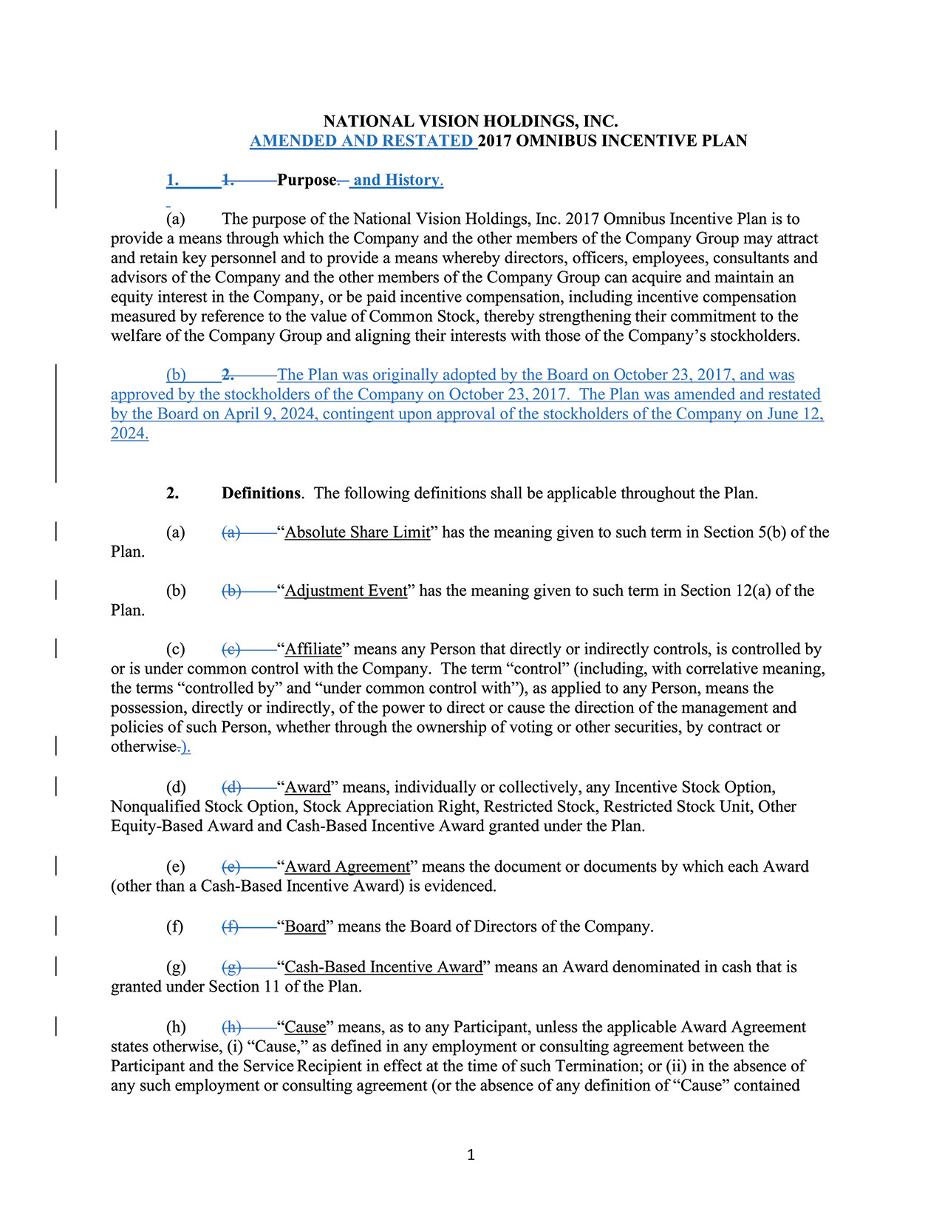
1NATIONAL VISION HOLDINGS, INC.AMENDED AND RESTATED 2017 OMNIBUS INCENTIVE PLAN1. 1. Purpose. and History.(a) The purpose of the National Vision Holdings, Inc. 2017 Omnibus Incentive Plan is toprovide a means through which the Company and the other members of the Company Group may attractand retain key personnel and to provide a means whereby directors, officers, employees, consultants andadvisors of the Company and the other members of the Company Group can acquire and maintain anequity interest in the Company, or be paid incentive compensation, including incentive compensationmeasured by reference to the value of Common Stock, thereby strengthening their commitment to thewelfare of the Company Group and aligning their interests with those of the Company’s stockholders.(b) 2. The Plan was originally adopted by the Board on October 23, 2017, and wasapproved by the stockholders of the Company on October 23, 2017. The Plan was amended and restatedby the Board on April 9, 2024, contingent upon approval of the stockholders of the Company on June 12,2024.2. Definitions. The following definitions shall be applicable throughout the Plan.(a) (a) “Absolute Share Limit” has the meaning given to such term in Section 5(b) of thePlan.(b) (b) “Adjustment Event” has the meaning given to such term in Section 12(a) of thePlan.(c) (c) “Affiliate” means any Person that directly or indirectly controls, is controlled byor is under common control with the Company. The term “control” ​(including, with correlative meaning,the terms “controlled by” and “under common control with”), as applied to any Person, means thepossession, directly or indirectly, of the power to direct or cause the direction of the management andpolicies of such Person, whether through the ownership of voting or other securities, by contract orotherwise.).(d) (d) “Award” means, individually or collectively, any Incentive Stock Option,Nonqualified Stock Option, Stock Appreciation Right, Restricted Stock, Restricted Stock Unit, OtherEquity-Based Award and Cash-Based Incentive Award granted under the Plan.(e) (e) “Award Agreement” means the document or documents by which each Award(other than a Cash-Based Incentive Award) is evidenced.(f) (f) “Board” means the Board of Directors of the Company.(g) (g) “Cash-Based Incentive Award” means an Award denominated in cash that isgranted under Section 11 of the Plan.(h) (h) “Cause” means, as to any Participant, unless the applicable Award Agreementstates otherwise, (i) “Cause,” as defined in any employment or consulting agreement between theParticipant and the Service Recipient in effect at the time of such Termination; or (ii) in the absence ofany such employment or consulting agreement (or the absence of any definition of “Cause” contained
2024 Proxy Statement 83

TABLE OF CONTENTS
Appendix B
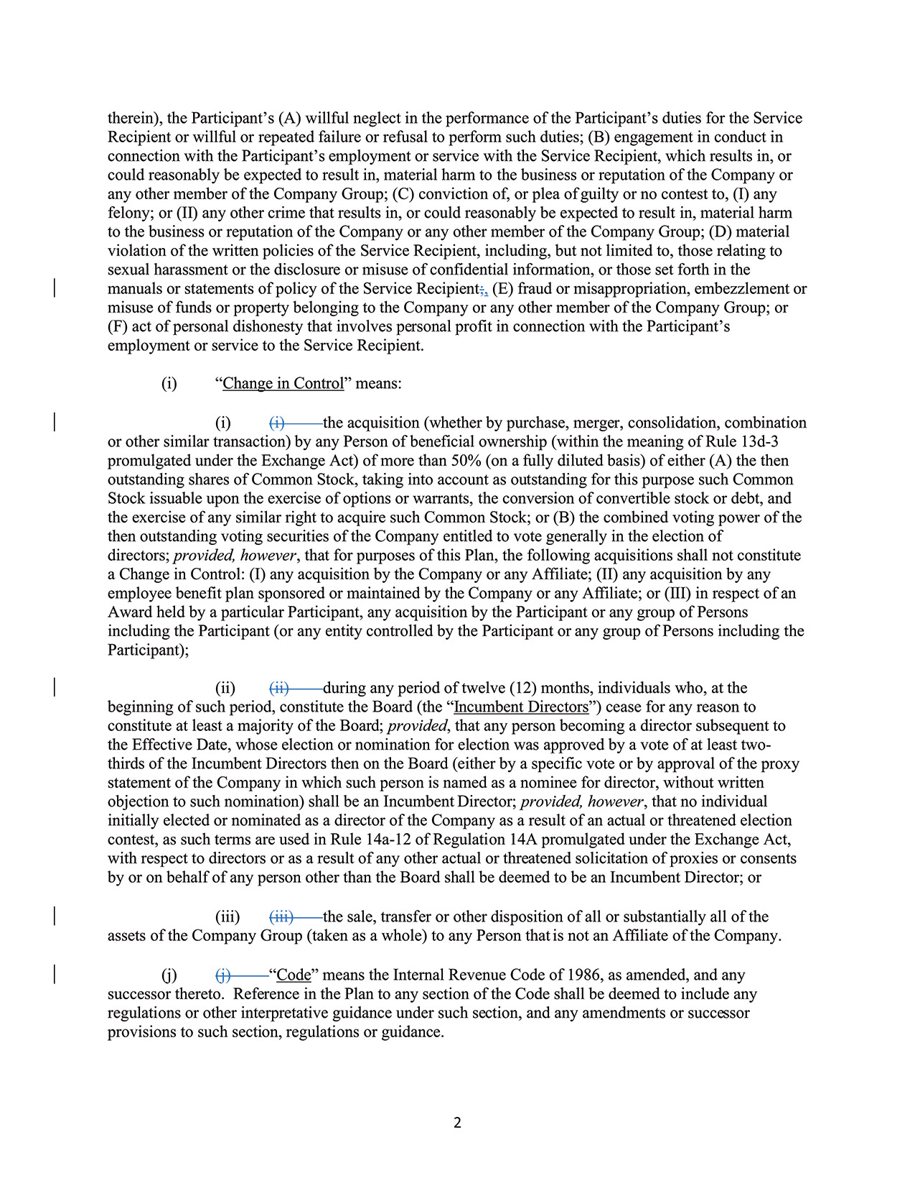
2therein), the Participant’s (A) willful neglect in the performance of the Participant’s duties for the ServiceRecipient or willful or repeated failure or refusal to perform such duties; (B) engagement in conduct inconnection with the Participant’s employment or service with the Service Recipient, which results in, orcould reasonably be expected to result in, material harm to the business or reputation of the Company orany other member of the Company Group; (C) conviction of, or plea of guilty or no contest to, (I) anyfelony; or (II) any other crime that results in, or could reasonably be expected to result in, material harmto the business or reputation of the Company or any other member of the Company Group; (D) materialviolation of the written policies of the Service Recipient, including, but not limited to, those relating tosexual harassment or the disclosure or misuse of confidential information, or those set forth in themanuals or statements of policy of the Service Recipient;, (E) fraud or misappropriation, embezzlement ormisuse of funds or property belonging to the Company or any other member of the Company Group; or(F) act of personal dishonesty that involves personal profit in connection with the Participant’semployment or service to the Service Recipient.(i) “Change in Control” means:(i) (i) the acquisition (whether by purchase, merger, consolidation, combinationor other similar transaction) by any Person of beneficial ownership (within the meaning of Rule 13d-3promulgated under the Exchange Act) of more than 50% (on a fully diluted basis) of either (A) the thenoutstanding shares of Common Stock, taking into account as outstanding for this purpose such CommonStock issuable upon the exercise of options or warrants, the conversion of convertible stock or debt, andthe exercise of any similar right to acquire such Common Stock; or (B) the combined voting power of thethen outstanding voting securities of the Company entitled to vote generally in the election ofdirectors; provided, however, that for purposes of this Plan, the following acquisitions shall not constitutea Change in Control: (I) any acquisition by the Company or any Affiliate; (II) any acquisition by anyemployee benefit plan sponsored or maintained by the Company or any Affiliate; or (III) in respect of anAward held by a particular Participant, any acquisition by the Participant or any group of Personsincluding the Participant (or any entity controlled by the Participant or any group of Persons including theParticipant);(ii) (ii) during any period of twelve (12) months, individuals who, at thebeginning of such period, constitute the Board (the “Incumbent Directors”) cease for any reason toconstitute at least a majority of the Board; provided, that any person becoming a director subsequent tothe Effective Date, whose election or nomination for election was approved by a vote of at least twothirdsof the Incumbent Directors then on the Board (either by a specific vote or by approval of the proxystatement of the Company in which such person is named as a nominee for director, without writtenobjection to such nomination) shall be an Incumbent Director; provided, however, that no individualinitially elected or nominated as a director of the Company as a result of an actual or threatened electioncontest, as such terms are used in Rule 14a-12 of Regulation 14A promulgated under the Exchange Act,with respect to directors or as a result of any other actual or threatened solicitation of proxies or consentsby or on behalf of any person other than the Board shall be deemed to be an Incumbent Director; or(iii) (iii) the sale, transfer or other disposition of all or substantially all of theassets of the Company Group (taken as a whole) to any Person that is not an Affiliate of the Company.(j) (j) “Code” means the Internal Revenue Code of 1986, as amended, and anysuccessor thereto. Reference in the Plan to any section of the Code shall be deemed to include anyregulations or other interpretative guidance under such section, and any amendments or successorprovisions to such section, regulations or guidance.
84 2024 Proxy Statement

TABLE OF CONTENTS
Appendix B​
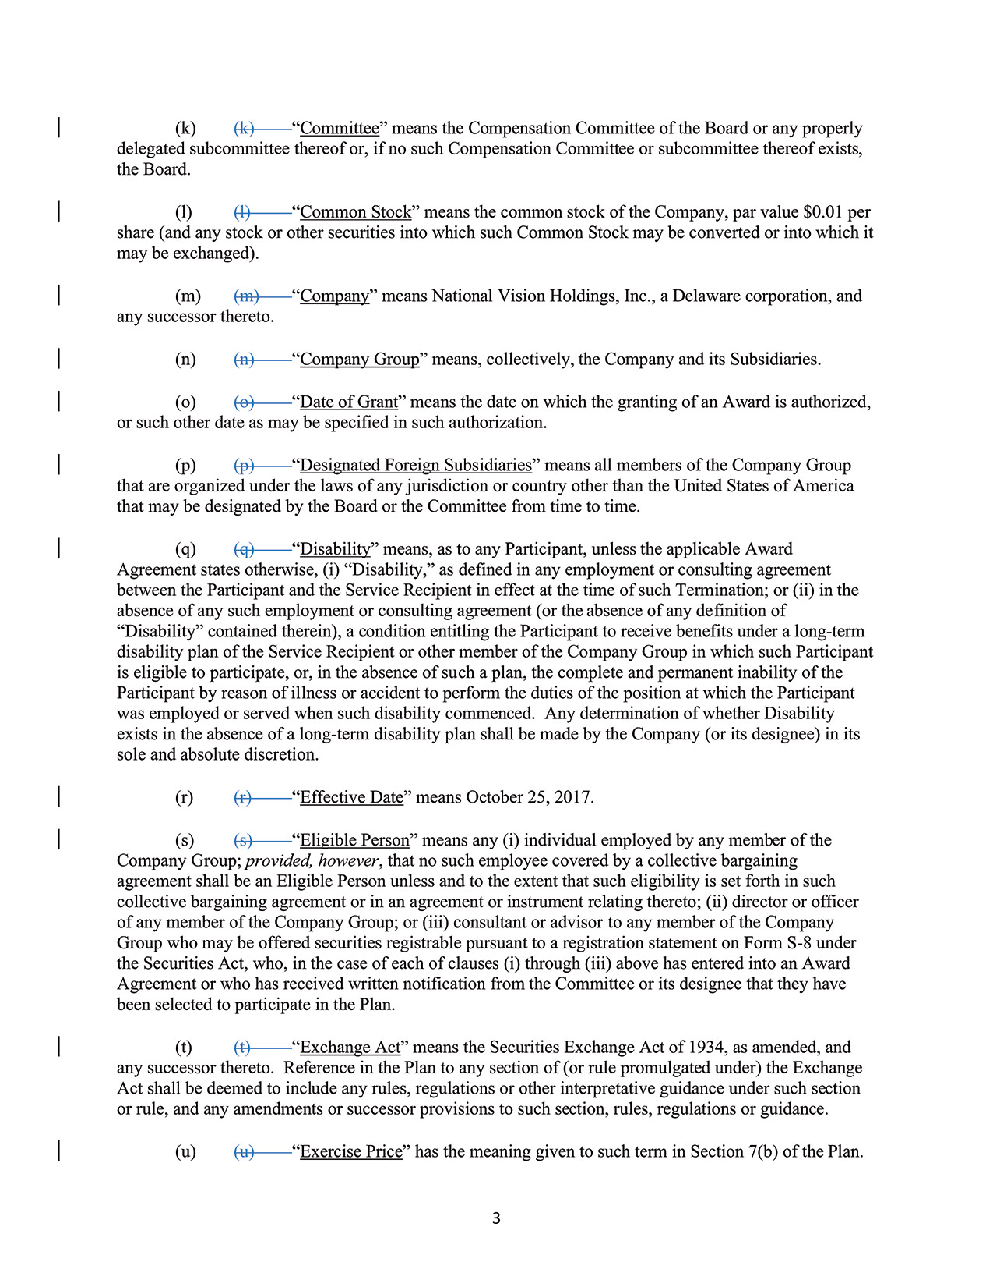
3(k) (k) “Committee” means the Compensation Committee of the Board or any properlydelegated subcommittee thereof or, if no such Compensation Committee or subcommittee thereof exists,the Board.(l) (l) “Common Stock” means the common stock of the Company, par value $0.01 pershare (and any stock or other securities into which such Common Stock may be converted or into which itmay be exchanged).(m) (m) “Company” means National Vision Holdings, Inc., a Delaware corporation, andany successor thereto.(n) (n) “Company Group” means, collectively, the Company and its Subsidiaries.(o) (o) “Date of Grant” means the date on which the granting of an Award is authorized,or such other date as may be specified in such authorization.(p) (p) “Designated Foreign Subsidiaries” means all members of the Company Groupthat are organized under the laws of any jurisdiction or country other than the United States of Americathat may be designated by the Board or the Committee from time to time.(q) (q) “Disability” means, as to any Participant, unless the applicable AwardAgreement states otherwise, (i) “Disability,” as defined in any employment or consulting agreementbetween the Participant and the Service Recipient in effect at the time of such Termination; or (ii) in theabsence of any such employment or consulting agreement (or the absence of any definition of“Disability” contained therein), a condition entitling the Participant to receive benefits under a long-termdisability plan of the Service Recipient or other member of the Company Group in which such Participantis eligible to participate, or, in the absence of such a plan, the complete and permanent inability of theParticipant by reason of illness or accident to perform the duties of the position at which the Participantwas employed or served when such disability commenced. Any determination of whether Disabilityexists in the absence of a long-term disability plan shall be made by the Company (or its designee) in itssole and absolute discretion.(r) (r) “Effective Date” means October 25, 2017.(s) (s) “Eligible Person” means any (i) individual employed by any member of theCompany Group; provided, however, that no such employee covered by a collective bargainingagreement shall be an Eligible Person unless and to the extent that such eligibility is set forth in suchcollective bargaining agreement or in an agreement or instrument relating thereto; (ii) director or officerof any member of the Company Group; or (iii) consultant or advisor to any member of the CompanyGroup who may be offered securities registrable pursuant to a registration statement on Form S-8 underthe Securities Act, who, in the case of each of clauses (i) through (iii) above has entered into an AwardAgreement or who has received written notification from the Committee or its designee that they havebeen selected to participate in the Plan.(t) (t) “Exchange Act” means the Securities Exchange Act of 1934, as amended, andany successor thereto. Reference in the Plan to any section of (or rule promulgated under) the ExchangeAct shall be deemed to include any rules, regulations or other interpretative guidance under such sectionor rule, and any amendments or successor provisions to such section, rules, regulations or guidance.(u) (u) “Exercise Price” has the meaning given to such term in Section 7(b) of the Plan.
2024 Proxy Statement 85

TABLE OF CONTENTS
Appendix B
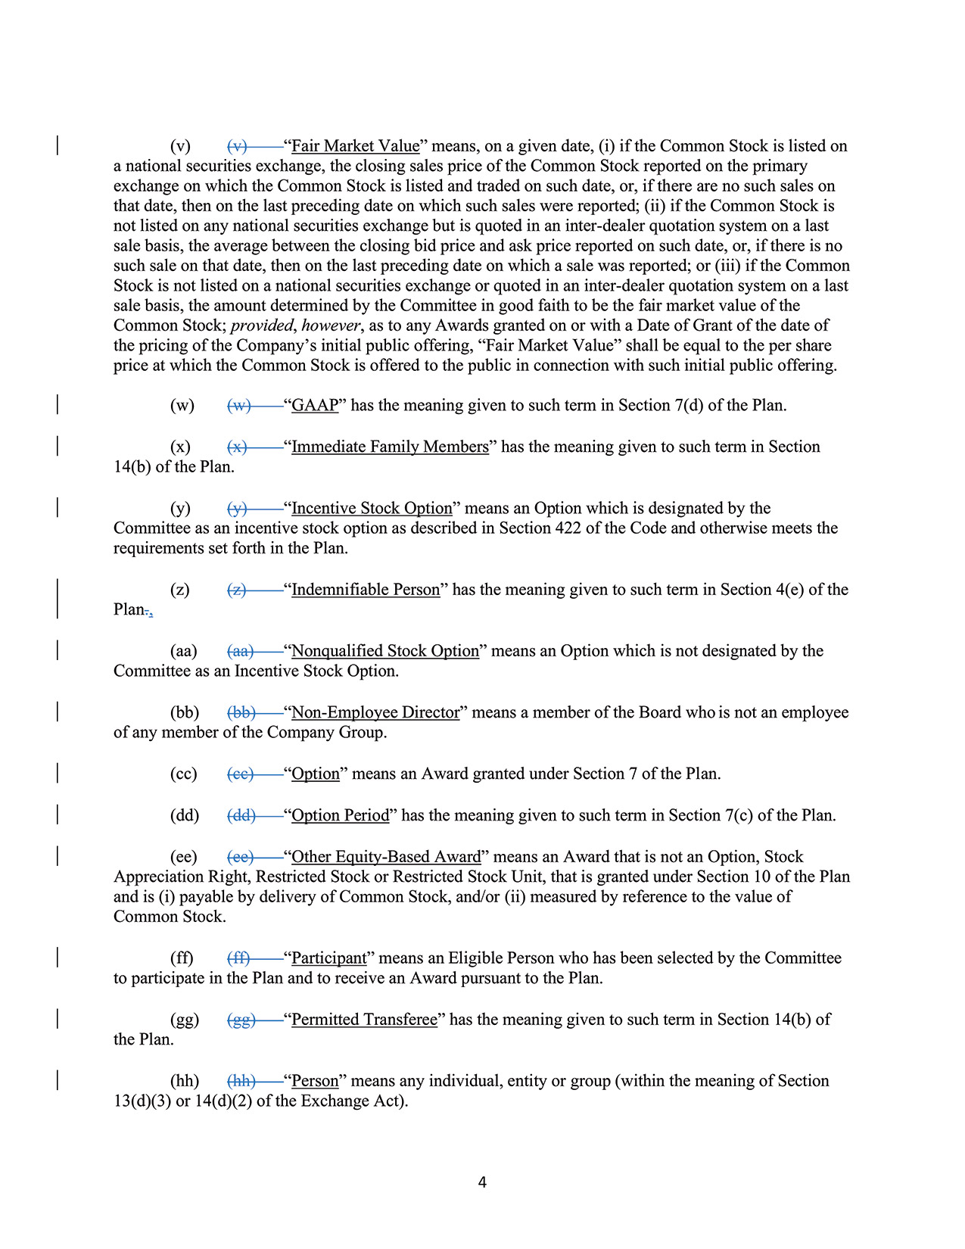
4(v) (v) “Fair Market Value” means, on a given date, (i) if the Common Stock is listed ona national securities exchange, the closing sales price of the Common Stock reported on the primaryexchange on which the Common Stock is listed and traded on such date, or, if there are no such sales onthat date, then on the last preceding date on which such sales were reported; (ii) if the Common Stock isnot listed on any national securities exchange but is quoted in an inter-dealer quotation system on a lastsale basis, the average between the closing bid price and ask price reported on such date, or, if there is nosuch sale on that date, then on the last preceding date on which a sale was reported; or (iii) if the CommonStock is not listed on a national securities exchange or quoted in an inter-dealer quotation system on a lastsale basis, the amount determined by the Committee in good faith to be the fair market value of theCommon Stock; provided, however, as to any Awards granted on or with a Date of Grant of the date ofthe pricing of the Company’s initial public offering, “Fair Market Value” shall be equal to the per shareprice at which the Common Stock is offered to the public in connection with such initial public offering.(w) (w) “GAAP” has the meaning given to such term in Section 7(d) of the Plan.(x) (x) “Immediate Family Members” has the meaning given to such term in Section14(b) of the Plan.(y) (y) “Incentive Stock Option” means an Option which is designated by theCommittee as an incentive stock option as described in Section 422 of the Code and otherwise meets therequirements set forth in the Plan.(z) (z) “Indemnifiable Person” has the meaning given to such term in Section 4(e) of thePlan.,(aa) (aa) “Nonqualified Stock Option” means an Option which is not designated by theCommittee as an Incentive Stock Option.(bb) (bb) “Non-Employee Director” means a member of the Board who is not an employeeof any member of the Company Group.(cc) (cc) “Option” means an Award granted under Section 7 of the Plan.(dd) (dd) “Option Period” has the meaning given to such term in Section 7(c) of the Plan.(ee) (ee) “Other Equity-Based Award” means an Award that is not an Option, StockAppreciation Right, Restricted Stock or Restricted Stock Unit, that is granted under Section 10 of the Planand is (i) payable by delivery of Common Stock, and/or (ii) measured by reference to the value ofCommon Stock.(ff) (ff) “Participant” means an Eligible Person who has been selected by the Committeeto participate in the Plan and to receive an Award pursuant to the Plan.(gg) (gg) “Permitted Transferee” has the meaning given to such term in Section 14(b) ofthe Plan.(hh) (hh) “Person” means any individual, entity or group (within the meaning of Section13(d)(3) or 14(d)(2) of the Exchange Act).
86 2024 Proxy Statement

TABLE OF CONTENTS
Appendix B​
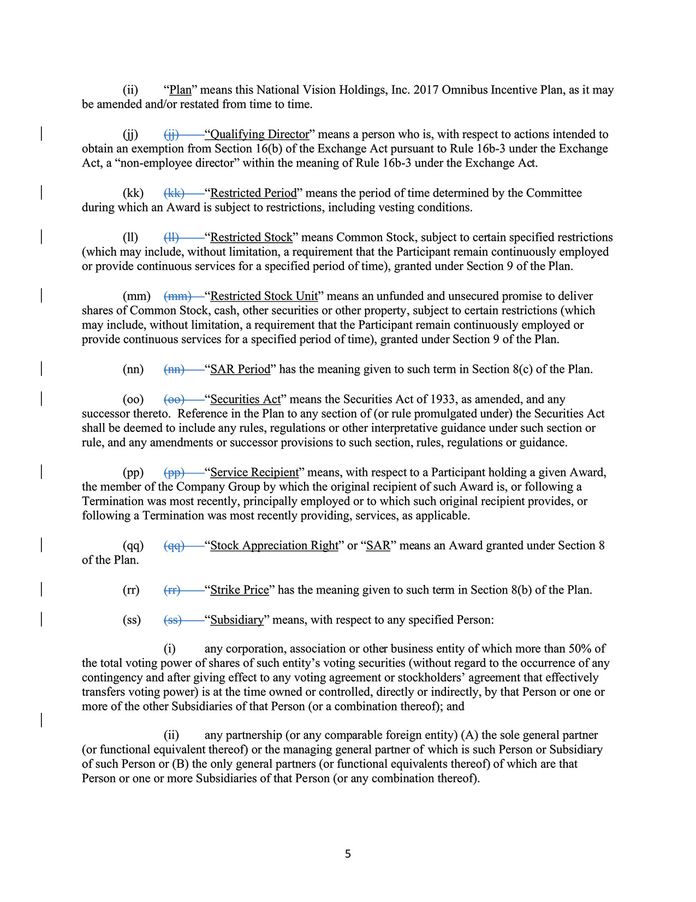
5(ii) “Plan” means this National Vision Holdings, Inc. 2017 Omnibus Incentive Plan, as it maybe amended and/or restated from time to time.(jj) (jj) “Qualifying Director” means a person who is, with respect to actions intended toobtain an exemption from Section 16(b) of the Exchange Act pursuant to Rule 16b-3 under the ExchangeAct, a “non-employee director” within the meaning of Rule 16b-3 under the Exchange Act.(kk) (kk) “Restricted Period” means the period of time determined by the Committeeduring which an Award is subject to restrictions, including vesting conditions.(ll) (ll) “Restricted Stock” means Common Stock, subject to certain specified restrictions(which may include, without limitation, a requirement that the Participant remain continuously employedor provide continuous services for a specified period of time), granted under Section 9 of the Plan.(mm) (mm) “Restricted Stock Unit” means an unfunded and unsecured promise to delivershares of Common Stock, cash, other securities or other property, subject to certain restrictions (whichmay include, without limitation, a requirement that the Participant remain continuously employed orprovide continuous services for a specified period of time), granted under Section 9 of the Plan.(nn) (nn) “SAR Period” has the meaning given to such term in Section 8(c) of the Plan.(oo) (oo) “Securities Act” means the Securities Act of 1933, as amended, and anysuccessor thereto. Reference in the Plan to any section of (or rule promulgated under) the Securities Actshall be deemed to include any rules, regulations or other interpretative guidance under such section orrule, and any amendments or successor provisions to such section, rules, regulations or guidance.(pp) (pp) “Service Recipient” means, with respect to a Participant holding a given Award,the member of the Company Group by which the original recipient of such Award is, or following aTermination was most recently, principally employed or to which such original recipient provides, orfollowing a Termination was most recently providing, services, as applicable.(qq) (qq) “Stock Appreciation Right” or “SAR” means an Award granted under Section 8of the Plan.(rr) (rr) “Strike Price” has the meaning given to such term in Section 8(b) of the Plan.(ss) (ss) “Subsidiary” means, with respect to any specified Person:(i) any corporation, association or other business entity of which more than 50% ofthe total voting power of shares of such entity’s voting securities (without regard to the occurrence of anycontingency and after giving effect to any voting agreement or stockholders’ agreement that effectivelytransfers voting power) is at the time owned or controlled, directly or indirectly, by that Person or one ormore of the other Subsidiaries of that Person (or a combination thereof); and(ii) any partnership (or any comparable foreign entity) (A) the sole general partner(or functional equivalent thereof) or the managing general partner of which is such Person or Subsidiaryof such Person or (B) the only general partners (or functional equivalents thereof) of which are thatPerson or one or more Subsidiaries of that Person (or any combination thereof).
2024 Proxy Statement 87

TABLE OF CONTENTS
Appendix B
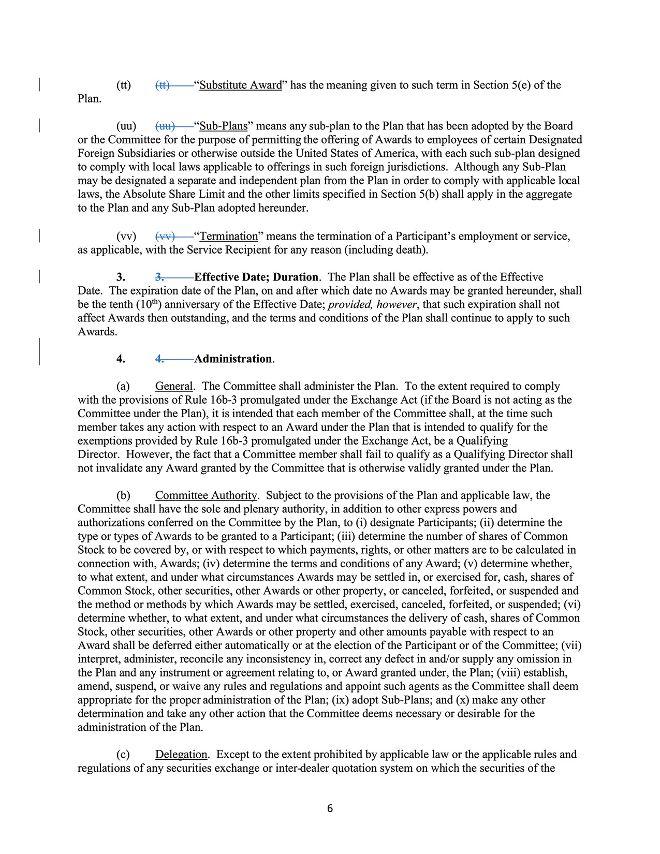
6(tt) (tt) “Substitute Award” has the meaning given to such term in Section 5(e) of thePlan.(uu) (uu) “Sub-Plans” means any sub-plan to the Plan that has been adopted by the Boardor the Committee for the purpose of permitting the offering of Awards to employees of certain DesignatedForeign Subsidiaries or otherwise outside the United States of America, with each such sub-plan designedto comply with local laws applicable to offerings in such foreign jurisdictions. Although any Sub-Planmay be designated a separate and independent plan from the Plan in order to comply with applicable locallaws, the Absolute Share Limit and the other limits specified in Section 5(b) shall apply in the aggregateto the Plan and any Sub-Plan adopted hereunder.(vv) (vv) “Termination” means the termination of a Participant’s employment or service,as applicable, with the Service Recipient for any reason (including death).3. 3. Effective Date; Duration. The Plan shall be effective as of the EffectiveDate. The expiration date of the Plan, on and after which date no Awards may be granted hereunder, shallbe the tenth (10th) anniversary of the Effective Date; provided, however, that such expiration shall notaffect Awards then outstanding, and the terms and conditions of the Plan shall continue to apply to suchAwards.4. 4. Administration.(a) General. The Committee shall administer the Plan. To the extent required to complywith the provisions of Rule 16b-3 promulgated under the Exchange Act (if the Board is not acting as theCommittee under the Plan), it is intended that each member of the Committee shall, at the time suchmember takes any action with respect to an Award under the Plan that is intended to qualify for theexemptions provided by Rule 16b-3 promulgated under the Exchange Act, be a QualifyingDirector. However, the fact that a Committee member shall fail to qualify as a Qualifying Director shallnot invalidate any Award granted by the Committee that is otherwise validly granted under the Plan.(b) Committee Authority. Subject to the provisions of the Plan and applicable law, theCommittee shall have the sole and plenary authority, in addition to other express powers andauthorizations conferred on the Committee by the Plan, to (i) designate Participants; (ii) determine thetype or types of Awards to be granted to a Participant; (iii) determine the number of shares of CommonStock to be covered by, or with respect to which payments, rights, or other matters are to be calculated inconnection with, Awards; (iv) determine the terms and conditions of any Award; (v) determine whether,to what extent, and under what circumstances Awards may be settled in, or exercised for, cash, shares ofCommon Stock, other securities, other Awards or other property, or canceled, forfeited, or suspended andthe method or methods by which Awards may be settled, exercised, canceled, forfeited, or suspended; (vi)determine whether, to what extent, and under what circumstances the delivery of cash, shares of CommonStock, other securities, other Awards or other property and other amounts payable with respect to anAward shall be deferred either automatically or at the election of the Participant or of the Committee; (vii)interpret, administer, reconcile any inconsistency in, correct any defect in and/or supply any omission inthe Plan and any instrument or agreement relating to, or Award granted under, the Plan; (viii) establish,amend, suspend, or waive any rules and regulations and appoint such agents as the Committee shall deemappropriate for the proper administration of the Plan; (ix) adopt Sub-Plans; and (x) make any otherdetermination and take any other action that the Committee deems necessary or desirable for theadministration of the Plan.(c) Delegation. Except to the extent prohibited by applicable law or the applicable rules andregulations of any securities exchange or inter-dealer quotation system on which the securities of the
88 2024 Proxy Statement

TABLE OF CONTENTS
Appendix B​
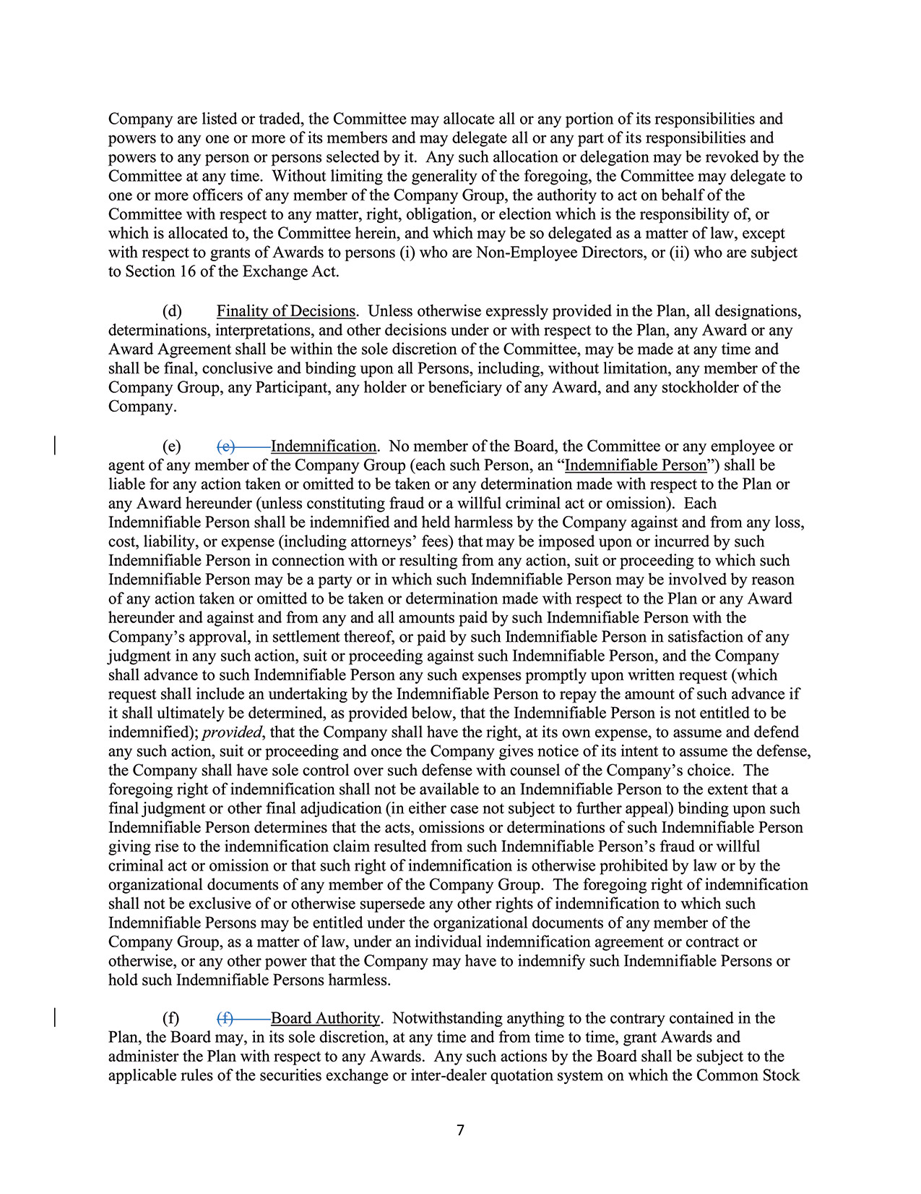
7Company are listed or traded, the Committee may allocate all or any portion of its responsibilities andpowers to any one or more of its members and may delegate all or any part of its responsibilities andpowers to any person or persons selected by it. Any such allocation or delegation may be revoked by theCommittee at any time. Without limiting the generality of the foregoing, the Committee may delegate toone or more officers of any member of the Company Group, the authority to act on behalf of theCommittee with respect to any matter, right, obligation, or election which is the responsibility of, orwhich is allocated to, the Committee herein, and which may be so delegated as a matter of law, exceptwith respect to grants of Awards to persons (i) who are Non-Employee Directors, or (ii) who are subjectto Section 16 of the Exchange Act.(d) Finality of Decisions. Unless otherwise expressly provided in the Plan, all designations,determinations, interpretations, and other decisions under or with respect to the Plan, any Award or anyAward Agreement shall be within the sole discretion of the Committee, may be made at any time andshall be final, conclusive and binding upon all Persons, including, without limitation, any member of theCompany Group, any Participant, any holder or beneficiary of any Award, and any stockholder of theCompany.(e) (e) Indemnification. No member of the Board, the Committee or any employee oragent of any member of the Company Group (each such Person, an “Indemnifiable Person”) shall beliable for any action taken or omitted to be taken or any determination made with respect to the Plan orany Award hereunder (unless constituting fraud or a willful criminal act or omission). EachIndemnifiable Person shall be indemnified and held harmless by the Company against and from any loss,cost, liability, or expense (including attorneys’ fees) that may be imposed upon or incurred by suchIndemnifiable Person in connection with or resulting from any action, suit or proceeding to which suchIndemnifiable Person may be a party or in which such Indemnifiable Person may be involved by reasonof any action taken or omitted to be taken or determination made with respect to the Plan or any Awardhereunder and against and from any and all amounts paid by such Indemnifiable Person with theCompany’s approval, in settlement thereof, or paid by such Indemnifiable Person in satisfaction of anyjudgment in any such action, suit or proceeding against such Indemnifiable Person, and the Companyshall advance to such Indemnifiable Person any such expenses promptly upon written request (whichrequest shall include an undertaking by the Indemnifiable Person to repay the amount of such advance ifit shall ultimately be determined, as provided below, that the Indemnifiable Person is not entitled to beindemnified); provided, that the Company shall have the right, at its own expense, to assume and defendany such action, suit or proceeding and once the Company gives notice of its intent to assume the defense,the Company shall have sole control over such defense with counsel of the Company’s choice. Theforegoing right of indemnification shall not be available to an Indemnifiable Person to the extent that afinal judgment or other final adjudication (in either case not subject to further appeal) binding upon suchIndemnifiable Person determines that the acts, omissions or determinations of such Indemnifiable Persongiving rise to the indemnification claim resulted from such Indemnifiable Person’s fraud or willfulcriminal act or omission or that such right of indemnification is otherwise prohibited by law or by theorganizational documents of any member of the Company Group. The foregoing right of indemnificationshall not be exclusive of or otherwise supersede any other rights of indemnification to which suchIndemnifiable Persons may be entitled under the organizational documents of any member of theCompany Group, as a matter of law, under an individual indemnification agreement or contract orotherwise, or any other power that the Company may have to indemnify such Indemnifiable Persons orhold such Indemnifiable Persons harmless.(f) (f) Board Authority. Notwithstanding anything to the contrary contained in thePlan, the Board may, in its sole discretion, at any time and from time to time, grant Awards andadminister the Plan with respect to any Awards. Any such actions by the Board shall be subject to theapplicable rules of the securities exchange or inter-dealer quotation system on which the Common Stock
2024 Proxy Statement 89

TABLE OF CONTENTS
Appendix B
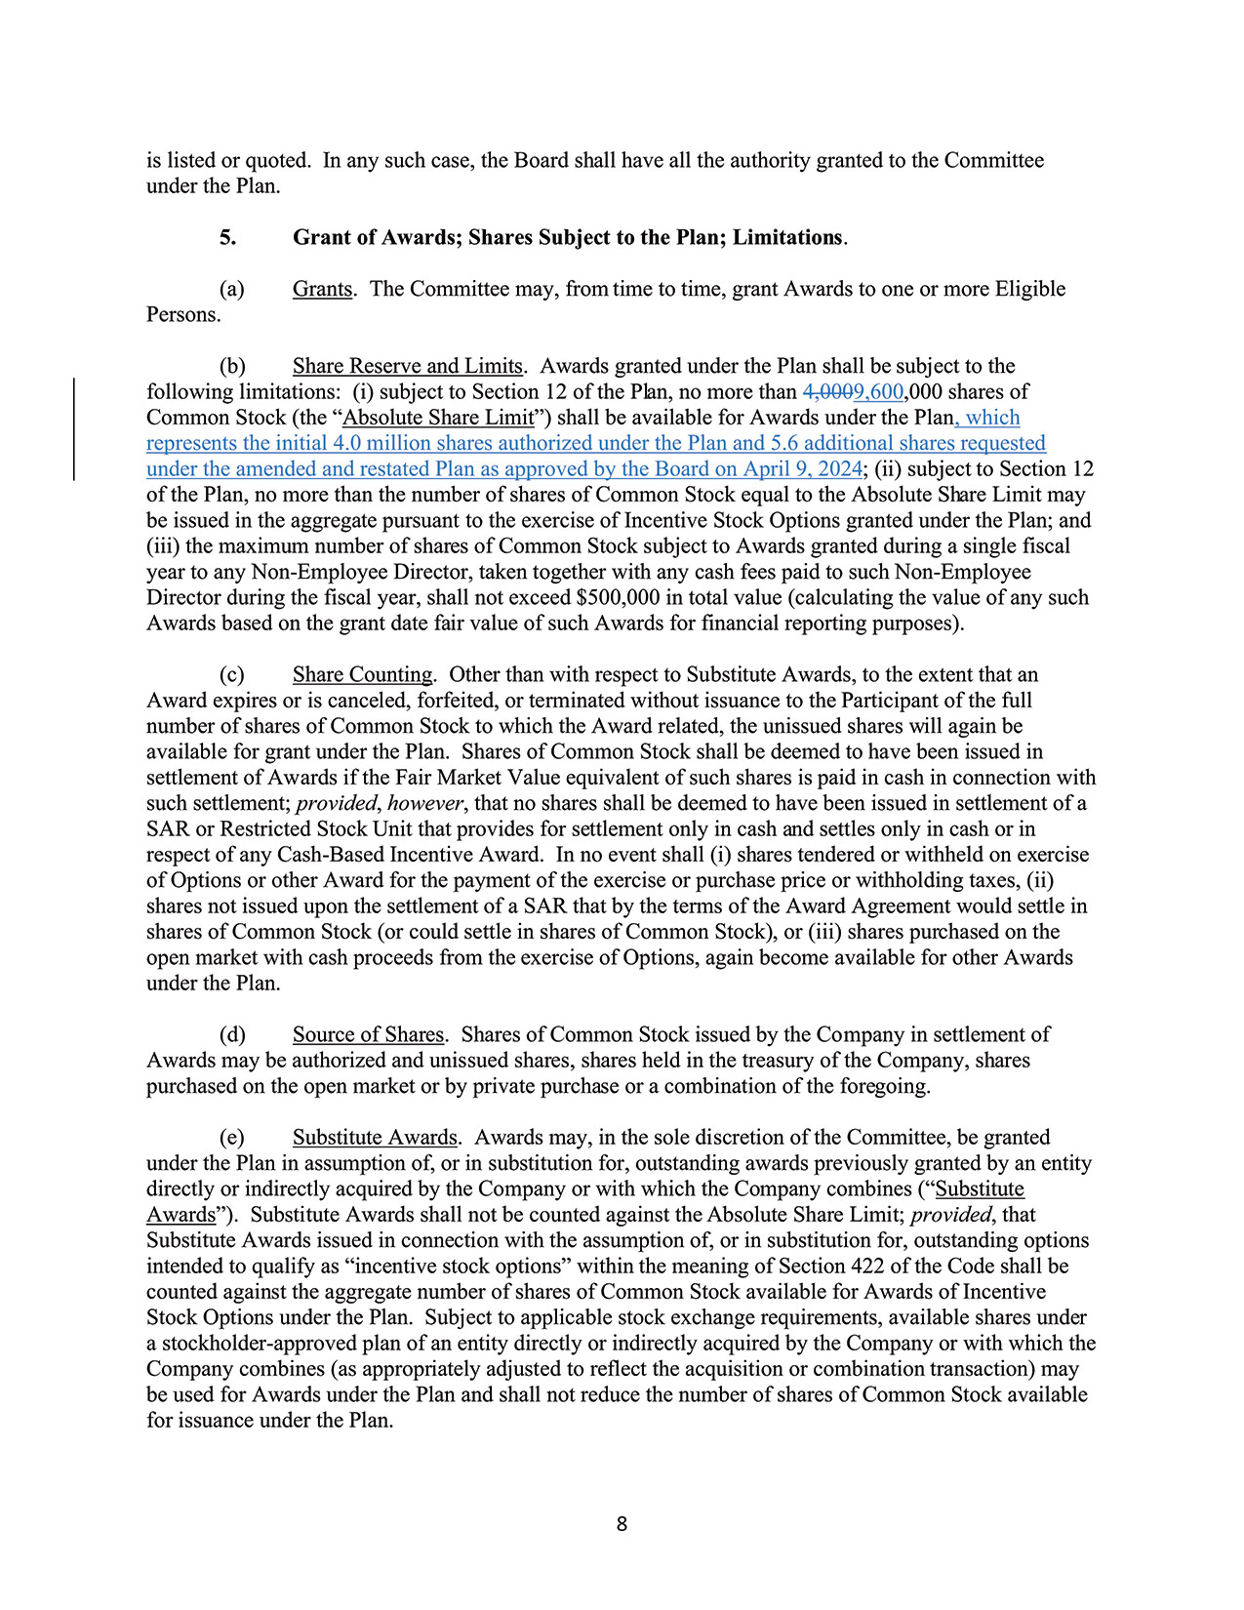
8is listed or quoted. In any such case, the Board shall have all the authority granted to the Committeeunder the Plan.5. Grant of Awards; Shares Subject to the Plan; Limitations.(a) Grants. The Committee may, from time to time, grant Awards to one or more EligiblePersons.(b) Share Reserve and Limits. Awards granted under the Plan shall be subject to thefollowing limitations: (i) subject to Section 12 of the Plan, no more than 4,0009,600,000 shares ofCommon Stock (the “Absolute Share Limit”) shall be available for Awards under the Plan, whichrepresents the initial 4.0 million shares authorized under the Plan and 5.6 additional shares requestedunder the amended and restated Plan as approved by the Board on April 9, 2024; (ii) subject to Section 12of the Plan, no more than the number of shares of Common Stock equal to the Absolute Share Limit maybe issued in the aggregate pursuant to the exercise of Incentive Stock Options granted under the Plan; and(iii) the maximum number of shares of Common Stock subject to Awards granted during a single fiscalyear to any Non-Employee Director, taken together with any cash fees paid to such Non-EmployeeDirector during the fiscal year, shall not exceed $500,000 in total value (calculating the value of any suchAwards based on the grant date fair value of such Awards for financial reporting purposes).(c) Share Counting. Other than with respect to Substitute Awards, to the extent that anAward expires or is canceled, forfeited, or terminated without issuance to the Participant of the fullnumber of shares of Common Stock to which the Award related, the unissued shares will again beavailable for grant under the Plan. Shares of Common Stock shall be deemed to have been issued insettlement of Awards if the Fair Market Value equivalent of such shares is paid in cash in connection withsuch settlement; provided, however, that no shares shall be deemed to have been issued in settlement of aSAR or Restricted Stock Unit that provides for settlement only in cash and settles only in cash or inrespect of any Cash-Based Incentive Award. In no event shall (i) shares tendered or withheld on exerciseof Options or other Award for the payment of the exercise or purchase price or withholding taxes, (ii)shares not issued upon the settlement of a SAR that by the terms of the Award Agreement would settle inshares of Common Stock (or could settle in shares of Common Stock), or (iii) shares purchased on theopen market with cash proceeds from the exercise of Options, again become available for other Awardsunder the Plan.(d) Source of Shares. Shares of Common Stock issued by the Company in settlement ofAwards may be authorized and unissued shares, shares held in the treasury of the Company, sharespurchased on the open market or by private purchase or a combination of the foregoing.(e) Substitute Awards. Awards may, in the sole discretion of the Committee, be grantedunder the Plan in assumption of, or in substitution for, outstanding awards previously granted by an entitydirectly or indirectly acquired by the Company or with which the Company combines (“SubstituteAwards”). Substitute Awards shall not be counted against the Absolute Share Limit; provided, thatSubstitute Awards issued in connection with the assumption of, or in substitution for, outstanding optionsintended to qualify as “incentive stock options” within the meaning of Section 422 of the Code shall becounted against the aggregate number of shares of Common Stock available for Awards of IncentiveStock Options under the Plan. Subject to applicable stock exchange requirements, available shares undera stockholder-approved plan of an entity directly or indirectly acquired by the Company or with which theCompany combines (as appropriately adjusted to reflect the acquisition or combination transaction) maybe used for Awards under the Plan and shall not reduce the number of shares of Common Stock availablefor issuance under the Plan.
90 2024 Proxy Statement

TABLE OF CONTENTS
Appendix B​
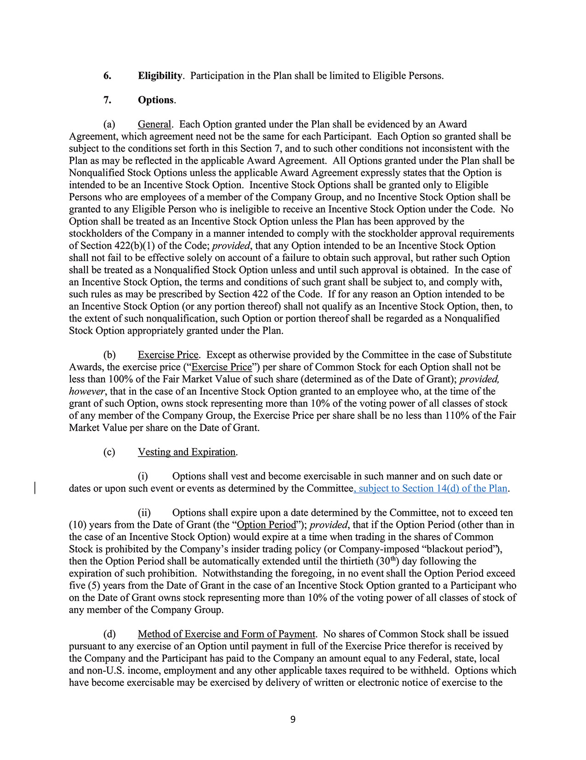
96. Eligibility. Participation in the Plan shall be limited to Eligible Persons.7. Options.(a) General. Each Option granted under the Plan shall be evidenced by an AwardAgreement, which agreement need not be the same for each Participant. Each Option so granted shall besubject to the conditions set forth in this Section 7, and to such other conditions not inconsistent with thePlan as may be reflected in the applicable Award Agreement. All Options granted under the Plan shall beNonqualified Stock Options unless the applicable Award Agreement expressly states that the Option isintended to be an Incentive Stock Option. Incentive Stock Options shall be granted only to EligiblePersons who are employees of a member of the Company Group, and no Incentive Stock Option shall begranted to any Eligible Person who is ineligible to receive an Incentive Stock Option under the Code. NoOption shall be treated as an Incentive Stock Option unless the Plan has been approved by thestockholders of the Company in a manner intended to comply with the stockholder approval requirementsof Section 422(b)(1) of the Code; provided, that any Option intended to be an Incentive Stock Optionshall not fail to be effective solely on account of a failure to obtain such approval, but rather such Optionshall be treated as a Nonqualified Stock Option unless and until such approval is obtained. In the case ofan Incentive Stock Option, the terms and conditions of such grant shall be subject to, and comply with,such rules as may be prescribed by Section 422 of the Code. If for any reason an Option intended to bean Incentive Stock Option (or any portion thereof) shall not qualify as an Incentive Stock Option, then, tothe extent of such nonqualification, such Option or portion thereof shall be regarded as a NonqualifiedStock Option appropriately granted under the Plan.(b) Exercise Price. Except as otherwise provided by the Committee in the case of SubstituteAwards, the exercise price (“Exercise Price”) per share of Common Stock for each Option shall not beless than 100% of the Fair Market Value of such share (determined as of the Date of Grant); provided,however, that in the case of an Incentive Stock Option granted to an employee who, at the time of thegrant of such Option, owns stock representing more than 10% of the voting power of all classes of stockof any member of the Company Group, the Exercise Price per share shall be no less than 110% of the FairMarket Value per share on the Date of Grant.(c) Vesting and Expiration.(i) Options shall vest and become exercisable in such manner and on such date ordates or upon such event or events as determined by the Committee, subject to Section 14(d) of the Plan.(ii) Options shall expire upon a date determined by the Committee, not to exceed ten(10) years from the Date of Grant (the “Option Period”); provided, that if the Option Period (other than inthe case of an Incentive Stock Option) would expire at a time when trading in the shares of CommonStock is prohibited by the Company’s insider trading policy (or Company-imposed “blackout period”),then the Option Period shall be automatically extended until the thirtieth (30th) day following theexpiration of such prohibition. Notwithstanding the foregoing, in no event shall the Option Period exceedfive (5) years from the Date of Grant in the case of an Incentive Stock Option granted to a Participant whoon the Date of Grant owns stock representing more than 10% of the voting power of all classes of stock ofany member of the Company Group.(d) Method of Exercise and Form of Payment. No shares of Common Stock shall be issuedpursuant to any exercise of an Option until payment in full of the Exercise Price therefor is received bythe Company and the Participant has paid to the Company an amount equal to any Federal, state, localand non-U.S. income, employment and any other applicable taxes required to be withheld. Options whichhave become exercisable may be exercised by delivery of written or electronic notice of exercise to the
2024 Proxy Statement 91

TABLE OF CONTENTS
Appendix B
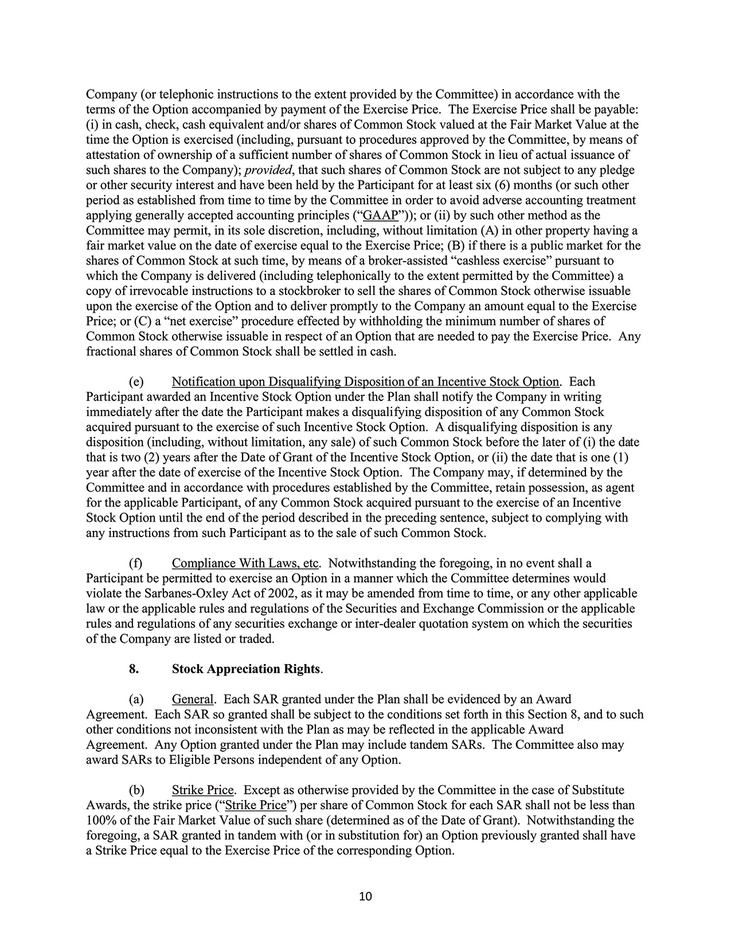
10Company (or telephonic instructions to the extent provided by the Committee) in accordance with theterms of the Option accompanied by payment of the Exercise Price. The Exercise Price shall be payable:(i) in cash, check, cash equivalent and/or shares of Common Stock valued at the Fair Market Value at thetime the Option is exercised (including, pursuant to procedures approved by the Committee, by means ofattestation of ownership of a sufficient number of shares of Common Stock in lieu of actual issuance ofsuch shares to the Company); provided, that such shares of Common Stock are not subject to any pledgeor other security interest and have been held by the Participant for at least six (6) months (or such otherperiod as established from time to time by the Committee in order to avoid adverse accounting treatmentapplying generally accepted accounting principles (“GAAP”)); or (ii) by such other method as theCommittee may permit, in its sole discretion, including, without limitation (A) in other property having afair market value on the date of exercise equal to the Exercise Price; (B) if there is a public market for theshares of Common Stock at such time, by means of a broker-assisted “cashless exercise” pursuant towhich the Company is delivered (including telephonically to the extent permitted by the Committee) acopy of irrevocable instructions to a stockbroker to sell the shares of Common Stock otherwise issuableupon the exercise of the Option and to deliver promptly to the Company an amount equal to the ExercisePrice; or (C) a “net exercise” procedure effected by withholding the minimum number of shares ofCommon Stock otherwise issuable in respect of an Option that are needed to pay the Exercise Price. Anyfractional shares of Common Stock shall be settled in cash.(e) Notification upon Disqualifying Disposition of an Incentive Stock Option. EachParticipant awarded an Incentive Stock Option under the Plan shall notify the Company in writingimmediately after the date the Participant makes a disqualifying disposition of any Common Stockacquired pursuant to the exercise of such Incentive Stock Option. A disqualifying disposition is anydisposition (including, without limitation, any sale) of such Common Stock before the later of (i) the datethat is two (2) years after the Date of Grant of the Incentive Stock Option, or (ii) the date that is one (1)year after the date of exercise of the Incentive Stock Option. The Company may, if determined by theCommittee and in accordance with procedures established by the Committee, retain possession, as agentfor the applicable Participant, of any Common Stock acquired pursuant to the exercise of an IncentiveStock Option until the end of the period described in the preceding sentence, subject to complying withany instructions from such Participant as to the sale of such Common Stock.(f) Compliance With Laws, etc. Notwithstanding the foregoing, in no event shall aParticipant be permitted to exercise an Option in a manner which the Committee determines wouldviolate the Sarbanes-Oxley Act of 2002, as it may be amended from time to time, or any other applicablelaw or the applicable rules and regulations of the Securities and Exchange Commission or the applicablerules and regulations of any securities exchange or inter-dealer quotation system on which the securitiesof the Company are listed or traded.8. Stock Appreciation Rights.(a) General. Each SAR granted under the Plan shall be evidenced by an AwardAgreement. Each SAR so granted shall be subject to the conditions set forth in this Section 8, and to suchother conditions not inconsistent with the Plan as may be reflected in the applicable AwardAgreement. Any Option granted under the Plan may include tandem SARs. The Committee also mayaward SARs to Eligible Persons independent of any Option.(b) Strike Price. Except as otherwise provided by the Committee in the case of SubstituteAwards, the strike price (“Strike Price”) per share of Common Stock for each SAR shall not be less than100% of the Fair Market Value of such share (determined as of the Date of Grant). Notwithstanding theforegoing, a SAR granted in tandem with (or in substitution for) an Option previously granted shall havea Strike Price equal to the Exercise Price of the corresponding Option.
92 2024 Proxy Statement

TABLE OF CONTENTS
Appendix B​
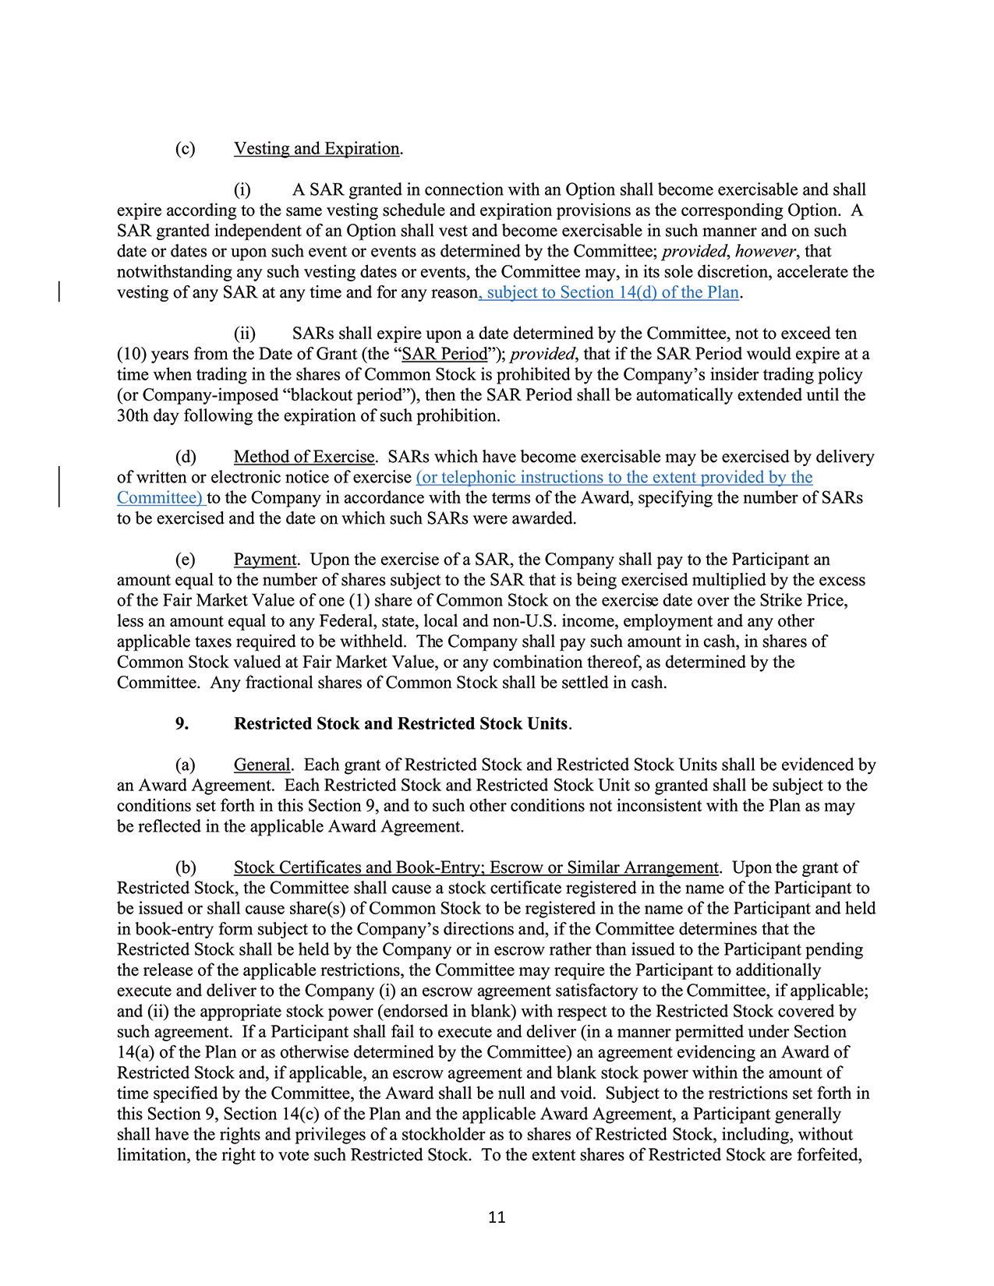
11(c) Vesting and Expiration.(i) A SAR granted in connection with an Option shall become exercisable and shallexpire according to the same vesting schedule and expiration provisions as the corresponding Option. ASAR granted independent of an Option shall vest and become exercisable in such manner and on suchdate or dates or upon such event or events as determined by the Committee; provided, however, thatnotwithstanding any such vesting dates or events, the Committee may, in its sole discretion, accelerate thevesting of any SAR at any time and for any reason, subject to Section 14(d) of the Plan.(ii) SARs shall expire upon a date determined by the Committee, not to exceed ten(10) years from the Date of Grant (the “SAR Period”); provided, that if the SAR Period would expire at atime when trading in the shares of Common Stock is prohibited by the Company’s insider trading policy(or Company-imposed “blackout period”), then the SAR Period shall be automatically extended until the30th day following the expiration of such prohibition.(d) Method of Exercise. SARs which have become exercisable may be exercised by deliveryof written or electronic notice of exercise (or telephonic instructions to the extent provided by theCommittee) to the Company in accordance with the terms of the Award, specifying the number of SARsto be exercised and the date on which such SARs were awarded.(e) Payment. Upon the exercise of a SAR, the Company shall pay to the Participant anamount equal to the number of shares subject to the SAR that is being exercised multiplied by the excessof the Fair Market Value of one (1) share of Common Stock on the exercise date over the Strike Price,less an amount equal to any Federal, state, local and non-U.S. income, employment and any otherapplicable taxes required to be withheld. The Company shall pay such amount in cash, in shares ofCommon Stock valued at Fair Market Value, or any combination thereof, as determined by theCommittee. Any fractional shares of Common Stock shall be settled in cash.9. Restricted Stock and Restricted Stock Units.(a) General. Each grant of Restricted Stock and Restricted Stock Units shall be evidenced byan Award Agreement. Each Restricted Stock and Restricted Stock Unit so granted shall be subject to theconditions set forth in this Section 9, and to such other conditions not inconsistent with the Plan as maybe reflected in the applicable Award Agreement.(b) Stock Certificates and Book-Entry; Escrow or Similar Arrangement. Upon the grant ofRestricted Stock, the Committee shall cause a stock certificate registered in the name of the Participant tobe issued or shall cause share(s) of Common Stock to be registered in the name of the Participant and heldin book-entry form subject to the Company’s directions and, if the Committee determines that theRestricted Stock shall be held by the Company or in escrow rather than issued to the Participant pendingthe release of the applicable restrictions, the Committee may require the Participant to additionallyexecute and deliver to the Company (i) an escrow agreement satisfactory to the Committee, if applicable;and (ii) the appropriate stock power (endorsed in blank) with respect to the Restricted Stock covered bysuch agreement. If a Participant shall fail to execute and deliver (in a manner permitted under Section14(a) of the Plan or as otherwise determined by the Committee) an agreement evidencing an Award ofRestricted Stock and, if applicable, an escrow agreement and blank stock power within the amount oftime specified by the Committee, the Award shall be null and void. Subject to the restrictions set forth inthis Section 9, Section 14(c) of the Plan and the applicable Award Agreement, a Participant generallyshall have the rights and privileges of a stockholder as to shares of Restricted Stock, including, withoutlimitation, the right to vote such Restricted Stock. To the extent shares of Restricted Stock are forfeited,
2024 Proxy Statement 93

TABLE OF CONTENTS
Appendix B
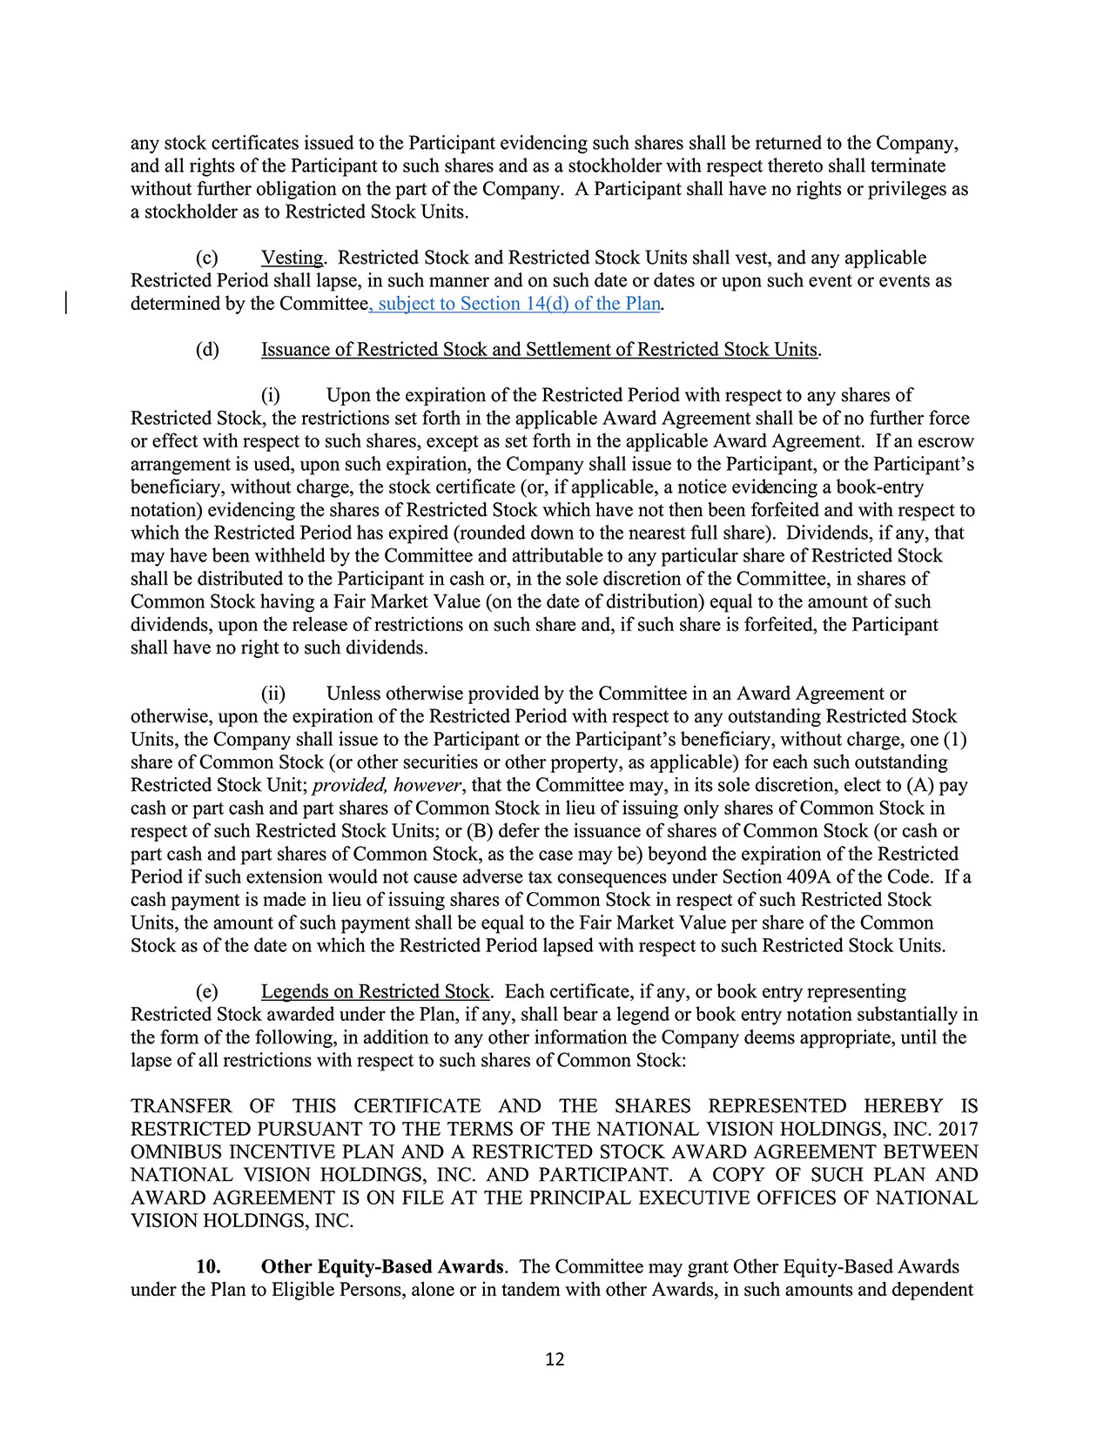
12any stock certificates issued to the Participant evidencing such shares shall be returned to the Company,and all rights of the Participant to such shares and as a stockholder with respect thereto shall terminatewithout further obligation on the part of the Company. A Participant shall have no rights or privileges asa stockholder as to Restricted Stock Units.(c) Vesting. Restricted Stock and Restricted Stock Units shall vest, and any applicableRestricted Period shall lapse, in such manner and on such date or dates or upon such event or events asdetermined by the Committee, subject to Section 14(d) of the Plan.(d) Issuance of Restricted Stock and Settlement of Restricted Stock Units.(i) Upon the expiration of the Restricted Period with respect to any shares ofRestricted Stock, the restrictions set forth in the applicable Award Agreement shall be of no further forceor effect with respect to such shares, except as set forth in the applicable Award Agreement. If an escrowarrangement is used, upon such expiration, the Company shall issue to the Participant, or the Participant’sbeneficiary, without charge, the stock certificate (or, if applicable, a notice evidencing a book-entrynotation) evidencing the shares of Restricted Stock which have not then been forfeited and with respect towhich the Restricted Period has expired (rounded down to the nearest full share). Dividends, if any, thatmay have been withheld by the Committee and attributable to any particular share of Restricted Stockshall be distributed to the Participant in cash or, in the sole discretion of the Committee, in shares ofCommon Stock having a Fair Market Value (on the date of distribution) equal to the amount of suchdividends, upon the release of restrictions on such share and, if such share is forfeited, the Participantshall have no right to such dividends.(ii) Unless otherwise provided by the Committee in an Award Agreement orotherwise, upon the expiration of the Restricted Period with respect to any outstanding Restricted StockUnits, the Company shall issue to the Participant or the Participant’s beneficiary, without charge, one (1)share of Common Stock (or other securities or other property, as applicable) for each such outstandingRestricted Stock Unit; provided, however, that the Committee may, in its sole discretion, elect to (A) paycash or part cash and part shares of Common Stock in lieu of issuing only shares of Common Stock inrespect of such Restricted Stock Units; or (B) defer the issuance of shares of Common Stock (or cash orpart cash and part shares of Common Stock, as the case may be) beyond the expiration of the RestrictedPeriod if such extension would not cause adverse tax consequences under Section 409A of the Code. If acash payment is made in lieu of issuing shares of Common Stock in respect of such Restricted StockUnits, the amount of such payment shall be equal to the Fair Market Value per share of the CommonStock as of the date on which the Restricted Period lapsed with respect to such Restricted Stock Units.(e) Legends on Restricted Stock. Each certificate, if any, or book entry representingRestricted Stock awarded under the Plan, if any, shall bear a legend or book entry notation substantially inthe form of the following, in addition to any other information the Company deems appropriate, until thelapse of all restrictions with respect to such shares of Common Stock:TRANSFER OF THIS CERTIFICATE AND THE SHARES REPRESENTED HEREBY ISRESTRICTED PURSUANT TO THE TERMS OF THE NATIONAL VISION HOLDINGS, INC. 2017OMNIBUS INCENTIVE PLAN AND A RESTRICTED STOCK AWARD AGREEMENT BETWEENNATIONAL VISION HOLDINGS, INC. AND PARTICIPANT. A COPY OF SUCH PLAN ANDAWARD AGREEMENT IS ON FILE AT THE PRINCIPAL EXECUTIVE OFFICES OF NATIONALVISION HOLDINGS, INC.10. Other Equity-Based Awards. The Committee may grant Other Equity-Based Awardsunder the Plan to Eligible Persons, alone or in tandem with other Awards, in such amounts and dependent
94 2024 Proxy Statement

TABLE OF CONTENTS
Appendix B​
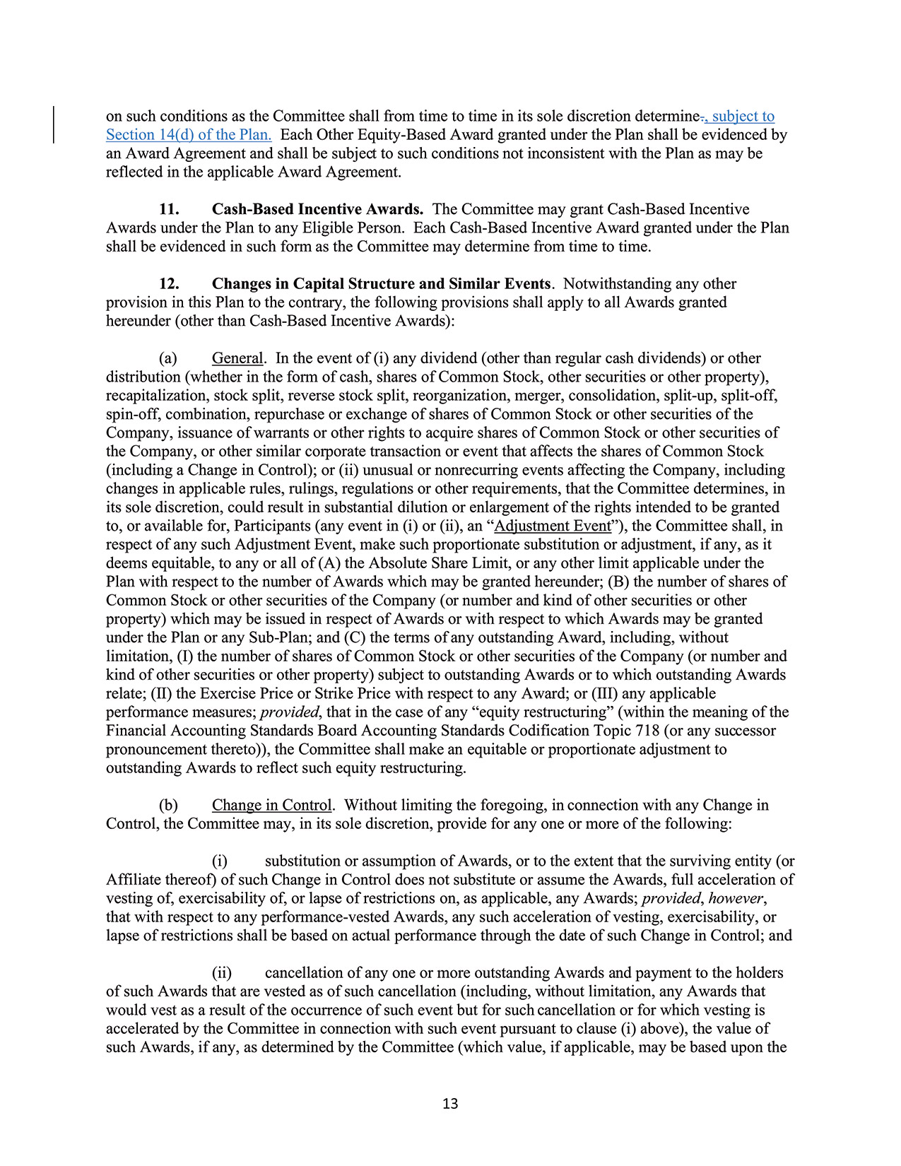
13on such conditions as the Committee shall from time to time in its sole discretion determine., subject toSection 14(d) of the Plan. Each Other Equity-Based Award granted under the Plan shall be evidenced byan Award Agreement and shall be subject to such conditions not inconsistent with the Plan as may bereflected in the applicable Award Agreement.11. Cash-Based Incentive Awards. The Committee may grant Cash-Based IncentiveAwards under the Plan to any Eligible Person. Each Cash-Based Incentive Award granted under the Planshall be evidenced in such form as the Committee may determine from time to time.12. Changes in Capital Structure and Similar Events. Notwithstanding any otherprovision in this Plan to the contrary, the following provisions shall apply to all Awards grantedhereunder (other than Cash-Based Incentive Awards):(a) General. In the event of (i) any dividend (other than regular cash dividends) or otherdistribution (whether in the form of cash, shares of Common Stock, other securities or other property),recapitalization, stock split, reverse stock split, reorganization, merger, consolidation, split-up, split-off,spin-off, combination, repurchase or exchange of shares of Common Stock or other securities of theCompany, issuance of warrants or other rights to acquire shares of Common Stock or other securities ofthe Company, or other similar corporate transaction or event that affects the shares of Common Stock(including a Change in Control); or (ii) unusual or nonrecurring events affecting the Company, includingchanges in applicable rules, rulings, regulations or other requirements, that the Committee determines, inits sole discretion, could result in substantial dilution or enlargement of the rights intended to be grantedto, or available for, Participants (any event in (i) or (ii), an “Adjustment Event”), the Committee shall, inrespect of any such Adjustment Event, make such proportionate substitution or adjustment, if any, as itdeems equitable, to any or all of (A) the Absolute Share Limit, or any other limit applicable under thePlan with respect to the number of Awards which may be granted hereunder; (B) the number of shares ofCommon Stock or other securities of the Company (or number and kind of other securities or otherproperty) which may be issued in respect of Awards or with respect to which Awards may be grantedunder the Plan or any Sub-Plan; and (C) the terms of any outstanding Award, including, withoutlimitation, (I) the number of shares of Common Stock or other securities of the Company (or number andkind of other securities or other property) subject to outstanding Awards or to which outstanding Awardsrelate; (II) the Exercise Price or Strike Price with respect to any Award; or (III) any applicableperformance measures; provided, that in the case of any “equity restructuring” ​(within the meaning of theFinancial Accounting Standards Board Accounting Standards Codification Topic 718 (or any successorpronouncement thereto)), the Committee shall make an equitable or proportionate adjustment tooutstanding Awards to reflect such equity restructuring.(b) Change in Control. Without limiting the foregoing, in connection with any Change inControl, the Committee may, in its sole discretion, provide for any one or more of the following:(i) substitution or assumption of Awards, or to the extent that the surviving entity (orAffiliate thereof) of such Change in Control does not substitute or assume the Awards, full acceleration ofvesting of, exercisability of, or lapse of restrictions on, as applicable, any Awards; provided, however,that with respect to any performance-vested Awards, any such acceleration of vesting, exercisability, orlapse of restrictions shall be based on actual performance through the date of such Change in Control; and(ii) cancellation of any one or more outstanding Awards and payment to the holdersof such Awards that are vested as of such cancellation (including, without limitation, any Awards thatwould vest as a result of the occurrence of such event but for such cancellation or for which vesting isaccelerated by the Committee in connection with such event pursuant to clause (i) above), the value ofsuch Awards, if any, as determined by the Committee (which value, if applicable, may be based upon the
2024 Proxy Statement 95

TABLE OF CONTENTS
Appendix B
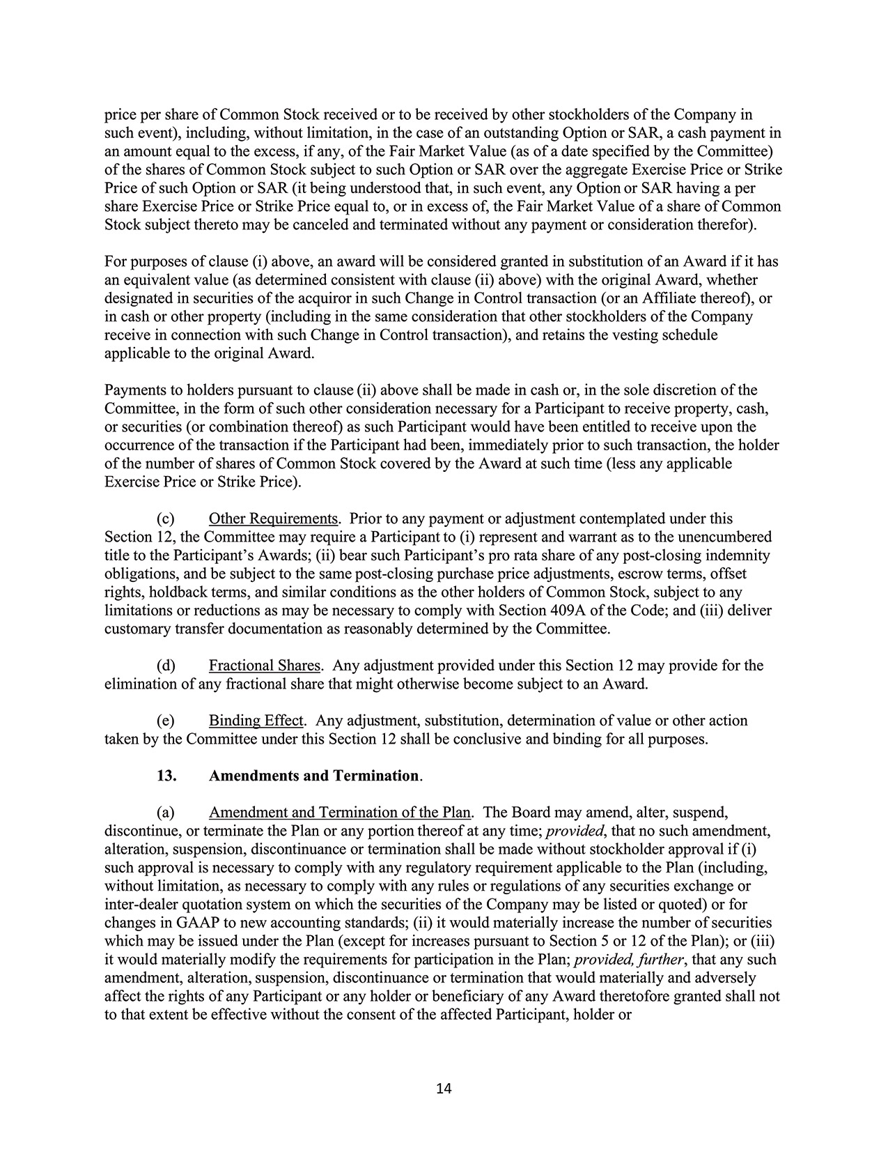
14price per share of Common Stock received or to be received by other stockholders of the Company insuch event), including, without limitation, in the case of an outstanding Option or SAR, a cash payment inan amount equal to the excess, if any, of the Fair Market Value (as of a date specified by the Committee)of the shares of Common Stock subject to such Option or SAR over the aggregate Exercise Price or StrikePrice of such Option or SAR (it being understood that, in such event, any Option or SAR having a pershare Exercise Price or Strike Price equal to, or in excess of, the Fair Market Value of a share of CommonStock subject thereto may be canceled and terminated without any payment or consideration therefor).For purposes of clause (i) above, an award will be considered granted in substitution of an Award if it hasan equivalent value (as determined consistent with clause (ii) above) with the original Award, whetherdesignated in securities of the acquiror in such Change in Control transaction (or an Affiliate thereof), orin cash or other property (including in the same consideration that other stockholders of the Companyreceive in connection with such Change in Control transaction), and retains the vesting scheduleapplicable to the original Award.Payments to holders pursuant to clause (ii) above shall be made in cash or, in the sole discretion of theCommittee, in the form of such other consideration necessary for a Participant to receive property, cash,or securities (or combination thereof) as such Participant would have been entitled to receive upon theoccurrence of the transaction if the Participant had been, immediately prior to such transaction, the holderof the number of shares of Common Stock covered by the Award at such time (less any applicableExercise Price or Strike Price).(c) Other Requirements. Prior to any payment or adjustment contemplated under thisSection 12, the Committee may require a Participant to (i) represent and warrant as to the unencumberedtitle to the Participant’s Awards; (ii) bear such Participant’s pro rata share of any post-closing indemnityobligations, and be subject to the same post-closing purchase price adjustments, escrow terms, offsetrights, holdback terms, and similar conditions as the other holders of Common Stock, subject to anylimitations or reductions as may be necessary to comply with Section 409A of the Code; and (iii) delivercustomary transfer documentation as reasonably determined by the Committee.(d) Fractional Shares. Any adjustment provided under this Section 12 may provide for theelimination of any fractional share that might otherwise become subject to an Award.(e) Binding Effect. Any adjustment, substitution, determination of value or other actiontaken by the Committee under this Section 12 shall be conclusive and binding for all purposes.13. Amendments and Termination.(a) Amendment and Termination of the Plan. The Board may amend, alter, suspend,discontinue, or terminate the Plan or any portion thereof at any time; provided, that no such amendment,alteration, suspension, discontinuance or termination shall be made without stockholder approval if (i)such approval is necessary to comply with any regulatory requirement applicable to the Plan (including,without limitation, as necessary to comply with any rules or regulations of any securities exchange orinter-dealer quotation system on which the securities of the Company may be listed or quoted) or forchanges in GAAP to new accounting standards; (ii) it would materially increase the number of securitieswhich may be issued under the Plan (except for increases pursuant to Section 5 or 12 of the Plan); or (iii)it would materially modify the requirements for participation in the Plan; provided, further, that any suchamendment, alteration, suspension, discontinuance or termination that would materially and adverselyaffect the rights of any Participant or any holder or beneficiary of any Award theretofore granted shall notto that extent be effective without the consent of the affected Participant, holder or
96 2024 Proxy Statement

TABLE OF CONTENTS
Appendix B​
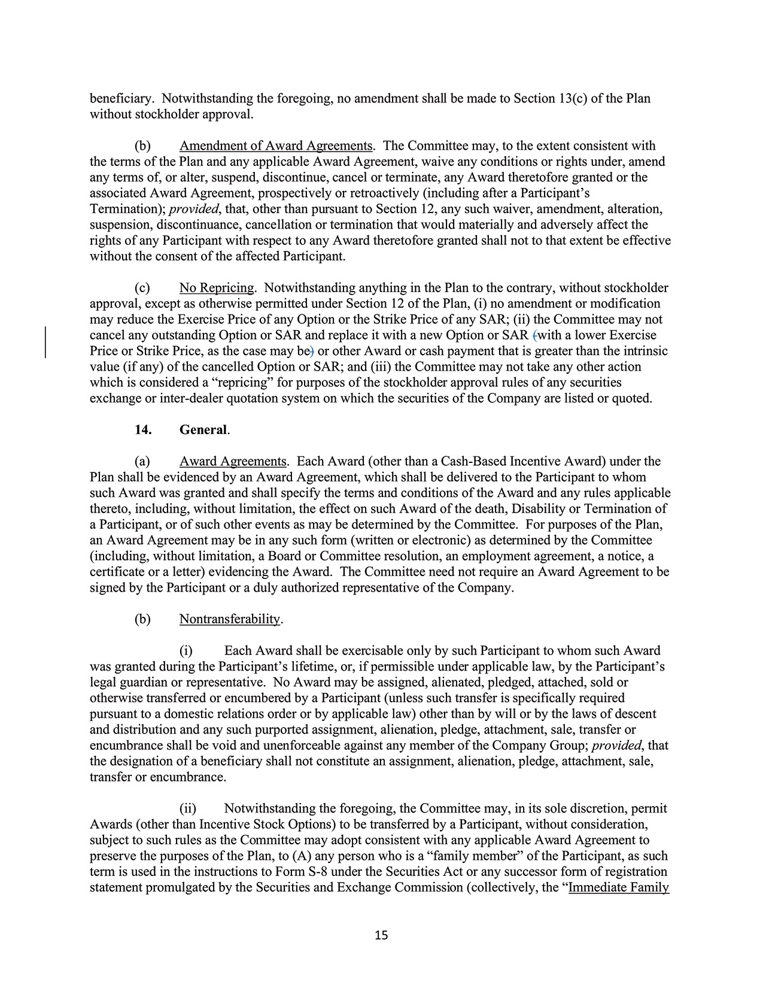
15beneficiary. Notwithstanding the foregoing, no amendment shall be made to Section 13(c) of the Planwithout stockholder approval.(b) Amendment of Award Agreements. The Committee may, to the extent consistent withthe terms of the Plan and any applicable Award Agreement, waive any conditions or rights under, amendany terms of, or alter, suspend, discontinue, cancel or terminate, any Award theretofore granted or theassociated Award Agreement, prospectively or retroactively (including after a Participant’sTermination); provided, that, other than pursuant to Section 12, any such waiver, amendment, alteration,suspension, discontinuance, cancellation or termination that would materially and adversely affect therights of any Participant with respect to any Award theretofore granted shall not to that extent be effectivewithout the consent of the affected Participant.(c) No Repricing. Notwithstanding anything in the Plan to the contrary, without stockholderapproval, except as otherwise permitted under Section 12 of the Plan, (i) no amendment or modificationmay reduce the Exercise Price of any Option or the Strike Price of any SAR; (ii) the Committee may notcancel any outstanding Option or SAR and replace it with a new Option or SAR (with a lower ExercisePrice or Strike Price, as the case may be) or other Award or cash payment that is greater than the intrinsicvalue (if any) of the cancelled Option or SAR; and (iii) the Committee may not take any other actionwhich is considered a “repricing” for purposes of the stockholder approval rules of any securitiesexchange or inter-dealer quotation system on which the securities of the Company are listed or quoted.14. General.(a) Award Agreements. Each Award (other than a Cash-Based Incentive Award) under thePlan shall be evidenced by an Award Agreement, which shall be delivered to the Participant to whomsuch Award was granted and shall specify the terms and conditions of the Award and any rules applicablethereto, including, without limitation, the effect on such Award of the death, Disability or Termination ofa Participant, or of such other events as may be determined by the Committee. For purposes of the Plan,an Award Agreement may be in any such form (written or electronic) as determined by the Committee(including, without limitation, a Board or Committee resolution, an employment agreement, a notice, acertificate or a letter) evidencing the Award. The Committee need not require an Award Agreement to besigned by the Participant or a duly authorized representative of the Company.(b) Nontransferability.(i) Each Award shall be exercisable only by such Participant to whom such Awardwas granted during the Participant’s lifetime, or, if permissible under applicable law, by the Participant’slegal guardian or representative. No Award may be assigned, alienated, pledged, attached, sold orotherwise transferred or encumbered by a Participant (unless such transfer is specifically requiredpursuant to a domestic relations order or by applicable law) other than by will or by the laws of descentand distribution and any such purported assignment, alienation, pledge, attachment, sale, transfer orencumbrance shall be void and unenforceable against any member of the Company Group; provided, thatthe designation of a beneficiary shall not constitute an assignment, alienation, pledge, attachment, sale,transfer or encumbrance.(ii) Notwithstanding the foregoing, the Committee may, in its sole discretion, permitAwards (other than Incentive Stock Options) to be transferred by a Participant, without consideration,subject to such rules as the Committee may adopt consistent with any applicable Award Agreement topreserve the purposes of the Plan, to (A) any person who is a “family member” of the Participant, as suchterm is used in the instructions to Form S-8 under the Securities Act or any successor form of registrationstatement promulgated by the Securities and Exchange Commission (collectively, the “Immediate Family
2024 Proxy Statement 97

TABLE OF CONTENTS
Appendix B
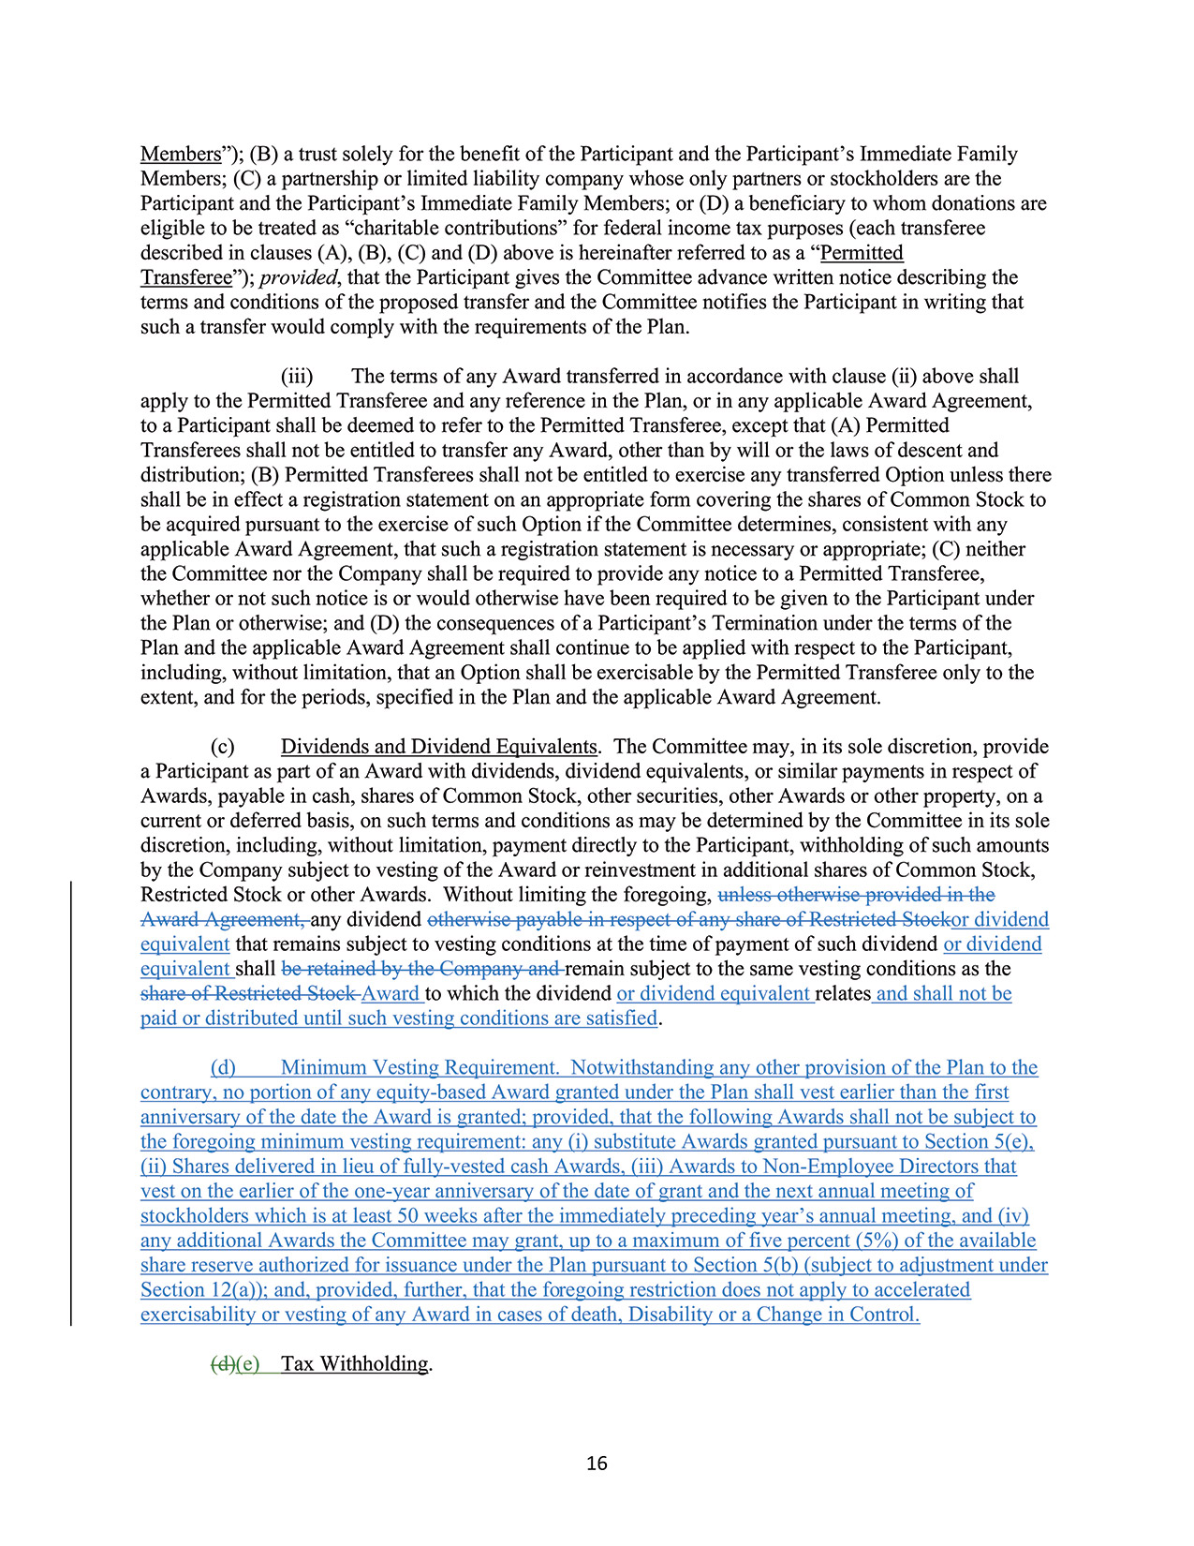
16Members”); (B) a trust solely for the benefit of the Participant and the Participant’s Immediate FamilyMembers; (C) a partnership or limited liability company whose only partners or stockholders are theParticipant and the Participant’s Immediate Family Members; or (D) a beneficiary to whom donations areeligible to be treated as “charitable contributions” for federal income tax purposes (each transfereedescribed in clauses (A), (B), (C) and (D) above is hereinafter referred to as a “PermittedTransferee”); provided, that the Participant gives the Committee advance written notice describing theterms and conditions of the proposed transfer and the Committee notifies the Participant in writing thatsuch a transfer would comply with the requirements of the Plan.(iii) The terms of any Award transferred in accordance with clause (ii) above shallapply to the Permitted Transferee and any reference in the Plan, or in any applicable Award Agreement,to a Participant shall be deemed to refer to the Permitted Transferee, except that (A) PermittedTransferees shall not be entitled to transfer any Award, other than by will or the laws of descent anddistribution; (B) Permitted Transferees shall not be entitled to exercise any transferred Option unless thereshall be in effect a registration statement on an appropriate form covering the shares of Common Stock tobe acquired pursuant to the exercise of such Option if the Committee determines, consistent with anyapplicable Award Agreement, that such a registration statement is necessary or appropriate; (C) neitherthe Committee nor the Company shall be required to provide any notice to a Permitted Transferee,whether or not such notice is or would otherwise have been required to be given to the Participant underthe Plan or otherwise; and (D) the consequences of a Participant’s Termination under the terms of thePlan and the applicable Award Agreement shall continue to be applied with respect to the Participant,including, without limitation, that an Option shall be exercisable by the Permitted Transferee only to theextent, and for the periods, specified in the Plan and the applicable Award Agreement.(c) Dividends and Dividend Equivalents. The Committee may, in its sole discretion, providea Participant as part of an Award with dividends, dividend equivalents, or similar payments in respect ofAwards, payable in cash, shares of Common Stock, other securities, other Awards or other property, on acurrent or deferred basis, on such terms and conditions as may be determined by the Committee in its solediscretion, including, without limitation, payment directly to the Participant, withholding of such amountsby the Company subject to vesting of the Award or reinvestment in additional shares of Common Stock,Restricted Stock or other Awards. Without limiting the foregoing, unless otherwise provided in theAward Agreement, any dividend otherwise payable in respect of any share of Restricted Stockor dividendequivalent that remains subject to vesting conditions at the time of payment of such dividend or dividendequivalent shall be retained by the Company and remain subject to the same vesting conditions as theshare of Restricted Stock Award to which the dividend or dividend equivalent relates and shall not bepaid or distributed until such vesting conditions are satisfied.(d) Minimum Vesting Requirement. Notwithstanding any other provision of the Plan to thecontrary, no portion of any equity-based Award granted under the Plan shall vest earlier than the firstanniversary of the date the Award is granted; provided, that the following Awards shall not be subject tothe foregoing minimum vesting requirement: any (i) substitute Awards granted pursuant to Section 5(e),(ii) Shares delivered in lieu of fully-vested cash Awards, (iii) Awards to Non-Employee Directors thatvest on the earlier of the one-year anniversary of the date of grant and the next annual meeting ofstockholders which is at least 50 weeks after the immediately preceding year’s annual meeting, and (iv)any additional Awards the Committee may grant, up to a maximum of five percent (5%) of the availableshare reserve authorized for issuance under the Plan pursuant to Section 5(b) (subject to adjustment underSection 12(a)); and, provided, further, that the foregoing restriction does not apply to acceleratedexercisability or vesting of any Award in cases of death, Disability or a Change in Control.(d)(e) Tax Withholding.
98 2024 Proxy Statement

TABLE OF CONTENTS
Appendix B​
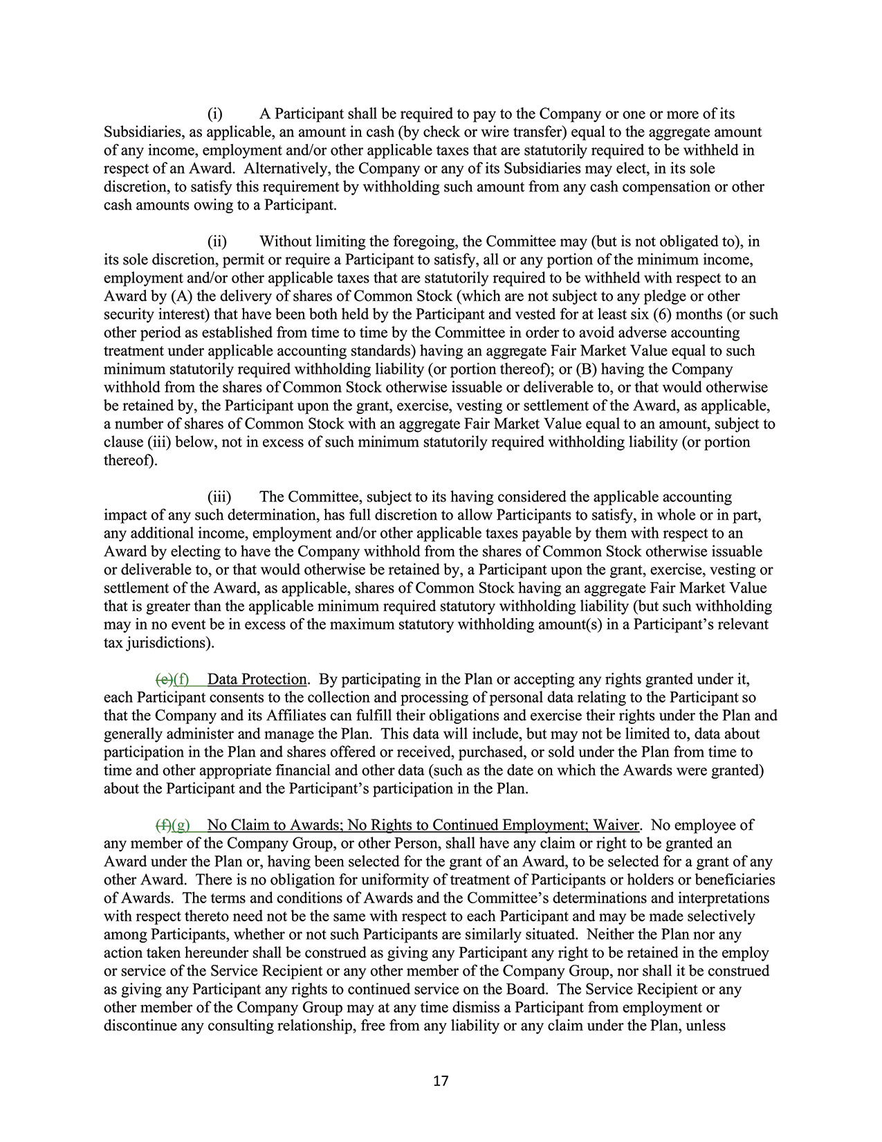
17(i) A Participant shall be required to pay to the Company or one or more of itsSubsidiaries, as applicable, an amount in cash (by check or wire transfer) equal to the aggregate amountof any income, employment and/or other applicable taxes that are statutorily required to be withheld inrespect of an Award. Alternatively, the Company or any of its Subsidiaries may elect, in its solediscretion, to satisfy this requirement by withholding such amount from any cash compensation or othercash amounts owing to a Participant.(ii) Without limiting the foregoing, the Committee may (but is not obligated to), inits sole discretion, permit or require a Participant to satisfy, all or any portion of the minimum income,employment and/or other applicable taxes that are statutorily required to be withheld with respect to anAward by (A) the delivery of shares of Common Stock (which are not subject to any pledge or othersecurity interest) that have been both held by the Participant and vested for at least six (6) months (or suchother period as established from time to time by the Committee in order to avoid adverse accountingtreatment under applicable accounting standards) having an aggregate Fair Market Value equal to suchminimum statutorily required withholding liability (or portion thereof); or (B) having the Companywithhold from the shares of Common Stock otherwise issuable or deliverable to, or that would otherwisebe retained by, the Participant upon the grant, exercise, vesting or settlement of the Award, as applicable,a number of shares of Common Stock with an aggregate Fair Market Value equal to an amount, subject toclause (iii) below, not in excess of such minimum statutorily required withholding liability (or portionthereof).(iii) The Committee, subject to its having considered the applicable accountingimpact of any such determination, has full discretion to allow Participants to satisfy, in whole or in part,any additional income, employment and/or other applicable taxes payable by them with respect to anAward by electing to have the Company withhold from the shares of Common Stock otherwise issuableor deliverable to, or that would otherwise be retained by, a Participant upon the grant, exercise, vesting orsettlement of the Award, as applicable, shares of Common Stock having an aggregate Fair Market Valuethat is greater than the applicable minimum required statutory withholding liability (but such withholdingmay in no event be in excess of the maximum statutory withholding amount(s) in a Participant’s relevanttax jurisdictions).(e)(f) Data Protection. By participating in the Plan or accepting any rights granted under it,each Participant consents to the collection and processing of personal data relating to the Participant sothat the Company and its Affiliates can fulfill their obligations and exercise their rights under the Plan andgenerally administer and manage the Plan. This data will include, but may not be limited to, data aboutparticipation in the Plan and shares offered or received, purchased, or sold under the Plan from time totime and other appropriate financial and other data (such as the date on which the Awards were granted)about the Participant and the Participant’s participation in the Plan.(f)(g) No Claim to Awards; No Rights to Continued Employment; Waiver. No employee ofany member of the Company Group, or other Person, shall have any claim or right to be granted anAward under the Plan or, having been selected for the grant of an Award, to be selected for a grant of anyother Award. There is no obligation for uniformity of treatment of Participants or holders or beneficiariesof Awards. The terms and conditions of Awards and the Committee’s determinations and interpretationswith respect thereto need not be the same with respect to each Participant and may be made selectivelyamong Participants, whether or not such Participants are similarly situated. Neither the Plan nor anyaction taken hereunder shall be construed as giving any Participant any right to be retained in the employor service of the Service Recipient or any other member of the Company Group, nor shall it be construedas giving any Participant any rights to continued service on the Board. The Service Recipient or anyother member of the Company Group may at any time dismiss a Participant from employment ordiscontinue any consulting relationship, free from any liability or any claim under the Plan, unless
2024 Proxy Statement 99

TABLE OF CONTENTS
Appendix B
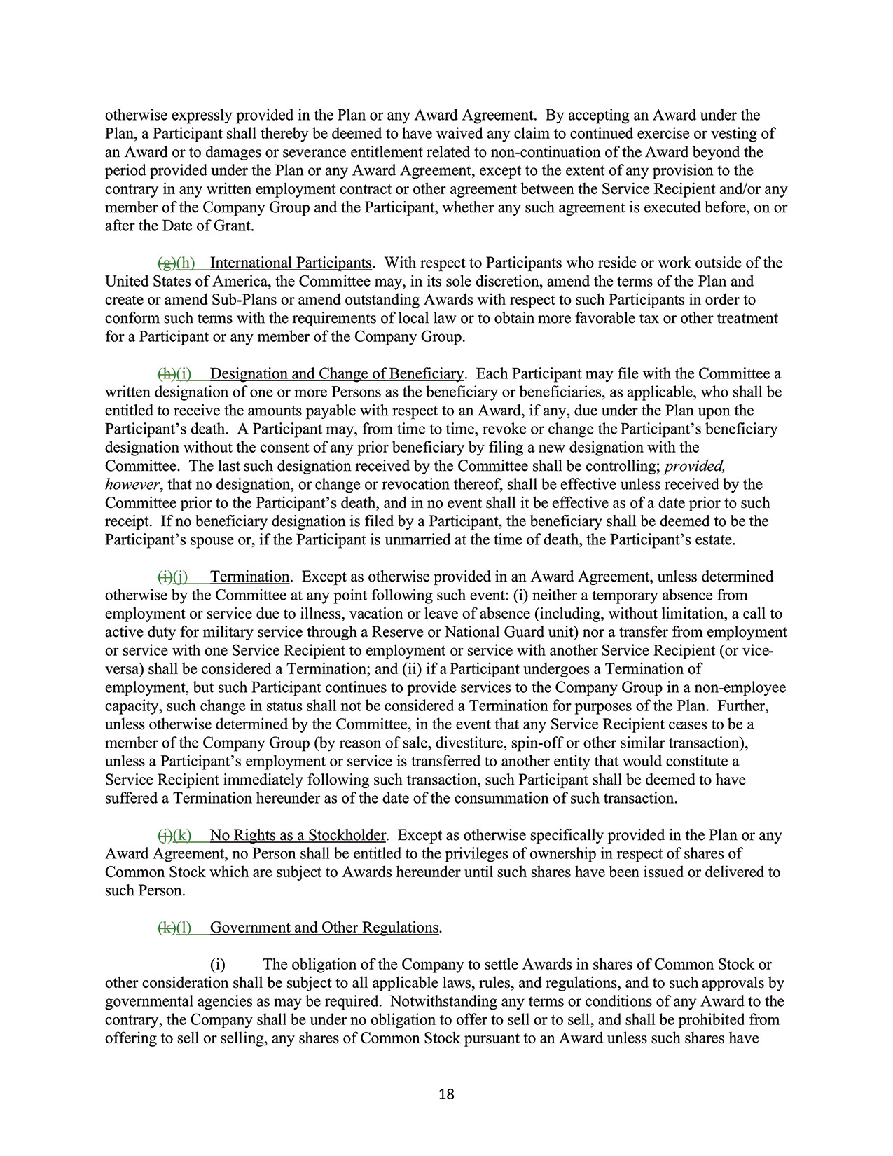
18otherwise expressly provided in the Plan or any Award Agreement. By accepting an Award under thePlan, a Participant shall thereby be deemed to have waived any claim to continued exercise or vesting ofan Award or to damages or severance entitlement related to non-continuation of the Award beyond theperiod provided under the Plan or any Award Agreement, except to the extent of any provision to thecontrary in any written employment contract or other agreement between the Service Recipient and/or anymember of the Company Group and the Participant, whether any such agreement is executed before, on orafter the Date of Grant.(g)(h) International Participants. With respect to Participants who reside or work outside of theUnited States of America, the Committee may, in its sole discretion, amend the terms of the Plan andcreate or amend Sub-Plans or amend outstanding Awards with respect to such Participants in order toconform such terms with the requirements of local law or to obtain more favorable tax or other treatmentfor a Participant or any member of the Company Group.(h)(i) Designation and Change of Beneficiary. Each Participant may file with the Committee awritten designation of one or more Persons as the beneficiary or beneficiaries, as applicable, who shall beentitled to receive the amounts payable with respect to an Award, if any, due under the Plan upon theParticipant’s death. A Participant may, from time to time, revoke or change the Participant’s beneficiarydesignation without the consent of any prior beneficiary by filing a new designation with theCommittee. The last such designation received by the Committee shall be controlling; provided,however, that no designation, or change or revocation thereof, shall be effective unless received by theCommittee prior to the Participant’s death, and in no event shall it be effective as of a date prior to suchreceipt. If no beneficiary designation is filed by a Participant, the beneficiary shall be deemed to be theParticipant’s spouse or, if the Participant is unmarried at the time of death, the Participant’s estate.(i)(j) Termination. Except as otherwise provided in an Award Agreement, unless determinedotherwise by the Committee at any point following such event: (i) neither a temporary absence fromemployment or service due to illness, vacation or leave of absence (including, without limitation, a call toactive duty for military service through a Reserve or National Guard unit) nor a transfer from employmentor service with one Service Recipient to employment or service with another Service Recipient (or viceversa)shall be considered a Termination; and (ii) if a Participant undergoes a Termination ofemployment, but such Participant continues to provide services to the Company Group in a non-employeecapacity, such change in status shall not be considered a Termination for purposes of the Plan. Further,unless otherwise determined by the Committee, in the event that any Service Recipient ceases to be amember of the Company Group (by reason of sale, divestiture, spin-off or other similar transaction),unless a Participant’s employment or service is transferred to another entity that would constitute aService Recipient immediately following such transaction, such Participant shall be deemed to havesuffered a Termination hereunder as of the date of the consummation of such transaction.(j)(k) No Rights as a Stockholder. Except as otherwise specifically provided in the Plan or anyAward Agreement, no Person shall be entitled to the privileges of ownership in respect of shares ofCommon Stock which are subject to Awards hereunder until such shares have been issued or delivered tosuch Person.(k)(l) Government and Other Regulations.(i) The obligation of the Company to settle Awards in shares of Common Stock orother consideration shall be subject to all applicable laws, rules, and regulations, and to such approvals bygovernmental agencies as may be required. Notwithstanding any terms or conditions of any Award to thecontrary, the Company shall be under no obligation to offer to sell or to sell, and shall be prohibited fromoffering to sell or selling, any shares of Common Stock pursuant to an Award unless such shares have
100 2024 Proxy Statement

TABLE OF CONTENTS
Appendix B​
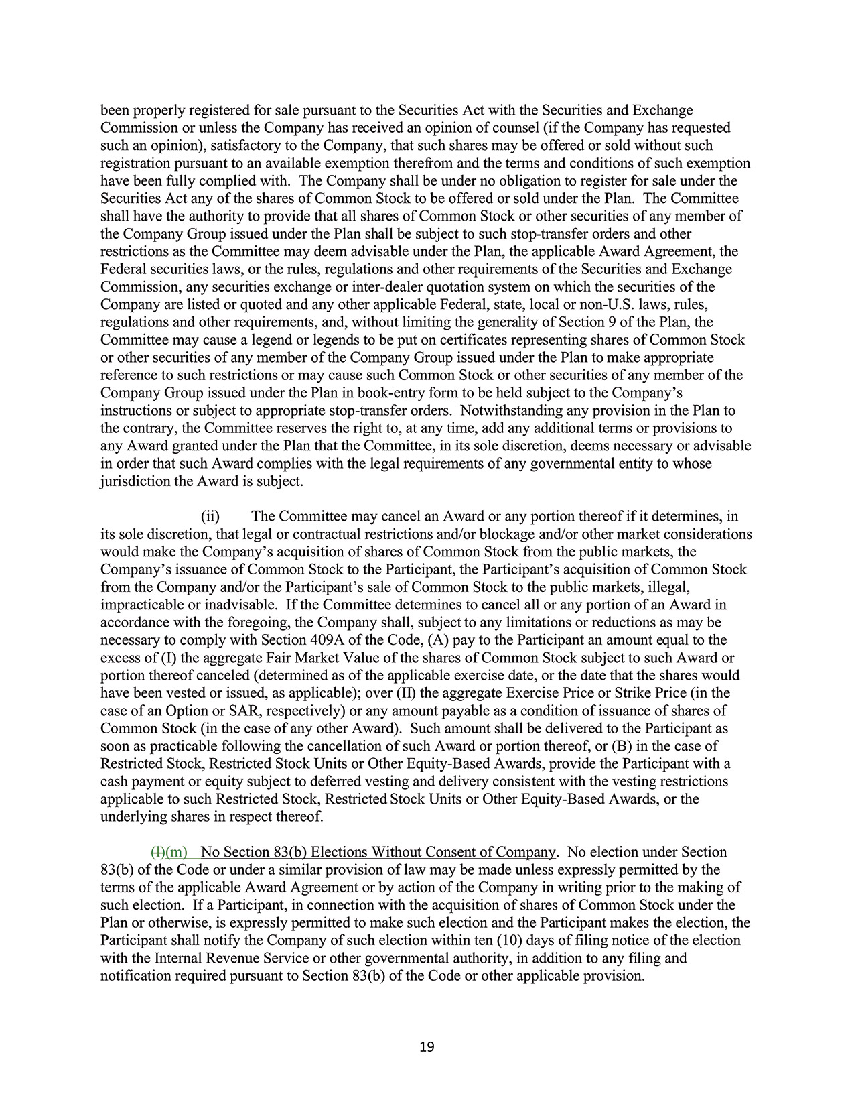
19been properly registered for sale pursuant to the Securities Act with the Securities and ExchangeCommission or unless the Company has received an opinion of counsel (if the Company has requestedsuch an opinion), satisfactory to the Company, that such shares may be offered or sold without suchregistration pursuant to an available exemption therefrom and the terms and conditions of such exemptionhave been fully complied with. The Company shall be under no obligation to register for sale under theSecurities Act any of the shares of Common Stock to be offered or sold under the Plan. The Committeeshall have the authority to provide that all shares of Common Stock or other securities of any member ofthe Company Group issued under the Plan shall be subject to such stop-transfer orders and otherrestrictions as the Committee may deem advisable under the Plan, the applicable Award Agreement, theFederal securities laws, or the rules, regulations and other requirements of the Securities and ExchangeCommission, any securities exchange or inter-dealer quotation system on which the securities of theCompany are listed or quoted and any other applicable Federal, state, local or non-U.S. laws, rules,regulations and other requirements, and, without limiting the generality of Section 9 of the Plan, theCommittee may cause a legend or legends to be put on certificates representing shares of Common Stockor other securities of any member of the Company Group issued under the Plan to make appropriatereference to such restrictions or may cause such Common Stock or other securities of any member of theCompany Group issued under the Plan in book-entry form to be held subject to the Company’sinstructions or subject to appropriate stop-transfer orders. Notwithstanding any provision in the Plan tothe contrary, the Committee reserves the right to, at any time, add any additional terms or provisions toany Award granted under the Plan that the Committee, in its sole discretion, deems necessary or advisablein order that such Award complies with the legal requirements of any governmental entity to whosejurisdiction the Award is subject.(ii) The Committee may cancel an Award or any portion thereof if it determines, inits sole discretion, that legal or contractual restrictions and/or blockage and/or other market considerationswould make the Company’s acquisition of shares of Common Stock from the public markets, theCompany’s issuance of Common Stock to the Participant, the Participant’s acquisition of Common Stockfrom the Company and/or the Participant’s sale of Common Stock to the public markets, illegal,impracticable or inadvisable. If the Committee determines to cancel all or any portion of an Award inaccordance with the foregoing, the Company shall, subject to any limitations or reductions as may benecessary to comply with Section 409A of the Code, (A) pay to the Participant an amount equal to theexcess of (I) the aggregate Fair Market Value of the shares of Common Stock subject to such Award orportion thereof canceled (determined as of the applicable exercise date, or the date that the shares wouldhave been vested or issued, as applicable); over (II) the aggregate Exercise Price or Strike Price (in thecase of an Option or SAR, respectively) or any amount payable as a condition of issuance of shares ofCommon Stock (in the case of any other Award). Such amount shall be delivered to the Participant assoon as practicable following the cancellation of such Award or portion thereof, or (B) in the case ofRestricted Stock, Restricted Stock Units or Other Equity-Based Awards, provide the Participant with acash payment or equity subject to deferred vesting and delivery consistent with the vesting restrictionsapplicable to such Restricted Stock, Restricted Stock Units or Other Equity-Based Awards, or theunderlying shares in respect thereof.(l)(m) No Section 83(b) Elections Without Consent of Company. No election under Section83(b) of the Code or under a similar provision of law may be made unless expressly permitted by theterms of the applicable Award Agreement or by action of the Company in writing prior to the making ofsuch election. If a Participant, in connection with the acquisition of shares of Common Stock under thePlan or otherwise, is expressly permitted to make such election and the Participant makes the election, theParticipant shall notify the Company of such election within ten (10) days of filing notice of the electionwith the Internal Revenue Service or other governmental authority, in addition to any filing andnotification required pursuant to Section 83(b) of the Code or other applicable provision.
2024 Proxy Statement 101

TABLE OF CONTENTS
Appendix B
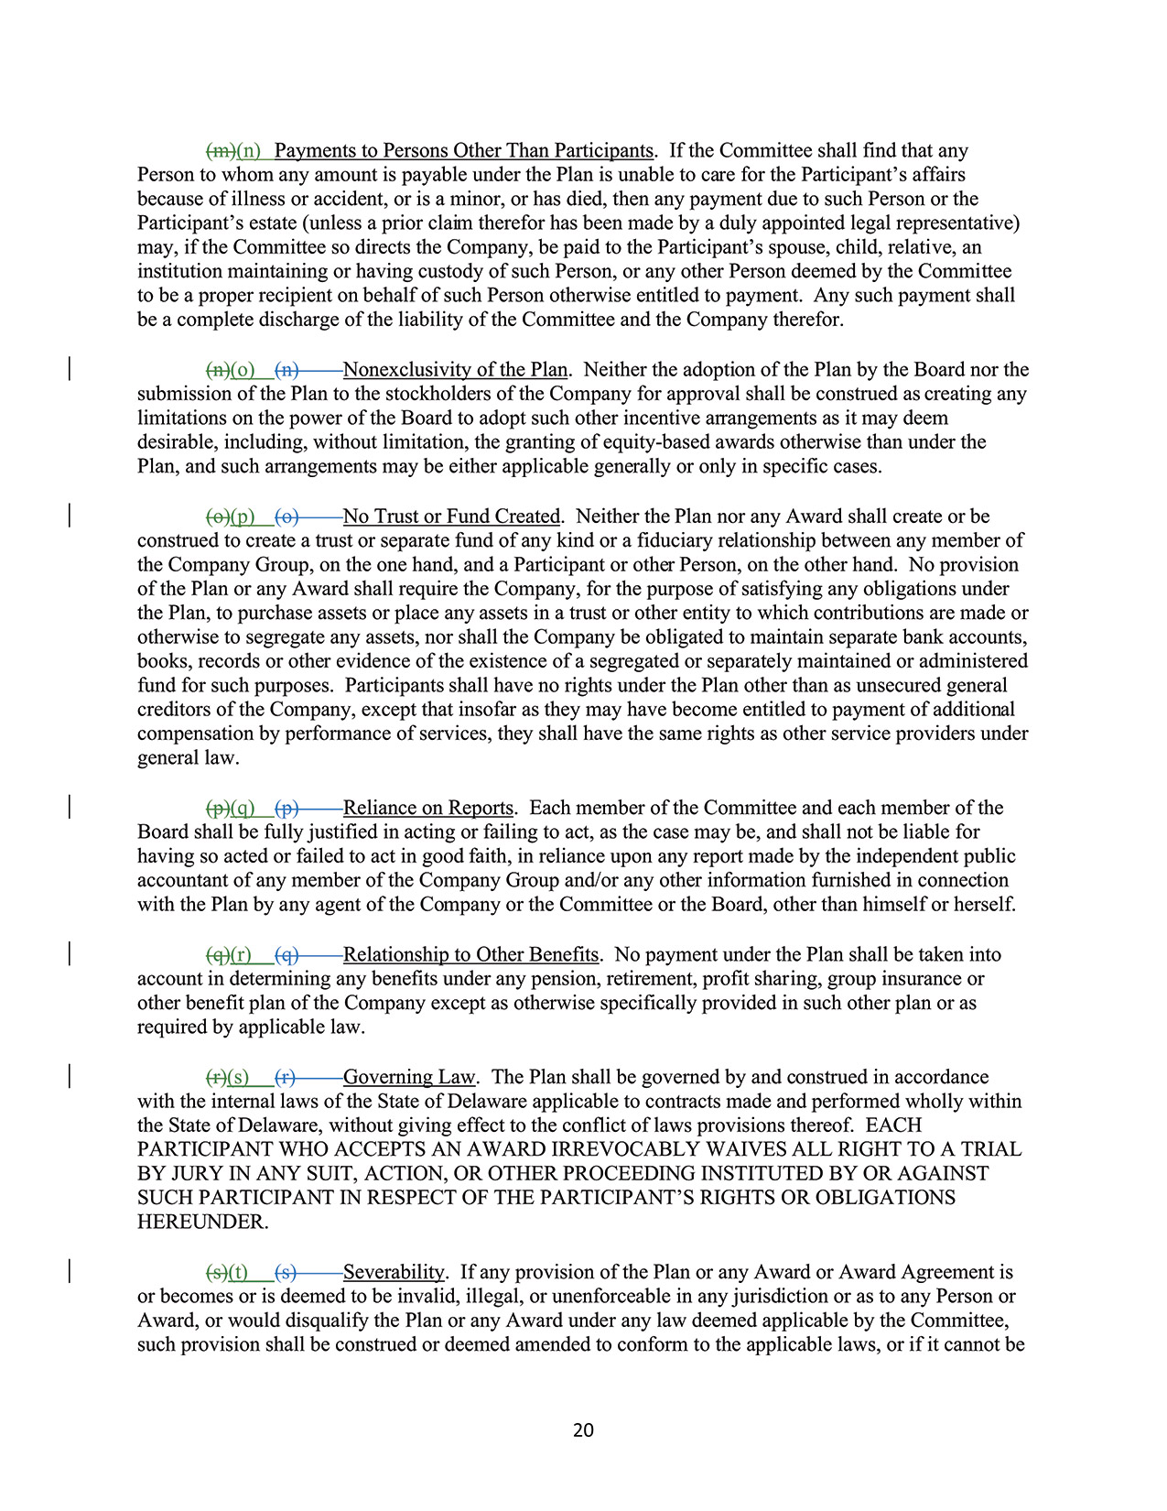
20(m)(n) Payments to Persons Other Than Participants. If the Committee shall find that anyPerson to whom any amount is payable under the Plan is unable to care for the Participant’s affairsbecause of illness or accident, or is a minor, or has died, then any payment due to such Person or theParticipant’s estate (unless a prior claim therefor has been made by a duly appointed legal representative)may, if the Committee so directs the Company, be paid to the Participant’s spouse, child, relative, aninstitution maintaining or having custody of such Person, or any other Person deemed by the Committeeto be a proper recipient on behalf of such Person otherwise entitled to payment. Any such payment shallbe a complete discharge of the liability of the Committee and the Company therefor.(n)(o) (n) Nonexclusivity of the Plan. Neither the adoption of the Plan by the Board nor thesubmission of the Plan to the stockholders of the Company for approval shall be construed as creating anylimitations on the power of the Board to adopt such other incentive arrangements as it may deemdesirable, including, without limitation, the granting of equity-based awards otherwise than under thePlan, and such arrangements may be either applicable generally or only in specific cases.(o)(p) (o) No Trust or Fund Created. Neither the Plan nor any Award shall create or beconstrued to create a trust or separate fund of any kind or a fiduciary relationship between any member ofthe Company Group, on the one hand, and a Participant or other Person, on the other hand. No provisionof the Plan or any Award shall require the Company, for the purpose of satisfying any obligations underthe Plan, to purchase assets or place any assets in a trust or other entity to which contributions are made orotherwise to segregate any assets, nor shall the Company be obligated to maintain separate bank accounts,books, records or other evidence of the existence of a segregated or separately maintained or administeredfund for such purposes. Participants shall have no rights under the Plan other than as unsecured generalcreditors of the Company, except that insofar as they may have become entitled to payment of additionalcompensation by performance of services, they shall have the same rights as other service providers undergeneral law.(p)(q) (p) Reliance on Reports. Each member of the Committee and each member of theBoard shall be fully justified in acting or failing to act, as the case may be, and shall not be liable forhaving so acted or failed to act in good faith, in reliance upon any report made by the independent publicaccountant of any member of the Company Group and/or any other information furnished in connectionwith the Plan by any agent of the Company or the Committee or the Board, other than himself or herself.(q)(r) (q) Relationship to Other Benefits. No payment under the Plan shall be taken intoaccount in determining any benefits under any pension, retirement, profit sharing, group insurance orother benefit plan of the Company except as otherwise specifically provided in such other plan or asrequired by applicable law.(r)(s) (r) Governing Law. The Plan shall be governed by and construed in accordancewith the internal laws of the State of Delaware applicable to contracts made and performed wholly withinthe State of Delaware, without giving effect to the conflict of laws provisions thereof. EACHPARTICIPANT WHO ACCEPTS AN AWARD IRREVOCABLY WAIVES ALL RIGHT TO A TRIALBY JURY IN ANY SUIT, ACTION, OR OTHER PROCEEDING INSTITUTED BY OR AGAINSTSUCH PARTICIPANT IN RESPECT OF THE PARTICIPANT’S RIGHTS OR OBLIGATIONSHEREUNDER.(s)(t) (s) Severability. If any provision of the Plan or any Award or Award Agreement isor becomes or is deemed to be invalid, illegal, or unenforceable in any jurisdiction or as to any Person orAward, or would disqualify the Plan or any Award under any law deemed applicable by the Committee,such provision shall be construed or deemed amended to conform to the applicable laws, or if it cannot be
102 2024 Proxy Statement

TABLE OF CONTENTS
Appendix B​
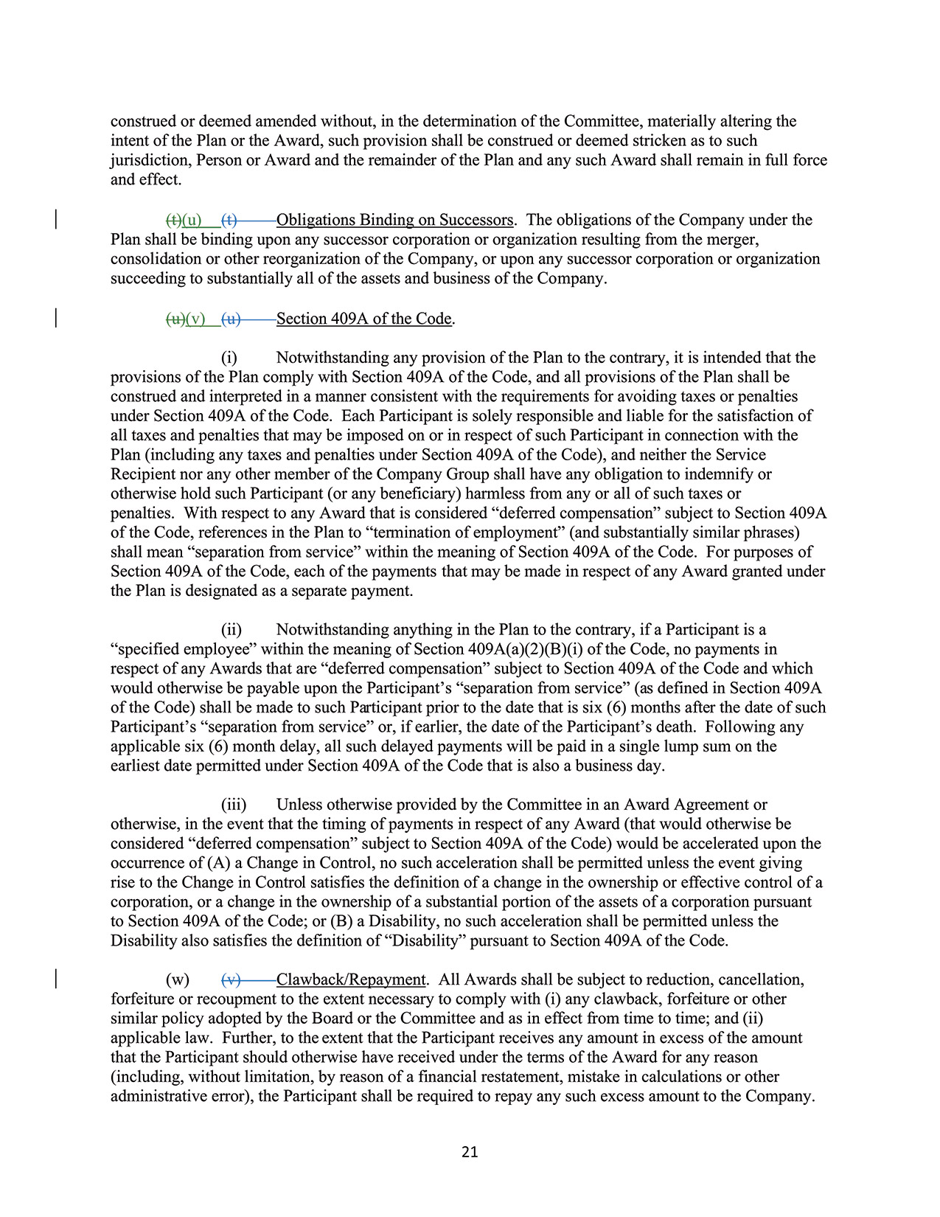
21construed or deemed amended without, in the determination of the Committee, materially altering theintent of the Plan or the Award, such provision shall be construed or deemed stricken as to suchjurisdiction, Person or Award and the remainder of the Plan and any such Award shall remain in full forceand effect.(t)(u) (t) Obligations Binding on Successors. The obligations of the Company under thePlan shall be binding upon any successor corporation or organization resulting from the merger,consolidation or other reorganization of the Company, or upon any successor corporation or organizationsucceeding to substantially all of the assets and business of the Company.(u)(v) (u) Section 409A of the Code.(i) Notwithstanding any provision of the Plan to the contrary, it is intended that theprovisions of the Plan comply with Section 409A of the Code, and all provisions of the Plan shall beconstrued and interpreted in a manner consistent with the requirements for avoiding taxes or penaltiesunder Section 409A of the Code. Each Participant is solely responsible and liable for the satisfaction ofall taxes and penalties that may be imposed on or in respect of such Participant in connection with thePlan (including any taxes and penalties under Section 409A of the Code), and neither the ServiceRecipient nor any other member of the Company Group shall have any obligation to indemnify orotherwise hold such Participant (or any beneficiary) harmless from any or all of such taxes orpenalties. With respect to any Award that is considered “deferred compensation” subject to Section 409Aof the Code, references in the Plan to “termination of employment” ​(and substantially similar phrases)shall mean “separation from service” within the meaning of Section 409A of the Code. For purposes ofSection 409A of the Code, each of the payments that may be made in respect of any Award granted underthe Plan is designated as a separate payment.(ii) Notwithstanding anything in the Plan to the contrary, if a Participant is a“specified employee” within the meaning of Section 409A(a)(2)(B)(i) of the Code, no payments inrespect of any Awards that are “deferred compensation” subject to Section 409A of the Code and whichwould otherwise be payable upon the Participant’s “separation from service” ​(as defined in Section 409Aof the Code) shall be made to such Participant prior to the date that is six (6) months after the date of suchParticipant’s “separation from service” or, if earlier, the date of the Participant’s death. Following anyapplicable six (6) month delay, all such delayed payments will be paid in a single lump sum on theearliest date permitted under Section 409A of the Code that is also a business day.(iii) Unless otherwise provided by the Committee in an Award Agreement orotherwise, in the event that the timing of payments in respect of any Award (that would otherwise beconsidered “deferred compensation” subject to Section 409A of the Code) would be accelerated upon theoccurrence of (A) a Change in Control, no such acceleration shall be permitted unless the event givingrise to the Change in Control satisfies the definition of a change in the ownership or effective control of acorporation, or a change in the ownership of a substantial portion of the assets of a corporation pursuantto Section 409A of the Code; or (B) a Disability, no such acceleration shall be permitted unless theDisability also satisfies the definition of “Disability” pursuant to Section 409A of the Code.(w) (v) Clawback/Repayment. All Awards shall be subject to reduction, cancellation,forfeiture or recoupment to the extent necessary to comply with (i) any clawback, forfeiture or othersimilar policy adopted by the Board or the Committee and as in effect from time to time; and (ii)applicable law. Further, to the extent that the Participant receives any amount in excess of the amountthat the Participant should otherwise have received under the terms of the Award for any reason(including, without limitation, by reason of a financial restatement, mistake in calculations or otheradministrative error), the Participant shall be required to repay any such excess amount to the Company.
2024 Proxy Statement 103

TABLE OF CONTENTS
Appendix B
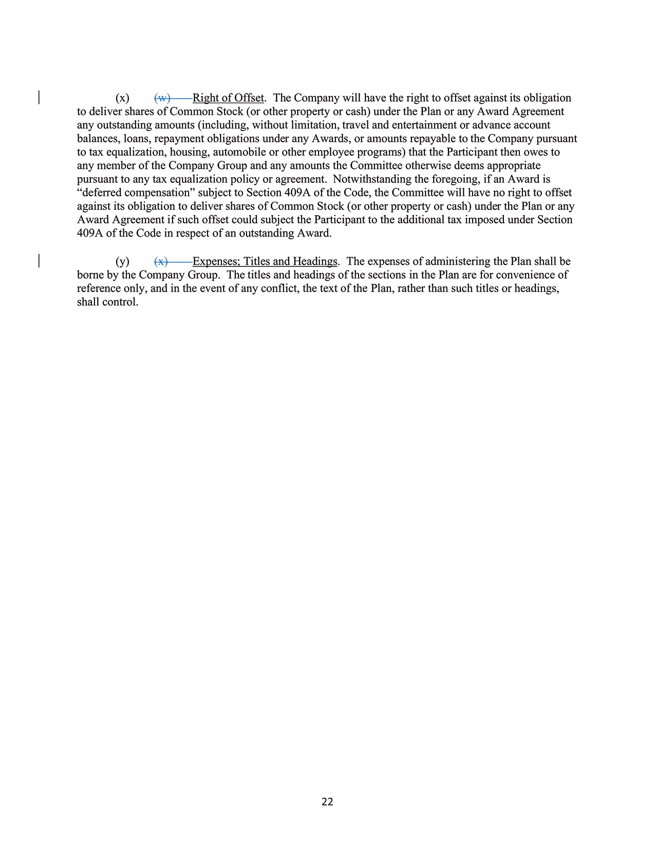
22(x) (w) Right of Offset. The Company will have the right to offset against its obligationto deliver shares of Common Stock (or other property or cash) under the Plan or any Award Agreementany outstanding amounts (including, without limitation, travel and entertainment or advance accountbalances, loans, repayment obligations under any Awards, or amounts repayable to the Company pursuantto tax equalization, housing, automobile or other employee programs) that the Participant then owes toany member of the Company Group and any amounts the Committee otherwise deems appropriatepursuant to any tax equalization policy or agreement. Notwithstanding the foregoing, if an Award is“deferred compensation” subject to Section 409A of the Code, the Committee will have no right to offsetagainst its obligation to deliver shares of Common Stock (or other property or cash) under the Plan or anyAward Agreement if such offset could subject the Participant to the additional tax imposed under Section409A of the Code in respect of an outstanding Award.(y) (x) Expenses; Titles and Headings. The expenses of administering the Plan shall beborne by the Company Group. The titles and headings of the sections in the Plan are for convenience ofreference only, and in the event of any conflict, the text of the Plan, rather than such titles or headings,shall control.
104 2024 Proxy Statement

TABLE OF CONTENTS

Thank You​
for being a stockholder​

Learn more at www.nationalvision.com

TABLE OF CONTENTS
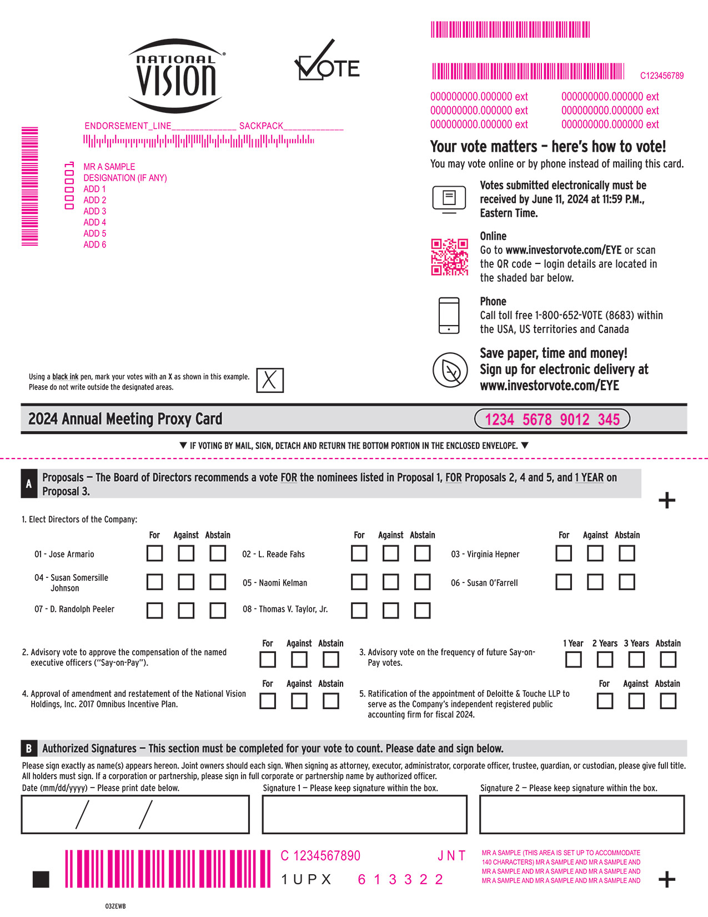
MMMMMMMMMENDORSEMENT_LINE______________ SACKPACK_____________000001MR A SAMPLEDESIGNATION (IF ANY)ADD 1ADD 2ADD 3ADD 4ADD 5ADD 6Using a black ink pen, mark your votes with an X as shown in this example.Please do not write outside the designated areas. MMMMMMMMMMMMMMMMMMMMMMMMMM C123456789000000000.000000 ext000000000.000000 ext000000000.000000 ext000000000.000000 ext000000000.000000 ext000000000.000000 extYour vote matters – here’s how to vote!You may vote online or by phone instead of mailing this card.Votes submitted electronically must be received by June 11, 2024 at 11:59 P.M., Eastern Time.OnlineGo to www.investorvote.com/EYE or scan the QR code — login details are located in the shaded bar below.PhoneCall toll free 1-800-652-VOTE (8683) within the USA, US territories and CanadaSave paper, time and money!Sign up for electronic delivery atwww.investorvote.com/EYE 2024 Annual Meeting Proxy Card1234 5678 9012 345IF VOTING BY MAIL, SIGN, DETACH AND RETURN THE BOTTOM PORTION IN THE ENCLOSED ENVELOPE.AProposals — The Board of Directors recommends a vote FOR the nominees listed in Proposal 1, FOR Proposals 2, 4 and 5, and 1 YEAR onProposal 3.+1. Elect Directors of the Company:For Against AbstainFor Against AbstainFor Against Abstain 01 - Jose Armario04 - Susan SomersilleJohnson07 - D. Randolph Peeler2.Advisory vote to approve the compensation of the named executive officers (“Say-on-Pay”). 02 - L. Reade Fahs03 - Virginia Hepner05- Naomi Kelman06 - Susan O’Farrell08- Thomas V. Taylor, Jr.ForAgainstAbstain1 Year 2 Years3 YearsAbstain3. Advisory vote on the frequency of future Say-on-Pay votes.ForAgainstAbstainForAgainstAbstain 4.Approval of amendment and restatement of the National Vision Holdings, Inc. 2017 Omnibus Incentive Plan. 5. Ratification of the appointment of Deloitte & Touche LLP to serve as the Company’s independent registered public accounting firm for fiscal 2024. BAuthorized Signatures — This section must be completed for your vote to count. Please date and sign below.Please sign exactly as name(s) appears hereon. Joint owners should each sign. When signing as attorney, executor, administrator, corporate officer, trustee, guardian, or custodian, please give full title. All holders must sign. If a corporation or partnership, please sign in full corporate or partnership name by authorized officer.Date (mm/dd/yyyy) — Please print date below.Signature 1 — Please keep signature within the box.Signature 2 — Please keep signature within the box. MMMMMMM C 1234567890J N T1 U P X 6 1 3 3 2 2 MR A SAMPLE (THIS AREA IS SET UP TO ACCOMMODATE 140 CHARACTERS) MR A SAMPLE AND MR A SAMPLE ANDMR A SAMPLE AND MR A SAMPLE AND MR A SAMPLE AND + MR A SAMPLE AND MR A SAMPLE AND MR A SAMPLE AND 03ZEWB

TABLE OF CONTENTS
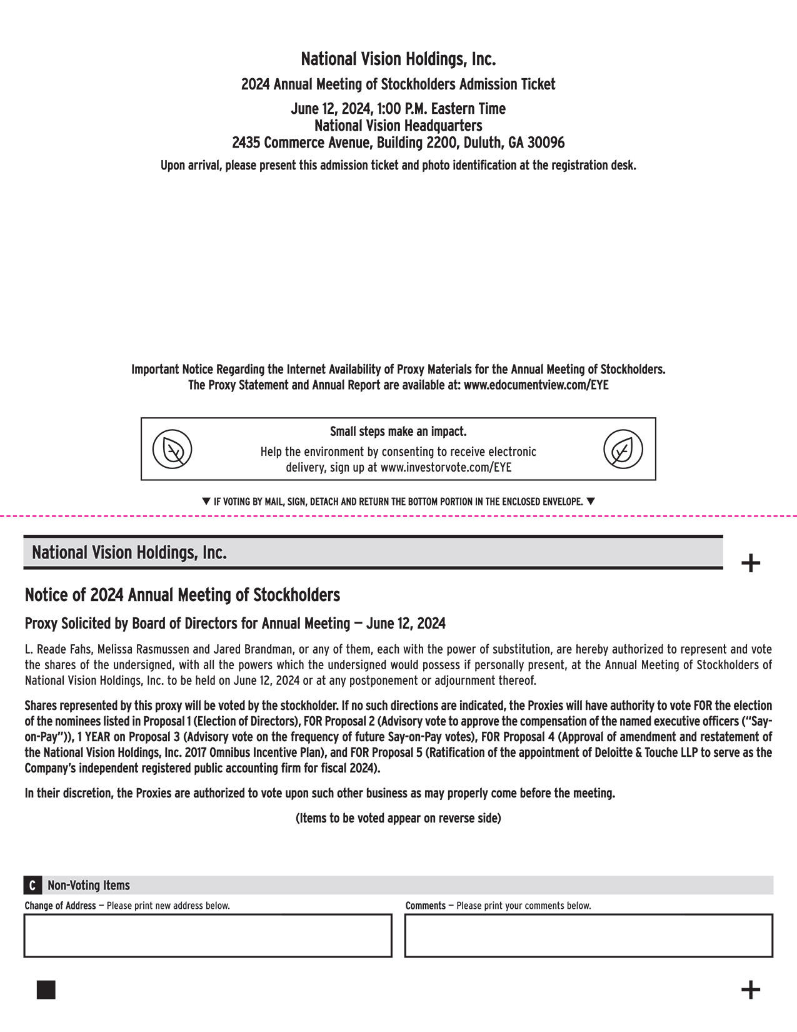
National Vision Holdings, Inc.2024 Annual Meeting of Stockholders Admission TicketJune 12, 2024, 1:00 P.M. Eastern TimeNational Vision Headquarters2435 Commerce Avenue, Building 2200, Duluth, GA 30096Upon arrival, please present this admission ticket and photo identification at the registration desk.Important Notice Regarding the Internet Availability of Proxy Materials for the Annual Meeting of Stockholders.The Proxy Statement and Annual Report are available at: www.edocumentview.com/EYESmall steps make an impact.Help the environment by consenting to receive electronic delivery, sign up at www.investorvote.com/EYEIF VOTING BY MAIL, SIGN, DETACH AND RETURN THE BOTTOM PORTION IN THE ENCLOSED ENVELOPE.National Vision Holdings, Inc.+Notice of 2024 Annual Meeting of StockholdersProxy Solicited by Board of Directors for Annual Meeting — June 12, 2024L. Reade Fahs, Melissa Rasmussen and Jared Brandman, or any of them, each with the power of substitution, are hereby authorized to represent and vote the shares of the undersigned, with all the powers which the undersigned would possess if personally present, at the Annual Meeting of Stockholders of National Vision Holdings, Inc. to be held on June 12, 2024 or at any postponement or adjournment thereof.Shares represented by this proxy will be voted by the stockholder. If no such directions are indicated, the Proxies will have authority to vote FOR the election of the nominees listed in Proposal 1 (Election of Directors), FOR Proposal 2 (Advisory vote to approve the compensation of the named executive officers (“Say-on-Pay”)), 1 YEAR on Proposal 3 (Advisory vote on the frequency of future Say-on-Pay votes), FOR Proposal 4 (Approval of amendment and restatement of the National Vision Holdings, Inc. 2017 Omnibus Incentive Plan), and FOR Proposal 5 (Ratification of the appointment of Deloitte & Touche LLP to serve as the Company’s independent registered public accounting firm for fiscal 2024).In their discretion, the Proxies are authorized to vote upon such other business as may properly come before the meeting.(Items to be voted appear on reverse side)CNon-Voting ItemsChange of Address — Please print new address below.Comments — Please print your comments below. +

