SEC Form 3
FORM 3 | UNITED STATES SECURITIES AND EXCHANGE COMMISSION  Washington, D.C. 20549  INITIAL STATEMENT OF BENEFICIAL OWNERSHIP OF SECURITIES  Filed pursuant to Section 16(a) of the Securities Exchange Act of 1934  or Section 30(h) of the Investment Company Act of 1940
  OMB APPROVAL
  OMB Number: | 3235-0104
  Estimated average burden
  hours per response: | 0.5
1. Name and Address of Reporting Person*  (Street) | 2. Date of Event Requiring Statement (Month/Day/Year)  08/01/2024 | 3. Issuer Name and Ticker or Trading Symbol  National Vision Holdings, Inc. [ EYE ]
  Zulla Caitlin
  (Last) | (First) | (Middle)
  C/O NATIONAL VISION HOLDINGS, INC.
  2435 COMMERCE AVENUE, BLDG 2200
  DULUTH | GA | 30096
  (City) | (State) | (Zip)
 |  | 4. Relationship of Reporting Person(s) to Issuer  (Check all applicable) | 5. If Amendment, Date of Original Filed (Month/Day/Year)
   | Director |  | 10% Owner
   | Officer (give title below) |  | Other (specify below)
6. Individual or Joint/Group Filing (Check Applicable Line)
Form filed by One Reporting Person
Form filed by More than One Reporting Person

Table I - Non-Derivative Securities Beneficially Owned
1. Title of Security (Instr. 4) | 2. Amount of Securities Beneficially Owned (Instr. 4) | 3. Ownership Form: Direct (D) or Indirect (I) (Instr. 5) | 4. Nature of Indirect Beneficial Ownership (Instr. 5)
Table II - Derivative Securities Beneficially Owned
(e.g., puts, calls, warrants, options, convertible securities)
1. Title of Derivative Security (Instr. 4) | 2. Date Exercisable and Expiration Date (Month/Day/Year) |  | 3. Title and Amount of Securities Underlying Derivative Security (Instr. 4) |  | 4. Conversion or Exercise Price of Derivative Security | 5. Ownership Form: Direct (D) or Indirect (I) (Instr. 5) | 6. Nature of Indirect Beneficial Ownership (Instr. 5)
1. Title of Derivative Security (Instr. 4) | Date Exercisable | Expiration Date | Title | Amount or Number of Shares | 4. Conversion or Exercise Price of Derivative Security | 5. Ownership Form: Direct (D) or Indirect (I) (Instr. 5) | 6. Nature of Indirect Beneficial Ownership (Instr. 5)
Explanation of Responses:
Remarks:
No securities are beneficially owned.
 | /s/ Jared Brandman, as Attorney-in-Fact | 08/02/2024
 | ** Signature of Reporting Person | Date
Reminder: Report on a separate line for each class of securities beneficially owned directly or indirectly.
* If the form is filed by more than one reporting person, see Instruction 5 (b)(v).
** Intentional misstatements or omissions of facts constitute Federal Criminal Violations See 18 U.S.C. 1001 and 15 U.S.C. 78ff(a).
Note: File three copies of this Form, one of which must be manually signed. If space is insufficient, see Instruction 6 for procedure.
Persons who respond to the collection of information contained in this form are not required to respond unless the form displays a currently valid OMB Number.
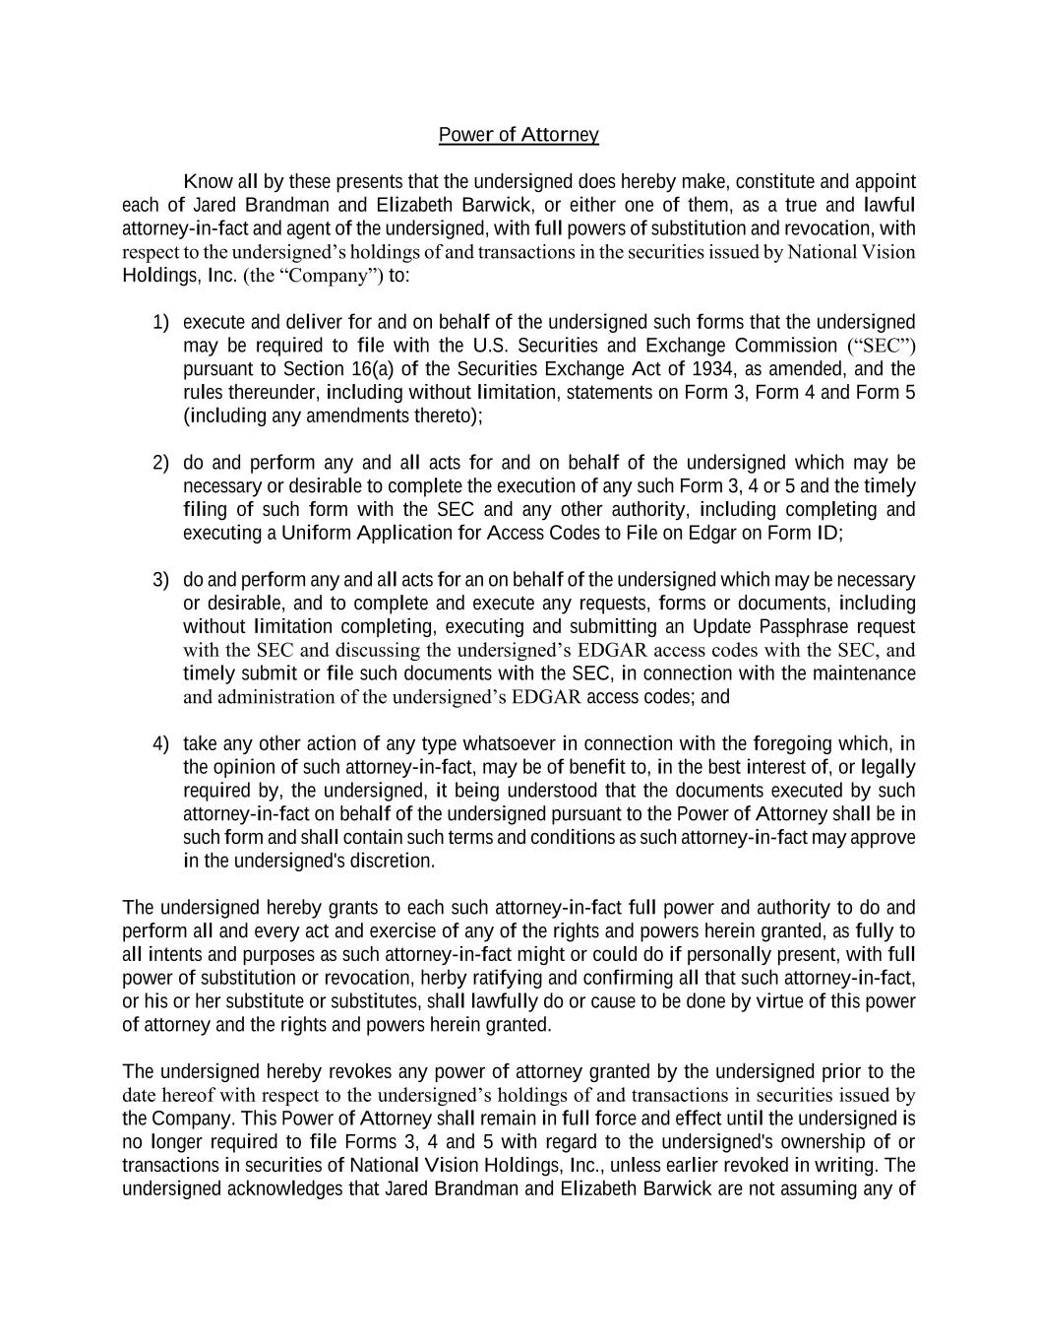
Power of Attorney Know all by these presents that the undersigned does hereby make, constitute and appoint each of Jared Brandman and Elizabeth Barwick, or either one of them, as a true and lawful attorney-in-fact and agent of the undersigned, with full powers of substitution and revocation, with respect to the undersigned’s holdings of and transactions in the securities issued by National Vision Holdings, Inc. (the “Company”) to: 1) execute and deliver for and on behalf of the undersigned such forms that the undersigned may be required to file with the U.S. Securities and Exchange Commission (“SEC”) pursuant to Section 16(a) of the Securities Exchange Act of 1934, as amended, and the rules thereunder, including without limitation, statements on Form 3, Form 4 and Form 5 (including any amendments thereto); 2) do and perform any and all acts for and on behalf of the undersigned which may be necessary or desirable to complete the execution of any such Form 3, 4 or 5 and the timely filing of such form with the SEC and any other authority, including completing and executing a Uniform Application for Access Codes to File on Edgar on Form ID; 3) do and perform any and all acts for an on behalf of the undersigned which may be necessary or desirable, and to complete and execute any requests, forms or documents, including without limitation completing, executing and submitting an Update Passphrase request with the SEC and discussing the undersigned’s EDGAR access codes with the SEC, and timely submit or file such documents with the SEC, in connection with the maintenance and administration of the undersigned’s EDGAR access codes; and 4) take any other action of any type whatsoever in connection with the foregoing which, in the opinion of such attorney-in-fact, may be of benefit to, in the best interest of, or legally required by, the undersigned, it being understood that the documents executed by such attorney-in-fact on behalf of the undersigned pursuant to the Power of Attorney shall be in such form and shall contain such terms and conditions as such attorney-in-fact may approve in the undersigned's discretion. The undersigned hereby grants to each such attorney-in-fact full power and authority to do and perform all and every act and exercise of any of the rights and powers herein granted, as fully to all intents and purposes as such attorney-in-fact might or could do if personally present, with full power of substitution or revocation, herby ratifying and confirming all that such attorney-in-fact, or his or her substitute or substitutes, shall lawfully do or cause to be done by virtue of this power of attorney and the rights and powers herein granted. The undersigned hereby revokes any power of attorney granted by the undersigned prior to the date hereof with respect to the undersigned’s holdings of and transactions in securities issued by the Company. This Power of Attorney shall remain in full force and effect until the undersigned is no longer required to file Forms 3, 4 and 5 with regard to the undersigned's ownership of or transactions in securities of National Vision Holdings, Inc., unless earlier revoked in writing. The undersigned acknowledges that Jared Brandman and Elizabeth Barwick are not assuming any of

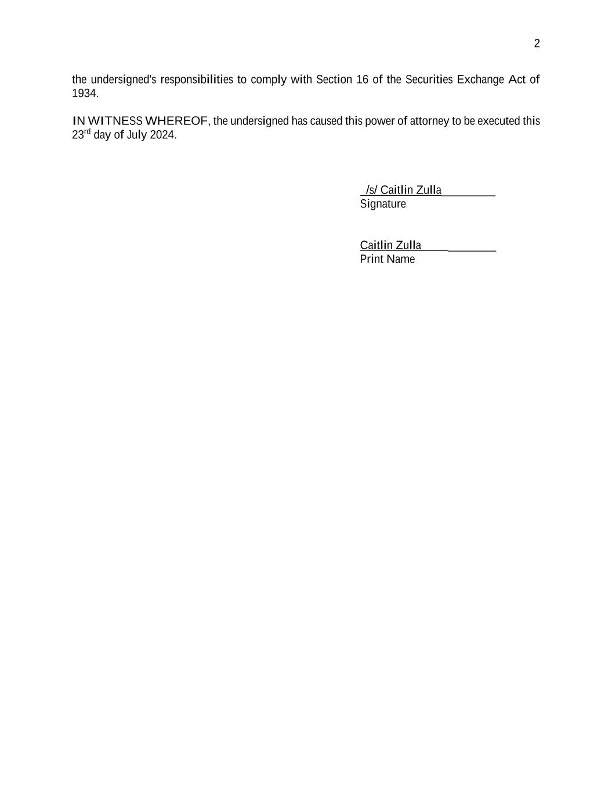
2 the undersigned's responsibilities to comply with Section 16 of the Securities Exchange Act of 1934. IN WITNESS WHEREOF, the undersigned has caused this power of attorney to be executed this 23rd day of July 2024. /s/ Caitlin Zulla_________ Signature Caitlin Zulla ________ Print Name

