SEC Form 3
FORM 3 | UNITED STATES SECURITIES AND EXCHANGE COMMISSION
 | Washington, D.C. 20549
 | Washington, D.C. 20549 |  | OMB APPROVAL
 | INITIAL STATEMENT OF BENEFICIAL OWNERSHIP OF SECURITIES
 | INITIAL STATEMENT OF BENEFICIAL OWNERSHIP OF SECURITIES |  | OMB Number: | 3235-0104
 |  |  | Estimated average burden
 | Filed pursuant to Section 16(a) of the Securities Exchange Act of 1934 |  | hours per response: | 0.5

or Section 30(h) of the Investment Company Act of 1940
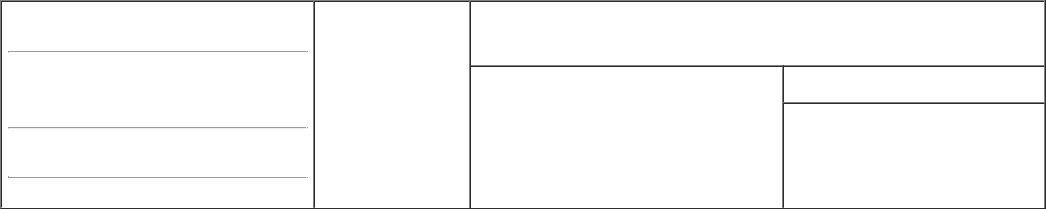

1. Name and Address of Reporting Person*
Johnson Susan S

- Date of Event Requiring Statement (Month/Day/Year)
10/26/2020

3. Issuer Name and Ticker or Trading Symbol

National Vision Holdings, Inc. [ EYE ]

(Last) (First) (Middle)

C/O NATIONAL VISION HOLDINGS, INC.

2435 COMMERCE AVENUE, BLDG 2200

(Street)

DULUTH GA 30096

- Relationship of Reporting Person(s) to Issuer (Check all applicable)
X | Director | 10% Owner
 | Officer (give title | Other (specify below)
 | below) | Other (specify below)

- If Amendment, Date of Original Filed (Month/Day/Year)

- Individual or Joint/Group Filing (Check Applicable Line) X Form filed by One Reporting Person

Form filed by More than One Reporting Person

(City) (State) (Zip)

Table I - Non-Derivative Securities Beneficially Owned

 | 1. Title of Security (Instr. 4) | 2. Amount of Securities Beneficially | 3. Ownership Form: | 4. Nature of Indirect Beneficial Ownership (Instr. 5)
 |  | Owned (Instr. 4) | Direct (D) or Indirect
 |  |  | (I) (Instr. 5)
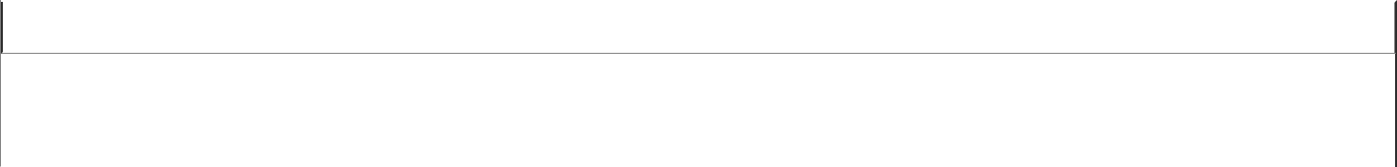

Table II - Derivative Securities Beneficially Owned

(e.g., puts, calls, warrants, options, convertible securities)

1. Title of Derivative Security (Instr. 4) | 2. Date Exercisable and |  | 3. Title and Amount of Securities Underlying |  | 4. | 5. Ownership |  |  | 6. Nature of Indirect Beneficial
 | Expiration Date |  | Derivative Security (Instr. 4) |  | Conversion | Form: Direct |  |  | Ownership (Instr. 5)
 | (Month/Day/Year) |  |  |  | or Exercise | (D) or Indirect
 |  |  |  |  | Price of | (I) (Instr. 5)
 |  |  |  | Amount or | Price of
 | Date | Expiration |  | Amount or | Derivative
 | Date | Expiration | Title | Number of | Security
 | Exercisable | Date | Title | Shares
Explanation of Responses:
Remarks:
Exhibit List: Exhibit 24 - Power of Attorney
No securities are beneficially owned.
 |  |  |  | /s/ Jared Brandman, as Attorney-in-Fact 10/28/2020
 |  |  |  | ** Signature of Reporting Person |  |  |  | Date

Reminder: Report on a separate line for each class of securities beneficially owned directly or indirectly.

* If the form is filed by more than one reporting person, see Instruction 5 (b)(v).

- Intentional misstatements or omissions of facts constitute Federal Criminal Violations See 18 U.S.C. 1001 and 15 U.S.C. 78ff(a). Note: File three copies of this Form, one of which must be manually signed. If space is insufficient, see Instruction 6 for procedure.
Persons who respond to the collection of information contained in this form are not required to respond unless the form displays a currently valid OMB Number.



