SEC Form 3
FORM 3 | UNITED STATES SECURITIES AND EXCHANGE COMMISSION
 | Washington, D.C. 20549
 | Washington, D.C. 20549 |  | OMB APPROVAL
 | INITIAL STATEMENT OF BENEFICIAL OWNERSHIP OF SECURITIES
 | INITIAL STATEMENT OF BENEFICIAL OWNERSHIP OF SECURITIES |  | OMB Number: | 3235-0104
 |  |  | Estimated average burden
 | Filed pursuant to Section 16(a) of the Securities Exchange Act of 1934 |  | hours per response: | 0.5
or Section 30(h) of the Investment Company Act of 1940
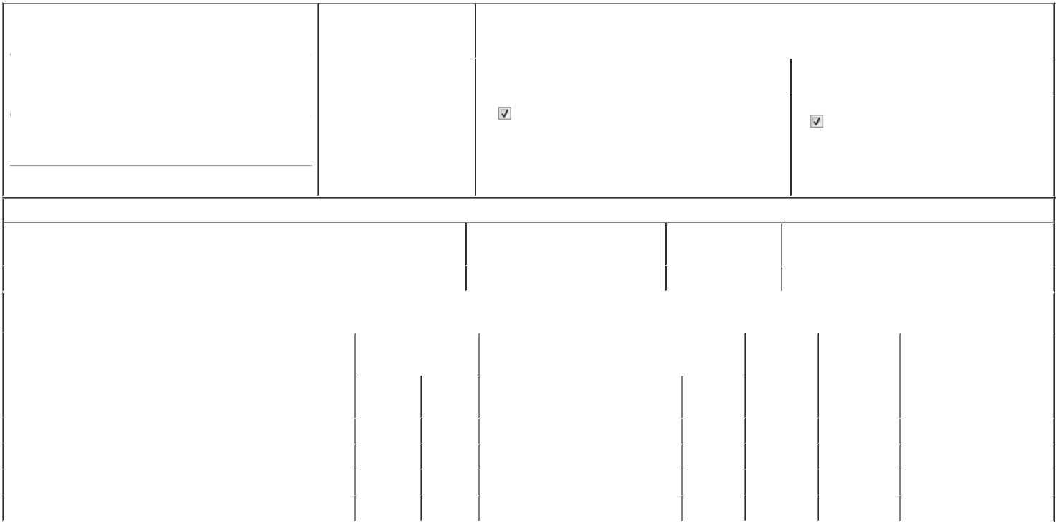

1. Name and Address of Reporting Person* |  |  |  |  |  | 2. Date of Event Requiring
 |  | Patel Priti V |  |  |  | Statement (Month/Day/Year)
 |  | Patel Priti V |  |  | 01/24/2025
 |  | (Last) |  | (First) | (Middle)
 |  | 2435 COMMERCE AVENUE, BLDG 2200
(Street)
 |  | DULUTH |  | GA | 30096

3. |  | Issuer Name and Ticker or Trading Symbol
National Vision Holdings, Inc. [ EYE ]
4. |  | Relationship of Reporting Person(s) to Issuer |  |  | 5. | If Amendment, Date of Original Filed (Month/Day/Year)
(Check all applicable)
 |  | Director |  | 10% Owner
 |  |  |  | 10% Owner | 6. | Individual or Joint/Group Filing (Check Applicable Line)
 |  | Officer (give title |  | Other (specify below) | 6. | Individual or Joint/Group Filing (Check Applicable Line)
 |  | below) |  | Other (specify below) |  | Form filed by One Reporting Person
 |  | General Manager |  |  |  | Form filed by More than One Reporting Person

(City) (State) (Zip)

Table I - Non-Derivative Securities Beneficially Owned

1. Title of Security (Instr. 4) | 2. Amount of Securities Beneficially | 3. Ownership Form: | 4. Nature of Indirect Beneficial Ownership (Instr. 5)
 | Owned (Instr. 4) | Direct (D) or Indirect
 |  | (I) (Instr. 5)

 | Common Stock |  |  |  | 8,958 | D
 |  |  | Table II - Derivative Securities Beneficially Owned
 |  | (e.g., puts, calls, warrants, options, convertible securities)
 | 1. Title of Derivative Security (Instr. 4) |  | 2. Date Exercisable and |  | 3. Title and Amount of Securities Underlying |  | 4. | 5. Ownership | 6. Nature of Indirect Beneficial
 |  |  | Expiration Date |  | Derivative Security (Instr. 4) |  | Conversion | Form: Direct | Ownership (Instr. 5)
 |  |  | (Month/Day/Year) |  |  |  | or Exercise | (D) or Indirect
 |  |  |  |  |  |  | Price of | (I) (Instr. 5)
 |  |  |  |  |  | Amount or | Price of | (I) (Instr. 5)
 |  |  |  |  |  | Amount or | Derivative
 |  |  | Date | Expiration | Title | Number of | Security
 |  |  | Exercisable | Date | Title | Shares
 | Restricted Stock Units | (1) |  | (1) | Common Stock | 17,919 | (2) | D
 | Stock Option (Right to Buy) | (3) |  | 03/01/2029 | Common Stock | 1,876 | 35.19 | D
 | Stock Option (Right to Buy) | (3) |  | 03/05/2031 | Common Stock | 864 | 45.66 | D
 | Stock Option (Right to Buy) | (3) |  | 02/28/2030 | Common Stock | 1,461 | 34.82 | D
 | Explanation of Responses:

- Reflects 17,919 unvested restricted stock units, of which 350 vest on 2/28/25, 2,988 vest on 3/3/25, 1,502 vest on 10/3/25, 2,989 vest on 3/3/26 and 10,090 vest in increments of one-third on each of 2/28/25, 3/1/26, and 3/1/27.

- Restricted stock units convert into common stock on a one-for-one basis.

- These stock options are fully vested.

Remarks:

/s/ Jared Brandman as Attorney-in-Fact 02/07/2025

** Signature of Reporting Person Date

Reminder: Report on a separate line for each class of securities beneficially owned directly or indirectly.

* If the form is filed by more than one reporting person, see Instruction 5 (b)(v).

- Intentional misstatements or omissions of facts constitute Federal Criminal Violations See 18 U.S.C. 1001 and 15 U.S.C. 78ff(a). Note: File three copies of this Form, one of which must be manually signed. If space is insufficient, see Instruction 6 for procedure.
Persons who respond to the collection of information contained in this form are not required to respond unless the form displays a currently valid OMB Number.



